Name- Niraj Lavankar

Technologies/Tools- Java 8, JUnit 4 bundle, Log4j,Eclipse IDE

Sample output-

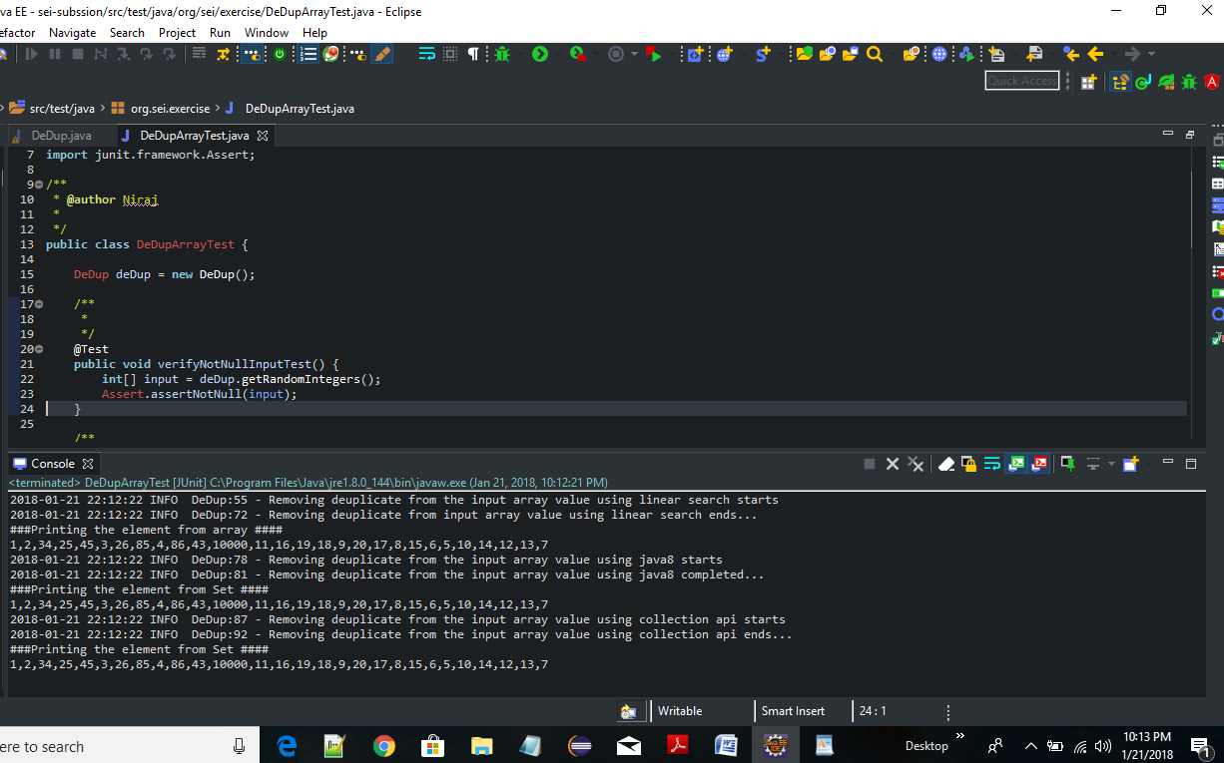

-Sample output with Junit Test case execution.

