1. Pre-requisite for Route53 is domain name.

Login to Godday.com and then create your own domain.

I choose rameshadapaka.ca as the domain name and purchased with 16$ CAD per anum. (it seems like a reasonable price for a domain registration, considered monthly fee of 1.25$)

We can choose with other names as well for low cost or low prices.

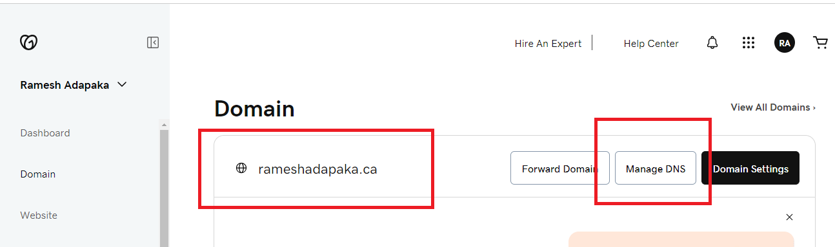

Note down my domain name: rameshadapaka.ca

1. Pre-requisite : Create a load balancer with an ec2 instance of t2.micro and then install httpd for testing the ec2 instance.

# Create Route 53

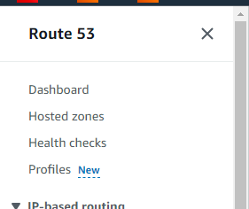

Click on Hosted zones

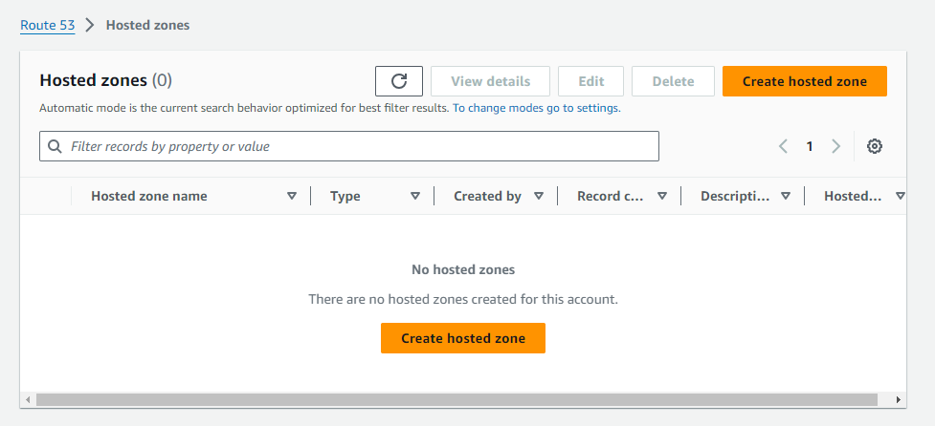

Click on Create hosted zone

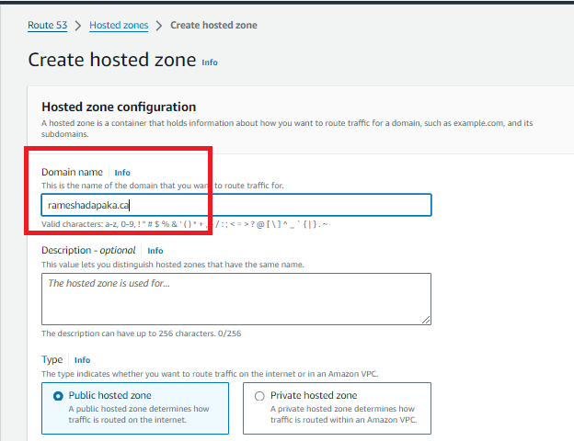 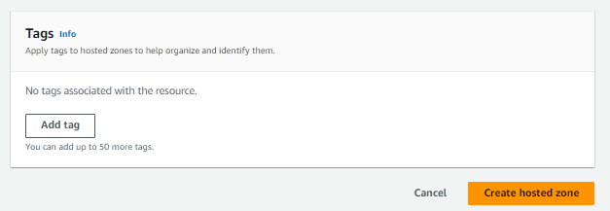

Click on Create hosted zone.

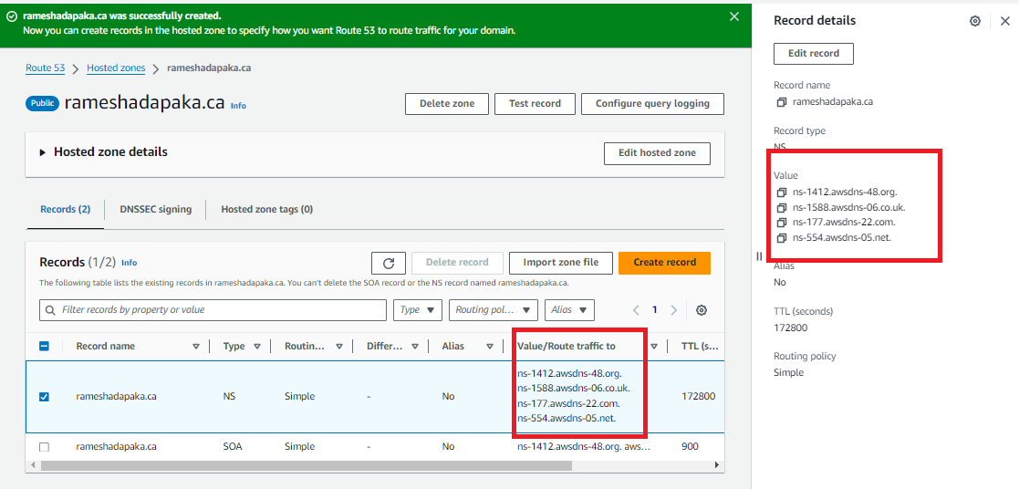

Copy each NS (name servers) and configure to our domain name.

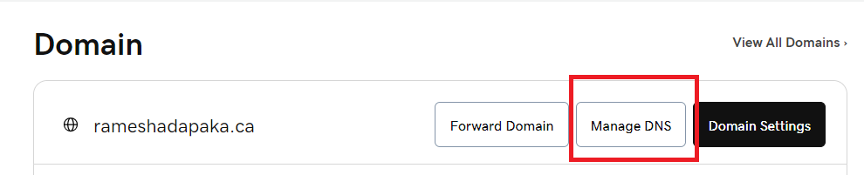

Click on Manage DNS

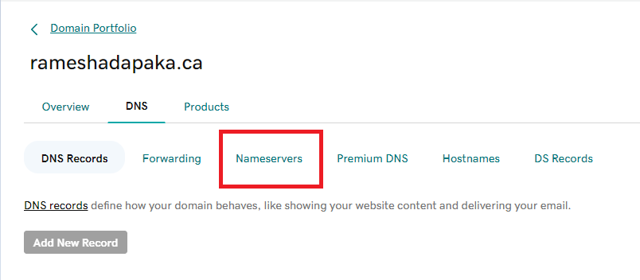

Click on Nameservers

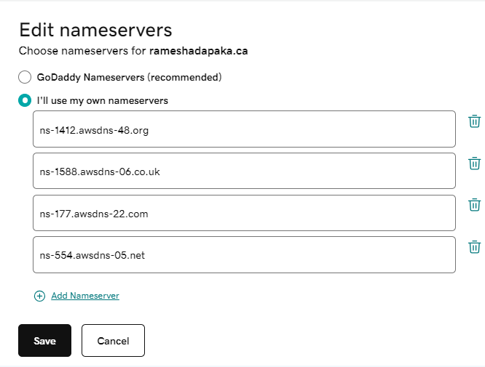

Click on Save

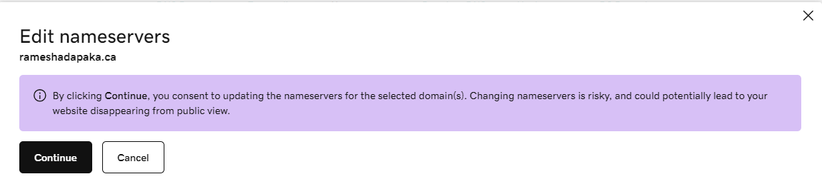 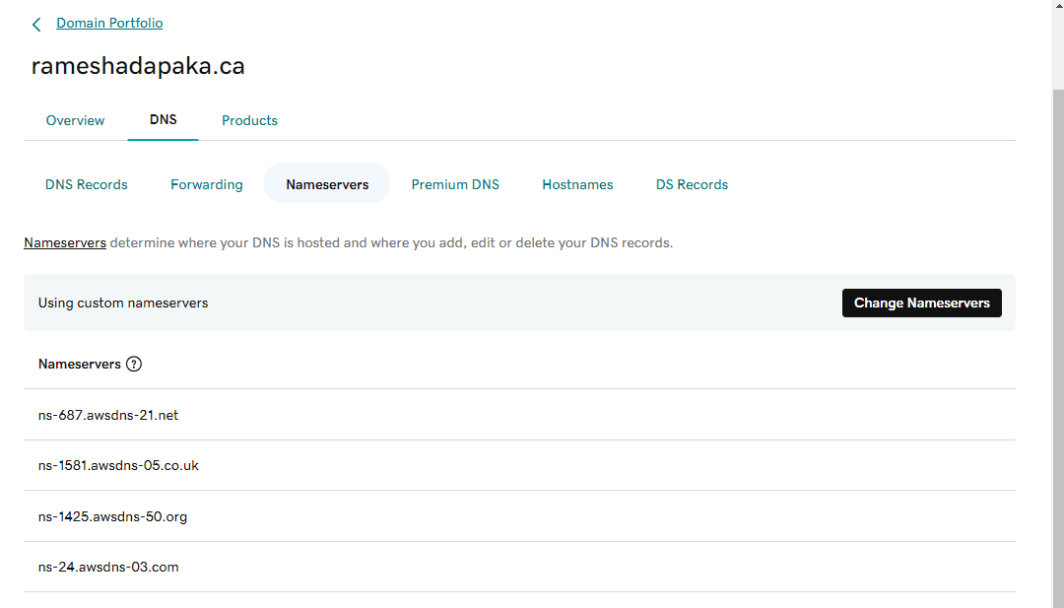

Now you switch to aws console for our Hosted Zone

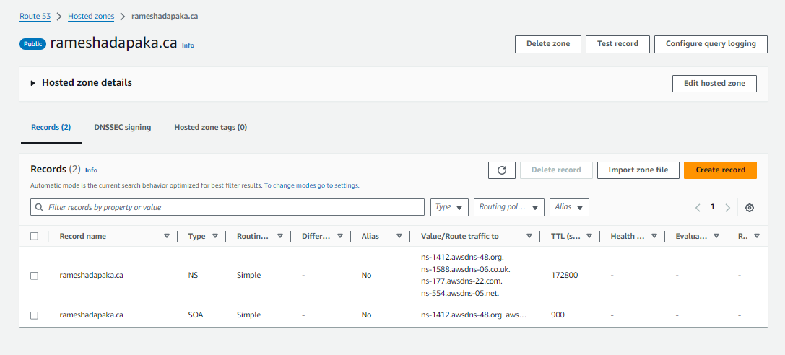

Click on Create record

Configured the highlighted box parameters

Alias should be enabled.

Load balancer type, region and load balancer name should be selected

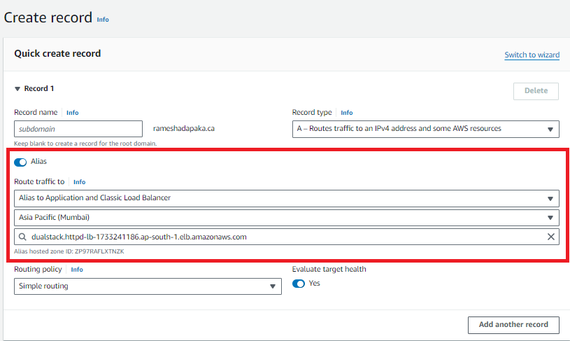

Click on create record in the bottom of this page

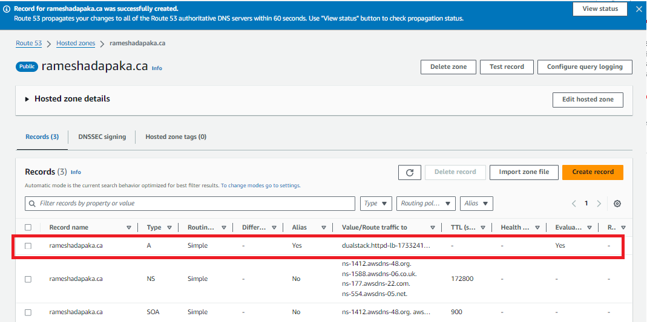

One record was created

Everything is setup now to access the ec2 httpd from the domain name. but it will take few minutes to access the application from the domain name. so be patience.

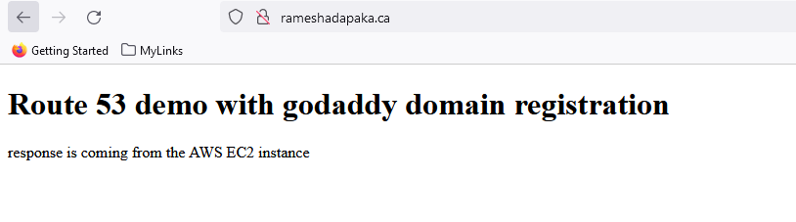

****************** Lab is over. ********************