Nohup cmd used for BG,
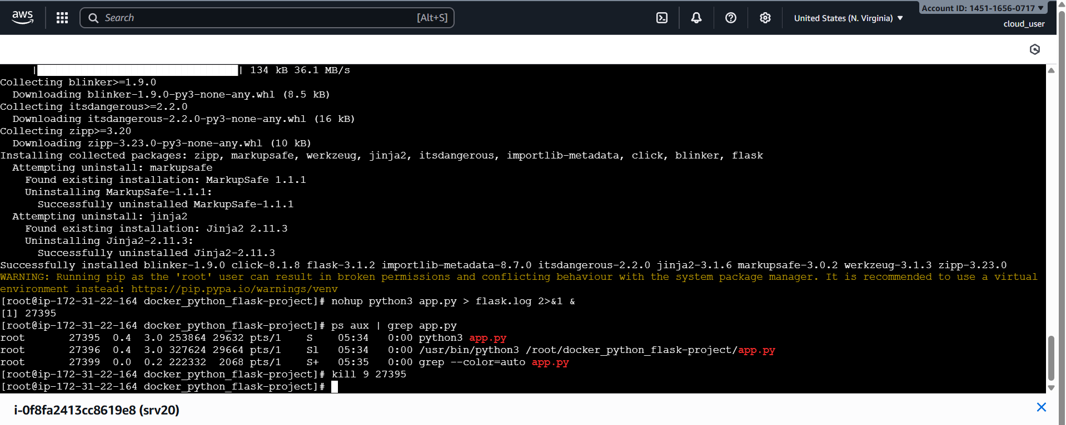
After killing process. Site not reached.
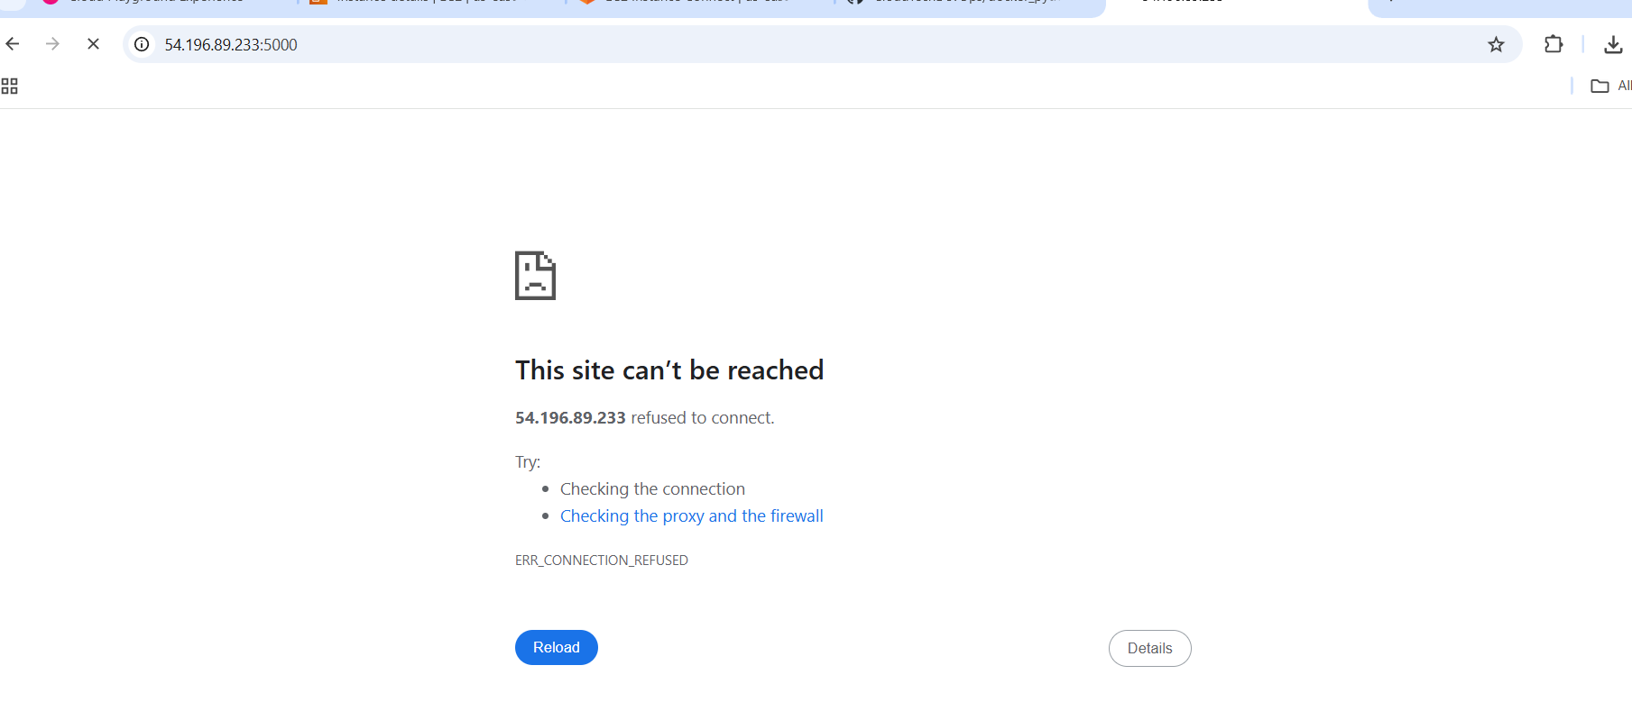
Checked logs
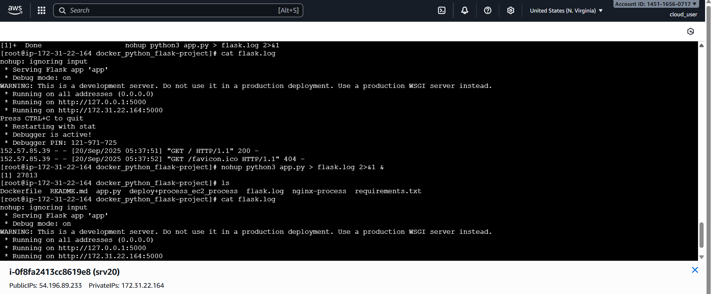

Deployed python app in private server
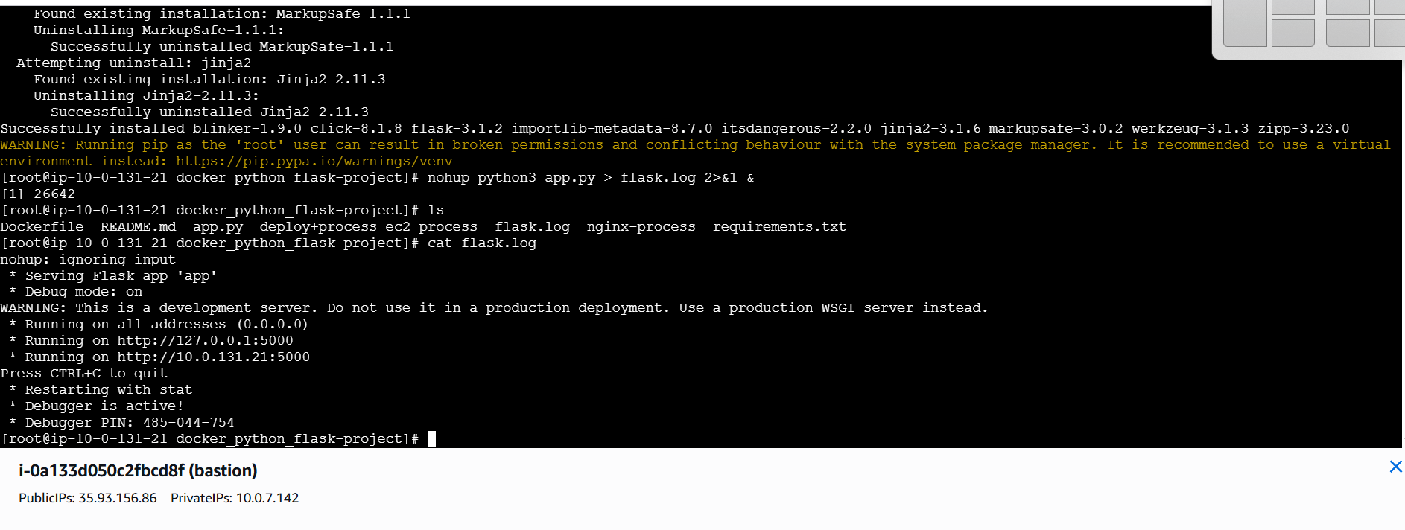
Installed nginx in bastion and uploaded proxy config file
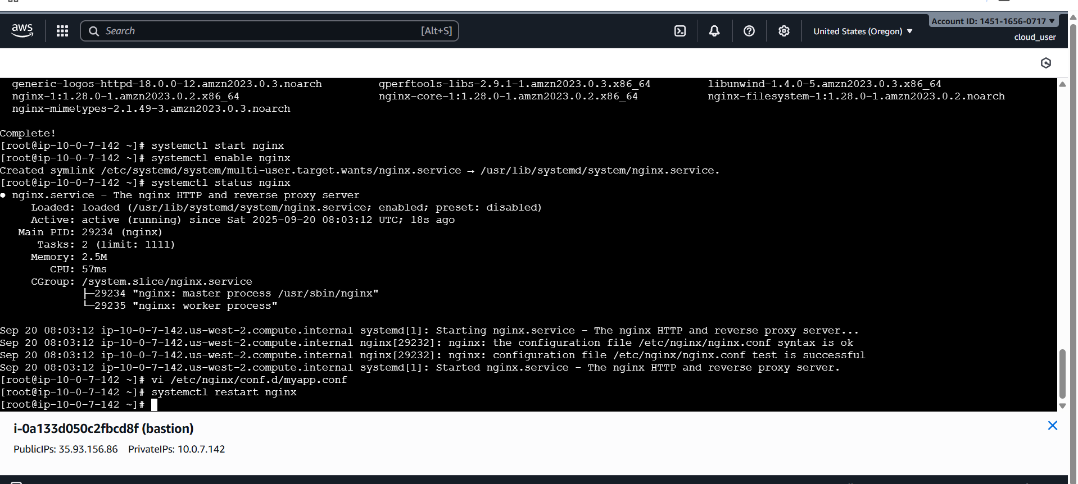
Updated config for proxy
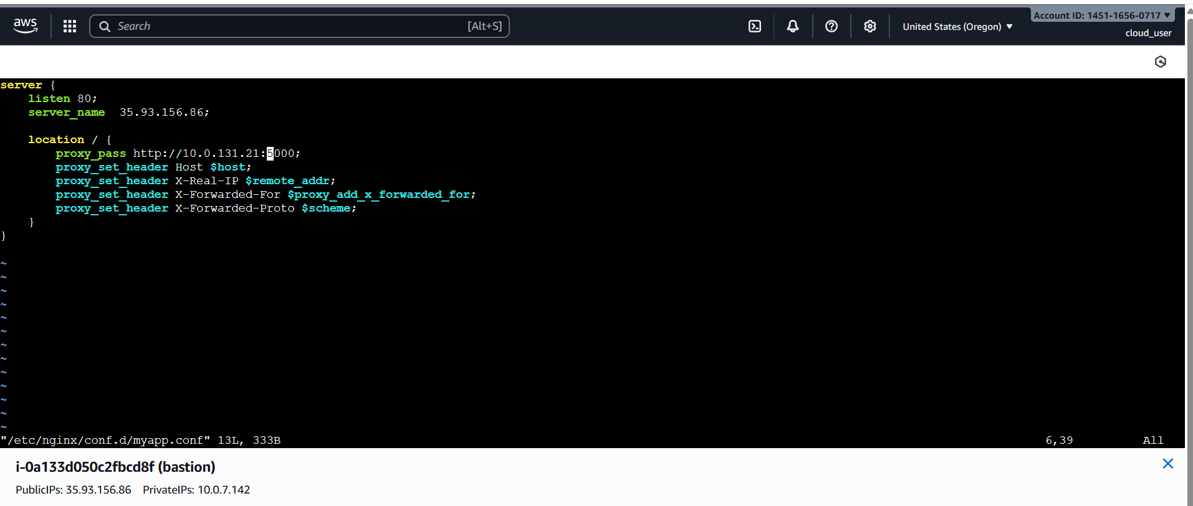

Public Ip without listening default port 80 is configured with private server(python app) port 5000, hence output of puplic ip

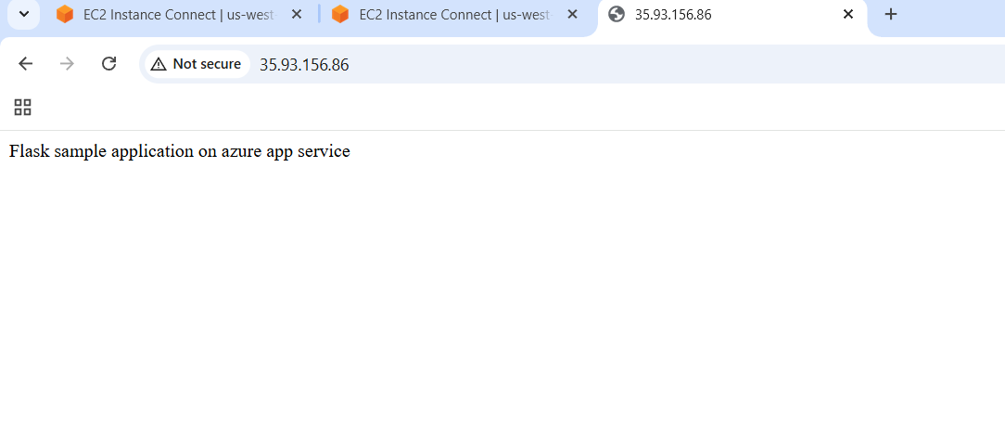
Nodejs server app
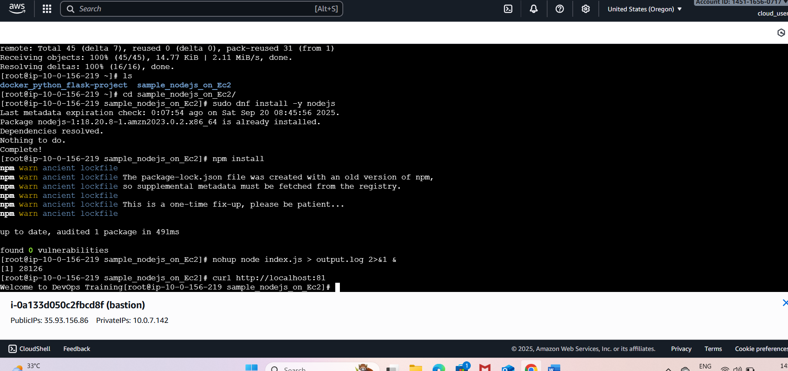
Configured public ip with both python app and node js server
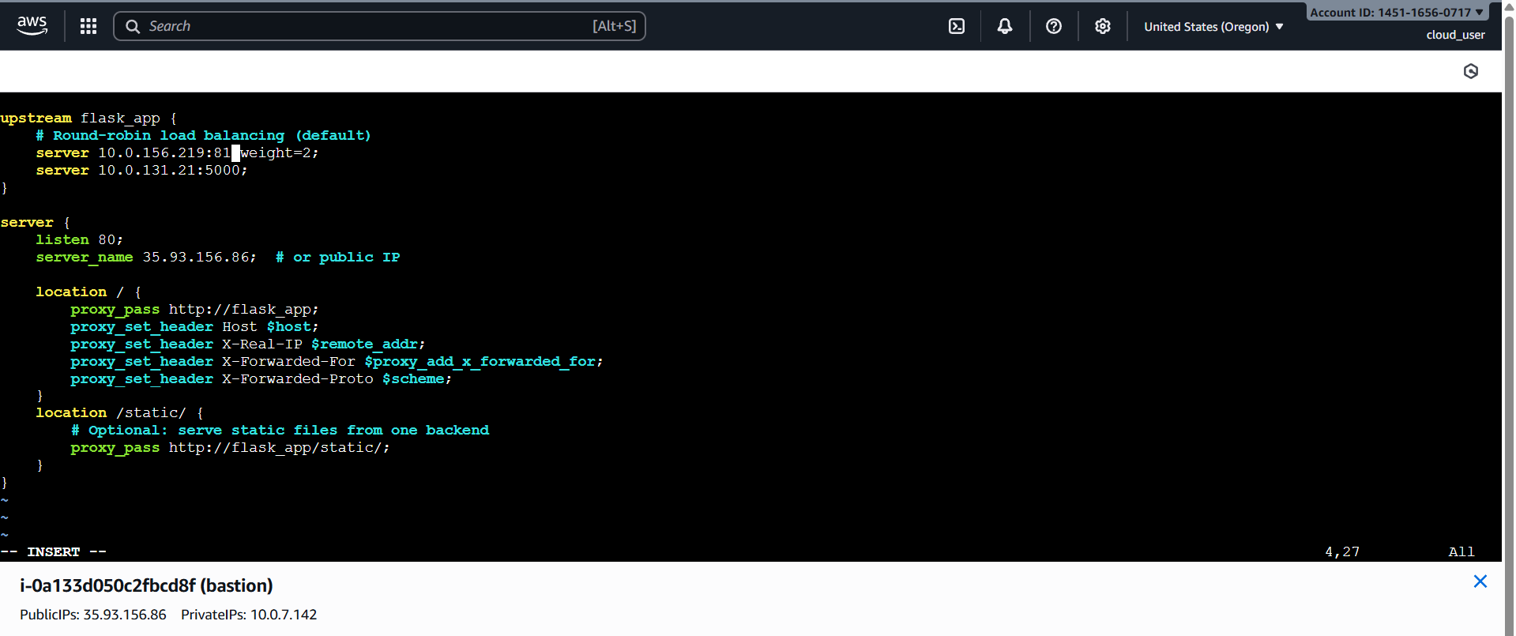
As weight given to node server output of public ip
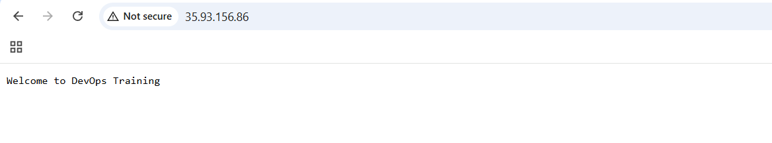
Mapping domain for proxy
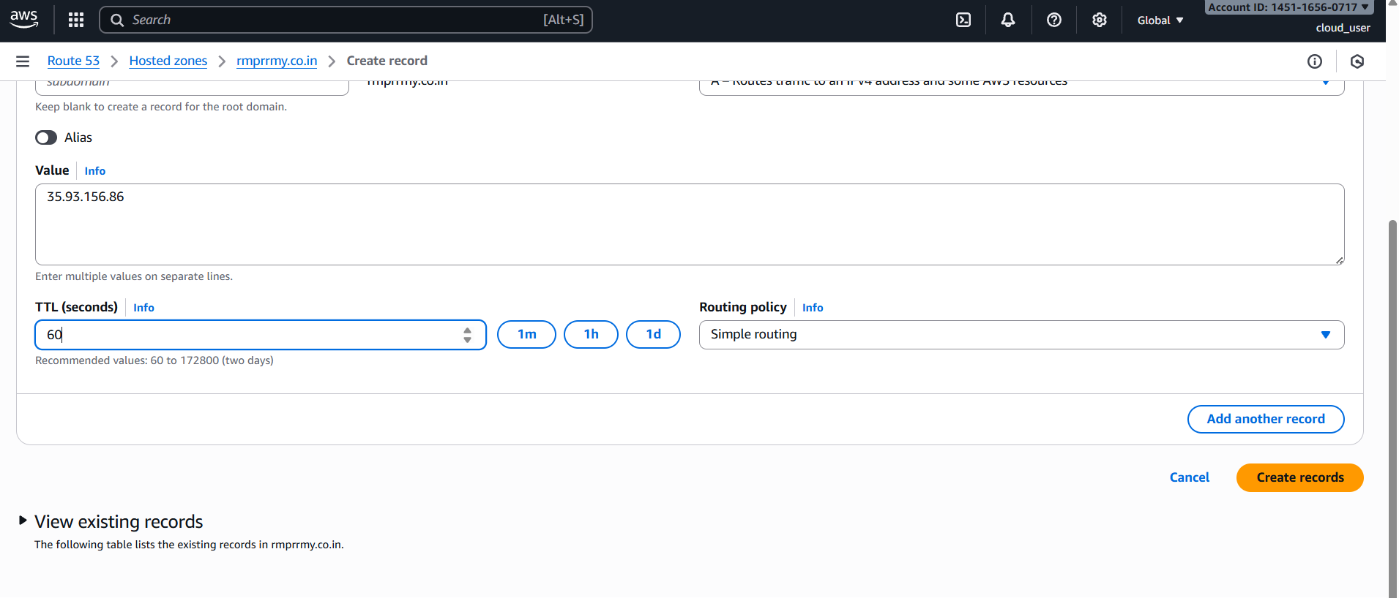

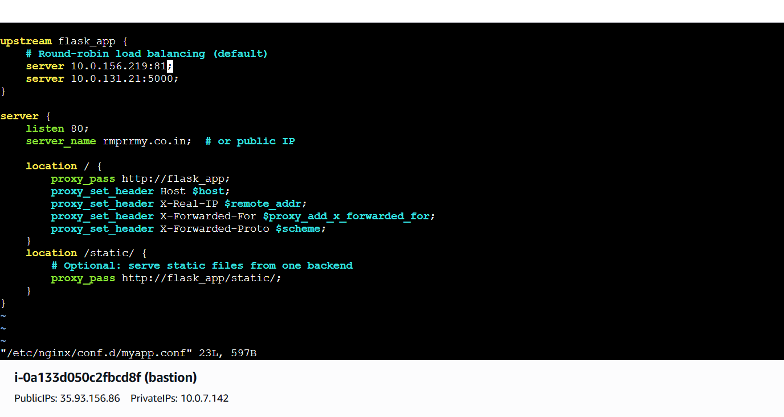
For some hits output from node-js server and for some output from python app server
