Task:-

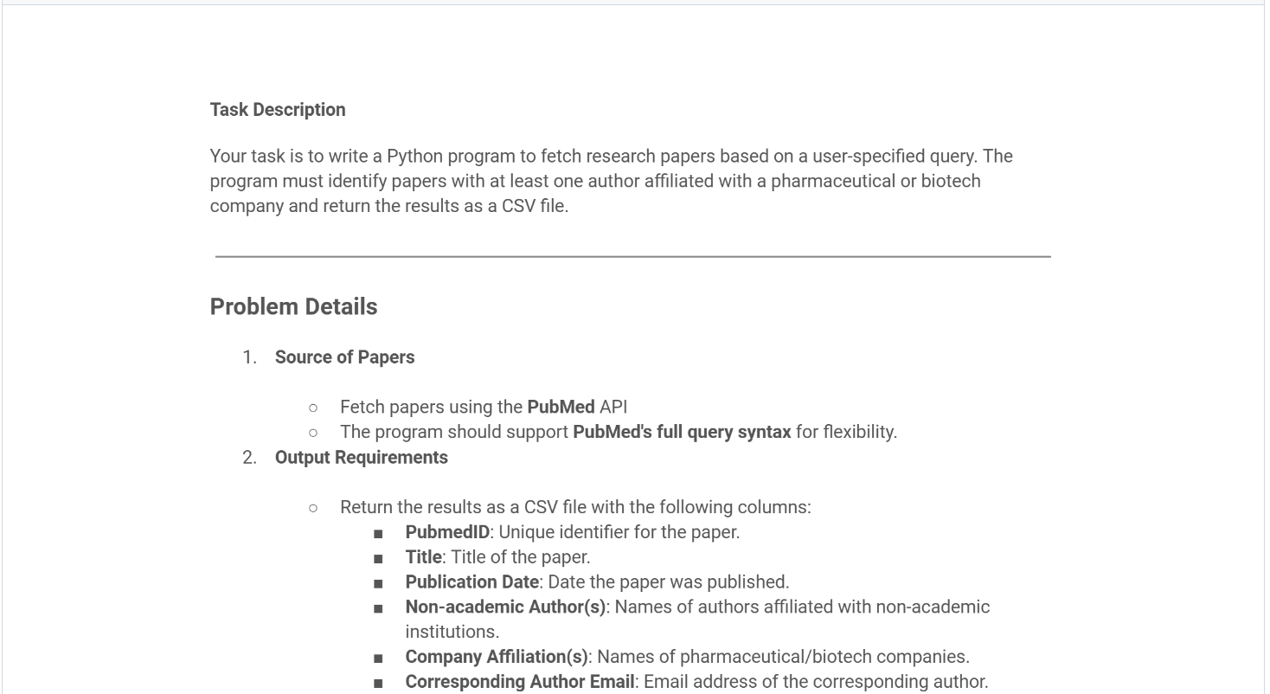

Code:-

from Bio import Entrez, Medline

import csv

import time

Entrez.email = [nirajasamineni2025@gmail.com](mailto:nirajasamineni2025@gmail.com)

COMPANY_KEYWORDS = [

'pharma', 'biotech', 'therapeutics', 'biosciences', 'life sciences',

'laboratories', 'lab', 'inc', 'ltd', 'llc', 'corporation', 'gmbh',

's.a.', 'co.', 'company', 'genomics', 'biopharma'

]

def is_pharma_affiliation(affiliation):

"""Check if any pharma/biotech keyword appears in the affiliation."""

return any(keyword.lower() in affiliation.lower() for keyword in COMPANY_KEYWORDS)

def fetch_pubmed_ids(query, max_results=100):

"""Fetch PubMed IDs for the given search query."""

handle = Entrez.esearch(db="pubmed", term=query, retmax=max_results)

result = Entrez.read(handle)

handle.close()

return result["IdList"]

def fetch_medline_records(pmids):

"""Fetch and parse MEDLINE records for given PMIDs."""

handle = Entrez.efetch(db="pubmed", id=",".join(pmids), rettype="medline", retmode="text")

records = list(Medline.parse(handle))

handle.close()

return records

def filter_pharma_papers(records):

"""Filter records with at least one author affiliated with a pharma/biotech company."""

filtered = []

for record in records:

affiliations = record.get("AD", [])

if isinstance(affiliations, str):

affiliations = [affiliations]

if any(is_pharma_affiliation(aff) for aff in affiliations):

filtered.append({

"PubmedID": record.get("PMID", ""),

"Title": record.get("TI", ""),

"Authors": "; ".join(record.get("AU", [])),

"Affiliations": "; ".join(affiliations),

"Journal": record.get("JT", ""),

"Year": record.get("DP", "").split()[0]

})

return filtered

def save_to_csv(data, filename="pharma_papers.csv"):

"""Save results to a CSV file."""

with open(filename, mode="w", newline="", encoding="utf-8") as f:

writer = csv.DictWriter(f, fieldnames=["PubmedID", "Title", "Authors", "Affiliations", "Journal", "Year"])

writer.writeheader()

writer.writerows(data)

def main():

query = input("Enter your PubMed search query: ")

max_results = int(input("Enter max number of papers to fetch (e.g. 100): "))

print("\nFetching PubMed IDs...")

pmids = fetch_pubmed_ids(query, max_results)

print("Fetching MEDLINE records...")

records = fetch_medline_records(pmids)

print("Filtering for pharma/biotech affiliations...")

filtered = filter_pharma_papers(records)

print(f"\nFound {len(filtered)} papers with pharma/biotech authors.")

save_to_csv(filtered)

print("Results saved to 'pharma_papers.csv'.")

if __name__ == "__main__":

main()

output:-

