**SYNOPSIS**

**Title:**

Image encryption using SCAN methodology.

**Team Details:**

**Team Mentor’s Name -** Mr. Navneet Yadav

**Team Members:**

|  |  |  |  |
| --- | --- | --- | --- |
| ***S.No.*** | ***Name*** | ***Enrollment No.*** | ***Email-ID*** |
| 1 | Mr. Niraj Agarwal | 07114802810 | niraj.agarwal@hotmail.co.in |

**Objective:**

In the colour image encryption method, image is encrypted by specific rule that guides the rearrangement of image pixels*.* In this project, we implement colour image encryption and decryption by using partition and scanning pattern pertaining to SCAN approach. SCAN language is based on spatial accessing methodology that can generate a wide range of scanning paths.

We will further extend the project to work on any image size given.

**Partition patterns:**

There are three basic partition patterns:

1. B type
2. Z type
3. X type

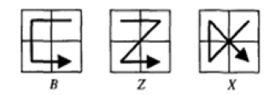

Each partition pattern can be further characterized in 8 different orientations depending upon starting and finishing point as shown:

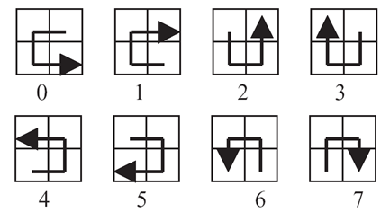

B type transformations

This partition technique is used to divide an image into 4 sub-images.

**Scanning Patterns:**

We have four scanning patterns:

1. Continuous Raster C
2. Continuous Diagonal D
3. Continuous Orthogonal O
4. Spiral S

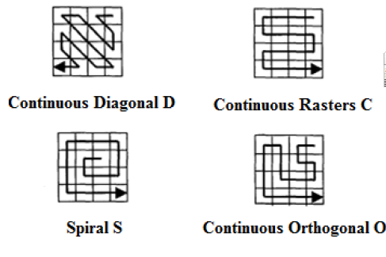

Scanning pattern determines the ordering of pixels.

**Example of encryption key:**

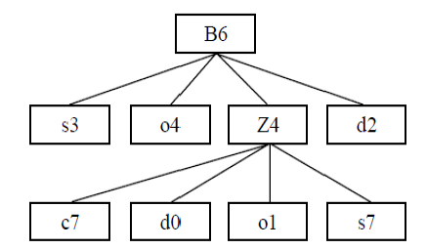

Encryption Key : B6( s3, o4, Z4( c7, d0, o1, s7),d2)

**Advantages:**

* Lossless encryption of image.
* Variable lengths of encryption key.
* High processing speed.
* Uses only integer arithmetic.
* Can be easily implemented.
* Perfect guess of encryption key impossible.

**References:**

1. R. Gupta, J. Bisht, “Colour image encryption and decryption by using SCAN approach”, International Journal of software and Hardware Research in Engineering, Volume 1 Issue 2, October 2013.
2. Panduranga, Naveen Kumar, “Hybrid approach for image encryption using SCAN patterns and carrier images”, International Journal on Computer Science and Engineering, Vol 2, No 2, 2010, 297-300
3. www.mathworks.in/academia/student_center/**tutorials**/‎