St. Lawrence College
Chabahil, Kathmandu
Lab reports of Introduction to Information technology



Submitted by:
Nirajan Chaudhary
CSIT 1st semester
Roll no : 17
Submitted to:
PRAJWAL BISTA
Lecturer Bsc.Csit
A lab report of
“Computer Fundamentals and Application, CAS-101”
as required for the partial fulfillment of the
Bsc.Csit 1st semester
Affiliated to Tribhuvan university

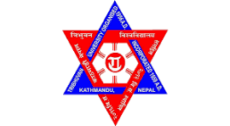
This is to certify that the Lab Report entitled “Introduction to Information and Technology” is an academic work done by Nirajan Chaudhary submitted in the partial fulfillment of the requirements for the degree of Bachelor of Computer Science and information technology at the Institute of Science and Technology, Tribhuvan University, under my guidance and supervision. To the best of my knowledge, the work performed by him in the Lab Report is his own creation.
Certificate From The Supervisor
Lab reports of Introduction to Information technology

