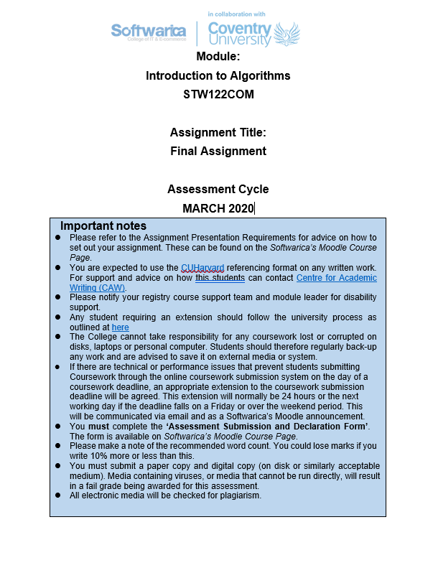

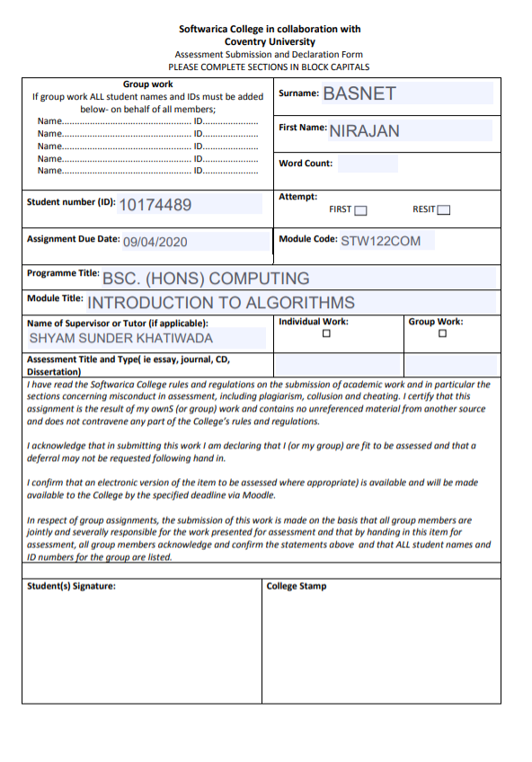

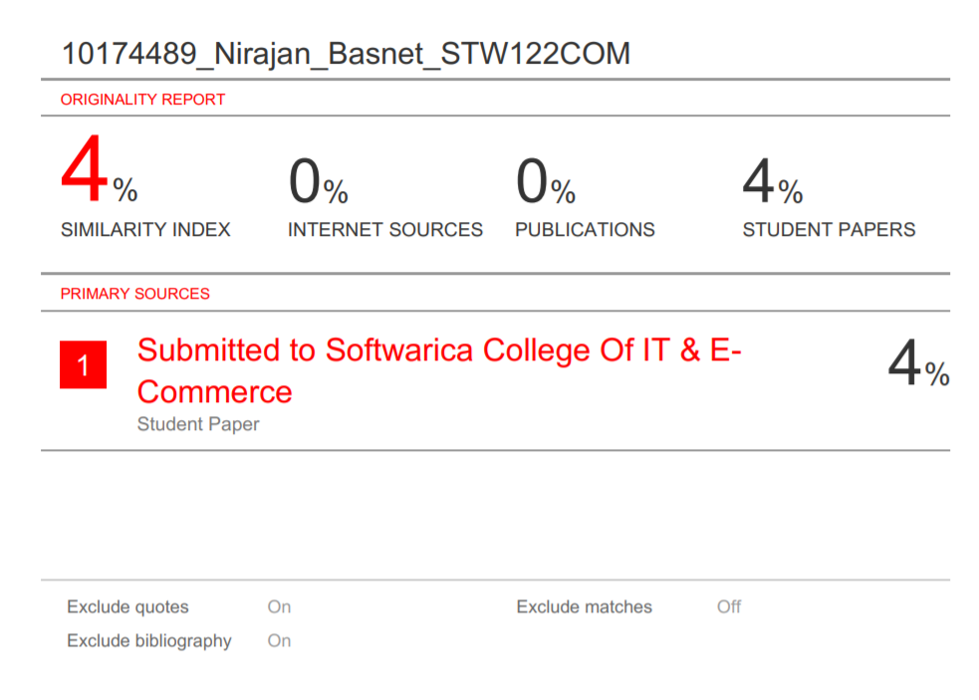

**Table of Contents**

Introduction: …………………………………………………………………. 4

Application Functionalities: …………………………………………… 4

Application Interfaces: …………………………………………………… 5-10

Source Code: …………………………………………………………………. 11-20

Conclusion: ……………………………………………………………………. 21

**Introduction**

This documentation that is shown in this document holds all the detailed features along with its application interface and source code of the restaurant management system which is an application developed using Tkinter module in python. This restaurant management system is capable of editing the menu and can know their bill in that menu itself. It is an application which is developed to make work easier, faster and reliable.

**Application Functionalities:**

* This restaurant management system provides a user a friendly interface or simply screen.
* The user can cancel and again edit the order.
* This application provides user a detailed name, price and type.
* The user can order the food as much as it is available in the menu.
* User can see the message like if their order is successful or not and to pay the bill u need to go to the counter for payment and so on.
* The management can edit, delete and add to menu whenever they want.

**Application Interfaces:**

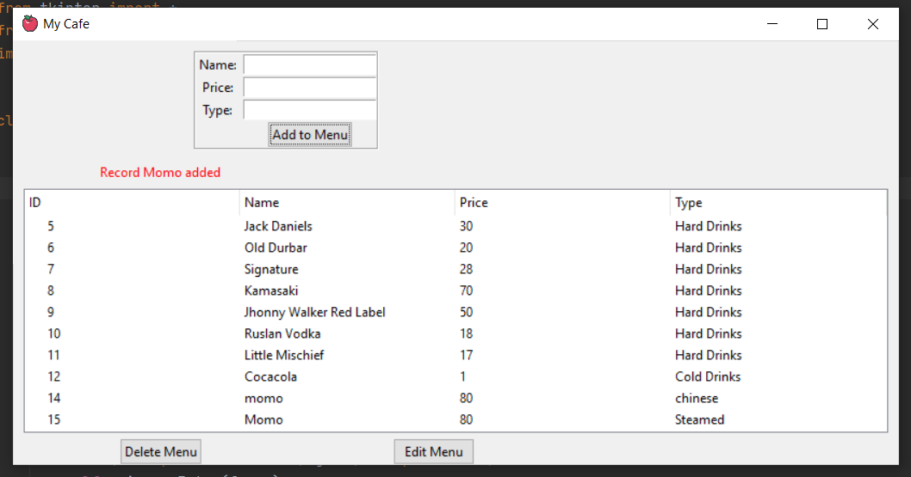

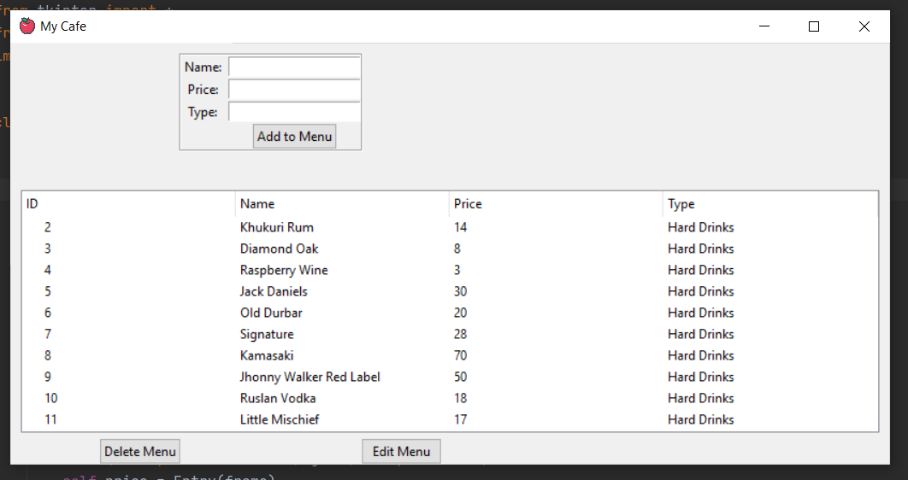

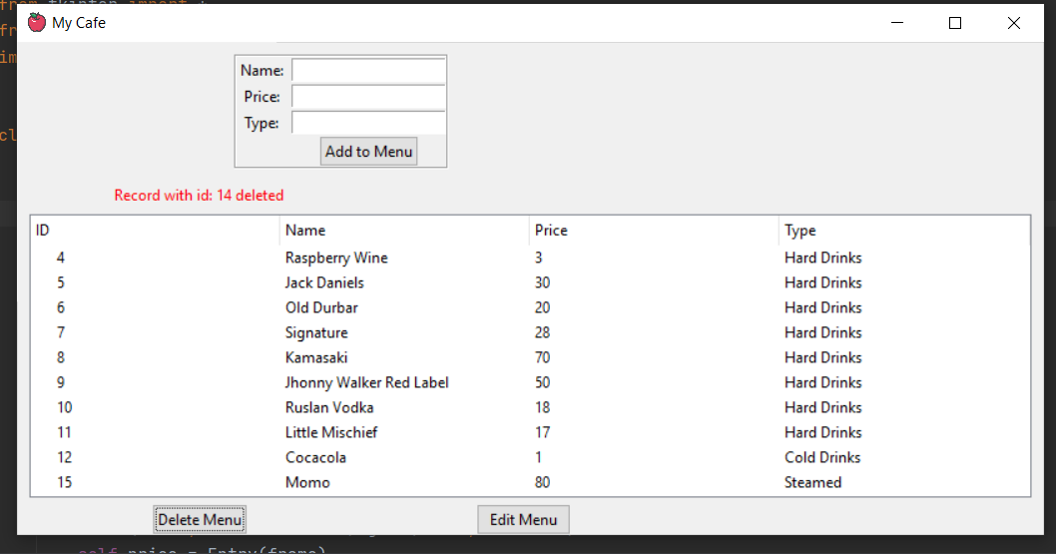

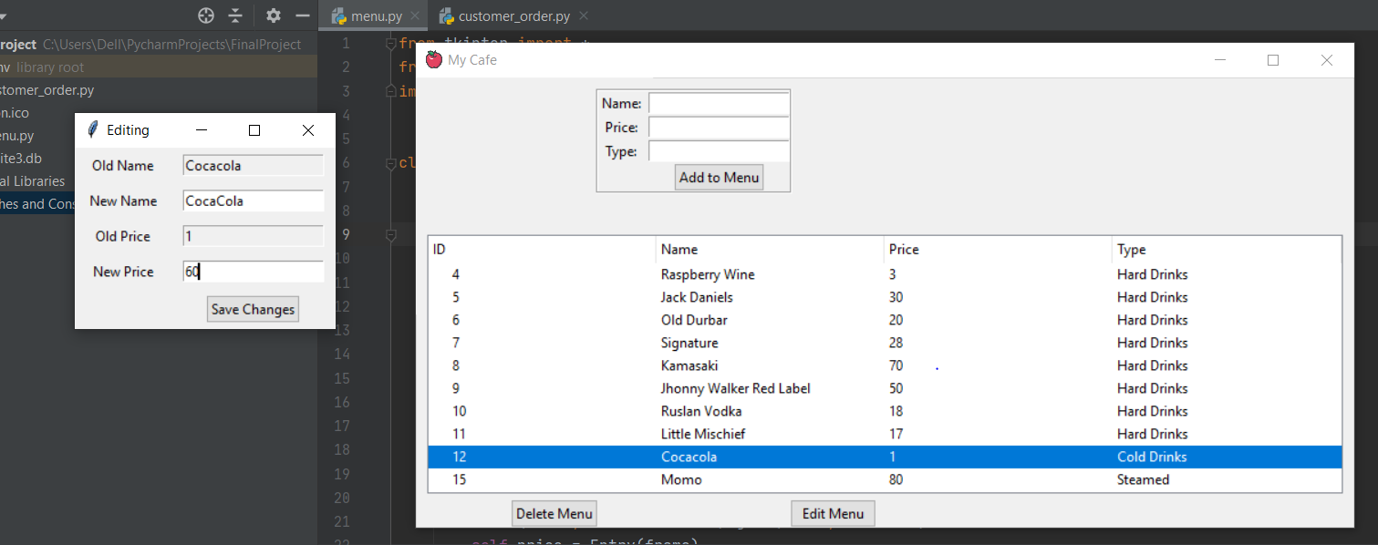

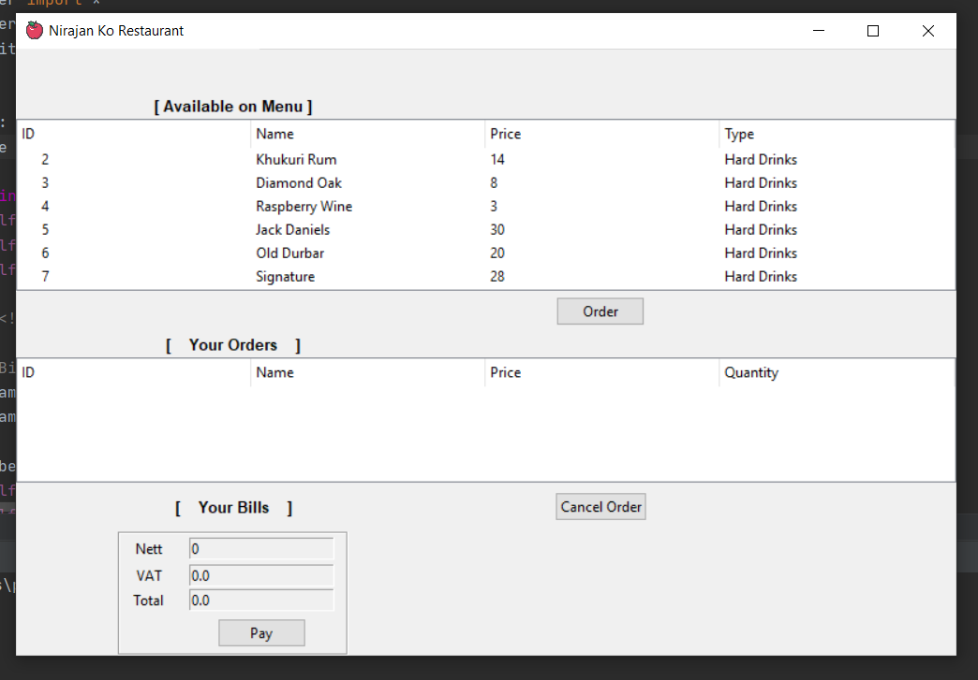

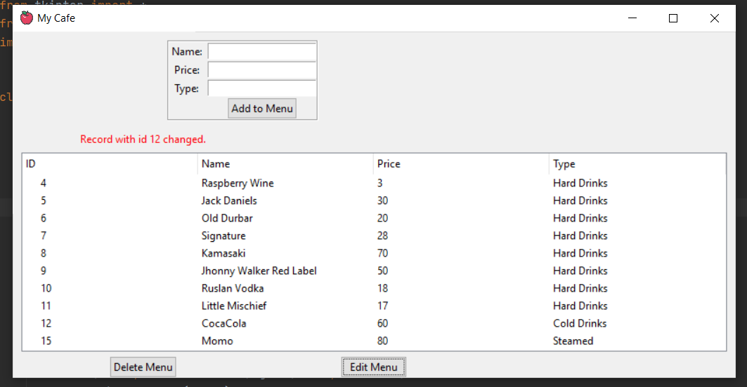

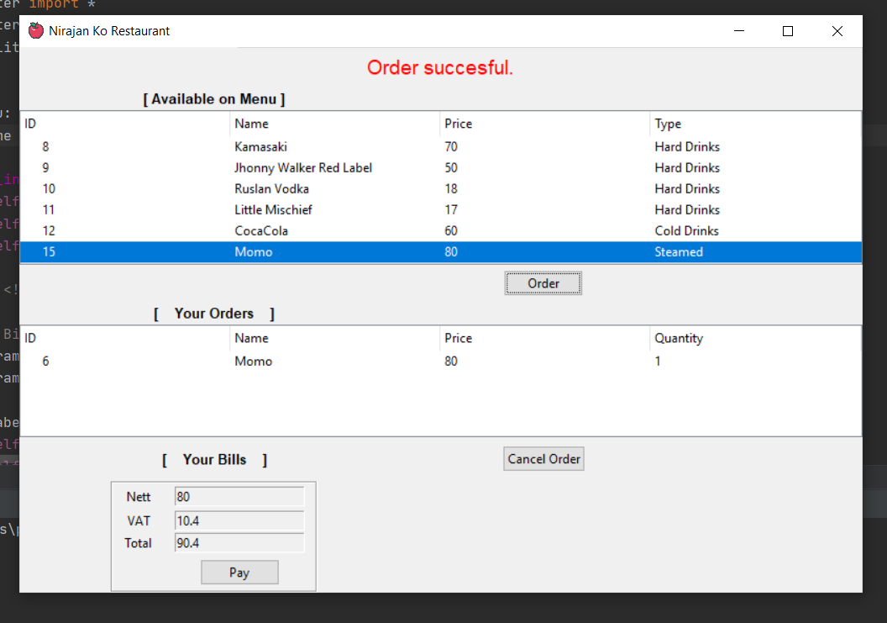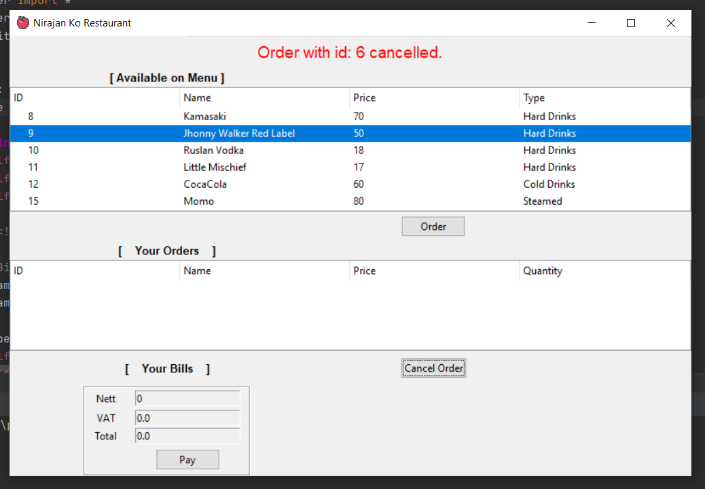

Table of Contents

Acknowledgement.......................................................................................................................................4

List of tables and figures................................................................................................6

Task 1:.........................................................................................................................................................6

Introduction................................................................................................................................................6

Comparison on HDDs and SSDs..................................................................................................................6

Analysis.......................................................................................................................................................9

File Opening and Write Speed.......................................................................................9

Access Time...................................................................................................................9

Clock Frequency............................................................................................................9

Power Consumption.......................................................................................................9

Price...............................................................................................................................9

Findings.......................................................................................................................................................9

Conclusion.................................................................................................................................................10

Table of Contents

Acknowledgement.......................................................................................................................................4

List of tables and figures................................................................................................6

Task 1:.........................................................................................................................................................6

Introduction................................................................................................................................................6

Comparison on HDDs and SSDs..................................................................................................................6

Analysis.......................................................................................................................................................9

File Opening and Write Speed.......................................................................................9

Access Time...................................................................................................................9

Clock Frequency............................................................................................................9

Power Consumption.......................................................................................................9

Price...............................................................................................................................9

Findings.......................................................................................................................................................9

Conclusion.................................................................................................................................................10

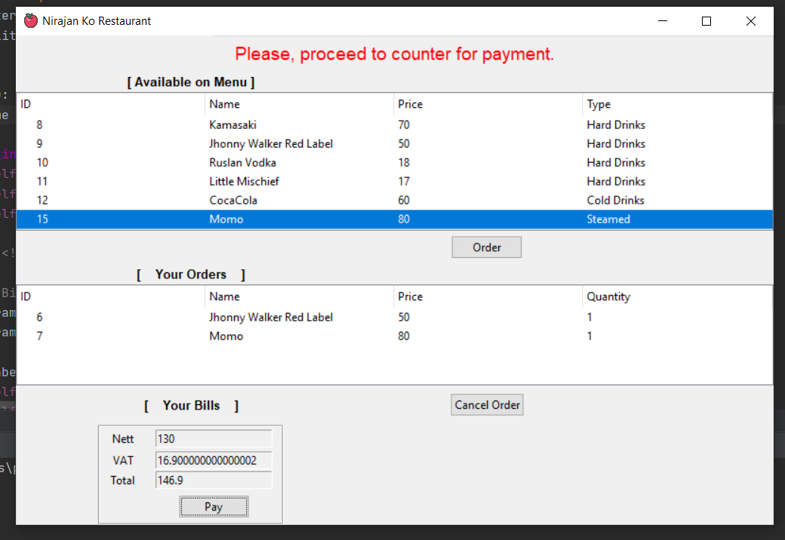

**Source Code:**

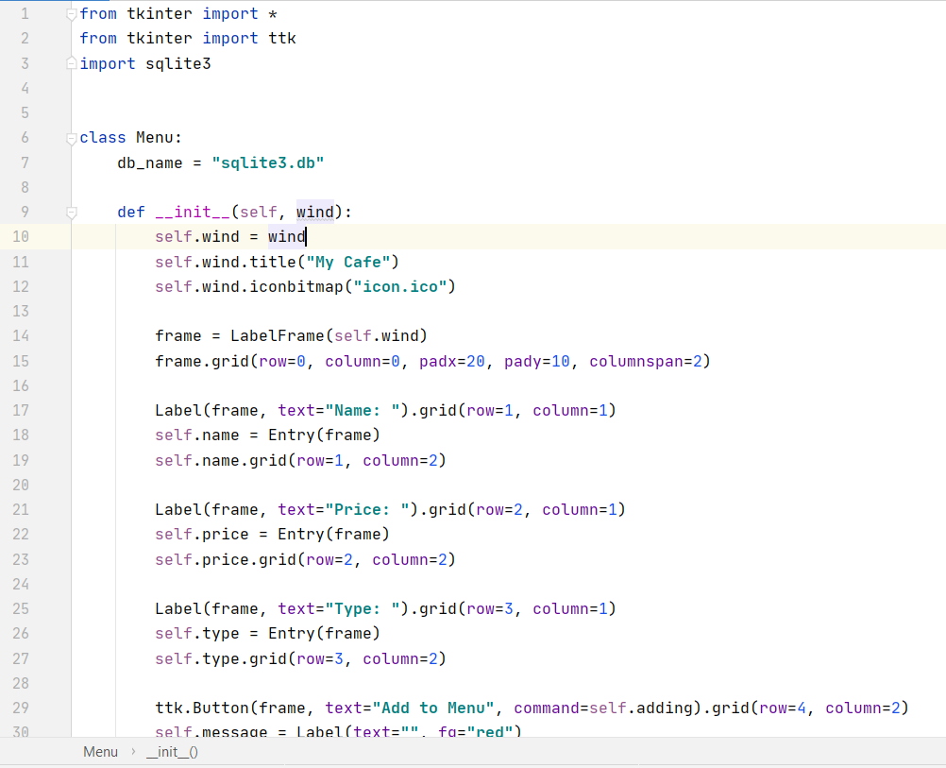

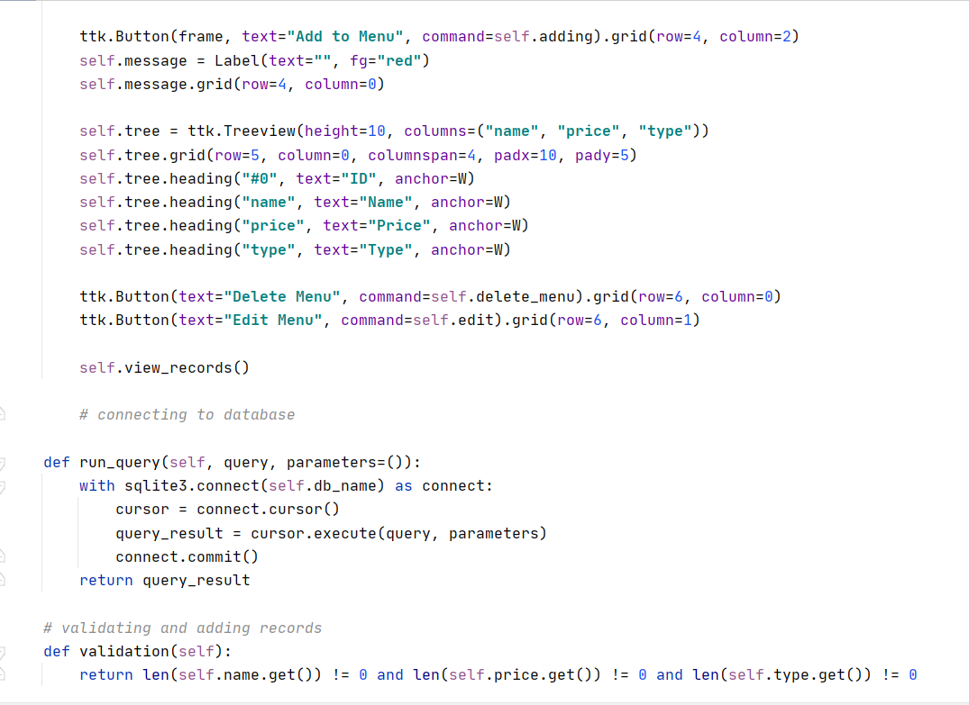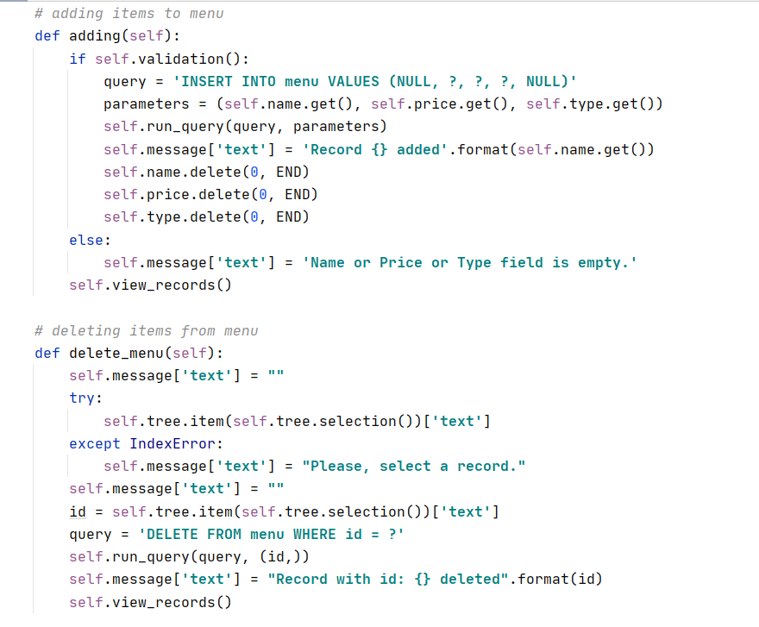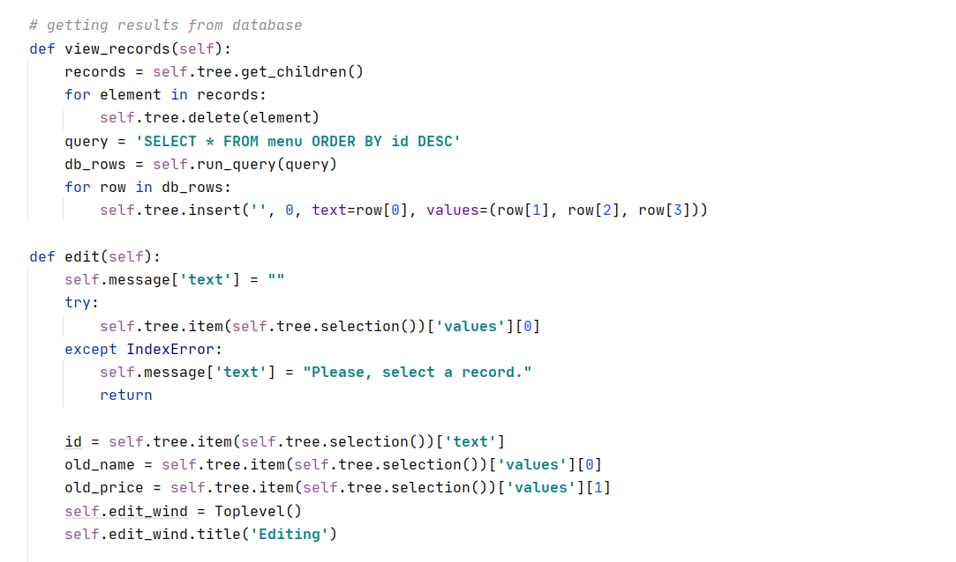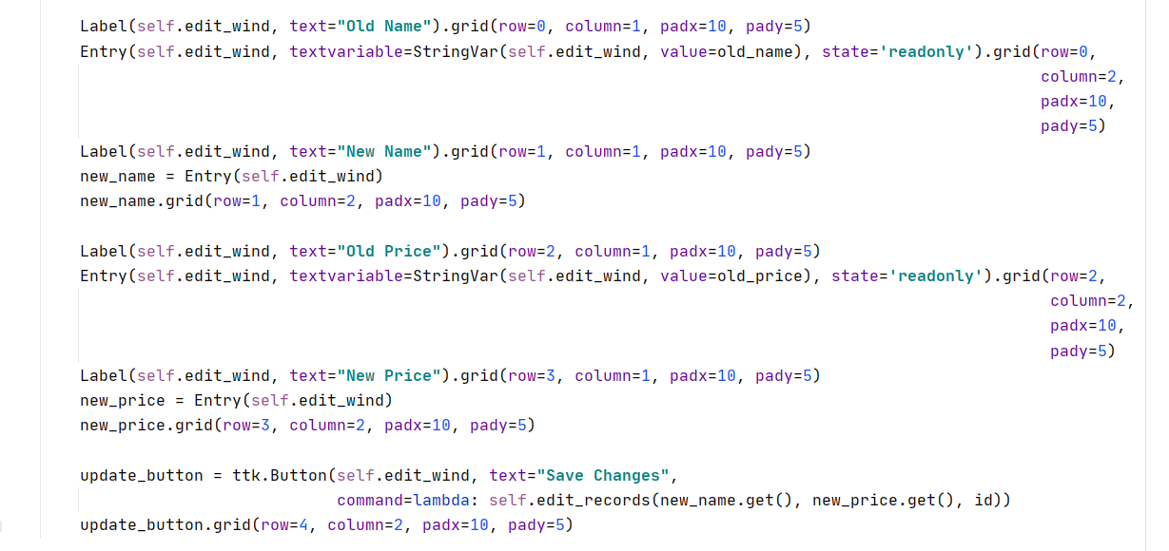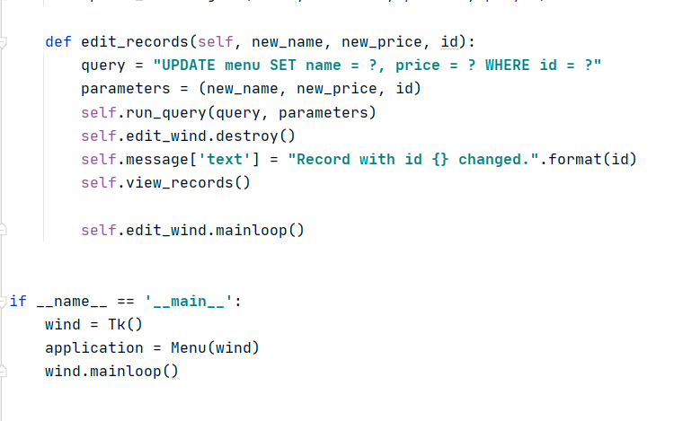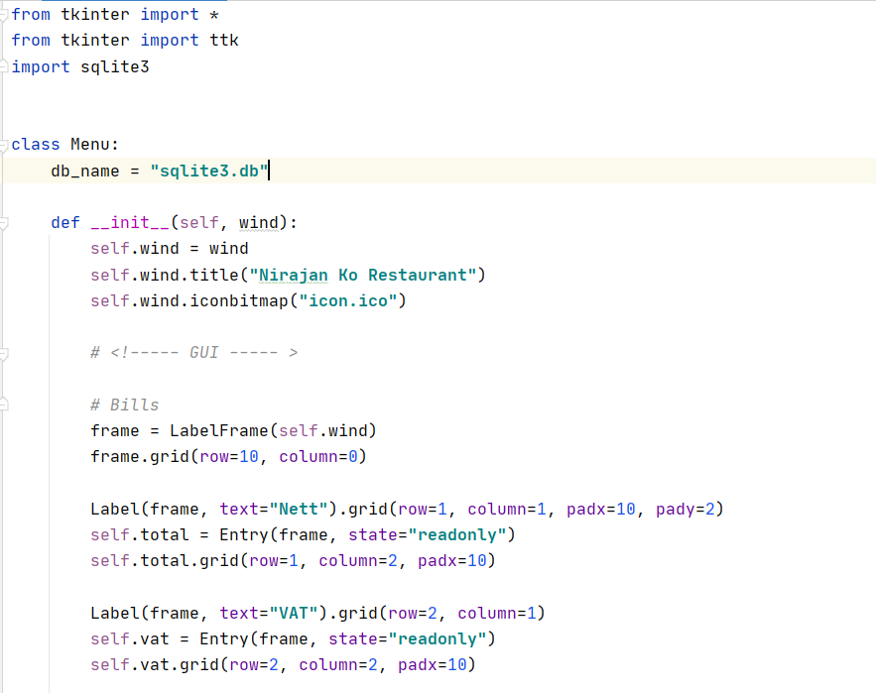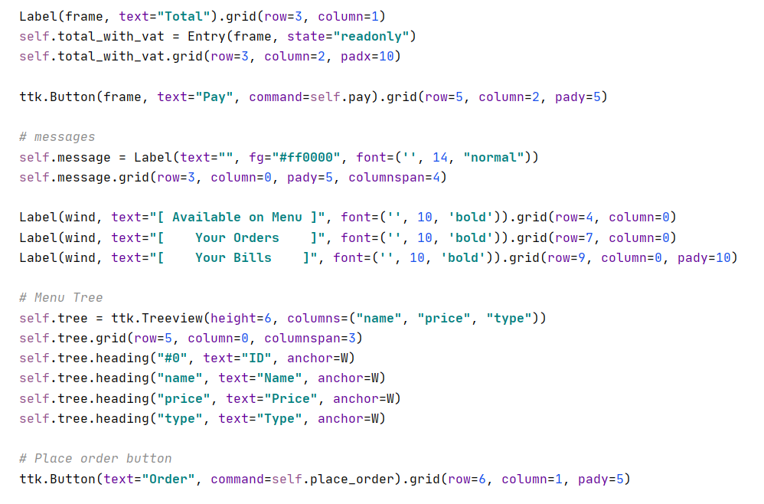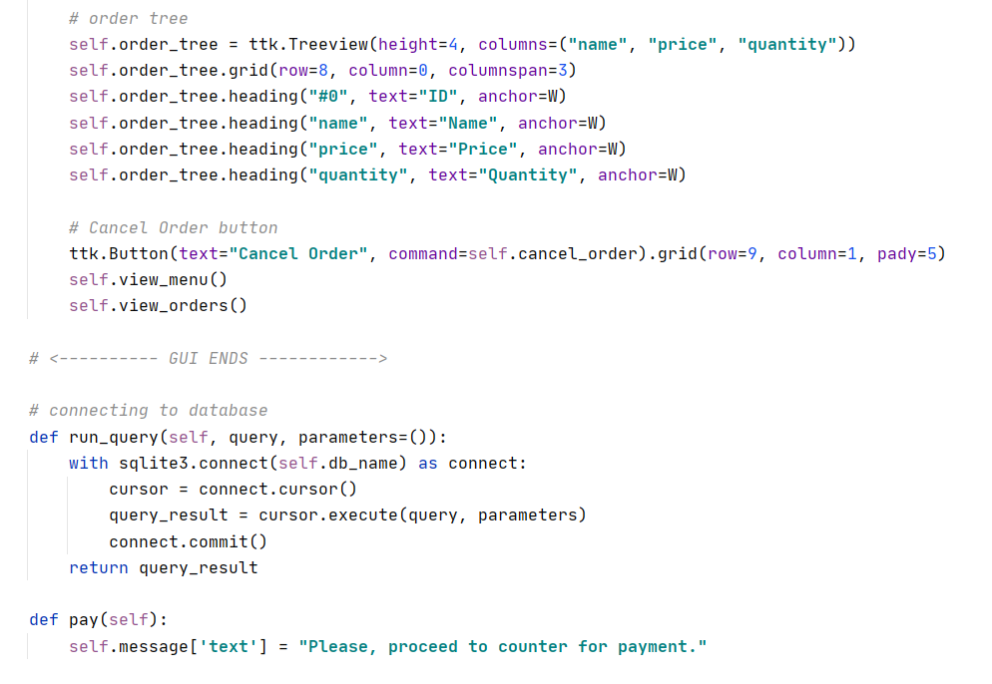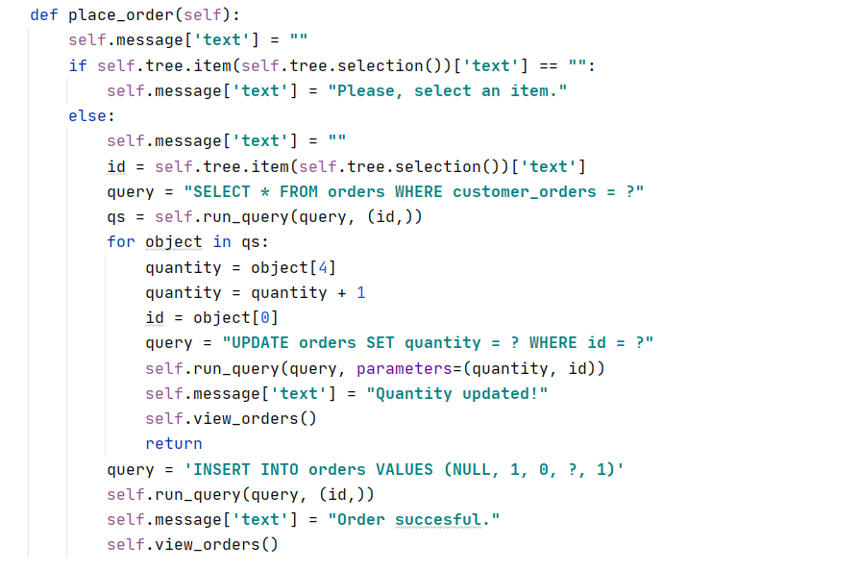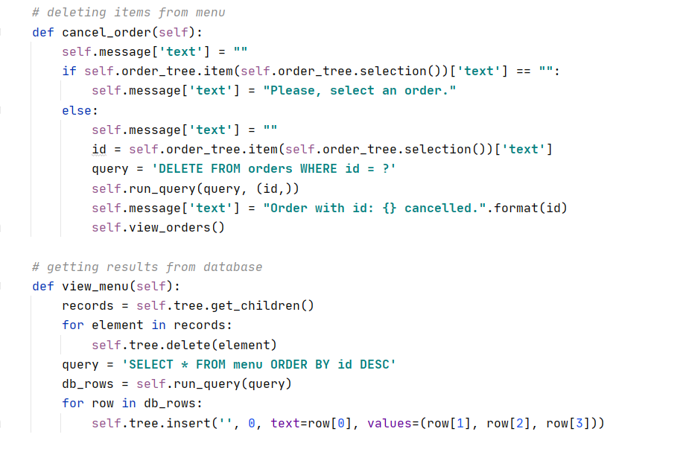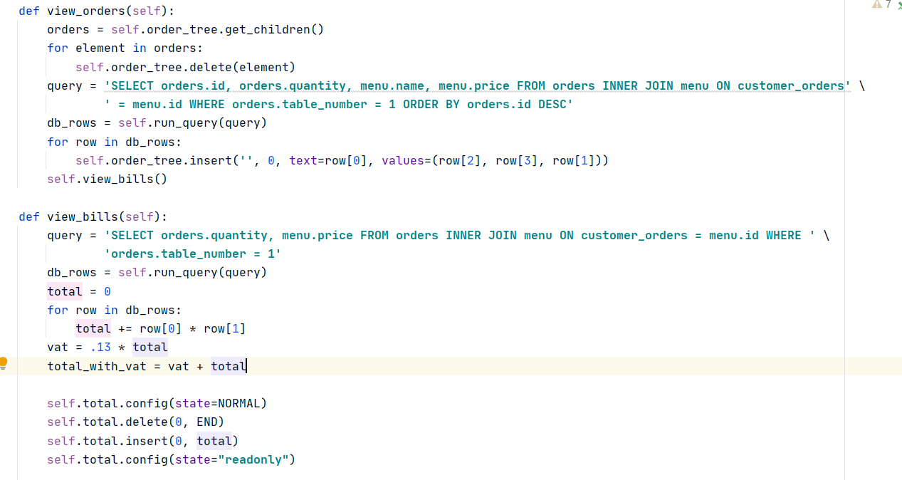

**Conclusion**

Overall, A user-friendly GUI application that helps in the management of restaurant using PyCharm which is a Python IDE and SQLite to store data in our database. The programming of this restaurant management system is based classes and objects (Object-oriented programming). SQLite has been used in this application to store data in our database. There has also been the use of exception handling in this restaurant management system. I developed this management as my project for college which was good experience for me. I didn’t feel that much of difficulties to build a device as it is simply made with simple coding.