LiDAR Processing Methodology
From raw airborne point cloud to building-ready elevation surfaces — USGS 3DEP, West Austin, Texas

1. Overview
This document records the point-cloud processing pipeline that produced the Digital Surface Model (DSM) and Digital Terrain Model (DTM) used in the rooftop-solar analysis. The work takes a raw, 24.6-million-point airborne LiDAR tile and derives correct 1 m surface and terrain rasters with verified coordinate handling. Processing was performed in ArcGIS Pro using its LAS dataset and rasterization tools; the downstream slope, aspect, and solar analysis was then performed in Python (documented separately).
Source data: USGS 3DEP Lidar Point Cloud, project TX Central B1 2017, tile over the West Austin Neighborhood Group. The tile contains 24,579,588 points and was retrieved as a compressed LAZ file via the USGS 3DEP LidarExplorer.

2. Data acquisition
The tile was selected from the USGS 3DEP LidarExplorer by drawing a small area of interest over a mixed residential and commercial neighborhood in West Austin, then downloading the single LAZ tile covering that extent. A compact, built-up area was chosen deliberately: dense enough to contain varied rooftops, but not downtown high-rises that complicate roof-plane analysis.
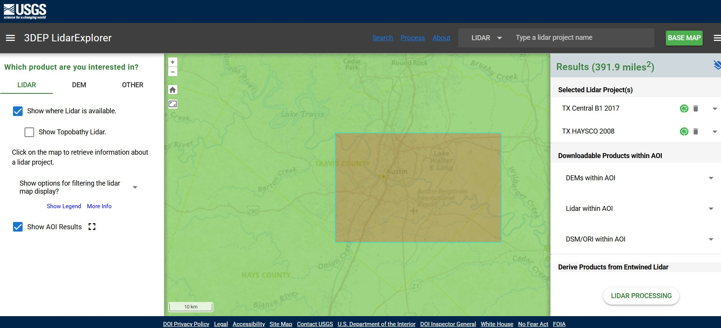
Figure 1. Tile selection in USGS 3DEP LidarExplorer. The TX Central B1 2017 project covers Austin; a small AOI isolates a single downloadable tile.

3. Building the LAS dataset
ArcGIS Pro's Create LAS Dataset tool initially rejected the file with Error 000814 (invalid file type), because the tool does not read compressed .laz directly. The Convert LAS tool was used to decompress the tile to uncompressed .las and build the LAS dataset in a single step.
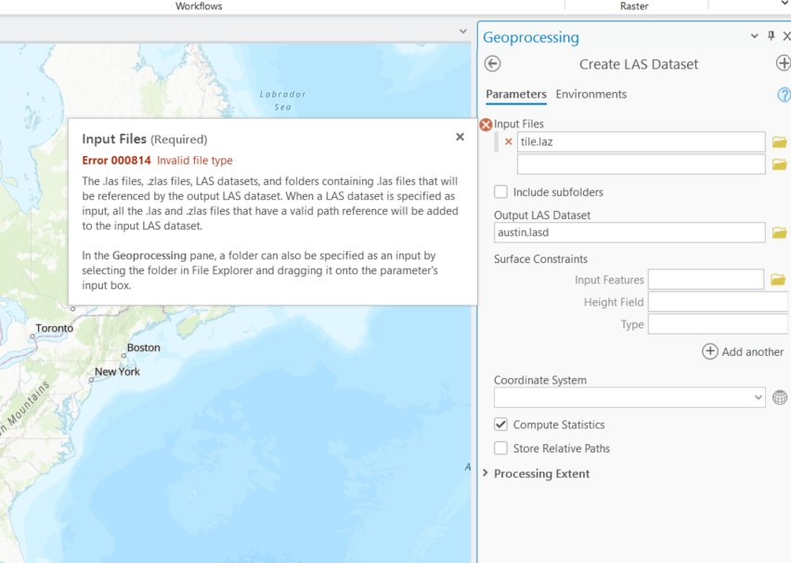
Figure 2. Convert LAS resolves the compressed-LAZ limitation and produces the LAS dataset (austin.lasd) in one operation.

4. Coordinate system verification
Before rasterizing, the LAS dataset's spatial reference was confirmed. Correct CRS handling is essential: if the horizontal or vertical units were misread, all downstream slope and area calculations would be wrong.
- Projected CRS: NAD83(2011) / UTM Zone 14N (EPSG 6343), linear unit metres.
- Vertical CRS: NAVD88 height, unit metres.
- Implication: Both horizontal and vertical units are metres, so slope (degrees) and area (m²) are computed directly with no unit conversion. EPSG 6343 was carried through to the Python analysis.
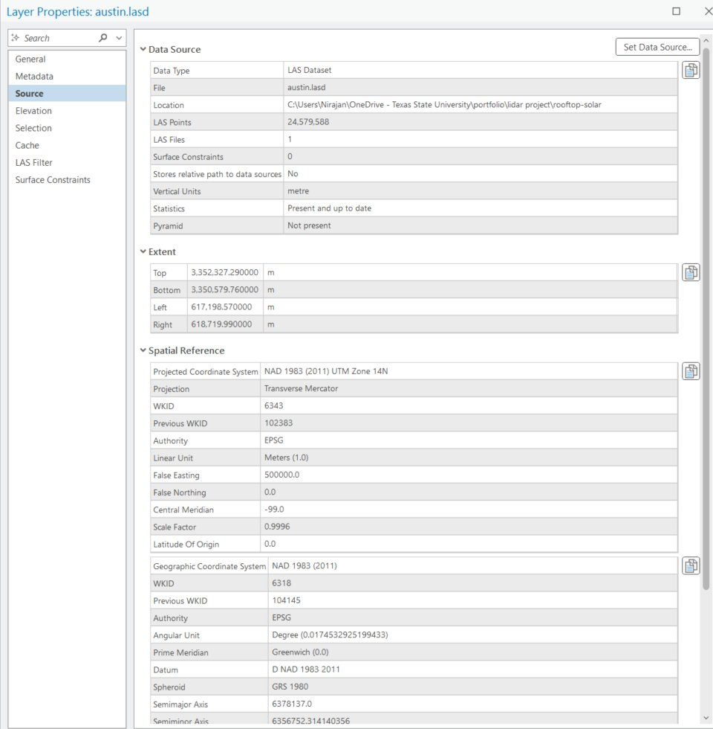
Figure 3. Spatial reference confirmation: EPSG 6343 (UTM 14N) horizontal, NAVD88 vertical, both in metres.

5. Generating the surfaces
Two rasters were produced from the LAS dataset using LAS Dataset To Raster, differing only in which returns are used and how cells are populated:

5.1 Digital Surface Model (DSM)
Using all returns with Maximum cell assignment captures the highest return per cell, the tops of roofs, tree canopy, and other above-ground structures. This is the surface the solar analysis needs.
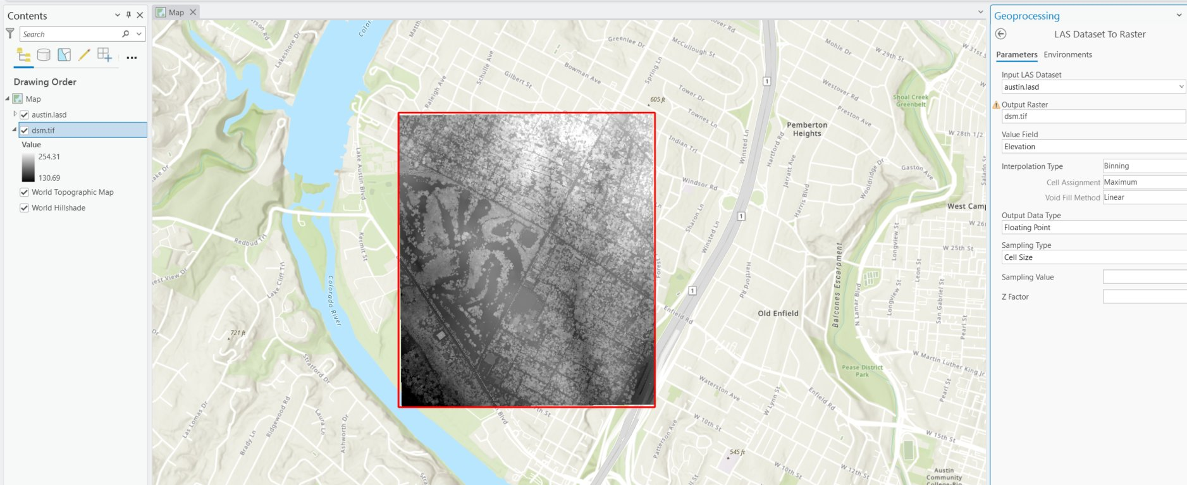
Figure 4. DSM (1 m). Building footprints, tree canopy, and the street grid are clearly resolved. Elevation range 130.7–254.3 m.

5.2 Digital Terrain Model (DTM)
Filtering the LAS dataset to ground-classified returns only, then rasterizing with Minimum cell assignment, produces the bare-earth terrain, no buildings or vegetation. The narrower elevation range (130.9–187.9 m versus the DSM's 254.3 m) confirms that above-ground features have been removed.
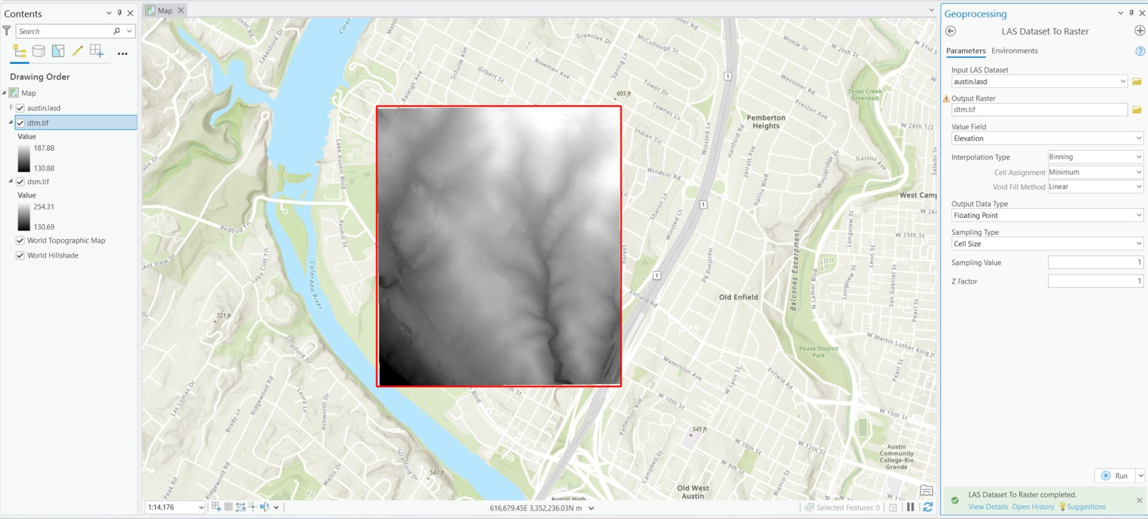
Figure 5. DTM (1 m), ground returns only. Smooth bare-earth terrain with natural drainage; buildings and trees absent.

5.3 Processing parameters
Parameter | DSM (surface) | DTM (bare earth)
Tool | LAS Dataset To Raster | LAS Dataset To Raster
LAS filter | All returns | Ground class only
Interpolation | Binning | Binning
Cell assignment | Maximum | Minimum
Void fill | Linear | Linear
Cell size | 1 m | 1 m
Output | dsm.tif | dtm.tif
Table 1. LAS Dataset To Raster parameters for each surface. The DSM/DTM differ in LAS filter and cell assignment; all else is identical.

6. Result
The DSM was carried into the Python pipeline, where per-building slope, aspect, usable area, and a first-order solar estimate were computed over OpenStreetMap footprints. The map below shows the final per-building rooftop-solar potential for the same West Austin tile, symbolized by estimated annual kWh.
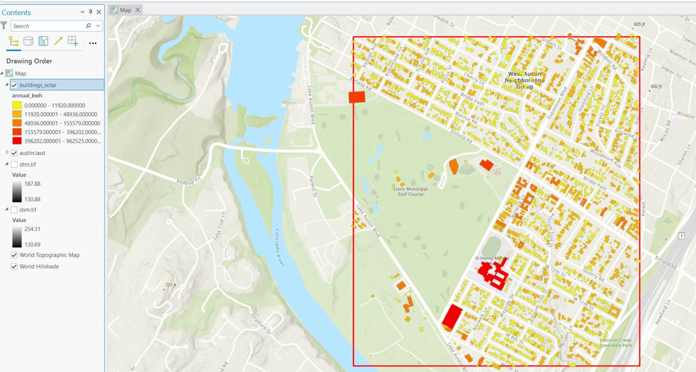
Figure 6. Final output: per-building rooftop solar potential, derived from the 1 m LiDAR DSM. Large institutional rooftops (red) carry the highest potential, small homes the least, the expected spatial pattern.

7. Reproducibility note
The point-cloud-to-raster stage was performed in the ArcGIS Pro GUI rather than in code, a standard professional workflow, so it is documented here by tool, parameter, and decision rather than by script. Every parameter needed to reproduce the surfaces is given in Table 1. From the DSM onward, the workflow is fully scripted in Python and reproducible from the project repository.
Source: USGS 3DEP Lidar Point Cloud, TX Central B1 2017 (public domain). Processing in ArcGIS Pro; downstream analysis in Python.

