Rooftop Solar Potential Across Data Environments
A comparative analysis of high-resolution LiDAR versus open global DSM for building-level solar estimation: Austin, Texas and Kathmandu, Nepal

1. Summary
This study applies a single rooftop-solar estimation method to two cities that sit at opposite ends of the elevation-data spectrum. Austin is analyzed with 1 m airborne LiDAR (USGS 3DEP); Kathmandu, where open LiDAR does not exist, is analyzed with a 30 m open global Digital Surface Model (Copernicus GLO-30). The identical pipeline, slope and aspect from the surface model, per-building zonal aggregation over OpenStreetMap footprints, and a first-order energy estimate, is run on both.
The central finding is that data resolution, not geography, dominates the results. Coarse open data does not simply add noise; it introduces systematic, directional bias. Specifically, the 30 m DSM flattens roof pitch (mean modeled slope falls from 40.3° to 3.7°), causing it to treat nearly every roof as an ideal flat solar surface, and it silently discards small buildings (only 13% of fetched footprints survive analysis versus 96% in Austin). Together these inflate Kathmandu's per-building estimates and make a naive city-to-city comparison misleading.

2. Headline comparison
Metric | Austin (1 m LiDAR) | Kathmandu (30 m DSM)
Elevation source | USGS 3DEP airborne LiDAR | Copernicus GLO-30 (open)
Native resolution | 1 m | 30 m
OSM footprints fetched | 1,795 | 7,290
Buildings analyzed | 1,728 | 947
Footprint survival | 96.3% | 13%
Mean roof slope (deg) | 40.3 | 3.7
Mean usable roof fraction | 0.47 | 1.00
Median annual kWh / building | 7,404 | 14,355
Mean annual kWh / building | 11,104 | 38,285
Max annual kWh / building | 962,525 | 869,361
Total annual kWh (study area) | 19,187,570 | 36,256,333
Table 1. Side-by-side metrics. Both pipelines are identical; differences trace to elevation-data resolution, not method.

3. Distribution of per-building solar potential
The two cities' per-building distributions differ significantly. A Mann-Whitney U test rejects the null of equal distributions (p ≈ 2.9e-68), and a Kolmogorov-Smirnov test confirms a large separation (D = 0.31). Counter-intuitively, Kathmandu's median per-building estimate (14,355 kWh) is nearly double Austin's (7,404 kWh), despite Kathmandu's buildings being physically smaller on the ground. Section 4 explains why this is an artifact, not a real difference.
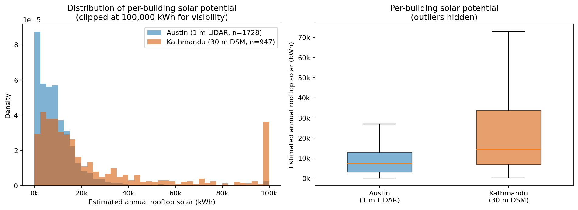
Figure 1. Left: density of per-building annual solar estimates (clipped at 100,000 kWh; the right-edge pile-up is the clip). Right: boxplots (outliers hidden). Kathmandu's distribution is shifted upward and has a fatter tail.

4. The resolution-bias mechanism
Why does coarser data produce higher estimates? Two compounding mechanisms, both quantified in Figure 2.

4.1 Roof-pitch flattening
At 1 m, the LiDAR DSM resolves individual roof planes, so Austin's modeled mean roof slope is 40.3° and only 47% of roof area falls under the usability slope cap. At 30 m, a single cell spans an entire small building, averaging the pitched surfaces into a near-flat patch: Kathmandu's modeled mean slope collapses to 3.7° and 100% of roof area is marked usable. The coarse DSM literally cannot see that roofs are tilted, so it over-credits usable area and aspect.

4.2 Small-building dropout
A 30 m cell is larger than many Kathmandu buildings. Footprints that contain too few valid raster cells are dropped, so only 13% of the 7,290 fetched footprints survive to analysis, versus 96% of Austin's 1,795. The survivors are disproportionately the largest buildings, which biases the surviving sample toward high-yield structures.
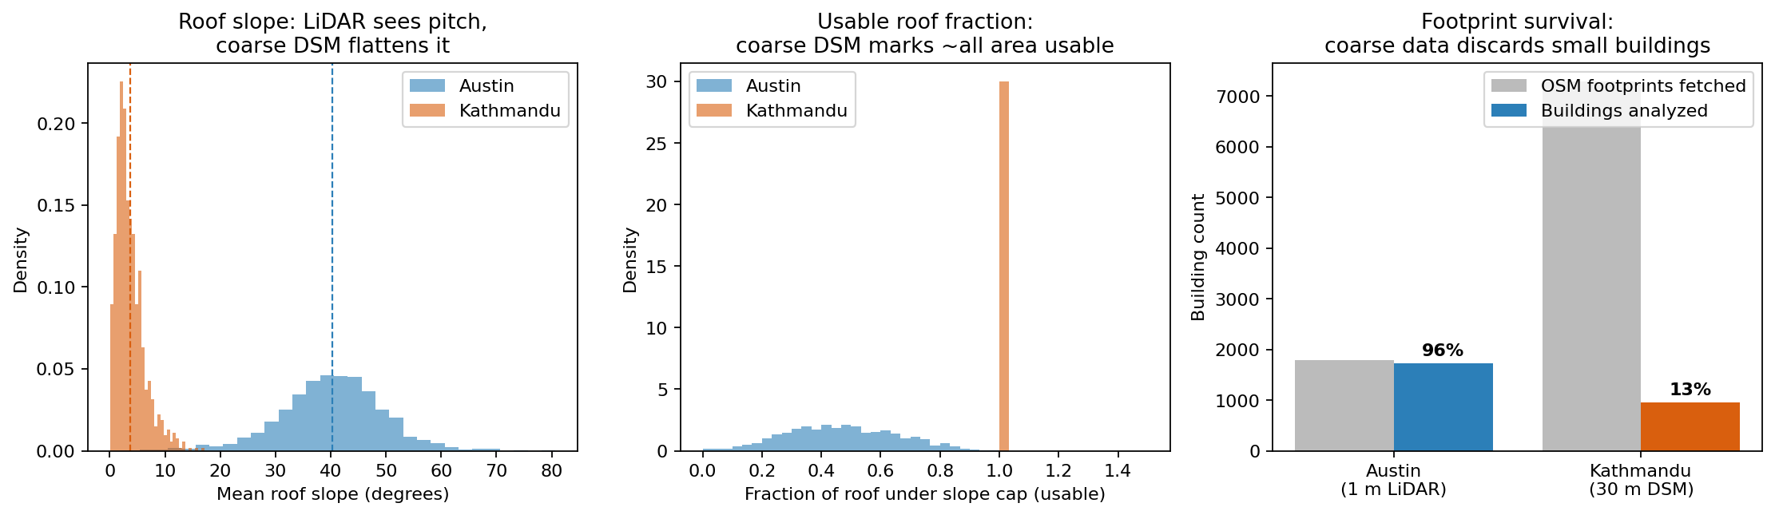
Figure 2. The bias mechanism. Left: roof-slope distributions, LiDAR sees pitch (~40°), the coarse DSM flattens it (~4°). Center: usable-roof fraction, the coarse DSM marks essentially all area usable (spike at 1.0). Right: footprint survival, coarse data discards ~87% of small buildings.
Building footprint area correlates strongly with estimated yield in both cities (Pearson r = 0.98 Austin, 0.92 Kathmandu), confirming that usable area is the dominant driver, exactly the quantity the coarse DSM distorts.

5. Advantages and disadvantages of each data environment

5.1 Airborne LiDAR (Austin)
- Strength: Resolves individual roof planes, enabling true per-facet slope and aspect and credible usable-area estimates.
- Strength: High footprint survival; nearly all buildings are analyzable.
- Limitation: Not available openly for most of the world, including Nepal. Large file sizes and heavier processing.

5.2 Open global DSM (Kathmandu)
- Strength: Globally available, free, small, and fast, the only feasible option where LiDAR is absent.
- Strength: Adequate for coarse screening: identifying which districts or large rooftops merit a closer look.
- Limitation: Cannot resolve roof planes; systematically flattens pitch and over-credits usable area.
- Limitation: Discards small buildings, biasing the analyzed sample toward large structures.
- Limitation: Per-building estimates should be read as a relative screen, not absolute design figures.

6. Limitations and honest caveats
- Both cities use placeholder global horizontal irradiation values (Austin 1,700; Kathmandu 1,800 kWh/m²/yr). Absolute totals are provisional until replaced with cited Global Solar Atlas figures; relative within-city rankings are robust.
- The energy model is first-order and does not model inter-building shading in the Python step.
- OSM footprint completeness is strong in Kathmandu's urban core but weaker in peri-urban areas, and open footprint datasets disagree by roughly 50% in total building area, an additional source of uncertainty on the Kathmandu side.
- Identical map class breaks were applied to both cities so the visuals are comparable, but the underlying Kathmandu values still carry the coarse-resolution inflation described above.

7. Conclusion
The same method, run honestly on two data environments, shows that elevation-data resolution is not a minor parameter but a primary driver of rooftop-solar estimates. High-resolution LiDAR supports per-roof design; a coarse open DSM supports only a screening-level assessment and, if used naively, over-estimates potential by flattening roofs and dropping small buildings. The practical takeaway for any energy or planning analysis in data-scarce regions is to treat open-DSM solar estimates as a relative screen, to report the resolution explicitly, and to validate against higher-resolution data wherever it can be obtained.
Data: USGS 3DEP (TX Central B1 2017); European Space Agency (2024), Copernicus GLO-30 DEM, distributed by OpenTopography; OpenStreetMap contributors (ODbL). Analysis reproducible from the project repository.

