Tribhuvan University
Institute of Science and Technology



A Dissertation Proposal on
“Comparing CatBoost, TabPFN, and TabFM for Explainable Hair Fall Risk Prediction”

Supervised by
Asst. Prof. Jagadish Bhatta

Submitted by
Nirajan Shahi
Roll no. 49/079

Submitted to
Central Department of Computer Science and Information Technology
Tribhuvan University, Kirtipur
Kathmandu, Nepal

In partial fulfillment of the requirement for Master’s Degree in Computer Science and Information technology (M.Sc. CSIT)

Table of Contents
Chapter 1: Introduction 1
1.1 Introduction 1
1.2 Problem Statement 2
1.3 Objectives 3
Chapter 2: Background Study and Literature Review 4
2.1 Background Study 4
2.2 Literature Review 5
2.2.1 Research Gap 7
Chapter 3: Methodology 8
3.1 Research Framework 8
3.2 Dataset Description 8
3.2.1 Source datasets and how they are related 8
3.2.2 Use of the datasets 11
3.2.3 The final dataset 11
3.3 Data Preprocessing 12
3.4 Model Selection 13
3.4.1 CatBoost 13
3.4.2 TabPFN 14
3.4.3 TabFM 15
3.5 Explainability with SHAP 16
3.6 Tools and Technologies 17
3.7 Experimental Environment 17
3.8 Performance Evaluation Metrics 18
Chapter 4: Expected Outcome and Working Schedule 21
4.1 Expected Outcomes 21
4.2 Working Schedule 21
References 23
List of Figures
Figure 3.1: Overall research framework 8
Figure 3.2: Relationship between the source datasets and the final dataset 10
Figure 3.3: CatBoost model (gradient boosted symmetric trees) 13
Figure 3.4: TabPFN model (in-context learning) 14
Figure 3.5: TabFM model (zero-shot tabular foundation model) 15
Figure 3.6: SHAP explainability workflow 16
Figure 3.7: Experimental environment 18
Figure 4.1: Working schedule (Gantt chart) 22
List of Tables
Table 3.1: The source datasets, the super dataset, and the final dataset 9
Table 3.2: Source of each column of the final dataset in Dataset 1, Dataset 2, and the super dataset 10
Table 3.3: Risk factors in Dataset 2 and in the final dataset 11
Table 3.4: Clinical range check of the final dataset 12
Table 3.5: Software tools 17
List of Abbreviations
ALT Alanine Aminotransferase
ARIMAX Autoregressive Integrated Moving Average with Exogenous Variables
AUC Area Under the Curve
AutoML Automated Machine Learning
CNN Convolutional Neural Network
COVID-19 Coronavirus Disease 2019
DT Decision Tree
EHR Electronic Health Record
GB Gradient Boosting
GPU Graphics Processing Unit
KNN k-Nearest Neighbours
LR Logistic Regression
LSTM Long Short-Term Memory
RF Random Forest
ROC Receiver Operating Characteristic
ROC-AUC Area Under the Receiver Operating Characteristic Curve
SHAP Shapley Additive Explanations
SVM Support Vector Machine
TabFM Tabular Foundation Model
TabPFN Tabular Prior-Data Fitted Network
TFT Temporal Fusion Transformer
XGBoost Extreme Gradient Boosting

Chapter 1: Introduction

1.1 Introduction
Alopecia, the clinical term for pathological hair loss, affects individuals across a broad range of ages and demographic backgrounds worldwide. Some degree of hair shedding is a normal part of the follicular growth cycle, but a marked or sudden increase in shedding often points to an underlying disturbance in the body's systems, commonly hormonal imbalance, significant nutrient depletion, prolonged physical strain, or sustained psychological stress (Bai et al., 2026; Guo & Katta, 2017; Hussein et al., 2023). Beyond its visible effects, noticeable hair loss frequently carries a real emotional cost, contributing to lowered self-confidence, elevated anxiety, and a reduced sense of overall well-being. In this proposal, "hair loss" and "hair fall" are used with the same meaning, and "hair fall" is also the name of the target variable in the dataset.
Determining an individual's likelihood of experiencing hair loss is inherently difficult because no single biomarker reliably predicts it. Risk instead emerges from the combined, non-linear interaction of physiological traits, everyday habits, environmental factors, and pre-existing health conditions. Elements such as diet quality, sleep regularity, scalp care practices, thyroid activity, iron levels, and hereditary predisposition all interact at once, making it impractical for clinicians or individuals to gauge overall risk through observation alone.
Healthcare systems today generate large volumes of patient data through Electronic Health Records (EHRs), capturing detailed clinical histories over time. A substantial share of this clinical data is inherently tabular in structure: laboratory results, vital signs, diagnostic codes, medication histories, and patient demographics are all naturally represented as structured rows and columns rather than as free text or medical imagery. Consequently, tabular data forms the backbone of a large fraction of real-world clinical prediction tasks, including disease risk stratification, treatment outcome prediction, and, as in this study, early screening for conditions such as hair loss. Machine learning offers a way to surface patterns within this dense, multi-source tabular data that would otherwise go unnoticed. Gradient boosting methods have long been the standard tool for prediction on structured, tabular data (Prokhorenkova et al., 2018). More recently, however, tabular foundation models, which are transformer architectures pretrained to perform prediction directly from context without task-specific training, have begun to reshape this space. Prior Labs' TabPFN (Hollmann et al., 2025) and Google's TabFM (Kong et al., 2026) both represent this newer generation of zero-shot tabular models, offering predictions through a single forward pass rather than the conventional train-and-tune cycle.
A persistent limitation of both gradient boosting and transformer-based approaches, however, is their tendency to operate as opaque, uninterpretable systems. This research addresses that limitation by building a comparative machine learning framework for evaluating and explaining multi-tier hair fall risk, using structured clinical and lifestyle data. The study benchmarks three distinct modelling paradigms: CatBoost, a gradient-boosted decision tree architecture purpose-built for categorical data; TabPFN, an established prior-fitted transformer foundation model for tabular in-context learning; and TabFM, Google Research's more recently released zero-shot tabular foundation model. Post-hoc explainability is layered across all three models via Shapley Additive Explanations (SHAP; Lundberg & Lee, 2017), giving each prediction a transparent, feature-level justification grounded in the underlying medical and lifestyle indicators.

1.2 Problem Statement
Determining hair loss risk remains a difficult clinical problem, shaped by the interplay of hormonal shifts, metabolic irregularities, chronic stress, nutritional gaps, and hair care habits. Assessment often relies on subjective self-reporting or delayed clinical evaluation, both of which are vulnerable to observer bias, inconsistent standards, and limited reach in under-resourced settings.
Machine learning can model these interacting risk factors systematically, but earlier studies that predict hair loss from survey and clinical tables have used only classical algorithms such as Logistic Regression, Random Forest, and Extreme Gradient Boosting (XGBoost), and their reported accuracies differ widely (Khatun et al., 2022; Kumar et al., 2025; Siami & Azis, 2025). Newer tabular foundation models such as TabPFN and TabFM have been tested on general benchmarks (Hollmann et al., 2025; Kong et al., 2026) but not on hair loss data, and they have not been compared with a carefully tuned gradient-boosted model such as CatBoost. The predictions of both kinds of model are also difficult to explain, which limits their use in a clinical setting.
This study therefore builds and benchmarks an explainable machine learning framework for multi-tier hair fall risk classification. It compares CatBoost with the two tabular foundation models, TabPFN and TabFM, and uses SHAP-based feature attribution to keep every predicted risk tier traceable to specific, interpretable indicators.

1.3 Objectives
This dissertation has two objectives:
1. To implement and benchmark CatBoost, TabPFN, and TabFM for predicting multi-tier hair fall risk from structured clinical and lifestyle data.
2. To provide transparent, feature-level decision-support insights for every model through SHAP-based explainability, so that each predicted risk tier can be traced to specific clinical and lifestyle indicators.

Chapter 2: Background Study and Literature Review

2.1 Background Study
Human hair grows in a repeating cycle of three phases: a growth phase (anagen), a short regression phase (catagen), and a resting phase (telogen) after which the hair is shed. Losing some hair every day is therefore normal. Hair loss becomes a medical problem when this cycle is disturbed, so that too many follicles enter the resting phase early or the follicles shrink and stop producing thick hair. Clinically, the most common forms are androgenetic alopecia (pattern hair loss driven by hormones and inheritance), telogen effluvium (a temporary but heavy shedding that follows a physical or emotional trigger), and alopecia areata (patchy loss caused by an autoimmune reaction).
Hormones and heredity. Androgenetic alopecia depends on inherited sensitivity of the follicles to androgen hormones, which is why family history is an important risk indicator. Agaoglu et al. (2021) studied how common early-onset androgenetic alopecia is and how it relates to lifestyle and dietary habits.
Nutrition and iron status. Hair follicles are among the most active tissues in the body, so they are sensitive to shortages of iron, zinc, and some vitamins. Guo and Katta (2017) reviewed the evidence on nutrient deficiency, supplement use, and hair loss. Lin et al. (2023) focused on iron-deficiency-related alopecia in women, and Treister-Goltzman et al. (2022) combined the available studies in a systematic review and meta-analysis of iron deficiency and non-scarring alopecia in women. Blood indicators such as haemoglobin and iron are therefore treated as important risk markers.
Thyroid function. Thyroid hormones help regulate the hair cycle, and both an underactive and an overactive thyroid are linked with hair disorders (Hussein et al., 2023). In Nepal, Marahatta et al. (2018) reported on the association between alopecia areata and thyroid dysfunction in patients from eastern Nepal.
Psychological stress. Stress is thought to push follicles out of the growth phase too early, which leads to increased shedding some weeks later (Bai et al., 2026).
Infection and physical illness. A sudden illness, fever, or major physical strain can trigger telogen effluvium. Cline et al. (2021) documented a surge in telogen effluvium in communities heavily affected by coronavirus disease 2019 (COVID-19), showing how a large health event can raise the number of people who present with hair loss.
How people are affected in real life. Hair loss is rarely only a cosmetic matter. It is linked with lower self-confidence, anxiety, and a poorer quality of life, and in many cases the person does not know which of the factors above is responsible. Survey evidence shows that young people are affected too. In a survey of 610 participants in Bangladesh, most respondents were aged 18 to 24, and stress, allergies, dandruff, and family history were the main causes they reported (Khatun et al., 2022). Worldwide, the burden of alopecia areata has been analysed over three decades using the Global Burden of Disease data, including differences in lifetime risk between women and men (Sun et al., 2025).
Current trend. Reports suggest that hair loss is being seen more often and at a younger age. Early-onset androgenetic alopecia has been linked to lifestyle and dietary habits (Agaoglu et al., 2021), and shedding after infection rose sharply during the COVID-19 period (Cline et al., 2021).
From biology to machine learning. Because the causes above overlap and interact, no single test can predict hair loss risk. Diagnosis today relies mostly on clinical examination and the patient's own history, which is slow, subjective, and hard to reach in rural areas. This has led researchers to apply machine learning to hair loss. Earlier work mainly used scalp or hair images (Shakeel et al., 2021; Sayyad et al., 2022), and more recent work uses survey and clinical tables with classical algorithms such as Random Forest and XGBoost (Khatun et al., 2022; Kumar et al., 2025; Sai et al., 2023). The newest direction is tabular foundation models such as TabPFN (Hollmann et al., 2025) and TabFM (Kong et al., 2026), which have not yet been tested on hair loss.

2.2 Literature Review
Hair loss prediction from survey and lifestyle data. Khatun et al. (2022) surveyed 610 people in Bangladesh and trained a Support Vector Machine (SVM), k-Nearest Neighbours (KNN), Logistic Regression, Random Forest, and XGBoost to diagnose hair fall disorder. XGBoost gave the best accuracy of 92.62%. The study shows that questionnaire data can carry a useful signal, but it tested only classical models and did not explain individual predictions.
Sai et al. (2023) compared SVM, KNN, decision tree, random forest, and logistic regression with an ensemble method for hair fall prediction. The ensemble was better than every single algorithm in accuracy, precision, and recall. The study did not include boosting models designed for categorical data or any explanation method.
Kumar et al. (2025) built a Random Forest hair loss predictor on a dataset of 2,000 records with 10 features (genetics, hormones, medical history, nutrition, stress) and added a web interface built with Django. Random Forest reached 100% accuracy, while XGBoost (67.5%), CatBoost (49.5%), and LightGBM (47.5%) scored much lower. A score of 100% is unusual and should be read as a result on that one dataset, and the low CatBoost score suggests that the boosting models were not tuned.
Siami and Azis (2025) compared Logistic Regression, Decision Tree, Random Forest, Gradient Boosting, XGBoost, and a voting ensemble on a balanced dataset of genetic, hormonal, lifestyle, and environmental indicators. Accuracy and F1-score stayed at about 50% at best, although age, stress, and nutritional deficiency were identified as important factors. The authors concluded that richer clinical inputs were needed.
Leema et al. (2025) collected questionnaire data from 750 university students and community members and proposed HairSentinel, which forecasts hair fall trends and flags unusual episodes using a Temporal Fusion Transformer (TFT). It reached 97.5% accuracy and was compared with a Long Short-Term Memory network (LSTM), Random Forest, and an Autoregressive Integrated Moving Average with Exogenous Variables model (ARIMAX). Their dataset is not public, which makes the result impossible to reproduce, and it rests on self-reported data rather than blood test values.
Hair loss detection from images and deep learning. Shakeel et al. (2021) proposed a framework that classifies healthy hair and alopecia areata from hair images using colour, texture, and shape features with SVM and KNN, with accuracies of 91.4% and 88.9%. Sayyad et al. (2022) used a VGG network with an SVM classifier and reported 98.31% accuracy on 200 healthy-hair images (Figaro1k) and 68 alopecia areata images (DermNet). Pandikumar et al. (2024) proposed a deep learning framework that combines convolutional neural networks (CNNs) on scalp images with LSTM networks on lifestyle sequences. These studies need images or specialised equipment, address alopecia areata or scalp condition rather than risk from routine health indicators, and use small image sets.
Gradient boosting and CatBoost. Prokhorenkova et al. (2018) introduced CatBoost, which handles categorical features with ordered target statistics and ordered boosting to avoid target leakage. This design makes CatBoost a strong choice for survey-style data with many categorical answers. In hair loss research, however, CatBoost appears only as a side comparison and was not tuned (Kumar et al., 2025).
Tabular foundation models. Hollmann et al. (2025) presented TabPFN, a transformer pretrained on millions of synthetic datasets that predicts on a new table in a single forward pass without task-specific training. It performed best on small datasets of up to about 10,000 rows. Kong et al. (2026) introduced TabFM, a 400-million-parameter model trained on synthetic tables, which ranked first among default tabular foundation models on the 51 datasets of the TabArena benchmark and outperformed tuned automated machine learning (AutoML) pipelines. An independent reproduction on three machines and 13 TabArena datasets confirmed competitive accuracy against XGBoost, Random Forest, and TabPFN, but reported four upstream software defects and memory failures above about 10,000 rows on a 24 GB graphics processing unit (GPU) (Pandey, 2026). None of these studies used medical or hair loss data.
Explainability. Lundberg and Lee (2017) proposed SHAP, which assigns each feature a contribution to a prediction using Shapley values from game theory. Because SHAP works with any model, it can be used to compare explanations from architecturally different models on the same data. Among the hair loss studies above, the emphasis is on accuracy, and none compares explanations across a boosted-tree model and foundation models.

2.2.1 Research Gap
• Hair loss prediction studies used only classical algorithms, and their accuracies differ widely (about 50% to 100%) on different datasets.
• CatBoost was compared only once, and it was not tuned.
• TabPFN and TabFM have not been tested on hair loss data.
• TabFM has only one independent check, which reported software defects and memory limits.
• No study explains a boosted-tree model and foundation models side by side.

Chapter 3: Methodology

3.1 Research Framework
The study follows one pipeline from data to explanation, shown in Figure 3.1. The final dataset is cleaned and split once. The same training and test rows are then given to three models, CatBoost, TabPFN, and TabFM. To see how each model behaves when little data is available, each will also be given two smaller stratified subsets of the training rows (500 and 2,000 records) in addition to all 17,284. Their predictions are compared with the same metrics and statistical tests, and SHAP is applied to all three so that each predicted risk tier can be traced to its features.
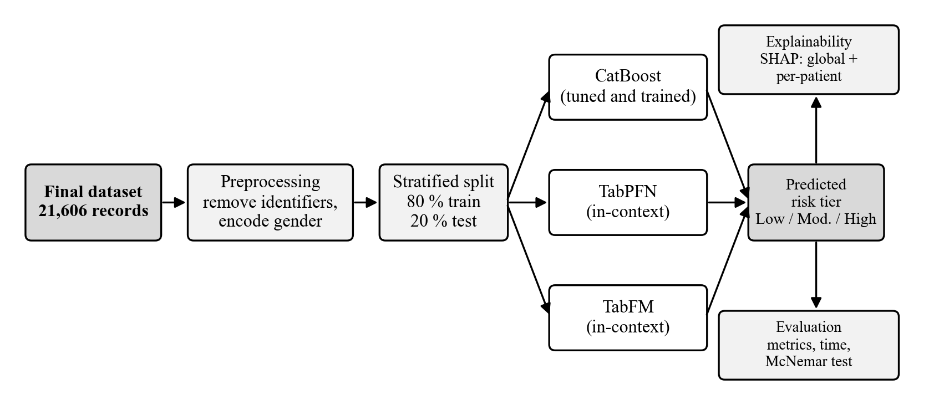
Figure 3.1: Overall research framework

3.2 Dataset Description

3.2.1 Source datasets and how they are related
Two public datasets were the sources of the data.
Dataset 1 (Dhankour, 2023) has 100,000 records and 13 columns: age, gender, ten numeric measurement columns (total_protein, total_keratine, hair_texture, vitamin, manganese, iron, calcium, body_water_content, stress_level, and liver_data), and the target hair_fall with values from 0 to 5.
Dataset 2 (Arnob et al., 2024) is a survey of 716 people with 14 columns: a timestamp, the name of the respondent (removed before use), age, gender, whether the person has a hair fall problem, eight yes/no questions (family history of hair fall, chronic illness, staying up late, sleep disturbance, water as a reason, use of chemicals on hair, anemia, and stress), and food habit.
One super dataset of about 200,000 records was made. It contains all the fields of Dataset 1 and Dataset 2 and many additional fields (for example age group, hair fall tier, and number of risk factors). In the super dataset, age and gender were identified and the records were kept according to them. The super dataset was compared with Dataset 1 and Dataset 2, and this produced the final dataset of 21,606 records that is used in this study.
Table 3.1: The source datasets, the super dataset, and the final dataset
Dataset | Source | Rows | Columns | Content | Row identifier
Dataset 1 | Kaggle "Hair Loss Dataset" (Dhankour, 2023) | 100,000 | 13 | age, gender, 10 numeric measurement columns, and hair_fall (0 to 5) | Age and gender
Dataset 2 | Mendeley "Dataset for evaluating hair fall causes" (Arnob et al., 2024) | 716 | 14 | Questionnaire: age, gender, 8 Yes/No health and lifestyle answers, hair fall problem, food habit | Age and gender
Super dataset | Dataset 1 and Dataset 2 combined | About 200,000 | All columns of both and many additional fields | Every column of Dataset 1 and Dataset 2 and additional derived fields | Age and gender
Final dataset | Made from Dataset 1, Dataset 2, and the super dataset | 21,606 | 23 | 20 features and the 3-tier target hair_fall | id (1 to 21,606)

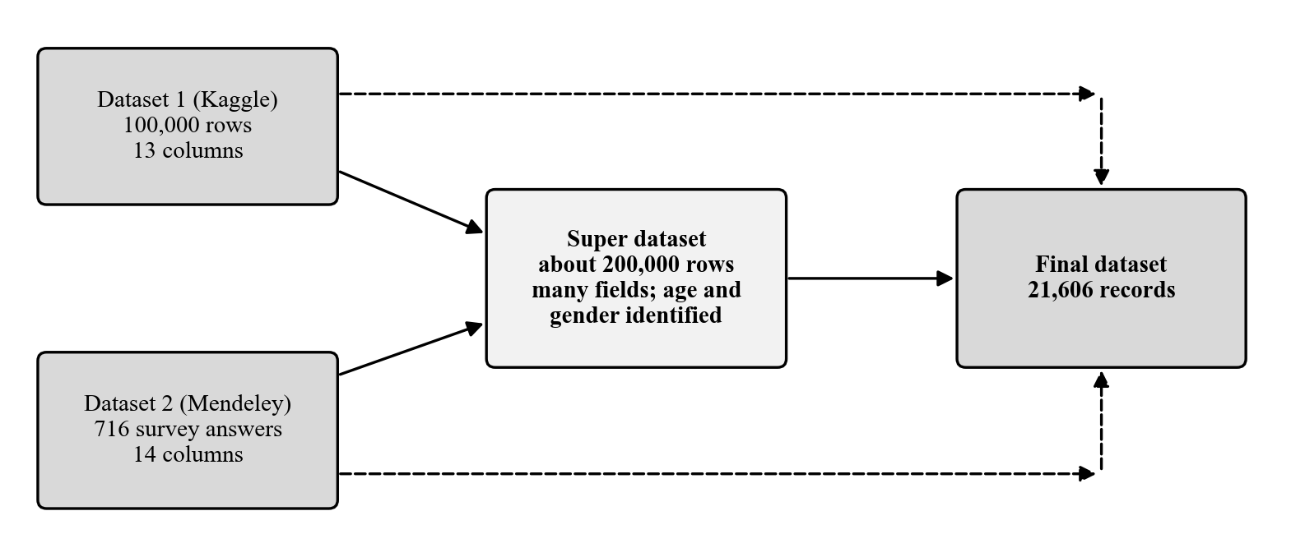
Figure 3.2: Relationship between the source datasets and the final dataset
Table 3.2: Source of each column of the final dataset in Dataset 1, Dataset 2, and the super dataset
Final dataset column | Dataset 1 | Dataset 2 | Super dataset field | Unit or coding
age | age | age | d1_age, d2_age | years
gender | gender | gender | d1_gender, d2_gender | Female, Male, Other
total_protein | total_protein | none | d1_total_protein | g/dL
calcium | calcium | none | d1_calcium | mg/dL
iron | iron | none | d1_iron | µg/dL
vitamin_d | vitamin | none | d1_vitamin | ng/mL
alt_liver | liver_data | none | d1_liver_data | U/L
manganese | manganese | none | d1_manganese | µg/L
body_water_content | body_water_content | none | d1_body_water_content | %
stress_level | stress_level | none | d1_stress_level | 0 to 40
total_keratine | total_keratine | none | d1_total_keratine | 0 to 100 score
hair_texture | hair_texture | none | d1_hair_texture | 0 to 100 score
family_hair_fall_history | none | Family history | d2_family_hair_fall_history | 0 = No, 1 = Yes
chronic_illness | none | Chronic illness | d2_chronic_illness | 0 = No, 1 = Yes
late_night_sleep | none | Stay up late | d2_late_night_sleep | 0 = No, 1 = Yes
sleep_disturbance | none | Sleep disturbance | d2_sleep_disturbance | 0 = No, 1 = Yes
water_reason | none | Water as a reason | d2_water_reason | 0 = No, 1 = Yes
chemical_use | none | Chemical use | d2_chemical_use | 0 = No, 1 = Yes
anemia | none | Anemia | d2_anemia | 0 = No, 1 = Yes
stress | none | Stress | d2_stress | 0 = No, 1 = Yes
hair_fall (target) | hair_fall (0 to 5) | Hair fall problem | d1_hair_fall, d2_hair_fall_problem | 0 Low, 1 Moderate, 2 High

3.2.2 Use of the datasets
Dataset 1 and Dataset 2 were the two source datasets. The super dataset was made from them and holds all their fields. The final dataset was made using all three (Dataset 1, Dataset 2, and the super dataset), and only the final dataset is used for modelling.
Dataset 1 supplied the blood and body measurements. In the final dataset they lie in real clinical ranges (for example iron 10 to 217 µg/dL) and most of them are related to the target (for example iron ρ = −0.31 and stress_level ρ = +0.33). Dataset 2 supplied the survey answers. As Table 3.3 shows, the risk factors point the same way in both: people with a hair fall problem report each factor more often than people without.
Table 3.3: Risk factors in Dataset 2 and in the final dataset
Risk factor | Dataset 2 (% of respondents) | Final dataset (% of records) | More common with hair fall in both
Family history | 72.7 | 34.5 | Yes
Chronic illness | 45.7 | 29.9 | Yes
Late-night sleep | 65.3 | 40.2 | Yes
Sleep disturbance | 55.4 | 35.2 | Yes
Water as a reason | 60.0 | 29.8 | Yes
Chemical use | 63.9 | 39.9 | Yes
Anemia | 28.7 | 24.6 | Yes
Stress | 72.0 | 40.3 | Yes

3.2.3 The final dataset
The final dataset has 21,606 records with 20 features and one target.
• Demographics and heredity: age (20 to 55 years), gender, family_hair_fall_history.
• Blood and body measurements: total_protein, calcium, iron, vitamin_d, alt_liver (alanine aminotransferase, ALT), manganese, body_water_content, stress_level, total_keratine, and hair_texture.
• Clinical conditions (0/1): chronic_illness, anemia, stress.
• Lifestyle and environment (0/1): late_night_sleep, sleep_disturbance, water_reason, chemical_use.
• Target hair_fall: 0 = Low (9,723 records, 45%), 1 = Moderate (7,562, 35%), 2 = High (4,321, 20%).

3.3 Data Preprocessing
The following steps were applied to the final dataset before any model was run.
1. Removal of identifiers. The id column and the full_name column (which holds personal names in encoded form) were removed, because they do not describe health and could create false patterns. After removal, 20 features remain.
2. Quality checks. The dataset has no missing values and no duplicate records (ignoring id).
3. Clinical range check. Each blood and body measurement was compared with its normal reference range and with limits that are physiologically impossible (Table 3.4). No values were impossible, so no record was removed. Values outside the normal range were kept on purpose, because they are the information that indicates risk.
4. Encoding. Gender was coded 0 = Female, 1 = Male, 2 = Other. The yes/no columns were already 0/1, and the target was already coded 0, 1, 2.
5. Stratified split. The records were split 80% to 20% with the class shares kept equal (random seed 42): 17,284 training records and 4,322 test records, with 45% Low, 35% Moderate, and 20% High in both parts.
6. Training sizes. Three training sizes were prepared from the 17,284 training records: 500 records, 2,000 records, and all 17,284. The smaller sets were drawn with the class shares kept equal (45% Low, 35% Moderate, 20% High). The same 4,322 test records are used for every size and every model.
Table 3.4: Clinical range check of the final dataset
Measurement | Normal range | Below normal | Above normal | % outside normal | Impossible values
total_protein (g/dL) | 6.0 to 8.3 | 406 | 605 | 4.7 | 0
calcium (mg/dL) | 8.5 to 10.5 | 1,675 | 392 | 9.6 | 0
iron (µg/dL) | 60 to 170 | 2,217 | 209 | 11.2 | 0
vitamin_d (ng/mL) | 25 to 80 | 8,606 | 0 | 39.8 | 0
alt_liver (U/L) | 7 to 56 | 2,300 | 403 | 12.5 | 0
manganese (µg/L) | 4 to 15 | 1,960 | 208 | 10.0 | 0
body_water_content (%) | 45 to 65 | 2,225 | 2,227 | 20.6 | 0

3.4 Model Selection
Three models from different families are compared: a tuned gradient boosting model (CatBoost) and two tabular foundation models that predict without training (TabPFN and TabFM).

3.4.1 CatBoost
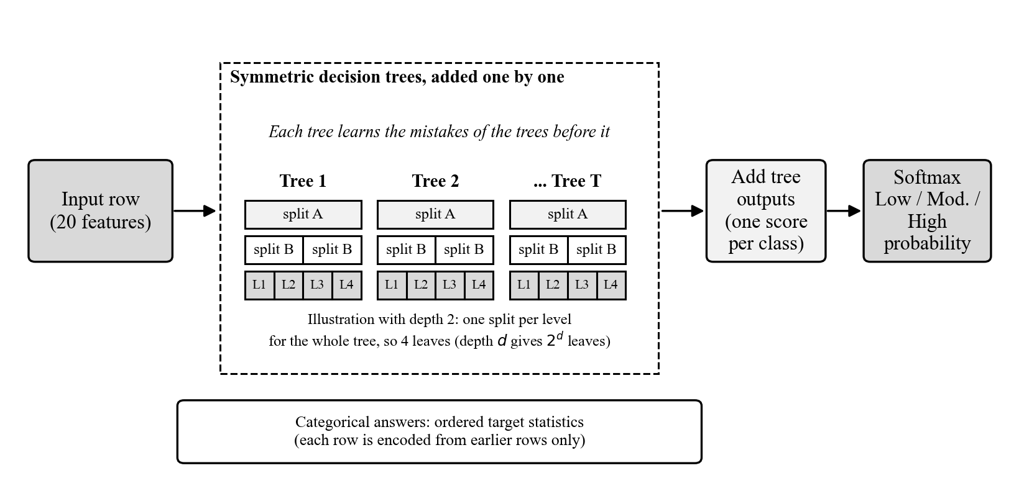
Figure 3.3: CatBoost model (gradient boosted symmetric trees)
CatBoost builds many small decision trees one after another, and each new tree h_{t} is trained to correct the mistakes of the ensemble F_{t-1} built so far, by minimising
 | 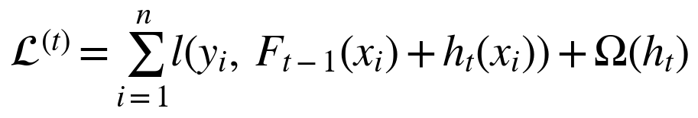 | (i)

where l is the multi-class cross-entropy loss, y_{i} is the true tier of record i, and Ω(h_{t}) is a penalty on the complexity of the new tree, which limits overfitting. All trees are symmetric, meaning that one split is used for a whole level of the tree, which makes the model fast and hard to overfit. The tree outputs are added to give one score s_{k} for each risk tier k, and a softmax turns the three scores into probabilities:
 | 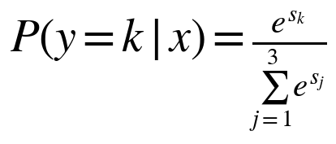 | (ii)

Categorical answers are encoded using only earlier rows, which avoids target leakage (Prokhorenkova et al., 2018). CatBoost is the only model that will be trained and tuned on the hair fall data. Its tuning will be a grid search over tree depth and learning rate, scored by macro-F1 with 5-fold cross-validation on the training rows only, so that the test set stays untouched. The two foundation models will not be tuned.

3.4.2 TabPFN
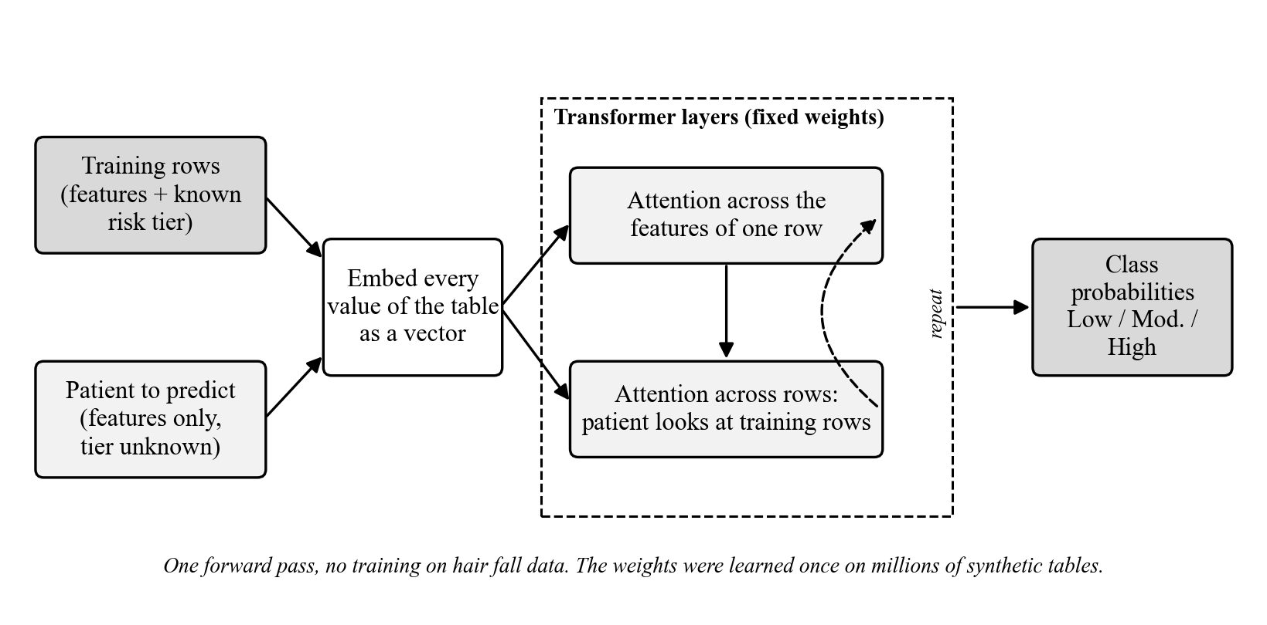
Figure 3.4: TabPFN model (in-context learning)
TabPFN is a transformer that was trained beforehand on millions of synthetic tables (Hollmann et al., 2025). To predict, it receives the training rows together with their known risk tiers and the patient to be predicted. Every value is turned into a vector, and attention layers let the model relate the features of a row and relate the patient to the training rows. The class probabilities are produced in a single forward pass:
 | 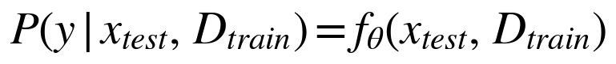 | (iii)

where D_{train} is the set of training rows with their tiers and f_{θ} is the pretrained network with fixed weights θ. No weights are changed, so nothing is trained on the hair fall data. TabFM works in the same way, with its own network in place of f_{θ}.

3.4.3 TabFM
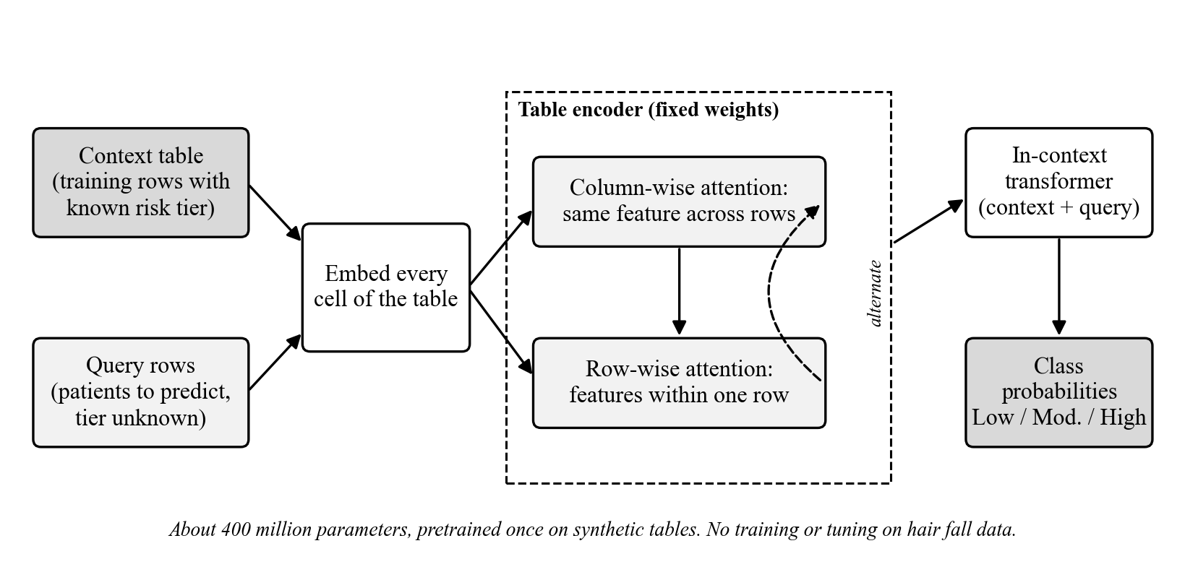
Figure 3.5: TabFM model (zero-shot tabular foundation model)
TabFM is a model of about 400 million parameters developed by Google Research and pretrained on synthetic tables (Kong et al., 2026). Like TabPFN, it takes the training rows as context and predicts in one forward pass without tuning. Its table encoder alternates attention along columns and along rows, and an in-context transformer then combines the context rows with the query rows to give the class probabilities. It was published in 2026 and has been tested by others only on general benchmarks (Pandey, 2026), so how it behaves on real health data is one of the open questions of this study.

3.5 Explainability with SHAP
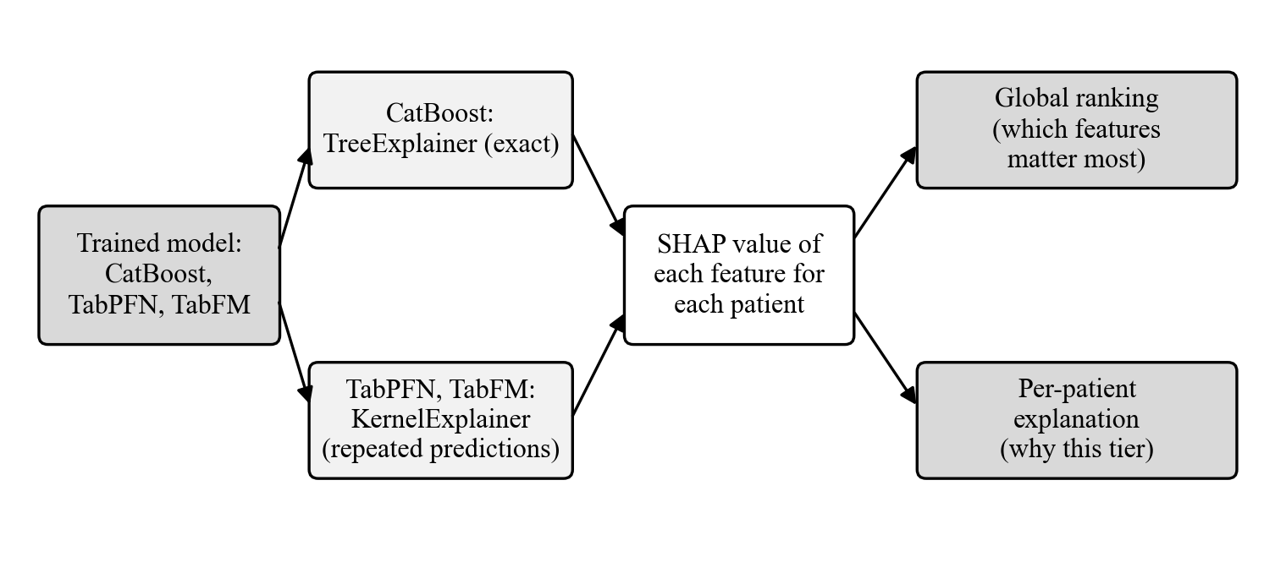
Figure 3.6: SHAP explainability workflow
SHAP splits a prediction into one contribution per feature, based on Shapley values from game theory (Lundberg & Lee, 2017). The contributions add up to the difference between the model's output and its average output:
 | 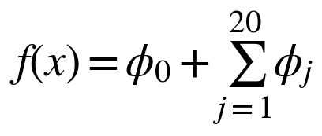 | (iv)

where f(x) is the model output for a patient x, φ₀ is the average prediction and φ_{j} is the contribution of feature j (for example iron or stress_level) to the predicted risk tier.
• CatBoost: TreeExplainer, which uses the tree structure to compute exact values, will be applied to a sample of 1,000 test records.
• TabPFN and TabFM: KernelExplainer, which estimates the values by repeatedly changing the inputs and predicting again. Because every repeat is a full forward pass of a large model, it will be applied to a small sample of test records (a few tens) with a small k-means background set.
The results will be a global ranking of the features (which matter most overall) and per-patient explanations (why this person received this tier). The rankings of the three models will be compared with each other and with the known biology from Chapter 2.

3.6 Tools and Technologies
Table 3.5: Software tools
Purpose | Tool | Version
Language | Python | 3.12.14
Data handling | pandas, NumPy | 3.0.6, 2.5.3
Split, metrics, cross-validation | scikit-learn | 1.9.1
Statistical tests | statsmodels (McNemar's test, Wilson intervals) | 0.15.0
Gradient boosting model | CatBoost | 1.2.10
Foundation model 1 | TabPFN | 9.0.0
Foundation model 2 | TabFM (weights from Hugging Face: google/tabfm-1.0.0-pytorch) | 1.0.1
Explainability | SHAP | 0.52.0
Deep learning backend | PyTorch | 2.14.0
Charts | Matplotlib | 3.11.2
Workflow | Local lab application (notebook-style steps) with PostgreSQL and MinIO | —
GPU runs | Kaggle notebooks | —

Package versions used on Kaggle are recorded at the start of each notebook and reported with the results.

3.7 Experimental Environment
The work is divided between two environments (Figure 3.7).
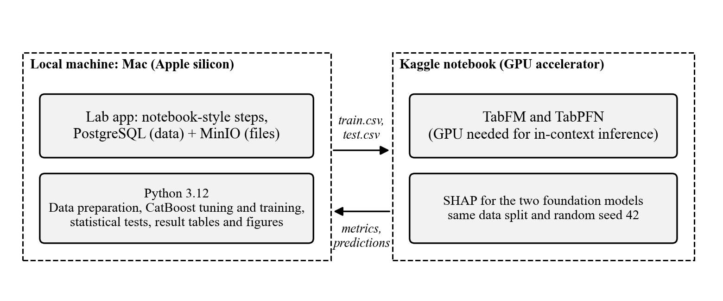
Figure 3.7: Experimental environment
Local machine. Data preparation and the split have already been done on an Apple-silicon Mac (macOS, 17.2 GB memory, Apple GPU) with Python 3.12, and CatBoost tuning and training, the statistical tests, and the result tables and figures will be run there as well. The steps are run one by one in a local lab application that stores the data in PostgreSQL and the outputs in MinIO, so every run is saved and can be reopened.
Kaggle notebooks. TabFM and TabPFN need a GPU to make their predictions in reasonable time, and TabFM is the largest model (about 6.5 GB of weights). These runs will therefore be done in Kaggle notebooks, which offer more GPU capacity than Google Colab. The train and test files created on the local machine are uploaded to the notebook, and the metrics and predictions are downloaded back for comparison. SHAP for the two foundation models will also be run there.
To keep the comparison fair, all three models use the same split and the same random seed (42), and the environment of every session (Python, GPU, memory, package versions) is recorded and reported.

3.8 Performance Evaluation Metrics
Model performance will be measured on the same held-out test set for every model. Because the three risk tiers are not equally common (45%, 35%, 20%), the class-averaged (macro) versions of the metrics are used, so that the smaller High tier counts as much as the Low tier. Here TP_{k}, FP_{k}, and FN_{k} are the true positives, false positives, and false negatives of tier k. Each equation is numbered on the right and cited in the text as Equation (i), (ii), and so on.
Accuracy is the share of test records whose tier is predicted correctly, where N is the number of test records:
 | 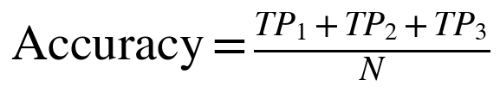 | (v)

Precision shows how trustworthy a predicted tier is. It is computed for each tier k and then averaged over the three tiers (macro-precision):
 | 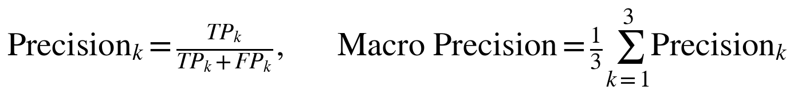 | (vi)

Recall shows how many patients of a tier are found (macro-recall is the average over the three tiers):
 |  | (vii)

Macro-F1 is the harmonic mean of precision and recall for each tier, averaged over the tiers:
 | 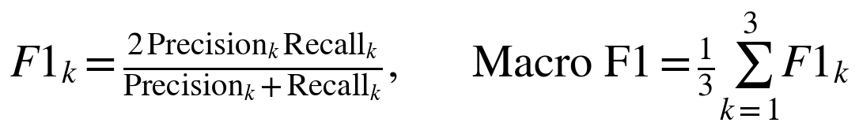 | (viii)

ROC-AUC is the area under the receiver operating characteristic (ROC) curve of each tier against the other two (one-versus-rest), averaged over the three tiers. It measures how well the predicted probabilities rank patients, independent of any cut-off:
 |  | (ix)

• Confusion matrix: shows which tiers are mixed up. This matters here because the tiers are ordered, and confusing Low with High is a worse mistake than confusing neighbouring tiers.
Statistical significance. McNemar's test will be applied to every pair of models on the test set, to decide whether a difference in the number of correct predictions is larger than chance. Let b be the number of records that only the first model predicts correctly and c the number that only the second model predicts correctly:
 | 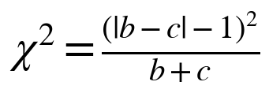 | (x)

with one degree of freedom (the −1 is the continuity correction). The accuracy of each model is also given with a 95% Wilson confidence interval, where p̂ is the accuracy, n is the number of test records, and z = 1.96:
 | 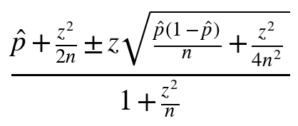 | (xi)

Chapter 4: Expected Outcome and Working Schedule

4.1 Expected Outcomes
This study is expected to give a fair comparison of CatBoost, TabPFN, and TabFM on hair fall data, because all three use the same dataset, split, random seed, and metrics, unlike earlier studies that compared different classical models on different datasets (Khatun et al., 2022; Kumar et al., 2025; Siami & Azis, 2025). CatBoost is tuned with a grid search and cross-validation on the training data, so it should act as a strong baseline, unlike the untuned CatBoost result in earlier work (Kumar et al., 2025). TabPFN and TabFM are expected to be competitive with the tuned CatBoost without any tuning, especially with small training sets, as their benchmark results suggest (Hollmann et al., 2025; Kong et al., 2026). The study can also show the opposite, and a difference between models is accepted only if McNemar's test shows that it is larger than chance. It will also record the practical limits of TabFM on a real health dataset, such as how much training data it can take, how long it runs, and what problems appear, since an independent reproduction reported software defects and memory failures on larger tables (Pandey, 2026).
SHAP is expected to show which measurements and habits drive each model's predicted risk tier and whether the three models agree. The factors the models rely on are expected to match the known biological causes of hair loss, such as iron level, stress, and family history. Agreement would support the use of the models as decision support, and disagreement would be reported as a finding. Overall, the study expects to show whether explainable, data-efficient tabular modelling can be a practical alternative to heavily tuned gradient boosting for structured health risk prediction, and to leave a documented and reproducible pipeline that others can rerun on their own data.

4.2 Working Schedule
The work is planned over six months, with the schedule shown as a Gantt chart in Figure 4.1. The tasks on the left are split into what has already been done up to this proposal (black bars) and what will be done after the proposal is approved (hatched bars). The completed tasks are the problem formulation, the literature review, the comparison and preparation of the datasets, the preprocessing and split, and the setup of the local environment and pipeline code. The planned tasks follow the order of the methodology in Chapter 3: model training, the training-size experiment, SHAP, evaluation, discussion, and thesis writing.
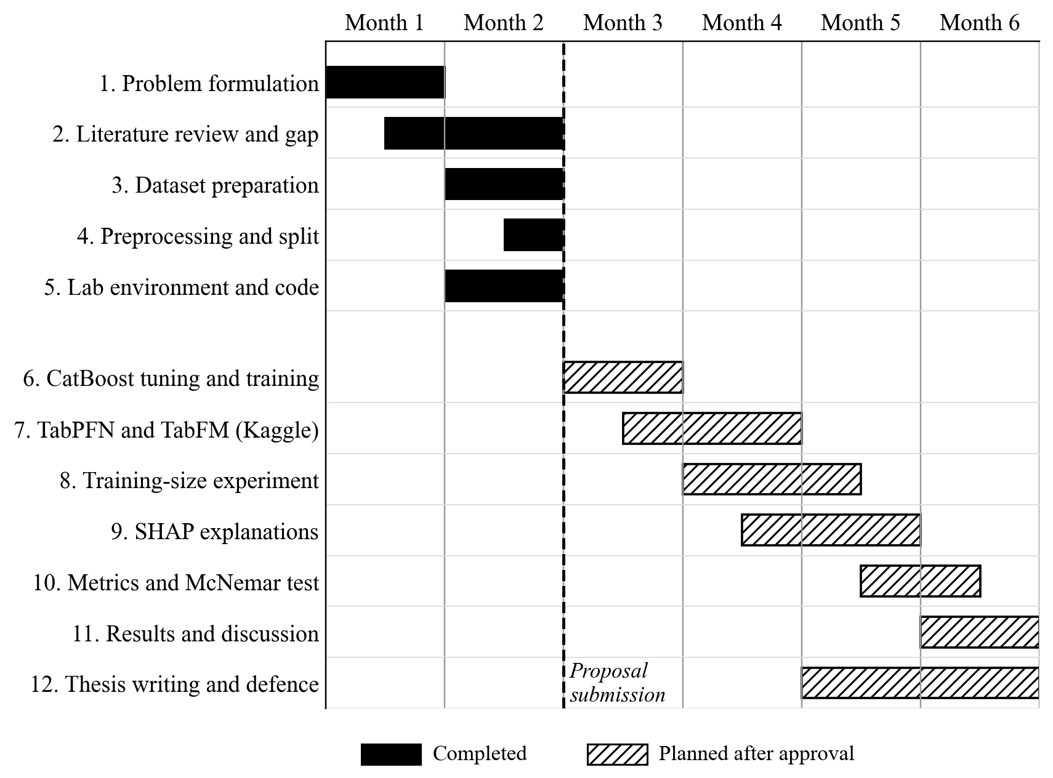
Figure 4.1: Working schedule (Gantt chart)

References
Agaoglu, E., Kaya Erdogan, H., Acer, E., Atay, E., Metintas, S., & Saracoglu, Z. N. (2021). Prevalence of early-onset androgenetic alopecia and its relationship with lifestyle and dietary habits. Italian Journal of Dermatology and Venereology, 156(6), 675–680. https://doi.org/10.23736/S2784-8671.21.06874-7
Arnob, M. S., Islam, O., Tapos, M. A., & Chakraborty, N. R. (2024). Dataset for evaluating hair fall causes using machine learning techniques (Version 1) [Data set]. Mendeley Data. https://doi.org/10.17632/g46n66frrh.1
Bai, Y., McMullen, E., Sibbald, R. G., Dumont, N., Mainville, L., Julanon, N., & Donovan, J. (2026). The role of psychological stress in hair loss: A review. JAAD Reviews, 7, 9–19. https://doi.org/10.1016/j.jdrv.2025.10.002
Cline, A., Kazemi, A., Moy, J., Safai, B., & Marmon, S. (2021). A surge in the incidence of telogen effluvium in minority predominant communities heavily impacted by COVID-19. Journal of the American Academy of Dermatology, 84(3), 773–775. https://doi.org/10.1016/j.jaad.2020.11.032
Dhankour, B. (2023). Hair loss dataset [Data set]. Kaggle. https://www.kaggle.com/datasets/brijlaldhankour/hair-loss-dataset
Guo, E. L., & Katta, R. (2017). Diet and hair loss: Effects of nutrient deficiency and supplement use. Dermatology Practical & Conceptual, 7(1), 1–10. https://doi.org/10.5826/dpc.0701a01
Hollmann, N., Müller, S., Purucker, L., Krishnakumar, A., Körfer, M., Hoo, S. B., Schirrmeister, R. T., & Hutter, F. (2025). Accurate predictions on small data with a tabular foundation model. Nature, 637(8045), 319–326. https://doi.org/10.1038/s41586-024-08328-6
Hussein, R. S., Atia, T., & Bin Dayel, S. (2023). Impact of thyroid dysfunction on hair disorders. Cureus, 15(8), e43266. https://doi.org/10.7759/cureus.43266
Khatun, M., Ajmain, M., Khushbu, S. A., Ria, N. J., & Noori, S. R. H. (2022). Survey-based machine learning approaches to diagnosis of hair fall disorder in Bangladeshi community. In 2022 13th International Conference on Computing, Communication and Networking Technologies (ICCCNT) (pp. 1–6). IEEE. https://doi.org/10.1109/ICCCNT54827.2022.9984226
Kong, W., Ilan, E. L., Nie, S., Narayan, T., Sen, R., Zhou, Y., Fu, D., Oymak, S., & Das, A. (2026). TabFM: A zero-shot foundation model for tabular data (arXiv:2609.37959). arXiv. https://arxiv.org/abs/2609.37959
Kumar, M. S., Reddy, P. L. K., Reddy, G. D., Kumar, A. S., & Nagendra, P. (2025). Predictive modeling of hair fall using random forest algorithms. In Proceedings of ICITSM-Part II 2025. European Alliance for Innovation. https://doi.org/10.4108/eai.28-4-2025.2358120
Leema, A. A., Saktheshwaran, T., Sri, G. R., & Balakrishnan, P. (2025). HairSentinel: A time-aware anomaly detection framework for forecasting hairfall trends using temporal fusion transformers. Frontiers in Artificial Intelligence, 8. https://doi.org/10.3389/frai.2025.1649740
Lin, C.-S., Chan, L.-Y., Wang, J.-H., & Chang, C.-H. (2023). Diagnosis and treatment of female alopecia: Focusing on the iron deficiency-related alopecia. Tzu Chi Medical Journal, 35(4), 322–328. https://doi.org/10.4103/tcmj.tcmj_95_23
Lundberg, S. M., & Lee, S.-I. (2017). A unified approach to interpreting model predictions. In Advances in neural information processing systems (Vol. 30, pp. 4765–4774). Curran Associates.
Marahatta, S., Agrawal, S., & Mehata, K. D. (2018). Alopecia areata and thyroid dysfunction association: A study from eastern Nepal. Kathmandu University Medical Journal, 16(62), 161–165.
Pandey, Y. (devYRPauli). (2026). tabfm-evaluation: An independent reproduction and hardware study of Google TabFM [Computer software]. GitHub. https://github.com/devYRPauli/tabfm-evaluation
Pandikumar, S., Sevugapandi, N., & Arun, M. (2024). Predicting hair loss with AI: A deep learning framework combining genetic and scalp health data. In Integrating AI, machine learning, and IoT in bioinformatics: Innovations in biotech and medical research (pp. 100–107). QTanalytics. https://doi.org/10.48001/978-81-966500-0-1-6
Prokhorenkova, L., Gusev, G., Vorobev, A., Dorogush, A. V., & Gulin, A. (2018). CatBoost: Unbiased boosting with categorical features. In Advances in neural information processing systems (Vol. 31, pp. 6638–6648). Curran Associates.
Sai, C. N. V., Archana, E., Vivek, B., Dhanwanth, B., & K. S., V. (2023). Enhancing hairfall prediction: A comparative analysis of individual algorithms and an ensemble method. International Journal on Recent and Innovation Trends in Computing and Communication, 11(6s), 499–508.
Sayyad, S., Midhunchakkaravarthy, D., & Sayyad, F. (2022). An analysis of alopecia areata classification framework for human hair loss based on VGG-SVM approach. Journal of Pharmaceutical Negative Results, 13(Suppl. 1), 9–15. https://doi.org/10.47750/pnr.2022.13.s01.02
Shakeel, C. S., Khan, S. J., Chaudhry, B., Aijaz, S. F., & Hassan, U. (2021). Classification framework for healthy hairs and alopecia areata: A machine learning (ML) approach. Computational and Mathematical Methods in Medicine, 2021, Article 1102083. https://doi.org/10.1155/2021/1102083
Siami, M. I., & Azis, H. (2025). Predicting hair loss with machine learning: A multi-factor analysis. International Journal of Artificial Intelligence in Medical Issues, 3(1). https://doi.org/10.56705/ijaimi.v3i1.360
Sun, J., Li, Y., Ye, Z., Wang, S., & Wang, W. (2025). Global sex disparities in lifetime risk of alopecia areata: A systematic analysis from the Global Burden of Disease Study, 1990 to 2021. Biology of Sex Differences, 16, Article 68. https://doi.org/10.1186/s13293-025-00749-w
Treister-Goltzman, Y., Yarza, S., & Peleg, R. (2022). Iron deficiency and nonscarring alopecia in women: Systematic review and meta-analysis. Skin Appendage Disorders, 8(2), 83–92. https://doi.org/10.1159/000519952

