**Assignment**

* Write a JavaScript program to count the number of vowels in a given string. Take the input with

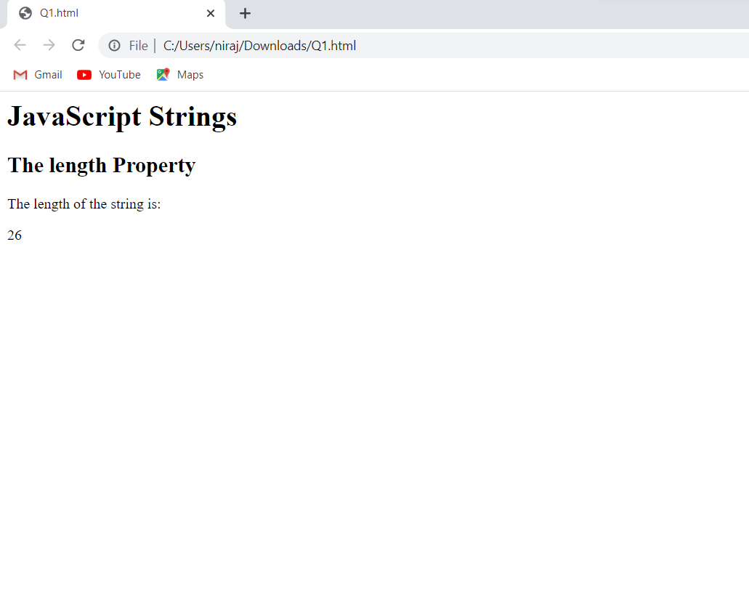

* Write a JavaScript program to check whether a given value in textbox is alpha numeric or not.

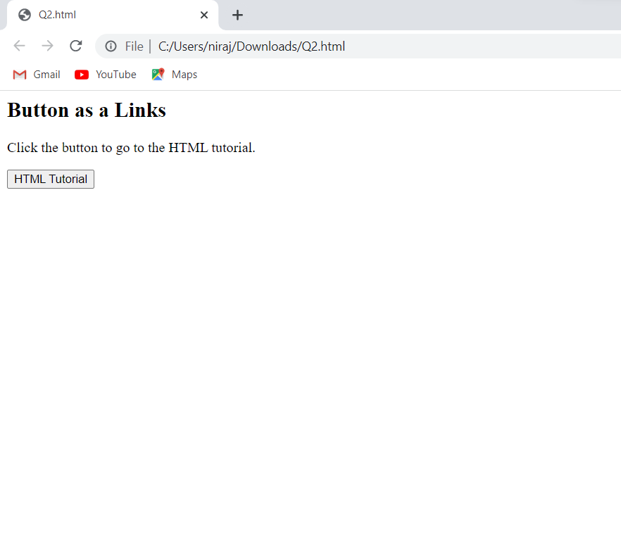

* Form

