1. Search for a specific word “apple” in a file and count it.
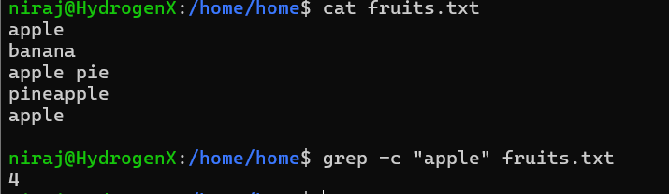
2. Show current users logged in.
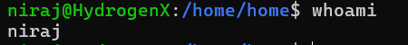
3. Show total number of .txt files in current directory.
4. Show list of all system users from /etc/passwd.
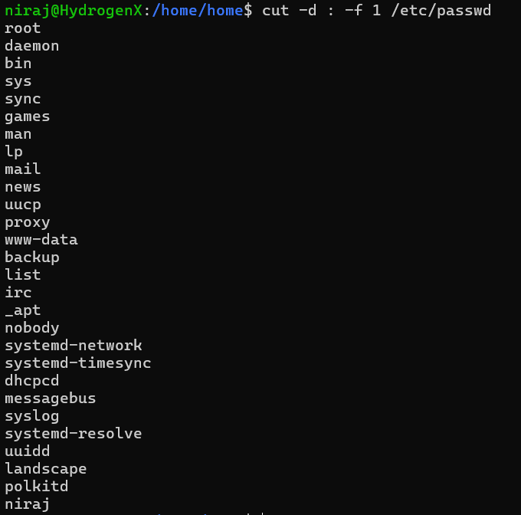
5. Find how many times a word and each match should be on newline.
6. Show running processes and search for &quot;root&quot;.
7. Show only .log files and sort them alphabetically.
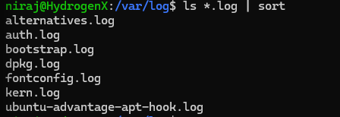
8. See disk space and filter &quot;drivers”.
9. Sort names alphabetically and remove duplicates.
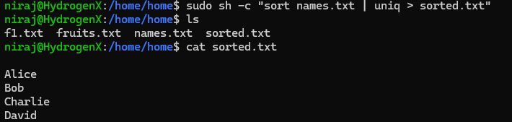
10. Find all .log files modified in last 1 day.
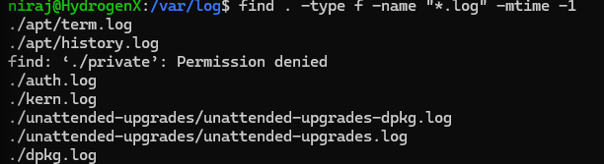
11. Delete .tmp files older than 7 days.

12. Count how many .java files exist in a project.

13. Create the access.log file with the following contents.
192.168.0.2 - - [03/Aug/2025:10:01:23 +0000] &quot;GET /index.html HTTP/1.1&quot; 200 1024
192.168.0.3 - - [03/Aug/2025:10:01:24 +0000] &quot;POST /login HTTP/1.1&quot; 200 512
192.168.0.2 - - [03/Aug/2025:10:01:25 +0000] &quot;GET /about HTTP/1.1&quot; 200 2048
192.168.0.4 - - [03/Aug/2025:10:01:26 +0000] &quot;GET /index.html HTTP/1.1&quot; 200 1024
192.168.0.2 - - [03/Aug/2025:10:01:27 +0000] &quot;GET /contact HTTP/1.1&quot; 404 256
192.168.0.3 - - [03/Aug/2025:10:01:28 +0000] &quot;GET /profile HTTP/1.1&quot; 200 512
192.168.0.2 - - [03/Aug/2025:10:01:29 +0000] &quot;GET /products HTTP/1.1&quot; 200 3072
192.168.0.2 - - [03/Aug/2025:10:01:30 +0000] &quot;GET /cart HTTP/1.1&quot; 200 4096
• Count how many times the log was accessed.
• Show only lines where status code is 404
List all unique IPs that accessed the server. Please note, IP means example,
192.168.0.2.
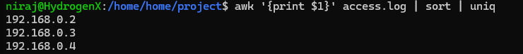
• Count how many requests were POST
• List all requested URLs
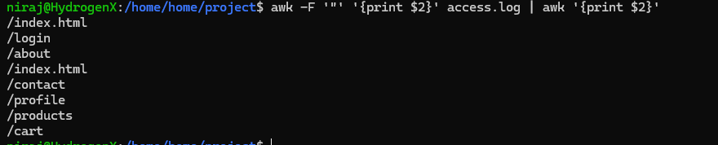
• Find which IPs triggered 404 errors

