1. Write a script that creates a new directory, then creates three empty files
inside it, and finally lists the contents of the directory.
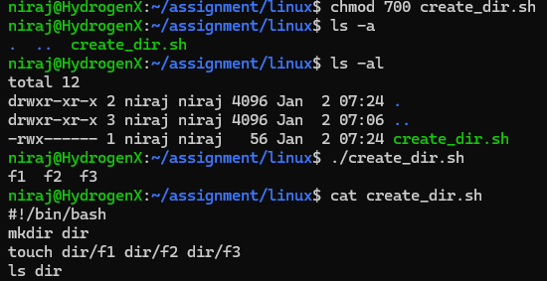
2. Create a script that prompts the user for a filename, then checks if the file
exists and whether it is a regular file or a directory.
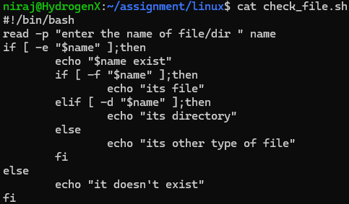

3. Write a script to copy a file from a source path to a destination path
provided as arguments. Handle cases where source or destination are
invalid.
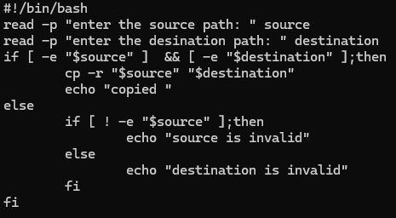
4. Develop a script that displays the current date, time, and your username.
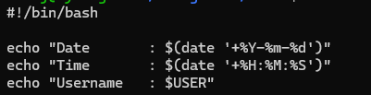
5. Create a script that checks if a given file has read, write, and execute
permissions for the owner.
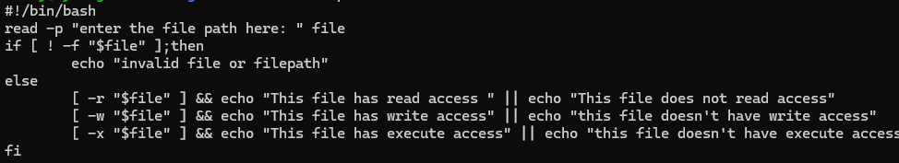
6. Develop a script that compares two strings provided as arguments and
indicates if they are equal or different.
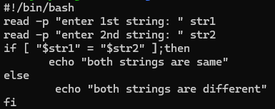

7. Write a script that lists all currently running processes and their PIDs.
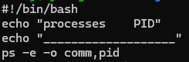
8. Create a script that takes a process ID as an argument and attempts to
terminate that process.
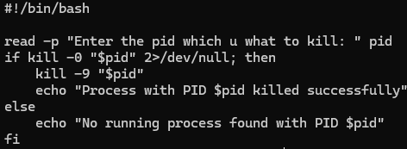
9. Develop a script that displays disk usage information for all mounted
filesystems.
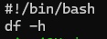
10. Write a script that counts the number of words, lines, and characters in a
given text file.
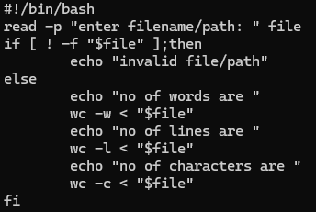

11. Create a script that searches for a specific string within a file or directory
recursively.
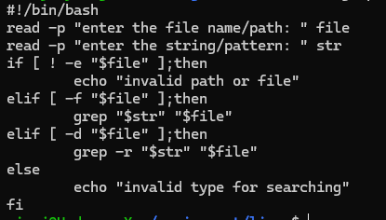
12. Develop a script that backs up a specific directory to a compressed
archive, including a timestamp in the filename.
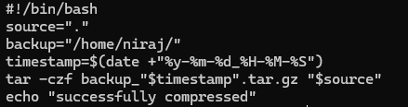
13. Write a script that schedules a task to run at a specific time using cron.
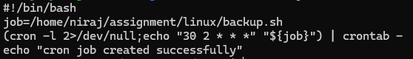
14. Write a script to replace all occurrences of one word with another
throughout data.txt.
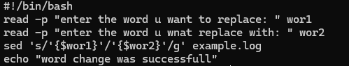
15. Print only the lines from data.txt where the second field is a number greater
than 10. Use awk command.
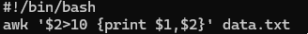

16. Print lines from data.txt that contain a specific pattern, and then print a
custom message for each matched line.

