Intro to SQL Server Assignment

### **Problem Statement:**

Consider yourself to be Sam, who is a student at a prestigious university. You have enrolled for the SQL course and it is your first semester.

## Tasks to be done:

1. Install MS SQL Server

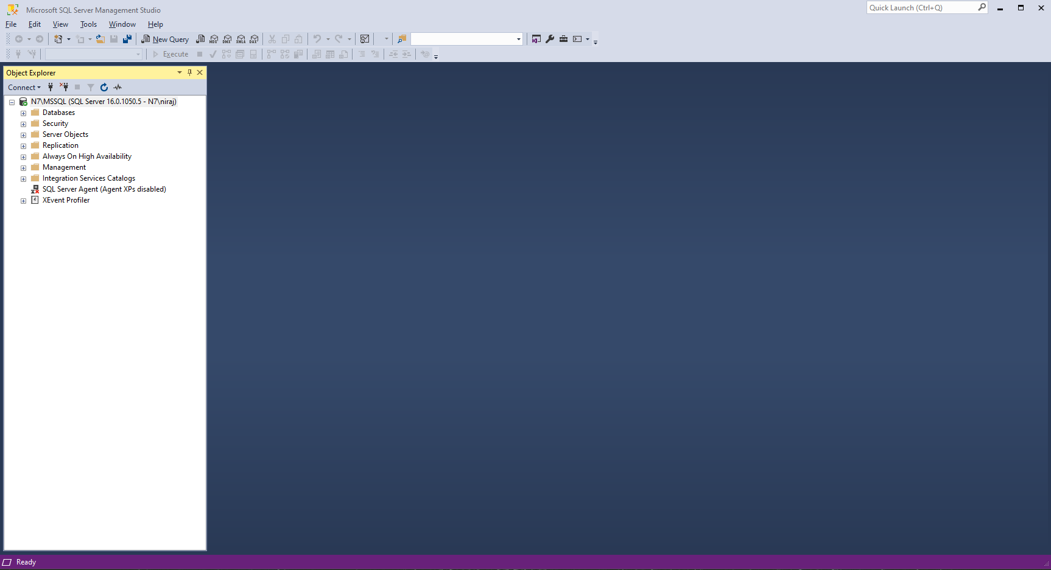

1. Learn the basics of Structured Query Language

SQL

DATA -> IS A RAW FACT THAT DESCRIBE PROPERTIES / ATTRIBUTE OF AN ENTITY

RAW FACT->CANT CHANGE

STUDENT NAME IS ANITHA

ATTRIBUTE ->PROPERTIES OF AN OBJECT / ENTITY

ENTITY / OBJECT

ANYTHING WHICH PHYSICALLY EXISTS IN THE REAL WORLD

2 IMP FEATURE

PROPERTIES

BEHAVIOUR

FAN

PROPERTIES->COLOR , NO OF BLADES, BRAND ,SIZE ,PRICE

BEHAVIOUR ->SWTICH OFF , ON , ROTATING

PEN

PROPERTIES->COLOUR , SIZE , PRICE, BRAND

BEHAVIOUR -> WRITING

COMPUTER

PROPERTIES->BRAND, RAM , OS , PRICE

BEHAVIOUR->MULTI TASKING

DATABASE

PLACE OR MEDIA WHERE WE CAN STORE A DATA IN A SYSTEMATIC & ORGANIZED MANNER

WHICH THE BASIC OPEARTION THAT CAN BE PERFORMED ON ANY DATABASE?

CRUD OPERATION -> CREATE , READ , UPDATE , DELETE

DBMS ->SOFTWARE WHICH MAINTAIN AND MANAGE THE DATABASE

EX : MSSQL , MYSQL , ORCALE ETC ->SQL

SQL LANG OR STATEMENT ?

DDL(Data Definition Language) ->CREATE , RENAME , ALTER, TRUNCATE ,DROP

DML(Data Manipulation Language)->INSERT ,UPDATE ,DELETE

DQL(Data Query Language)->SELECT

TCL(Transaction Control Language)-> COMMIT , SAVEPOINT ,ROLLBACK

DCL(Data Control Language)->GRANT ,REVOKE