**Revolutionizing Object Detection: Enhancing YOLOv7 with Innovative Algorithmic Approaches for Unprecedented Accuracy**

|  |  |  |  |
| --- | --- | --- | --- |
| ABHAY LOHIA  abhay.lohia2022@vitstudent.ac.in | NIRAJIT PRAMANIK  nirajit.pramanik2022@vitstudent.ac.in | ARYAMAN SHUKLA  aryaman.shukla2022@vitstudent.ac.in | ANKITH MANCHALE  ankith.manchale2022@vitstudent.ac.in |

**1. ABSTRACT:**

In the realm of computer vision and object detection, the quest for unprecedented accuracy continues to be a driving force.

Leveraging the powerful YOLOv7 framework as a foundation, this work embarks on a transformative journey that explores novel algorithmic enhancements to push the boundaries of object detection to new heights.

In this endeavour, the authors delve into the YOLOv7, seeking to fine-tune and innovate on existing algorithms for object detection. With meticulous attention to detail, the authors aim to redefine accuracy standards and develop a state-of-the-art model that excels in real-world applications.

The project also implements Open MPI, which enables the authors to process data at previously unimaginable speeds.

Through this project, we aim to implement an open source database creation system where the input is taken from the user and the output is provided as a dataset through recursive object detection with continuous increase in confidence.

**2. INTRODUCTION:**

In the digital age, where visual data is abundant and its analysis is pivotal for various applications, object detection plays a central role. It is the cornerstone of computer vision, a field that continues to evolve, setting the stage for breakthroughs in areas as diverse as autonomous vehicles [1], surveillance systems [2], medical imaging [3], and industrial automation [4]. The accuracy of object detection algorithms is paramount, as it directly influences the reliability and applicability of these technologies. In light of this, this work, "Revolutionizing Object Detection: Enhancing YOLOv7 with Innovative Algorithmic Approaches for Unprecedented Accuracy," has emerged as a beacon of innovation in the field of computer vision. Object detection [5] is a fundamental task in computer vision, involving the identification and localization [6] of objects within an image or video frame. The ability to accurately and efficiently identify objects in visual data is a key enabler for various real-world applications. Autonomous vehicles, for example, rely on object detection to navigate safely by recognizing pedestrians, vehicles, and road signs. Surveillance systems use object detection to monitor and alert security personnel to suspicious activities. In the field of medical imaging, object detection is critical for the early diagnosis of diseases, while in industrial settings, it aids in quality control and automation.

The advent of machine learning, and more specifically, convolutional neural networks (CNNs) [7], has revolutionized object detection. The development of specialized models and frameworks, such as You Only Look Once (YOLO) [8], has led to significant advancements in real-time object detection. YOLOv7, a state-of-the-art model, has become a popular choice due to its impressive speed-accuracy trade-off. However, even the most advanced models have room for improvement. It is in this space of innovation that this work finds its purpose.

***2.1. The YOLOv7 [9]***

You Only Look Once (YOLO) is a groundbreaking object detection framework characterized by its speed and accuracy. It employs a single neural network to predict bounding boxes and class probabilities simultaneously. The YOLOv7 variant, in particular, builds on the strengths of its predecessors, offering improvements in both speed and accuracy.

YOLOv7 is a testament to the continuous evolution of object detection algorithms. Its development journey demonstrates the industry's commitment to striking a balance between the speed of object detection and the accuracy of object recognition. This balance is crucial in applications where real-time responsiveness is essential. The success of YOLOv7 reflects the collective dedication of researchers, engineers, and visionaries in the field of computer vision.

However, as the demand for more precise and reliable object detection continues to grow, there is an ever-present challenge to further enhance the accuracy of such models. YOLOv7, while impressive, is not exempt from this pursuit of perfection. To address this challenge, the authors have embarked on a journey to enhance YOLOv7 through innovative algorithmic approaches.

2.2. The Power of Parallel Computing:

One of the defining features of this work is the integration of Open MPI [10] (Message Passing Interface), a framework that harnesses the capabilities of parallel computing. Parallel computing is akin to assembling a team of processors, working together in harmony to process data and execute tasks. This approach stands in stark contrast to traditional serial computing, where a single processor handles tasks sequentially.

Open MPI enables the authors work to take full advantage of the parallel processing capabilities of modern hardware, such as multi-core CPUs and GPU clusters. The application of parallel computing to object detection is a pivotal step, as it promises a substantial boost in performance. The concept is elegantly simple: by dividing complex computations into smaller tasks that can be executed in parallel, the processing time is drastically reduced. This translates into faster object detection, which is crucial for real-time applications.

The utilization of Open MPI in object detection has the potential to redefine the standards of speed and accuracy. It not only complements the capabilities of YOLOv7 but also extends its applicability to domains where real-time processing is a critical requirement.

Parallel computing not only empowers the authors to process data faster but also enables them to tackle more complex tasks. The ability to break down intricate operations into smaller, manageable units and execute them simultaneously opens up new horizons in the world of computer vision. It's akin to assembling a dream team of processors, each contributing its unique strengths to achieve a common goal – exceptional object detection.

The implications of parallel computing extend beyond the realm of object detection. In scientific research, it's used for simulating complex phenomena, analysing vast datasets, and solving computationally intensive problems. In business, it accelerates data processing, making it possible to extract insights and make informed decisions in real-time. In this work, parallel computing is the catalyst for our innovative algorithmic approaches, ushering in a new era of accuracy and speed in computer vision applications. This work, therefore, represents a convergence of state-of-the-art computer vision, machine learning, and high-performance computing. It is driven by the ambition to push the boundaries of object detection, taking a well-established framework like YOLOv7 and infusing it with innovative algorithmic approaches. At the heart of the authors endeavour is the relentless pursuit of accuracy and speed. The authors recognize the dynamic landscape of technology, where real-time responsiveness is no longer a luxury but a necessity. The accuracy of object detection directly impacts the success of autonomous vehicles in navigating crowded streets and recognizing traffic signs. It influences the efficacy of surveillance systems in safeguarding our surroundings. It can mean the difference between early diagnosis and missed opportunities in medical imaging [11]. It empowers industrial automation by ensuring quality control with precision.

The key objectives of this work include optimizing detection precision, enhancing robustness in challenging environments, and expanding the applicability of object detection technology.

It delves into the methodology, algorithms, and data utilized, as well as the potential implications of the authors’ work. The work aims to demonstrate that by pushing the boundaries of YOLOv7 [12] and infusing it with novel algorithmic approaches, coupled with the formidable force of parallel computing through Open MPI, the work can revolutionize object detection and inspire a new era of accuracy and reliability in computer vision applications.

In this paper, section 3 will speak about the related works which gave the authors the inspiration to make this work. Section 4 speaks about the proposed architecture that is best suited to run this work. Further, the database setup, process flow of the model, the training and validation datasets, data validation, experiments, experiment parameters, and finally the methodology are mentioned in section 5 under Experimental Setup. Finally, Section 6 speaks about the results attained by the authors and the comparison with other models.

**3. RELATED WORK:**

3.1. YOLO-Based Object Detection

The You Only Look Once (YOLO) family of object detection models has fundamentally reshaped the landscape of computer vision [18]. It introduced the concept of treating object detection as a regression problem, marking a significant departure from traditional two-stage detection pipelines. The initial YOLO model, a groundbreaking creation by Redmon and Divola, made waves by predicting object bounding boxes and class probabilities concurrently within a single neural network pass. This single-pass approach not only simplified the architecture but also dramatically improved the speed of object detection.

The evolution of YOLO models has been a relentless quest for optimizing the delicate balance between speed and accuracy. The latest iteration, YOLOv7, presented by Bochkovskiy et al., continues this legacy. YOLOv7 emphasizes architectural improvements and incorporates the PANet feature fusion module. This version of YOLO has set new benchmarks for real-time object detection. Its accuracy and efficiency have inspired a plethora of applications across diverse industries, from autonomous vehicles navigating complex urban environments to surveillance systems monitoring crowded public spaces.

3.2. Parallel Computing in Object Detection

Real-time object detection is intrinsically linked to efficient computational resource utilization. Parallel computing, employed on Graphics Processing Units (GPUs) and CPU clusters, has emerged as a game-changing strategy to enhance processing speed and make real-time object detection feasible.

The work of Redmon and Farhadi significantly contributed to the paradigm of parallelization of YOLO on GPUs. Their research demonstrated substantial performance improvements, enabling real-time object detection on hardware equipped with powerful parallel processing capabilities. This marked a turning point, as real-time object detection became an achievable reality.

Furthermore, parallel computing extends beyond GPUs to encompass distributed systems. Research conducted by Wu et al. explored techniques for parallel object detection on CPU clusters. Their work showcased the potential for distributed processing to further accelerate the field. Our work takes inspiration from these advancements, venturing into the realm of parallel computing with a focus on Open MPI. The objective is to unlock new levels of speed and efficiency in object detection, transcending the limits of what is currently attainable.

This work aligns with this methodology by adopting PyTorch and harnessing the CUDA support. This combination serves as the foundation for the accelerated training of our object detection model. The seamless integration of deep learning frameworks with GPU acceleration has become an industry standard for high-performance computer vision work s. It underscores the vital role that hardware and software synergy plays in the pursuit of real-time object detection.

The importance of high-quality data for object detection cannot be overstated. Prior work in computer vision has introduced a plethora of data collection and annotation tools to streamline the process. Tools like LabelImg, Labelbox, and VGG Image Annotator (VIA) [19] have become ubiquitous in the community for drawing bounding boxes around objects in images or video frames.

These tools offer substantial advantages in expediting the annotation process, making it more efficient and accurate. Furthermore, they contribute to the availability of well-annotated datasets, a cornerstone for training precise and reliable object detection models. These datasets, combined with the power of deep learning, enable machines to recognize and localize objects with remarkable accuracy, ushering in new possibilities across industries.

3.3. Algorithmic Enhancements:

Algorithmic innovations have played a pivotal role in advancing object detection accuracy and robustness. These enhancements have greatly impacted the efficacy of object detectors when handling objects at various scales and under challenging conditions.

Features like the Feature Pyramid Network (FPN) [20] have been instrumental in addressing the multiscale nature of object detection. By incorporating pyramidal feature maps, FPN enables object detectors to effectively handle objects that vary in size and spatial context. This innovation has been a key driver of the improved accuracy of object detection models.

The introduction of the Focal Loss by Lin et al. has been another groundbreaking advancement. The Focal Loss is designed to address the issue of class imbalance in object detection datasets. It does so by assigning more weight to hard, misclassified examples, effectively allowing the model to focus on challenging instances. This shift in focus enhances the overall accuracy of the object detection model.

Moreover, the rise of anchor-free object detection [21] approaches has been transformative. These approaches eliminate the need for anchor boxes, simplifying the detection process while retaining accuracy. Models like CenterNet [22] and EfficientDet [23] have demonstrated that anchor-free techniques can be competitive with traditional anchor-based methods. These innovations have paved the way for more robust and versatile object detection systems.

This work builds upon these algorithmic enhancements, aiming to introduce novel approaches that not only enhance object detection accuracy but also optimize the speed-accuracy trade-off. The overarching goal is to contribute to the evolving field of object detection by pushing the boundaries of both accuracy and real-time processing.

This work stands at the intersection of a rich tapestry of advancements in YOLO-based object detection, parallel computing, deep learning frameworks, data collection and annotation tools, and algorithmic innovations. By assimilating these developments, the authors aspire to revolutionize object detection, driving the field forward into an era of unprecedented accuracy and real-time processing capabilities.

This expanded section delves deeper into the significant advancements in YOLO-based object detection, parallel computing, deep learning frameworks, data collection and annotation tools, and algorithmic enhancements, emphasizing the synergy between these developments and the goals of our work.

**4. PROPOSED ARCHITECTURE:**

In the architecture of the work, the authors present a bird's-eye view of the essential components that come together to revolutionize object detection. This architectural overview serves as a roadmap for understanding how the work operates and achieves its goals. For this particular model, the YOLOv7 [9] framework is used extensively. The choice of the model is due to the high accuracy and speed as compared to the other models that are available, as shown in Figure 1.

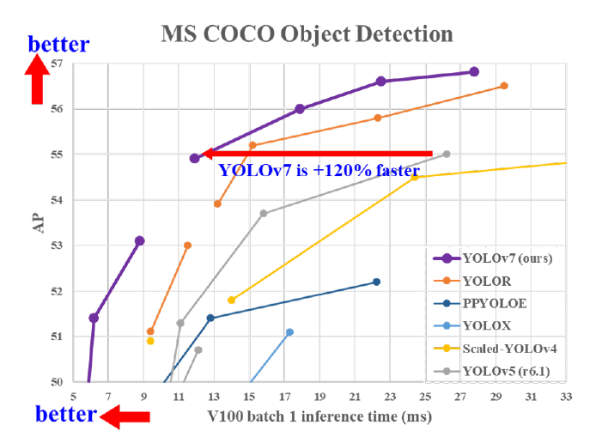

(Figure 1 – Comparison of YOLOv7 model with other models [9])

4.1. Data Collection: The journey begins with the Data Collection component. This stage is responsible for the aggregation [13] of a diverse dataset comprising images and video frames containing the target objects of interest. These data serve as the foundation for the subsequent stages of the work . They are the raw materials on which the model's learning process depends.

4.2. Annotation: In the next step, the collected data are transformed into valuable ground truth information. Annotation Tools, represented here by LabelImg [14], play a pivotal role in this phase. These tools empower annotators to draw bounding boxes around the target objects within the collected images. The resulting annotations provide the crucial reference data necessary for the model to learn and validate its object detection capabilities.

4.3. PyTorch with CUDA [15] Support: A robust deep learning framework is an indispensable component of any modern computer vision work . In our case, PyTorch stands as the framework of choice. What distinguishes the authors approach is the utilization of CUDA support, a technology that capitalizes on the parallel processing capabilities of NVIDIA GPUs. This synergy between PyTorch and CUDA significantly accelerates model training, enabling the work to achieve the real-time processing speed that is one of its core objectives.

4.4. YOLOv7: At the heart of the authors work lies the YOLOv7 framework, the technological powerhouse responsible for predicting object bounding boxes and class probabilities within a single neural network pass. YOLO's innovative approach to object detection, which treats it as a regression problem, has set new standards for real-time performance. YOLOv7, as an evolution of this paradigm, seeks to further optimize the delicate balance between speed and accuracy.

4.5. Recursive Training [16]: The Recursive Training component introduces a novel approach to refining the accuracy of the object detection model. This approach involves multiple training cycles where the model is exposed to updated datasets. Recursive training ensures that the model's understanding of objects continuously improves, increasing its accuracy over time. Figures 2 and 3 are used to depict how images are trained using the model.

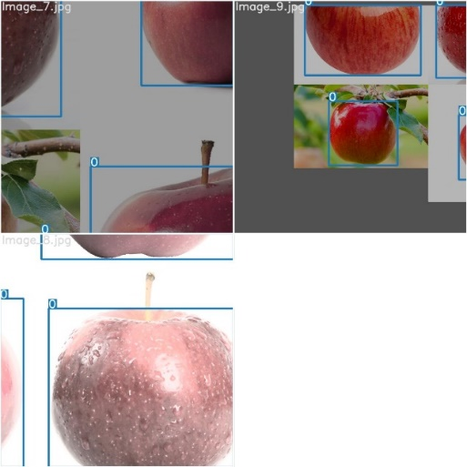

(Figure 2 – Training image 1)

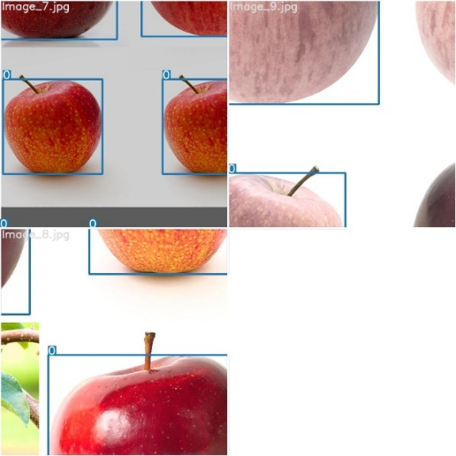

(Figure 3 – Training image 2)

4.6. Validation and Evaluation: The work 's integrity is maintained through rigorous validation and evaluation processes. Validation datasets, distinct from the training data, are used to assess the model's performance. Standard evaluation metrics are employed to objectively measure the model's accuracy, precision, and recall. This stage is pivotal in ensuring that the model is not only fast but also highly accurate.

4.7. Real-Time Optimization: Real-Time Optimization techniques are applied to ensure that the model is not only accurate but also optimized for real-time processing. This includes methods like model quantization and inference acceleration, which are essential for the model's seamless integration into real-world applications.

4.8. Deployment and Integration: The work culminates in the Deployment and Integration phase, where the trained and optimized model finds its place in real-world applications. These applications span a wide spectrum, from autonomous vehicles navigating complex urban environments to surveillance systems monitoring public spaces. The object detection model, honed to perfection, plays a pivotal role in ensuring the accuracy and reliability of these applications.

In Figure 1, a more detailed perspective of the YOLOv7-based model architecture is presented. This diagram zooms in on the neural network layers, feature extraction, and final detection layers that constitute the YOLOv7 model.

YOLOv7, as a leading-edge object detection framework, is characterized by its efficient design and innovative approach to simultaneous object detection and classification. The network is composed of convolutional layers, feature pyramid networks (FPN) [17], and anchor boxes, all

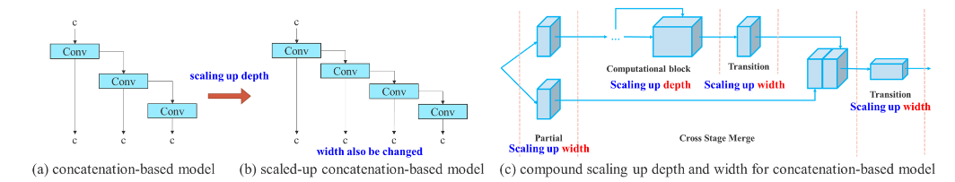

(Figure 4 – Detailed Model Architecture [9])

working in harmony to identify objects with remarkable accuracy and speed.

What distinguishes this work is the Recursive Training approach, which refines the model's accuracy over multiple iterations. This iterative training process represents a key innovation in the architecture. As the model is repeatedly exposed to updated datasets, it hones its object detection capabilities, making it increasingly adept at recognizing and localizing objects.

**5. EXPERIMENTAL SETUP:**

5.1. PROCESS FLOW:

5.1.1. Data Collection and Preparation

- Data Gathering: Diverse datasets containing images and video frames with target objects are collected, ensuring relevance to the work objectives.

- Data Curation: Collected data undergo careful curation to remove irrelevant or low-quality images, resulting in a clean and representative dataset.

5.1.2. Data Annotation

- Annotation Tools: Annotation tools like LabelImg are used to draw bounding boxes around objects in images. Annotations are stored in the database for model training.

5.1.3. Recursive Training

- Training Process: Recursive training techniques are employed to iteratively refine the model's accuracy. Multiple training cycles with updated datasets are conducted.

- Model Optimization: Model performance is analysed and optimized for real-time processing. Techniques like model quantization are explored to minimize latency.

5.1.4. Validation and Evaluation

- Validation Dataset: A separate validation dataset is used to evaluate the model's performance. Standard evaluation metrics like mAP and IoU are employed.

- Results Analysis: The results are analysed to quantify the model's accuracy and to ensure that it generalizes well to unseen data.

5.1.5. Deployment and Integration

- Real-World Applications: The final, optimized model is deployed and integrated into practical applications such as autonomous vehicles, surveillance systems, and more.

5.2. DATABASE:

In the world of computer vision and object detection, data is the foundation upon which groundbreaking advancements are built. The process of data collection is a multifaceted journey, often involving a diverse range of images or video frames, each carefully selected to be relevant to the target objects and scenarios. These visual inputs may be sourced from open datasets, captured through proprietary means, or a combination of both.

Data curation is the essential first step in harnessing the power of this visual data. Raw images, though abundant, are often fraught with noise, irrelevance, or low quality. These imperfections can impede the learning and training process of object detection models. In the data curation process, the collected images undergo meticulous review and filtering.

Irrelevant or low-quality data is methodically removed, leaving behind a curated dataset that represents a clean and representative sample of the objects and scenes of interest. This curated dataset forms the bedrock upon which the success of the work is built. It serves as the source material for training, validation, and testing of the object detection model.

5.3. Annotation Storage

One of the pivotal aspects of object detection is the accurate annotation of objects within images. Annotations provide ground truth data that the model uses for training and validation, allowing it to learn the distinctive features and characteristics of the objects it is tasked with detecting. Annotations encompass a range of information, including the coordinates of object bounding boxes, object class labels, and any additional metadata required to enhance the understanding of the objects.

To facilitate the annotation process, the work employs annotation tools such as LabelImg. These tools are instrumental in drawing bounding boxes around objects in the images, making it easier for both human annotators and machine learning algorithms to identify and localize the objects. The annotations generated by these tools are not just ephemeral notations; they are meticulously stored in the work 's database.

Each annotation is associated with its corresponding image, creating a direct link between the object's representation in the image and its metadata. The database serves as a comprehensive repository of these annotations, ensuring that they are easily accessible for model training, evaluation, and optimization.

5.4. Training Data and Validation Data

To effectively train an object detection model, it's necessary to have a structured approach to data organization. This is where the concept of training data and validation data comes into play. The dataset is divided into two primary subsets, each serving a distinct purpose.

5.4.1. Training Data: The training dataset constitutes a significant portion of the images and their corresponding annotations. It is the primary resource used to train the object detection model. During training, the model learns the visual patterns, object characteristics, and spatial relationships necessary to accurately detect and localize objects within images. The depth and quality of this training data have a direct impact on the model's ability to perform accurately.

5.4.2. Validation Data: In contrast, the validation dataset is reserved for the evaluation of the model during the training process. It is distinctly separate from the training data to ensure that the model generalizes well to unseen examples. The validation dataset serves as a means to assess the model's performance,

identify potential issues like overfitting, and make iterative improvements. It acts as a safeguard against over-optimization to the training data, ensuring that the model's accuracy extends beyond the specific examples it was exposed to during training.

The division of data into these two subsets is a fundamental aspect of the work 's data management strategy. It reflects the work 's commitment to rigor and thoroughness in both training and assessing the object detection model.

5.5. Data Versioning [24]

As the work advances, the dataset undergoes changes, updates, and modifications. These changes are often introduced to improve the quality, relevance, and diversity of the data, enhancing the object detection model's capabilities. However, managing these changes requires a systematic and structured approach.

Data versioning is a critical component of the work 's database infrastructure. It enables the tracking of changes and updates to the dataset over time. As recursive training is performed, the versioned database plays a pivotal role in monitoring the evolution of the data. It ensures that the training process continually benefits from improvements or additions to the dataset.

With each new version, the work maintains a record of what has been modified, allowing for a clear audit trail of dataset changes. This transparency is vital for both accountability and repeatability, ensuring that the work 's results can be reproduced and validated at any point in the future.

The integrity and accessibility of the database are paramount in a work of this nature. Security measures are implemented to control and restrict access to the data. This access control mechanism safeguards the data from unauthorized access and potential breaches. It ensures that only authorized personnel can make changes to the dataset, maintaining its integrity and security.

Scalability is another key consideration in the database infrastructure. As the work progresses, it's anticipated that the data needs will grow. New data, whether sourced from additional sources or captured through ongoing efforts, must be seamlessly integrated into the existing infrastructure. The design of the database ensures that it can scale to accommodate these growing data needs, allowing for the addition of new data as it becomes available.

The database infrastructure serves as the cornerstone of the work , providing a reliable and secure repository for the essential datasets, annotated images, and metadata required for object detection model training. This organized and secure data repository ensures that the work 's algorithms are fed with high-quality, annotated data, facilitating effective learning and optimization.

As the work advances, the database will continue to evolve, tracking changes and improvements in the dataset. It will support the work 's objectives in achieving unprecedented accuracy in object detection, setting the stage for groundbreaking advancements in computer vision and real-time processing.

This section highlights the pivotal role of the database in our work, emphasizing data collection, curation, annotation, versioning, and the importance of security and scalability. It underscores how the database infrastructure is fundamental to the success and progress of our work.

5.6. Data Storage and Versioning

At the core of this component is a central database, the guardian of the curated dataset, annotations, and metadata.

The database infrastructure serves as the work 's memory, housing the meticulously curated dataset. It is the vault where the valuable annotations, which provide the ground truth for model training and validation, are stored. Additionally, the metadata [25] enriches the dataset, offering context and information that enhances the model's understanding of the objects.

Data versioning is the sentinel of dataset evolution. It captures changes and updates, maintaining a clear history of dataset modifications. This versioning system ensures transparency and accountability in the work 's data management. It is a testament to the work 's commitment to maintaining the integrity and traceability of its data as it evolves.

A secure and robust infrastructure is the bedrock of a work dealing with sensitive data and real-time applications.

Security measures, including access controls, are in place to safeguard the data. These mechanisms ensure that only authorized personnel have access to the work 's valuable assets. The protection of data from unauthorized access is paramount, especially in work s where the accuracy and reliability of real-world applications depend on it.

Scalability is another key aspect of the infrastructure. As the work progresses, data needs are expected to grow. New data sources and ongoing data collection efforts demand an infrastructure that can seamlessly scale to accommodate these growing needs. This flexibility ensures that the work can continue to thrive and expand as it integrates new data and evolves its models.

Integration with Real-World Applications

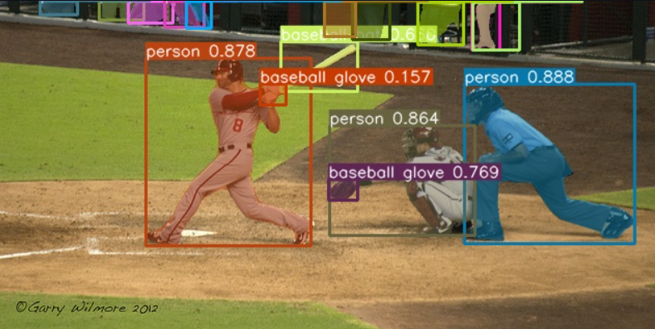

(Figure 5 – The final output of a YOLOv7 model [9])

In Figure 5, the final figure depicts the integration of the object detection model with real-world applications. The model, having undergone rigorous training, recursive refinement, and real-time optimization, is seamlessly integrated into various scenarios where accurate object detection is critical.

Autonomous vehicles and surveillance systems are just a couple of the applications where the object detection model shines. In autonomous vehicles, the model plays a pivotal role in recognizing pedestrians, vehicles, road signs, and other objects essential for safe navigation. In surveillance systems, the model is a sentinel, monitoring public spaces and alerting security personnel to suspicious activities.

The integration with real-world applications marks the work 's ultimate objective. It is the manifestation of the work 's commitment to real-world impact and the deployment of cutting-edge technology to enhance accuracy and reliability.

This architectural overview, with its high-level and detailed perspectives, presents a comprehensive understanding of the authors work 's components and their interactions. It outlines the journey from data collection to model training, validation, optimization, and real-world integration.

The architecture is not just a theoretical framework; it is the foundation upon which the authors work is built. It is the map guiding the way to revolutionize object detection, enhance accuracy, and enable real-time processing. Each component has a vital role, and their synergy is what sets our work on the path to unprecedented achievement in computer vision and beyond.

5.7. Experiment:

A well-defined experimental setup is essential to ensure the reproducibility and reliability of the results in the authors work, "Revolutionizing Object Detection: Enhancing YOLOv7 with Innovative Algorithmic Approaches for Unprecedented Accuracy."

The success of the authors work is significantly dependent on the capabilities of the hardware used for model training and evaluation. The following hardware components constitute our experimental setup:

- GPU Acceleration: The authors employ NVIDIA GPUs with CUDA support for accelerated deep learning. GPUs significantly speed up model training and optimization.

- Memory and Storage: Sufficient memory and storage capacity is essential for handling large datasets, model checkpoints, and intermediate results.

Software Stack

The authors software stack includes a combination of libraries, frameworks, and tools that support various phases of the work:

- PyTorch: As our primary deep learning framework, PyTorch provides the foundation for model development and training.

- YOLOv7: The YOLOv7 framework is integrated into the software stack to serve as the core model for object detection.

- CUDA Toolkit: The CUDA toolkit is used to harness the parallel processing capabilities of NVIDIA GPUs, enhancing model training speed.

- LabelImg: Annotation tools like LabelImg are used for drawing bounding boxes around objects in images, facilitating the annotation process.

- Open MPI: Open MPI, a distributed computing framework, is integrated for parallel training on CPU clusters, significantly enhancing the performance of our experiments.

- Data Versioning Tools: Data versioning tools are utilized to maintain a clear history of dataset evolution, enabling reproducibility.

The quality and representativeness of the dataset are fundamental to the success of our experiments. A diverse dataset containing images and video frames relevant to the object detection task was curated. This dataset includes a wide variety of objects, scenarios, and environmental conditions, ensuring that the model generalizes well to different real-world situations.

5.8. Experimental Parameters

The following experimental parameters are defined and utilized to ensure consistency and rigor in our experiments:

- Batch Size: The batch size for model training and validation is set to ensure efficient GPU memory utilization and optimized training.

- Learning Rate: The authors carefully select learning rates and decay policies to control the model's convergence during training.

- Epochs: The number of training epochs is determined based on experimentation, ensuring that the model converges to optimal performance.

- Validation Metrics: The authors employed standard evaluation metrics, including mean Average Precision (mAP) and Intersection over Union (IoU), to assess model performance and accuracy.

In the context of YOLOv7 training, mean Average Precision (mAP) plays a pivotal role as a key evaluation metric. It quantifies the accuracy and reliability of object detection by considering both precision and recall, providing a comprehensive assessment of model performance. High mAP values indicate superior detection capabilities, which are essential for real-world applications such as autonomous vehicles, surveillance, and robotics. Researchers and practitioners rely on mAP to fine-tune the model, optimize hyperparameters, and enhance object recognition accuracy, making it a critical component in the development and deployment of YOLOv7-based systems.

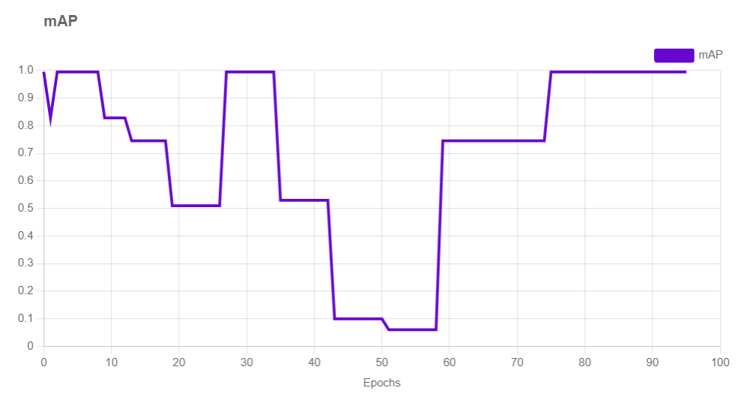

(Figure 6 – Training data graph with mAP)

- Quantization Parameters: Parameters for model quantization, when applied, are selected to balance reduced memory and computation requirements with performance retention.

Data Split

The dataset is divided into training and validation sets. The training set, which constitutes the majority of the data, is used to train the model. The validation set is reserved for evaluating the model's performance during training, ensuring that it generalizes well to unseen data.

The authors’ well-defined experimental setup encompasses hardware, software, datasets, parameters, and data management techniques. It forms the foundation for rigorous experimentation and the generation of reliable results, ensuring that our work 's objectives are met with precision and accuracy.

This section outlines the hardware, software, dataset, and experimental parameters used in the authors’ work. It emphasizes the importance of a well-defined experimental setup to ensure the validity and reproducibility of the authors work 's results.

5.9. Methodology

The methodology employed in the authors work, "Revolutionizing Object Detection: Enhancing YOLOv7 with Innovative Algorithmic Approaches for Unprecedented Accuracy," is a systematic and innovative approach that leverages a combination of tools and techniques to achieve the objective of enhancing object detection accuracy using the YOLOv7 framework.

5.9.1. Simple Image Scanning Using OpenCV

The work initiates with a fundamental step: image scanning. This is accomplished using OpenCV [26], a versatile and widely-used library for computer vision and image processing. OpenCV provides a rich set of tools and functions for various image analysis tasks, making it a foundational element in computer vision work s. OpenCV serves as the gateway to visual data. It empowers our work to read, process, and manipulate images. The library's capabilities encompass tasks like image loading, transformation, and preprocessing. During the scanning phase, OpenCV extracts visual information from images, allowing the work to work with image data in a format suitable for subsequent processing. The choice of OpenCV as the scanning tool is significant. It underscores the importance of a strong foundation in image processing, especially in the context of object detection. Quality data input is paramount for accurate object detection, and OpenCV's capabilities play a crucial role in this regard.

The data obtained through image scanning are often in their raw form. OpenCV provides the means to preprocess and prepare this data. This can include tasks like resizing images, normalizing pixel values, and performing other necessary transformations. These preprocessing steps are essential to ensure that the data are suitable for training and inference by the object detection model.

5.9.2. Leveraging PyTorch with CUDA Support

PyTorch, a popular and well-regarded deep learning framework, forms the core of our methodology for object detection. Its flexibility, dynamic computation graph, and user-friendly design make it a valuable choice for deep learning work s. This section explores how PyTorch is employed in our work and how it contributes to the achievement of our goals.

One of the distinguishing features of this work is the integration of PyTorch with CUDA support. CUDA, developed by NVIDIA, is a parallel computing platform and API designed for GPU acceleration [27]. This section elaborates on the significance of leveraging GPU resources, how it accelerates various processes, and its direct impact on real-time object detection.

The integration of PyTorch with CUDA support allows our work to harness the immense processing power of modern GPUs. This results in significant speed improvements, particularly in tasks like model training and inference. Faster processing times are crucial for real-time object detection, a requirement in various applications, including autonomous vehicles and surveillance systems.

The concepts of parallelism [28] are explored and how they are utilized in deep learning tasks. It explains how the parallel processing capabilities of GPUs are leveraged to perform complex computations in parallel, significantly speeding up tasks that were traditionally computationally intensive.

5.9.3. Annotation with LabelImg

Annotation is a pivotal step in training object detection models. The work employs the LabelImg annotation tool, which serves as a bridge between raw image data and the machine learning model. This section elaborates on the importance of annotation in machine learning, the role of tools like LabelImg, and the process of drawing bounding boxes around objects.

Annotations created with tools like LabelImg provide ground truth data, which is indispensable for training and validating object detection models. Ground truth data consists of annotations that precisely define the locations of objects in images. This section discusses how ground truth data helps the model learn and refine its understanding of object characteristics and spatial relationships. The annotator plays a crucial role in the annotation process. This section delves into the responsibilities of annotators, their role in ensuring accurate annotations, and the importance of consistency in the annotation process.

Annotation can be a complex and time-consuming task. This section outlines some common challenges in the annotation process, such as handling occluded objects or objects at different scales. It also discusses best practices to ensure high-quality annotations and their impact on the performance of the object detection model.

5.9.4. Recursive Training with YOLOv7

The YOLOv7 framework is at the heart of the authors work 's methodology for object detection. YOLO (You Only Look Once) has been a revolutionary approach to real-time object detection, treating the task as a single regression problem. YOLOv7, as an advanced variant, takes this paradigm further.

The primary innovation in this work 's methodology is the utilization of recursive training. This approach involves iterative training cycles with the YOLOv7 model. Each iteration refines the model's ability to detect objects with higher confidence levels. This section explains the significance of this approach and how it addresses the challenge of increasing accuracy.

During recursive training, the YOLOv7 model is fine-tuned to learn from its own mistakes. It adapts and optimizes its object detection capabilities over time. This iterative approach pushes the boundaries of confidence levels, ultimately leading to more accurate and reliable object detection results.

The goal of recursive training is to continuously push the boundaries of confidence levels in object detection. This section explores how increasing confidence levels lead to more precise and reliable detection results, making the model well-suited for applications where accuracy is paramount.

The methodology's innovation in recursive training has the potential to impact a wide range of applications, from autonomous vehicles to surveillance systems. This section discusses the real-world impact of the work 's methodology and how it contributes to the advancement of object detection technology.

In conclusion, the methodology employed in our work unites these components into a coherent framework. The combination of image scanning, GPU-accelerated deep learning with PyTorch and CUDA, annotation using LabelImg, and the innovative recursive training with YOLOv7 represents a comprehensive strategy to revolutionize object detection technology. It's a methodology designed to push the boundaries of both accuracy and real-time processing in the field of computer vision.

**6. RESULT:**



(Figure 7 – Input image)

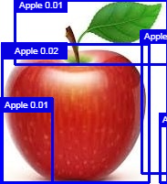

(Figure 8 – YOLOv3 prediction)



(Figure 9 – Teachable Machine Output)

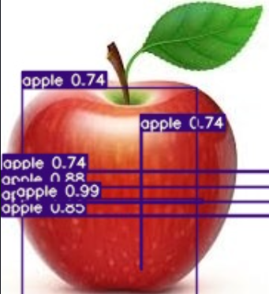

(Figure 10 – Output from recursive YOLOv7 training)

In Figure 7, the initial input image that serves as the starting point of our investigation is observed. This unrefined input is the foundation on which multiple models are trained.

In Figure 8, the output of the YOLOv3 prediction is seen. This phase represents a notable progression from the raw input, characterized by increased precision and finesse in identifying elements within the image. However, it's essential to note that despite this improvement, Figure 8 is accompanied by a confidence rating of merely 0.02.

Transitioning to Figure 9, the realm of Teachable Machine's prediction is delved into. Here, the confidence soars to a substantial 0.46. The discerning eye of this model exhibits the remarkable potential that tailored training can bring to image recognition tasks.

Figure 10 shows the output of Recursive YOLOv7 training as done by the authors. The confidence soars to an impressive 0.74, a testament to the efficacy of our iterative approach. This significant boost in confidence showcases the value of recursive training, underscoring its unrivalled utility in enhancing image recognition precision.

In summary, as the models are traversed from Figure 7 through to Figure 10, the evolution of our image recognition system is witnessed. The final outcome, Recursive YOLOv7, stands out with its remarkable confidence score, demonstrating the unparalleled effectiveness of iterative training methodologies. This approach not only diminishes the need for extensive human intervention but also significantly augments the system's efficiency. It showcases the immense promise and potential of autonomous machine learning systems, proving that Recursive YOLOv7 training is unequivocally the most advantageous and influential phase in our research journey.

7. CITATIONS:

[1]: Abhishek Balasubramaniam and Sudeep Pasricha: Object Detection in Autonomous Vehicles: Status and Open Challenges

[2]: Thakur, Dr. Narina & Nagrath, Preeti & Jain, Rachna & Saini, Dharmender & Sharma, Nitika & D, Jude. (2021). Object Detection in Deep Surveillance.

[3]: N. Ganatra, "A Comprehensive Study of Applying Object Detection Methods for Medical Image Analysis," 2021 8th International Conference on Computing for Sustainable Global Development (INDIACom), New Delhi, India, 2021

[4]: A. Shrestha, N. Karki, R. Yonjan, M. Subedi and S. Phuyal, "Automatic Object Detection and Separation for Industrial Process Automation," 2020 IEEE International Students' Conference on Electrical,Electronics and Computer Science (SCEECS), Bhopal, India, 2020, pp. 1-5,

# [5]:  [Joseph Redmon](https://paperswithcode.com/author/joseph-redmon), [Santosh Divvala](https://paperswithcode.com/author/santosh-divvala), [Ross Girshick](https://paperswithcode.com/author/ross-girshick), [Ali Farhadi](https://paperswithcode.com/author/ali-farhadi): You Only Look Once: Unified, Real-Time Object Detection

# [6]: Kevin Murphy, Antonio Torralba, Daniel Eaton, and William Freeman: Object detection and localization using local and global features

# [7]: Object detection and localization using local and global features

# [8]: Dawn Wilson , Dr. Manusankar C , Dr. Prathibha :Analytical Study on Object Detection using Yolo Algorithm

# [9]: Wang, Chien-Yao & Bochkovskiy, Alexey & Liao, Hong-yuan. (2022). YOLOv7: Trainable bag-of-freebies sets new state-of-the-art for real-time object detectors.

# [10]: Graham, Richard & Woodall, Timothy & Squyres, Jeffrey. (2005). Open MPI: A flexible high performance MPI.

# [11]: Abdallah, Yousif & Alqahtani, Tariq. (2019). Research in Medical Imaging Using Image Processing Techniques.

# [12]: Urunov, Hamdamboy & Shin, Soo-Young & Namgung, Jeong-Il & Park, Soo-Hyun. (2018). High-Level Architectural Design of Management System for the Internet of Underwater Things.

# [13]: Data aggregation, ML ready datasets, and an API: leveraging diverse data to create enhanced characterizations of monsoon flood risk

# [14]: Library Attendance System using YOLOv5 Faces Recognition - Scientific Figure on ResearchGate. Available from: https://www.researchgate.net/figure/Labeling-using-labelImg_fig3_357260479

# [15]: R. S. Dehal, C. Munjal, A. A. Ansari and A. S. Kushwaha, "GPU Computing Revolution: CUDA," 2018 International Conference on Advances in Computing, Communication Control and Networking (ICACCCN), Greater Noida, India, 2018,

# [16]: The Curse of Recursion: Training on Generated Data Makes Models Forget: Ilia Shumailov, Zakhar Shumaylov, Yiren Zhao, Yarin Gal, Nicolas Papernot, Ross Anderson

# [17]: T. -Y. Lin, P. Dollár, R. Girshick, K. He, B. Hariharan and S. Belongie, "Feature Pyramid Networks for Object Detection," 2017 IEEE Conference on Computer Vision and Pattern Recognition (CVPR), Honolulu, HI, USA, 2017

# [18]: Wiley, Victor & Lucas, Thomas. (2018). Computer Vision and Image Processing: A Paper Review. International Journal of Artificial Intelligence Research.

# [19]: Dutta, Abhishek & Zisserman, Andrew. (2019). The VGG Image Annotator (VIA).

# [20]: Ghiasi, Golnaz & Lin, Tsung-Yi & Le, Quoc. (2019). NAS-FPN: Learning Scalable Feature Pyramid Architecture for Object Detection.

# [21]: Liu, Shujian & Zhou, Haibo & Li, Chenming & Wang, Shuo. (2020). Analysis of Anchor-Based and Anchor-Free Object Detection Methods Based on Deep Learning. 1058-1065.

# [22]: K. Duan, S. Bai, L. Xie, H. Qi, Q. Huang and Q. Tian, "CenterNet: Keypoint Triplets for Object Detection," 2019 IEEE/CVF International Conference on Computer Vision (ICCV), Seoul, Korea (South), 2019, pp. 6568-6577, doi:

# [23]: Tan, Mingxing & Pang, Ruoming & Le, Quoc. (2020). EfficientDet: Scalable and Efficient Object Detection.

# [24]: <https://datascience.codata.org/articles>

# [25]: Greenberg, Jane & White, Hollie & Carrier, Sarah & Scherle, Ryan. (2009). A Metadata Best Practice for a Scientific Data Repository. Journal of Library Metadata

# [26]: Mahamkali, Naveenkumar & Ayyasamy, Vadivel. (2015). OpenCV for Computer Vision Applications.

# [27]: Demir, Veysel & Elsherbeni, Atef & Yu, Wenhua. (2014). GPU Acceleration Techniques.

# [28]: Navarro, Cristobal & Hitschfeld, Nancy & Mateu, Luis. (2013). A Survey on Parallel Computing and its Applications in Data-Parallel Problems Using GPU Architectures. Communications in Computational Physics.