Standard Operating Procedure
OpenShift Logging with LokiStack
Junior-Friendly Installation and Validation Guide

Document Owner | DevOps / Platform Team
Platform | OpenShift Container Platform
Logging Stack | Red Hat OpenShift Logging + Loki Operator + Cluster Observability Operator
Object Storage | MinIO / S3-compatible bucket
Validated Scenario | Application logs visible in OpenShift Console > Observe > Logs
Document Version | v1.0

Important: This SOP is intentionally simple. It captures the working setup from our implementation and can be reused by junior engineers for dev, test, and similar environments. Replace all environment-specific values before running commands.

Table of Contents
- 1. Purpose
- 2. What We Installed
- 3. Simple Architecture Flow
- 4. Prerequisites
- 5. UI Installation Steps
- 6. MinIO Bucket Preparation
- 7. LokiStack Creation
- 8. ClusterLogForwarder Configuration
- 9. Enable Logs in Console
- 10. Validation Steps
- 11. Pod and PVC Explanation
- 12. Troubleshooting
- 13. Production Recommendations
- 14. Rollback / Safe Removal
- 15. Appendices - YAML and Commands
- 16. References

1. Purpose
This document explains how to set up Loki-based logging on OpenShift Container Platform (OCP) using the Loki Operator, Red Hat OpenShift Logging Operator, Cluster Observability Operator, and MinIO/S3 object storage. It also explains how the logs flow from an application pod to the OpenShift Console.
The SOP is based on the actual implementation and troubleshooting performed in our environment. The final working validation was application logs visible under OpenShift Console > Observe > Logs.
Caution: For production, do not keep the setup on demo sizing. Use Red Hat-supported sizing after capacity planning. For dev/test validation, demo sizing may be used when resources are limited.

2. What We Installed
Component | Where/Namespace | Purpose
Loki Operator | openshift-operators-redhat or via OperatorHub | Creates and manages LokiStack components.
Red Hat OpenShift Logging Operator | openshift-logging | Creates collector/Vector and manages ClusterLogForwarder.
Cluster Observability Operator | openshift-cluster-observability-operator | Provides the logging UI plugin for OpenShift Console.
MinIO bucket | External MinIO server | S3-compatible object storage for Loki log chunks and index data.
LokiStack | openshift-logging | Actual Loki backend: gateway, distributor, ingester, querier, compactor, index gateway.
ClusterLogForwarder | openshift-logging | Defines which logs are forwarded to Loki.
UIPlugin / logging-view-plugin | Cluster-scoped Console plugin | Shows logs in OpenShift Console > Observe > Logs.

3. Simple Architecture Flow
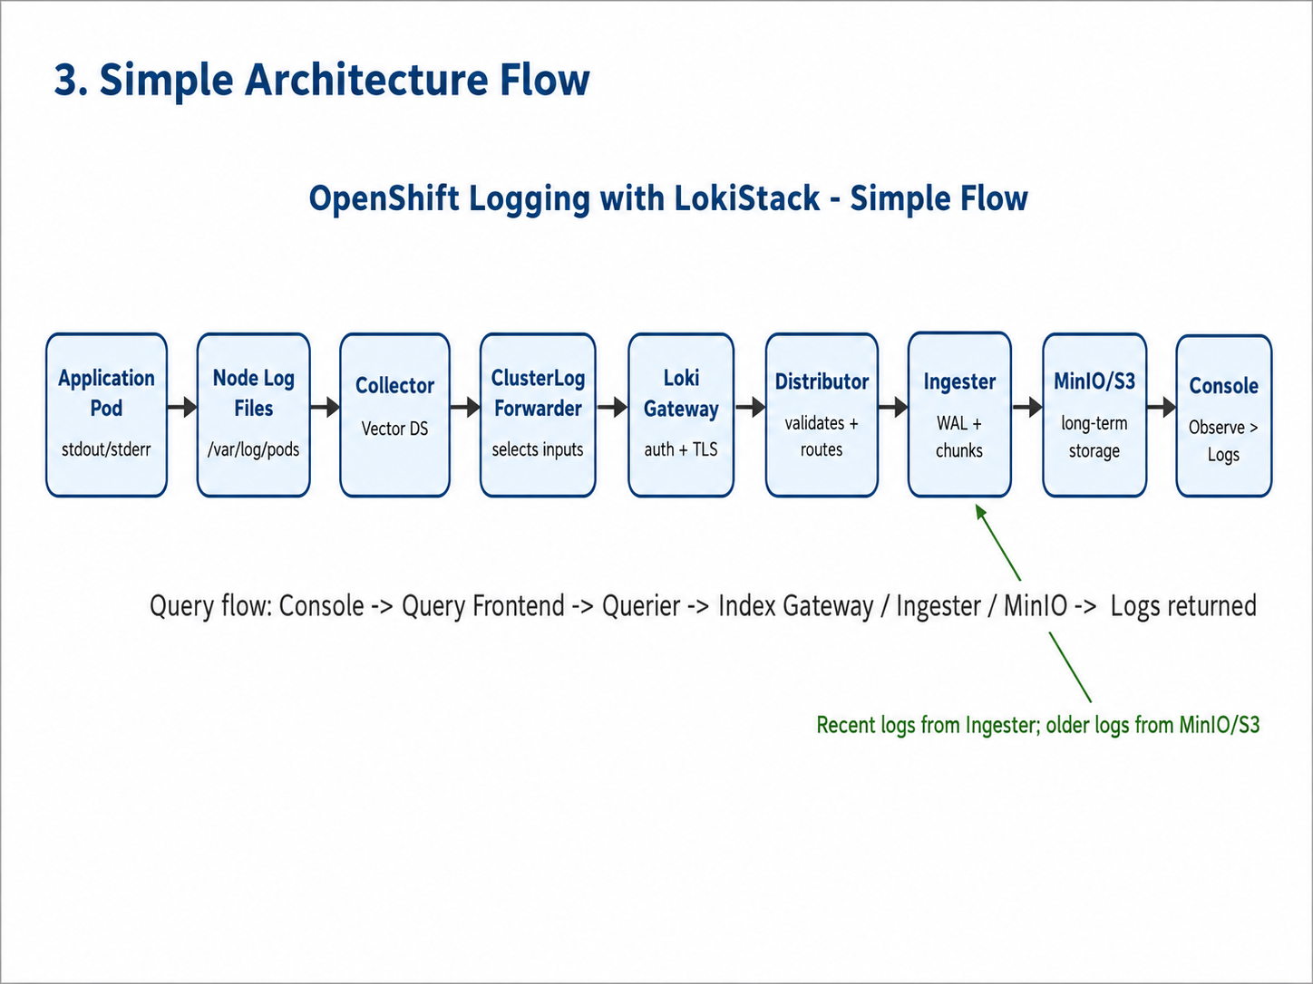
Figure 1: End-to-end application log flow from pod to OpenShift Console
The working flow is:
- Application pod writes logs to stdout/stderr.
- Kubernetes stores those logs on the node under /var/log/pods and /var/log/containers.
- Collector pods read the node log files.
- ClusterLogForwarder decides which logs are forwarded.
- Logs are sent securely to Loki Gateway.
- Distributor validates the logs and sends them to Ingester.
- Ingester uses WAL/PVC for temporary safety and flushes log chunks to MinIO/S3.
- OpenShift Console queries Loki using the Logging UI plugin.

4. Prerequisites
Requirement | Example / Notes
OCP access | cluster-admin access with oc CLI.
Storage class | A working RWO storage class for Loki PVCs, for example thin-csi.
Object storage | MinIO/S3 endpoint, bucket, access key, secret key.
Operators | Loki Operator, OpenShift Logging Operator, Cluster Observability Operator.
Node capacity | Enough CPU and memory for Loki pods. Demo size uses less resources; production size needs more.
Network | OCP cluster must reach the MinIO/S3 endpoint.
Console access | Admin access to OpenShift Console for OperatorHub and Observe > Logs validation.

# Basic pre-check commands
oc version
oc get nodes -o wide
oc get sc
oc get pods -n openshift-logging
oc get csv -A | egrep -i "loki|logging|observability"

5. UI Installation Steps
For junior engineers, the simplest way to install the required operators is from OpenShift Console > Operators > OperatorHub. CLI examples are also included later for repeatable automation.

5.1 Install Loki Operator from UI
- Login to OpenShift Console as a cluster administrator.
- Go to Operators > OperatorHub.
- Search for Loki Operator.
- Select the Red Hat Loki Operator.
- Choose the supported stable channel matching your OpenShift Logging version.
- Click Install and wait until the operator status is Succeeded.
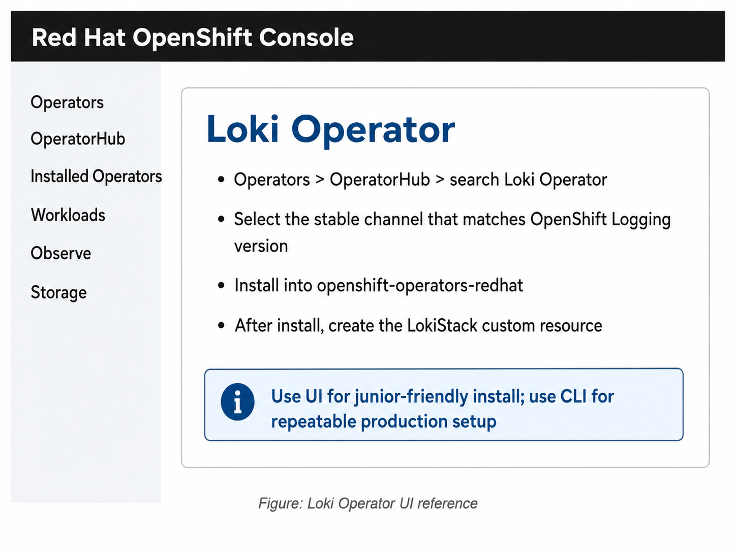
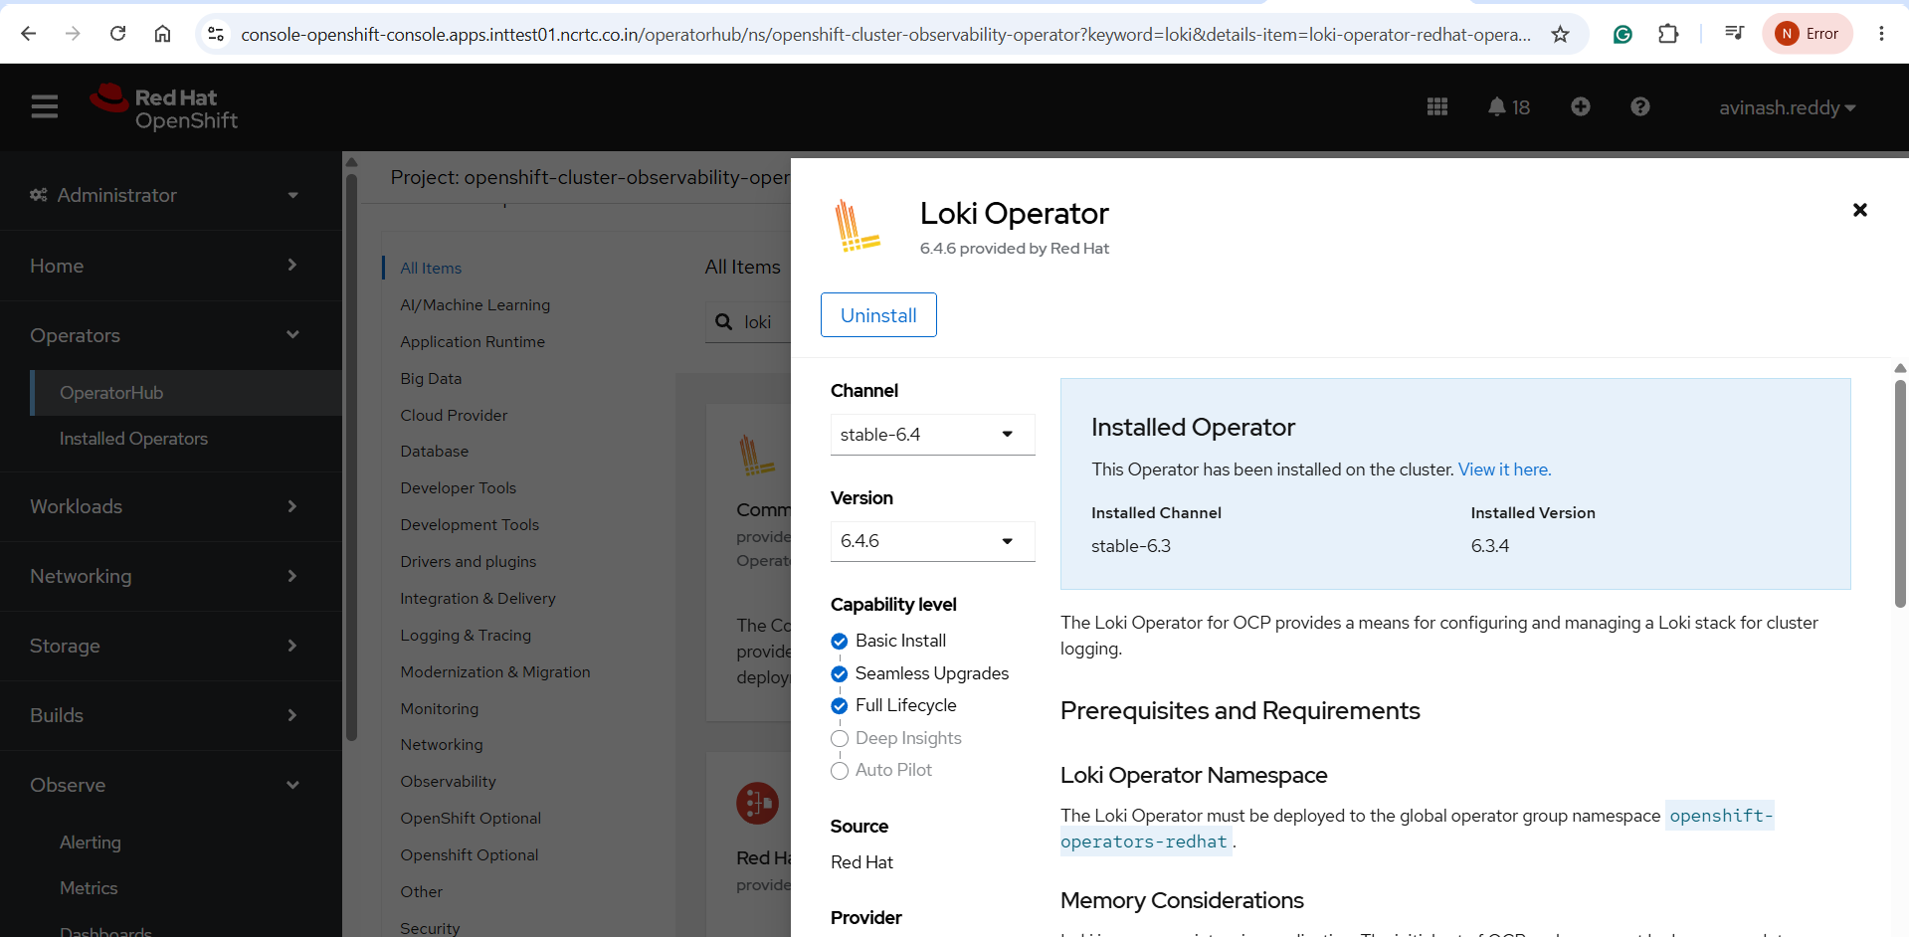
Figure 2: Loki Operator UI reference for junior engineers

5.2 Install Red Hat OpenShift Logging Operator from UI
- Go to Operators > OperatorHub.
- Search for Red Hat OpenShift Logging.
- Select the supported channel matching the Loki Operator version.
- Install it in openshift-logging or the recommended namespace shown by OperatorHub.
- Verify the installed operator status is Succeeded.

5.3 Install Cluster Observability Operator from UI
- Go to Operators > OperatorHub.
- Search for Cluster Observability Operator.
- Install the Red Hat operator.
- Wait for all pods under openshift-cluster-observability-operator to become Running.
- This operator is required for the Observe > Logs UI experience.
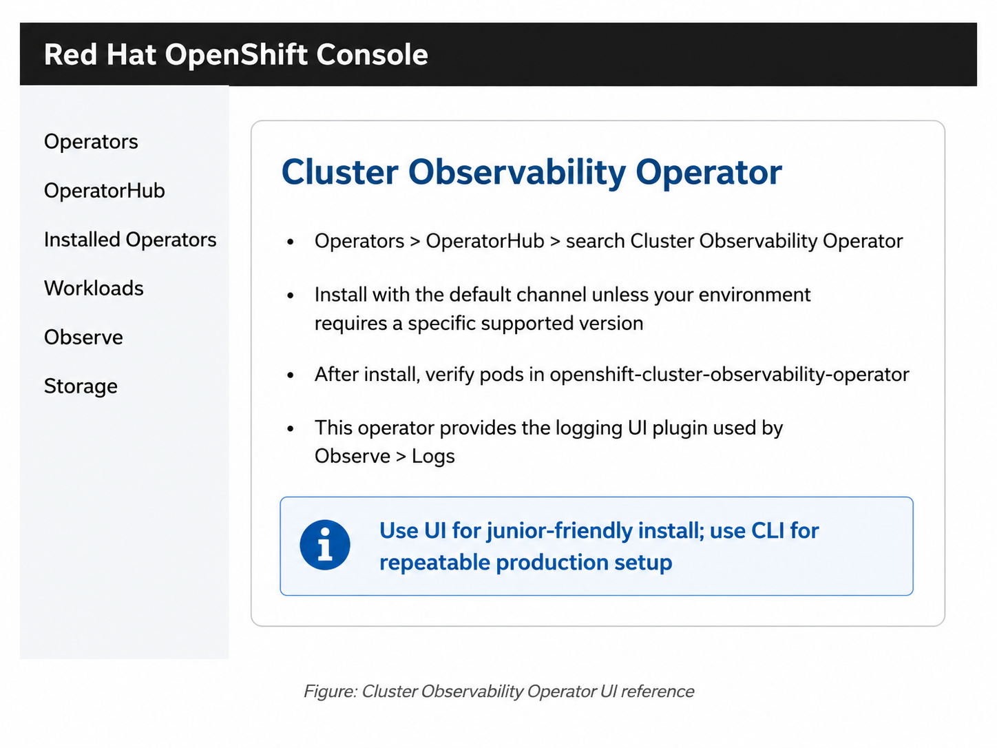
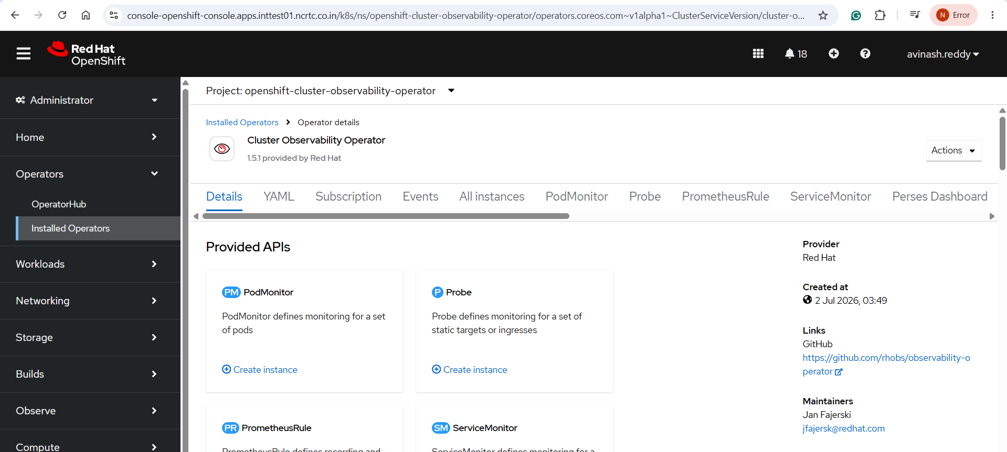
Figure 3: Cluster Observability Operator UI reference

6. MinIO Bucket Preparation
Loki uses object storage as the main backend for log chunks and index data. In our validated setup, MinIO was used as an S3-compatible object storage backend.
Note: MinIO is not the same as the Loki PVC. PVCs are used by stateful Loki pods for local WAL and working data. MinIO stores the actual Loki log data for long-term retrieval.
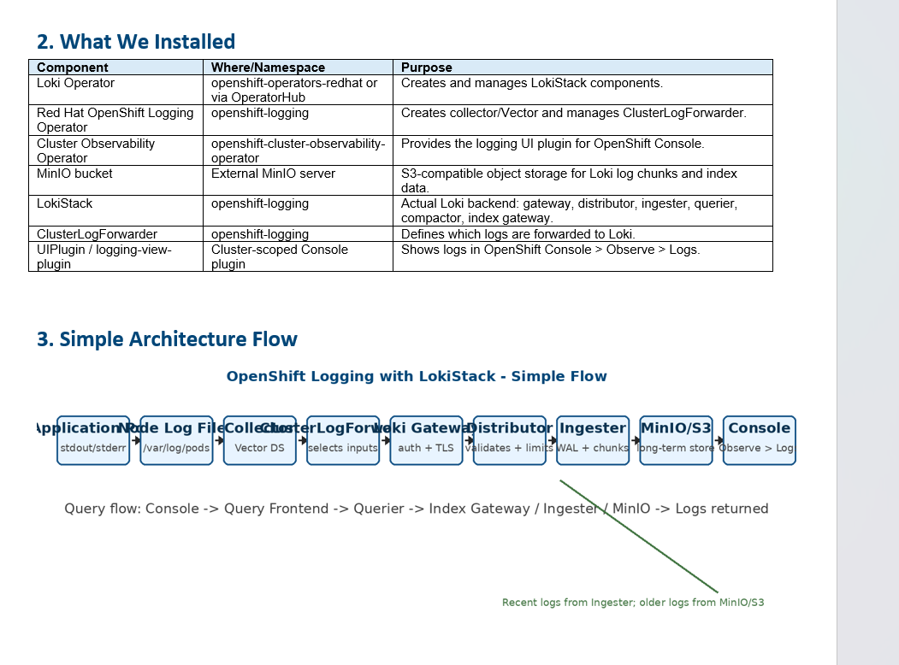
Figure 4: MinIO bucket showing Loki-created paths such as application, audit, index, and infrastructure

6.1 Create bucket in MinIO UI
- Open MinIO Console.
- Go to Object Browser or Buckets.
- Create a bucket for Loki, for example test-ocp-logging-loki.
- Keep the bucket private.
- Create or use an access key with permission to read and write this bucket.
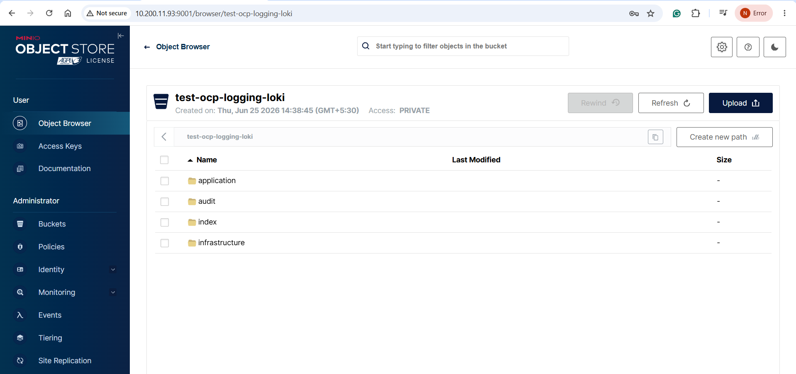
# Example values used in our environment
MinIO API endpoint: http://10.200.11.93:9000
MinIO Console: http://10.200.11.93:9001
Bucket: test-ocp-logging-loki
Secret name: logging-loki-s3
# Create Loki S3 secret in openshift-logging
oc create secret generic logging-loki-s3 -n openshift-logging --from-literal=access_key_id='<ACCESS_KEY>' --from-literal=access_key_secret='<SECRET_KEY>' --from-literal=bucketnames='test-ocp-logging-loki' --from-literal=endpoint='http://10.200.11.93:9000' --from-literal=region='us-east-1'
oc get secret logging-loki-s3 -n openshift-logging

7. Create LokiStack
The LokiStack custom resource tells the Loki Operator what size to deploy, which storage class to use for PVCs, and which object storage secret to use.
Caution: In our environment, 1x.demo was used only after CPU and memory constraints blocked larger ingester scheduling. For production, plan resources and use a supported production size.
cat <<'EOF' | oc apply -f -
apiVersion: loki.grafana.com/v1
kind: LokiStack
metadata:
name: logging-loki
namespace: openshift-logging
spec:
managementState: Managed
size: 1x.demo
storage:
schemas:
- version: v13
effectiveDate: "2026-06-25"
secret:
name: logging-loki-s3
type: s3
storageClassName: thin-csi
tenants:
mode: openshift-logging
EOF
# Verify LokiStack
oc get lokistack logging-loki -n openshift-logging
oc describe lokistack logging-loki -n openshift-logging
oc get pods -n openshift-logging | egrep -i 'loki|ingester'
oc get pvc -n openshift-logging | grep loki

7.1 Optional: Schedule Loki on infra nodes
If infra nodes are used for platform workloads, patch LokiStack templates with nodeSelector and tolerations. This was required in our environment because worker nodes had insufficient CPU and infra nodes had taints.
oc patch lokistack logging-loki -n openshift-logging --type=json -p='[
{"op":"add","path":"/spec/template","value":{}},
{"op":"add","path":"/spec/template/ingester","value":{
"nodeSelector":{"node-role.kubernetes.io/infra":""},
"tolerations":[
{"key":"node-role.kubernetes.io/infra","operator":"Equal","value":"reserved","effect":"NoSchedule"},
{"key":"node-role.kubernetes.io/infra","operator":"Equal","value":"reserved","effect":"NoExecute"}
]
}}
]'
# If JSON add fails because template already exists, use oc edit lokistack logging-loki -n openshift-logging.

8. Configure Log Collector and ClusterLogForwarder
The collector service account requires permissions to collect and write logs. For the initial validation, we forwarded application logs only. This avoided audit rate-limit and old infrastructure timestamp issues.
# Create service account if needed
oc get sa logcollector -n openshift-logging || oc create sa logcollector -n openshift-logging
# Required for application logs
oc adm policy add-cluster-role-to-user collect-application-logs system:serviceaccount:openshift-logging:logcollector
oc adm policy add-cluster-role-to-user cluster-logging-write-application-logs system:serviceaccount:openshift-logging:logcollector
Important: Do not enable audit and infrastructure logs in the first validation if Loki is small or the cluster has heavy audit logs. Start with application logs, prove the flow, then tune and expand.
cat <<'EOF' > clf-app-only.yaml
apiVersion: observability.openshift.io/v1
kind: ClusterLogForwarder
metadata:
name: collector
namespace: openshift-logging
spec:
serviceAccount:
name: logcollector
outputs:
- name: lokistack
type: lokiStack
lokiStack:
target:
name: logging-loki
namespace: openshift-logging
authentication:
token:
from: serviceAccount
tls:
ca:
configMapName: logging-loki-gateway-ca-bundle
key: service-ca.crt
pipelines:
- name: app-logs-to-loki
inputRefs:
- application
outputRefs:
- lokistack
EOF
oc apply -f clf-app-only.yaml
oc describe clusterlogforwarder collector -n openshift-logging
Caution: TLS must be configured under outputs[].tls, not inside lokiStack.tls. In our troubleshooting, lokiStack.tls did not persist in the final resource and collectors continued to fail TLS validation.

9. Enable Logs in OpenShift Console
The Loki route is not a dashboard. Logs are viewed through OpenShift Console after enabling the Logging UI plugin from the Cluster Observability Operator.
cat <<'EOF' | oc apply -f -
apiVersion: observability.openshift.io/v1alpha1
kind: UIPlugin
metadata:
name: logging
spec:
type: Logging
logging:
lokiStack:
name: logging-loki
logsLimit: 50
timeout: 30s
schema: viaq
EOF
oc get uiplugin
oc get consoleplugin
# Enable logging-view-plugin in Console
oc patch consoles.operator.openshift.io cluster --type merge -p '{"spec":{"plugins":["monitoring-plugin","networking-console-plugin","logging-view-plugin"]}}'
oc get co console

10. Validation Steps
- Confirm LokiStack is Ready.
- Confirm collector pods are Running.
- Create a test namespace and pod that prints logs.
- Check oc logs output.
- Open OpenShift Console > Observe > Logs.
- Select Last 30 minutes, Log type application, namespace log-test.
- Search for loki migration test log.
oc delete project log-test --ignore-not-found=true
oc new-project log-test
oc run loki-test --image=registry.access.redhat.com/ubi9/ubi --restart=Never -- /bin/bash -c 'for i in {1..200}; do echo "loki migration test log $i"; sleep 2; done'
oc logs loki-test -n log-test

11. Pod and PVC Explanation
Pod/Component | Stateful? | PVC? | Use
collector-* | No | No | Runs as DaemonSet on nodes, reads container log files and forwards logs.
logging-loki-gateway-* | No | No | Secure entry point for collectors and console queries. Handles auth/TLS/tenant routing.
logging-loki-distributor-* | No | No | Receives write requests, validates timestamps/labels, applies rate limits, sends to ingester.
logging-loki-ingester-0 | Yes | Yes | Receives logs, writes WAL, creates chunks, flushes to MinIO/S3.
logging-loki-compactor-0 | Yes | Usually yes | Compacts indexes and handles retention/deletion work.
logging-loki-index-gateway-0 | Yes | Profile-dependent | Helps queriers find indexes/chunks.
logging-loki-querier-* | No | No | Reads logs from ingester and object storage.
logging-loki-query-frontend-* | No | No | Optimizes, queues and splits console queries.

11.1 What is MinIO used for?
MinIO is the S3-compatible storage backend. Loki stores log chunks and index data there. After logs are accepted by the ingester, the data is eventually flushed into the MinIO bucket. That is why the bucket shows paths such as application, audit, index, and infrastructure.

11.2 What are PVCs used for?
PVCs are local persistent volumes for stateful Loki components. The most important PVCs are ingester WAL and storage PVCs. WAL means Write Ahead Log. It protects logs during pod restart before data is flushed to MinIO.
# Check actual PVCs
oc get pvc -n openshift-logging | grep loki
# Describe an ingester pod to see PVC mounts
oc describe pod logging-loki-ingester-0 -n openshift-logging

12. Troubleshooting
Issue | What we saw | Fix
Operator channel mismatch | Loki Operator channel stable failed or did not match required version. | Use the supported channel matching OpenShift Logging version, for example stable-6.3 in our setup.
COO pods Pending | Insufficient CPU on workers and infra taints. | Patch subscription/deployments with infra nodeSelector and tolerations or add capacity.
Loki ingester Pending | Insufficient CPU/memory, wrong selector, taints. | Move to infra nodes, add memory, or use smaller size only for dev/test.
No Logs tab | logging-view-plugin missing. | Install Cluster Observability Operator, create UIPlugin, patch Console plugins.
No datapoints found | Collector not writing or wrong filters. | Check collector logs, CLF, LokiStack Ready, and test fresh application logs.
TLS certificate verify failed | Collector did not trust Loki gateway certificate. | Use output-level tls.ca with Loki gateway CA bundle.
400 Bad Request | Old infrastructure timestamps rejected. | Start with application-only pipeline; clean/tune infrastructure later.
429 Too Many Requests | Audit logs exceeded Loki ingestion rate. | Do not enable audit initially; tune ingestion limits or reduce audit volume.
500 Internal Server Error | Loki rejected writes due backend/limits/stale logs. | Inspect distributor logs and keep initial pipeline application-only.

# Useful troubleshooting commands
oc describe lokistack logging-loki -n openshift-logging
oc get pods -n openshift-logging | egrep -i 'collector|loki'
oc describe clusterlogforwarder collector -n openshift-logging
for p in $(oc get pods -n openshift-logging -o name | grep collector); do
echo "===== $p ====="
oc logs -n openshift-logging $p --tail=100 | egrep -i 'error|warn|certificate|tls|400|429|500|loki' || true
done
oc logs -n openshift-logging -l app.kubernetes.io/component=distributor --tail=150

13. Production Recommendations
- Do not use 1x.demo in production. It is suitable only for dev/test validation.
- Size Loki based on daily log volume, query load, retention, and node capacity.
- Use dedicated infra nodes for platform logging workloads if available.
- Keep application logs enabled first. Add infrastructure logs after testing. Add audit logs only after rate-limit planning.
- Configure retention and bucket lifecycle policies before production go-live.
- Monitor Loki PVC usage, WAL usage, MinIO bucket usage, distributor errors, and collector errors.
- Keep the old Elasticsearch/Kibana stack until Loki is fully validated and the client/team signs off.
- Store YAML files and SOP in Git for repeatability.

14. Rollback / Safe Removal
Rollback should be planned before migration. Do not remove the old logging stack until Loki validation is complete.
# Disable logging UI plugin if required
oc patch consoles.operator.openshift.io cluster --type merge -p '{"spec":{"plugins":["monitoring-plugin","networking-console-plugin"]}}'
# Remove UIPlugin if required
oc delete uiplugin logging --ignore-not-found=true
# Keep backups of all CRs before changing or deleting anything
oc get lokistack logging-loki -n openshift-logging -o yaml > lokistack-backup.yaml
oc get clusterlogforwarder collector -n openshift-logging -o yaml > clf-backup.yaml

15. Final Checklist
Check | Command / Action | Status
Loki Operator installed | oc get csv -A | grep -i loki
OpenShift Logging Operator installed | oc get csv -A | grep -i logging
Cluster Observability Operator installed | oc get pods -n openshift-cluster-observability-operator
MinIO bucket created | Check MinIO UI bucket
S3 secret created | oc get secret logging-loki-s3 -n openshift-logging
LokiStack Ready | oc describe lokistack logging-loki -n openshift-logging
Collector Running | oc get pods -n openshift-logging | grep collector
CLF Ready | oc describe clusterlogforwarder collector -n openshift-logging
UIPlugin created | oc get uiplugin
Console plugin enabled | oc get consoleplugin
Application logs visible | Observe > Logs > namespace log-test

16. References
- Red Hat OpenShift Logging 6.3 - Installing Logging: https://docs.redhat.com/en/documentation/red_hat_openshift_logging/6.3/html/installing_logging/installing-logging
- Red Hat OpenShift Logging 6.3 - Configuring Logging: https://docs.redhat.com/en/documentation/red_hat_openshift_logging/6.3/html-single/configuring_logging/index
- Red Hat Cluster Observability Operator - Logging UI Plugin: https://docs.redhat.com/en/documentation/red_hat_openshift_cluster_observability_operator/1-latest/html/ui_plugins_for_red_hat_openshift_cluster_observability_operator/logging-ui-plugin
- Grafana Loki Components: https://grafana.com/docs/loki/latest/get-started/components/
- Grafana Loki WAL: https://grafana.com/docs/loki/latest/operations/storage/wal/

