**Assignment 1:**

* Enabled kubernetes in Docker Desktop:

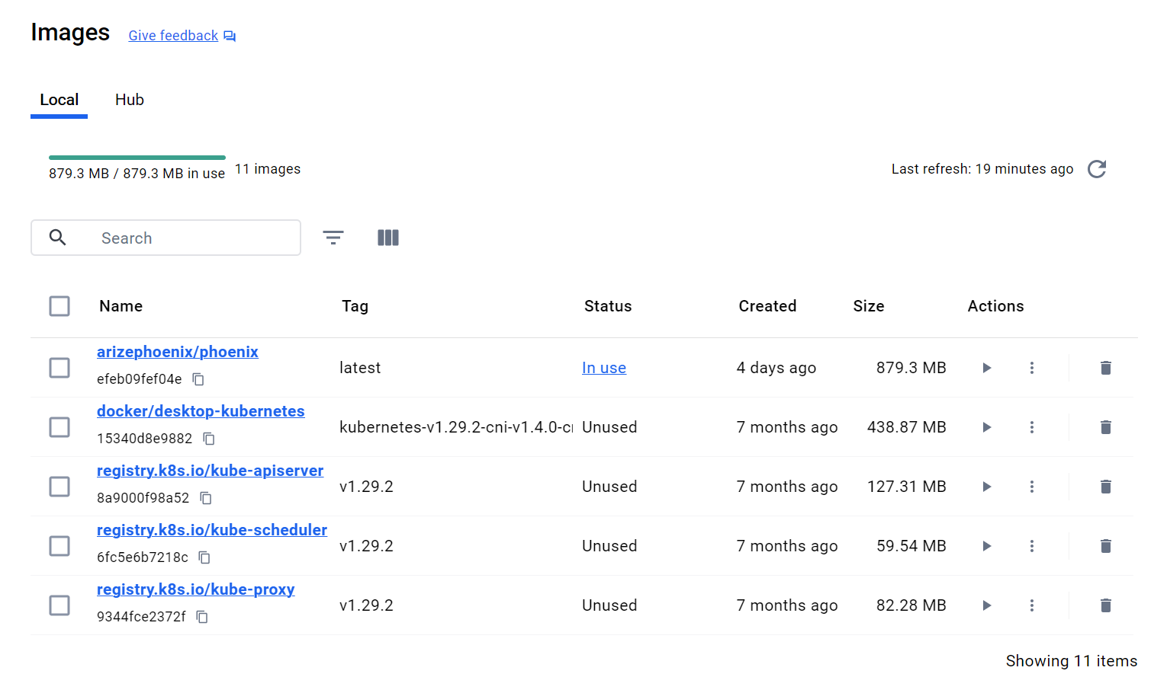

1. **Set Up Your Kubernetes Environment**:

2. **Create a Pod Using the Imperative Method**:

3. **Access the Pod:**

4. **Create a Deployment Using the Declarative Method:**



5. **Scaling the Deployment:**



6. **Clean Up Resources:**

**Assignment 2:**

1. **Create a Secret:**

2. **Create a Persistent Volume and Persistent Volume Claim:**

3. **Create a Deployment Using the PVC and Secret:**

4. **Access the Pods to Verify Configuration:**

5. **Clean Up Resources:**

