Annexure3b- Complete filing

INVENTION DISCLOSURE FORM

- TITLE: NyayaPacket Secure Evidence & Case Intake Station for Source-Aware AI-Assisted Legal Case Preparation

- INTERNAL INVENTOR(S)/ STUDENT(S): All fields in this column are mandatory to be filled

A. Full name | Dr. Navneet Kaur
Mobile Number | 9463438612
Email (personal) | navneetphul@gmail.com
UID/Registration number | 24950
Address of Internal Inventors | Lovely Professional University, Punjab-144411, India
Signature (Mandatory) | 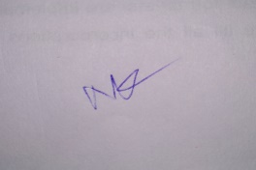
B. Full name | Aniket Kumar
Mobile Number | 7209808821
Email (personal) | aniket.kr2103@gmail.com
UID/Registration number | 12308729
Address of Internal Inventors | Lovely Professional University, Punjab-144411, India
Signature (Mandatory) | 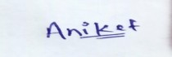
C. Full name | Khushboo Gupta
Mobile Number | 9104619162

Email (personal) | Khushboogupta9104@gmail.com
UID/Registration number | 12413158
Address of Internal Inventors | Lovely Professional University, Punjab-144411, India
Signature (Mandatory) | 
D. Full name | Aditya Raj
Mobile Number | 8709468317
Email (personal) | adityaraj76666@gmail.com
UID/Registration number | 12310345
Address of Internal Inventors | Lovely Professional University, Punjab-144411, India
Signature (Mandatory) | 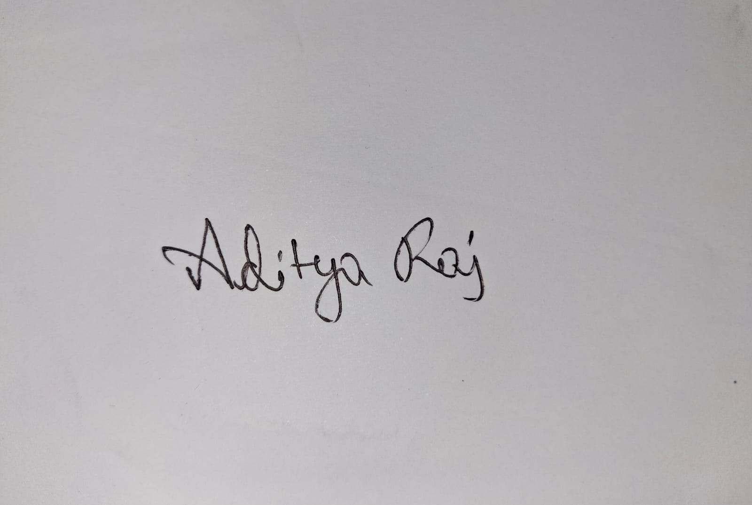
D. Full name | Anand Kumar
Mobile Number | 8207786048
Email (personal) | anandkashyap6048@gmail.com
UID/Registration number | 12309788
Address of Internal Inventors | Lovely Professional University, Punjab-144411, India
Signature (Mandatory) | 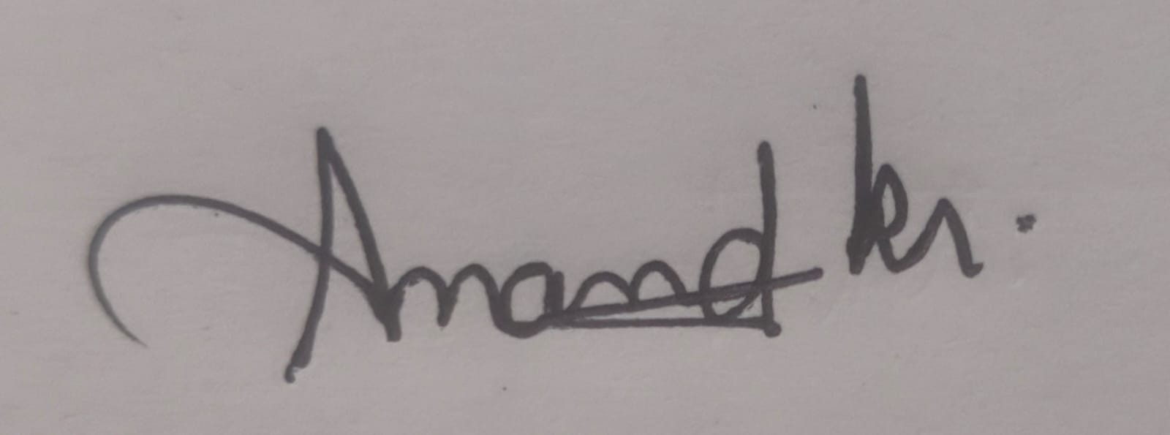
E. Full name | Niraj Kumar
Mobile Number | 9709802096
Email (personal) | nirajkr2604@gmail.com
UID/Registration number | 12308399
Address of Internal Inventors | Lovely Professional University, Punjab-144411, India
Signature (Mandatory) | 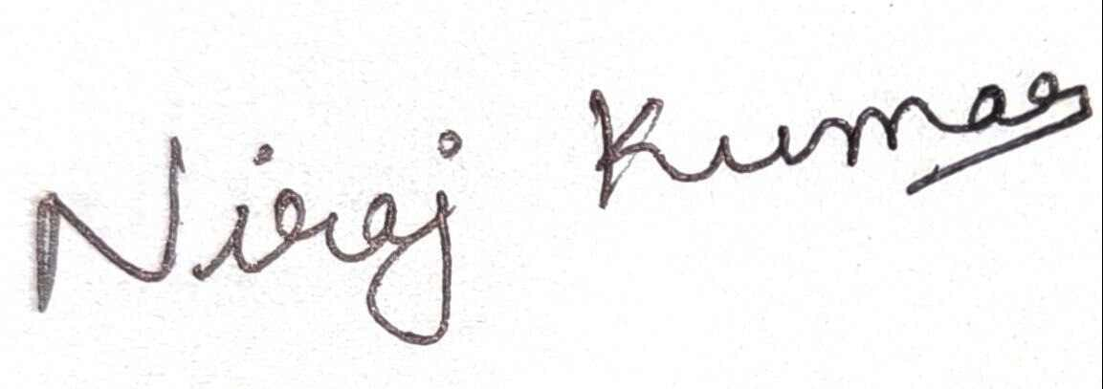
F. Full name | Akriti Mishra
Mobile Number | 8360542592
Email (personal) | mishraakriti097@gmail.com
UID/Registration number | 12308680
Signature (Mandatory) | 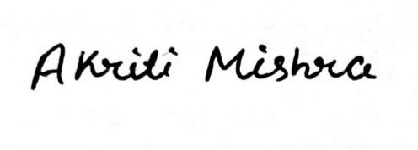

3. DESCRIPTION OF THE INVENTION
NyayaPacket Secure Evidence & Case Intake Station is a hardware-assisted system for capturing, protecting, organizing, and transferring citizen-provided legal evidence and statements into an AI-assisted case-preparation workflow. The invention combines a physical evidence-intake station containing a scanner and/or camera, microphone, embedded processor, secure cryptographic element, local encrypted storage, user interface, and network connectivity with a software platform that organizes the captured material into a source-aware case structure.
During an evidence session, the hardware captures a document, image, audio statement, or other supported material and associates the capture with a case session, evidence identifier, device identity, timestamp, integrity digest, and relevant case context. The resulting evidence record is securely transferred to the NyayaPacket platform, where evidence can be linked to a citizen statement or timeline event. A pre-trained AI service then produces a structured draft summary, chronology, party list, missing-information checklist, and consultation questions. Important generated items carry source identifiers and remain subject to citizen verification before inclusion in the final case packet.
The invention is not intended to provide final legal advice, predict case outcomes, determine legal merit, select charges, or replace a lawyer. Its principal contribution is the controlled combination of physical evidence acquisition, integrity-aware evidence handling, case-event association, source-aware AI organization, citizen verification, and controlled professional handoff.

A. PROBLEM ADDRESSED BY THE INVENTION
Citizens often approach legal-aid services with unstructured narratives and evidence distributed across paper documents, screenshots, receipts, photographs, messaging applications, PDFs, and voice recordings. Conventional digital intake systems generally depend on manual uploads and do not provide a dedicated physical capture workflow that binds the newly captured evidence to the citizen's case context.
The invention addresses the problem of fragmented evidence intake and uncertain provenance at the beginning of a legal consultation. It seeks to reduce manual reconstruction by capturing evidence through a controlled hardware session, assigning a stable evidence identity, generating integrity metadata, associating evidence with case events, and passing only structured, source-linked information into the AI-assisted preparation workflow.

B. OBJECTIVE OF THE INVENTION
- Secure Evidence Capture: Provide a controlled physical mechanism for capturing documents, images, and audio statements without relying solely on uncontrolled personal-device uploads.
- Evidence Integrity: Generate a cryptographic digest and capture metadata for each evidence item so later modifications can be detected.
- Device-Bound Capture Context: Associate evidence with a registered capture device and evidence session.
- Case-Event Association: Link captured evidence to a citizen statement, timeline event, or case entity rather than maintaining only an undifferentiated file folder.
- Source-Aware AI Organization: Provide structured AI output in which important generated entries reference available source identifiers.
- Human Verification: Require the citizen to accept, edit, reject, or mark AI-generated information as uncertain before packet generation.
- Controlled Handoff: Provide permission-based sharing with an authorized volunteer or lawyer and maintain an audit trail.
- Practical Deployment: Provide a hardware/software architecture that can be demonstrated in a legal-aid clinic, university legal clinic, NGO, or community assistance setting.

C. STATE OF THE ART / RESEARCH GAP / NOVELTY
The following comparison is intended as a preliminary invention-disclosure review. The listed prior-art documents show that secure digital evidence capture, hashing, metadata signing, timestamps, and chain-of-custody mechanisms are already known. Therefore, the proposed novelty should not be stated as merely 'a device that captures and hashes evidence'. The proposed distinction is the integration of controlled physical capture with case-event binding, source-aware AI organization, citizen verification, and a legal-consultation handoff workflow. A formal patent search and claim analysis should be completed before filing.

Sr. No. | Patent / Reference | Known Technology | Research Gap | Proposed Novelty / Distinction
1 | US20200202465A1 | Portable-device and cloud-server method for preserving chain of custody for digital evidence using digitally signed metadata, integrity codes, authentication credentials, controlled upload and deletion. | Does not establish the proposed citizen-centered legal intake workflow that binds captured evidence to a structured case chronology and source-aware AI draft followed by citizen verification. | Proposed system combines a dedicated intake station, case-session identity, evidence-to-event binding, source-aware AI organization and human verification within one controlled workflow.
2 | US11212416B2 | Secure digital media capture and analysis using hashes, timestamps, device identifiers and digital signatures to detect manipulation of captured media. | Secure media capture is already known; the gap for this invention is the domain-specific transformation from captured material to a verified legal-preparation packet. | The proposed system uses capture integrity as an input to a legal case-preparation workflow rather than treating secure media capture as the final objective.
3 | US20220294640A1 | Connected media-capture device generating cryptographic hashes, signed timestamps and digital signatures for authenticatable media. | Authenticatable capture itself is known and therefore should not be claimed alone. | The proposed architecture adds case-session context, evidence-to-statement/event relationships, AI source references and citizen-controlled verification before professional handoff.
4 | WO2023129706A1 | Forensic evidence collection system using sensor input, cryptographic checksums, local/cloud storage and report comparison. | Forensic evidence protection is established; it is not focused on citizen legal intake and AI-assisted pre-consultation preparation. | The proposed system is designed for pre-consultation legal case preparation and integrates evidence capture with citizen narrative, timeline, verification and lawyer handoff.

The invention therefore proposes a combined architecture in which the physical capture device is not merely a peripheral scanner. It participates in establishing an evidence session and generating capture context that is consumed by the workflow engine, evidence service, and AI orchestration service. The intended technical contribution is the coordinated interaction between the hardware capture layer and the case-structuring workflow.

D. DETAILED DESCRIPTION
Refer to Fig 1.

1. Hardware Evidence Intake Station
- Embedded Processor: A Raspberry Pi-class embedded computer or equivalent processor controls the capture workflow, local storage, device registration, user interface and communication.
- Document Scanner: A scanner or document-imaging module captures paper notices, receipts, agreements, statements and other physical documents.
- Camera Module: A camera captures photographs, screenshots displayed on another device, physical objects, or other visual evidence supported by the workflow.
- Microphone: A microphone records the citizen's original spoken statement or other permitted audio evidence.
- Touchscreen / User Interface: A local interface allows the user to select a case, start an evidence session, select capture type, review capture status and approve transfer.
- Secure Cryptographic Element: A hardware security element may protect a device-specific private key used to authenticate or sign evidence metadata.
- Encrypted Local Storage: Temporary evidence and metadata may be stored in encrypted local storage until successful transfer and acknowledgement.
- Network Connectivity: Wi-Fi or Ethernet enables secure transfer to the NyayaPacket backend.
- NFC Reader (Optional): An NFC token can identify a case session without requiring the user to manually enter a long case identifier.

2. Evidence Capture and Integrity Layer
When a capture action is initiated, the device creates or retrieves an evidence-session identifier. The captured content is assigned a unique evidence identifier. The system records metadata such as capture time, device identifier, case-session identifier, content type and file size. A cryptographic digest such as SHA-256 is calculated over the captured content and/or defined metadata structure.
Where implemented, the secure cryptographic element signs the evidence record or metadata. The server verifies the signature and recalculates the digest after transfer. A mismatch causes the evidence item to be marked as integrity-failed and prevents it from being treated as verified evidence in the packet.

3. Case-Event Binding Layer
The invention differs from a generic secure evidence recorder by allowing each captured item to be associated with a specific case context. For example, after the citizen states that a salary was due on a particular date, the guided workflow creates a timeline event. When the citizen captures a related receipt or message, the device or application can associate the evidence identifier with that event. The relationship is stored in a dedicated evidence-link structure.

4. AI Orchestration Layer
The backend sends only the information necessary for the selected AI task. The AI is instructed to organize supplied information rather than make legal judgments. The expected response is schema-constrained JSON containing fields such as summary, people, timeline, source identifiers, missing questions and unsupported assumptions. The backend validates the returned schema and verifies that referenced source identifiers exist.

5. Citizen Verification Layer
AI output remains a draft until reviewed by the citizen. Each important generated item may be accepted, edited, rejected, or marked uncertain. The original citizen statement and original captured evidence remain separately preserved. Verification actions and revisions are recorded in the audit history.

6. Case Packet Generation
After the required verification state is reached, the server generates a case packet containing the verified summary, chronology, parties, evidence index, unresolved information, consultation questions, verification statement and AI-use disclaimer. The packet contains references to evidence rather than modifying the original evidence files.

7. Professional Handoff and Action Plan
The citizen can create a case-specific permission grant for an authorized volunteer or lawyer. The access grant may contain the recipient, permission scope, consent timestamp and expiry. The professional reviews the preparation material and can record consultation notes and create dated action items. Professional legal judgment remains outside the AI workflow.

8. Security and Audit
- Endpoint-level authorization prevents a valid account from automatically accessing another citizen's case.
- Evidence files are stored outside a public web root and are assigned non-predictable storage identifiers.
- File type, size, signature and MIME-type checks are applied before storage.
- Sensitive content is minimized before transmission to an AI provider.
- Audit events record evidence capture, integrity verification, citizen verification, sharing, access, packet generation and professional review.
- Expired or revoked access grants are denied by the server.
- The system distinguishes file integrity from authenticity and does not claim that a hash proves legal admissibility.

9. Optional Extensions
- OCR for printed notices and receipts followed by citizen confirmation.
- Speech-to-text with playback and correction before transcript acceptance.
- Multilingual interface while preserving the original language content.
- Environmental sensors for recording capture-session conditions where useful and lawful.
- Offline capture mode with encrypted local queue and later authenticated synchronization.
- Physical status indicators showing capture, integrity verification, transfer and approval states.

FIG 1 – HARDWARE-ASSISTED NYAYAPACKET WORKFLOW
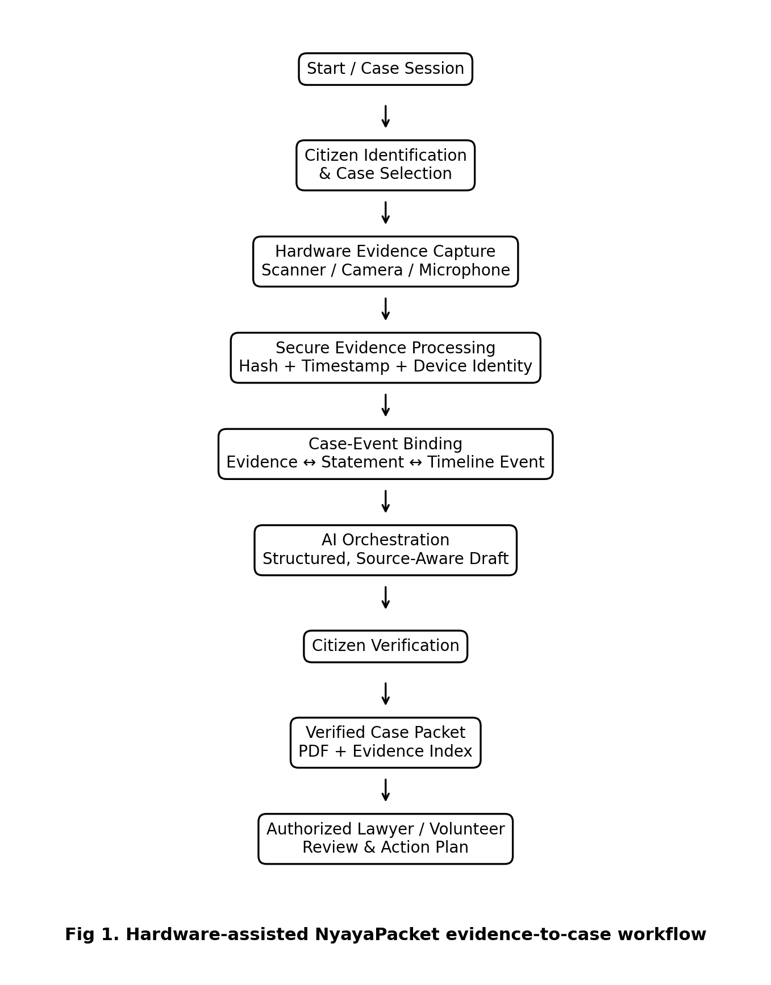
Fig 1 illustrates the end-to-end operation. The evidence station starts a case session, captures multimodal evidence, creates an integrity-aware evidence record, associates the evidence with case context, and transfers it to the NyayaPacket software platform. The AI produces an organization draft, the citizen verifies the generated information, and the system generates a controlled case packet for an authorized professional.

FIG 2 – Data Flow Diagram (DFD) of the NyayaPacket Secure Evidence and AI-Assisted Legal Case Preparation System
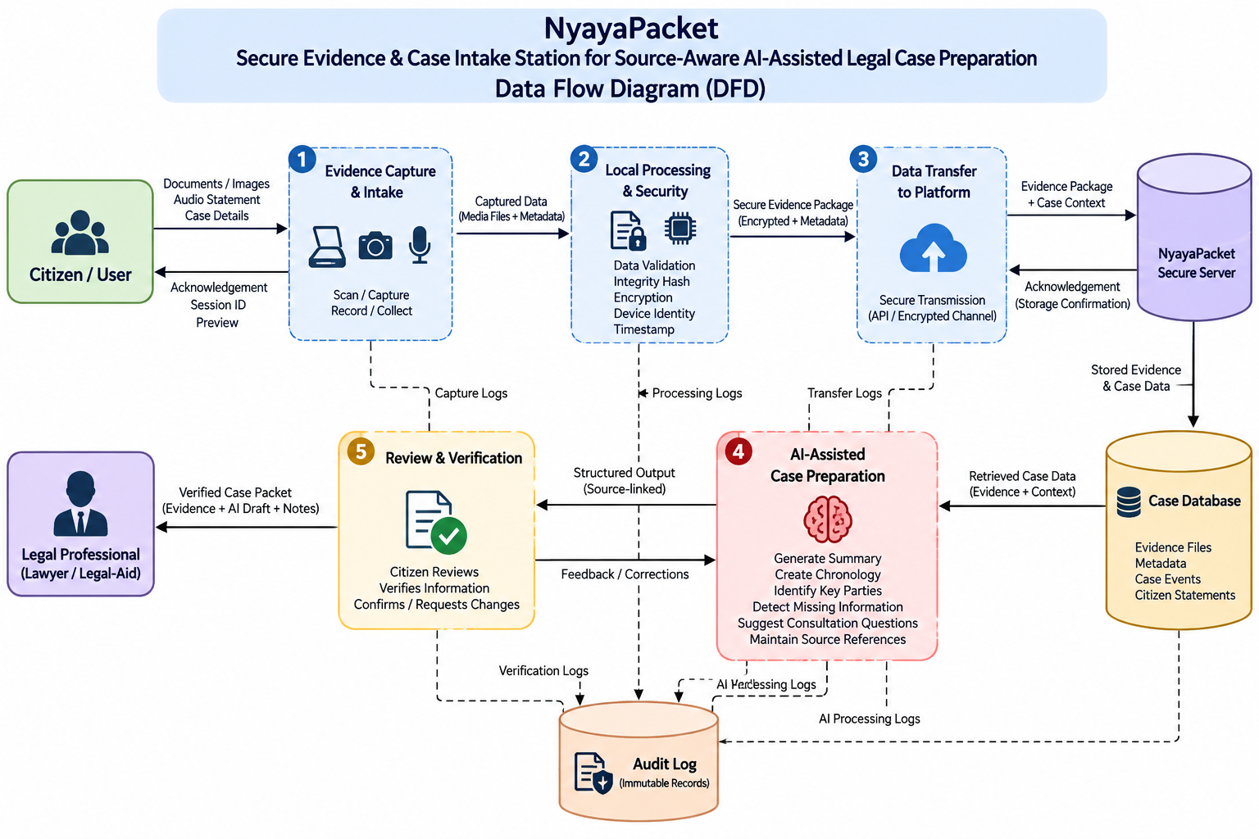
Fig. 2 illustrates the data flow within the NyayaPacket system. The citizen provides documents, images, audio statements, and case details through the evidence capture station. The captured data undergoes local processing, integrity verification, encryption, and secure transfer to the NyayaPacket platform. The platform stores the evidence and case information, retrieves relevant data for AI-assisted case preparation, and generates structured, source-linked information. The citizen reviews and verifies the generated information before a verified case packet is provided to the authorized legal professional, while system activities are recorded in the audit log.

E. SYSTEM ARCHITECTURE AND COMPONENT INTERACTION
Component | Primary Function
Hardware Intake Station | Physical capture of documents, images and audio; local session control.
Secure Element | Protects device credential/private key and supports authenticated evidence metadata.
Capture Integrity Module | Creates evidence identifier, timestamp, digest and capture metadata.
API Gateway + RBAC | Authentication, authorization and case-specific access control.
Case Workflow Service | Enforces valid case states and prevents unverified drafts from entering final packet generation.
Evidence Service | Validates, stores, hashes, indexes and links evidence.
AI Orchestration Service | Constructs task-specific prompts, enforces output schema and validates source identifiers.
PostgreSQL | Stores users, cases, events, evidence metadata, links, verification states, permissions and audit events.
Secure Object Storage | Stores original evidence and generated packets.
Packet Service | Generates the verified PDF case packet.
Professional Portal | Provides authorized volunteer/lawyer access and action-plan management.

The proposed architecture can be implemented as modules in a Node.js/Express application for the capstone prototype. The hardware station can communicate with the backend through authenticated REST APIs or a controlled device protocol. The architecture is intentionally modular so that the hardware can be replaced by an equivalent registered capture station without changing the case workflow.

Suggested Database Entities
- users – citizen, volunteer, lawyer and administrator accounts.
- cases – owner, category, workflow state and timestamps.
- evidence_sessions – hardware device, session identifier, start/end status and integrity state.
- evidence_files – evidence identifier, storage key, MIME type, size, digest and capture metadata.
- evidence_links – links between evidence, statements and timeline events.
- statements – original written or transcribed citizen statements.
- timeline_events – chronology, date certainty, source and verification status.
- ai_outputs – structured AI results, prompt version, source identifiers and verification status.
- access_grants – recipient, permissions, consent, expiry and revocation.
- consultations – authorized professional review records.
- action_items – professional next steps, owner, due date and status.
- audit_logs – append-oriented security and workflow events.

Software Stack
- Frontend: React + TypeScript.
- Backend: Node.js + Express.
- Database: PostgreSQL.
- AI: Pre-trained generative AI API with schema-constrained output.
- Storage: Secure object storage.
- Security: HTTPS, role-based authorization, cryptographic hashing and hardware-backed device identity.
- PDF: PDFKit, Puppeteer, or equivalent server-side document-generation library.

4. USE AND DISCLOSURE (IMPORTANT)
A. Have you described or shown your invention/design to anyone or in any conference? | [YES / NO ]
B. Have you made any attempts to commercialize your invention? | [YES / NO ]
C. Has your invention been described in any printed publication or other media, including the Internet? | [YES / NO ]
D. Do you have any collaboration with another institute or organization on the same? | [YES / NO ]
E. Name of Regulatory body or any other approvals if required. | [YES / NO ]

5. Provide links and dates for such actions if the information has been made public
N/A

6. Provide the terms and conditions of the MOU
N/A

7. Potential Chances of Commercialization
Yes. Potential applications include legal-aid clinics, university legal clinics, NGOs, community service centers, assisted digital-service centers, law firms and organizations requiring structured citizen intake. The physical station can be offered as a managed intake appliance while the NyayaPacket platform can operate as a subscription or institutional service.

8. List of companies / organizations that may be contacted for commercialization
- Legal technology and practice-management companies.
- Document-scanning and imaging companies.
- Secure hardware and embedded-device manufacturers.
- Digital public-service and legal-aid technology organizations.
- Cloud and AI service providers for institutional deployment.
Specific company names and contact links should be finalized after the university's technology-transfer team reviews the commercialization strategy.

9. Any basic patent which has been used and royalty is required to be paid
Preliminary prior-art review indicates that secure digital evidence capture, hashing, metadata signing, timestamps and chain-of-custody mechanisms are already described in earlier patent documents. The proposed invention therefore should not claim these generic mechanisms in isolation. The inventors should obtain a professional freedom-to-operate and novelty review before making a final claim set.

10. FILING OPTIONS
Recommended initial filing level: PROVISIONAL, subject to review by the university IPR/technology-transfer office and patent counsel.
A provisional filing can be used to establish an early priority date while the prototype and detailed claim strategy are developed. The final filing route and timing should be decided with qualified patent counsel.

11. KEYWORDS
- NyayaPacket AI
- Secure evidence capture
- Legal case intake
- Hardware-assisted legal technology
- Evidence intake station
- Digital evidence integrity
- Hardware-backed evidence identity
- Cryptographic evidence hash
- Case-event binding
- Source-aware artificial intelligence
- Human-in-the-loop verification
- Legal case preparation
- Citizen-to-lawyer handoff
- Secure document capture
- Multimodal evidence capture
- Voice evidence capture
- Evidence chronology
- Evidence indexing
- Role-based access control
- Audit trail
- Secure object storage
- AI-assisted documentation
- Legal aid technology
- Evidence provenance
- Secure intake kiosk

12. CLAIM-ORIENTED INVENTION SUMMARY
In one aspect, the invention provides a hardware-assisted legal case intake apparatus comprising a capture module configured to acquire at least one of a document, image, audio statement or other supported evidence; a hardware processor configured to create an evidence-session identifier and evidence identifier; an integrity module configured to generate a cryptographic digest over captured evidence and defined metadata; a secure credential module configured to authenticate the capture station; and a communication module configured to transfer the captured evidence and integrity metadata to a case-preparation server.
In another aspect, the server associates the evidence identifier with a citizen statement and/or timeline event, invokes a schema-constrained AI orchestration service to organize supplied information into source-referenced structured output, and prevents unverified generated information from entering a final case packet until the citizen completes an explicit verification action.
The above is a technical invention summary for disclosure purposes, not a final patent claim set. Final claims must be drafted and narrowed after a formal novelty and prior-art assessment.

13. REFERENCES / PRELIMINARY PRIOR-ART SOURCES
Reference | Title | Source
US20200202465A1 | Method and operation of a portable device and a cloud server for preserving the chain of custody for digital evidence. | Google Patents
US11212416B2 | Secure digital media capture and analysis. | Google Patents
US20220294640A1 | System and method for capturing authenticatable digital media files on connected media-capture devices. | Google Patents
WO2023129706A1 | Forensic evidence collection systems and methods. | Google Patents

These references are included to make the disclosure more defensible about what is already known. They should be reviewed in full by the patent professional before filing. The proposed differentiation is the combined hardware-assisted legal intake workflow, case-event binding, source-aware AI structuring, explicit citizen verification, and controlled lawyer handoff.

14. EXPECTED COMMERCIAL / SOCIAL IMPACT
- Reduces repeated retelling of a legal problem during the first consultation.
- Provides a structured way to organize scattered evidence.
- Creates a controlled bridge between physical documents and digital case records.
- Supports source-aware AI without presenting the AI as a legal decision-maker.
- Can be deployed in assisted-access environments where citizens may not have the technical ability to organize evidence themselves.
- Provides a reusable hardware/software platform for multiple bounded legal-aid intake categories.

NO OBJECTION CERTIFICATE
This is to certify that University/Organization Name or its associates shall have no objection if Lovely Professional University files an IPR (Patent/Copyright/Design/any other…….) entitled "…………………." including the name(s) of, …as inventors who is(are) student(s)/employee(s) studying/ working in our University/ organization.
Further Name of the University/Organization shall not provide any financial assistance in respect of said IPR nor shall raise any objection later with respect to filing or commercialization of the said IPR or otherwise claim any right to the patent/invention at any stage.

End of Invention Disclosure Draft

