Annexure3b- Complete filing

INVENTION DISCLOSURE FORM

- TITLE: NyayaPacket Secure Evidence & Case Intake Station for Source-Aware AI-Assisted Legal Case Preparation

- INTERNAL INVENTOR(S)/ STUDENT(S): All fields in this column are mandatory to be filled

A. Full name | Dr. Navneet Kaur
Mobile Number | 9463438612
Email (personal) | navneetphul@gmail.com
UID/Registration number | 24950
Address of Internal Inventors | Lovely Professional University, Punjab-144411, India
Signature (Mandatory) | 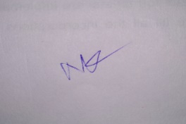
B. Full name | Aniket Kumar
Mobile Number | 7209808821
Email (personal) | aniket.kr2103@gmail.com
UID/Registration number | 12308729
Address of Internal Inventors | Lovely Professional University, Punjab-144411, India
Signature (Mandatory) | 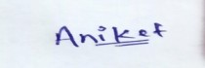
C. Full name | Khushboo Gupta
Mobile Number | 9104619162

Email (personal) | Khushboogupta9104@gmail.com
UID/Registration number | 12413158
Address of Internal Inventors | Lovely Professional University, Punjab-144411, India
Signature (Mandatory) | 
D. Full name | Aditya Raj
Mobile Number | 8709468317
Email (personal) | adityaraj76666@gmail.com
UID/Registration number | 12310345
Address of Internal Inventors | Lovely Professional University, Punjab-144411, India
Signature (Mandatory) | 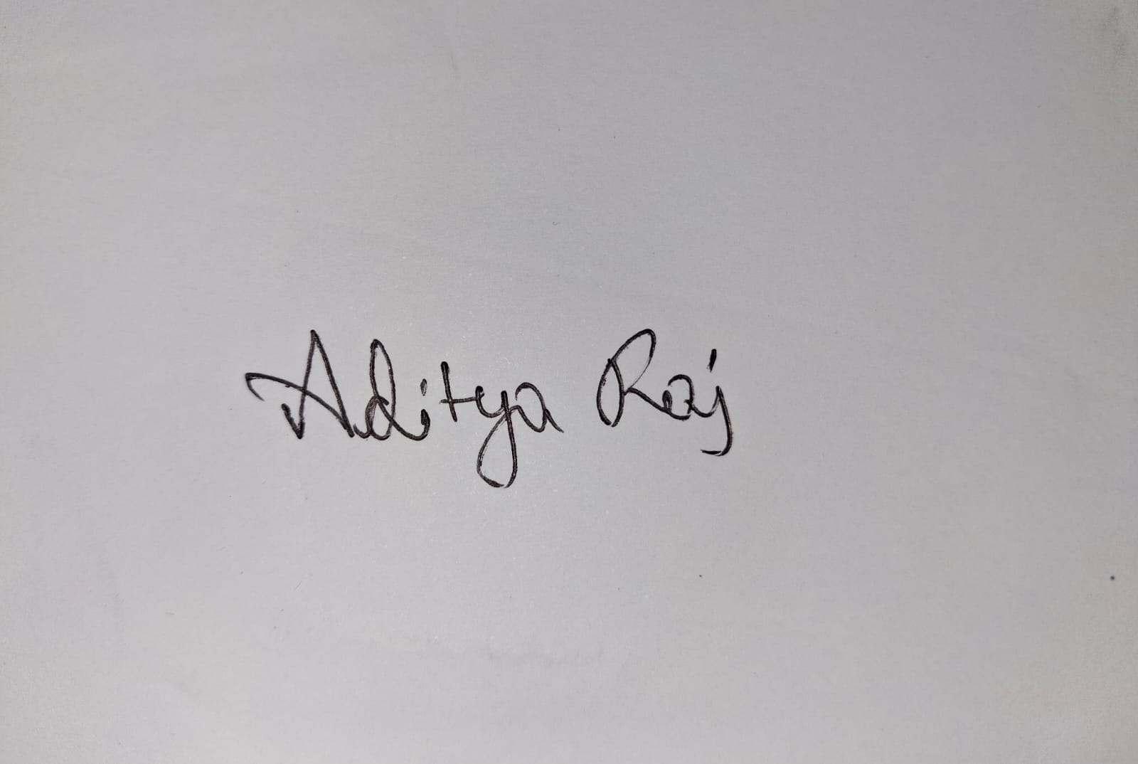
D. Full name | Anand Kumar
Mobile Number | 8207786048
Email (personal) | anandkashyap6048@gmail.com
UID/Registration number | 12309788
Address of Internal Inventors | Lovely Professional University, Punjab-144411, India
Signature (Mandatory) | 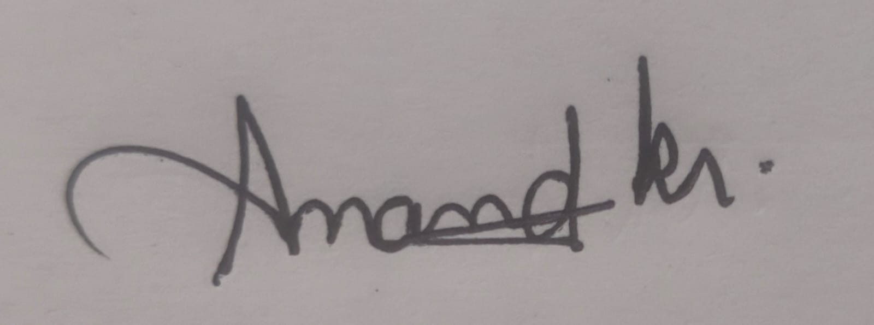
E. Full name | Niraj Kumar
Mobile Number | 9709802096
Email (personal) | nirajkr2604@gmail.com
UID/Registration number | 12308399
Address of Internal Inventors | Lovely Professional University, Punjab-144411, India
Signature (Mandatory) | 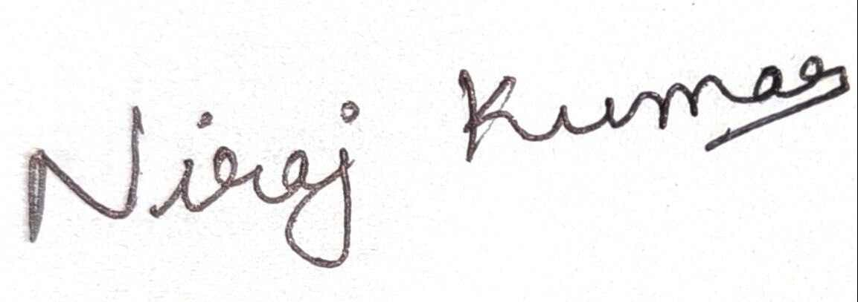
F. Full name | Akriti Mishra
Mobile Number | 8360542592
Email (personal) | mishraakriti097@gmail.com
UID/Registration number | 12308680
Signature (Mandatory) | 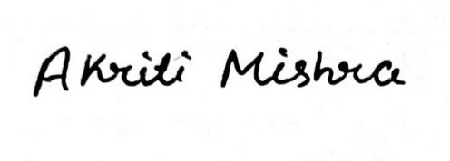

3. DESCRIPTION OF THE INVENTION
The NyayaPacket Secure Evidence & Case Intake Station is an artificial intelligence and hardware based solution that captures, stores, sorts and transfers the evidence and the statements made by citizens into the artificial intelligence assisted case preparation process. The solution includes the physical evidence intake station and software module. The physical evidence intake station consists of scanner/camera, microphone, processing power, cryptography, encryption-based storage, user interface and network. The software module sorts the information gathered by the station in the form of a source specific case.
During the process of gathering evidence, the evidence intake station gathers the evidence in the form of a document, picture, audio statement or any other evidence. This piece of evidence is tied to the case session, evidence ID, device ID, timestamp, integrity digest, and case context. The result is then securely transmitted to the NyayaPacket Platform and linked to the citizen statement or timeline event. Thereupon, the pre-trained AI service creates source specific case draft summary, chronology, parties list, checklist of the missing information and consultation questions.
The device does not offer legal counseling, make any predictions about legal results, make decisions about appropriateness of the case, select legal charges, nor does it replace attorneys. The thing that this device does is automate the process of evidence collection, ensure the integrity of evidence handling, connect events within the case, apply classification by artificial intelligence taking into account the source of evidence, and evidence transmission automation to experts.

A. PROBLEM ADDRESSED BY THE INVENTION
These people who approach the legal advisory firm will have an unstructured story with respect to evidences since the evidences will come from various documents such as photographs, receipts, screen shots, instant messaging system, PDFs, and audio messages. The existing digital intake system is extremely dependent on the manual submission of all these documents. There is no particular physical process that can enable the recording of these evidences in relation to the case of the individual concerned.
This invention solves the problem of evidence gathering and its source right from the initial process of legal advisory process itself. It will reduce the manual efforts involved in preparing these evidences by providing them in hardware format.

B. OBJECTIVE OF THE INVENTION
- Encryption of Evidence Capture: Design the way to safely capture evidence in the form of documents, images and oral evidence without making citizen dependent only on the unencrypted upload from his personal device.
- Integrity of the Evidence: Design cryptographic hash and metadata for each item of evidence in order to discover possible changes made after the evidence was captured.
- Bound to Capture Device and Session: Bind each piece of evidence to the capture device and session.
- Evidence Connection to Case Entity or Timeline Event: Connect each piece of evidence to the statement of citizen, timeline event or case entity rather than just save the file in the standard folder.
- References to Source ID in AI Output: Design AI outputs including references to source ID’s.
- Human Verification of Entry: Make citizen confirm, disapprove, amend or classify the every piece of outputted AI before the creation of packet.
- Permissioned Sharing: Enable the permissioned sharing of the data with authorized volunteer or lawyer and track the process.
- Implementation Feasibility:Designing of an architectural framework of the hardware and software architecture that is implementable in legal aid clinics, law clinics in colleges, NGOs and other help organizations.

C. STATE OF THE ART / RESEARCH GAP / NOVELTY
It is a comparative analysis of the invention disclosure test at an early stage. From the list of literature cited above, it can be seen that the technologies such as digital evidence collecting, evidence hash creation, evidence signature, timestamps, and chain of custody were already available. Hence, it cannot be said that the invention is novel since it is "a device that collects and hashes evidence". Novelty of the invention lies in the fact that physical evidence collecting occurs in respect to some event and organizing it by an AI aware of the source of evidence and the citizen.

Sr. No. | Patent / Reference | Known Technology | Research Gap | Proposed Novelty / Distinction
1 | US20200202465A1 | Technique to preserve chain of custody of digital evidence by digitally signing meta-data, integrity codes, authentication codes, and uploading and deletion processes on mobile and cloud servers. | Nevertheless, this does not contain the intake process involving citizens mentioned above in which the collected information has been done through the case history and an AI-created document that is being verified by the citizens. | Characteristics of the proposed model include the presence of the intake center that will be responsible for managing sessions cases, identifying evidences with events, organizing AI from the sources, and validating through human means.
2 | US11212416B2 | It entails elements like hashes, timestamps, digital signatures, and device identification so that digital media can be captured and analyzed to confirm whether there is manipulation of the media captured. | There is technology for the acquisition of media in a secure manner. The problem that is solved by this technology is the specific technology for the conversion of acquired media into the legal preparation package. | The process of preparing for law necessitates integrity of capture as an input, but not as an output.
3 | US20220294640A1 | Media Device Linker that provides cryptographic hash, signed time stamp, and digital signature for media authentication. | This concept is quite widespread; thus, it cannot exist independently. | The recommended framework includes the contextualization of the discourse in the case, the relationship between evidence and statements/events, the source of the information to the AI, and the role of the citizen before professional intervention.
4 | WO2023129706A1 | Process of collecting evidence using sensors, checksums, storage and comparison. | The steps involved in the process of forensics have been explained. Yet these steps do not have anything to do with the intake of people through the law or pre-consultation steps. | This proposed model needs to be used in preparation of the case before the consultation process where the evidence gathering, story telling of the citizens, timeline making, verification and then forwarding to the lawyers.

This is a very complete framework. Firstly, the capture device is not merely a peripheral device, but rather an aspect that works in unison with the process of evidence generation and context capturing in regards to the workflow engine, evidence service, and artificial intelligence orchestration service. The technological innovation of this concept is the use of the hardware capture layer along with the case structure workflow.

D. DETAILED DESCRIPTION
Refer to Fig 1.

1. Hardware Evidence Intake Station
- Encryption of Evidence Capture: Develop an approach for evidence capture through documents, images, and oral evidence without making the citizen rely solely on the non-encrypted upload of data by his personal device.
- Checking for Integrity of Evidence: Develop the cryptography hash and metadata for each evidence piece in order to determine the changes done to it after the evidence was captured.
- Linking the Evidence to the Device and Session: Link each evidence piece to the device that was used to capture it and session.
- Relation of the Evidence to the Citizen’s Statement or Timeline Event: Link every evidence to citizen’s statement, timeline event or case entity rather than keeping it as a file in the common folder.
- Citation of Source ID’s in the AI Output: Develop the AI output with citation of the source ID’s.
- Validation of the Output of AI by Humans: Have the citizen approve, disapprove, amend or classify the outputted AI before developing the packet.
- Permissioned Data Sharing: Develop the permissioned data sharing of the data with authorized volunteer or lawyer and track the process.
- Feasibility of Implementation: Develop hardware and software architecture that could be implemented in the

2. Evidence Capture and Integrity Layer
When the process of capturing starts, the evidence session identifier is created/received. The identifier for the evidence is set on the captured data. The data concerning capturing time, identifier of the device, identifier of the case session, type of the content, and file size is recorded in the system. This is done via the cryptographic digest (SHA-256) of the captured data or certain metadata structure or both.
When there is a presence of the cryptographic component, then the evidence or metadata is signed by the server; the signature is checked and the digest is calculated after the data transmission. When the digests do not match, then the evidence fails the integrity check and cannot be accepted as the evidence in the packet.

3. Case-Event Binding Layer
It should be noted that the invention is not similar to the usual secure evidence recorder because there might be a context for this evidence. In other words, the citizen claims that he/she had the right to receive his/her salary at a certain time due to a certain workflow and there will be a timeline event created. Then, when the citizen receives a receipt or a message concerning the situation, an evidence ID will be associated with this event.

4. AI Orchestration Layer
Data is made available only for what needs to be done to perform the task. The AI is supposed to make use of the information given by the backend and not to arrive at any legal conclusion. The AI will give output in the JSON schema form where the fields involved include summary, people, timeline, source ID, missing questions, and unprovable assumptions.

5. Citizen Verification Layer
The result of the AI would remain a draft until such a time that it is reviewed by the citizen. Every document created by the AI may be accepted, amended, rejected, or considered ambiguous. The original statement of the citizen and the evidence shall remain separate.

6. Case Packet Generation
At the point where the verification is in the required state, a packet is generated out of the case by the server. The packet contains the verified summary, chronology, parties, evidence index, unknown data, consulting questions, verification note, and AI usage note. It refers to the evidence without changing them.

7. Professional Handoff and Action Plan
Citizen is capable of generating the permission request concerning the case on behalf of the volunteer and lawyer. The information includes the name of the individual concerned, the permissions given, consent date, and expiration date where necessary. Professional checks the preparation material, observes the consultations, and makes an action plan. Professional legal advice is not a part of the AI process.

8. Security and Audit
- Authorization level at endpoint does not guarantee that the authorized account has access to the file belonging to the other citizen.
- Files are stored using public web root and hence it is not possible to use it for accessing the evidence files due to the unavailability of the storage IDs.
- Verification of file type, file size, signature, and MIME type is done prior to saving of files.
- Sensitive information is sanitized before it is sent to the AI service provider.
- Evidence collection, evidence integrity verification, citizen verification, evidence sharing, evidence access, packet creation, and professional evaluation are audit loggable actions.
- Server denies all the access requests if the authorization is expired or revoked.
- File integrity and authenticity checks are performed independently and there are no guarantees on the admissibility of the hashes.

9. Optional Extensions
- OCR for printed notifications and receipts and verification by the citizen.
- Speech to text where the audio is verified first.
- Interface that supports multiple languages where all the language details are preserved.
- Sensors to record the environment while capturing the data.
- Offline capture where the data captured is stored in an encrypted queue on the device and then verified.
- Status information regarding all phases of capture, verification, transfer, and validation.

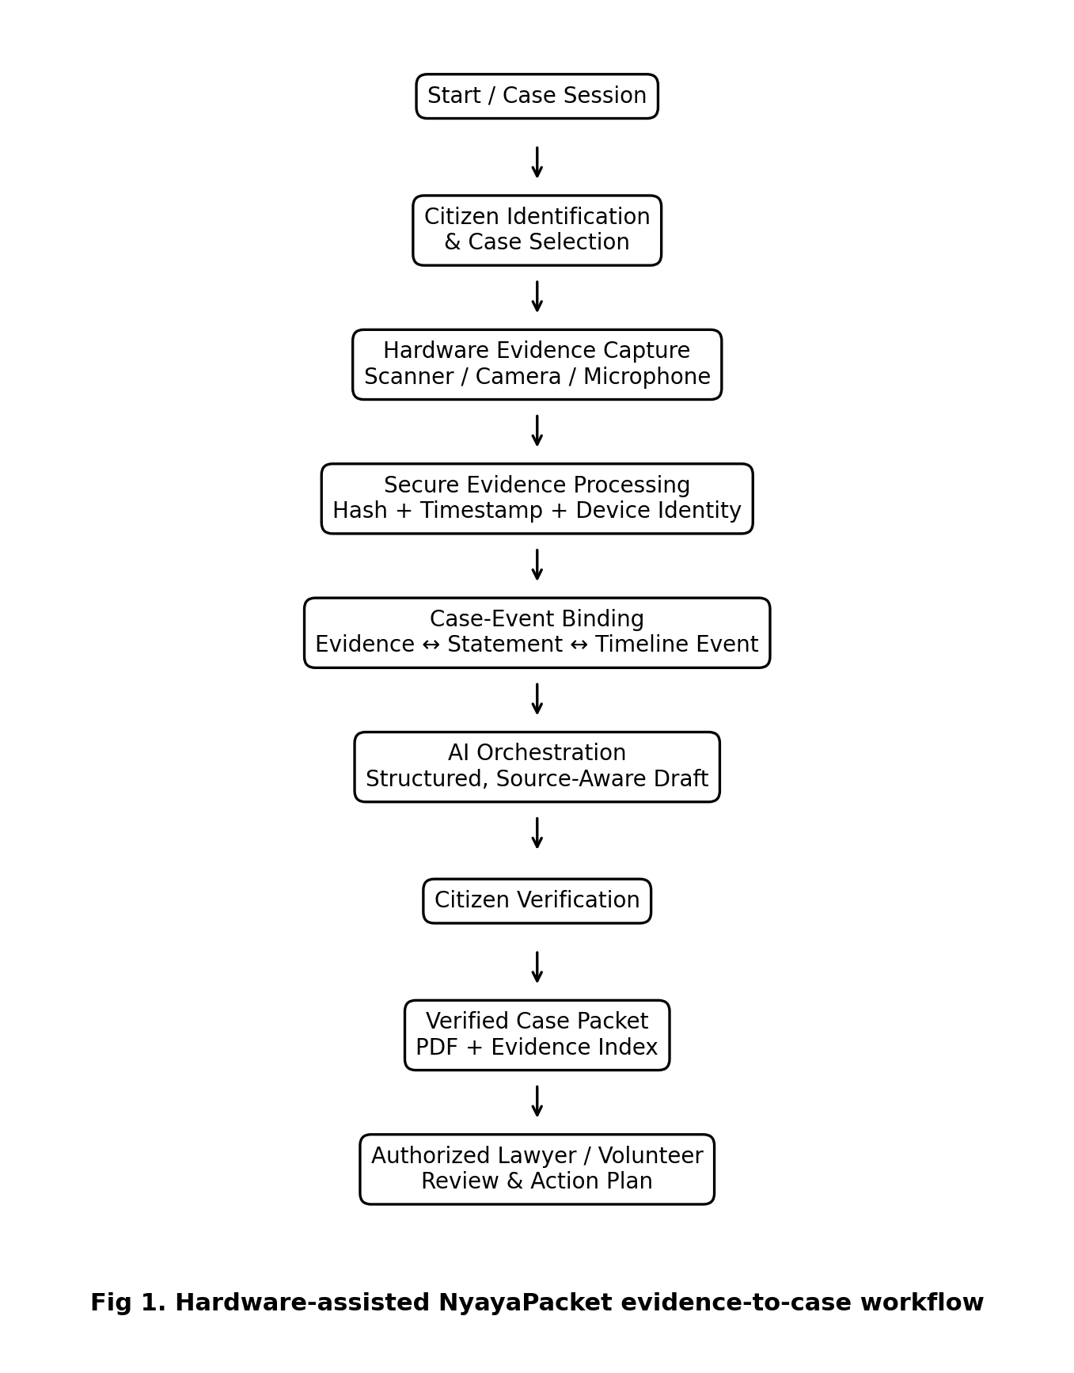
This process is shown in Fig 1 below. The evidence station begins a case session, collects multimodal evidence, makes a documentation of the evidence taking into consideration the integrity of evidence, makes connections between the evidence and the context of the case, and finally transfers the evidence to the NyayaPacket platform. AI develops a draft of the organization, and the citizen confirms the generated information, and a case packet is developed.

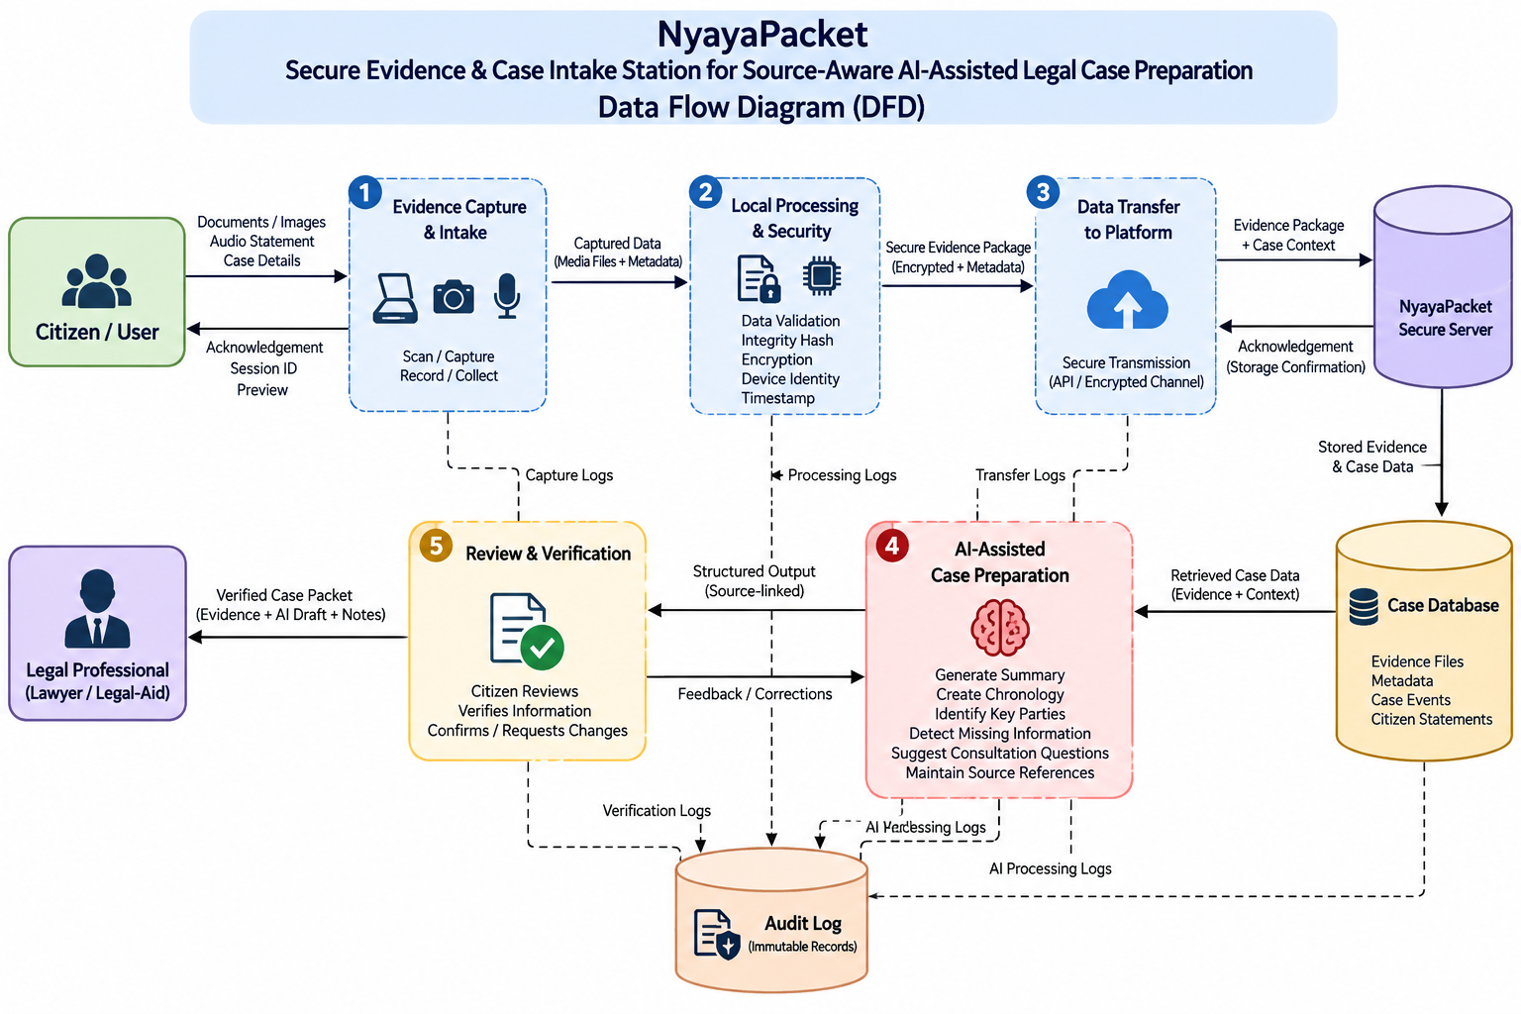

Fig 2: Data Flow Diagram (DFD) of the NyayaPacket Secure Evidence and AI-Assisted Legal Case Preparation System

The second figure below demonstrates the data flow in NyayaPacket. The citizen uploads the evidences in the form of documents, images, audio statements, and case information through the evidence capturing station. This data is then processed locally, verified, encrypted, and transferred securely to the platform. The platform uploads the evidences, retrieves the necessary information needed for preparing the case using artificial intelligence and generates structured information with their respective sources. This information is then verified by the citizen and sent to the legal professional.

Table 1. System architecture and component interaction
Component | Primary Function
Hardware Intake Station | Gathers evidence, evidence images, and audio files physically; controls the physical gathering of evidence.
Secure Element | Secures the device credential or private key and provides for the authenticated evidence metadata.
Capture Integrity Module | Generates the evidence identifier, time stamp, evidence digest, and evidence metadata.
API Gateway + RBAC | Generates the authentication, authorization, and access control for the case.
Case Workflow Service | Guarantees the validity of the case states and ensures that unvalidated drafts do not get into the packet generation process.
Evidence Service | Verifies, stores, hashes, indexes, and links evidence.
AI Orchestration Service | Generates task-specific prompts, output schema, and source identifier validation.
PostgreSQL | Storing users, cases, events, evidence metadata, links, verification states, permissions, and audit events.
Secure Object Storage | Stores original evidence and packets.
Packet Service | Generates the validated PDF case packet.
Professional Portal | Gives access to volunteers and attorneys and action plans.

The architecture has been shown in Table 1 below and could be implemented as modules in a Node.js/Express framework as a prototype for the capstone. The hardware station could interface with the back-end via secured RESTful APIs or device control protocol. The architecture is modular to such an extent that the hardware could be swapped for another capture station that would register with the case process without a hitch.

Suggested Database Entities
- users: citizen, volunteer, lawyer, and administrative user accounts.
- cases: owner, category, state of the workflow, and timestamps.
- evidence_sessions: hardware, session ID, initial/final state, and integrity state.
- evidence_files: evidence ID, storage key, MIME type, size, digest, and capture metadata.
- evidence_links: linking evidence, statements, and timeline events.
- statements: citizen statements in written and transcribed form.
- timeline_events: position, certainty of date, source, and validation state.
- ai_outputs: AI output, variation of prompts, source data, and verification data.
- access_grants: Recipient of grant, permissions, consent, expiry date, and revocation status.
- consultations: professional consultations by an authorized professional.
- action_items: actions to be performed by a professional, owner, due date, and status.
- audit_logs: security and workflow events in sequence.

Software Stack
- Frontend: React and TypeScript.
- Backend: Node.js with Express.
- Database: PostgreSQL.
- AI: Generative AI API (with schema constraint on output).
- Storage: object storage.
- Security: https, rbac, hashing, device authentication.

E. FORMULATION/DESIGN/PATTERN OF THE WORK:
As for the prototype of the item, it has not yet been produced and its production can take about one year.

5. USE AND DISCLOSURE (IMPORTANT)
Have you disclosed your invention/ design orally or in any kind of presentation in any conference? | YES () | NO (√ )
- Have you made any effort to make your invention commercially successful (i.e., have you approached any company for acquiring or manufacturing your invention)? | YES ( ) | NO (√ )
- Have you ever published your invention in any printed form or any other means such as on internet? | YES ( ) | NO ( √)
- Is there any partnership with any other organization in connection with the above? Mention their names and other details. | YES ( ) | NO (√ )
- Name of regulatory authority or other approvals (if any). | YES ( ) | NO (√ )

6. If the information about the activities has been provided previously on public domain (Google, research papers, YouTube videos, etc.) Please provide the links along with the dates and send it to us later.
NA
7. If the project is being planned to conduct in collaboration with industry/university (Any industry, Other universities or any other organization), please provide the terms and conditions of MOU as well.
NA
8. Likelihood of Commercialization
Yes. The possible users of the product will include legal aid clinics, university clinics, NGOs, community centers, assisted digital services centers, law firms, or any organization requiring structured citizen intake. Physical station can be used as an intake tool while the NyayaPacket application can be a subscription or institutional service.
9. Companies/Organization for commercialization
• Legal technology and practice management companies.
• Document scanning and imaging companies.
• Hardware and embedded devices company.
• Digital Public Services and Legal aid technology organization.
• Cloud and AI services providers for institutional deployment.
The names of companies and contact information will be provided by the technology transfer team of the university once evaluated for commercialization.
10. Patent in use and Royalty to be paid
NA

10. FILING OPTIONS
Please indicate the level of your work which can be considered for provisional/ complete/ PCT filings - (Provisional)

11. KEYWORDS
- NyayaPacket AI
- Secure evidence capture
- Legal case intake
- Hardware-assisted legal technology
- Evidence intake station
- Digital evidence integrity
- Hardware-backed evidence identity
- Cryptographic evidence hash
- Case-event binding
- Source-aware artificial intelligence
- Human-in-loop verification
- Legal case preparation
- Citizen-to-lawyer handoff
- Secure document capture
- Multimodal evidence capture
- Voice evidence capture
- Evidence chronology
- Evidence indexing
- Role-based access control
- Audit trail
- Secure object storage
- AI-assisted documentation
- Legal aid technology
- Evidence provenance
- Secure intake kiosk

NO OBJECTION CERTIFICATE
This is to certify that University/Organization Name or its associates shall have no objection if Lovely Professional University files an IPR (Patent/Copyright/Design/any other…….) entitled "…………………." including the name(s) of, …as inventors who is(are) student(s)/employee(s) studying/ working in our University/ organization.
Further Name of the University/Organization shall not provide any financial assistance in respect of said IPR nor shall raise any objection later with respect to filing or commercialization of the said IPR or otherwise claim any right to the patent/invention at any stage.

End of Invention Disclosure Draft

