Practice Set:- 1
# 1.Write an application in „Python‟ to display the given strings on the standard output device in the
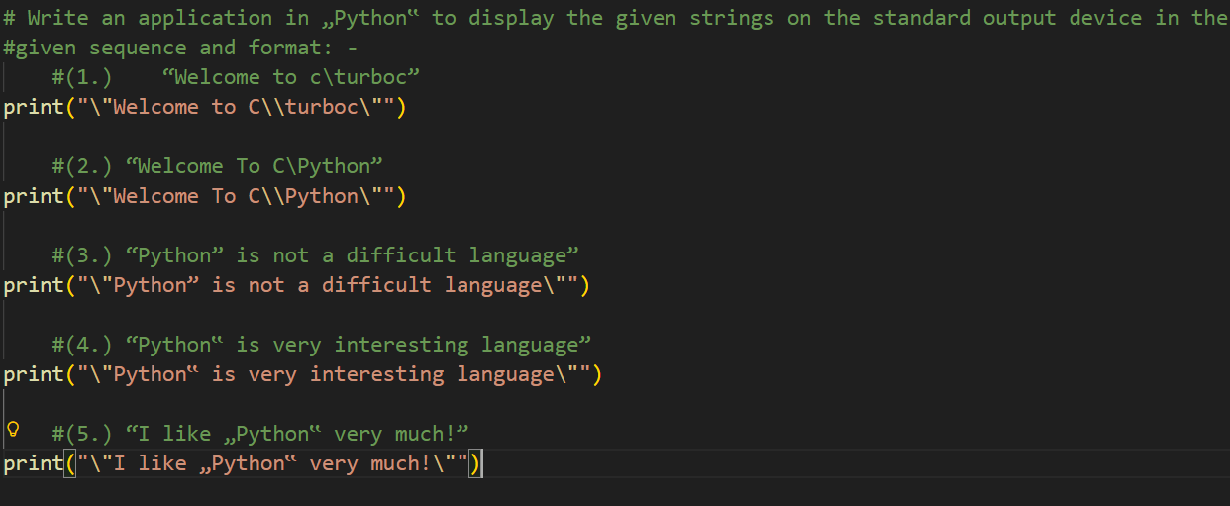
#given sequence and format: -
#(1.) “Welcome to c\turboc”
print("\"Welcome to C\\turboc\"")

#(2.) “Welcome To C\Python”
print("\"Welcome To C\\Python\"")

#(3.) “Python” is not a difficult language”
Output
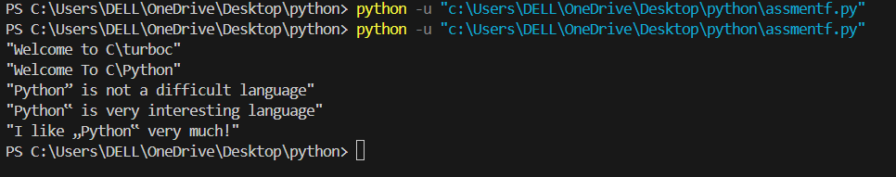
print("\"Python” is not a difficult language\"")

#(4.) “Python‟ is very interesting language”
print("\"Python‟ is very interesting language\"")

#(5.) “I like „Python‟ very much!”
print("\"I like „Python‟ very much!\"")
#2. Write an application in „Python‟ to print the following string in a specific format
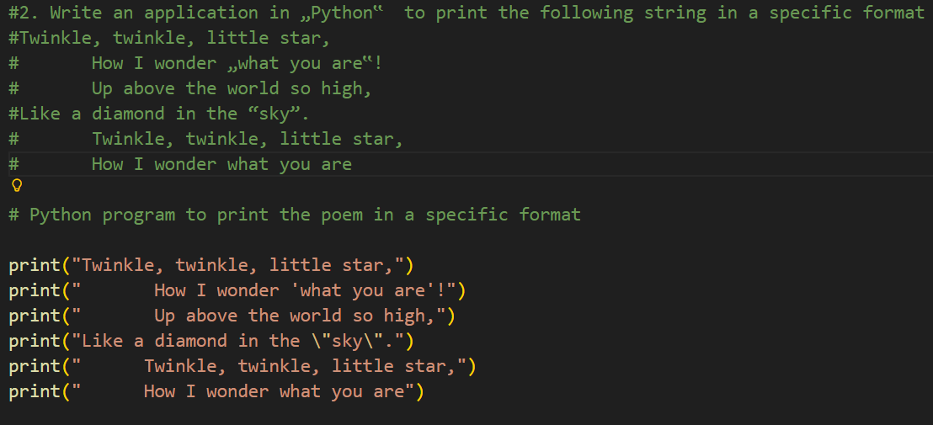
#Twinkle, twinkle, little star,
# How I wonder „what you are‟!
# Up above the world so high,
#Like a diamond in the “sky”.
# Twinkle, twinkle, little star,
# How I wonder what you are
# Python program to print the poem in a specific format
print("Twinkle, twinkle, little star,")
Output
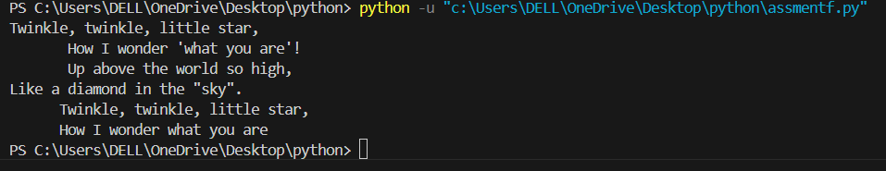
print(" How I wonder 'what you are'!")
print(" Up above the world so high,")
print("Like a diamond in the \"sky\".")
print(" Twinkle, twinkle, little star,")
print(" How I wonder what you are")

#3. Write an application in „Python‟ to accept one integer and one fractional value from keyboard,
#calculate and display product.
a = int(input("Enter an intereger Values:"))
b = float(input("Enter a fractional Values:"))
product = a*b
print("The Product Of Interager and Fractional Values is : ", product)
OUTPUT
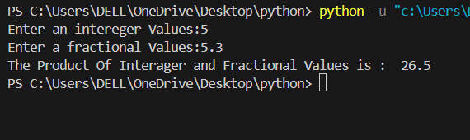
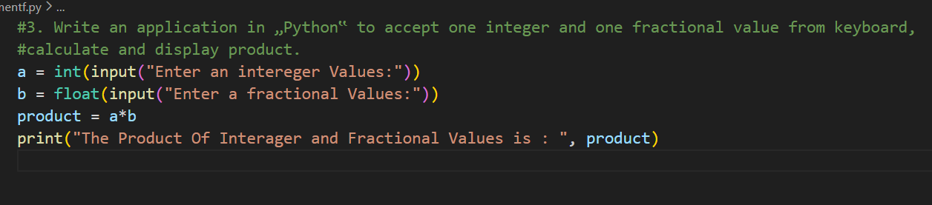
#4. Write an application in „Python‟ to print series 1 to 5 as a following format:
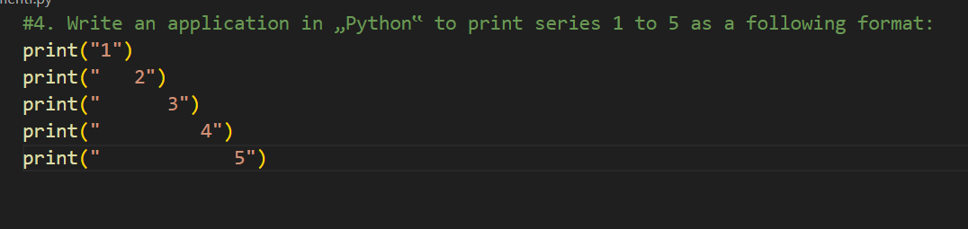
print("1")
OUTPUT
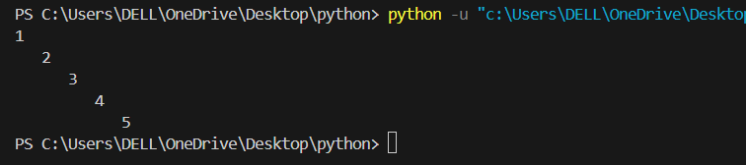
print(" 2")
print(" 3")
print(" 4")
print(" 5")
# 5. Write an application program in „Python‟ to reserve three memory locations named empno, salary
# and itax having values 8801, 12000.00, and 347.82 respectively. Also display the same on the
# standard output device in the following sequence and format: -
# EmpNo
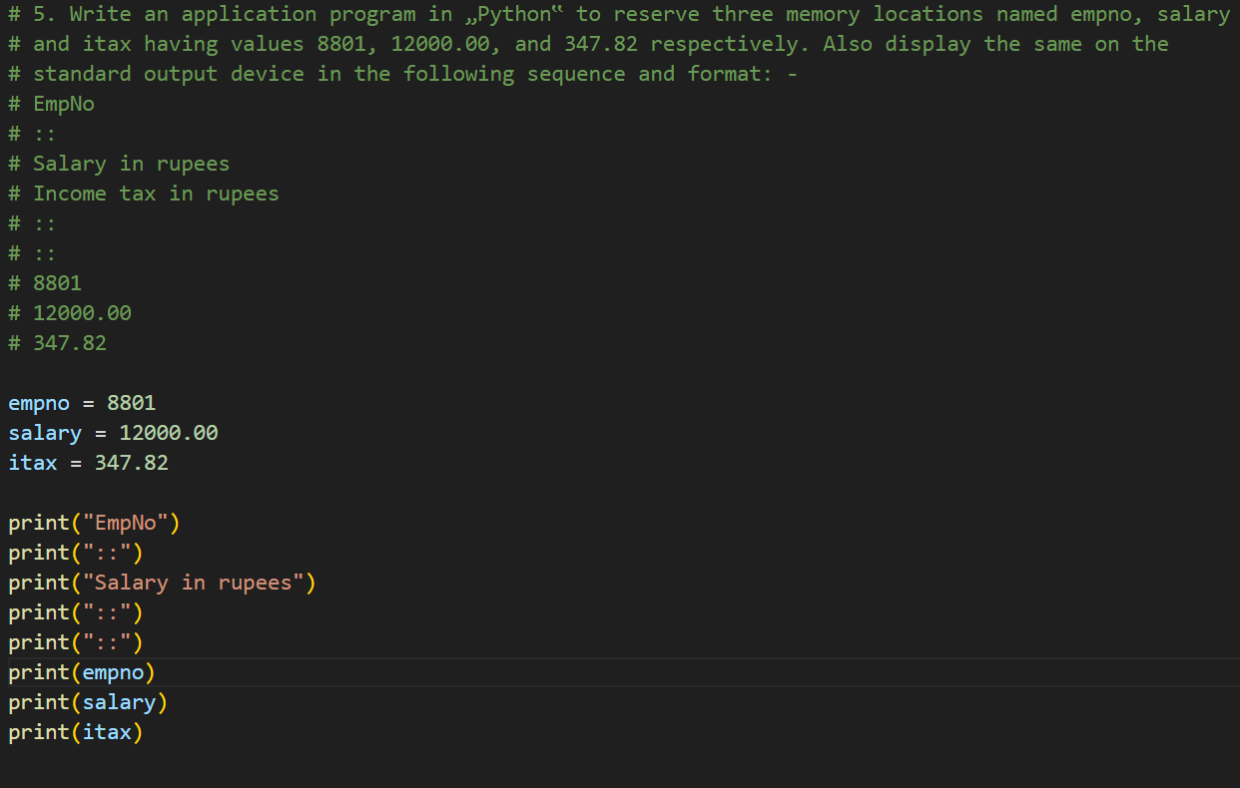
# ::
# Salary in rupees
# Income tax in rupees
# ::
# ::
# 8801
# 12000.00
# 347.82

empno = 8801
salary = 12000.00
itax = 347.82
OUTPUT
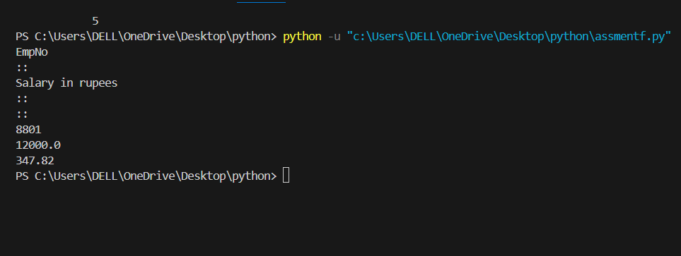

print("EmpNo")
print("::")
print("Salary in rupees")
print("::")
print("::")
print(empno)
print(salary)
print(itax)
# 6. Write an application in „Python‟ to accept values for product number, unit price, and quantity
# taken from the standard input device. Also display the same on the standard output device in the
# following sequence and format: -
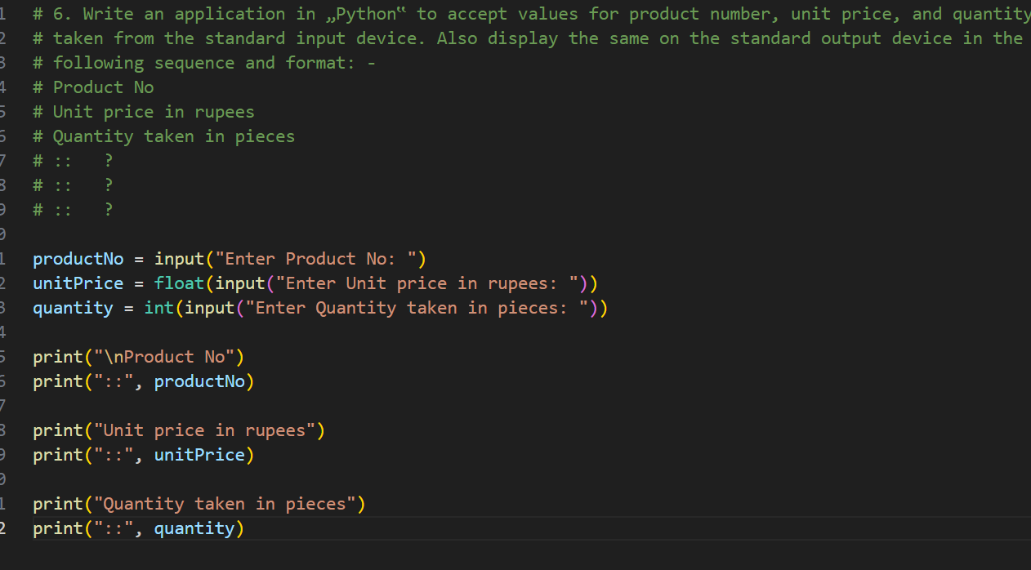
# Product No
# Unit price in rupees
# Quantity taken in pieces
# :: ?
# :: ?
# :: ?

productNo = input("Enter Product No: ")
unitPrice = float(input("Enter Unit price in rupees: "))
quantity = int(input("Enter Quantity taken in pieces: "))

print("\nProduct No")
print("::", productNo)
Output
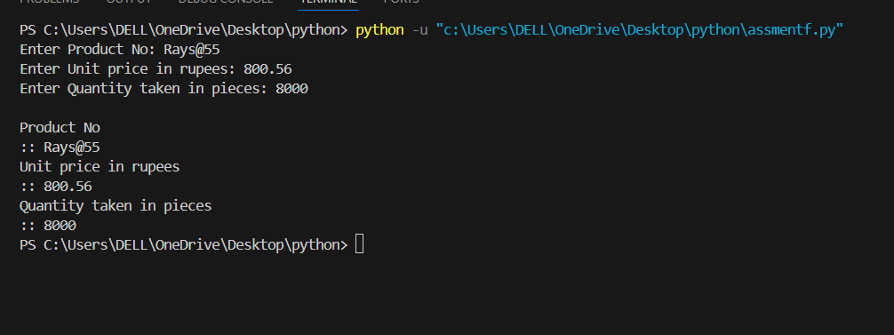
print("Unit price in rupees")
print("::", unitPrice)

print("Quantity taken in pieces")
print("::", quantity)

