# 1. WAP in “Python” language to accept two numbers from keyboard and display the sum, product and
# average of the given numbers in the following sequence and format: -
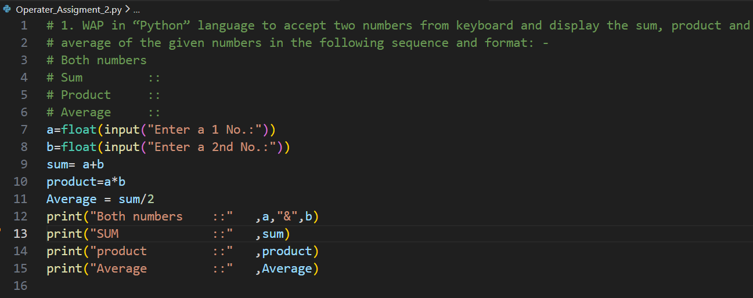
# Both numbers
# Sum ::
# Product ::
# Average ::
a=float(input("Enter a 1 No.:"))
b=float(input("Enter a 2nd No.:"))
sum= a+b
product=a*b
Average = sum/2
print("Both numbers ::" ,a,"&",b)
print("SUM ::" ,sum)
Output:
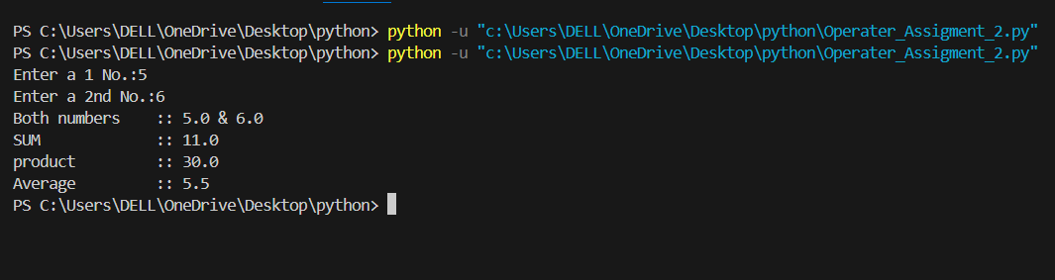
print("product ::" ,product)
print("Average ::" ,Average)

# 2. WAP in “Python” language to accept basic, da , and hra from keyboard. Calculate total and display gross salary .
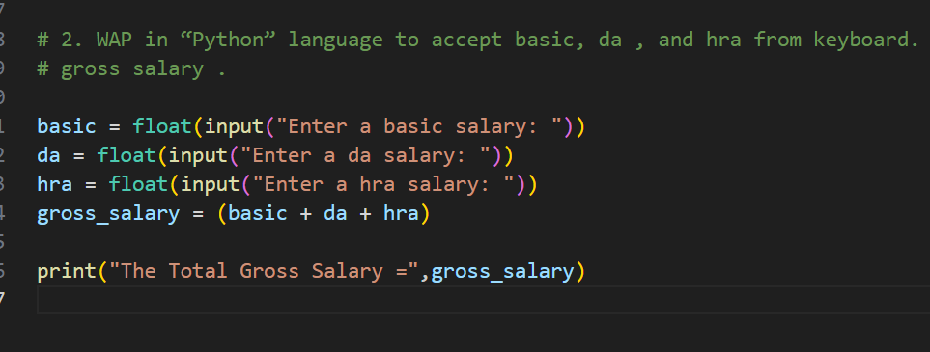
basic = float(input("Enter a basic salary: "))
da = float(input("Enter a da salary: "))
hra = float(input("Enter a hra salary: "))
gross_salary = (basic + da + hra)
print("The Total Gross Salary =",gross_salary)
Output:
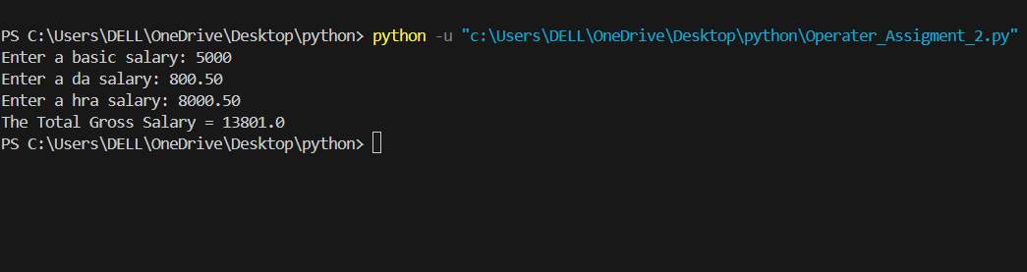

#4. WAP in “Python” language to accept student registration number and marks obtained in physics,
# chemistry, and math papers. Each paper is of maximum 100 marks. Calculate and display the result
# in the following sequence and format: -
# ========================================
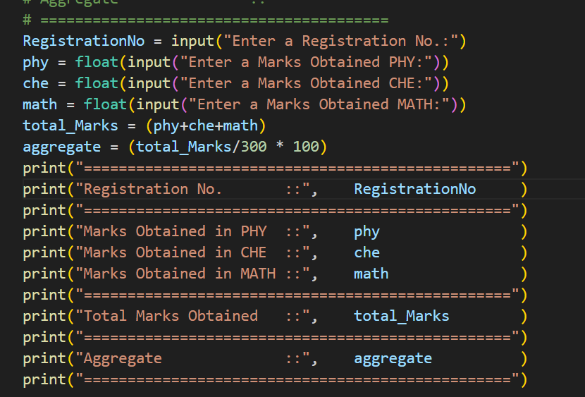
# Registration No. ::
# ========================================
# Marks Obtained in PHY ::
# Marks Obtained in CHE ::
# Marks Obtained in MATH ::
# ========================================
# Total Marks Obtained ::
# ========================================
# Aggregate ::
# ========================================
RegistrationNo = input("Enter a Registration No.:")
phy = float(input("Enter a Marks Obtained PHY:"))
che = float(input("Enter a Marks Obtained CHE:"))
math = float(input("Enter a Marks Obtained MATH:"))
total_Marks = (phy+che+math)
aggregate = (total_Marks/300 * 100)
print("=================================================")
print("Registration No. ::", RegistrationNo )
print("=================================================")
print("Marks Obtained in PHY ::", phy )
print("Marks Obtained in CHE ::", che )
print("Marks Obtained in MATH ::", math )
print("=================================================")
print("Total Marks Obtained ::", total_Marks )
print("=================================================")
print("Aggregate ::", aggregate )
print("=================================================")
Output:
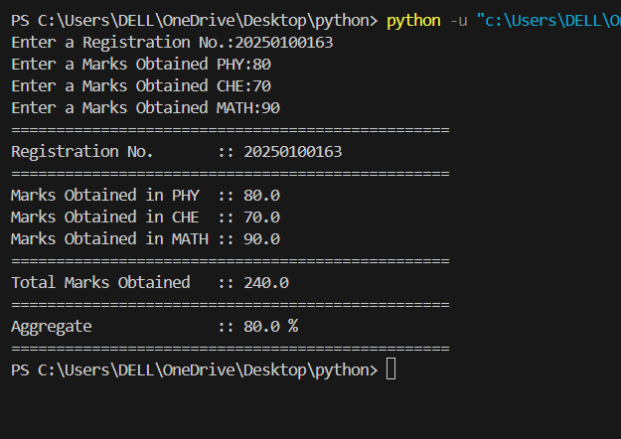

# 5. WAP in “Python” language to accept item code, unit price and quantity taken. Calculate and print
# the bill in the following sequence and format, as 20% discount available on all items.
# ========================================
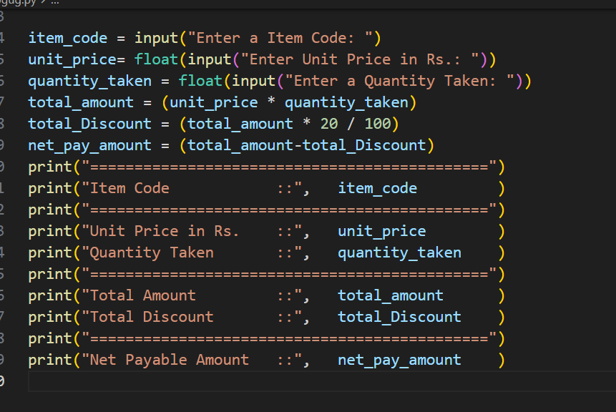
# Item Code ::
# ========================================
# Unit Price in Rs. ::
# Quantity Taken ::
# ========================================
# Total Amount in ::
# Discount Amount ::
# ========================================
# Net Payable Amount ::

item_code = input("Enter a Item Code: ")
unit_price= float(input("Enter Unit Price in Rs.: "))
quantity_taken = float(input("Enter a Quantity Taken: "))
total_amount = (unit_price * quantity_taken)
total_Discount = (total_amount * 20 / 100)
net_pay_amount = (total_amount-total_Discount)
print("=============================================")
print("Item Code ::", item_code )
print("=============================================")
print("Unit Price in Rs. ::", unit_price )
print("Quantity Taken ::", quantity_taken )
print("=============================================")
print("Total Amount ::", total_amount )
print("Total Discount ::", total_Discount )
print("=============================================")
print("Net Payable Amount ::", net_pay_amount )

output:
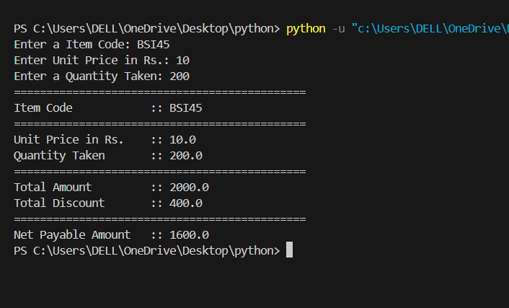

# 6. WAP in “Python” language to accept five digit no. from keyboard, calculate the sum of the digits
# of a given number and display the same on the screen.
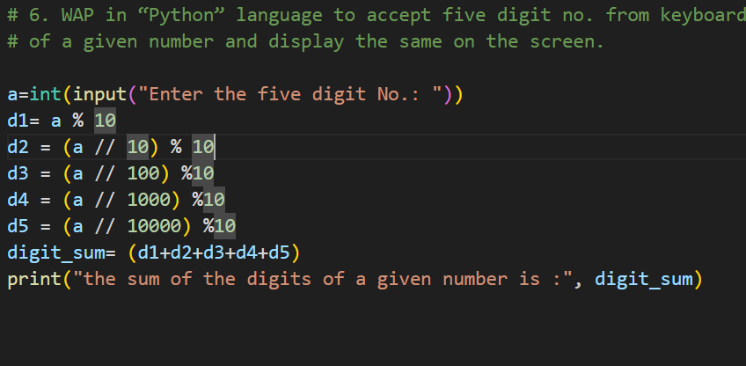

a=int(input("Enter the five digit No.: "))
d1= a % 10
d2 = (a // 10) % 10
d3 = (a // 100) %10
d4 = (a // 1000) %10
d5 = (a // 10000) %10
digit_sum= (d1+d2+d3+d4+d5)
print("the sum of the digits of a given number is :", digit_sum)

output:
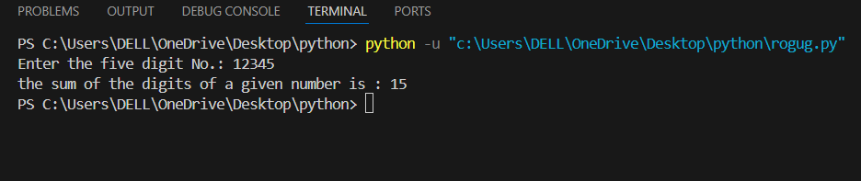

# 7. WAP in “Python” language to accept any five-digit number and print its reverse.
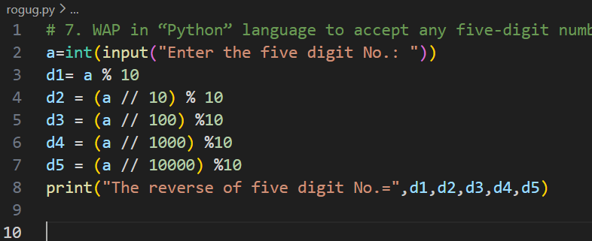
a=int(input("Enter the five digit No.: "))
d1= a % 10
d2 = (a // 10) % 10
d3 = (a // 100) %10
d4 = (a // 1000) %10
d5 = (a // 10000) %10
print("The reverse of five digit No.=",d1,d2,d3,d4,d5)
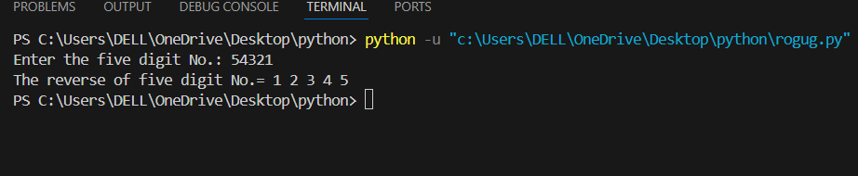

# 8. WAP in “Python” language to accept two number from keyboard and swap both to each other without
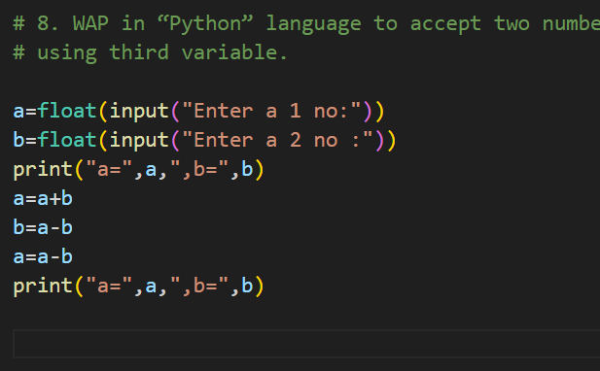
# using third variable.

a=float(input("Enter a 1 no:"))
b=float(input("Enter a 2 no :"))
print("a=",a,",b=",b)
a=a+b
b=a-b
a=a-b
print("a=",a,",b=",b)
Output:-
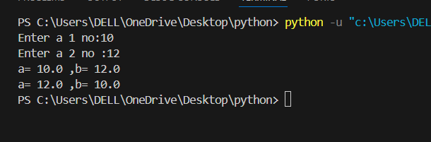

# 9. WAP in “Python” language to accept kilometer from keyboard and convert it into meters.
Kilometer = float(input("Enter a Kalometer to conver in meeter: "))
Meter = Kilometer*1000
print("meter: ",Meter,"M")
Output:-
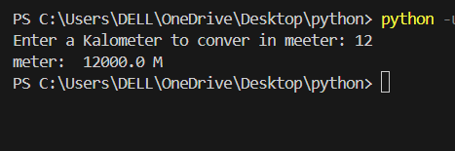
# 10. WAP in “Python” language to accept temperature of city in Fahrenheit degree then Convert this
# temperature into centigrade degrees. [Hint: c/100=(f-32)/180]

fr = float(input("Enter a Fahrenheit degree: "))
centigrade = (fr - 32) * 5 / 9
print("The centigrade degree is =", centigrade)

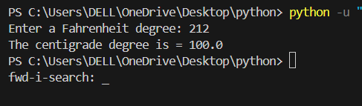

# 11. WAP in “Python” language to accept employee number and basic salary. Calculate dearness allowance
# and house rent allowance @ 10% and 15% of basic salary respectively and display the salary details as
# income tax is to be deducted @ 11% of gross salary.

emp_no = input("Enter Employee Number: ")
basic_salary = float(input("Enter Basic Salary: "))
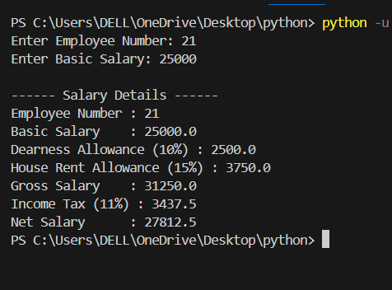
da = basic_salary * 10 / 100
hra = basic_salary * 15 / 100
gross_salary = basic_salary + da + hra
income_tax = gross_salary * 11 / 100
net_salary = gross_salary - income_tax

print("\n------ Salary Details ------")
print("Employee Number :", emp_no)
print("Basic Salary :", basic_salary)
print("Dearness Allowance (10%) :", da)
print("House Rent Allowance (15%) :", hra)
print("Gross Salary :", gross_salary)
print("Income Tax (11%) :", income_tax)
print("Net Salary :", net_salary)

# 12. WAP in “Python” language to accept the radius of a circle and calculate the circumference and area of
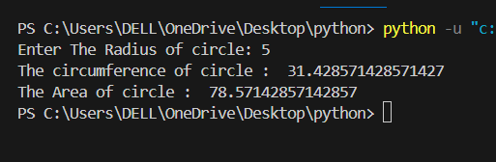
# the circle and also display the same on the screen.

radius = float(input("Enter The Radius of circle: "))
circumfrence = ( 2 *22/7 * radius )
area = (22/7 * radius * radius)

print("The circumference of circle : ",circumfrence)
print("The Area of circle : ",area)

# 13. WAP in “Python” language to accept the length and width of a rectangle and calculate its perimeter
# and area. Display the same on the screen.
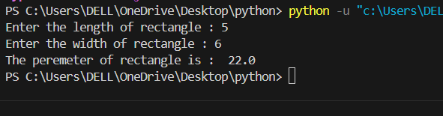
length = float(input("Enter the length of rectangle : "))
width = float(input("Enter the width of rectangle : "))

p= length+width
perim = 2*p

print("The peremeter of rectangle is : ", perim)

# 14. WAP in “Python” language to accept an integer value of five-digits, calculate and display the
# requirements as given below: -
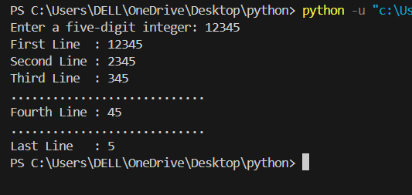
# First Line : <All Digits>
# Second Line: <All Except First Digit>
# Third Line : <All Except First Two Digits>
# …………………………………………………………………
# …………………………………………………………………
# Last Line : <The Last Digit>

num = input("Enter a five-digit integer: ")

print("First Line :", num)
print("Second Line :", num[1:])
print("Third Line :", num[2:])
print("............................")
print("Fourth Line :", num[3:])
print("............................")
print("Last Line :", num[4:])

#3. WAP in “Python” to accept total amount and currency type from keyboard and find out total no. #of note in the specified currency.
total_note = int(input("Enter Total No.:"))
cur_type = int(input("Enter Currency type as 20/10/20/50/100/200/500: "))
t_note = total_note/cur_type
print("Total Note:",t_note)

