# # 1. Wap in ‘Python’ language to accept two values and calculate highest value and lowest value.
a=int(input("Enter a 1 no.: "))
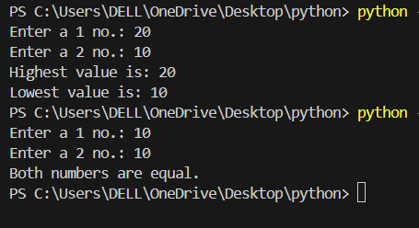
b=int(input("Enter a 2 no.: "))

if a > b:
print("Highest value is:", a)
print("Lowest value is:", b)
elif b > a:
print("Highest value is:", b)
print("Lowest value is:", a)
else:
print("Both numbers are equal.")
# # 2. Wap in ‘Python’ language to accept a number, check and display the message whether it is positive
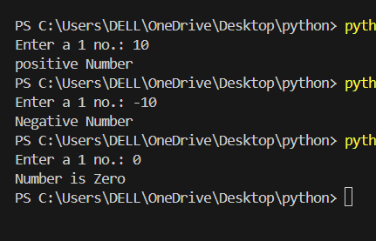
# # or negative number.

a=int(input("Enter a 1 no.: "))
if a>0:
print("positive Number")
elif a<0:
print("Negative Number")
else:
print("Number is Zero")
# 3. Wap in ‘Python’ language to accept a number, check and display the message whether it is even or
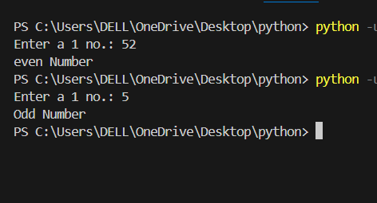
# odd number.
a=int(input("Enter a 1 no.: "))
if a%2==0:
print("even Number")
else:
print("Odd Number")

# # 4. Wap in ‘Python’ language to accept a number, check and display the message whether it is positive
# # even or positive odd or negative even or negative odd.
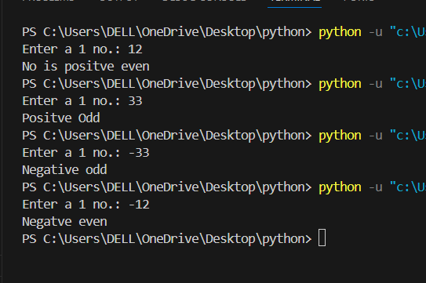
a=int(input("Enter a 1 no.: "))
if a>0:
if a%2==0:
print("No is positve even")
else:
print("Positve Odd")
elif a<0:
if a%2==0:
print("Negatve even")
else:
print("Negative odd")
else:
print("No is ZERO")

# # 5. Wap in ‘Python’ language to accept a character, check and display the message whether it is a digit
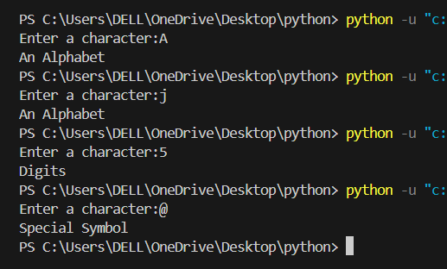
# # or an alphabet or a special symbol.
ch=ord(input("Enter a character:"))
if ch>=65 and ch<=90:
print("An Alphabet")
elif ch>=97 and ch<=122:
print("An Alphabet")
elif ch>=48 and ch<=57:
print("Digits")
else:
print("Special Symbol")

# #6 Wap in ‘Python’ to accept a character, and determine whether the character is small case or capital case
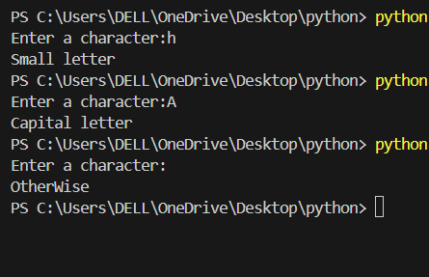
# # letter.

ch=ord(input("Enter a character:"))
if ch>=65 and ch<=90:
print("Capital letter")
elif ch>=97 and ch<=122:
print("Small letter")
elif ch>=48 and ch<=57:
print("Digits")
else:
print("OtherWise")

# # 7. Wap in ‘Python’ language to accept a number, check and display the message whether it is positive #or
# # negative or neither +ve nor –ve.
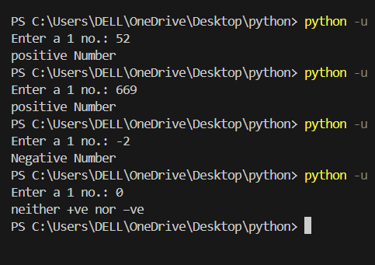

a=int(input("Enter a 1 no.: "))
if a>0:
print("positive Number")
elif a<0:
print("Negative Number")
else:
print("neither +ve nor –ve")

# # 8. Wap in ‘Python’ to accept total no. in 500 and find out percentage and display remarks, where remarks
# # will be given sequence and format:-
# # per>=30 and per < 45 pass
# # per>=45 and per <60 second
# # per>=60 and per <=100 first
# # otherwise fail.
total = 500
M = int(input("Enter total marks obtained (out of 500): "))
per = M / total * 100
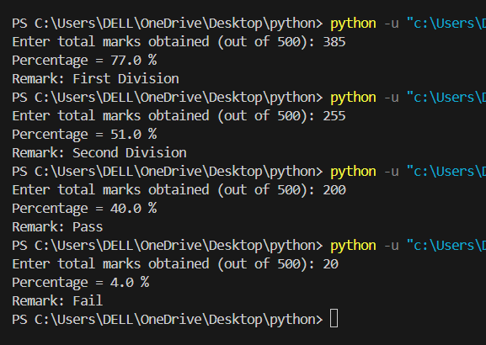
print("Percentage =", per, "%")
if per >= 30 and per < 45:
print("Remark: Pass")
elif per >= 45 and per < 60:
print("Remark: Second Division")
elif per >= 60 and per <= 100:
print("Remark: First Division")
else:
print("Remark: Fail")

# # 9. Wap in ‘Python’ to accept year and display a message whether the year is a leap year or not.
year = int(input("Enter a year: "))
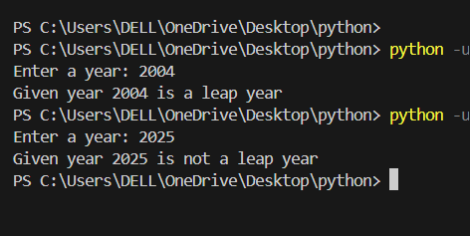
if year % 100 == 0:
if year % 400 == 0:
print("Given year", year, "is a leap year")
else:
print("Given year", year, "is not a leap year")
elif year % 4 == 0:
print("Given year", year, "is a leap year")
else:
print("Given year", year, "is not a leap year")
# # 10. Wap in ‘Python’ to accept six digit no. from keyboard, check and display a message whether given
# # number is palindrome or not.
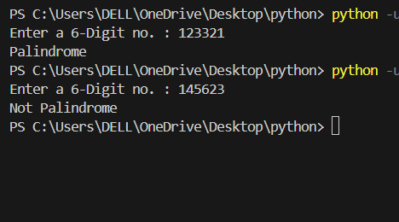
n=int(input("Enter a 6-Digit no. : "))
temp = n
d1=n%10
n=n//10
d2=n%10
n=n//10
d3=n%10
n=n//10
d4=n%10
n=n//10
d5=n%10
n=n//10
rev=d1*100000+d2*10000+d3*1000+d4*100+d5*10+n
if temp==rev:
print("Palindrome")
else:
print("Not Palindrome")
# 11. Wap in ‘Python’ language to accept three numbers, check and display the highest value on the
# standard output device, using nested if ..else.
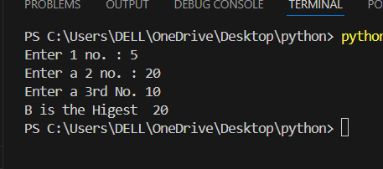
a=int(input("Enter 1 no. : "))
b=int(input("Enter a 2 no. : "))
c=int(input("Enter a 3rd No. "))

if a>b:
if a>c:
print("A is the higest",a)
else:
print("C is the higest ",c)
elif b>c:
print("B is the Higest ",b)
else:
print("C is the Higest ",c)

# # 12. Wap in ‘Python’ language to accept four numbers, check and display the highest value on the
# # standard output device, using nested if..else.
a=int(input("Enter a 1st no. : "))
b=int(input("Enter a 2nd No. : "))
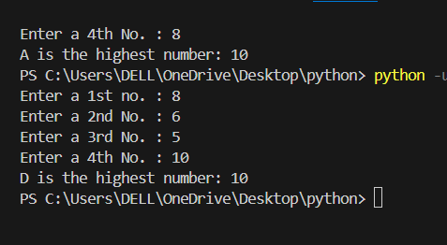
c=int(input("Enter a 3rd No. : "))
d=int(input("Enter a 4th No. : "))
if a > b:
if a > c:
if a > d:
print("A is the highest number:", a)
else:
print("D is the highest number:", d)
else:
if c > d:
print("C is the highest number:", c)
else:
print("D is the highest number:", d)
else:
if b > c:
if b > d:
print("B is the highest number:", b)
else:
print("D is the highest number:", d)
else:
if c > d:
print("C is the highest number:", c)
else:
print("D is the highest number:", d)

# 13. Wap in ‘Python’ language to accept five numbers, check and display the highest value on the
# standard output device, using nested if..else.
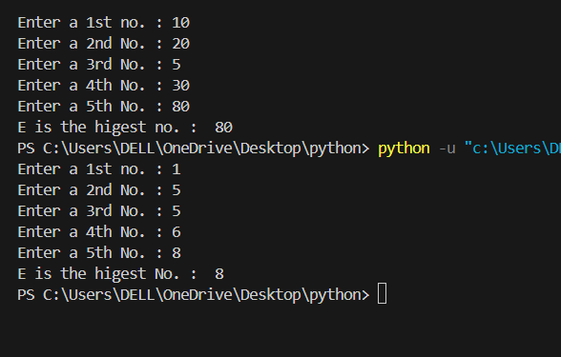
a=int(input("Enter a 1st no. : "))
b=int(input("Enter a 2nd No. : "))
c=int(input("Enter a 3rd No. : "))
d=int(input("Enter a 4th No. : "))
e=int(input("Enter a 5th No. : "))

if a > b:
if a > c:
if a > d:
if a>e:
print("A is the Higest No. : ",a)
else:
print("E is the Higest No. : ",e)
else:
if d>e:
print("D is the higest No. :",d)
else:
print("E is the higest No. : ",e)
else:
if c>e:
print("C is the higest No. : ",c)
else:
print("E is The Higest No. :",e)
else:
if b>c:
if b>d:
if b>e:
print("B is the Higest No. : ",b)
else:
print("E is the higest No. : ",e)
else:
if d>e:
print("D is the higest No. : ",d)
else:
print("E is the higest no. : ",e)
else:
if c>e:
print("C is the Higest No. : ",c)
else:
print("E is the higest No. : ",e)

# 14. Wap in ‘Python’ language for an institute to accept a student’s registration number and marks
# obtained in the papers c, cpp and java. Display the marks detail in the following format as criteria
# given below: -
# • Each paper is of maximum 60 marks.
# • Minimum pass marks in each paper is 30%.
# • No any negative marking in any paper.
# • The result will be PASS, if all the papers passed otherwise FAIL.

stud_reg = input("Enter a Regersation No. : " )
c=float(input("Enter a 'c' Marks (eg: maximum 60 marks) : "))
cpp =float(input("Enter a 'cpp' Marks (eg: maximum 60 marks) : "))
java = float(input("Enter a 'java' Marks (eg: maximum 60 marks) : "))

max_marks= 60
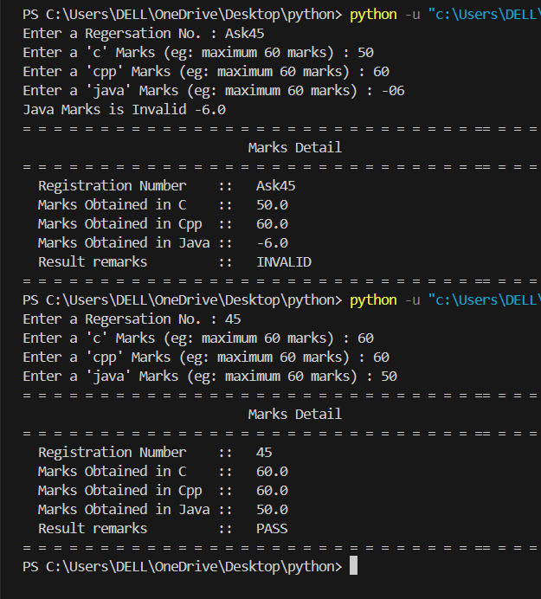
pass_marks=0.3* max_marks
result = "FAIL"

if c<0 or c>max_marks:
print("C Marks is Invalid",c)
result = "INVALID"
else:
if cpp<0 or cpp>max_marks:
print("CPP Marks is Invalid. ",cpp)
result = "INVALID"
else:
if java < 0 or java > max_marks:
print("Java Marks is Invalid",java)
result = "INVALID"
else:
# Nested PASS/FAIL checking
if c >= pass_marks:
if cpp >= pass_marks:
if java >= pass_marks:
result = "PASS"
else:
result = "FAIL"
else:
result = "FAIL"
else:
result = "FAIL"

print("= = = = = = = = = = = = = = = = = = = = = = = = = = = = = == = = = = = = = = = = =")
print(" Marks Detail")
print("= = = = = = = = = = = = = = = = = = = = = = = = = = = = = == = = = = = = = = = = =")
print(" Registration Number :: ",stud_reg)
print(" Marks Obtained in C :: ",c)
print(" Marks Obtained in Cpp :: ",cpp)
print(" Marks Obtained in Java :: ",java)
print(" Result remarks :: ",result)
print("= = = = = = = = = = = = = = = = = = = = = = = = = = = = = == = = = = = = = = = = =")

# 15.Wap in ‘C’ language for an organization to accept employee number and basic salary, calculate
# DA@10% of basic salary if the basic salary is more than 4000 otherwise @15%. Similarly calculate
# HRA@20% of basic salary if the basic salary is less than 8000 otherwise @15%. Calculate and display
# the salary detail of the employee in the following format, as income tax to be deducted @12% of Gross
# Salary if Gross Salary exceeds from 12000.

eno = input("Enter a Employees No. : ")
bas_saly = float(input("Enetr a Basics Salary. : "))
if bas_saly>4000:
da=bas_saly*10/100
else:
da=bas_saly*15/100
if bas_saly<8000:
hra =bas_saly*20/100
else:
hra= bas_saly*15/100
gross=bas_saly+da+hra
if gross>12000:
itax=gross*12/100
else:
itax=0
print("= = = = = = = = = = = = = = = = = = = = = = = = = = = = = == = = = = = = = = = = =")
print(" Salary Detail")
print("= = = = = = = = = = = = = = = = = = = = = = = = = = = = = == = = = = = = = = = = =")
print("Employee Number : ",eno)
print("Basic Salary in Rs. : ",bas_saly)
print("DA in Rs. : ",da)
print("HRA in Rs. : ",hra)
print("Gross Salary in Rs. : ",gross)
print("Income Tax Deduction in Rs. : ",itax)
print("Net Payable Amount in Rs. : ",gross-itax)
print("= = = = = = = = = = = = = = = = = = = = = = = = = = = = = == = = = = = = = = = = =")

