# 1. Wap in “Python‟ language to display “Python is General Purpose language” five times.
i=1
while i<=5:
print("Python is General Purpose language")
i=i+1
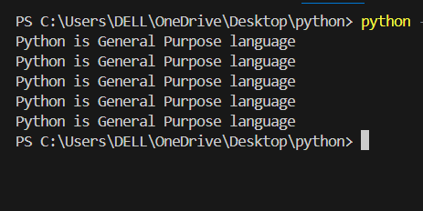
# 2. Wap in “Python‟ language to display “I like „Python‟ very much!” three times and each after two
# lines.
i=1
while i<=2:
print("“I like „Python‟ very much!”")
i=i+1
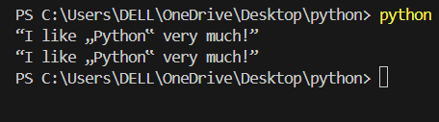
# 3. Wap in “Python‟ language to display “I like „Python‟ very much!” continuously until a zero is
# pressed.
while True:
print("“I like „Python‟ very much!”")
user=input("Press 0 to stop: ")
if user=='0':
break
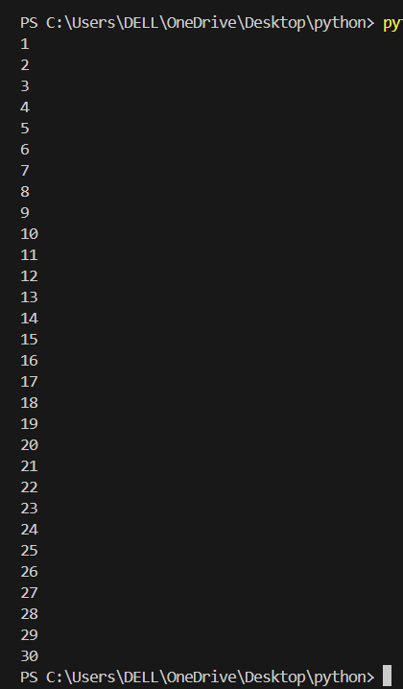
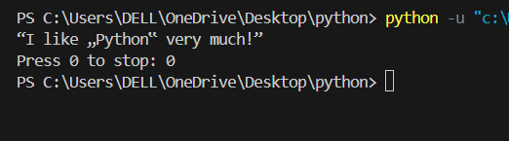
# 4. Wap in “Python‟ language to display the counting
# starting from 1 and up to 30.
i=1
while i<=30:
print(i)
i=i+1

# 5. Wap in “Python‟ language to display the following format:-
# 1) 1 2 3 ... up to 19
i=1
while i<=19:
print(i,end=" ")
i=i+1
print("\n")
# ¬ 1 3 5......................... Up to 19
i=1
while i<=19:
print(i,end=" ")
i=i+2
print("\n")
# ¬ 1 4 7......................... Up to 19
i=1
while i<=19:
print(i,end=" ")
i=i+3
print("\n")

# ¬ 19 18 17.................... Up to 1

i=19
while i>=1:
print(i,end=" ")
i=i-1
print("\n")

# ¬ 19 17 15.................... Up to 1
i=19
while i>=1:
print(i,end=" ")
i=i-2
print("\n")

# ¬ 19 16 13.................... Up to 1
i=19
while i>=1:
print(i,end=" ")
i=i-3
print("\n")

# ¬ 2 4 8.......................... Up to 20
i=2
while i<=19:
print(i,end=" ")
i=i+2
print("\n")

# ¬ 3 6 9.......................... Up to 30
i=3
while i<=30:
print(i,end=" ")
i=i+3
print("\n")
# ¬ 4 8 12........................ Up to 40
i=4
while i<=40:
print(i,end=" ")
i=i+4
print("\n")
# ¬ 20 18 16..................... Up to 2
i=20
while i>=2:
print(i,end=" ")
i=i-2
print("\n")
# ¬ 30 27 23..................... Up to 3
i=30
while i>=3:
print(i,end=" ")
i=i-3
print("\n")
# ¬ 40 38 36..................... Up to 4
i=40
while i>=4:
print(i,end=" ")
i=i-4
print("\n")

# ¬ 1 4 9........................... Up to 100
i=1
while i<=100:
print(i,end=" ")
i=i+3
print("\n")
# ¬ 1 8 27......................... Up to 1000
i=1
while i**3 <=1000:
print(i**3,end=" ")
i=i+1
print("\n")

# ¬ 1 16 81....................... Up to 10000
i=1
while i**4 <=10000:
print(i**4,end=" ")
i=i+1
print("\n")
# ¬ 1 10 100..................... Up to 1000000000
i=1
while i<=1000000000:
print(i,end=" ")
i=i*10
print("\n")
# ¬ 1000000000................... Up to 1
i=1000000000
while i>=1:
print(i,end=" ")
i=i//10
print("\n")
# ¬ 123456789
i=1
while i<=9:
print(i,end="")
i=i+1
print("\n")

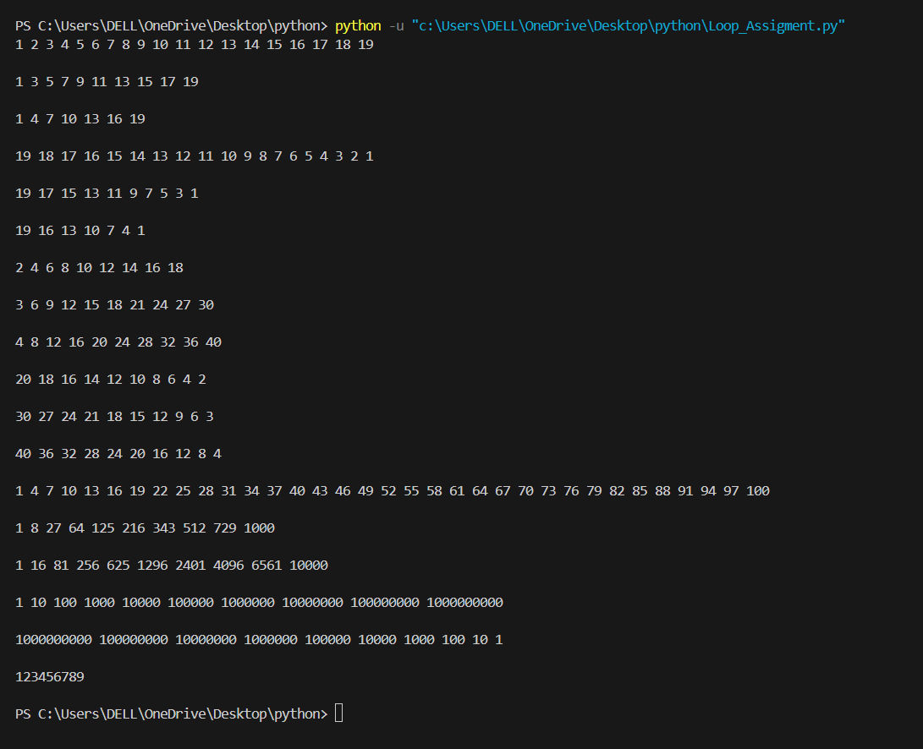

# 6. Wap in “Python‟ language to accept thirty numbers calculate and display the sum, product
c = 1
t = 0
p = 1
while c <= 30:
num = float(input("Enter number " + str(c) + ": "))
t = t + num
p = p * num
c = c + 1
average = t / 30
print("\nSum =", t)
print("Product =", p)
print("Average =", average)

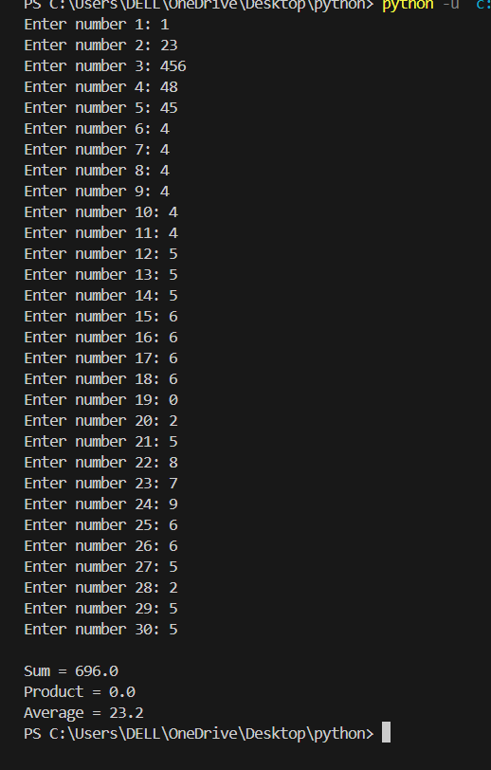

# 7. Wap in “Python‟ language to accept N numbers calculate and display the sum, product and
# average value.
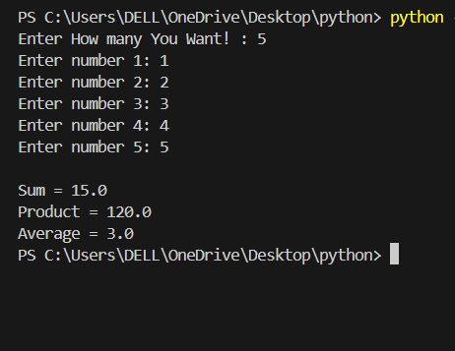
n=int(input("Enter How many You Want! : "))
c = 1
t = 0
p = 1
while c <= n:
num = float(input("Enter number " + str(c) + ": "))
t = t + num
p = p * num
c = c + 1
average = t / n
print("\nSum =", t)
print("Product =", p)
print("Average =", average)

# 8. Wap in “Python‟ language to accept N numbers calculate and display the total count of even and
# odd numbers.
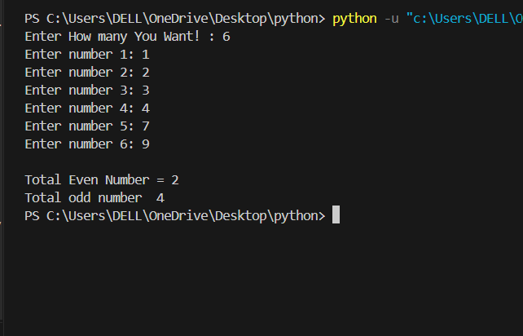
n=int(input("Enter How many You Want! : "))
c = 1
even_c=0
odd_c=0
while c <= n:
num = float(input("Enter number " + str(c) + ": "))
if num%2==0:
even_c +=1
else:
odd_c +=1
c +=1
print("\nTotal Even Number =", even_c)
print("Total odd number ", odd_c)

# 9. Wap in “Python‟ language to accept N numbers calculate and display the total count of +
# ve
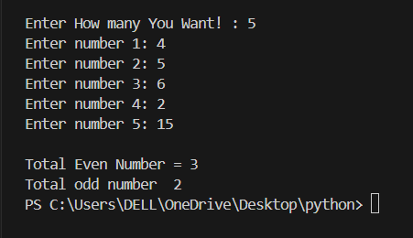
# even
# and -
# ve odd numbers.
n=int(input("Enter How many You Want! : "))
c = 1
even_c=0
odd_c=0
while c <= n:
num = float(input("Enter number " + str(c) + ": "))
if num%2==0:
even_c +=1
else:
odd_c +=1
c +=1
print("\nTotal Even Number =", even_c)
print("Total odd number ", odd_c)

# 10. Wap in “Python‟ language to accept N characters one-by-one calculate and display the total count
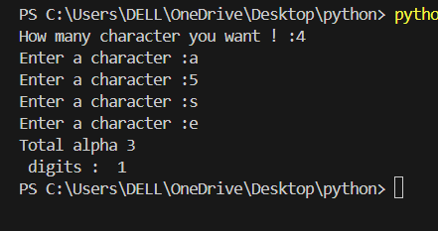
# of digits and alphabets.

n=int(input("How many character you want ! :"))
i=1
dig=alp=0
for i in range(1,n+1):
ch=ord(input("Enter a character :"))
if (ch>=65 and ch<=90) or (ch>=97 and ch<122):
alp=alp+1
elif ch>=48 and ch<=57:
dig=dig+1
i=i+1
print("Total alpha",alp , "\n digits : ",dig)

# 11. Wap in “Python‟ language to accept N numbers check and display the smallest and largest value
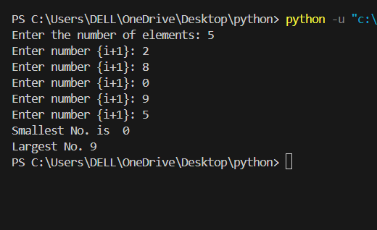
n=int(input("Enter the number of elements: "))
number = []
for i in range(n):
num = int(input("Enter number {i+1}: "))
number.append(num)
smallest=min(number)
largest=max(number)
print("Smallest No. is ",smallest,"\nLargest No.",largest)

# 12. Wap in “Python‟ language to accept a number calculates and display the total count of digits.
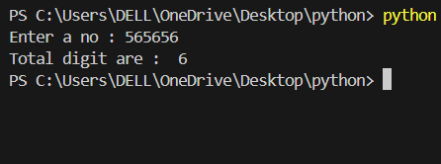
# n=input("Enter a No., You Want! :")
# c=len(n)
# print("The count of digits ",n," is : ",c)

n=int(input("Enter a no : "))
i=0
while n>0:
n=n//10
i=i+1
print("Total digit are : ",i)

# 13. Wap in “Python‟ language to accept a number calculates and display the sum, product and
# average of the digits.
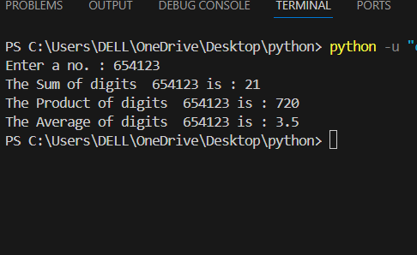
n=input("Enter a no. : ")
b=len(n)
n=int(n)
sum=0
product=1
temp=n
while n>0:
d=n%10
sum=sum+d
product=product*d
n = n // 10
avg = sum/b
print("The Sum of digits ",temp,"is :",sum)
print("The Product of digits ",temp,"is :",product)
print("The Average of digits ",temp,"is :",avg)

# # 14. Wap in “Python‟ language to generate even series from 1 to 50.
i=1
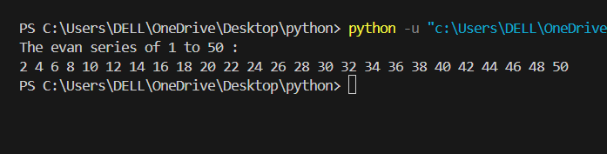
print("The evan series of 1 to 50 :")
while i<=50:
if i%2==0:
print(i,end=" ")
i=i+1

# 15. Wap in “Python‟ language to generate odd series from 1 to 50.
print("Odd series from 1 to 50:")
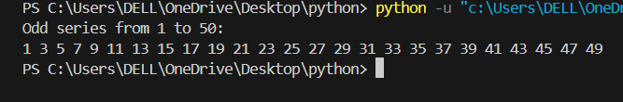
for i in range(1,51):
if i%2 !=0:
print(i)
i=i+1

# 16. Wap in “Python‟ language to accept a number, display it in reverse order
n=int(input("Enter a no. : "))
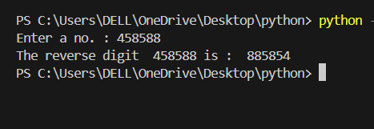
reverse_num = 0
num = n
while num > 0:
digit = num % 10
reverse_num = reverse_num * 10 + digit
num = num // 10
print("The reverse digit ",n,"is : ",reverse_num)

# 17. Wap in “Python‟ language to generate a table of any number.
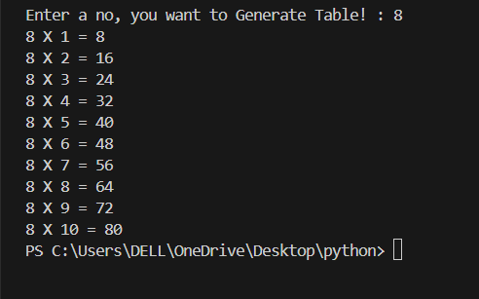
n=int(input("Enter a no, you want to Generate Table! : "))
i=1
for i in range (1,11):
print(n,"X", i, "=" ,n*i)
# 18. Wap in “Python‟ language to accept a number, check and display whether the number is prime or not.
n=int(input("Enter a No to check, prime or Not-prime : "))
if n<=1:
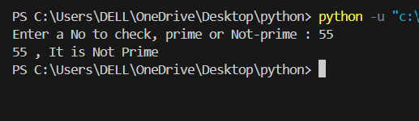
print(n,", It is Not prime.")
else:
i = 2
while i < n:
if n % i == 0:
print(n,", It is Not Prime")
break
i += 1
else:
print(n,", It is Prime")
# 19. Wap in “Python‟ language to accept initial and final position and find the prime numbers between the
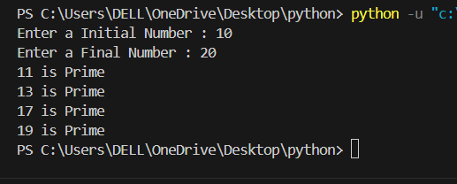
# initial and final position.
initial=int(input("Enter a Initial Number : "))
final=int(input("Enter a Final Number : "))
num=initial
while num<=final:
if num>1:
i=2
while i<num:
if num% i==0:
break
i+=1
else:
print(num, "is Prime")
num +=1
# 20. Wap in “Python‟ language to accept a number, check and display message whether it perfect
#number or not.
n=int(input("Enter a no : "))
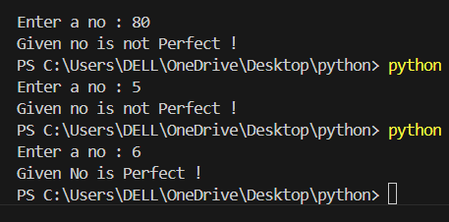
d=2
s=1
while d<=n/2:
if n%d==0:
s=s+d
d=d+1
if s==n:
print("Given No is Perfect !")
else:
print("Given no is not Perfect !")

# 21. Wap in “Python‟ language to accept a number, check and display whether the number is Armstrong
# or not.
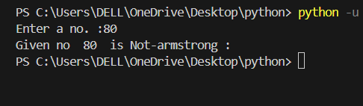
n=input("Enter a no. :")
b=len(n)
n=int(n)
s=0
temp = n
while n>0:
d=n%10
s=s+d**n
n=n//10
if temp==s:
print("Given no ",temp," is armstrong : ")
else:
print("Given no ",temp," is Not-armstrong : ")

# 22. Wap in “Python‟ language to accept initial and final position, print Armstrong number between initial
# and final position.
initial=int(input("Enter a Initial Number : "))
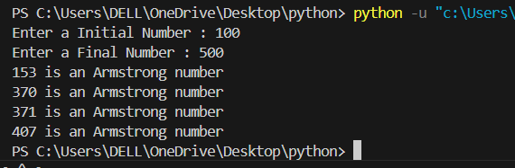
final=int(input("Enter a Final Number : "))
num=initial
while num<=final:
temp = num
sum_of_cubes = 0
while temp > 0:
digit = temp % 10
sum_of_cubes += digit ** 3
temp //= 10
if sum_of_cubes == num:
print(num, "is an Armstrong number")
num +=1
# 23. Wap in “Python‟ language to accept a number and display its factorialvalue.
# using for loop:
n=int(input("Enter a no. : "))
fact =1
for n in range(n,0,-1):
fact=fact*n
print("The factorial is : ",fact)
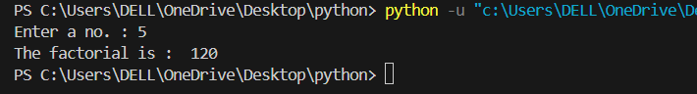

# 30. Wap in “Python‟ language to display 20 terms of Fibonacci series . (i.e 0,1,1,2,3,.).
a=0
b=1
i=1
print("Fibonancii seriecs are: ",a,b,end=" ")
while i<=18:
c=a+b
a=b
b=c
print(c,end=" ")
i=i+1
# 31. Wap in “Python‟ language to accept a positive integer value, determine and print its binary
# equivalent.
num = float(input("Enter a positive integer: "))
if num < 0:
print("Please enter a positive integer.")
else:
if num == 0:
print("Binary equivalent is: 0")
else:
binary = ""
while num > 0:
remainder = num % 2
binary = str(remainder) + binary
num = num // 2
print("Binary equivalent is:", binary)

# 31. Wap in “Python‟ language to accept a positive integer value, determine and print its binary
# equivalent.
num = float(input("Enter a positive integer: "))
if num < 0:
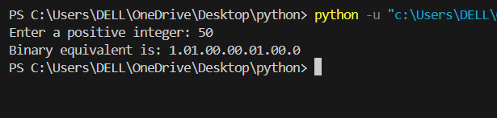
print("Please enter a positive integer.")
else:
if num == 0:
print("Binary equivalent is: 0")
else:
binary = ""
while num > 0:
remainder = num % 2
binary = str(remainder) + binary
num = num // 2
print("Binary equivalent is:", binary)

# 32. Wap in “Python‟ language to accept a positive value, convert into hexadecimal equivalent.
n = int(input("Enter a number: "))
hexa = ""
while n > 0:
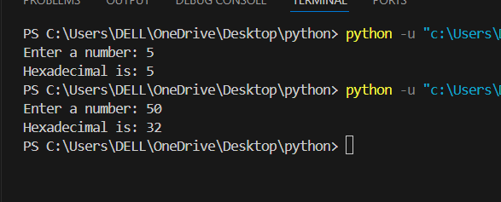
d = n % 16
n = n // 16
if d == 10:
hexa = "A" + hexa
elif d == 11:
hexa = "B" + hexa
elif d == 12:
hexa = "C" + hexa
elif d == 13:
hexa = "D" + hexa
elif d == 14:
hexa = "E" + hexa
elif d == 15:
hexa = "F" + hexa
else:
hexa = str(d) + hexa

print("Hexadecimal is:", hexa)
# 33. Wap in “Python‟ language to display the total count of Leap Years between 1000 and 2009.
year = 1000
count = 0
while year <= 2009:
if (year % 4 == 0 and year % 100 != 0) or (year % 400 == 0):
count += 1
year += 1

print("Total number of leap years between 1000 and 2009 is:", count)
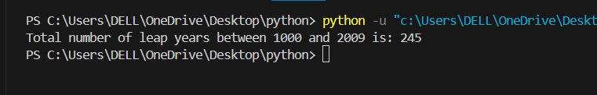
# 35. Wap in “Python‟ language to calculate and display the Fibonacci series up to n terms.
# [Hint: 0 1 1 2 3 5 8 13 21 …..]
a=0
b=1
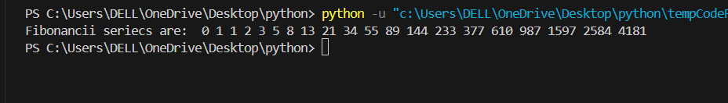
i=1
print("Fibonancii seriecs are: ",a,b,end=" ")
while i<=18:
c=a+b
a=b
b=c
print(c,end=" ")
i=i+1
# 36. Write a program in “Python‟ to generate the following given series:-
# using for loop:
n=int(input("Enter a no. : "))
fact =1
for n in range(n,0,-1):
fact=fact*n
print("The factorial is : ",fact)
###
for i in range(1,6):
print(" "*(5-i),"*"*(2*i-1),sep="")

##########
# # using for loop
for i in range(1,6):
j=1
for j in range(1,i+1):
print("*",end="")
print()
#############
for i in range(1,6):
for j in range(1,i+1):
print((i+j)%2,end=" ")
print()
