HR Tier-0 Agent
Architecture & Implementation Guide
Google ADK + LiteLLM + Ollama + Qwen3 + Qdrant + Docker
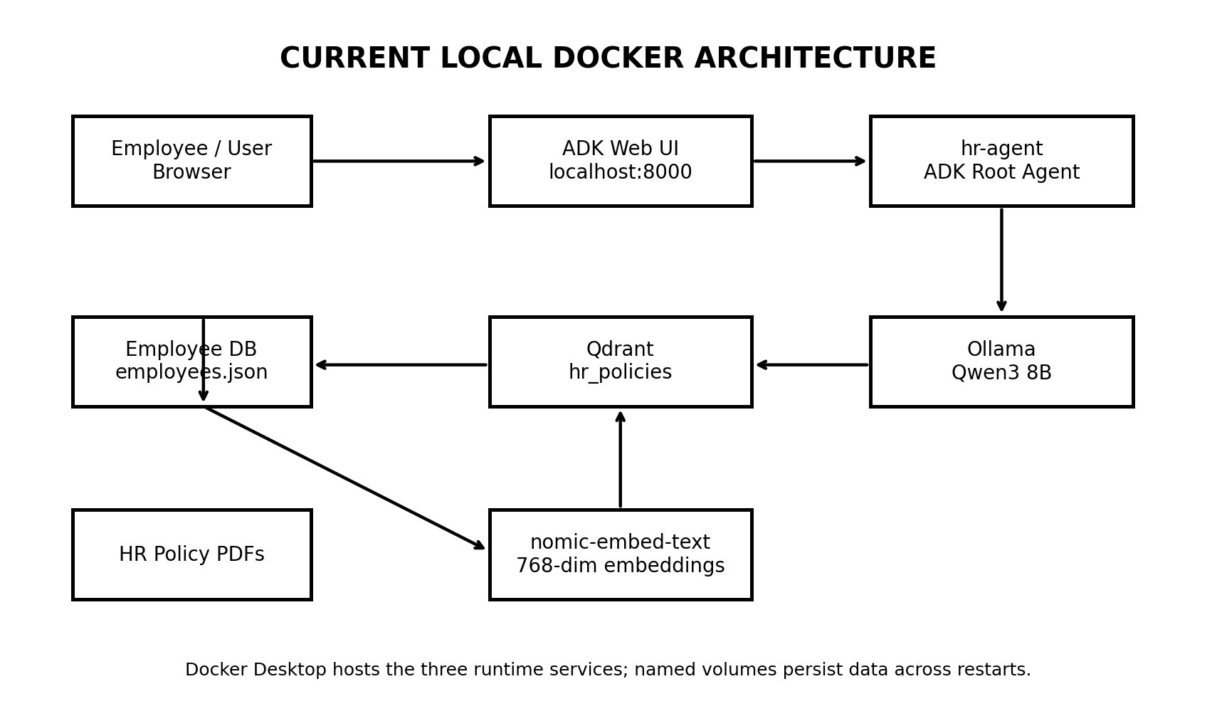
Figure 1. Current local Docker architecture
Prepared from the current HR_Agent implementation and runtime configuration.

1. Executive Summary
This document explains the HR Tier-0 employee assistant from the employee request all the way through authorization, agent reasoning, tool execution, RAG retrieval, local LLM inference, and response generation. It also documents the Docker deployment model currently running on the Mac.
The current implementation is a local, self-hosted stack. The ADK Web interface is exposed on localhost:8000; the ADK agent runs in the hr-agent container; Ollama runs Qwen3 8B and the nomic-embed-text embedding model; and Qdrant stores the HR policy vectors.
The architecture is intentionally separated into agent logic, tools, guardrails, callbacks, RAG, configuration, and data. This separation makes it possible to evolve the prototype into a larger multi-agent or enterprise-style HR assistant without replacing the foundation.

2. Architecture at a Glance
Figure 2. Current architecture: user → ADK → tools/RAG → local services
The current runtime contains three Docker services:
- hr-agent — Python 3.14 application containing Google ADK, the root agent, callbacks, tools, and RAG code.
- ollama — local LLM runtime. Qwen3 8B is the current chat model; nomic-embed-text is used for embeddings.
- qdrant — vector database containing the hr_policies collection and the indexed policy chunks.

3. Component Responsibilities
Component | Responsibility | Current implementation
Employee | Asks HR questions and receives answers. | ADK Web browser UI
Root ADK Agent | Entry point; interprets the request and decides which capability/tool to use. | hr_assistant Agent
Planner | Supports model-side reasoning/planning before execution. | ADK BuiltInPlanner
Authorization callback | Checks identity/authorization before the agent proceeds. | before_agent_callback
Employee DB tool | Returns employee-specific data. | employees.json
RAG tool | Searches official HR policy knowledge. | search_hr_policies
RAG retriever | Embeds the query and searches Qdrant. | top_k=5, cosine
Ollama | Runs local inference and embeddings. | Qwen3 8B + nomic-embed-text
Qdrant | Stores and retrieves policy vectors. | hr_policies, 81 chunks
Callbacks | Observe/intercept lifecycle events. | Authorization callback now; more can be added
Evals | Measure agent quality and safety. | ADK Evals area available; evaluation suite is future work
Docker Compose | Runs the services together. | hr-agent + ollama + qdrant

4. End-to-End Request Flow
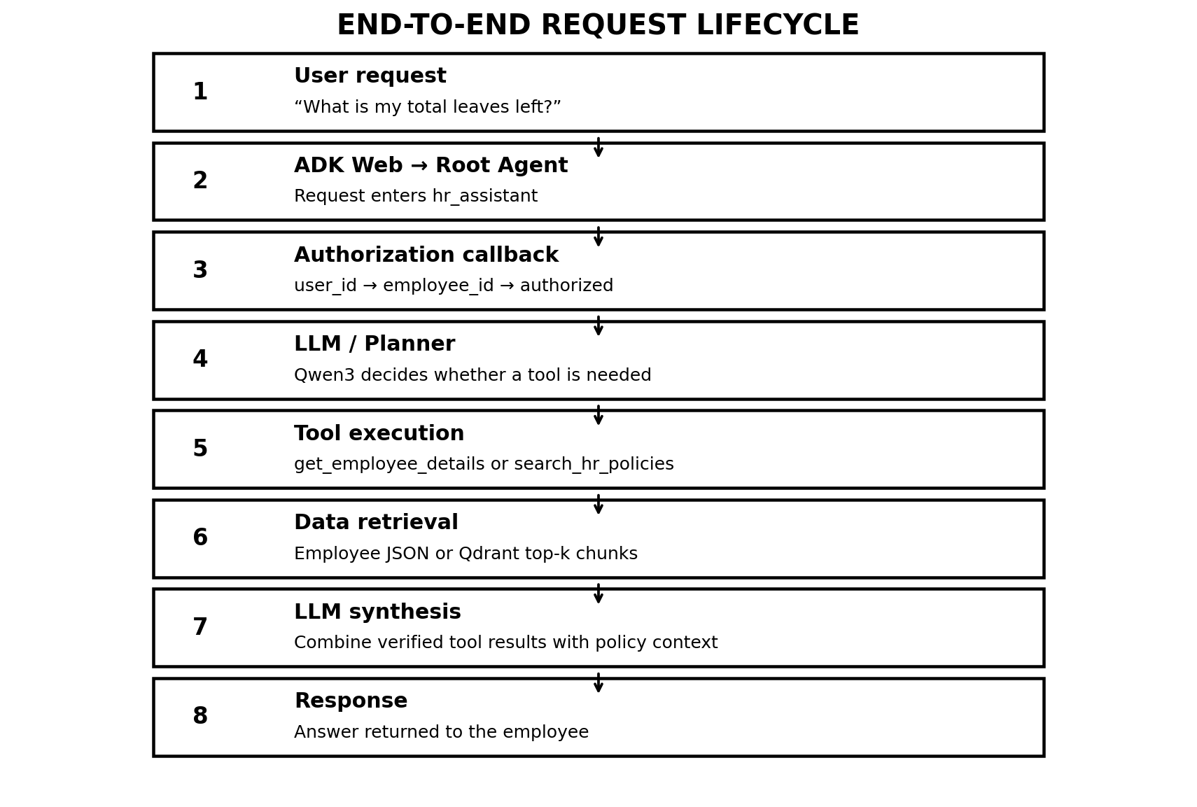
Figure 3. Example request lifecycle

Step 1 — Employee submits a request
Example: “Hi, what is my total leaves left?” The request is submitted through the ADK Web UI running at http://localhost:8000. The browser only needs access to the ADK service; it does not directly communicate with Ollama or Qdrant.

Step 2 — ADK receives the invocation
The request enters the root agent, named hr_assistant. The root agent is the entry point for the employee assistant and has access to the employee-details and HR-policy tools.

Step 3 — Authorization callback runs
The before_agent_callback executes before normal agent processing. In the current implementation it reads callback_context.user_id, validates the employee through the authorization guardrail, and stores employee_id and authorized=True in session state. The ADK Web event screenshot showed this state being populated before the model call.

Step 4 — Planner/model determines the required capability
The root agent uses ADK BuiltInPlanner with a thinking budget of 1024 and include_thoughts=False. The model decides whether the request can be answered directly or whether a tool is required.

Step 5 — Tool execution
For employee-specific information, the get_employee_details tool is the relevant deterministic data-access capability. For policy questions, search_hr_policies calls the RAG retriever.

Step 6 — Tool/data result is returned to the agent
The tool returns structured data. The model then uses the tool result rather than inventing an employee record or policy statement.

Step 7 — Response synthesis
The model produces the natural-language response. A future production version should add an output validation callback/guardrail to verify that sensitive information is not exposed and that policy answers are grounded in retrieved sources.

Step 8 — Response reaches the employee
ADK returns the final response to the Web UI. The ADK event/trace interface can be used during development to inspect the invocation lifecycle.

5. Root Agent Design
The root agent currently follows this pattern:
root_agent = Agent(
model=LiteLlm(
model=settings.MODEL,
api_base=settings.OLLAMA_HOST,
),
name="hr_assistant",
instruction=HR_ASSISTANT_INSTRUCTION,
planner=BuiltInPlanner(
thinking_config=types.ThinkingConfig(
include_thoughts=False,
thinking_budget=1024,
)
),
tools=[
get_employee_details,
search_hr_policies,
],
before_agent_callback=authorize_employee,
)
Important distinction: the current code has a root agent and ADK BuiltInPlanner, but it does not yet have a separate custom Orchestrator component. The earlier target architecture separates Planner and Orchestrator conceptually so that planning and deterministic execution can later be expanded into multiple specialized agents.

Recommended future agent decomposition
- HR Policy Agent — policy and procedure questions using RAG.
- Employee Data Agent — employee-specific balances, profile information, and status.
- Case/Service Agent — HR case creation and case-status operations.
- Escalation Agent — decides when a human HR case is required.
- Root Orchestrator — routes the request to one or more specialized capabilities.

6. Authorization and Guardrails
Authorization is intentionally implemented before the agent performs normal reasoning. This is important because employee data is sensitive: the model should not be the authority for deciding whether a user is allowed to access a record.
def authorize_employee(callback_context: CallbackContext):
employee_id = callback_context.user_id
if not employee_id:
return access_denied()
if not is_employee_authorized(employee_id):
return access_denied()
callback_context.state["employee_id"] = employee_id
callback_context.state["authorized"] = True
return None
Conceptually:
- Authentication answers: “Who is the user?”
- Authorization answers: “Is this user allowed to access the HR system/data?”
- The LLM should not be trusted as the authorization authority.
- For production, the user identity should come from SSO/OIDC rather than asking the employee to type an ID into the chat.

7. Employee Database Tool
The current prototype uses employees.json as the employee data source. The tool reads the file, finds the matching employee_id, and returns structured information. This makes the data access deterministic and easy to test.
Current path:
hr_assistant/data/employees/employees.json
A production deployment should replace the JSON file with PostgreSQL or the organization's actual HR system and keep the same tool contract so the agent layer does not need to know the database implementation.

8. RAG Architecture
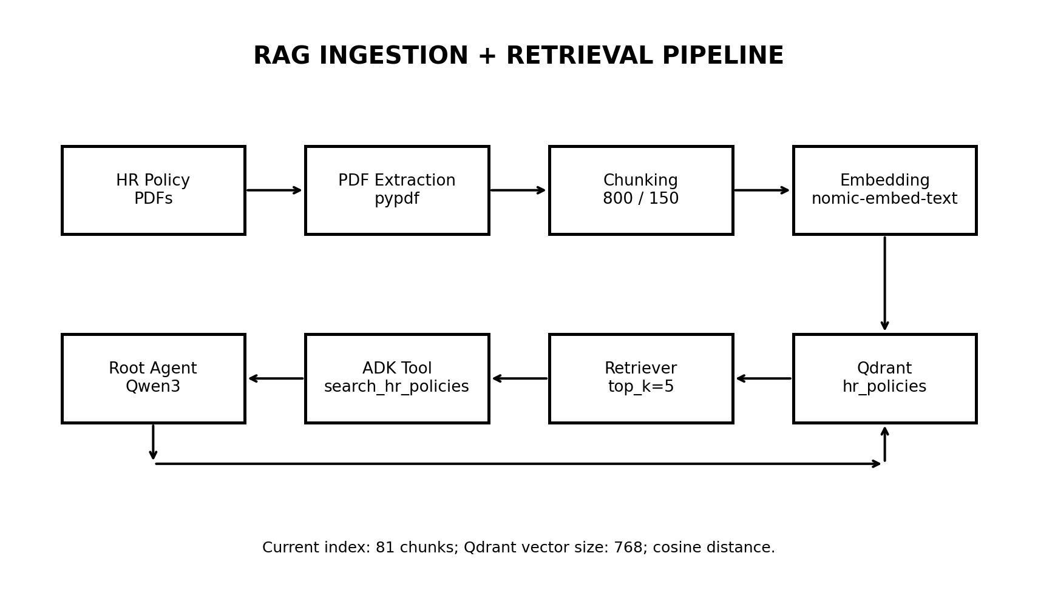
Figure 4. Current HR policy RAG pipeline
The current RAG pipeline has two phases: ingestion and retrieval.

8.1 Ingestion phase
- Read HR policy PDFs with pypdf.
- Extract text page by page.
- Split text into chunks of approximately 800 characters with 150-character overlap.
- Generate an embedding for each chunk with nomic-embed-text.
- Create the Qdrant hr_policies collection using the embedding dimension.
- Store the vector and payload containing text, source, and chunk_id.
The current index contains 81 chunks. The observed vector size is 768 and the distance metric is cosine.

8.2 Retrieval phase
- Employee asks a policy question.
- search_hr_policies receives the natural-language query.
- The retriever generates an embedding for the query using the same embedding model.
- Qdrant performs vector similarity search.
- The current retriever requests top_k=5 results.
- The tool returns the retrieved text and source metadata to the agent.
- The LLM uses that evidence to formulate the answer.

8.3 Why RAG is used
HR policies are organization-specific and can change independently of the model. RAG lets the application retrieve current policy content at query time rather than expecting the LLM's pretrained knowledge to contain the organization's internal rules.

9. Local LLM Layer: Ollama + Qwen3 8B
Ollama is running as a separate Docker service. The current chat model is Qwen3 8B. The earlier Gemma 4 12B attempt failed because the Docker VM had only 7.75 GiB RAM and the model's runtime memory requirement exceeded the available headroom. Qwen3 8B was successfully pulled and generated a response inside the Ollama container.
Current model configuration:
MODEL=ollama_chat/qwen3:8b
EMBEDDING_MODEL=nomic-embed-text
OLLAMA_HOST=http://ollama:11434
QDRANT_URL=http://qdrant:6333
LiteLLM provides the model abstraction used by the ADK agent. Its provider-specific api_base must point to the Ollama service. LiteLLM documents Ollama usage with a model name and an api_base endpoint.

10. Docker Networking — A Critical Concept
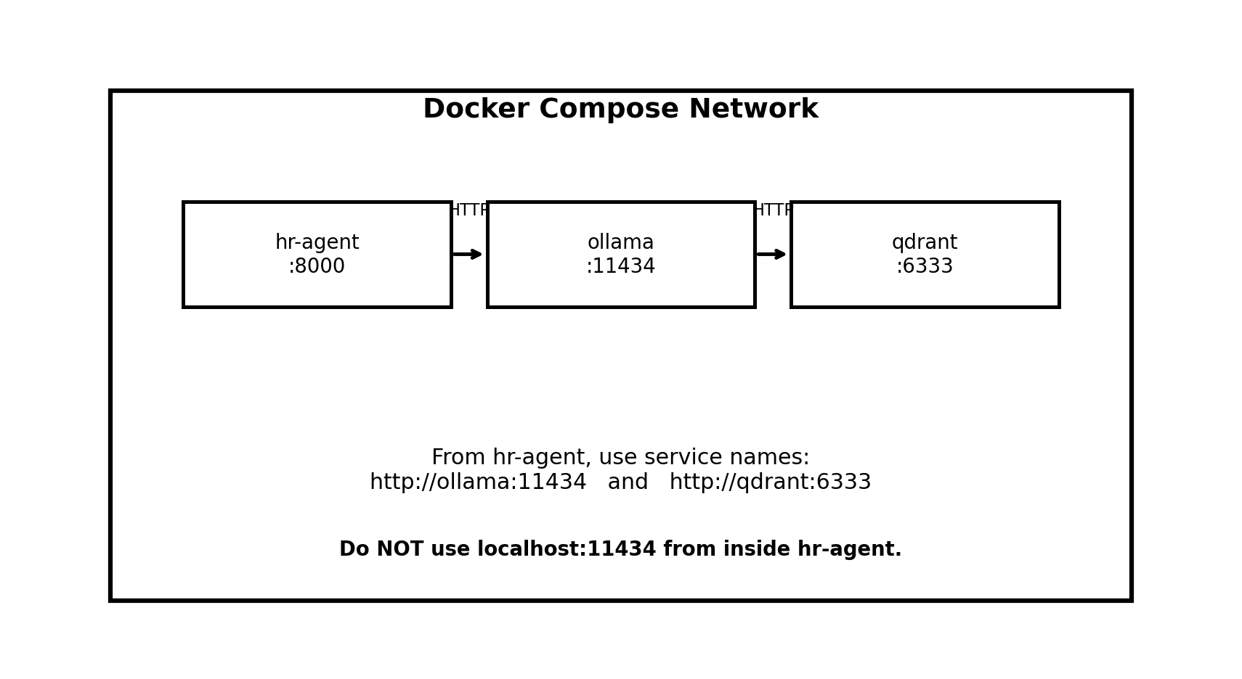
Figure 5. Docker service-to-service networking
The ADK Web UI is opened from the Mac at http://localhost:8000. Inside Docker, however, localhost means the current container. Therefore hr-agent must not use localhost:11434 to reach Ollama.
Correct:
http://ollama:11434
Incorrect from inside hr-agent:
http://localhost:11434
Docker Compose provides service-name DNS. The name ollama resolves to the Ollama container and qdrant resolves to the Qdrant container.

11. Docker Compose Runtime
The current stack is conceptually:
services:
hr-agent:
build: .
ports:
- "8000:8000"
environment:
MODEL: "ollama_chat/qwen3:8b"
EMBEDDING_MODEL: "nomic-embed-text"
OLLAMA_HOST: "http://ollama:11434"
QDRANT_URL: "http://qdrant:6333"
ollama:
image: ollama/ollama:latest
ports:
- "11434:11434"
volumes:
- ollama_data:/root/.ollama
qdrant:
image: qdrant/qdrant:latest
ports:
- "6333:6333"
volumes:
- qdrant_data:/qdrant/storage
Named volumes are important. docker compose down stops/removes the containers but keeps named volumes. docker compose down -v removes the named volumes and therefore deletes the stored Ollama model data and Qdrant storage.

12. ADK Web: Events, State and Traces
The ADK Web interface is not only a chat screen. During development it exposes execution information such as events, state and traces. In the current screenshot, the authorization callback is visible as a state update containing employee_id and authorized before the model error occurs.
This is useful for debugging because it lets the developer distinguish between failures in authorization, model connectivity, tool execution, and downstream services.

Typical debugging interpretation
- State shows employee_id/authorized → authorization callback executed.
- Model connection error → inspect OLLAMA_HOST, model name, and Docker network.
- Tool error → inspect the tool code and its data source.
- RAG retrieval issue → inspect embeddings, Qdrant collection, vector dimension, and top-k results.
- Unexpected answer → inspect retrieved chunks, tool output, prompt, and evaluation cases.

13. Project Structure and Responsibilities
HR_Agent/
├── hr_assistant/
│ ├── agent.py
│ ├── prompt/
│ │ └── instruction.py
│ ├── tools/
│ │ ├── employee_db_tool.py
│ │ └── rag_tool.py
│ ├── callbacks/
│ │ └── authorization_callback.py
│ ├── guardrails/
│ │ └── authorization.py
│ ├── rag/
│ │ ├── ingestion.py
│ │ ├── chunking.py
│ │ ├── embeddings.py
│ │ ├── vector_store.py
│ │ └── retriever.py
│ ├── core/
│ │ ├── config.py
│ │ ├── state.py
│ │ ├── constants.py
│ │ ├── exceptions.py
│ │ └── logging.py
│ └── data/
│ ├── employees/
│ │ └── employees.json
│ └── policies/
├── evals/
├── scripts/
├── tests/
├── Dockerfile
├── docker-compose.yml
├── requirements.txt
└── .dockerignore
The separation is intentional: tools perform deterministic actions, RAG manages knowledge retrieval, callbacks handle lifecycle interception, guardrails constrain access, and core contains shared infrastructure.

14. Current vs. Target Architecture
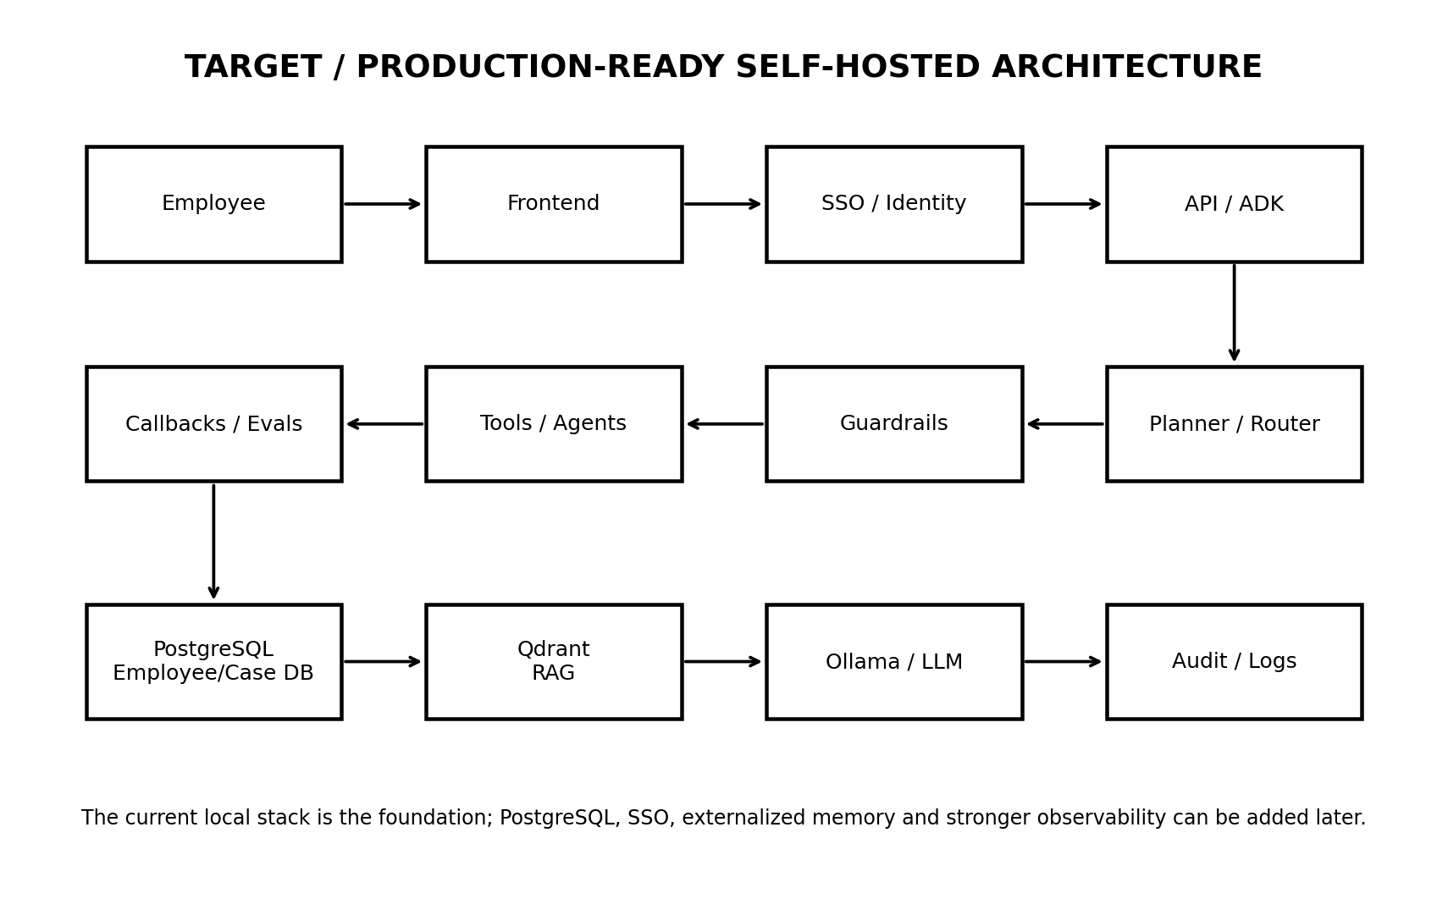
Figure 6. Target architecture for a more complete self-hosted HR assistant
The current implementation is the foundation. The following components are natural next steps:
- PostgreSQL instead of employees.json for durable employee and case data.
- SSO/OIDC so user identity comes from the organization's identity provider.
- Explicit specialized agents for policy, employee data, cases, and escalation.
- A deterministic orchestrator/router for multi-step workflows.
- Output guardrails for sensitive HR information.
- Persistent memory/session storage where business requirements justify it.
- Structured audit logging and evaluation datasets.
- Health checks and startup dependencies in Docker Compose.
- Stable vector IDs so repeated ingestion does not create ID collisions.
- A production API/frontend instead of relying on the ADK Web development UI.

15. Planner vs. Orchestrator vs. Tool
Layer | Question answered | Example | Determinism
Planner | What steps/capabilities are needed? | Need employee balance → call employee tool | LLM-driven
Orchestrator | How should those steps be executed? | Call employee tool, then policy tool if needed | Can be deterministic
Tool | What concrete operation should run? | Read employee record / search Qdrant | Deterministic
RAG | What knowledge supports the answer? | Retrieve policy chunks | Deterministic retrieval
In the current prototype, ADK's BuiltInPlanner handles planning support and the root agent directly owns the available tools. A dedicated orchestrator becomes valuable when workflows span multiple agents/tools or require strict execution order.

16. Guardrails: Recommended Layers
- Input guardrail — reject malformed or unsupported requests.
- Identity guardrail — establish authenticated user identity.
- Authorization guardrail — confirm the employee is allowed to access the requested data.
- Tool guardrail — prevent tools from being called with another employee's identifier.
- RAG grounding guardrail — require policy answers to have supporting retrieved evidence.
- Output guardrail — prevent leakage of secrets, unnecessary personal data, or unsupported HR claims.
- Escalation guardrail — route sensitive cases to human HR instead of improvising an answer.

17. Evaluation Strategy
A useful evaluation suite should test the system at several levels:
- Planner accuracy — did the agent choose the right capability?
- Tool selection — did it call employee DB vs. policy RAG appropriately?
- RAG retrieval — were the correct policy chunks retrieved?
- Groundedness — is the answer supported by the retrieved evidence?
- Authorization — can one employee access another employee's data?
- Safety — does the system avoid exposing unnecessary sensitive information?
- Escalation — does the system recognize requests that require human HR?
- End-to-end quality — is the final answer correct, concise, and actionable?
Evaluation should include both positive and adversarial cases. For example, test direct employee questions, policy questions, ambiguous requests, attempts to request another employee's information, and questions where the policy corpus contains no answer.

18. Operational Commands
# Start the complete stack
docker compose up -d
# Rebuild after code changes
docker compose up -d --build
# Check services
docker compose ps
# View ADK logs
docker compose logs hr-agent --tail=100
# View Ollama logs
docker compose logs ollama --tail=100
# View Qdrant logs
docker compose logs qdrant --tail=100
# Check the configured model
docker compose exec hr-agent python -c \
"from hr_assistant.core.config import settings; print(settings.MODEL)"
# Test Ollama
docker compose exec ollama ollama run qwen3:8b "Say hello in one sentence."
# Open ADK Web
http://localhost:8000

19. Current Milestone
At the time this document was created, the following pieces had been validated:
Area | Status | Evidence
Docker | Working | hr-agent, ollama and qdrant containers running
ADK Web | Working | Available on localhost:8000
Authorization callback | Working | State shows employee_id and authorized
Qwen3 8B | Working | Direct Ollama inference succeeded
nomic-embed-text | Working | 768-dimensional embeddings generated
Qdrant | Working | hr_policies collection with 81 chunks
RAG retrieval | Working | Top-k retrieval returned policy documents
Gemma 4 12B | Not used | Failed under 7.75 GiB Docker memory; Qwen3 8B selected
Dedicated orchestrator | Planned | Not yet implemented as a separate component
PostgreSQL | Planned | Current prototype uses employees.json
Production SSO | Planned | Current callback uses ADK user_id

20. Recommended Implementation Sequence
- Stabilize the current Qwen3 + ADK + tool + RAG flow.
- Add a clean session/state model and structured logging.
- Move employee data from JSON to PostgreSQL.
- Add a real authentication/SSO integration and map identity to employee_id.
- Create explicit specialized agents for policy, employee data, case management, and escalation.
- Introduce a deterministic orchestrator for multi-step workflows.
- Add input/output/tool guardrails.
- Build an evaluation dataset and automated regression tests.
- Add health checks and reliable startup ordering to Docker Compose.
- Add a frontend/API layer and treat ADK Web as development tooling.

21. References
Google ADK documentation and developer materials:
https://google.github.io/adk-docs/
LiteLLM documentation:
https://docs.litellm.ai/docs/
The LiteLLM documentation specifically shows Ollama usage with an api_base endpoint; this is relevant to the Docker networking configuration described in this guide.

End of Architecture Guide

