FINANCIAL OPERATIONS
ANALYTICS

U.S. Superstore | Revenue, Profitability & Customer Churn Analysis

$2.3M  Total Sales | $286K  Total Profit | 0.848  Churn Model AUC | $70–115K  Est. Profit Uplift/Year

Niraj Mehta
MS Engineering Management | Northeastern University
nirajmehta960@gmail.com | GitHub | LinkedIn

1. Executive Summary
Retail businesses need to understand not just revenue but where they make or lose money. This project analyzes four years of transactional data (2014–2017) from a U.S. Superstore operating across Furniture, Office Supplies, and Technology categories in all 50 states. The analysis is structured around three pillars:
- Revenue Analysis & Forecasting — trends, decomposition, 3–6 month forecast
- Profitability Deep-Dive — sub-category P&L, discount–profit analysis, regional/segment performance
- Customer Churn Prediction — churn rate (365-day inactivity), behavioral drivers, classification model (AUC-ROC target ≥ 0.70)
The dataset includes actual profit per transaction, enabling true P&L analysis rather than revenue-only tracking. The best churn model achieved 0.848 AUC-ROC (Logistic Regression), exceeding the 0.70 target. The primary recommendation — capping standard discounts at 20% — is projected to improve annual profit by $50K–$80K, with a combined improvement of $70K–$115K/year across all initiatives.

# | Finding | Detail
1 | ~$2.3M sales, ~$286K profit | ~12.5% margin; Tables, Bookcases, and Supplies at net loss
2 | Discount cliff at 20% | Beyond ~20% discount, profit margins collapse; 40%+ discounts largely unprofitable
3 | Churn drivers identified | Order frequency, category breadth, discount level, and customer segment
4 | Top recommendation | Cap standard discounts at 20%; est. profit improvement $50K–$80K/year
Table 1: Key Findings Summary

2. Data Source & Methodology

2.1 Dataset Overview
The analysis uses the Superstore Sales Dataset (Kaggle/Tableau sample data), comprising 9,993 transaction line items across 21 columns from January 2014 through December 2017. The dataset covers 793 unique customers, 5,009 unique orders, 4 regions, and all 50 U.S. states. Critically, the dataset includes actual profit per transaction, which is essential for financial operations analysis.

2.2 Data Pipeline Architecture
The project implements a four-stage pipeline: raw data ingestion, preprocessing (cleaning, deduplication, type standardization), feature engineering (order-level and customer-level aggregation, churn labeling), and model-ready output. Data leakage was identified and mitigated by excluding recency_days from model features, as it directly defines the churn target variable.
Feature engineering produced customer-level metrics including order_count, total_spent, total_profit, avg_discount, avg_shipping_days, avg_order_value, avg_profit_margin, tenure_days, unique_categories, and unique_subcategories. Customer churn is defined as no purchase in the last 365 days of the dataset window.

2.3 Tools & Technologies
Category | Tools
Languages | Python, SQL
Data Processing | Pandas, NumPy
Machine Learning | Scikit-learn (Logistic Regression, Random Forest, Gradient Boosting)
Visualization | Matplotlib, Seaborn
Dashboard | Power BI (5-page executive dashboard, star-schema model, DAX measures)
Environment | Jupyter Lab, GitHub
Table 2: Tools & Technologies

3. Revenue Analysis

3.1 Monthly Revenue & Profit Trend
Revenue and profit show clear seasonality with Q4 peaks each year. Over the four-year period, both revenue and profit demonstrate an upward growth trajectory. The business generated approximately $2.3M in total sales and $286K in profit, yielding an overall margin of approximately 12.5%.
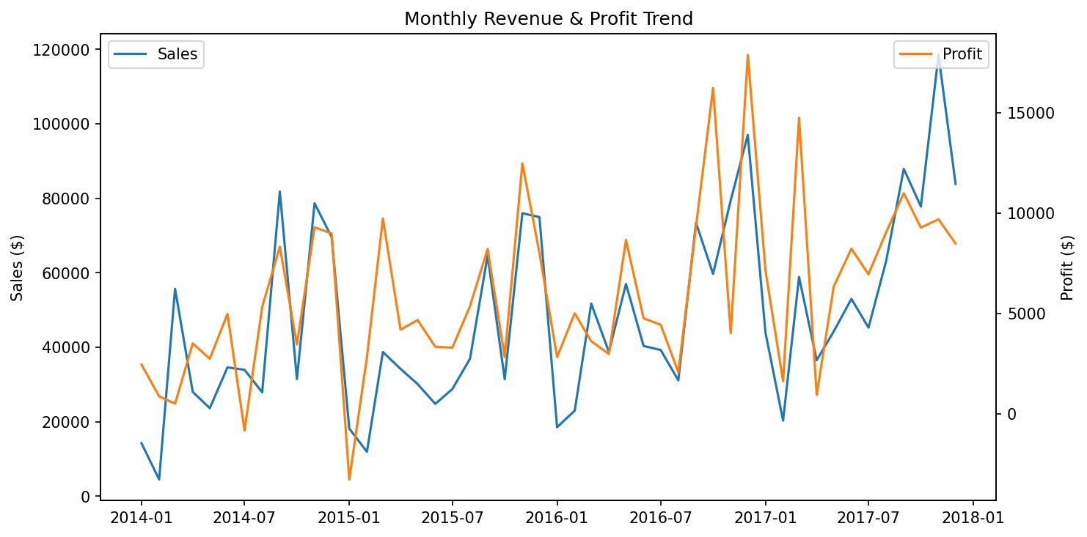
Figure 1: Monthly Revenue & Profit Trend (2014–2017)

3.2 Sub-Category Profitability (P&L)
Sub-category analysis reveals that not all high-revenue lines are profitable. Tables, Bookcases, and Supplies are net-loss sub-categories despite generating significant sales. In contrast, Copiers and Paper deliver the highest profit margins (39% and 36% respectively). This mismatch between revenue and profit underscores the need for pricing and discount strategy review.
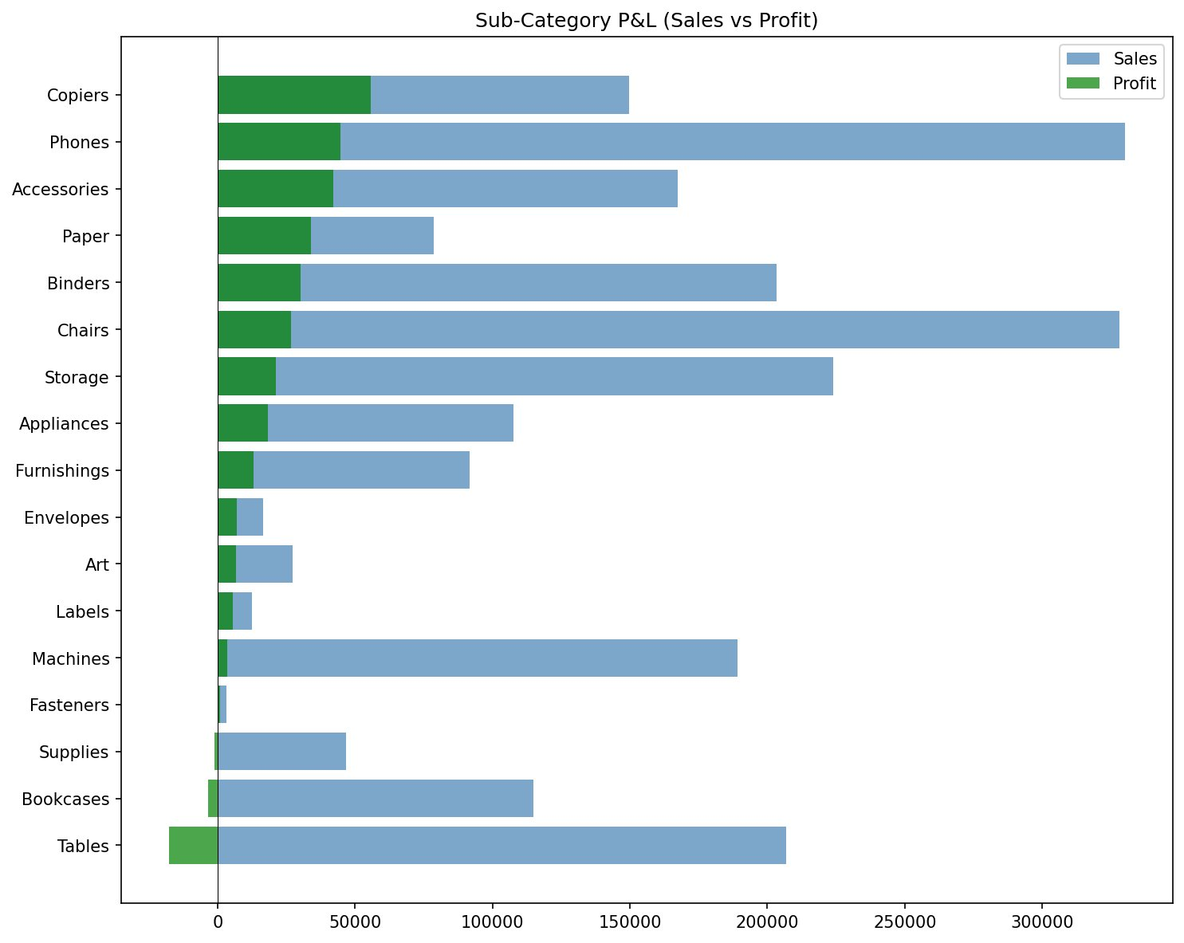
Figure 2: Sub-Category P&L — Sales vs. Profit

4. Profitability Deep-Dive

4.1 Discount vs. Profit Analysis
Transaction-level analysis reveals a clear "discount cliff": at discount levels above approximately 20%, average per-transaction profit turns negative. The scatter plot shows that while 0–10% discounts maintain healthy margins, heavy discounts (21–30%) and extreme discounts (31%+) generate consistent losses. This finding is the basis for the primary recommendation to cap standard discounts at 20%.
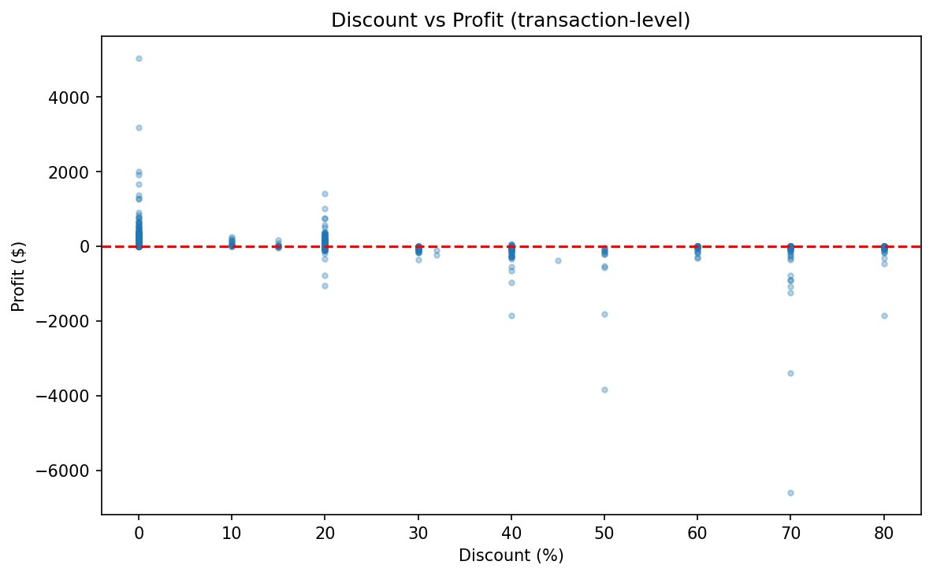
Figure 3: Discount vs. Profit — Transaction-Level Scatter

4.2 Discount Band Analysis
Grouping transactions into five discount bands confirms the cliff effect. No-discount and light-discount (1–10%) transactions average $67 and $95 profit respectively. Moderate discounts (11–20%) still maintain positive average profit at ~$25. However, heavy (21–30%) and extreme (31%+) bands average -$38 and -$100+ per transaction, respectively.
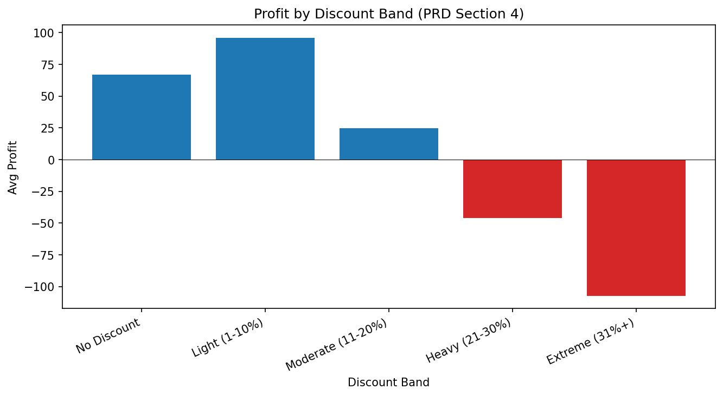
Figure 4: Average Profit by Discount Band

4.3 Regional & Segment Performance
The West region leads in both sales and profit margin (~15%), followed by the East (~13.5%). The Central region underperforms at approximately 8% margin, driven largely by Furniture losses. By segment, Home Office achieves the highest margin (~14%) despite lower volume, while Consumer (the largest segment) operates at ~11.5% margin.
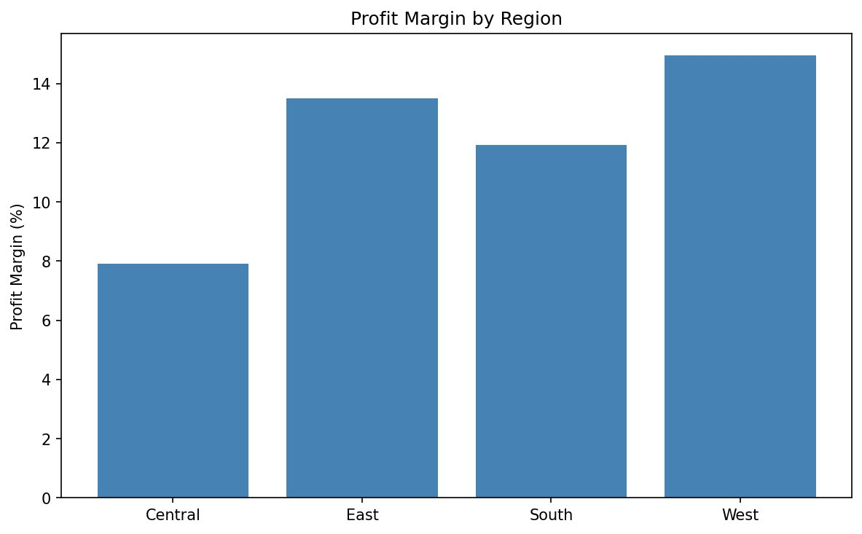
Figure 5: Profit Margin by Region
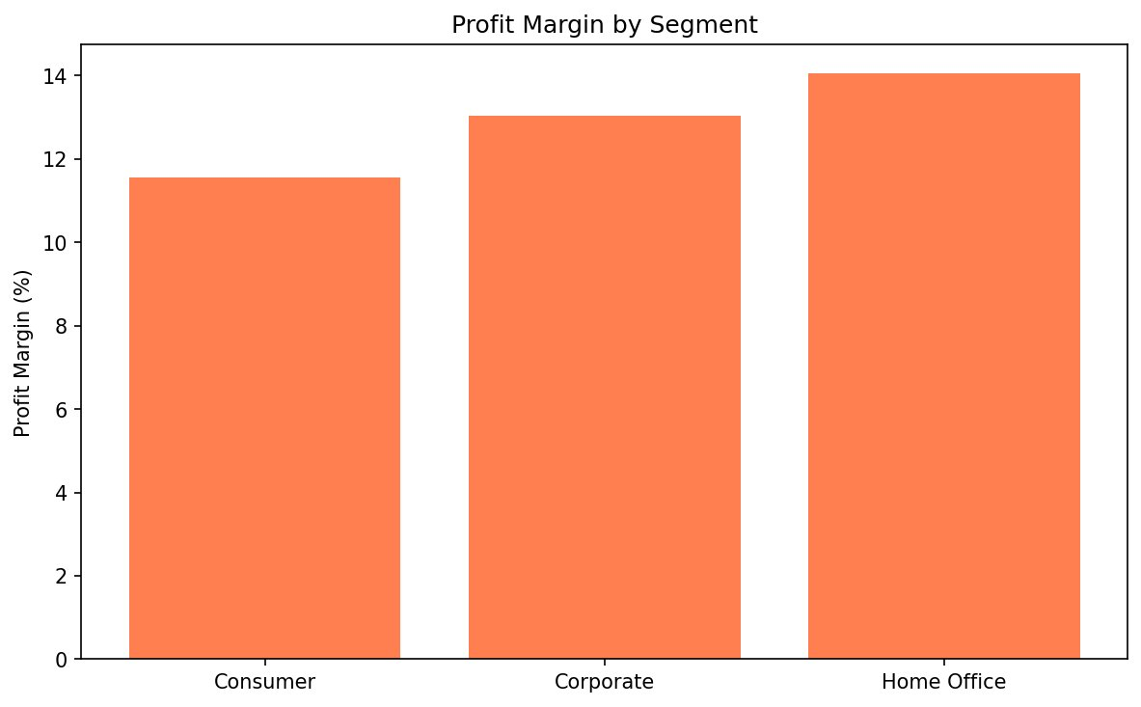
Figure 6: Profit Margin by Segment

5. Customer Churn Prediction

5.1 Target Variable Distribution
Customer churn is defined as 365+ days of inactivity from the last observed order date. Approximately 12.5% of the 793 customers are classified as churned (~100 customers), creating a moderately imbalanced classification problem.
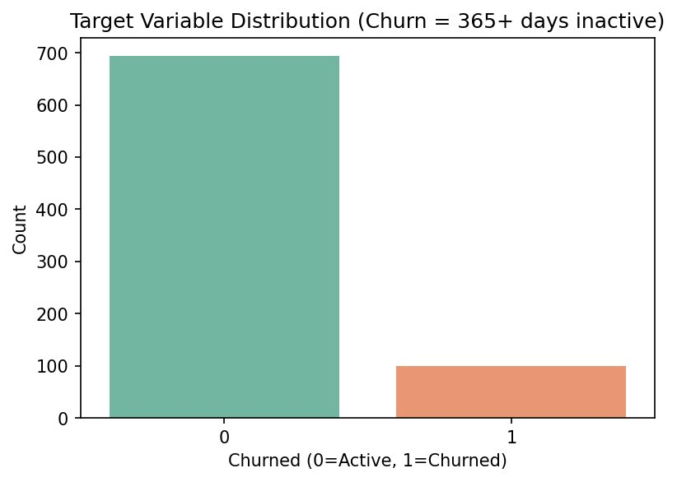
Figure 7: Churn Target Distribution (Active vs. Churned)

5.2 Feature Correlation
The customer-level correlation matrix reveals that order_count, total_spent, and unique_subcategories are strongly correlated, informing feature selection decisions. Tenure_days shows moderate positive correlation with churn — however, recency_days was excluded from all models as it directly defines the churn target, avoiding data leakage.
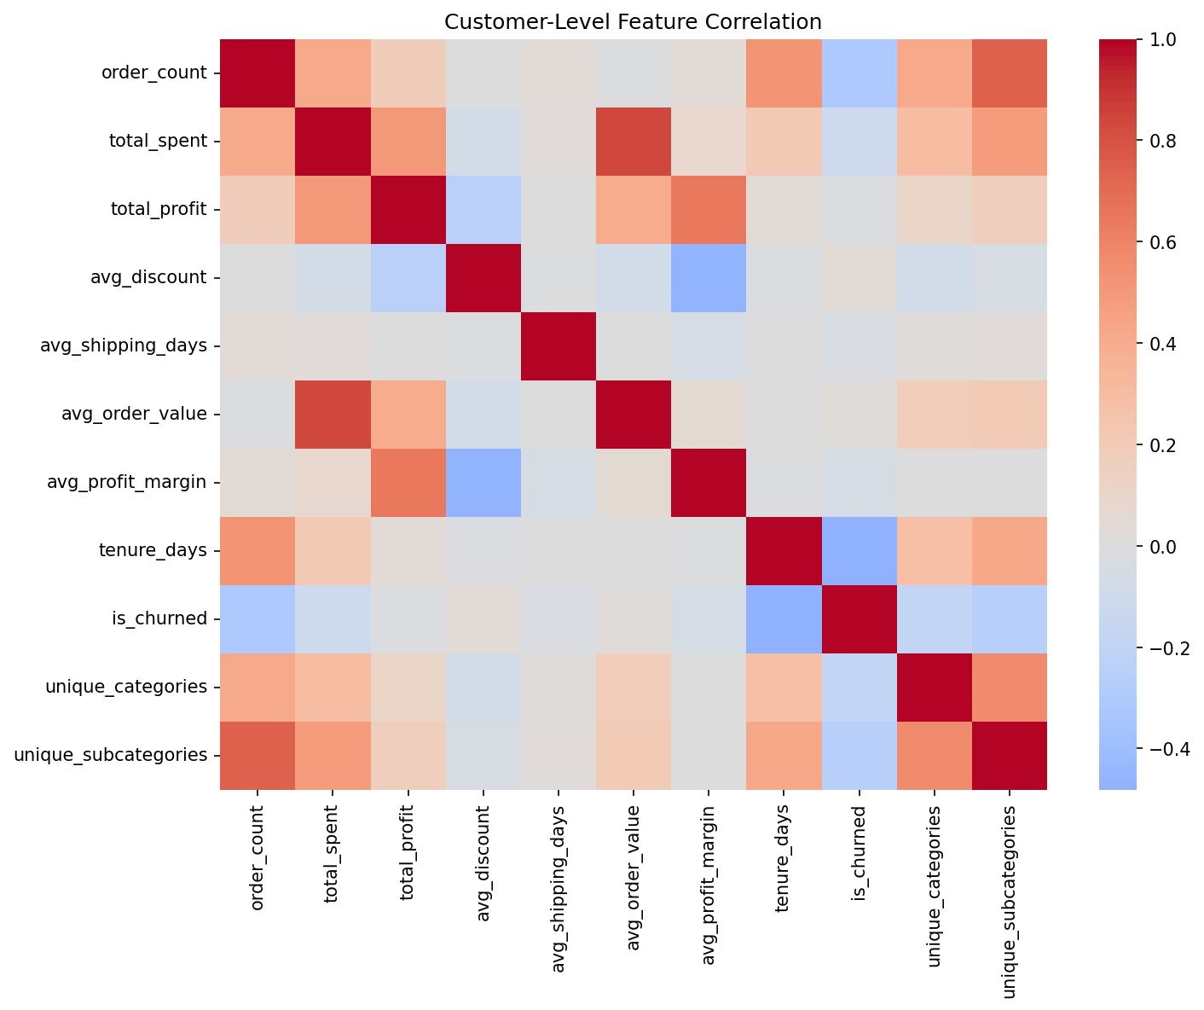
Figure 8: Customer-Level Feature Correlation Matrix

5.3 Model Performance Comparison
Three classification models were trained and evaluated: Logistic Regression, Random Forest, and Gradient Boosting. All models exceeded the 0.70 AUC-ROC target. Logistic Regression achieved the highest AUC-ROC at 0.848, followed by Random Forest (0.836) and Gradient Boosting (0.795). Logistic Regression was selected as the best model due to its superior discrimination and interpretability.
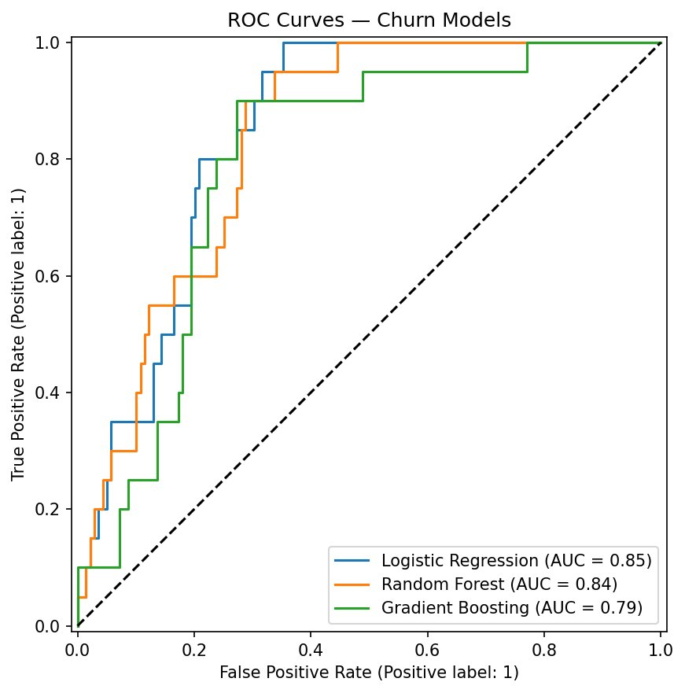
Figure 9: ROC Curve Comparison Across Models

5.4 Confusion Matrices
The confusion matrices show the precision/recall tradeoffs. Logistic Regression correctly identifies 16 of 20 actual churned customers (80% recall for churn class) while maintaining 109 of 139 true negatives. Random Forest shows very high precision but lower recall (15% for churn), suggesting it may miss at-risk customers. For a retention campaign, a higher recall (Logistic Regression) is preferred to ensure at-risk customers are flagged.
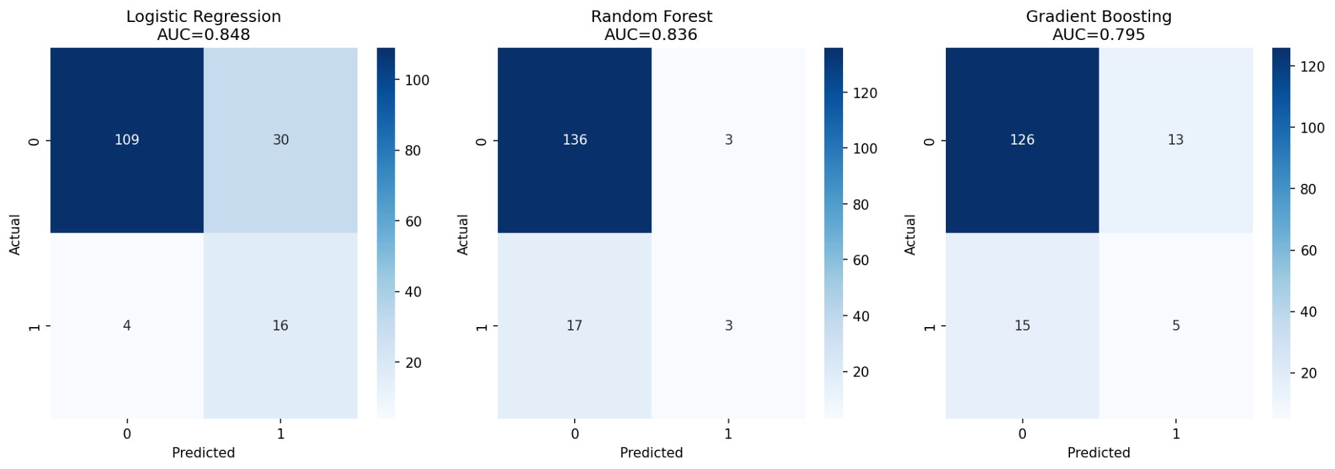
Figure 10: Confusion Matrices for All Three Models

5.5 Feature Importance
The tree-based feature importance (from the best tree model) shows tenure_days as the dominant predictor, followed by order_count and total_spent. Behavioral metrics such as avg_profit_margin, avg_discount, and unique_subcategories also contribute meaningfully. This aligns with business intuition: customers who order infrequently and engage with fewer product categories are more likely to churn.
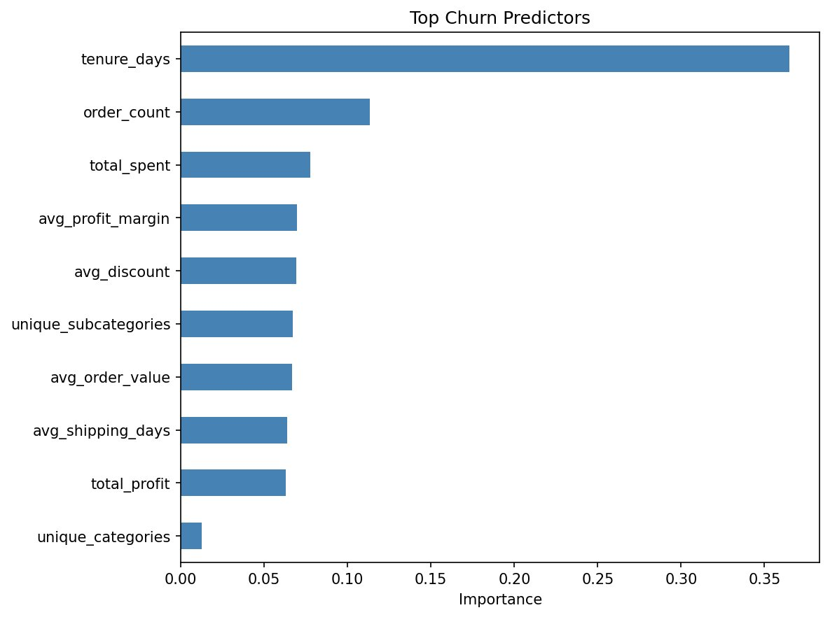
Figure 11: Top Churn Predictors (Feature Importance)

6. Interactive Dashboard (Power BI)
A five-page executive dashboard was built in Power BI Service using a star-schema data model (fact + dimension tables) and DAX measures. The dashboard provides drill-down capability across time, region, segment, and category dimensions.

6.1 Financial KPI Overview
The overview page surfaces top-level KPIs (Total Sales, Total Profit, Profit Margin %, Total Orders, Unique Customers) with monthly trend and year-over-year growth visuals. Slicer filters allow dynamic exploration by year, region, segment, and category.
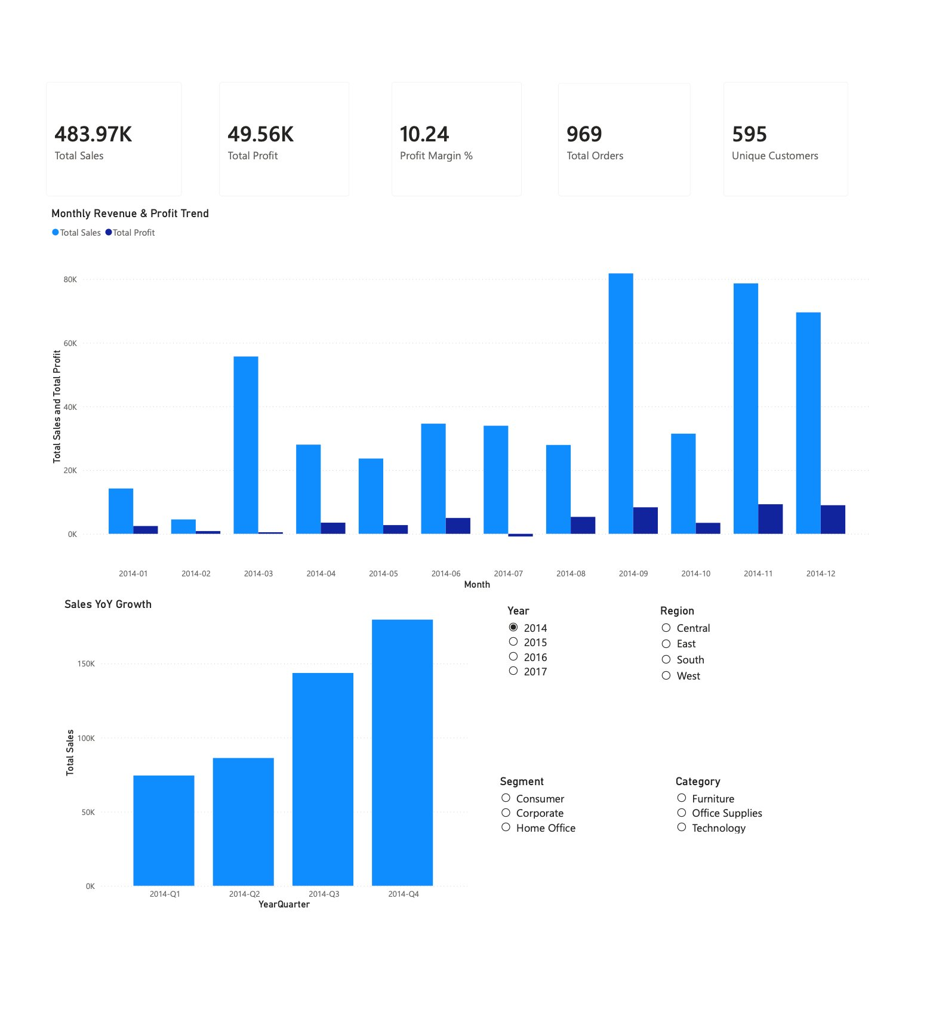
Figure 12: Dashboard Page 1 — Financial KPI Overview

6.2 Profitability Deep-Dive
This page presents sub-category P&L, discount vs. profit scatter, profit margin ranking, discount band analysis, and a state-level profitability map. It enables executives to identify which product lines and geographies drive or erode margin.
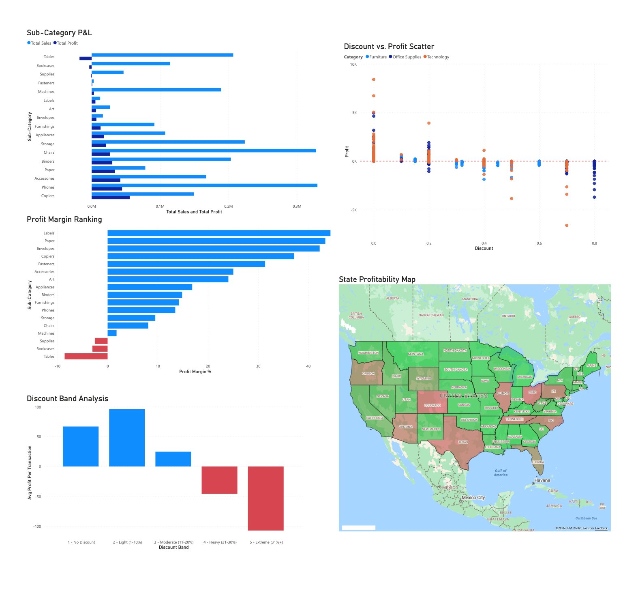
Figure 13: Dashboard Page 2 — Profitability Deep-Dive

6.3 Regional & Segment Performance
The regional page includes region comparison (sales, profit, margin), a top/bottom states table with profit margin ranking, category-by-region heatmap, ship mode analysis, and segment comparison. This enables resource allocation decisions at the regional and segment level.
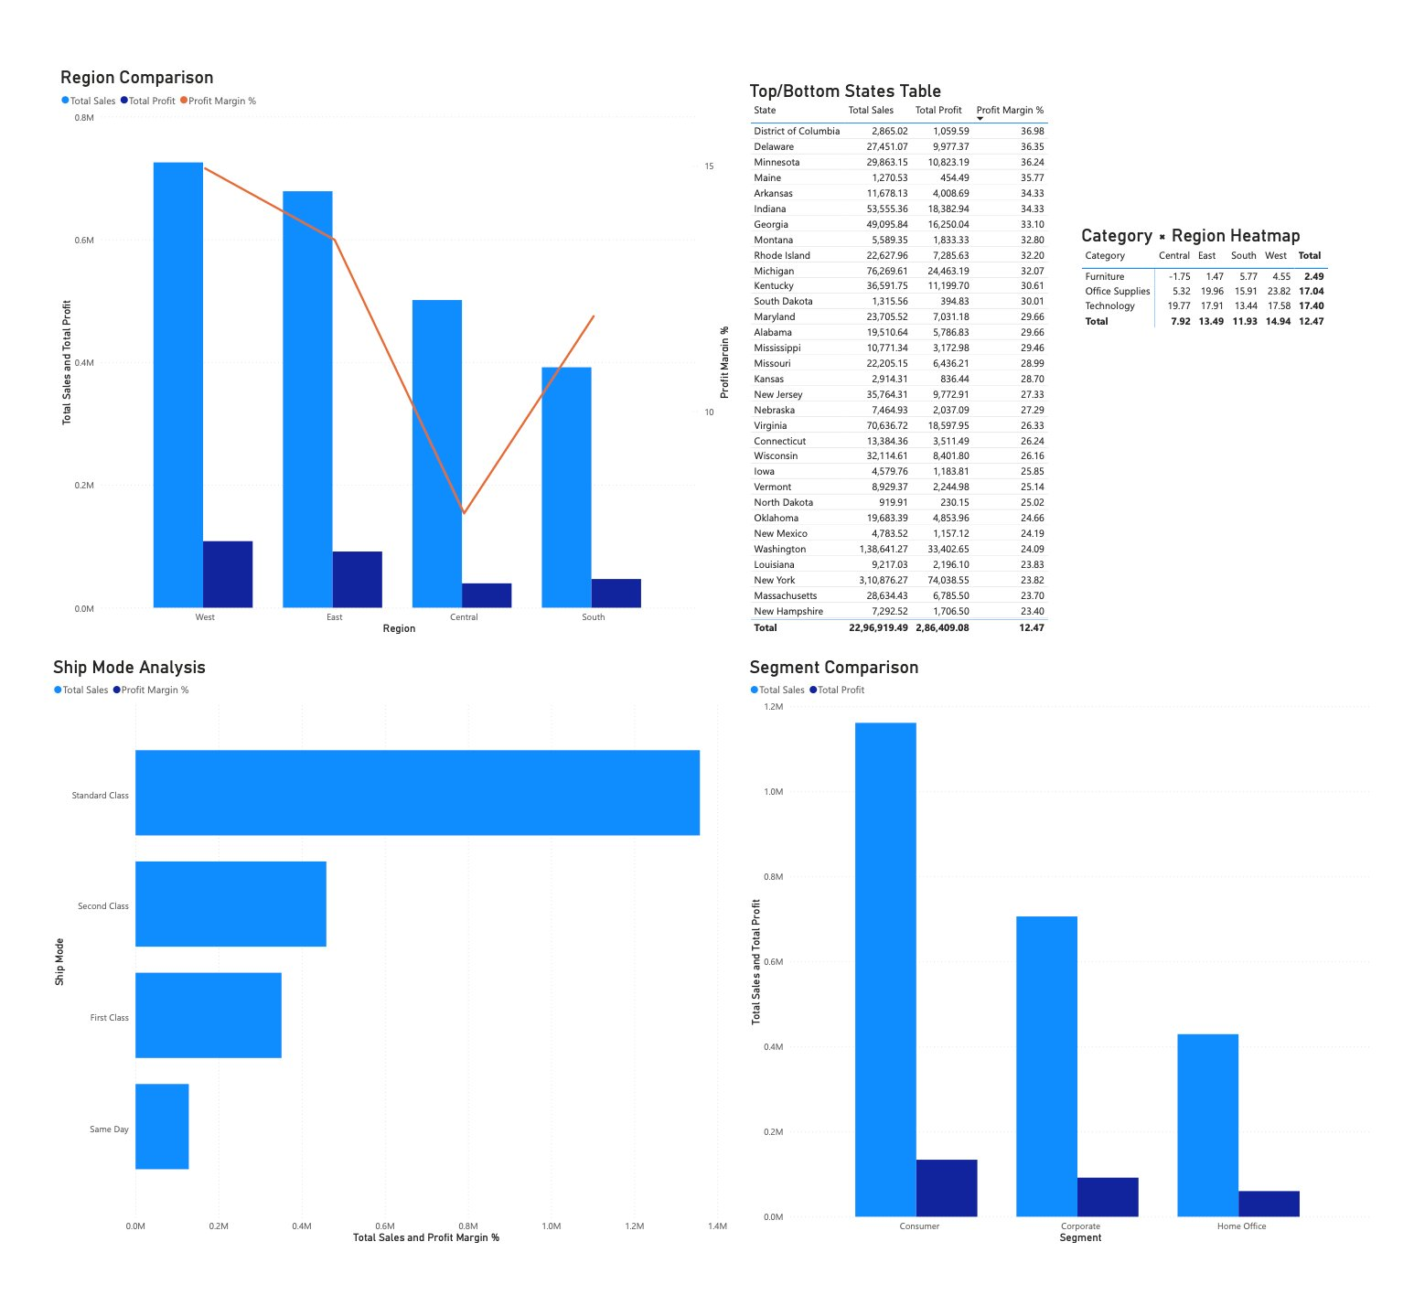
Figure 14: Dashboard Page 3 — Regional & Segment Performance

6.4 Customer Retention & Churn
The churn page visualizes churn rate by segment, order frequency, and customer value distribution. It surfaces the behavioral patterns identified by the predictive model, enabling targeted retention campaigns.
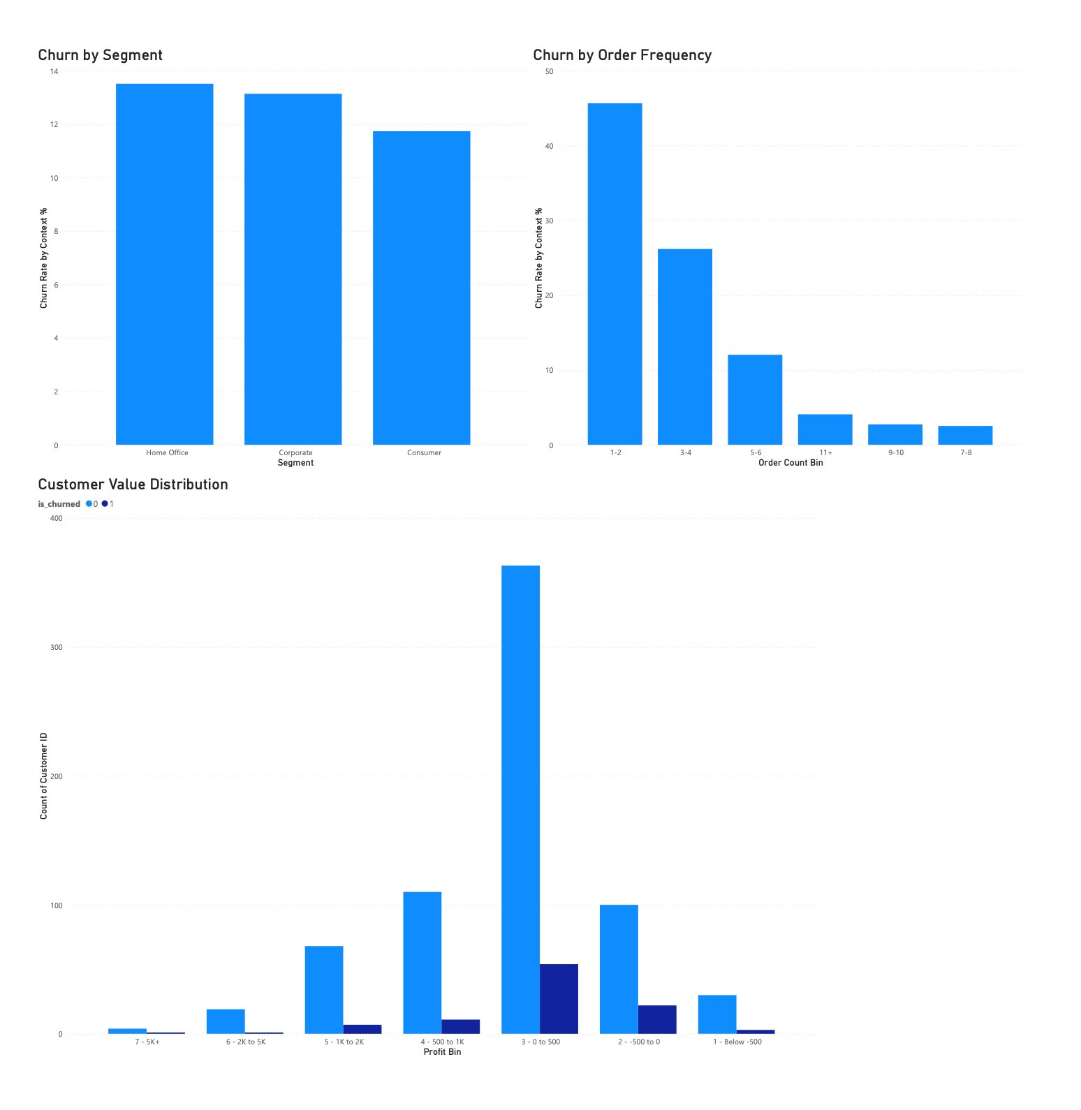
Figure 15: Dashboard Page 4 — Customer Retention & Churn

6.5 Executive Recommendations
The final page presents a waterfall chart showing the estimated profit impact of each recommendation (current profit → discount cap → loss sub-category fix → churn recovery → total), along with a prioritized action table with expected impact, responsible owner, and priority ranking.
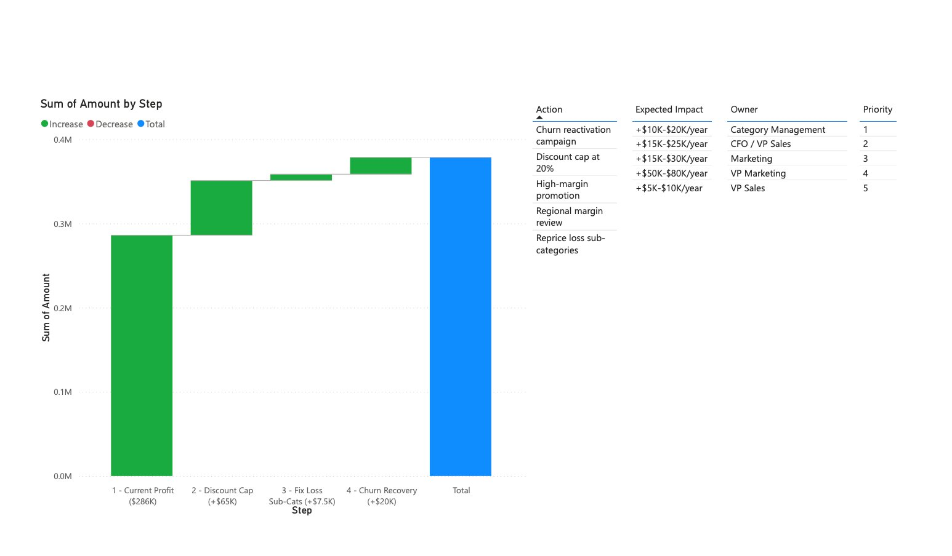
Figure 16: Dashboard Page 5 — Executive Recommendations

7. Business Recommendations
Based on the analysis across revenue trends, profitability, and customer churn, the following five strategic initiatives are recommended:

# | Action | Expected Impact | Rationale
1 | Cap standard discounts at 20%; VP approval above 20% | +$50K–$80K/year | Discount band analysis shows margins collapse beyond 20%
2 | Address loss sub-categories (Tables, Bookcases, Supplies) | +$5K–$10K/year | Reprice or reduce exposure; eliminate P&L drag
3 | Deploy churn model for at-risk customer flagging | +$15K–$25K/year | Proactive reactivation campaigns and loyalty programs
4 | Invest in high-margin regions/segments; review Central region | Margin improvement | Central region at 8% vs. West at 15%; targeted intervention
5 | Promote high-margin sub-categories (Copiers, Paper, Labels) | Mix shift | Shift revenue mix toward profitable product lines
Table 3: Strategic Recommendations

7.1 Estimated Profit Impact
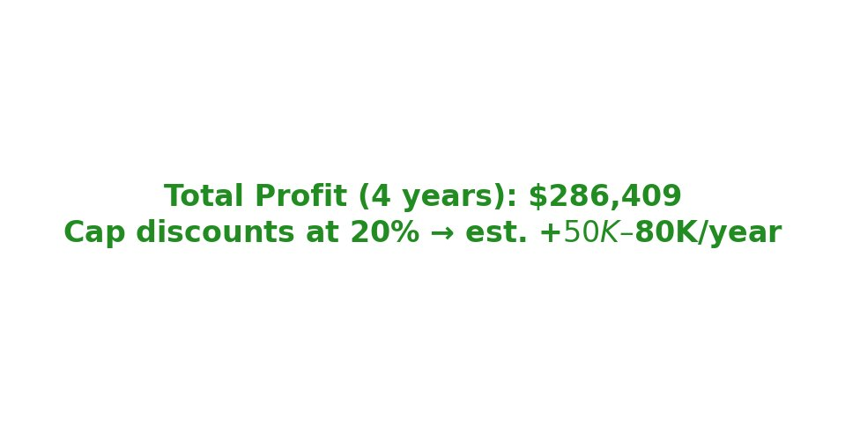
Figure 17: Profit Impact Summary

Initiative | Annual Impact
Discount cap at 20% | +$50,000 – $80,000
Loss sub-category elimination | +$5,000 – $10,000
Churn recovery (reactivation) | +$15,000 – $25,000
Conservative Total Improvement | ~$70,000 – $115,000/year
Table 4: Estimated Annual Profit Impact

8. Project Structure & Reproducibility
The project follows a modular architecture with clear separation between data processing, modeling, visualization, and testing. All code is version-controlled on GitHub.

Directory / File | Purpose
data/raw/ | Original Superstore CSV (latin-1 encoding)
data/preprocessed/ | Cleaned transaction-level data
data/featured/ | Order-level, customer-level, and model_ready.csv
src/ | Python modules: data_cleaning.py, feature_engineering.py, modeling.py, visualizations.py, forecasting.py, run_data_pipeline.py
notebooks/ (01–08) | End-to-end analysis: profiling, cleaning, feature eng., EDA, forecasting, profitability, churn prediction, recommendations
model/ | best_model.pkl and scaler.pkl
tests/ | Unit tests for cleaning, feature engineering, and modeling (pytest)
images/ | EDA charts and Power BI dashboard screenshots
Table 5: Project Structure
To reproduce: clone the repository, install requirements (pip install -r requirements.txt), place superstore.csv in data/raw/, run python src/run_data_pipeline.py, and execute notebooks 01–08 in sequence. Tests can be run with pytest tests/ -v.

9. Key Design Decisions
- Data leakage prevention: recency_days was excluded from all model features because it directly defines the churn target (365-day inactivity). This was caught during correlation analysis and is documented in the pipeline.
- Model selection rationale: Logistic Regression was selected over tree-based models despite comparable AUC-ROC because it provides higher recall for the churned class (critical for retention campaigns) and better interpretability for stakeholder communication.
- Dashboard architecture: Power BI Service with star-schema data model (fact + dimension tables) and DAX measures enables dynamic cross-filtering and drill-down across all five dashboard pages.
- Conservative estimates: All profit impact projections use conservative ranges (e.g., $50K–$80K rather than point estimates) to reflect uncertainty in behavioral response to policy changes.
- Preprocessing vs. feature engineering boundary: Preprocessing handles cleaning, renaming, and cardinality reduction. Feature engineering produces net-new derived columns only (e.g., tenure_days, avg_profit_margin, unique_subcategories).

