Conditional Tail Episode Risk:
A Path-Dependent Framework for Extreme-Loss Episodes
Beyond Value-at-Risk and Expected Shortfall
Niraj Neupane, CA (ICAI)
Quantitative Researcher, Korvane
Financial Economist, Calderyn Institute,
ORCID: 0009-0003-7026-7026 Email: nirajneupane17@gmail.com
This version: 2026-09-21
Abstract
Value-at-Risk (VaR) and Expected Shortfall (ES) are central tools for financial risk measurement, but both primarily characterize the marginal distribution of losses. Consequently, they can assign similar risk to two loss paths that contain the same individual tail observations but differ in the temporal organization of those observations. This paper develops Tail Episode Risk (TER), a path-dependent tail-risk functional that quantifies the severity of the most extreme contiguous cumulative-loss episode within a forecast horizon, and Conditional Tail Episode Risk (CTER), which decomposes future episode risk into (i) the conditional probability that an extreme-loss episode occurs and (ii) the conditional upper-tail severity of that episode. The framework is related to aggregate excess severity in extreme-value theory, clustered extremes, Conditional Expected Drawdown, and dynamic VaR/ES forecasting, but targets a distinct state variable: cumulative loss above a tail threshold within a contiguous episode.
We establish basic properties of TER—monotonicity, positive homogeneity, translation invariance under a translation-equivariant threshold rule (in the sense of a severity/deviation functional rather than a monetary risk measure), and sensitivity to temporal clustering—and give constructed counterexamples in which two paths share identical marginal VaR and ES but differ in TER. Monte Carlo experiments confirm that TER increases sharply with serial dependence while marginal VaR and ES remain essentially flat, and adversarial stress tests show that TER responds to sustained episodes rather than to isolated tail observations.
Empirically, we evaluate the framework on daily data for six equity, bond, foreign-exchange, and cryptocurrency markets over 2000–2026, with asset-specific out-of-sample windows (from 2005 for equities and FX, 2008 for Treasuries, and 2018 for Bitcoin). The evidence is cautionary. Under a strictly consistent Fissler–Ziegel scoring rule, GARCH-t is the strongest conventional benchmark and an EWMA specification a strong simple one. Episode-occurrence discrimination is weak and decays into the tail (mean AUC 0.56, 0.54, 0.47 at the 95%, 97.5%, 99% thresholds). A formal incremental test finds that augmenting a parsimonious volatility baseline with the full CTER conditioning set does not improve out-of-sample episode-severity forecasts—indeed it is significantly worse at the 95% and 97.5% thresholds and statistically indistinguishable at 99%. The evidence therefore supports a narrower conclusion: TER is a distinct path-dependent tail-risk functional that captures the temporal organization of extreme losses, while the forecasting value of its conditional extension (CTER) remains unresolved.
Keywords: Tail risk; Value-at-Risk; Expected Shortfall; extreme-value theory; clustered extremes; path-dependent risk; financial risk measurement; Conditional Tail Episode Risk; volatility clustering.
JEL Classification: C22; C53; G17; G32.

1 Introduction
Financial risk measurement traditionally focuses on the marginal distribution of portfolio or asset losses. The two most widely used measures are Value-at-Risk and Expected Shortfall: VaR identifies a loss quantile at a specified confidence level, while ES measures the expected loss beyond that quantile. Their importance reflects both their statistical interpretation and their role in risk management, capital allocation, and regulation.
Financial losses, however, are not independent draws from an unchanging marginal distribution. Extreme losses cluster, volatility varies over time, and market stress generates sequences of losses rather than isolated observations. Consequently, two future loss paths can share an identical marginal distribution—and therefore identical VaR and ES—while exhibiting very different temporal structure. Consider
$$A=\left(4,0,4,0,4,0\right), B=\left(4,4,4,0,0,0\right),$$
with a tail threshold q=2. Both contain three losses of magnitude four and three zeros, so their marginal distributions, and hence any marginal VaR or ES, coincide. Yet the losses in A occur as three isolated exceedances, whereas those in B form one contiguous extreme episode. This distinction motivates the central question:
Can financial tail risk be characterized by the temporal organization and cumulative severity of extreme-loss episodes, rather than only by the marginal magnitude of individual tail observations?
To investigate it we introduce Tail Episode Risk (TER). The idea is deliberately related to established extreme-value theory: aggregate excess severity—the sum of exceedances over a high threshold—has been studied for decades, and Anderson (1994) explicitly proposed aggregate excess as a measure of extreme-event severity, emphasizing that severity depends not only on peak magnitude but also on duration and temporal shape. The contribution here is therefore not the invention of threshold exceedances or aggregate excess. Rather, we formulate a financial risk functional around the upper tail of the maximum cumulative threshold-exceedance episode over a forecast horizon:
TERα,β,H=Qβ​maxj∈EHk∈j​Lk-qα+,
where $L_{k}$ is future loss, $q_{α}$ a tail threshold, $E_{H}$ the set of contiguous threshold-exceedance episodes over horizon H, and $Q_{β}$ an upper-tail quantile of the resulting episode-severity distribution. We then introduce Conditional Tail Episode Risk (CTER),
$${CTER}_{α,β,H,t}=P​\left(O_{t,H}=1∣X_{t}\right) {ES}_{β}​\left[S_{t,H}^{*}∣O_{t,H}=1,X_{t},Z_{t}\right],$$
which separates two questions: how likely is the market to enter an extreme-loss episode, and, conditional on entering, how severe could the episode become?
We pose two distinct research questions.
RQ1.
Does TER capture temporal information about extreme losses that marginal VaR and ES do not?
RQ2.
Does conditional forecasting of TER through CTER provide incremental predictive information beyond conventional tail-risk models?
The distinction is central: a risk functional can encode information absent from VaR/ES without necessarily producing superior forecasts in a finite real-world sample.
Contributions. First, we formulate TER as a path-dependent tail-risk functional based on maximum cumulative threshold-exceedance severity. Second, we introduce CTER as a conditional probability–severity decomposition of episode risk. Third, we provide theoretical and simulation-based evidence that TER reacts to temporal clustering even when marginal tail behavior is held approximately fixed. Fourth, we provide an empirical evaluation on 2000–2026 data that reports both positive and negative results and, in particular, does not find that CTER universally improves conventional VaR/ES-style forecasting.
Road map. Section 2 reviews related risk measures. Section 3 defines TER and Section 4 defines CTER. Section 5 establishes theoretical properties. Section 6 presents the Monte Carlo study and Section 7 the adversarial stress tests. Section 8 describes the empirical design and the fully specified estimation pipeline. Section 9 reports conventional VaR/ES benchmark results; Section 10 reports CTER out-of-sample results; and Section 11 reports the incremental-information test. Section 12 interprets the gap between measure innovation and forecasting performance, Section 13 positions TER among existing measures, Section 14 discusses economic and governance implications, Section 15 states limitations, Section 16 outlines future research, and Section 17 concludes.

2 Related Literature
Value-at-Risk and Expected Shortfall. For a loss $L$, ${VaR}_{α}\left(L\right)=Q_{α}\left(L\right)$ and ${ES}_{α}\left(L\right)=E\left[L∣L≥{VaR}_{α}\left(L\right)\right]$ under a continuous distribution. VaR provides a threshold but not the average magnitude beyond it; ES addresses this by averaging the tail. Modern forecast evaluation requires care: Fissler et al. (2016) and Fissler and Ziegel (2016) established the joint elicitability of VaR and ES, providing a foundation for consistent joint scoring and comparative backtesting (Nolde and Ziegel, 2017; Patton et al., 2019). We evaluate conventional VaR/ES forecasts with a strictly consistent Fissler–Ziegel scoring function (Section 9); CTER forecasts a different statistical object and is evaluated separately.
Aggregate excess and extreme-value theory. Instead of the single maximum, an extreme event can be characterized by the total amount by which observations exceed a threshold. Anderson (1994) proposed the aggregate excess measure $S=\sum_{j=1}^{N}{ζ_{j}}$, where $ζ_{j}$ is an excess over a high threshold, and emphasized that severity depends on duration and temporal shape. This literature establishes a clear prior-art boundary: the sum of threshold exceedances is not claimed here as an original primitive. The proposed distinction is the financial functional maxjk∈j​Lk-qα+ followed by a second tail operation over the resulting distribution.
Drawdown-based risk. Maximum drawdown is another path-dependent concept; Conditional Expected Drawdown (CED) formalizes the tail of maximum drawdown and is positively homogeneous, convex, and sensitive to serial correlation (Goldberg and Mahmoud, 2017). CED and TER are both path-dependent but have different state variables:
MDD=maxu<vWu-Wv versus St,H*=maxjk∈Kt,H,j​Lt+k-qt,α+,
where W denotes wealth. TER depends on threshold exceedances; CED depends on peak-to-trough wealth deterioration. TER is therefore not a drawdown measure in disguise.
Dynamic extreme-value models. A large literature develops dynamic EVT models for financial risk forecasting. Candia and Herrera (2024) review dynamic threshold-exceedance models and find that marked-point-process and time-series approaches can perform strongly, while no single specification dominates. Recent work continues to develop conditional extreme-value models with time-varying scale and tail parameters (Li et al., 2026) and dynamic tail-risk networks and mixed-frequency frameworks (Zhang et al., 2026a; Wang et al., 2026). These models improve estimation and forecasting of conventional tail measures; CTER instead targets future extreme-episode occurrence and severity.

3 Tail Episode Risk

3.1 Loss path and exceedances
Let the future loss path over horizon H be $L_{t,H}=\left(L_{t+1},…,L_{t+H}\right)$ and let $q_{t,α}$ denote a tail threshold. Define the (non-negative) exceedance and the exceedance indicator
$$y_{t+k}={\left(L_{t+k}-q_{t,α}\right)}_{+}, I_{t+k}=1\{L_{t+k}>q_{t,α}\}.$$
A tail episode is a maximal contiguous run of indices with $I_{t+k}=1$; let $E_{t,H}$ denote the set of such episodes.

3.2 Episode severity and TER
For episode $j∈E_{t,H}$, let $K_{t,H,j}⊆\{1,…,H\}$ be its (contiguous) index set and define its cumulative excess severity
St,H,j=k∈Kt,H,j​Lt+k-qt,α+,
and the worst-episode severity over the horizon
$$S_{t,H}^{*}=\max_{j∈E_{t,H}}S_{t,H,j} \left(\text{with }S_{t,H}^{*}=0\text{ if no exceedance occurs}\right).$$
The maximum operation focuses the measure on the single most severe contiguous episode. Tail Episode Risk is the upper-tail quantile of this worst-episode severity, conditional on information $F_{t}$:
$$\boxed{ {TER}_{α,β,H,t}=Q_{β}​\left(S_{t,H}^{*}∣F_{t}\right) }$$
where α sets the threshold for an extreme observation, β the tail level applied to the distribution of maximum episode severity, and $F_{t}$ the information set at date t. The two probability levels have distinct roles and need not be equal.

4 Conditional Tail Episode Risk

4.1 Episode probability
Define the episode-occurrence event
$$O_{t,H}=1​\left\{\max_{1≤k≤H}L_{t+k}>q_{t,α}\right\}, p_{t}=P\left(O_{t,H}=1∣X_{t}\right),$$
where $X_{t}$ collects observable state information (lagged returns, realized volatility, volatility acceleration, drawdown, cross-asset returns, and financial-stress indicators; see Section 8).

4.2 Conditional episode severity
Let $Z_{t}$ contain episode-state information (recent exceedance frequency, current run length, recent episode severity). Define the conditional upper-tail severity
$$m_{t}={ES}_{β}​\left[S_{t,H}^{*}∣O_{t,H}=1,X_{t},Z_{t}\right].$$

4.3 Definition of CTER
$$\boxed{ {CTER}_{α,β,H,t}=p_{t} m_{t}=P\left(O_{t,H}=1∣X_{t}\right) {ES}_{β}​\left[S_{t,H}^{*}∣O_{t,H}=1,X_{t},Z_{t}\right]. }$$
CTER thus factors episode risk into an episode probability and a conditional episode severity. This is economically different from forecasting another VaR or ES: it explicitly separates the likelihood of entering a stressed state from its potential severity.

5 Theoretical Properties
Proposition 1 (Monotonicity). If $L'_{k}≥L_{k}$ for all k under a common threshold q, then ${\left(L'_{k}-q\right)}_{+}≥{\left(L_{k}-q\right)}_{+}$, so no episode’s cumulative excess can decrease and $S^{*}\left(L'\right)≥S^{*}\left(L\right)$. Hence $TER\left(L'\right)≥TER\left(L\right)$.
Proposition 2 (Positive homogeneity under consistent scaling). For c>0, if $L'_{k}=cL_{k}$ and q′=cq then ${\left(L'_{k}-q'\right)}_{+}=c{\left(L_{k}-q\right)}_{+}$, so $S^{*'}=cS^{*}$ and $TER\left(cL\right)=c TER\left(L\right)$.
Proposition 3 (Translation invariance under a translation-equivariant threshold rule). If $L'_{k}=L_{k}+c$ and the threshold rule is translation-equivariant, q′=q+c, then $L'_{k}-q'=L_{k}-q$, so $S^{*'}=S^{*}$ and $TER'=TER$.
A clarification is warranted, because VaR and ES are translation equivariant ($ρ\left(L+c\right)=ρ\left(L\right)+c$) as monetary risk measures. TER is not a monetary risk measure but a severity aggregate, and the natural analogue is a deviation functional, which satisfies translation invariance ($D\left(L+c\right)=D\left(L\right)$). Proposition 3 is exactly this: when the threshold shifts with the losses, the exceedances—and hence S*—are unchanged, so TER is invariant, not equivariant. TER neither satisfies nor targets the monetary equivariance property; it measures the magnitude of a threshold-exceedance episode rather than a capital requirement. The qualifications also matter for homogeneity: both properties hold conditional on the threshold being scaled or shifted jointly with the losses, and because $q_{t,α}$ is in practice estimated dynamically, they are properties of the joint (loss, threshold) rule rather than unconditional axioms.
Proposition 4 (Temporal-clustering sensitivity). For $A=\left(4,0,4,0,4,0\right)$ and $B=\left(4,4,4,0,0,0\right)$ with q=2, the three exceedances in A are separate singletons, giving $S^{*}\left(A\right)=2$, whereas in B they form one contiguous episode, giving $S^{*}\left(B\right)=6$. Since the two paths are marginal permutations of one another, $VaR\left(A\right)=VaR\left(B\right)$ and $ES\left(A\right)=ES\left(B\right)$, yet $S^{*}\left(A\right)≠S^{*}\left(B\right)$ and therefore $TER\left(A\right)≠TER\left(B\right)$.
This is the central conceptual distinction; Figure 1 illustrates it. (On a single path S* is a scalar; $TER=Q_{β}\left(S^{*}\right)$ becomes a genuine quantile once S* is viewed as a random variable over the horizon distribution.)
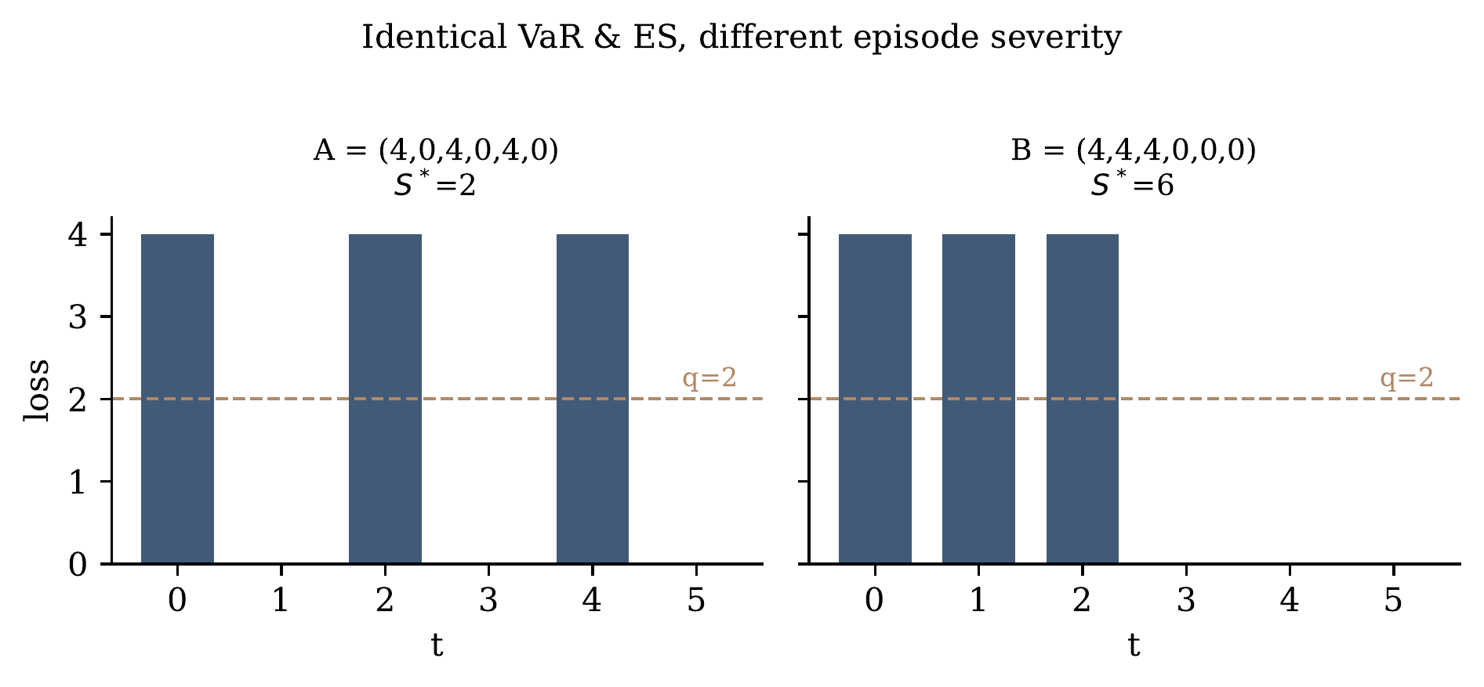
Two loss paths with identical marginals (three losses of 4, three of 0) and hence identical VaR and ES, but different worst-episode severity S* at threshold q=2.
Coherence. We do not claim that TER satisfies the full coherence axioms. Subadditivity in particular requires separate analysis because the threshold is distribution-dependent and because episode formation can change under portfolio aggregation. TER should therefore be treated as a path-dependent tail-risk functional, not automatically as a coherent risk measure.

6 Monte Carlo Simulation
Objective. We test whether TER is sensitive to temporal dependence when the marginal innovation distribution is held approximately fixed. We simulate stationary AR(1) processes $x_{t}=ρx_{t-1}+\sqrt{1-ρ^{2}} ε_{t}$, so the marginal variance is invariant to ρ, and compute VaR/ES on the marginal together with $Q_{β}\left(S^{*}\right)$ over rolling H=10 windows ($20,000$ windows per configuration; threshold $α=95\%$). VaR and ES are computed from the stationary marginal distribution implied by the standardized AR(1) process, whereas TER is computed from the rolling horizon paths; this isolates the dependence channel, since the marginal is held fixed by construction while only ρ varies.
Gaussian AR(1) dependence experiment ($ε∼N\left(0,1\right)$, standardized).
ρ | VaR 95% | ES 95% | TER 95% | TER 99%
0.0 | 1.633 | 2.059 | 0.981 | 1.508
0.3 | 1.645 | 2.053 | 1.010 | 1.737
0.7 | 1.655 | 2.046 | 1.065 | 2.580
0.9 | 1.668 | 2.093 | 1.060 | 4.541
Student-t AR(1) dependence experiment ($ε∼t_{5}$, standardized to unit variance).
ρ | VaR 95% | ES 95% | TER 95% | TER 99%
0.0 | 1.560 | 2.233 | 1.494 | 3.130
0.3 | 1.562 | 2.199 | 1.530 | 2.979
0.7 | 1.579 | 2.134 | 1.482 | 4.141
0.9 | 1.622 | 2.106 | 1.304 | 5.281
Tables 1–2 and Figure 2 report the result. In the Gaussian case, 95% VaR and ES are essentially flat in ρ (near the standard-normal values 1.645 and 2.063), while TER99 rises from ≈ 1.5 to ≈ 4.5. The Student-t case, with innovations standardized to unit variance so that the marginal is held fixed, shows the same qualitative pattern (TER99 rising from 3.1 to 5.3). We summarize:
$$\boxed{\text{Temporal dependence can materially raise episode risk without proportionally raising marginal VaR/ES.}}$$
This demonstrates that TER measures an additional dimension of path information; it does not by itself demonstrate a superior forecast.
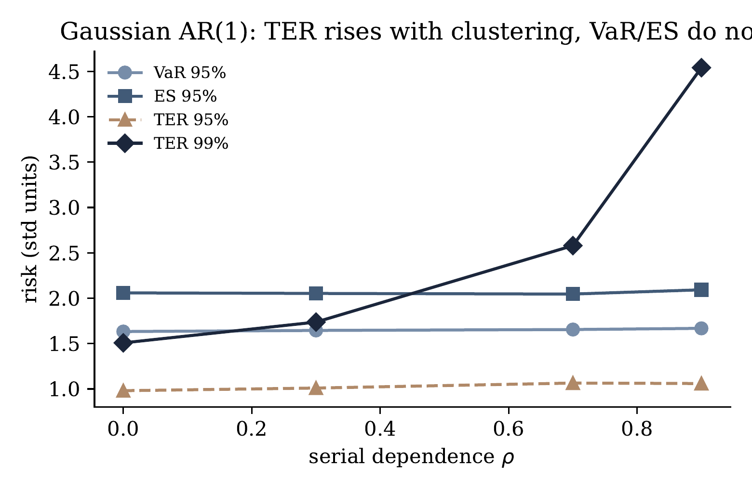
Gaussian AR(1) experiment. As serial dependence ρ increases, VaR and ES are flat while TER (especially at the 99% level) rises sharply.

7 Adversarial Stress Tests
To probe behavior directly, we construct six 60-day loss paths under a common, fixed threshold q=2.5 (in standardized loss units), so that differences in the measures reflect temporal organization rather than a path-specific threshold. Table 3 reports 95% VaR, 95% ES, and the worst-episode severity S*.
Adversarial stress tests (fixed threshold q=2.5). S* is the worst contiguous episode severity.
Scenario | VaR 95% | ES 95% | S*
Isolated crash | 1.42 | 4.00 | 6.50
Tail thickening (separated spikes) | 6.00 | 6.00 | 3.50
Liquidity collapse (sustained run) | 3.50 | 3.50 | 12.00
Volatility explosion (cluster) | 6.42 | 7.68 | 25.62
Broad contagion (all elevated) | 3.39 | 4.01 | 2.40
Escalating deterioration | 3.58 | 4.52 | 7.80
The decisive comparison is tail thickening versus liquidity collapse. Tail thickening has the highest VaR and ES (6.00, 6.00) because it contains several large isolated observations, yet its worst episode is small ($S^{*}=3.5$). The liquidity collapse has lower VaR and ES (3.50) but the sustained run yields a much larger $S^{*}=12.0$. Under these constructed paths, VaR and ES assign larger marginal-tail severity to tail thickening, whereas TER assigns larger episode severity to the sustained liquidity-collapse path; the measures therefore distinguish different dimensions of stress rather than producing a common risk ordering. The cross-asset (“broad contagion”) scenario also exposes a limitation: the present TER is univariate and a complete contagion measure would require an explicit multivariate extension.

8 Empirical Design

8.1 Data
We use daily log returns for six assets spanning 2000–2026: the S&P 500 and Nasdaq indices, the iShares 20+ Year Treasury Bond ETF (TLT), EUR/USD, USD/JPY, and Bitcoin. Data availability differs by asset: the equity indices and the two currency pairs begin in 2000, TLT in July 2002, and Bitcoin in September 2014. State variables are the VIX index (daily), the Chicago Fed National Financial Conditions Index (NFCI), and the St. Louis Fed Financial Stress Index (STLFSI); the two Fed indices are weekly and are carried forward to daily frequency by last-observation-carried-forward (LOCF), so that only information available up to date t enters $X_{t}$. The three stress series are used from their per-series source files rather than from a merged file, so that the weekly indices are never treated as daily observations.
Calendar convention. Because the paper studies temporal clustering, the observation calendar is stated explicitly. For the exchange-traded assets, observations follow the relevant market calendar; Bitcoin trades continuously and is observed on a calendar-day basis. The horizon is therefore defined in observations rather than calendar time: a 10-day observation horizon is ten trading days for the exchange-traded assets and ten calendar days for Bitcoin. All quantities ($q_{t,α}$, episodes, $S_{t,H}^{*}$) are defined on each asset’s own observation index.
Windows and horizon. The rolling estimation window is W=1,250 observations, the forecast horizon is H=10 observations, and the threshold levels are $α∈\{95\%,97.5\%,99\%\}$. Because the threshold window and a 252-observation training burn-in consume the first $1,502$ observations, out-of-sample forecasting begins at an asset-specific date: December 2005 for the S&P 500, Nasdaq, EUR/USD, and USD/JPY; July 2008 for TLT; and October 2018 for Bitcoin (reflecting its later inception and continuous calendar). The out-of-sample counts are $4,827$ (equity indices), $4,802$ (currencies), $4,183$ (TLT), and $2,496$ (Bitcoin).

8.2 Threshold and realized targets
At each date t, $q_{t,α}$ is the trailing-window empirical α-quantile of losses $L=-r$. Over the next H days we compute the exceedances, form contiguous episodes, and record the realized worst-episode severity $S_{t,H}^{*}$ and occurrence $O_{t,H}=1\{S_{t,H}^{*}>0\}$.

8.3 Conditioning information ($X_{t},Z_{t}$)
All features use information available through date t. The state vector $X_{t}$ contains: today’s loss; trailing 5- and 10-day cumulative losses; 20- and 60-day realized volatility; volatility acceleration (${rv}_{20}/{rv}_{60}$); 60-day drawdown; the VIX level and its 5-day change; NFCI; STLFSI; and the S&P 500 trailing 5-day loss as a systemic proxy. The episode-state vector $Z_{t}$ adds: the trailing 60-day exceedance frequency relative to $q_{t,α}$, the current in-episode run length, and the recent within-window episode severity. The full specification is given in Appendix [app:repro].

8.4 Estimators and evaluation
The framework is deliberately estimator-agnostic; we fix one transparent specification. Episode occurrence $p_{t}$ is estimated with a gradient-boosted classifier and episode severity with a gradient-boosted regressor (histogram GBMs; 200 trees, depth 3, learning rate 0.06, ℓ2 regularization 1.0). Models are fit by expanding-window walk-forward with annual (378-day) refits and a purge gap of H days between the last training label and the first test date, eliminating look-ahead from the horizon-H targets. Occurrence is evaluated by Brier score and AUC; severity by MAE and RMSE against realized $S_{t,H}^{*}$; conventional VaR/ES benchmarks by a strictly consistent Fissler–Ziegel score (Section 9). This avoids scoring different statistical targets with a single function.

9 Conventional VaR/ES Benchmark Results
We evaluate four one-day-ahead VaR/ES forecasters—Historical Simulation, an EWMA (RiskMetrics, λ=0.94) Gaussian model, a peaks-over-threshold EVT/GPD model, and a GARCH(1,1)-t model—using the 0-homogeneous Fissler–Ziegel loss (Fissler and Ziegel, 2016; Patton et al., 2019). For returns r, forecast VaR v and ES e (both negative in the lower tail) at tail probability α,
$$FZ0\left(r,v,e\right)=-\frac{1}{αe} 1\{r≤v\} \left(v-r\right) + \frac{v}{e} + ln\left(-e\right) - 1,$$
which is strictly consistent for the (VaR, ES) pair; lower average scores are better. Table 4 reports the mean score across the six assets and the associated breach rates.
Mean FZ0 score across assets (lower is better) and mean breach rate. Best model per level in bold.
 | Hist. Sim. | EWMA-Normal | EVT-POT | GARCH-t
Mean FZ0 score
95% | −3.627 | −3.768 | −3.618 | −3.789
97.5% | −3.395 | −3.535 | −3.383 | −3.590
99% | −3.127 | −3.177 | −3.092 | −3.350
Mean breach rate (target = 1−α)
95% | 0.0500 | 0.0548 | 0.0497 | 0.0531
97.5% | 0.0259 | 0.0339 | 0.0258 | 0.0290
99% | 0.0122 | 0.0199 | 0.0115 | 0.0124
GARCH-t attains the best FZ0 score at every level, with EWMA-Normal a strong second; Historical Simulation and EVT are best calibrated by breach rate but weaker under the joint score. Notably, the EWMA-Normal model over-breaches at the 99% level (1.99% versus a 1% target). We therefore use GARCH-t (strongest under FZ0) and EWMA (strong and simple) as the competitive baselines against which any incremental CTER value must be judged—rather than a deliberately weak model that would flatter the new framework.

10 CTER Out-of-Sample Results
Table 5 reports occurrence discrimination (Brier, AUC) and severity accuracy (MAE, RMSE) by asset and threshold. Two patterns stand out. Severity forecasts exhibit measurable cross-market predictability—their scale tracks each market’s volatility (MAE is smallest for FX, largest for Bitcoin)—although, as Section 11 shows, the full CTER conditioning set does not improve on a parsimonious baseline. Occurrence discrimination, by contrast, is weak and decays into the tail: the cross-asset mean AUC falls from 0.56 (95%) to 0.54 (97.5%) to 0.47 (99%)—below random at the deepest level (Figure 3). The bond market (TLT) is the exception, with AUC ≈0.64–0.67 at all levels, indicating that fixed-income episodes are more predictable than equity or crypto episodes. The two components of the decomposition therefore behave asymmetrically: the probability component is weak, while the severity target carries more predictable structure. The decomposition is thus conceptually useful even though the current conditioning set does not reliably forecast episode occurrence, and CTER should not be presented as a universal early-warning system.
CTER out-of-sample results by asset and threshold. “OOS start” is the first out-of-sample date for that asset (windows differ by data availability). Base rate is the realized episode frequency; AUC below 0.5 indicates worse-than-random discrimination.
Asset (OOS start) | Level | Base rate | Brier | AUC | MAE | RMSE
S&P 500 (Dec 2005) | 95% | 0.317 | 0.249 | 0.563 | 0.00652 | 0.01436
 | 97.5% | 0.179 | 0.209 | 0.471 | 0.00489 | 0.01256
 | 99% | 0.098 | 0.130 | 0.405 | 0.00318 | 0.01012
Nasdaq (Dec 2005) | 95% | 0.328 | 0.257 | 0.563 | 0.00661 | 0.01415
 | 97.5% | 0.193 | 0.182 | 0.519 | 0.00470 | 0.01280
 | 99% | 0.102 | 0.114 | 0.423 | 0.00306 | 0.00977
TLT (Jul 2008) | 95% | 0.371 | 0.227 | 0.672 | 0.00304 | 0.00637
 | 97.5% | 0.200 | 0.162 | 0.664 | 0.00206 | 0.00570
 | 99% | 0.093 | 0.094 | 0.644 | 0.00134 | 0.00520
EUR/USD (Dec 2005) | 95% | 0.337 | 0.241 | 0.597 | 0.00196 | 0.00336
 | 97.5% | 0.186 | 0.176 | 0.601 | 0.00117 | 0.00239
 | 99% | 0.090 | 0.096 | 0.467 | 0.00055 | 0.00153
USD/JPY (Dec 2005) | 95% | 0.372 | 0.258 | 0.599 | 0.00392 | 0.00720
 | 97.5% | 0.202 | 0.186 | 0.581 | 0.00296 | 0.00591
 | 99% | 0.119 | 0.132 | 0.473 | 0.00205 | 0.00504
Bitcoin (Oct 2018) | 95% | 0.251 | 0.308 | 0.377 | 0.02858 | 0.04827
 | 97.5% | 0.130 | 0.191 | 0.427 | 0.01920 | 0.03858
 | 99% | 0.054 | 0.131 | 0.403 | 0.00937 | 0.02754
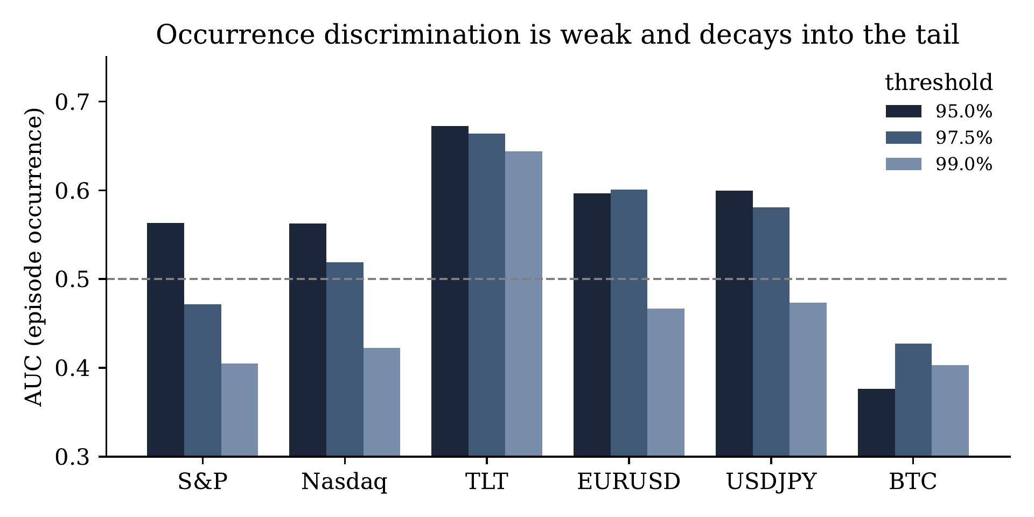
Episode-occurrence AUC by asset and threshold. Discrimination is weak overall and, except for bonds (TLT), falls toward or below 0.5 at the 99% threshold.
As an economic reality check, Figure 4 plots the realized 10-day episode severity for the S&P 500 over 2000–2026. The measure isolates precisely the sustained crises one would want it to flag: its worst distinct episodes are March 2020 (COVID, $S^{*}=11.3\%$), October–November 2008 (GFC), the March 2025 selloff, August 2011, and the 2002 and 2000 dot-com unwinds. This confirms that S* is economically meaningful even where its conditional forecast is difficult.
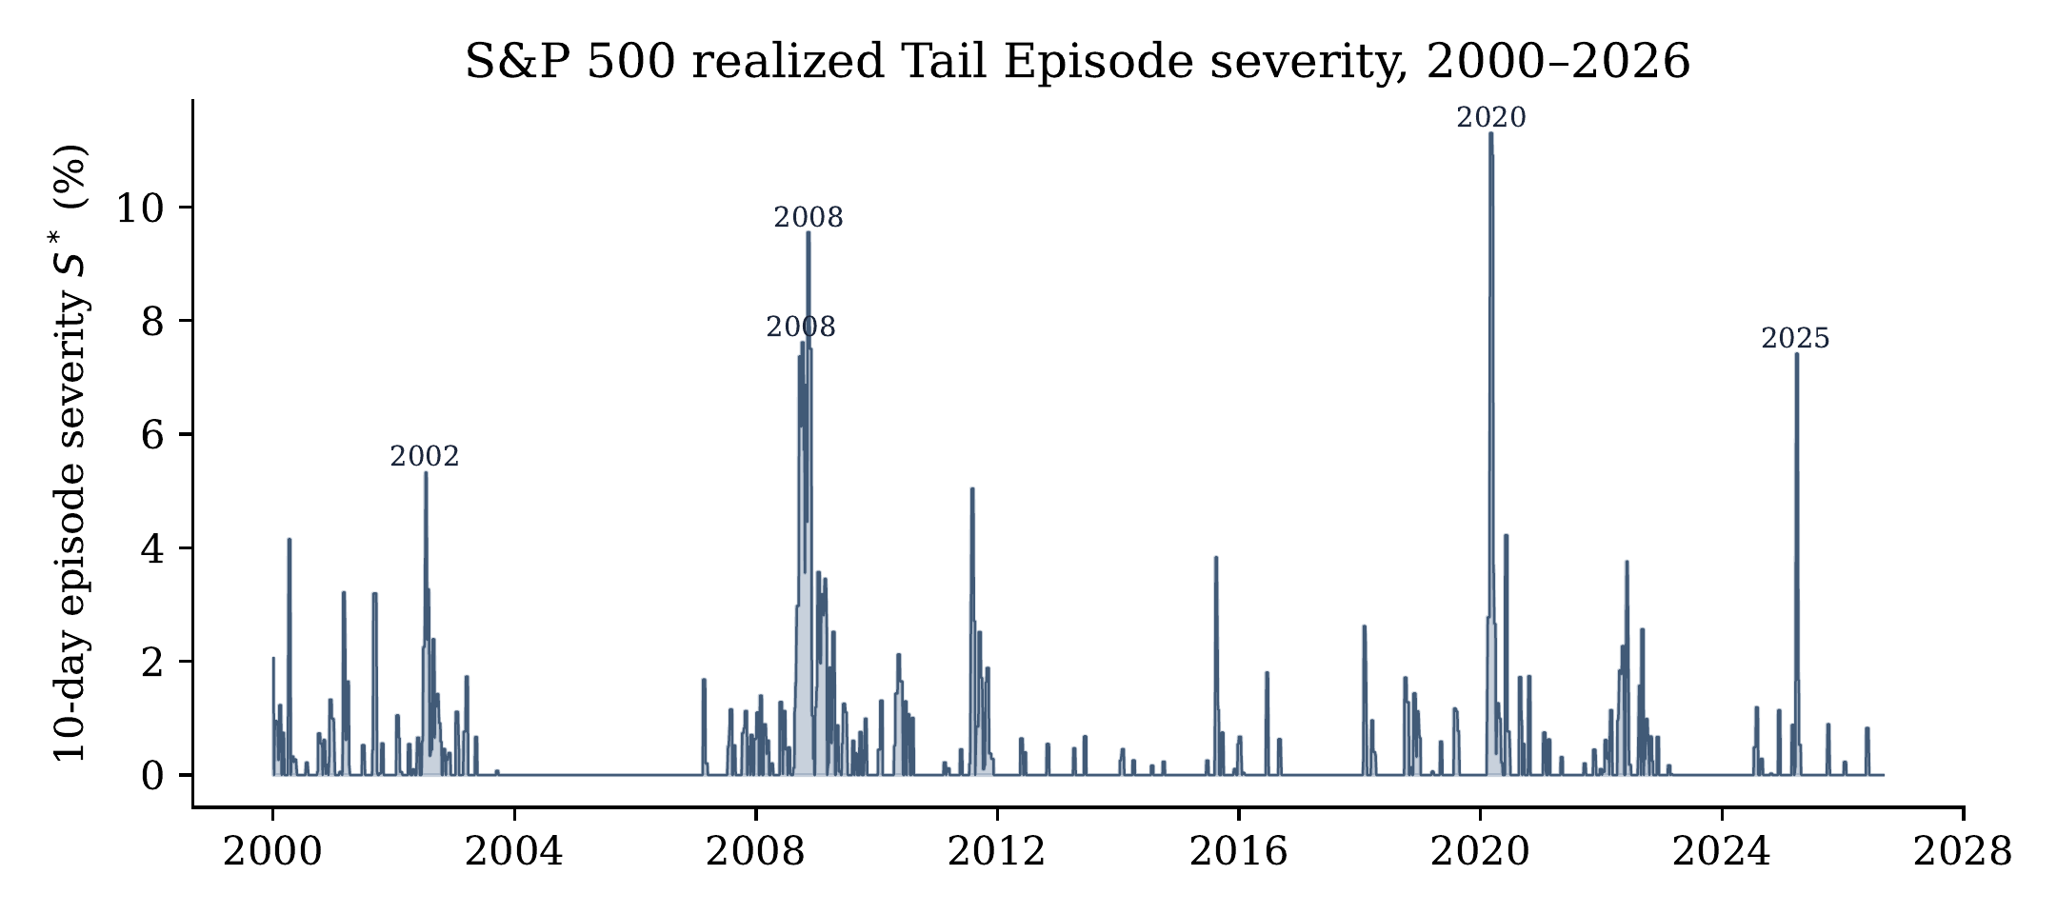
Realized S&P 500 Tail Episode severity $S_{t,H}^{*}$ (H=10, threshold q at the full-sample 95% loss quantile, 1.85%). Labeled peaks are the worst distinct episodes.

11 Incremental Information Test
The decisive question (RQ2) is whether CTER adds information beyond a competitive conventional model. We compare two forecasts of the same target $S_{t,H}^{*}$, produced by the same gradient-boosted regressor under the same walk-forward protocol, differing only in their inputs. The baseline regressor receives three EWMA-derived inputs—the EWMA volatility ${\hat{σ}}_{t}^{EWMA}$ and its induced one-day VaR and ES, ${\hat{σ}}_{t}^{EWMA}Φ^{-1}\left(α\right)$ and $-{\hat{σ}}_{t}^{EWMA}ϕ\left(Φ^{-1}\left(α\right)\right)/α$. The augmented regressor receives these three inputs plus the full $X_{t},Z_{t}$ conditioning set. The map from EWMA inputs to the 10-observation episode-severity forecast is thus the gradient-boosted regressor itself; no closed-form scaling is imposed, which is why both models must share the same estimator so that the comparison isolates the incremental value of the conditioning information. Let $Δ_{t}=\left|S_{t}^{*}-{\hat{S}}_{\text{aug},t}^{*}\right|-\left|S_{t}^{*}-{\hat{S}}_{\text{base},t}^{*}\right|$; negative values favor CTER. We aggregate equal-weight across assets and report the mean Δ, a moving-block bootstrap 95% confidence interval (block length 20), and a Diebold–Mariano p-value with a Newey–West HAC variance (lag $H-1=9$).
Incremental-information test. $Δ=$ MAE(augmented) $-$ MAE(baseline); negative favors CTER. Positive, significant values indicate the conditioning set does not help.
Level | Mean Δ | 95% block-bootstrap CI | DM p-value
95% | +0.001231 | [+0.000729, +0.001790] | <0.001
97.5% | +0.000722 | [+0.000339, +0.001141] | <0.001
99% | +0.000170 | [−0.000076, +0.000409] | 0.077
The result (Table 6 and Figure 5) is a clear negative. At the 95% and 97.5% thresholds the augmented model is significantly worse than the parsimonious volatility baseline ($Δ>0$, p<0.001), and at 99% the difference is statistically insignificant (the CI includes zero, p=0.077). This pattern is consistent with the additional conditioning variables introducing estimation variance without sufficient incremental predictive signal in this specification and sample. The appropriate conclusion is:
The 2000–2026 cross-asset sample provides no evidence that CTER conditioning improves aggregate out-of-sample episode-severity forecasting over a competitive volatility baseline, and some evidence that it degrades it at the 95% and 97.5% thresholds.
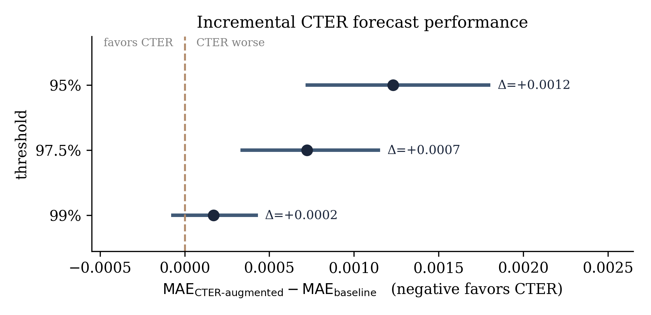
Incremental CTER forecast performance. Points are the mean MAE difference (augmented minus baseline) with 95% moving-block bootstrap intervals; values to the left of the dashed zero line would favor CTER. The augmented model is significantly worse at 95% and 97.5% and indistinguishable from the baseline at 99%.

12 Why the Distinction Matters
The theoretical and empirical findings are not contradictory. The simulations (Section 6) show that $TER$ captures the temporal organization of extreme losses; the forecasting experiments (Sections 10–11) show that CTER does not yet demonstrate incremental predictive value. A risk measure can encode a meaningful dimension of risk while being hard to forecast. The pipeline
$$\text{Risk functional} → \text{Target} → \text{Estimator} → \text{Forecast} → \text{Decision}$$
is supported here at the first two links and remains open at the later ones. Separating risk-functional innovation from forecasting performance is the paper’s central methodological point.

13 Relation to Existing Risk Measures
Primary question addressed by each measure.
Measure | Primary question
VaR | How large is the loss threshold?
ES | How severe is the marginal tail?
Aggregate excess | How much total exceedance occurs within an extreme event?
CED | How large can peak-to-trough drawdown become?
TER | How severe can the worst cumulative threshold-exceedance episode become?
CTER | Given current conditions, how likely and how severe is that episode?
TER occupies a position between marginal tail risk and fully path-dependent stress analysis. Table 8 restates this positioning against the specific structural properties that distinguish the proposed functionals from existing measures.
Contribution relative to existing measures. “Path dependent” indicates dependence on the ordering of observations; “temporal clustering” indicates sensitivity to whether exceedances are contiguous.
Measure | Object | Path dependent? | Temporal clustering? | Status
VaR | Quantile of loss | No | No | Existing
ES | Mean tail loss | No | No | Existing
Aggregate excess | Total threshold exceedance | Event-level | Yes | Related (prior art)
CED | Maximum drawdown | Yes | Yes | Related
TER | Max cumulative threshold-exceedance episode | Yes | Yes | Proposed
CTER | Conditional prob. × tail episode severity | Yes | Yes | Proposed

14 Economic and Governance Implications
TER is not proposed as a replacement for regulatory VaR or ES but as a complementary monitoring layer. A conventional system reporting, say, $VaR=5\%$ and $ES=7\%$ could additionally report an episode probability and a conditional episode severity, communicating the likelihood and potential severity of a sustained extreme-loss episode. Because the framework makes the temporal structure of tail events explicit, a risk system could separately track episode probability, severity, duration, escalation, and clustering—more interpretable than a single opaque score. That additional structure, however, creates additional model risk: the framework depends on threshold selection, episode definition, horizon, tail level, probability calibration, severity estimation, and dependence assumptions, and should be subject to model validation rather than treated as superior because it is more complex. The empirical results here reinforce that caution: the conditional layer did not add forecasting value in this sample.

15 Limitations
(i) Prior art. The cumulative threshold-exceedance component is established in EVT (Anderson, 1994); the potential contribution is the financial maximum-episode functional and its conditional probability–severity extension. (ii) No empirical superiority. The incremental tests are, at best, insignificant and, at worst, unfavorable to CTER. (iii) Univariate formulation. Cross-asset contagion requires an explicit multivariate extension. (iv) Threshold and horizon sensitivity. Different $q_{α}$ and H define different objects; stability warrants systematic study. (v) Sparse targets. Episode occurrence and severity are hard to forecast because extreme events are rare, especially at 99%. (vi) Estimator scope. A fully covariate-conditioned EVT specification for ${ES}_{β}\left(S^{*}∣O,X_{t},Z_{t}\right)$ remains unexplored and could differ from the gradient-boosted implementation used here.

16 Future Research
Natural extensions include a multivariate CTER for synchronized cross-asset episodes; a liquidity-adjusted variant incorporating spreads, depth, turnover, and price impact; an options-implied variant using implied volatility, skew, and the variance risk premium; state-dependent EVT with $ξ_{t}=f\left(X_{t}\right)$, $σ_{t}=g\left(X_{t}\right)$ in a conditional GPD; richer machine-learning estimators (quantile forests, distributional networks, temporal transformers) with the functional held fixed while only the estimator varies; and a decision-theoretic evaluation asking whether CTER changes capital, position sizing, or risk limits rather than relying only on statistical forecast error.

17 Conclusion
Financial tail risk has at least two dimensions: the magnitude of individual tail losses and the temporal organization of those losses. VaR and ES are built around the first; TER explicitly incorporates the second. We showed constructively and by simulation that two paths can share identical marginal VaR and ES while differing in TER, and that increasing serial dependence can sharply raise episode risk while leaving marginal measures nearly unchanged. The empirical evidence is more cautious: on 2000–2026 data across six markets, conditional forecasting of episode risk through CTER did not improve on—and at moderate thresholds underperformed—a competitive volatility baseline, and episode-occurrence discrimination was weak in the deep tail. The evidence therefore does not justify presenting CTER as a replacement for VaR or ES. It supports a narrower, more precise conclusion:
Tail Episode Risk provides a distinct path-dependent representation of extreme-loss severity that preserves temporal information discarded by marginal tail measures. Conditional Tail Episode Risk provides a framework for incorporating current-state information into that representation, but its empirical forecasting value in real markets remains an open question.
The broader implication is that risk measurement may benefit from moving beyond how large an individual tail loss can become toward the complementary question of how extreme losses organize themselves through time.
Reproducibility. All figures and tables are generated from daily 2000–2026 data by a single pipeline. The manuscript specifies the estimator, feature set, evaluation protocol, and configuration required to reproduce the reported analysis from the underlying data (Section 8 and Appendix C); the accompanying code repository contains the data-preprocessing, estimation, forecast, and scoring code together with fixed random seeds.
Anderson, C. W. (1994). The aggregate excess measure of severity of extreme events. Journal of Research of the National Institute of Standards and Technology, 99(4), 555–561. doi:10.6028/jres.099.054.
Candia, C., & Herrera, R. (2024). An empirical review of dynamic extreme value models for forecasting Value-at-Risk, Expected Shortfall and expectile. Journal of Empirical Finance, 77, 101488. doi:10.1016/j.jempfin.2024.101488.
Fissler, T., Ziegel, J. F., & Gneiting, T. (2016). Expected Shortfall is jointly elicitable with Value-at-Risk—implications for backtesting. Risk Magazine, 58–61.
Fissler, T., & Ziegel, J. F. (2016). Higher order elicitability and Osband’s principle. Annals of Statistics, 44(4), 1680–1707.
Goldberg, L. R., & Mahmoud, O. (2017). Drawdown: from practice to theory and back again. Mathematics and Financial Economics, 11, 275–297. doi:10.1007/s11579-016-0181-9.
Li, J., Hou, W., & Zhang, Z. (2026). A coupled autoregressive extreme-value model for dynamic tail risk with risk spirals. Finance Research Letters, 105, 110187. doi:10.1016/j.frl.2026.110187.
Nolde, N., & Ziegel, J. F. (2017). Elicitability and backtesting: perspectives for banking regulation. Annals of Applied Statistics, 11(4), 1833–1874.
Patton, A. J., Ziegel, J. F., & Chen, R. (2019). Dynamic semiparametric models for expected shortfall (and Value-at-Risk). Journal of Econometrics, 211(2), 388–413.
Zhang, D., Yan, X., & Shen, F. (2026). Dynamic financial tail risk networks: a backtesting-based conditional expected shortfall approach. PLOS ONE, 21(6), e0351966. doi:10.1371/journal.pone.0351966.
Wang, S., Wang, J., Lv, M., & Zhang, D. (2026). Forecasting financial risk with minute-level transaction data and economic policy uncertainty: a new mixed-frequency time-varying forecasting framework. Journal of Forecasting, 45(4), 1681–1713. doi:10.1002/for.70101.

Appendix A.Core Definitions
Tail episode set:Et,H={ j: Lt+k>qt,α for contiguous k }.Episode severity:St,H,j=k∈Kt,H,j​Lt+k-qt,α+.Maximum episode severity:St,H*=maxj∈Et,HSt,H,j.Tail Episode Risk:TERα,β,H,t=QβSt,H*∣Ft.Conditional TER:CTERα,β,H,t=POt,H=1∣Xt ESβSt,H*∣Ot,H=1,Xt,Zt.

Appendix B.Empirical Evaluation Protocol
Daily data, 2000–2026, with asset-specific out-of-sample start dates (2005 for equities and FX, 2008 for TLT, 2018 for Bitcoin); W=1,250-observation rolling threshold window; H=10-observation horizon; levels $95\%,97.5\%,99\%$; assets S&P 500, Nasdaq, TLT, EUR/USD, USD/JPY, Bitcoin. Conventional VaR/ES models are scored with the FZ0 loss the FZ0 loss in Section 9. CTER occurrence is scored by Brier and AUC and severity by MAE and RMSE. Incremental value compares an EWMA-only baseline with a fully conditioned model on the same target with paired, block-bootstrapped, HAC-adjusted tests. No post-out-of-sample tuning is used.

Appendix C.Reproducibility Details
Features $X_{t}$: today’s loss $L_{t}$; trailing 5- and 10-day cumulative loss; 20- and 60-day realized volatility; volatility acceleration ${rv}_{20}/{rv}_{60}$; 60-day drawdown; VIX level; VIX 5-day change; NFCI; STLFSI; S&P 500 trailing 5-day loss. Episode state $Z_{t}$: trailing 60-day exceedance frequency relative to $q_{t,α}$; current in-episode run length; recent within-window episode severity. Estimators: histogram gradient-boosting classifier (occurrence) and regressor (severity), 200 trees, max depth 3, learning rate 0.06, ℓ2 regularization 1.0. Walk-forward: expanding window, first fit after $W+252$ observations, refit every 378 days, purge gap H days between last training label and first test date. Benchmarks: Historical Simulation; EWMA (RiskMetrics, λ=0.94) Gaussian; EVT peaks-over-threshold GPD (threshold at the window 90% quantile); GARCH(1,1)-t refit every 126 days with an $O\left(N\right)$ variance filter between refits.
Note on citation checks: the pre-2025 references were verified against publisher records; the 2026 references were confirmed to exist. Before submission, verify the exact Finance Research Letters volume/article number and DOI for Li et al. (2026) and the final volume/pages for the Journal of Forecasting item on the publisher page.

We write the exceedance value as $y_{t+k}$ and reserve $O_{t,H}$ (Section 4) for the episode-occurrence event, avoiding the symbol reuse that would otherwise conflate a magnitude with an event.
Standardizing the t innovations is important: an un-standardized $t_{5}$ has variance 5/3, which by itself inflates all tail measures and confounds the dependence channel. With standardization, the residual rise in TER99 is attributable to clustering.

