Interview Questions & Answers

- Are all embedding models same?
Answer:-
Embedding models differ in size, speed, vector dimensions, training data, and how well it can understand meaning.
All-miniLM-L6-V2 is a general purpose, lightweight, and fast embedding model.
Vector size impacts a models information capacity, computational cost and storage requirements.
If a embedding model has more vector size (Dimensions) then it catches more semantic granularity means a more vector size model can capture subtle nuances, complex relationships, specific domain jargon. Its memory and storage footprint increases as well with vector size.

- Twilio’s format of webhook:-
Answer:-
From,
Body, and
media fields like NumMedia/MediaUrl0/MediaContentType0 if attachments are present

- How does twilio talk with local dev?
So first we need to install NGROK which is a reverse proxy tool.
Then we need to tunnel our exact port on which backend is running by command “ngrok http 8000” which exposes the 8000 port to internet.
Then the Ngrok will give a public URL which basically points to our local port.
Now suppose the public URL is :-
Forwarding https://a1b2-c3d4-e5f6.ngrok-free.app -> http://localhost:8000
So https://a1b2-c3d4-e5f6.ngrok-free.app is the URL and the endpoint should be :-
https://a1b2-c3d4-e5f6.ngrok-free.app/api/whatsapp
This endpoint we give to the twilio so that It sends HTTP post here as webhooks when message gets dropped.
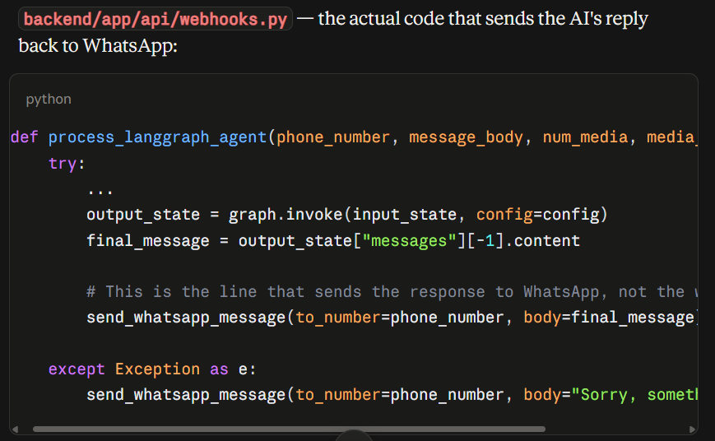
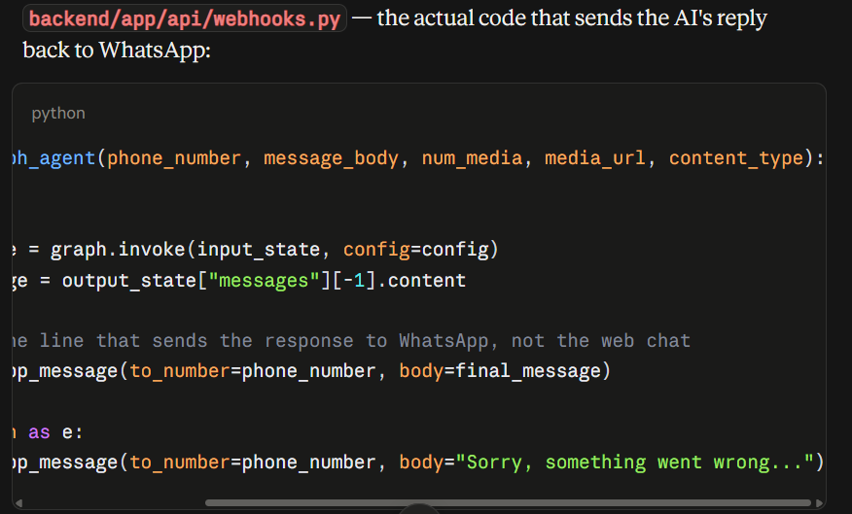
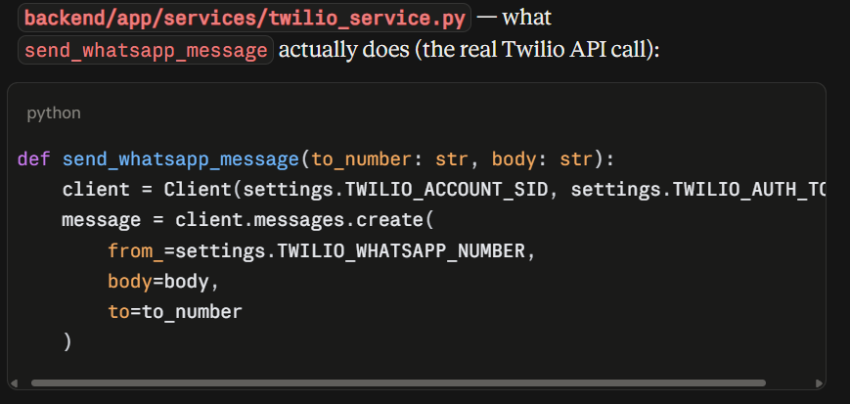

- How are both the whatsapp and in-built chat application maintaining same chat thread?
Answer:-
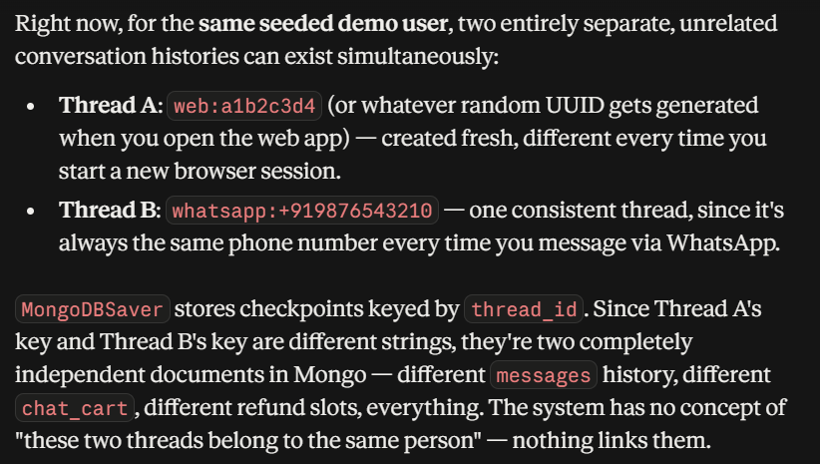
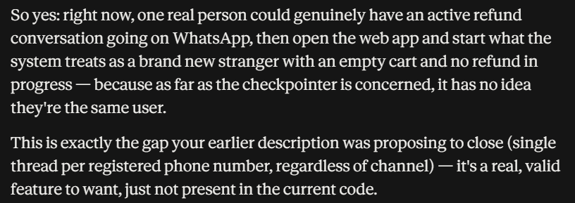
Both the channels have a separate chat thread.

- A chatRequest Class has following fields:-
ClientSide:- A chatRequest from frontend
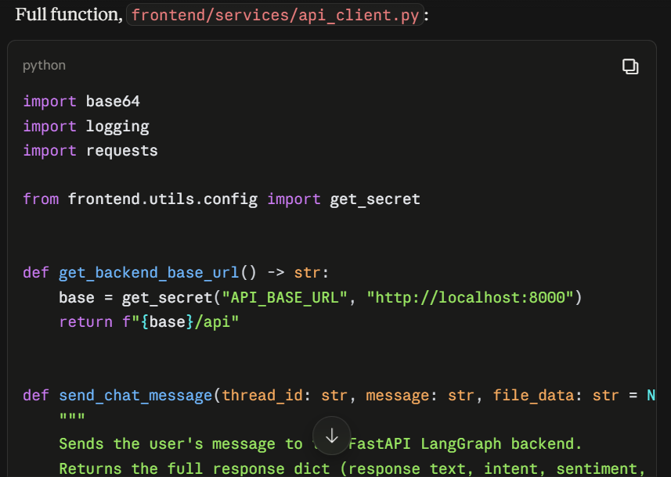
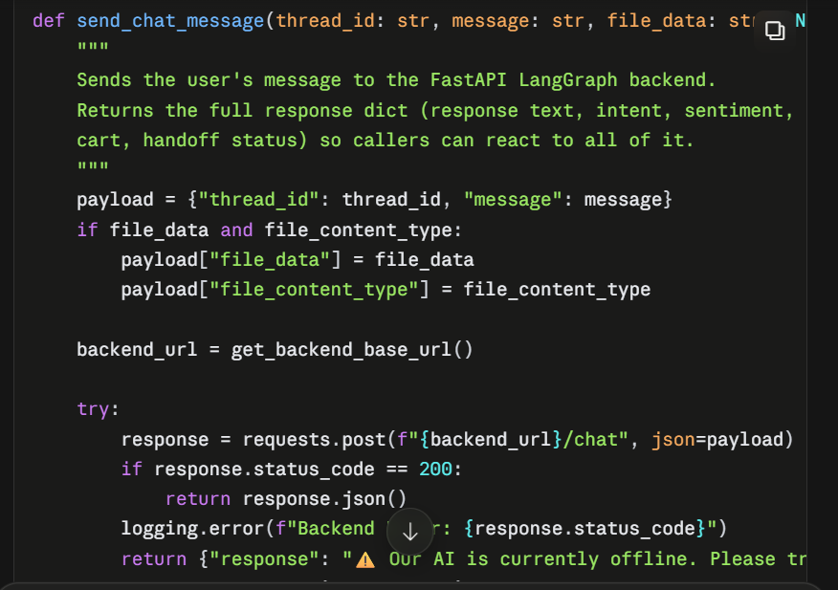
Backend:- This is the backend schema of how a chat message is formatted.
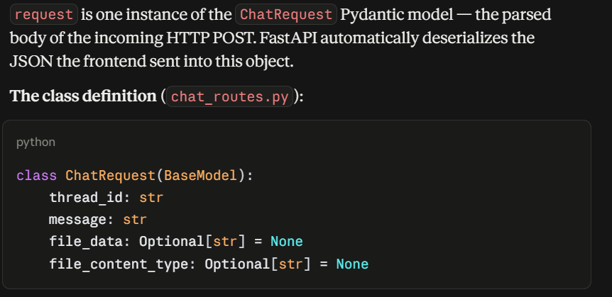
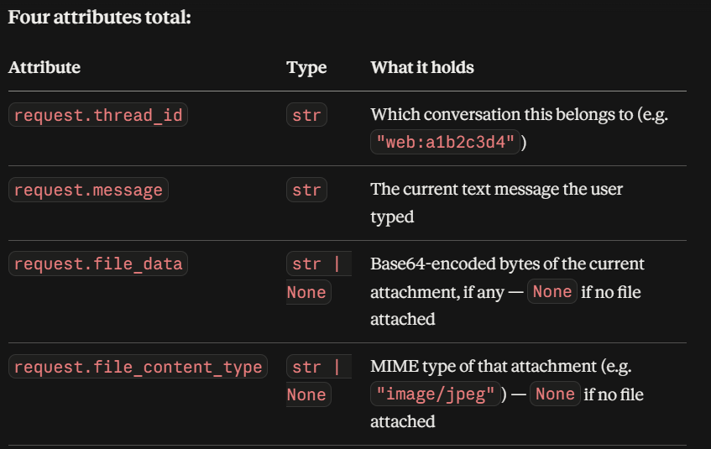
import base64
import logging
from fastapi import APIRouter, HTTPException
from pydantic import BaseModel
from typing import List, Dict, Any, Optional
from langchain_core.messages import HumanMessage

from backend.app.config import settings
from backend.app.graph.master_graph import get_compiled_graph_with_checkpointer
from backend.app.services.media_ingestion import upload_image_bytes_to_cloud, describe_image_bytes, transcribe_audio_bytes, extract_pdf_text

logger = logging.getLogger(settings.APP_NAME)
router = APIRouter()

DEMO_PHONE = "whatsapp:+919876543210" # Single shared demo account (per earlier decision: no real auth/login)

class ChatRequest(BaseModel):
thread_id: str
message: str
file_data: Optional[str] = None
file_content_type: Optional[str] = None

class ChatResponse(BaseModel):
response: str
current_intent: str
sentiment_score: float
chat_cart: List[Dict[str, Any]] = []
is_handed_off: bool = False

def _ingest_web_file(file_data: str, content_type: str) -> str:
"""Returns text to append to the user's message describing the upload."""
raw_bytes = base64.b64decode(file_data)
if content_type.startswith("audio"):
return f" {transcribe_audio_bytes(raw_bytes)}"
if content_type.startswith("image"):
description = describe_image_bytes(raw_bytes)
url = upload_image_bytes_to_cloud(raw_bytes)
return f" [image shows: {description}] [attached photo: {url}]"
if content_type == "application/pdf":
return f" [attached document: {extract_pdf_text(raw_bytes)[:1000]}]"
return ""

@router.post("/chat", response_model=ChatResponse)
async def process_web_chat(request: ChatRequest):
"""
Synchronous endpoint for the Streamlit Web UI.
Invokes the LangGraph engine and awaits the final response.
"""
logger.info(f"Web Chat Request from {request.thread_id}: {request.message}")

try:
effective_message = request.message
if request.file_data and request.file_content_type:
effective_message += _ingest_web_file(request.file_data, request.file_content_type)

graph = get_compiled_graph_with_checkpointer()
config = {"configurable": {"thread_id": request.thread_id}}

input_state = {
"messages": [HumanMessage(content=effective_message)],
"user_profile": {"platform": "web_storefront", "phone_number": DEMO_PHONE},
"thread_id": request.thread_id,
}

output_state = graph.invoke(input_state, config=config)

return ChatResponse(
response=output_state["messages"][-1].content,
current_intent=output_state.get("current_intent", "unknown"),
sentiment_score=output_state.get("sentiment_score", 0.0),
chat_cart=output_state.get("chat_cart", []),
is_handed_off=output_state.get("is_handed_off", False),
)

except Exception as e:
logger.error(f"Web Chat Execution Error: {e}")
raise HTTPException(status_code=500, detail="Internal AI Engine Error")

Equivalent to this, whatsapp twilio backend receiving end point which we have given to twilio and twilio is pushing webhooks to it:-
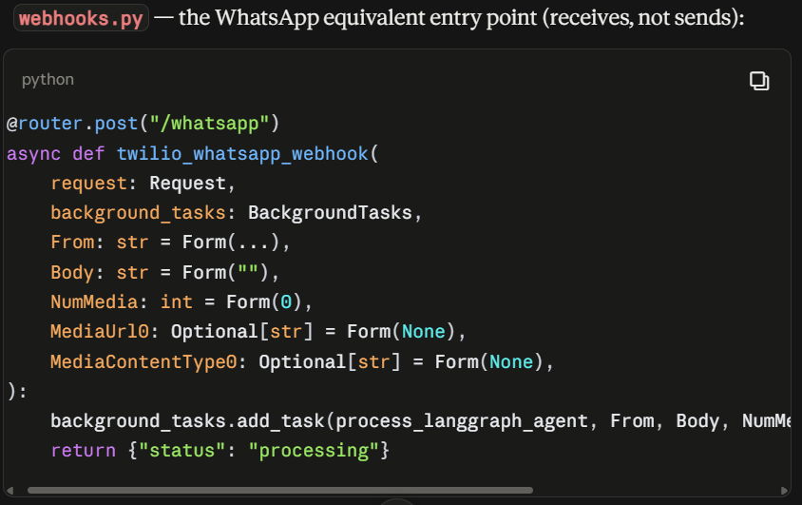
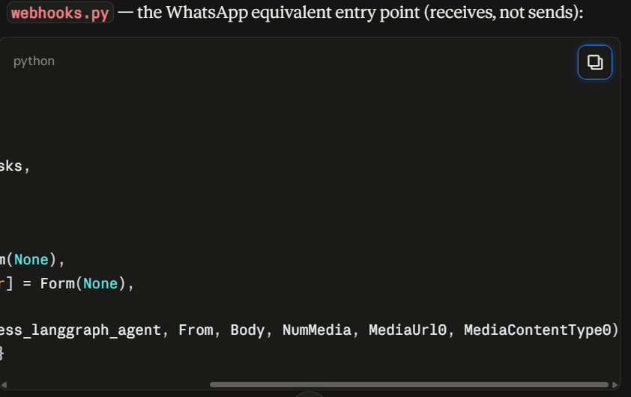

- Master graph flow:-
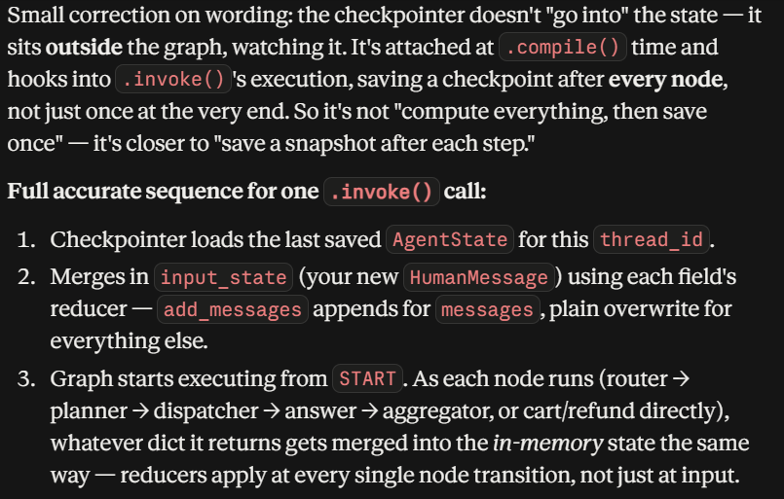
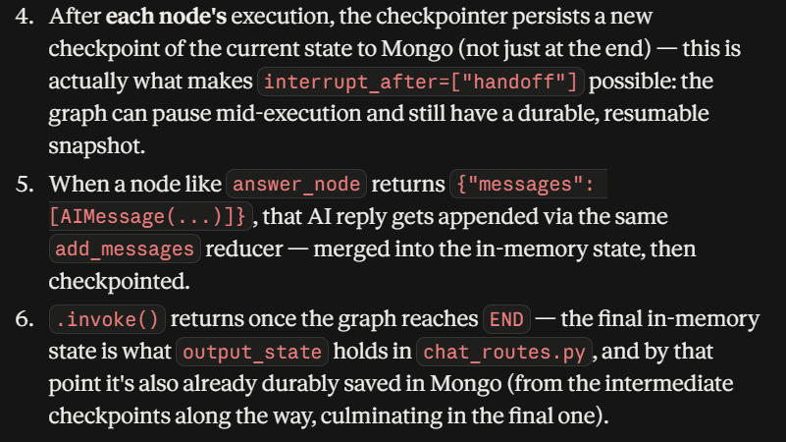

Every node reads from the master graph state to know what the past node produced as result and by the help of that do the current task.
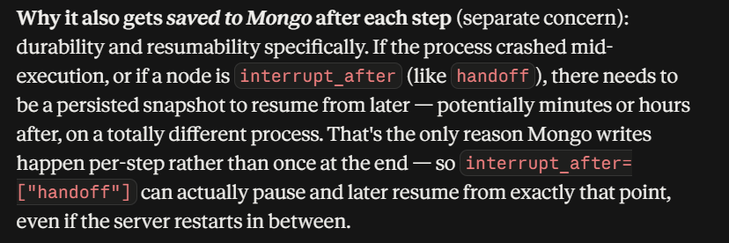
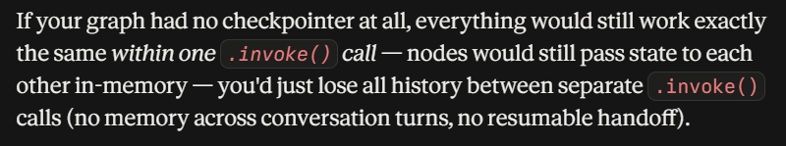

backend/app/graph/state.py :- Has the entire master graph state.:-
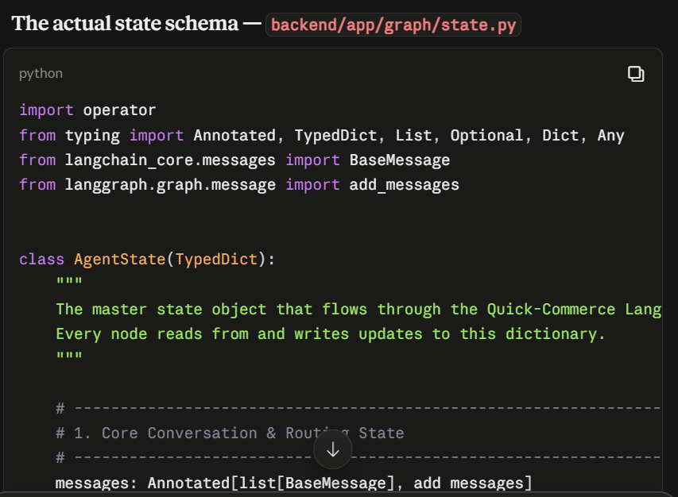
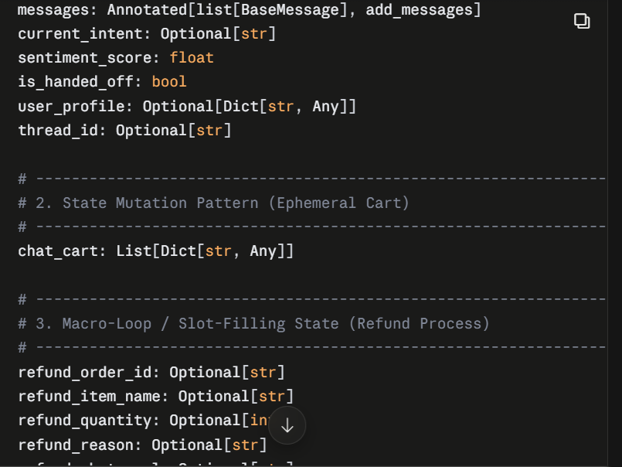
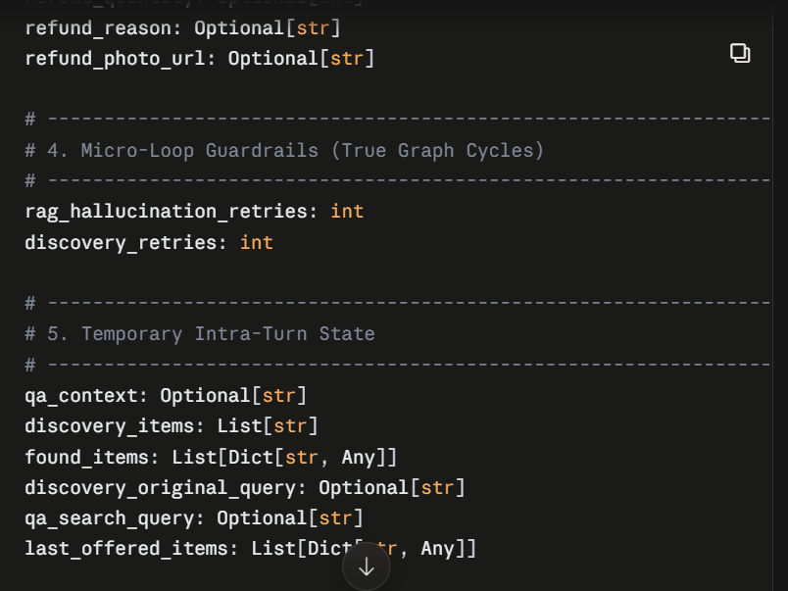
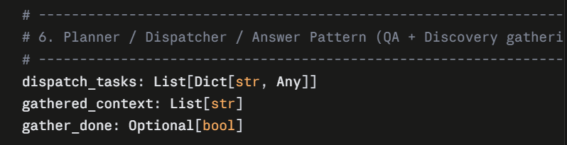

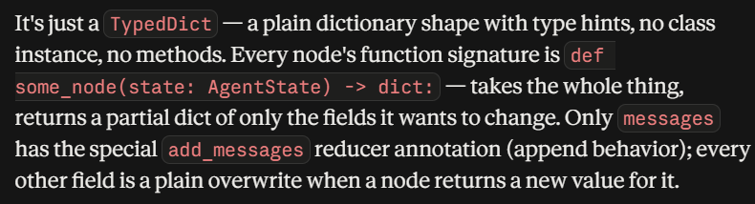

The nodes of master graph:-

Router Node:-
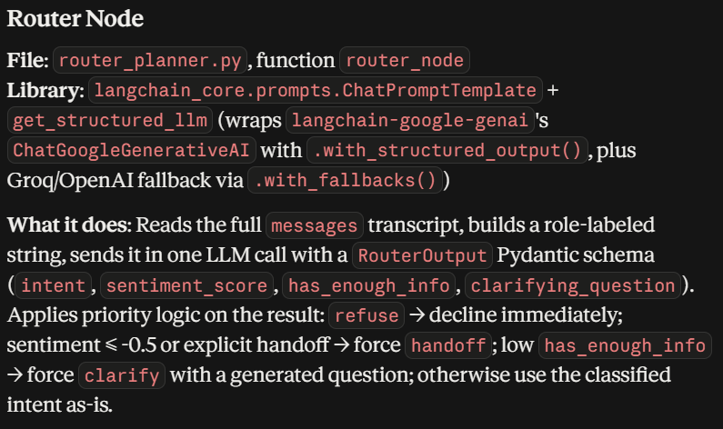

Question:-
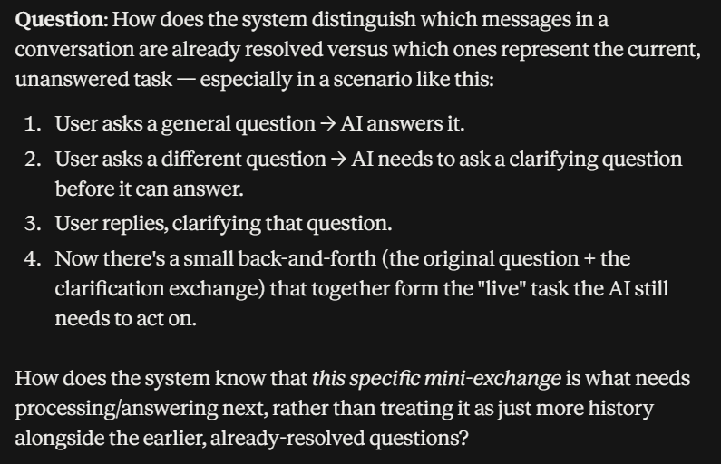
Answer:-
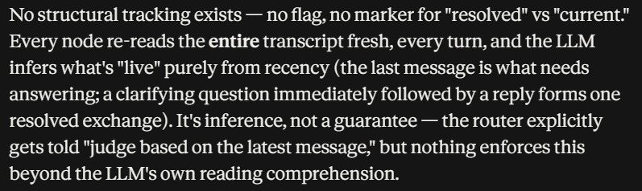
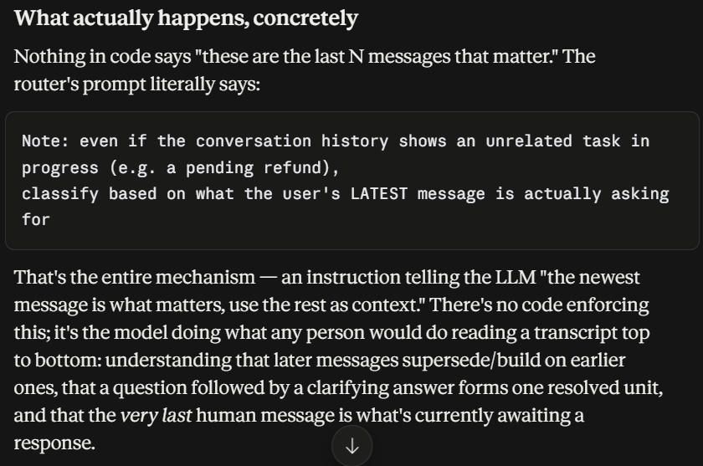

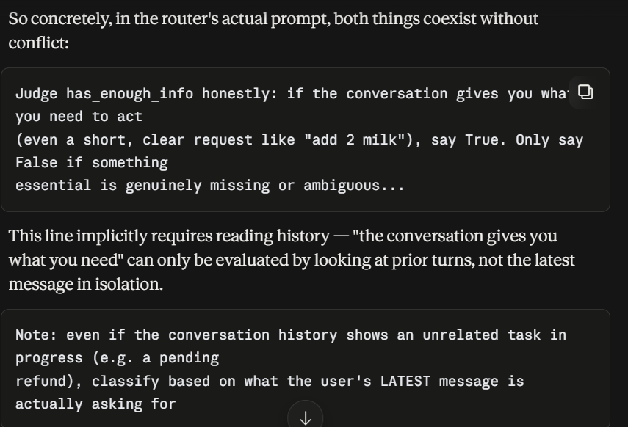
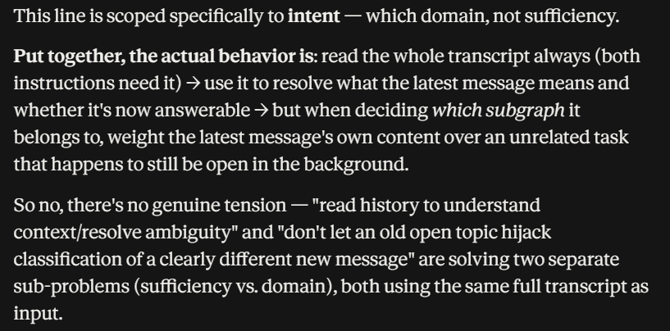

Latest message intent is clearly resolved by previous chat history when given in router LLM, the intent regarding the latest message is derived mainly from the current message that is put in the chat.

- Route_Intent (This isn’t a node exactly, its just a conditional edge you can say which reads the )
