**Topics: Descriptive Statistics and Probability**

1. Look at the data given below. Plot the data, find the outliers and find out $μ, σ, σ^{2}$

|  |  |
| --- | --- |
| **Name of company** | **Measure X** |
| Allied Signal | 24.23% |
| Bankers Trust | 25.53% |
| General Mills | 25.41% |
| ITT Industries | 24.14% |
| J.P.Morgan & Co. | 29.62% |
| Lehman Brothers | 28.25% |
| Marriott | 25.81% |
| MCI | 24.39% |
| Merrill Lynch | 40.26% |
| Microsoft | 32.95% |
| Morgan Stanley | 91.36% |
| Sun Microsystems | 25.99% |
| Travelers | 39.42% |
| US Airways | 26.71% |
| Warner-Lambert | 35.00% |

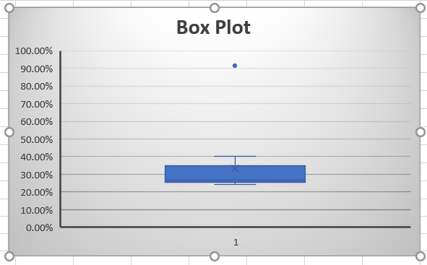

* **By looking at the box plot the outlier is 91.36.**
* **Mean( $μ$) = 33.27 %**
* **Variance ($σ$) = 268**
* **Standard D ( $σ^{2}$) = 16.3708**



Answer the following three questions based on the box-plot above.

1. What is inter-quartile range of this dataset? (please approximate the numbers) In one line, explain what this value implies.
2. What can we say about the skewness of this dataset?
3. If it was found that the data point with the value 25 is actually 2.5, how would the new box-plot be affected?

* **(1) IQR = 3 approximately, the Inter Quartile range gives us a measurement of how spread out the entirety of our data set is.**
* **(2) Right skewed, positive skewed.**
* **(3) The Mean Value will change.**

1. 

Answer the following three questions based on the histogram above.

1. Where would the mode of this dataset lie?
2. Comment on the skewness of the dataset.
3. Suppose that the above histogram and the box-plot in question 2 are plotted for the same dataset. Explain how these graphs complement each other in providing information about any dataset.

* **(1) The mode will be between 5 – 10**
* **(2) Right Skewed.**
* **(3) Skewness of both the plots will be same.**

1. AT&T was running commercials in 1990 aimed at luring back customers who had switched to one of the other long-distance phone service providers. One such commercial shows a businessman trying to reach Phoenix and mistakenly getting Fiji, where a half-naked native on a beach responds incomprehensibly in Polynesian. When asked about this advertisement, AT&T admitted that the portrayed incident did not actually take place but added that this was an enactment of something that “could happen.” Suppose that one in 200 long-distance telephone calls is misdirected. What is the probability that at least one in five attempted telephone calls reaches the wrong number? (Assume independence of attempts.)

* **One wrong number out of 200**
* **Probability of wrong number: P(WN) = 1/200 = 0.005**
* **Probability of not wrong number: 1 - P(WN) =1- 1/200 = 0.995**
* **Probability of at least one out of five is a wrong number**
* **1 – Probability that all five calls are not wrong numbers= 1 – (1 – P(WN))^5**
* **1 – (1-0.005) ^5**
* **1 – 0.975**
* **0.025**
* **2.5%**

1. Returns on a certain business venture, to the nearest $1,000, are known to follow the following probability distribution

|  |  |
| --- | --- |
| x | P(x) |
| -2,000 | 0.1 |
| -1,000 | 0.1 |
| 0 | 0.2 |
| 1000 | 0.2 |
| 2000 | 0.3 |
| 3000 | 0.1 |

1. What is the most likely monetary outcome of the business venture?
2. Is the venture likely to be successful? Explain
3. What is the long-term average earning of business ventures of this kind? Explain
4. What is the good measure of the risk involved in a venture of this kind? Compute this measure

* **(1)x=2000 with highest probability of 0.3**
* **(2) Since the probability of non-negative returns is more than 0.5 which is 50%, the venture will be successful if these rates are maintained. 0.2+0.3+0.1=0.6**
* **(3) p(x)*x = (-2000*0.1) +(-1000*0.1) +(0*0.2) +(1000*0.2) +(2000*0.3) +(3000*0.1)**

**= -200-100+0+200+600+300**

**=800**

* **(4) Standard Deviation.**