Unit | Description
% | percentage
in | inch
cm | centimeter
mm | millimeter
em | 1em is equal to the current font size. 2em means 2 times the size of the current font. E.g., if an element is displayed with a font of 12 pt, then '2em' is 24 pt. The 'em' is a very useful unit in CSS, since it can adapt automatically to the font that the reader uses
ex | one ex is the x-height of a font (x-height is usually about half the font-size)
pt | point (1 pt is the same as 1/72 inch)
pc | pica (1 pc is the same as 12 points)
px | pixels (a dot on the computer screen)

Comment
/* */

<link rel=”stylesheet” type=”text/css” href=”mystyle.css”/>

background
color | image | repeat | attachment | position
name of color  rgb(250,0,255)  #00ff00 | url(path) | Repeat-x, repeat-y,repeat,no-repeat | scroll,fixed | x% y%  px,

eg.
body{background-image:url(‘a.gif’);}

text prop.

color | line-height | letter-spacing | text-align | text-decoration | text-indent | text-transform | white-space | word-spacing
greeen | normal  %  length | normal  number | left  right  center  justify | underline  overline  line-through  none | length  % | uppercase  lowercase  capitalize | normal  pre  no  wrap | normal  length

font
style | variant | weight | size | family
normal  italic  oblique | normal  small-caps | normal  bold  bolder  lighter  100-900 | Number  x-small,xx-small  small  medium,  x-large  xx-large  larger | family-name

border
width | Style | color
thin  medium  thick  length | dotted  dashed  solid  double  inset  outset  groove  ridge
you can add different style in each horizontal and vertical border
border-bottom
top
left
right
margin
top | Right | bottom | left
length  % | length  % | length  % | length  %

Padding
Top | right | bottom | left
length  % | length  % | length  % | length  %

list-style
Type | position | image
disc  circle  square  lower-roman  upper-roma  none  inline | inside  outside | url

height | Width | min-height | min-width | max-height | max-width
Length  % | Length  % | Length  % | Length  % | Length  % | Length  %

cursor | Float | position | Visibility | Vertical-align
url  crosshair  pointer  move  wait  help  text | Left  Right | Relative  Absolute  Fixed  Static  sticky | Hidden  visible | Sub  Super  Top  Middle  Bottom  length

a:
Link | visited | hover | active
{Color:red} | {Color:yellow} | {Color:blue} | {Color:green}

Didplay
Inline block | none

vertical-align | baseline  sub  super  top  text-top  middle  bottom  text-bottom  length  %

Table
border-collapse | Separate/collapse(d)
Border-spacing | Xpx Ypx(work only if border-collapse :separate given)
Caption-side | Bottom/top(d)
empty-cells | Hide/show(d)
Table-layout | Fixed/auto(d)

opacity | 0.5

Direction
Ltr/rtl

CSS : Position
The position property specifies the type of positioning method used for an element.
There are five different position values:
- static
- relative
- fixed
- absolute
- sticky
Elements are then positioned using the top, bottom, left, and right properties. However, these properties will not work unless the position property is set first. They also work differently depending on the position value
Static:HTML elements are positioned static by default.
Static positioned elements are not affected by the top, bottom, left, and right properties.
An element with position: static; is not positioned in any special way; it is always positioned according to the normal flow of the page:

<!DOCTYPE html>
<html>
<head>
<style>
div.static {
position: static;
border: 3px solid #73AD21;
}
</style></head>
<body>
<h2>position: static;</h2>
<p>An element with position: static; is not positioned in any special way; it is
always positioned according to the normal flow of the page:</p>
<div class="static">
This div element has position: static;
</div>
</body> </html>

position: relative: An element with position: relative; is positioned relative to its normal position.
Setting the top, right, bottom, and left properties of a relatively-positioned element will cause it to be adjusted away from its normal position. Other content will not be adjusted to fit into any gap left by the element.
<!DOCTYPE html>
<html>
<head>
<style>
div.relative {
position: relative;
left: 30px;
border: 3px solid #73AD21;
}
</style>
</head>
<body>

<h2>position: relative;</h2>

<p>An element with position: relative; is positioned relative to its normal position:</p>

<div class="relative">
This div element has position: relative;
</div>

</body>
</html>

position: fixed;
An element with position: fixed; is positioned relative to the viewport, which means it always stays in the same place even if the page is scrolled. The top, right, bottom, and left properties are used to position the element.
A fixed element does not leave a gap in the page where it would normally have been located.

<!DOCTYPE html>
<html>
<head>
<style>
div.fixed {
position: fixed;
bottom: 0;
right: 0;
width: 300px;
border: 3px solid #73AD21;
}
</style>
</head>
<body>

<h2>position: fixed;</h2>

<p>An element with position: fixed; is positioned relative to the viewport, which means it always stays in the same place even if the page is scrolled:</p>

<div class="fixed">
This div element has position: fixed;
</div>

</body>
</html>

position: absolute;
An element with position: absolute; is positioned relative to the nearest positioned ancestor (instead of positioned relative to the viewport, like fixed).
However; if an absolute positioned element has no positioned ancestors, it uses the document body, and moves along with page scrolling.

<!DOCTYPE html>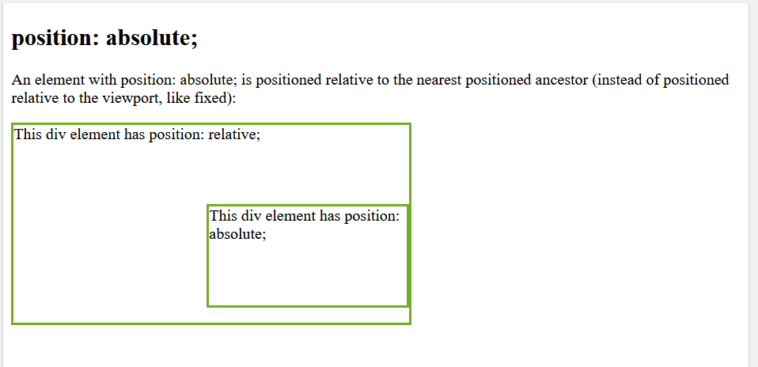
<html>
<head>
<style>
div.relative {
position: relative;
width: 400px;
height: 200px;
border: 3px solid #73AD21;
}

div.absolute {
position: absolute;
top: 80px;
right: 0;
width: 200px;
height: 100px;
border: 3px solid #73AD21;
}
</style>
</head>
<body>

<h2>position: absolute;</h2>

<p>An element with position: absolute; is positioned relative to the nearest positioned ancestor (instead of positioned relative to the viewport, like fixed):</p>

<div class="relative">This div element has position: relative;
<div class="absolute">This div element has position: absolute;</div>
</div>

</body>
</html>

position: sticky;
An element with position: sticky; is positioned based on the user's scroll position.
A sticky element toggles between relative and fixed, depending on the scroll position. It is positioned relative until a given offset position is met in the viewport - then it "sticks" in place (like position:fixed).

<!DOCTYPE html>
<html><head>
<style>
div.sticky {
position: -webkit-sticky;
position: sticky;
top: 0;
padding: 5px;
background-color: #cae8ca;
border: 2px solid #4CAF50;
}
</style></head>
<body>

<p>Try to <b>scroll</b> inside this frame to understand how sticky positioning works.</p>

<div class="sticky">I am sticky!</div>

<div style="padding-bottom:2000px">
<p>In this example, the sticky element sticks to the top of the page (top: 0), when you reach its scroll position.</p>
<p>Scroll back up to remove the stickyness.</p>
<p>Some text to enable scrolling.. Lorem ipsum dolor sit amet, illum definitiones no quo, maluisset concludaturque et eum, altera fabulas ut quo. Atqui causae gloriatur ius te, id agam omnis evertitur eum. Affert laboramus repudiandae nec et. Inciderint efficiantur his ad. Eum no molestiae voluptatibus.</p>
<p>Some text to enable scrolling.. Lorem ipsum dolor sit amet, illum definitiones no quo, maluisset concludaturque et eum, altera fabulas ut quo. Atqui causae gloriatur ius te, id agam omnis evertitur eum. Affert laboramus repudiandae nec et. Inciderint efficiantur his ad. Eum no molestiae voluptatibus.</p>
</div>
</body>
</html>
To dig in detail
https://developers.google.com/web/fundamentals

