Weekly Worksheet Solutions

Student Name: Niraj Poudel

Week Number:2

Worksheet No / Name:2

Exercise No 1 / eNotation: CIS016-1 - Principles of Programming / CIS096-1 – Principles of Programming and Data Structures / PAT001-1 – Principles of Programming - 2019/2020

Commented Code

public class Exercis1{

public static void main (String [] args){

double value1 = 0.000342;

// the value2 can be double or integer

// double value2 = 2345;

int value2 = 22345;

// Double value3 divides the double value2 by double value1

double value3 = (value1 / value2);

System.out.println(“The result of 0.000342/2345 is :” + value3);

}

}

Evidence of Testing

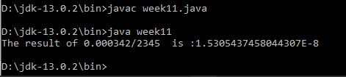

Explanation / Discussion of Solution

Here the program has the main class “week11” that consist of the method “public void static main(String args[])” where the declaration of the double values as the constant ( In some cases int value can be used if the float value is not there.

Exercise No 3 / Conversion:

public class Conversion{

public static double mileToKilomters = 1.609;

public static double kilomtersToMiles = 0.621;

public static double convertToMiles(double value1){

double result = value1 \* mileToKilomters;

return result;

}

public static double convertToKilometers(double value1){

double result = value1 \* kilomtersToMiles;

return result;

}

//main method

public static void main(String [] args){

int miles = 17;

int kilometers = 23;

//conversion of 23 kilomters to miles

double resultInMiles = convertToMiles(kilometers);

System.out.println("23 kilomters in miles is:" + resultInMiles);

//conversion of 17 miles to kilomters

double resultInKilometers = convertToKilometers(miles);

System.out.println("17 miles to kilometers is:" + resultInKilometers);

}

}

Evidence of Testing

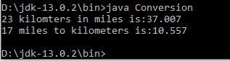

Explanation / Discussion of Solution

Exercise No 5 /Circle::

//class

class Exercise5{

//making PI constant

public static final double PI = 3.142857;

//making the method for the calculation of the circumference

public static double circumferenceCalc(double value1){

double result = 2 \* PI \* value1;

return result;

}

//making method for calculation of the area

public static double areaCalc(double value1){

double result = PI \* (value1 \* value1);

return result;

}

//making method for calculation of the volume

public static double volCalc(double value1){

double result = 4 \* PI \* (value1 \* value1 \* value1)/3;

return result;

}

// main method

public static void main (String [] args){

// declaring the radius

double radius = 7.5;

System.out.println("The radius of the circle is:" + radius);

//calculation of the circumference

double circumference = circumferenceCalc(radius);

System.out.println("The circumference of the circle is:" + circumference);

//calculation of the area

double area = areaCalc(radius);

System.out.println("The area of the circle is:" + area);

//calculation of the volume

double volume = volCalc(radius);

System.out.println("The volume of the circle is:" + volume);

}

}

Evidence of Testing

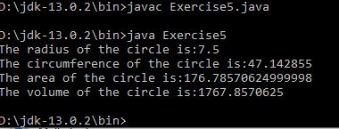

Explanation / Discussion of Solution

In the class Exercise5, there is two methods(double and main) where in the double method, the re is simple printing of the solutions and in the double method of the same class, there is calculation formulae that executes the code and have declaration of the pi value.

Exercise No 6/Odd or even:

public class Exercise6{

public static void modulo(double arg1){

double calc = arg1 % 2;

if (calc<=0){

System.out.println(arg1 + "is even");

}

else{

System.out.println(arg1 + "is odd");

}

}

public static void main(String [] arg){

double value1 = 17;

modulo(value1);

}

}

Evidence of Testing

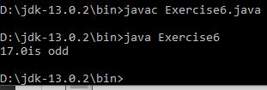

Explanation / Discussion of Solution

In this class Exercise6 and the method, I used the public static modulo instead of public static void main- the question asked for the modulo method . In the modulo method, arg1 is divided by the 2 in order to display the arg1 that is declared below the public static void main i.e. main method of the class Exercise6.