


Patan College for Professional Studies

Group Assignment
Python Project

Lenden: The Customer’s Satisfaction

Project Report

Submitted By Submitted To
Niraj Chudali(1915677) University of Bedfordshire
Chiranjeebi Khanal(1822747)
Roshan Bist(1915684)
Santosh Shahi(1916447)

1.Introduction

Shared power is the system that allows people to share the things rather than buying them. We have developed the system named Lenden: The customer’s satisfaction. Lenden is the Nepali word meaning ‘Liney rw Diney’. We have three actors in our system. We named them Seller, Buyer and insurance Agent. Seller and insurance agent have given the separate account so that they can directly login to the system but the buyers have to register first to access the features like searching tool, hiring tool, paying for tools and returning the tool. Seller can upload the tools and view all the uploaded tools details where as insurance can see all registered profiles and the tools that are uploaded by the seller.

2.objective of project

The main goal of the project is to help tradesmen to share tools easily. Lenden: the customers satisfaction is the easiest and most convenient way to hire and return the tool. It is developed for the people with the way easier to operate and charge less as compared to others.

3.Proposed system

Lenden: the customer’s satisfaction is the information system developed by using python Tkinter library. First we develop the CUI(Character User Interface) model of the system to see how the function inside the system will work and them we converted the same CUI(Character User Interface) system to the GUI(Graphical User Interface) system thinking of making more easier and convenient to use for the users.

4.Terms and Conditions

Like every system we have also the terms and conditions that the users have to follow.
1. New users have to first register themselves to access the user panel of the system. While registering to the system the user are not allowed to user the same username for the second time and the username and password must be more than 4 characters.
2. While uploading the tools the seller must include the tool name, tool description, tool condition , half day rate and fullday rate.
3. While hiring the tools buyer must include the number of days he/she want to hire.
4. While generating the invoice the 50% of the hired tool is included as the insurance charge.

5.System Design

5.1.Scenario

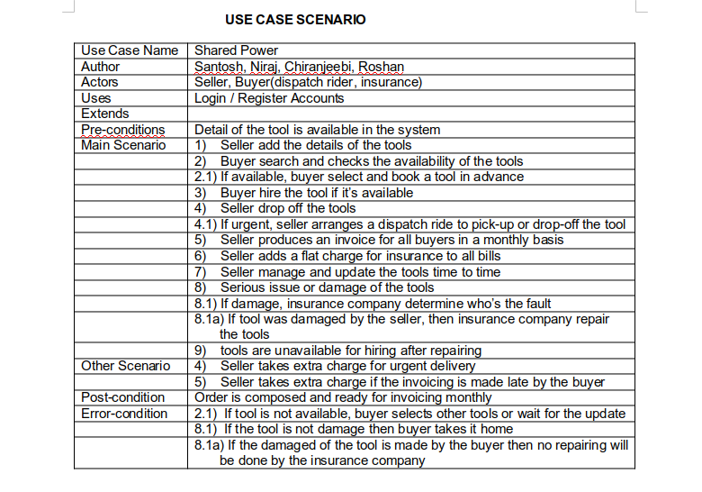

5.2.Sea Level user case diagram
This is the overall diagram of the system where the role of three actors are completely defined.

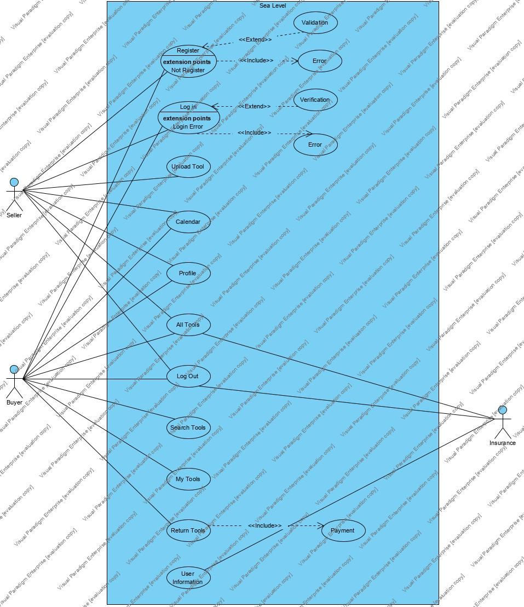

5.3.Fish Level Diagrams

5.3.1.Search Tools:

Registered user can search the tool that have been uploaded by the seller. If the tool is available then it is displayed with tool name, tool description, tool condition, half day rate and full day rate. If the tool is not available then message will be pop up displaying no items found.
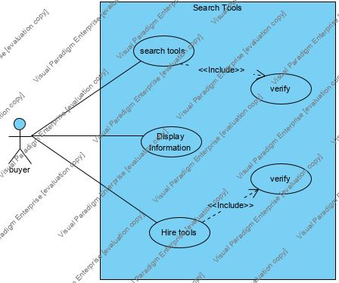

5.3.2.Upload Tool:
Seller upload the tools to the system.

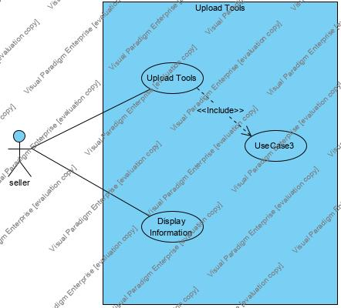

5.3.3.Payment Tools

The invoice is calculated according the tools price uploaded by the seller. The insurance charged is added to the invoice while calculating the total amount.
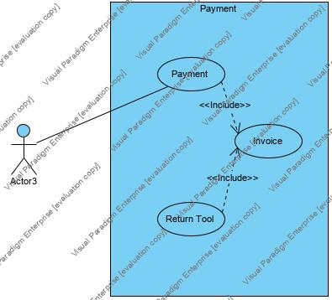

5.4.Calm Level Diagrams

5.4.1.Search and Hire Tools

Registered buyers can search and hire the tool if the tool is available then the buyer can choose the option whether they want rider or not. If the tool is not available then the pop up message is displayed showing items not found.

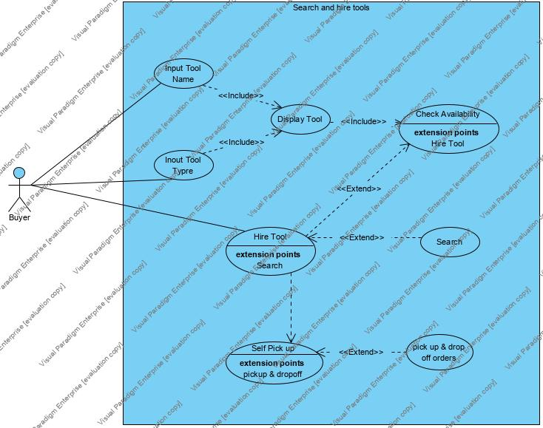

5.4.2.Return Tools

After hiring the tools tool buyer have to return the tool.
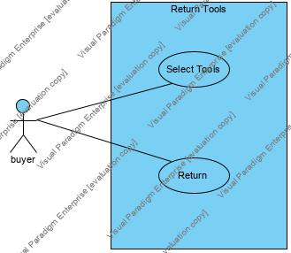

5.4.3.Upload Tools

While uploading the tool seller have to include the tool name, tool description, tool condition ,half day rate ,full day rate and the image of the tool.

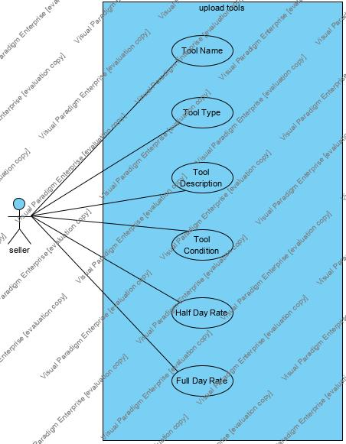

5.5.Activity Diagram

5.5.1.Activity diagram of seller

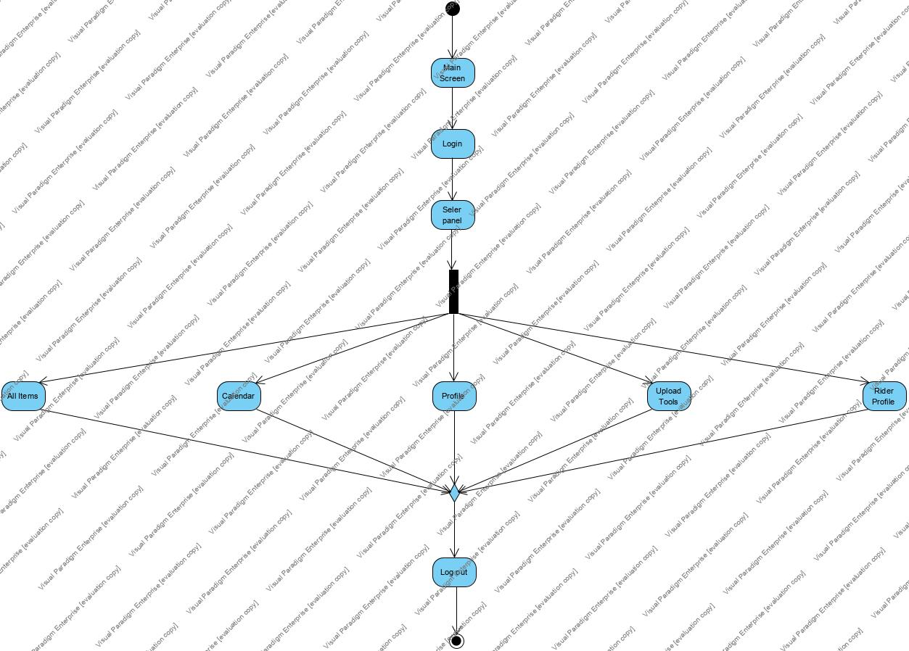

5.5.2.Activity diagram of insurance

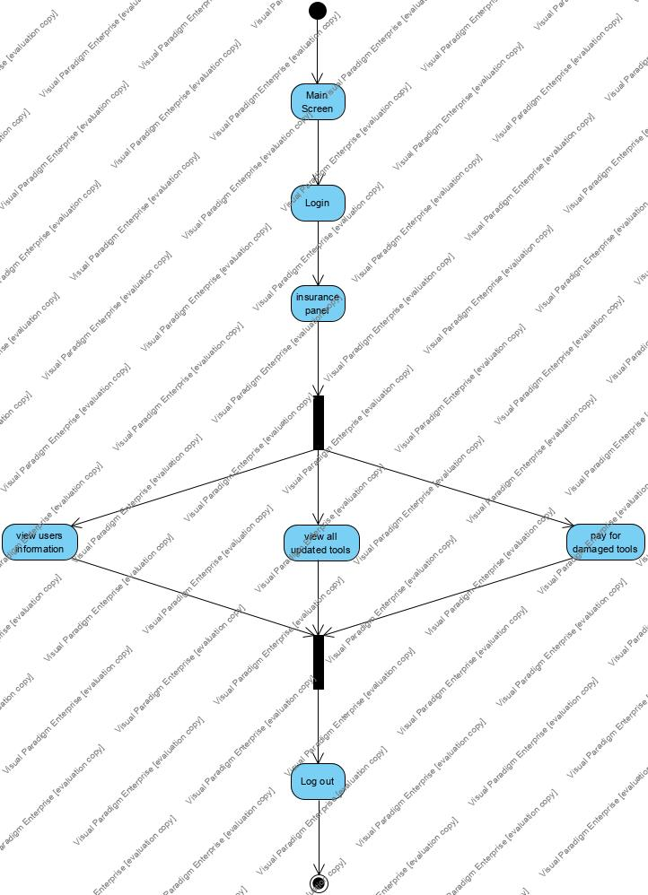

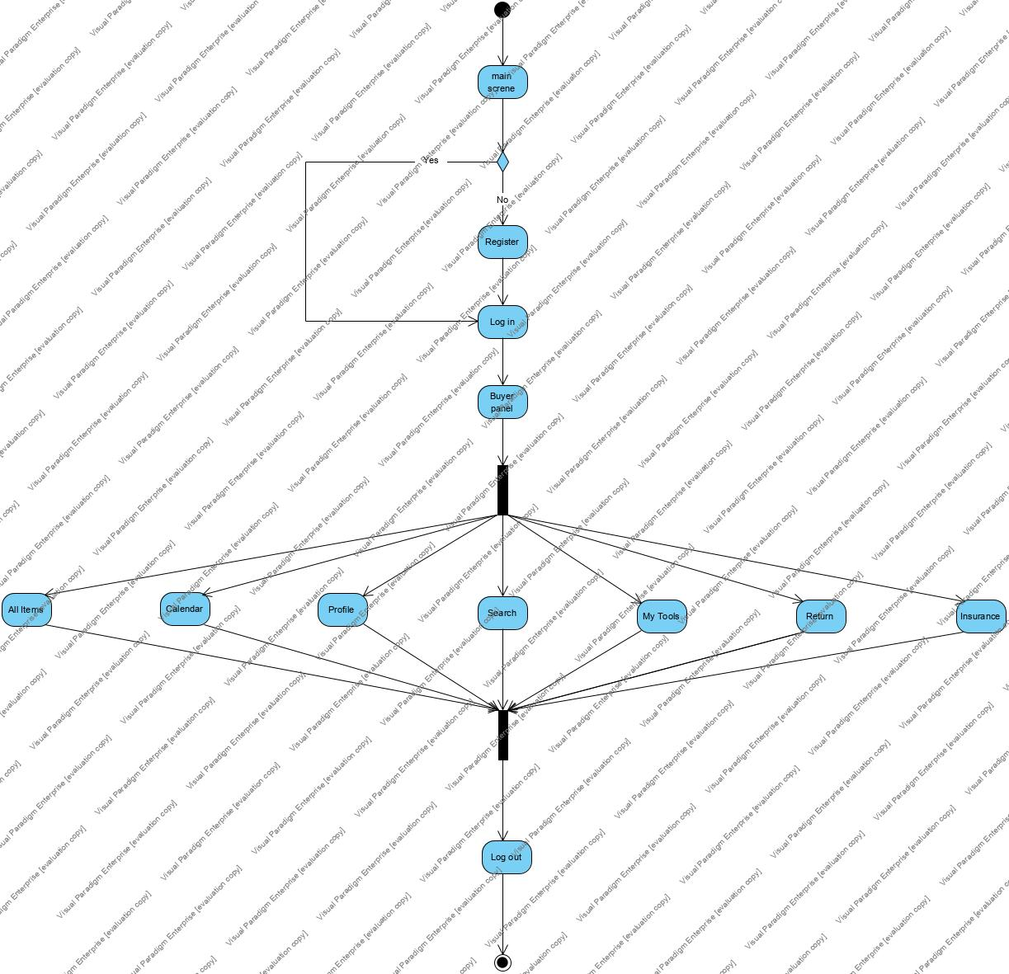
5.5.3.Activity Diagram of Buyer

5.6.Class Diagram(Object oriented approach)

This is the whole architecture of our system. The main screen is initialized when we start our software. Then the registered users can directly logged into their account whereas the new users have to register first to access the dashboard. In the dashboard we have search, hire, payment and return options. Whereas seller have only access to upload the tools and view all details of the tool. And we have the third user insurance who has given permission to check tools and view all the registered profiles in the system.

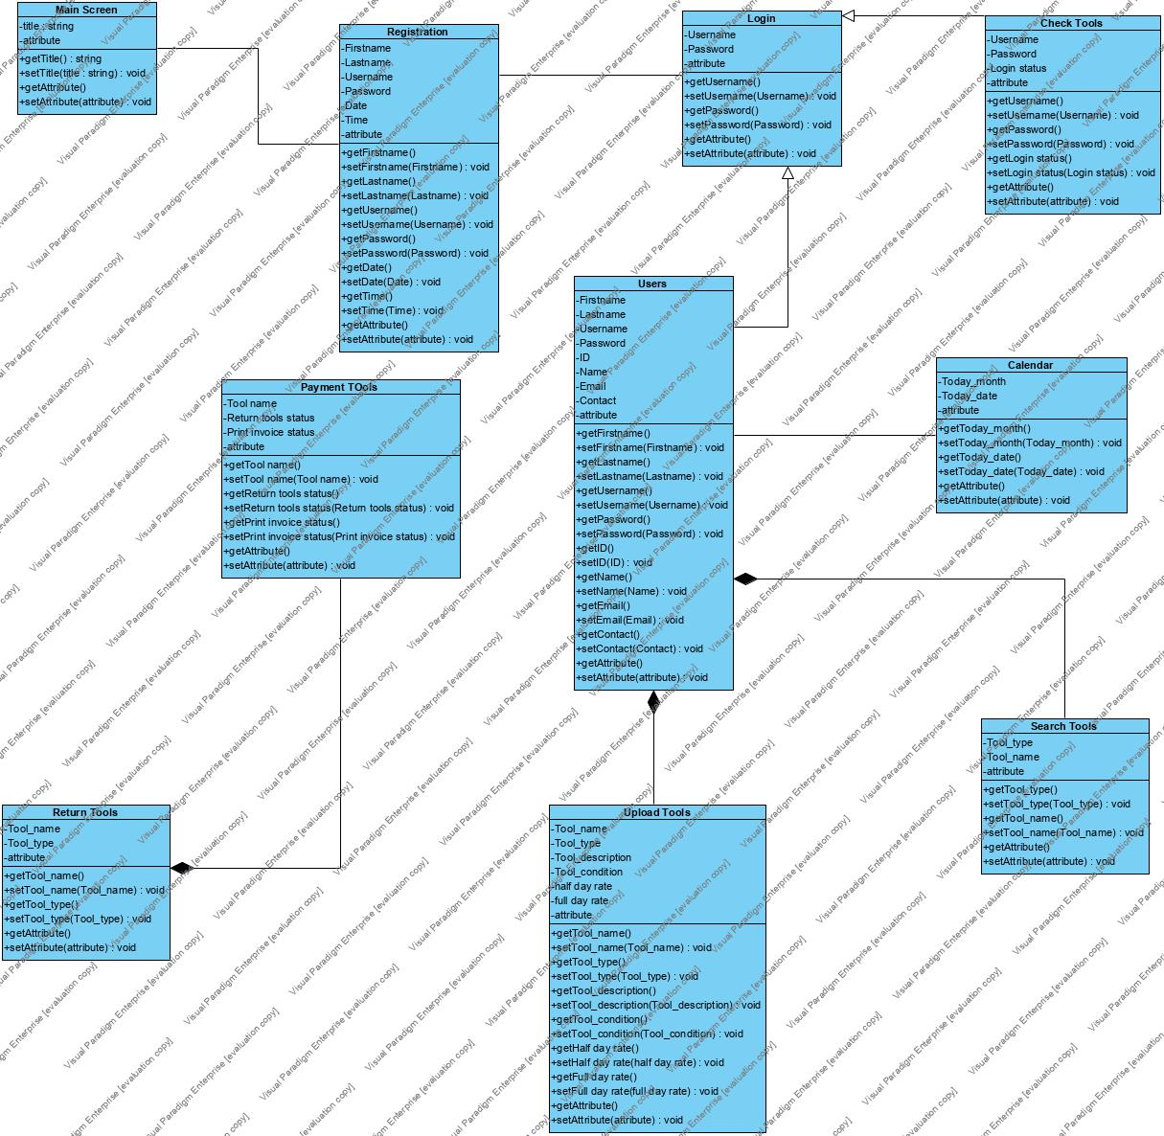

6. Implementation of Program

6.1.Screenshots of software(Character User Interface)

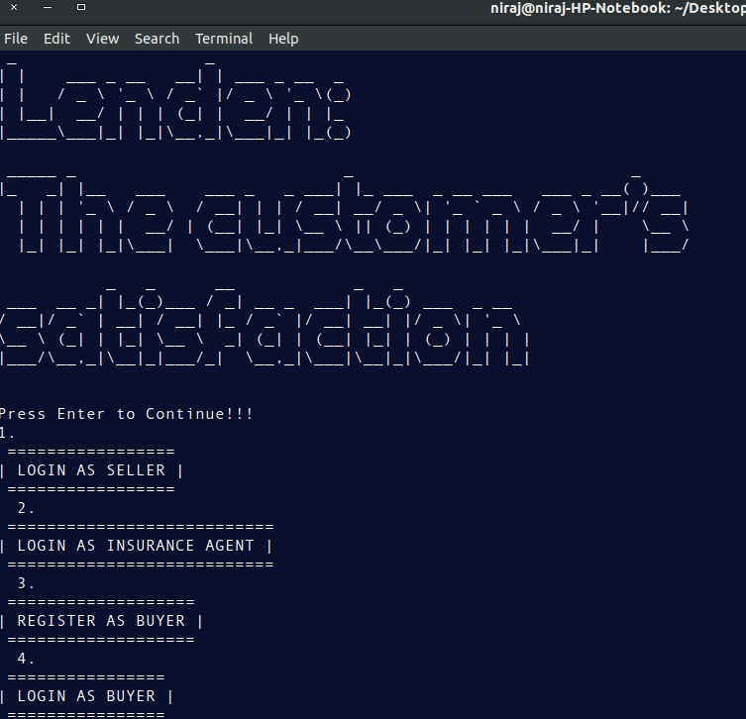

This is the main screen when software is initialized.

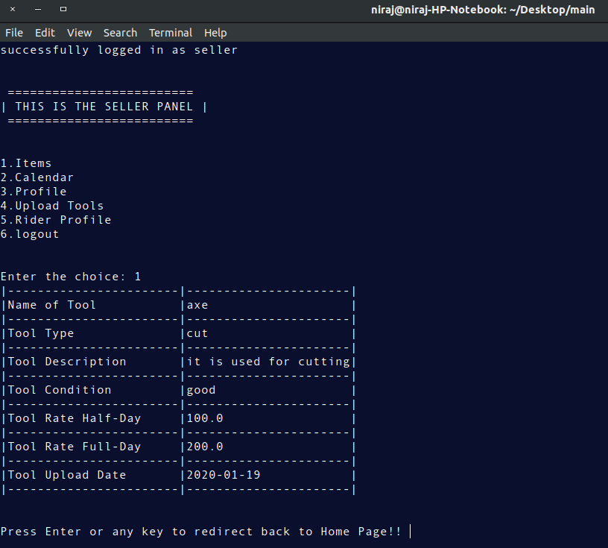

This is the tool that have been uploaded in the system.

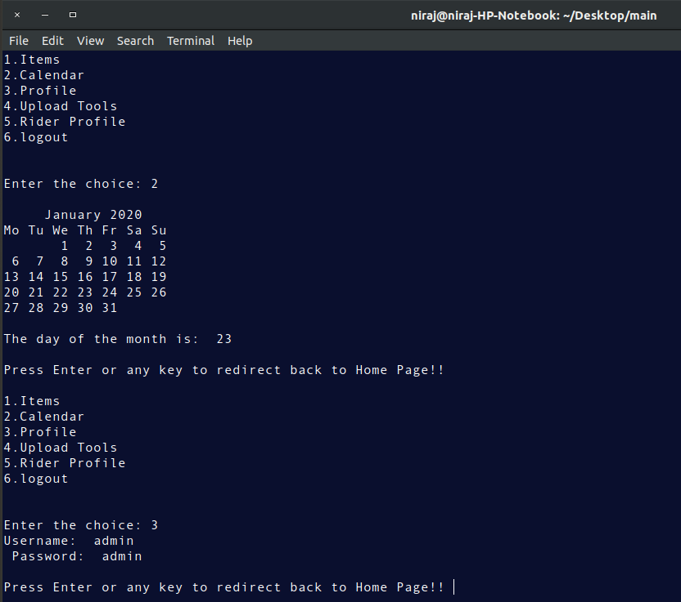

This is the seller panel that seller can see all items, view calendar, view his/her profile, upload tools , rider profile and logout.

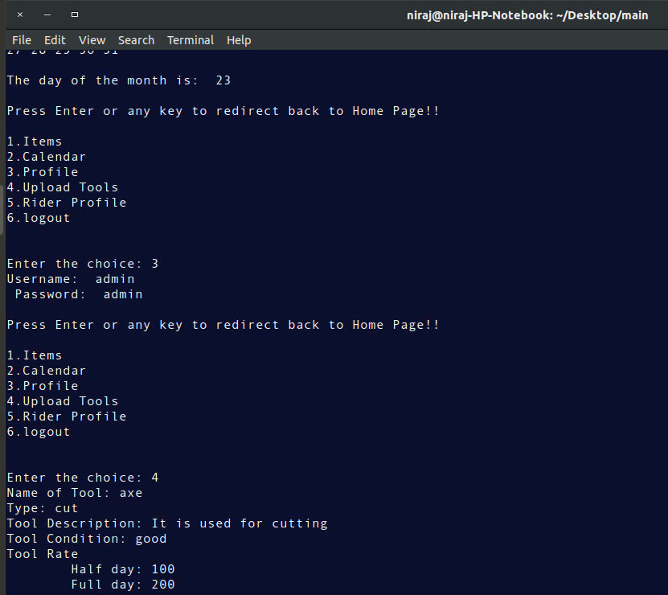

Tools are uploaded by giving their name, description, condition, half day rate and full day rate.

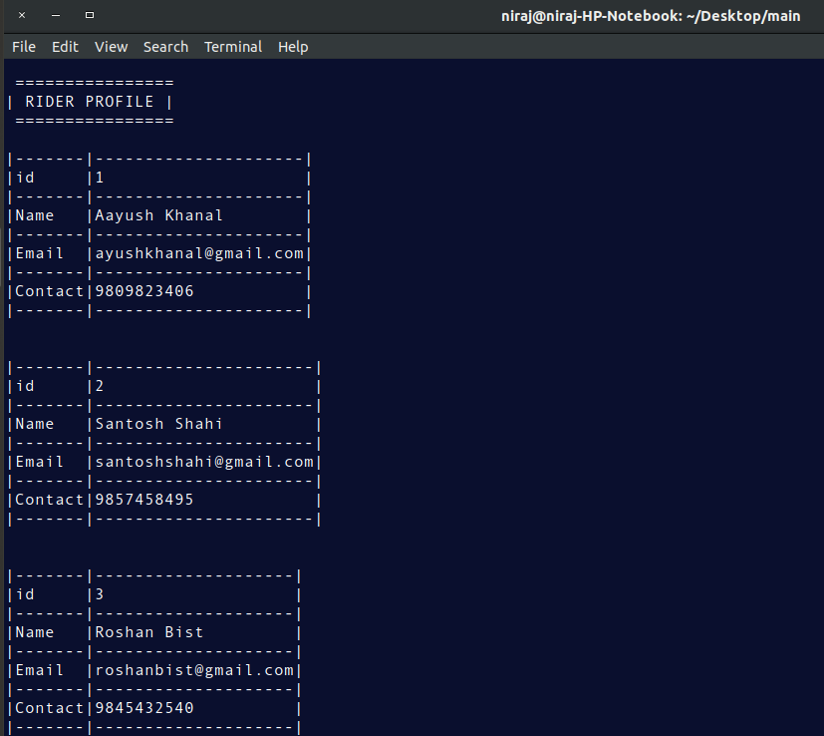

This is the rider profile which are registered by our system.

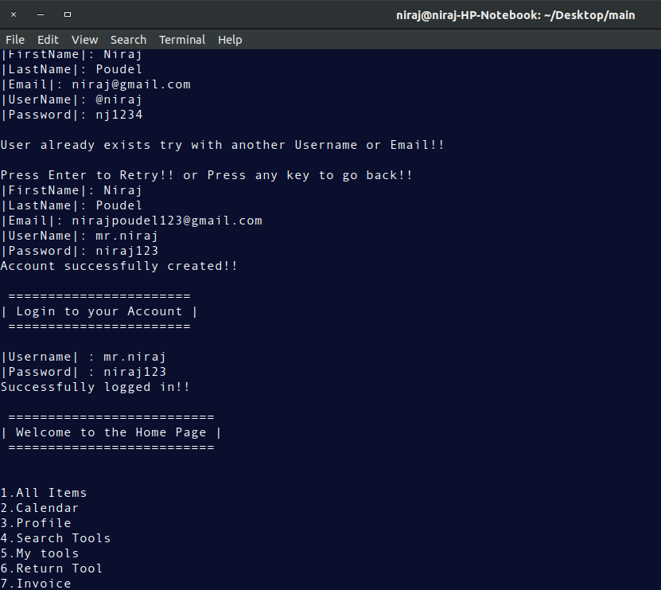

To access to the user panel user have to register their account first.

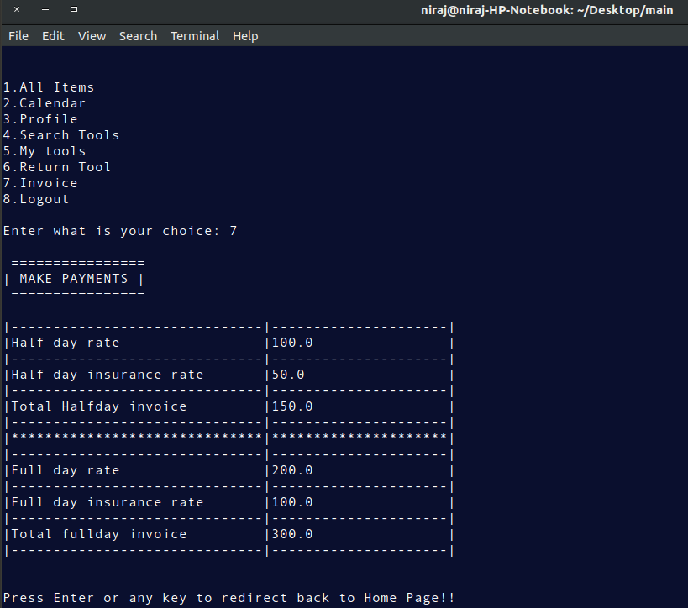

This the invoice printed after the buyer hire the tools.

6.2.Screenshots of software(Graphical User Interface)

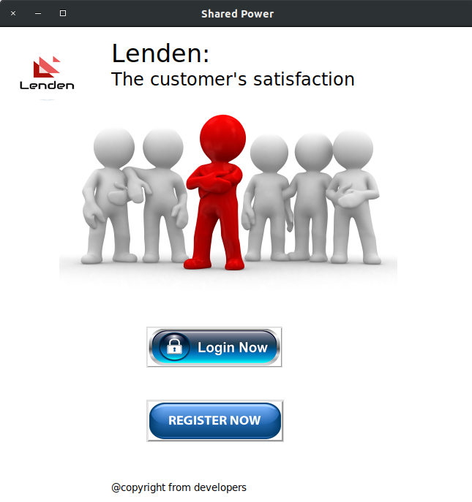

This is the main screen which
opens when software is initialized.

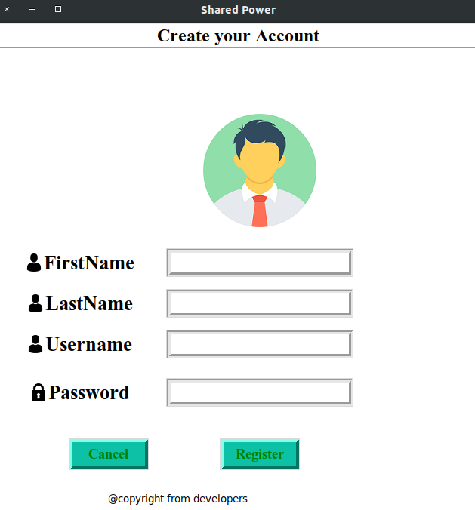

New users have to register into the account
to access the dashboard.

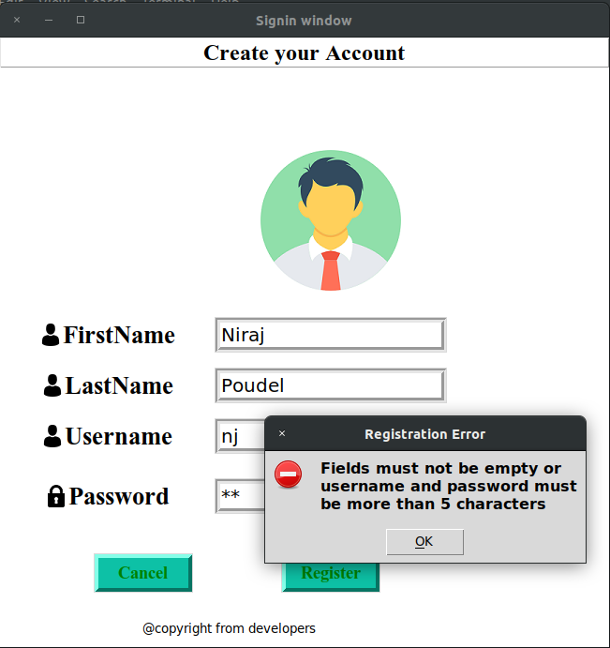

While registering to the account the fields must not be empty and username and password must be more than 5 characters.

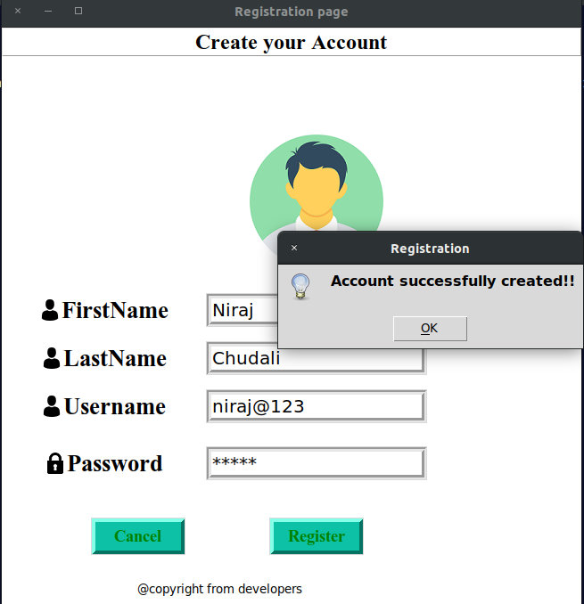

By entering the correct credentials account is successfully created.

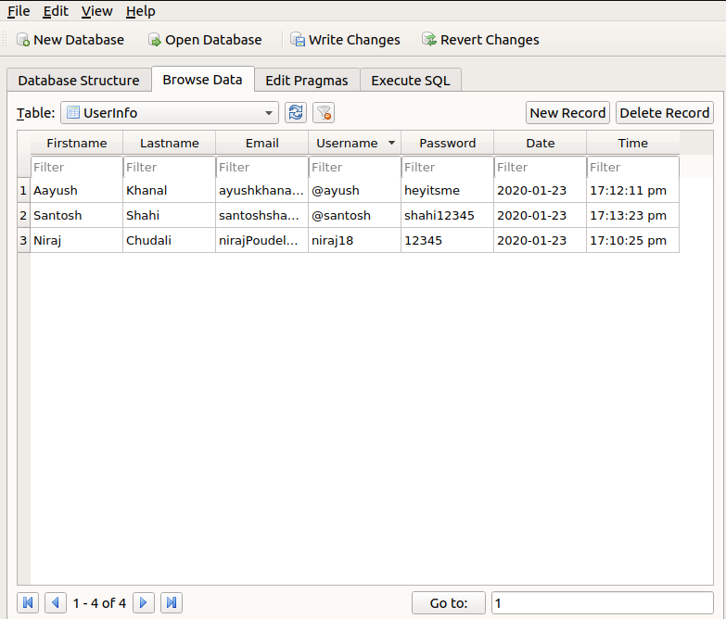

This is the database where registered user information get stored.

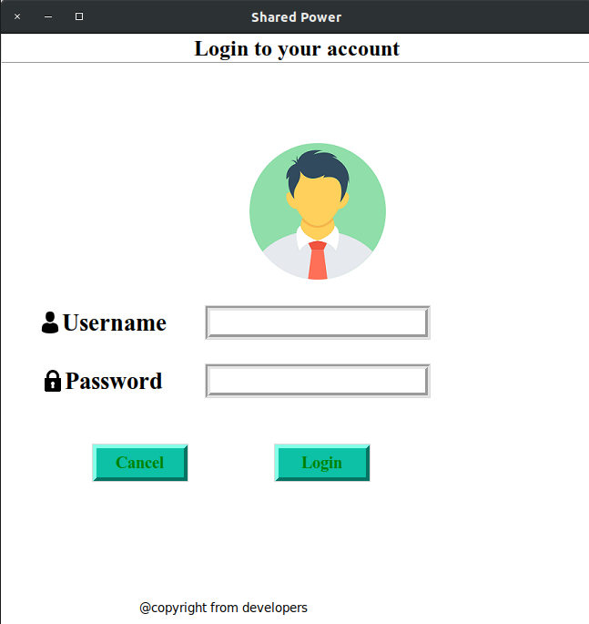

Registered user can directly logged in by entering
username and password.

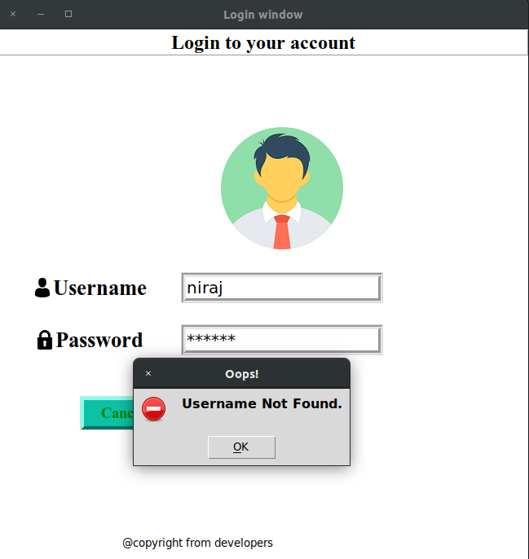

If either username or password is wrong then the system will generate invalid username or password message.

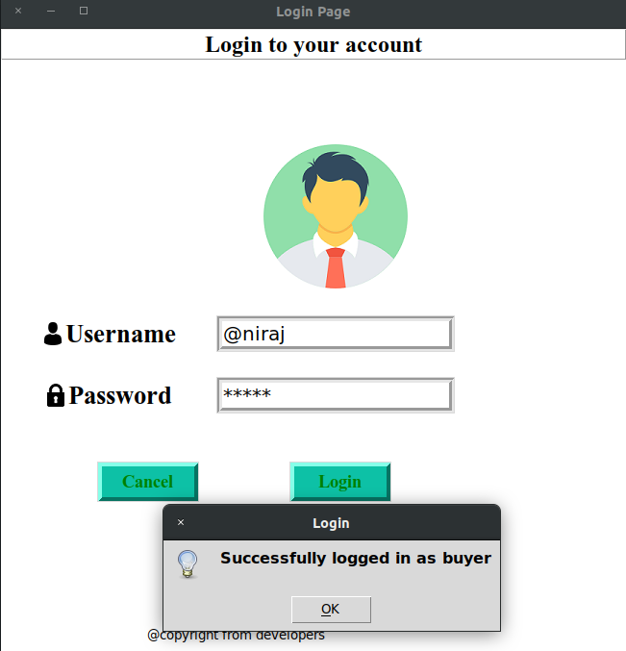

If the user provides the correct details then the user will be able to access the dashboard.

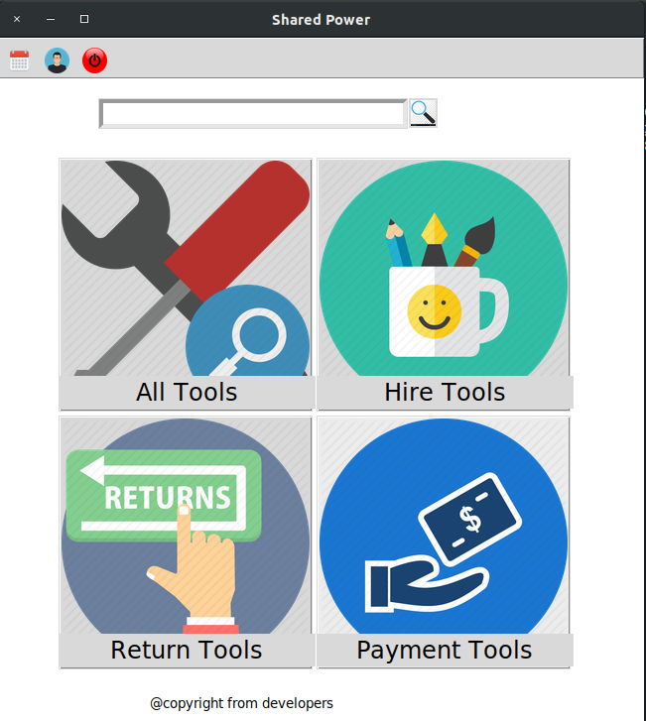

This is the user panel when user can search, hire,
return and pay the tools.

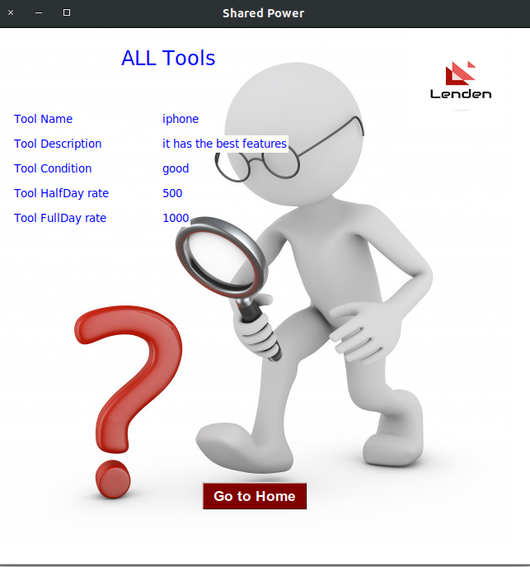

This is the all tool panel where user can see all the tools
that have been uploaded by the seller.

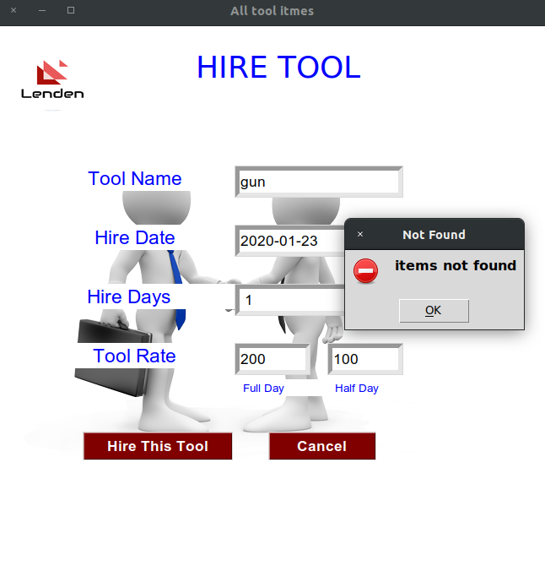

If the name of the item is not found then it will popup item not found message.

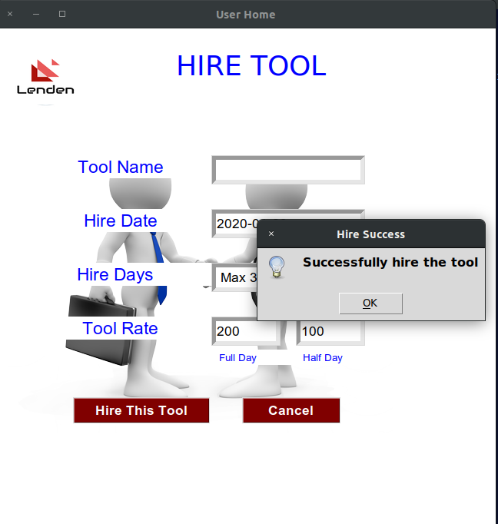

If the tool name is found then it will directed to the rider profile.

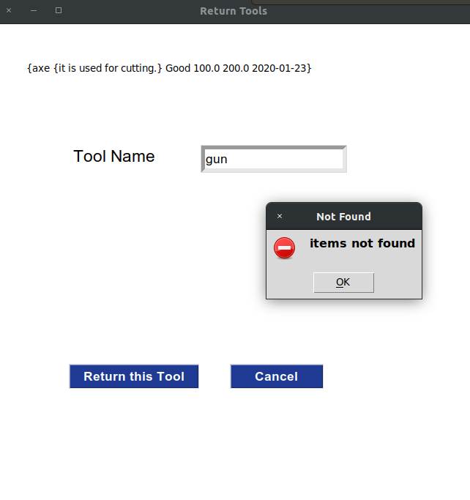

Tools are returned using their names.

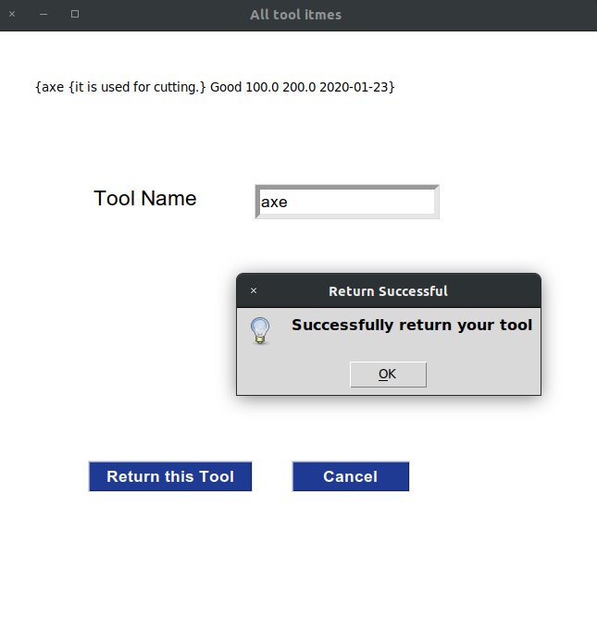

If the tool is found, the tool will be successfully returned.

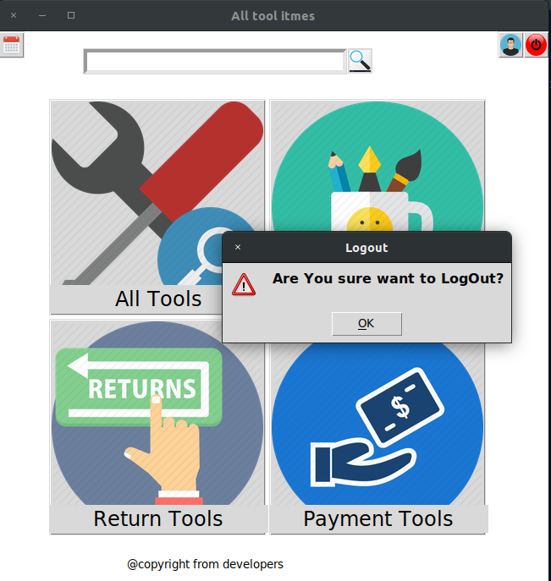

The top red button in the right is the logout button from which user can successfully logged out from the system.

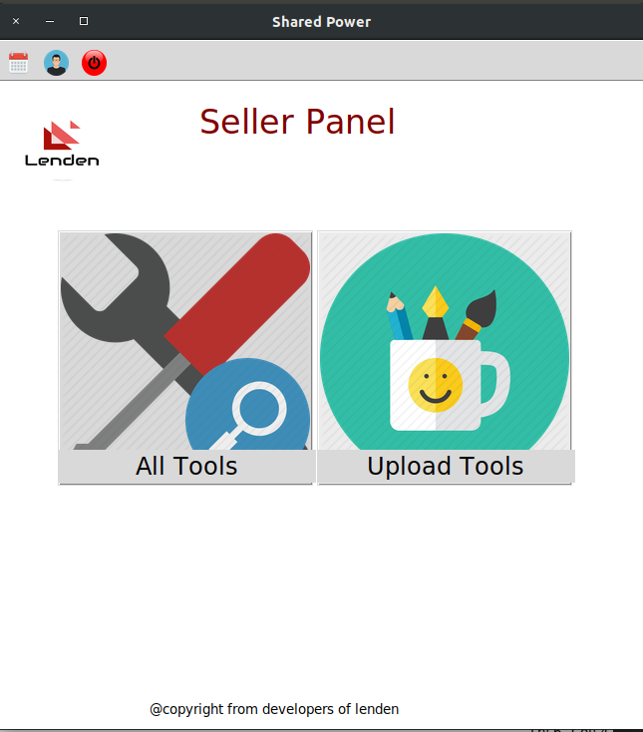

This is the seller panel of the system. The seller can view all tools and upload the tool.

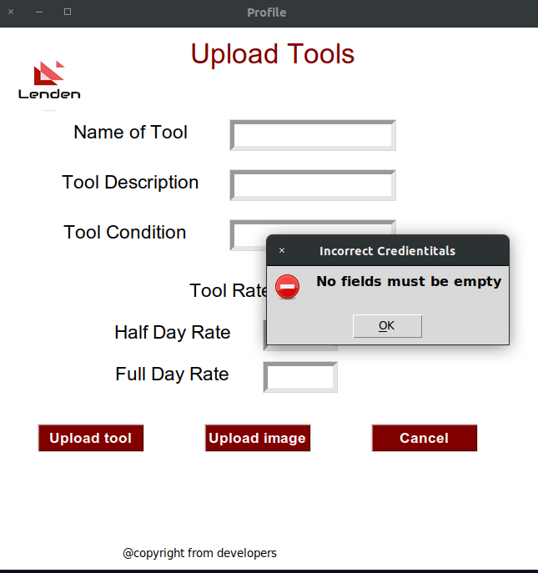

The seller can upload the tools. If any field is empty then the user have to reinput the details of the tool to upload.

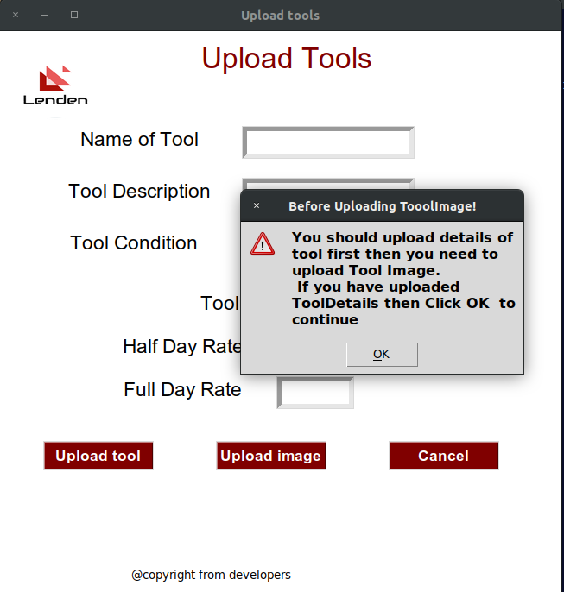

Before uploading the image all description should be given before. Only after the image must be uploaded.

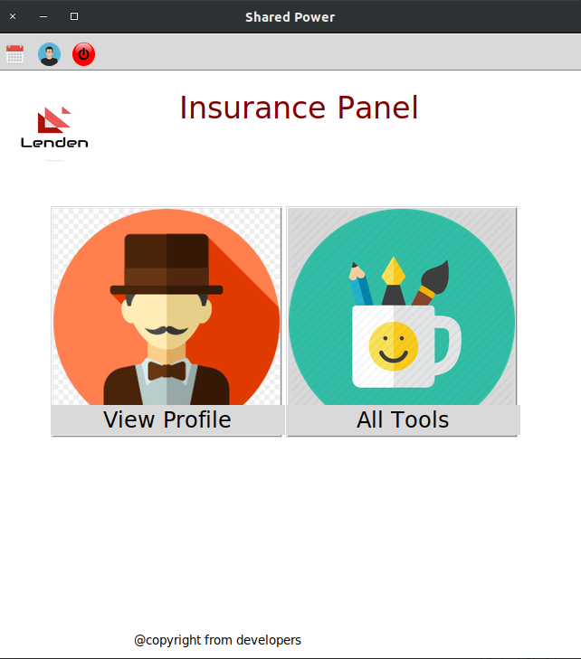

It is the insurance panel from where insurance agent can see all registered profiles and uploaded tools.

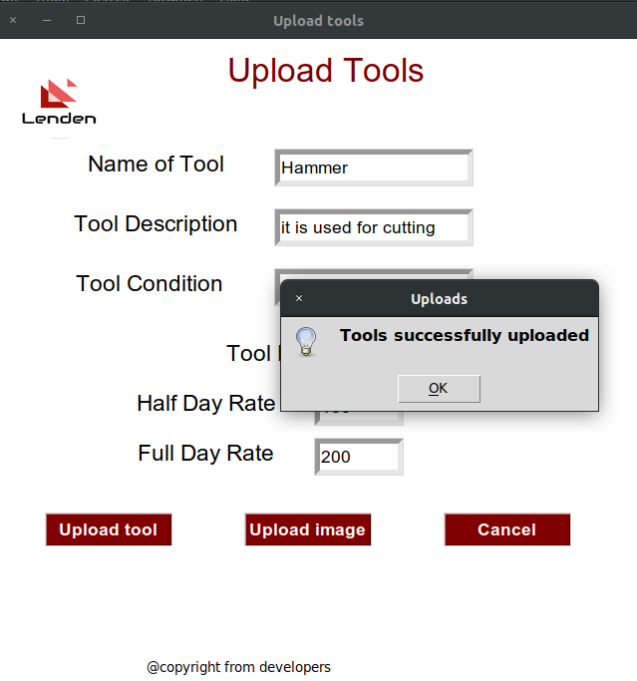

If all the credentials are correct then the tool will be successfully uploaded.

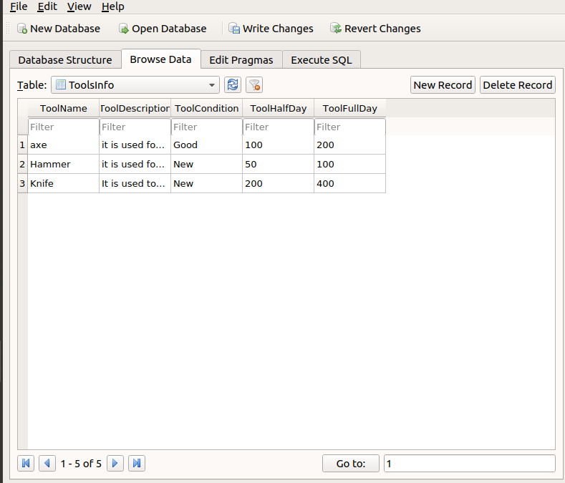

These are the all uploaded tools in the database.

7.Software used for development

For the development of the whole software we use Gimp and Photoshop for editing images,
Visual Paradigm for drawing Use case diagram, activity diagram and class diagram. And python 3.6.9 IDLE for coding.

8.Group organization and role division.

Before starting the project we divide our work equally to four of us
Student ID | Name | Roles
1915677 | Niraj Chudali | Developer
1916477 | Santosh Shahi | Designer
1915684 | Roshan Bist | Tester
1822747 | Chiranjeebi Khanal | Analyst

9.Group Division

S.N | Name | Work Division
1 | Niraj Chudali | Login, Register, Seller Panel(Upload Tools, View all tools), Class Diagram.
2 | Roshan Bist | Brainstorming, Insurance Panel(View all tools, View Registered Profile), Testing of software, Activity Diagram.
3 | Chiranjeebi Khanal | Brainstorming,User Panel, Search Tool, Hire Tool, Database Connection, UML Diagram(Sea Level Diagram), Overall analysis of Lenden.
4 | Santosh Shahi | Return Tools, Invoice, UML Diagram(Fish Level Diagram, Sea Level Diagram).

10.Conclusion

From this project we get the opportunity to learn lots of new things. Working in the team become beneficial for every team members. With the team effort we successfully built this fully functioning system. This project helps to motivate us and we will be able to built these types of software using the same knowledge we have used in this project. We are thankful to everyone who helped during the whole software development process. And we hope that we have successfully purposed the system that is assigned by the university of Bedfordshire.

Code(Character User Interface)

'''
Developers:
NIRAJ CHUDALI
CHIRANGEEVI KHANAL
SANTOSH SHAHI
ROSHAN BIST

Python interpreter = python 3.6.9
'''
#libraries that we have used during the software development process.

import sqlite3
import datetime
import sys
from colorama import init
from pyfiglet import figlet_format
import calendar
from getpass import getpass
from columnar import columnar

fancy=["""
=========================
| THIS IS THE SELLER PANEL |
=========================
""","""
===================
| REGISTER AS BUYER |
===================
""","""
================
| LOGIN AS BUYER |
================
""","""
================
| ENTER FIRSTNAME |
================
""","""
================
| ENTER LASTNAME |
================
""","""
================
| ENTER USERNAME |
================
""","""
================
| ENTER PASSWORD |
================
""","""
=======================
| Login to your Account |
=======================
""","""
==========================
| Welcome to the Home Page |
==========================
""","""
======
| EXIT |
======
""","""
=====================
| CREATE YOUR ACCOUNT |
=====================
""","""
-------------------------------
| Please Enter correct choice!! |
-------------------------------
""","""
=================
| LOGIN AS SELLER |
=================
""","""
==============
| DESCRIPTION |
==============
""","""
=====================
| TERMS AND CONDITONS |
=====================
""","""
===================
| CUSTOMER DETAILS |
===================
""","""
================
| RIDER DETAILS |
================
""","""
================
| MAKE PAYMENTS |
================
""","""
================
| RIDER PROFILE |
================
""","""
===========
| MY TOOLS |
===========
""","""
===========================
| LOGIN AS INSURANCE AGENT |
===========================
""","""
=============================
| THIS IS THE INSURANCE PANEL |
=============================
"""]

conn = sqlite3.connect('project.db')
c = conn.cursor()

#To check the customer detalis and check the tools by insurance company

class CheckTools:
def insurance_login(self):
self.username = input('Username: ')
self.password = getpass('Password: ')
if self.username == 'insurance' and self.password == 'insurance':
print("successfully logged in as insurance agent\n")
print(fancy[21])
self.insurance_home()
else:
print("You don't have Super User Permission!!\n")
choice = input("\nPress Enter or any key to redirect back to Home Page!! ")
if choice == '':
self.insurance_login()
else:
self.display_text()

def insurance_home(self):
print('\n1.Users info\n2.All Tools\n3.Pay for Repair\n4.Logout')
choice = input("\nEnter the choice: ")
if choice=='1':
self.view_profile()
elif choice=="2":
self.all_items()
elif choice=="3":
self.claim_insurance()
elif choice=="4":
choice=input("\nDo you really want to log out?: ")
if choice=="yes":
print("\nSuccessfully Logged out!!\n")
self.details()
else:
print(fancy[21])
self.insurance_home()

else:
print(fancy[11])
self.insurance_home()
def all_items(self):
conn = sqlite3.connect('project.db')
c = conn.cursor()
c.execute('SELECT * FROM ToolsInfo')
items=c.fetchall()
if items:
for elem in items:
dta=[
["Name of Tool\t\t ",elem[0]],
["Tool Type\t\t ",elem[1]],
["Tool Description\t ",elem[2]],
["Tool Condition\t\t ",elem[3]],
["Tool Rate Half-Day\t ",elem[4]],
["Tool Rate Full-Day\t ",elem[5]],
["Tool Upload Date\t",elem[6]]
]
print(columnar(dta))
else:
print("\nNo items are added yet!!")
choice=input("\nPress Enter or any key to redirect back to Home Page!! ")
if choice=='':
self.insurance_home()
else:
self.insurance_home()

def view_profile(self):
conn = sqlite3.connect('project.db')
c = conn.cursor()
c.execute('SELECT * FROM UserInfo')
conn.commit()
value = c.fetchall()
if value:
for elem in value:
data=[
["FirstName:\t ",elem[0]],
["LastName:\t ",elem[1]],
["UserName:\t ",elem[2]]
]
print(columnar(data))
choice=input("\nPress Enter or any key to redirect back to Home Page!! ")
if choice=="":
self.insurance_home()
else:
self.insurance_home()
else:
print("\nNo accounts are registered!!")
choice=input("\nPress Enter or any key to redirect back to Home Page!! ")
if choice=="":
self.insurance_home()
else:
self.insurance_home()
def claim_insurance(self):
print("\nYou will get according to the condition of the tools")
choice=input("\nPress Enter or any key to redirect back to Home Page!! ")
if choice=="":
self.insurance_home()
else:
self.insurance_home()

#to search the items that have been uploaded by the seller

class SearchTools(CheckTools):
def search(self):
conn = sqlite3.connect('project.db')
c = conn.cursor()
self.name_of_tool = input("Enter ToolName: ")
#self.tool_type = input("Enter Type: ")
c.execute('SELECT * FROM ToolsInfo WHERE NameOfTool = ?',(self.name_of_tool,))
conn.commit()
data = c.fetchall()
if data:
for elem in data:
print(fancy[13])
dta=[
["Name of Tool\t\t ",elem[0]],
["Tool Type\t\t ",elem[1]],
["Tool Description\t ",elem[2]],
["Tool Condition\t\t ",elem[3]],
["Tool Rate Half-Day\t ",elem[4]],
["Tool Rate Full-Day\t ",elem[5]],
["Tool Upload Date\t",elem[6]]
]
print(columnar(dta))

choice=input("\nDo you want to hire?: ")
if choice == 'yes':
file=open('nj.txt')
f=file.readlines()
print(fancy[14])
for values in f:
print(values)

choose = input("\nDo you want to continue or go back?: ")
if choose=="yes":
c.execute('SELECT * FROM ToolsInfo')
data=c.fetchall()
if data:
for i in data:
self.a=i[0]
self.b=i[1]
self.c=i[2]
self.d=i[3]
self.e=i[4]
self.f=i[5]
self.curr_date = datetime.datetime.now()
self.g = self.curr_date.strftime('%Y-%m-%d')
c.execute('INSERT INTO MyToolsInfo(NameOfTool, ToolType, ToolDescription, ToolCondition, HalfDayRate, FullDayRate, HireDate) VALUES(?,?,?,?,?,?,?)',
(self.a,self.b,self.c,self.d,self.e,self.f,self.g))
conn.commit()
else:
print("NO data found")
c.execute("DELETE FROM ToolsInfo WHERE NameOfTool=?", (self.name_of_tool,))
conn.commit()
data=c.fetchall()
choice = input("\nDo you want delivery or not?: ")
if choice=="yes":
address=input("Enter your address: ")
contact=input('Enter your contact: ')
print(fancy[15])
print('Customer Address: ',address)
print('Customer Contact: ',contact)
print(fancy[16])
Rider_id = '123'
print("Rider id:\t",Rider_id)
Rider_name = 'Roshan Bist'
print('Rider Name\t',Rider_name)
print("\nYou will get your items delivered in",address, "within 24 hours\nThank You!!")
choice=input("\nPress Enter or any key to redirect back to Home Page!! ")
if choice=='':
self.home_items()
else:
self.home_items()

else:
print("\nWe have our office in Baneshwor near Samsad Bhawan, Koteshwor and Kirtipur. Please visit there to get it.\nThank you!!")
choice=input("\nPress Enter or any key to redirect back to Home Page!! ")
if choice=='':
self.home_items()
else:
self.home_items()

else:
print(fancy[8])
self.home_items()
else:
self.home_items()
else:
print("Product not found!!")
choice=input("\nPress Enter to continue or Press any key to go back: ")
if choice=='':
self.search()
else:
self.home_items()

#To see the total invoice of the user.

class PaymentTools(SearchTools):
def rate(self):
conn = sqlite3.connect('project.db')
c = conn.cursor()
c.execute('SELECT * FROM MyToolsInfo')
rows=c.fetchall()
if rows:
for price in rows:
self.halfday_rate=price[4]
self.insurance_halfday_rate= 0.5 * self.halfday_rate
self.total_halfday_rate=self.halfday_rate + self.insurance_halfday_rate
self.fullday_rate=price[5]
self.insurance_fullday_rate=0.5 * self.fullday_rate
self.total_fullday_rate=self.fullday_rate + self.insurance_fullday_rate

prices=[

['Half day rate\t',self.halfday_rate],
['Half day insurance rate\t',self.insurance_halfday_rate],
['Total Halfday invoice\t',self.total_halfday_rate],
['******************************','*********************'],
['Full day rate\t',self.fullday_rate],
['Full day insurance rate\t',self.insurance_fullday_rate],
['Total fullday invoice\t',self.total_fullday_rate]

]
print(columnar(prices))
else:
print("You have no pending bill")

def payment(self):
print(fancy[17])
self.rate()
choice=input("\nPress Enter or any key to redirect back to Home Page!! ")
if choice=="":
self.home_items()
else:
self.home_items()

#To return tools once they have hired.

class ReturnTools(PaymentTools):
def Return_tool(self):
conn = sqlite3.connect('project.db')
c = conn.cursor()
c.execute('SELECT * FROM MyToolsInfo')
tools=c.fetchall()
if tools:
self.name_of_tool=input("Name of tool to return: ")
print(fancy[19])
for tool in tools:
a=[
['Tool Name',tool[0]],
['Tool type',tool[1]],
['Tool Description',tool[2]],
['Hired Date',tool[6]]
]
print(columnar(a))

choice=input("\nDo you really want to return tool: ")
if choice=="yes":
choice=input("\nDo you want rider or not?: ")
if choice=="yes":
print(fancy[16])
Rider_id = '2'
print("Rider id:\t",Rider_id)
Rider_name = 'Roshan Bist'
print('Rider Name\t',Rider_name)
Rider_contact = '9812987645'
print('Rider Contact\t',Rider_contact)
print("\nHe will pick items from you!!\nThank You")
c.execute('SELECT * FROM MyToolsInfo')
values=c.fetchall()
if values:
for value in values:
self.a=value[0]
self.b=value[1]
self.c=value[2]
self.d=value[3]
self.e=value[4]
self.f=value[5]
self.curr_date = datetime.datetime.now()
self.g = self.curr_date.strftime('%Y-%m-%d')
c.execute('INSERT INTO ToolsInfo(NameOfTool, ToolType, ToolDescription, ToolCondition, HalfDayRate, FullDayRate, UploadDate) VALUES(?,?,?,?,?,?,?)',
(self.a,self.b,self.c,self.d,self.e,self.f,self.g))
conn.commit()
else:
print("\nVisit to our nearby office and return your tool!!")
c.execute("DELETE FROM MyToolsInfo WHERE NameOfTool=?", (self.name_of_tool,))
conn.commit()
choice=input("\nPress Enter or any key to redirect back to Home Page!! ")
if choice=='':
self.home_items()
else:
self.home_items()
else:
self.home_items()
else:
print("\nNo items to return!!")
choice=input("\nPress Enter or any key to redirect back to Home Page!! ")
if choice=="":
self.home_items()
else:
self.home_items()

#To see all the hired tools description.

class MyTools(ReturnTools):
def my_tools(self):
print(fancy[19])
c.execute('SELECT * FROM MyToolsInfo')
tools=c.fetchall()
if tools:
for tool in tools:
a=[
['Tool Name',tool[0]],
['Tool type',tool[1]],
['Tool Description',tool[2]],
['Hired Date',tool[6]]
]
print(columnar(a))
choice=input("\nPress Enter or any key to redirect back to Home Page!! ")
if choice=='':
self.home_items()
else:
self.home_items()
else:
print("\nNo tools Added yet!!")
choice=input("\nPress Enter or any key to redirect back to Home Page!! ")
if choice=="":
self.home_items()
else:
self.home_items()

#From uploadtools class seller can upload their tools.

class UploadTools(MyTools):
def create_table1(self):
c.execute('CREATE TABLE IF NOT EXISTS ToolsInfo(NameOfTool NOT NULL, ToolType NOT NULL, ToolDescription NOT NULL, ToolCondition NOT NULL, HalfDayRate NOT NULL, FullDayRate NOT NULL, UploadDate NOT NULL)')
c.execute('CREATE TABLE IF NOT EXISTS MyToolsInfo(NameOfTool NOT NULL, ToolType NOT NULL, ToolDescription NOT NULL, ToolCondition NOT NULL, HalfDayRate NOT NULL, FullDayRate NOT NULL, HireDate NOT NULL)')

def upload_tools(self):
self.name_of_tool = input("Name of Tool: ")
self.tool_type = input('Type: ')
self.tool_description = input("Tool Description: ")
self.tool_condition = input("Tool Condition: ")
self.tool_rate_halfday = float(input('Tool Rate\n\tHalf day: '))
self.tool_rate_fullday = float(input('\tFull day: '))
self.up_date = datetime.datetime.now()
self.upload_date = self.up_date.strftime('%Y-%m-%d')
c.execute('INSERT INTO ToolsInfo (NameOfTool, ToolType, ToolDescription, ToolCondition, HalfDayRate, FullDayRate,UploadDate) VALUES(?,?,?,?,?,?,?)',
(self.name_of_tool, self.tool_type, self.tool_description, self.tool_condition, self.tool_rate_halfday, self.tool_rate_fullday,self.upload_date))
conn.commit()
choice=input("Press Enter or any key to redirect back to Home Page!! ")
if choice=="":
self.homepage_seller()
else:
self.homepage_seller()

#This is the userclass for the registers profiles.

class Users(UploadTools):
def profile(self):
conn = sqlite3.connect('project.db')
c = conn.cursor()
c.execute('SELECT * FROM UserInfo WHERE username = ? AND password = ?',(self.username, self.password))
conn.commit()
value = c.fetchall()
if value is not None:
for elem in value:
data=[
["FirstName:\t ",elem[0]],
["LastName:\t ",elem[1]],
["Email:\t ",elem[2]],
["Username:\t ",elem[3]],
["Password:\t ",elem[4]]
]
print(columnar(data))
choice=input("\nPress Enter or any key to redirect back to Home Page!! ")
if choice=="":
self.home_items()
else:
self.home_items()

def rider_profile(self):
data = [
['id', '1',],
['Name', 'Aayush Khanal'],
['Email', 'ayushkhanal@gmail.com'],
['Contact', "9809823406"]
]

data1 = [
['id', '2',],
['Name', 'Santosh Shahi'],
['Email', 'santoshshahi@gmail.com'],
['Contact',"9857458495"]
]

data2 = [
['id', '3',],
['Name', 'Roshan Bist'],
['Email', 'roshanbist@gmail.com'],
['Contact', "9845432540"]
]

data3 = [
['id', '4',],
['Name', 'Niraj Poudel'],
['Email', 'nirajpoudel@gmail.com'],
['Contact', "9801123432"]
]

print('\t\t',fancy[18])
print(columnar(data),'\n')
print(columnar(data1),'\n')
print(columnar(data2),'\n')
print(columnar(data3))
choice=input("\nPress Enter or any key to redirect back to Home Page!! ")
if choice=="":
self.homepage_seller()
else:
self.homepage_seller()

#This is the calendar class from which users can access the current date as well as calendar easily.

class Calendar(Users):
def calendar_seller(self):
self.today=datetime.date.today()
self.day=self.today.strftime('%d')
print('\n',calendar.month(2020,1))
print("The day of the month is: ",self.day)
choice=input("\nPress Enter or any key to redirect back to Home Page!! ")
if choice=='':
self.homepage_seller()
else:
self.homepage_seller()

def calendar_buyer(self):
self.today=datetime.date.today()
self.day=self.today.strftime('%d')
print('\n',calendar.month(2020,1))
print("The day of the month is: ",self.day)
choice=input("\nPress Enter or any key to redirect back to Home Page!! ")
if choice=='':
self.home_items()
else:
self.home_items()

#This is the home page for the both seller and buyer.

class Home(Calendar):
#This is the homepage of seller.
def homepage_seller(self):
print('\n1.Items\n2.Calendar\n3.Profile\n4.Upload Tools\n5.Rider Profile\n6.logout\n')
choice = input("\nEnter the choice: ")
if choice == '1':
self.admin_items()
elif choice == '2':
self.calendar_seller()
elif choice == '3':
print('Username: ',self.username,'\n','Password: ',self.password)
choice=input("\nPress Enter or any key to redirect back to Home Page!! ")
if choice=='':
self.homepage_seller()
else:
self.homepage_seller()
elif choice == '4':
self.upload_tools()
elif choice == '5':
self.rider_profile()
elif choice == '6':
choice=input("\nDo you really want to log out?: ")
if choice=="yes":
print("\nSuccessfully Logged out!!\n")
self.details()
else:
self.homepage_seller()

else:
print(fancy[11])
self.homepage_seller()

#This is the homepage of buyer.
def home_items(self):
print('\n1.All Items\n2.Calendar\n3.Profile\n4.Search Tools\n5.My tools\n6.Return Tool\n7.Invoice\n8.Logout\n')
choice = input("Enter what is your choice: ")
if choice == '1':
self.items()
elif choice == '2':
self.calendar_buyer()
elif choice == '3':
self.profile()
elif choice == '4':
self.search()
elif choice == '5':
self.my_tools()
elif choice == '6':
self.Return_tool()
elif choice == '7':
self.payment()
elif choice == '8':
choice=input("\nDo you really want to log out?: ")
if choice=="yes":
print("\nSuccessfully Logged out!!\n")
self.display_text()
else:
self.home_items()
else:
print(fancy[11])
self.home_items()
def admin_items(self):
conn = sqlite3.connect('project.db')
c = conn.cursor()
c.execute('SELECT * FROM ToolsInfo')
items=c.fetchall()
if items:
for elem in items:
dta=[
["Name of Tool\t\t ",elem[0]],
["Tool Type\t\t ",elem[1]],
["Tool Description\t ",elem[2]],
["Tool Condition\t\t ",elem[3]],
["Tool Rate Half-Day\t ",elem[4]],
["Tool Rate Full-Day\t ",elem[5]],
["Tool Upload Date\t",elem[6]]
]
print(columnar(dta))
else:
print("\nNo items are added yet!!")
choice=input("\nPress Enter or any key to redirect back to Home Page!! ")
if choice=='':
self.homepage_seller()
else:
self.homepage_seller()

def items(self):
conn = sqlite3.connect('project.db')
c = conn.cursor()
c.execute('SELECT * FROM ToolsInfo')
items=c.fetchall()
if items:
for elem in items:
dta=[
["Name of Tool\t\t ",elem[0]],
["Tool Type\t\t ",elem[1]],
["Tool Description\t ",elem[2]],
["Tool Condition\t\t ",elem[3]],
["Tool Rate Half-Day\t ",elem[4]],
["Tool Rate Full-Day\t ",elem[5]],
["Tool Upload Date\t",elem[6]]
]
print(columnar(dta))
else:
print("\nNo items are added yet!!")
choice=input("\nPress Enter or any key to redirect back to Home Page!! ")
if choice=='':
self.home_items()
else:
self.home_items()

#This is the login class from where the registered users can login to their accounts.

class Login(Home):
def admin_login(self):
self.username = input('Username: ')
self.password = input('Password: ')
if self.username == 'admin' and self.password == 'admin':
print("successfully logged in as seller\n")
print(fancy[0])
self.homepage_seller()
else:
print("You don't have Super User Permission!!\n")
choice = input("\nPress Enter or any key to redirect back to Home Page!! ")
if choice == '':
self.admin_login()
else:
self.display_text()

def login_info(self):
conn = sqlite3.connect('project.db')
c = conn.cursor()
self.username = input("|Username| : ")
self.password = input("|Password| : ")
c.execute('SELECT * FROM UserInfo WHERE username=? AND password=?',(self.username,self.password))
conn.commit()
if c.fetchall():
print("Successfully logged in!!")
print(fancy[8])
self.home_items()
else:
print("User not found!!\n")
choice = input('Press Enter to Retry!! or Press any key to go back!!')
if choice == '':
self.login_info()
else:
self.display_text()

#This is the registration class where new user can register to the system

class Registration(Login):
def create_table2(self):
c.execute('CREATE TABLE IF NOT EXISTS UserInfo(Firstname NOT NULL,Lastname NOT NULL, Email UNIQUE NOT NULL, Username UNIQUE NOT NULL, Password NOT NULL, Date NOT NULL, Time NOT NULL)')

def user_info(self):
self.firstname = input("|FirstName|: ")
self.lastname = input("|LastName|: ")
self.email = input('|Email|: ')
self.username = input("|UserName|: ")
self.password = input("|Password|: ")
self.date_time()
if len(self.username)<=5 and len(self.password)<=5:
print("\nUsername and Password must be more than five characters!!\n")
choice = input('\nPress Enter to Retry!! or Press any key to go back!!')
if choice=='':
self.user_info()
else:
self.display_text()
else:
c.execute('SELECT * FROM UserInfo WHERE Username=? OR Email=?',(self.username,self.email))
conn.commit()
if c.fetchall():
print("\nUser already exists try with another Username or Email!!")
choice = input('\nPress Enter to Retry!! or Press any key to go back!!')
if choice=='':
self.user_info()
else:
self.display_text()
else:
c.execute('INSERT INTO UserInfo (Firstname, Lastname, Email, Username, Password, Date, Time) VALUES(?,?,?,?,?,?,?)',
(self.firstname, self.lastname, self.email, self.username, self.password, self.current_date, self.current_time))
conn.commit()
print("Account successfully created!!")
print(fancy[7])
self.login_info()
def date_time(self):
self.curr_date = datetime.datetime.now()
self.current_date = self.curr_date.strftime('%Y-%m-%d')
self.current_time = self.curr_date.strftime('%H:%M:%S %P')

#This is the main screen which appears when we first start the software.

class MainScreen(Registration):
def __init__(self):
pass
def details(self):
self.text="Lenden:\nThe customer's satisfaction"
print(figlet_format(self.text, font="standard"))
choice = input("Press Enter to Continue!!!")
if choice == '':
self.display_text()
else:
sys.exit()
def display_text(self):
print('1.',fancy[12],'2.',fancy[20],'3.',fancy[1],'4.',fancy[2],'5.',fancy[9])
choice=input('Please choose one of the above option: ')
if choice == '1':
print(fancy[12])
self.admin_login()
elif choice == '2':
print(fancy[20])
self.insurance_login()
elif choice == '3':
print(fancy[2])
self.user_info()

elif choice == '4':
print(fancy[9])
self.login_info()

elif choice=='5':
print(fancy[9])
sys.exit()
else:
print(fancy[11])
self.display_text()

u=UploadTools()
u.create_table1()
r=Registration()
r.create_table2()
m=MainScreen()
m.details()

Code(Graphical User Interface)

from tkinter import*
from PIL import ImageTk,Image
from tkinter import ttk
import time
from tkinter import messagebox
import tkinter.messagebox as me
import sqlite3
from tkinter import Frame
from datetime import date
import datetime
import os
from tkinter import Tk, filedialog
from tkcalendar import *

conn = sqlite3.connect('form.db')
c = conn.cursor()
##class MainPage:
## def __init__(self,master):
## self.master=master
## super(MainPage, self).__init__()
##
## def progressBar(self):
## self.logo_icon=ImageTk.PhotoImage(file="images/first.png")
## title=Label(self.master, text='Lenden: the customers satisfaction', fg='black', bg='white',font=('times new roman',20,'bold'))
## title.place(x=0,y=20,relwidth=1)
##
## login_frame=Frame(self.master, bg="white")
## login_frame.place(x=200,y=80)
## logolbl1=Label(login_frame, image=self.logo_icon)
## logolbl1.grid(row=0, column=1, pady=20)
##
## self.button2 = ttk.Button(self.master, text = "Lets begin the journey with us!!", command = self.start_progressbar)
## self.button2.place(x=200,y=400)
##
## self.progress_bar = ttk.Progressbar(self.master, orient = 'horizontal', length = 400, mode = 'indeterminate')
## self.progress_bar.place(x=120,y=350)
##
## def start_progressbar(self):
## self.progress_bar.start()

class Login(Frame):
def __init__(self,master):
self.master = master

self.frame = Frame(master, bg='white')

self.username = StringVar()
self.password = StringVar()
# All Images
self.user_icon = PhotoImage(file="images/man-user.png")
self.pass_icon = PhotoImage(file="images/password.png")
self.logo_icon = PhotoImage(file="images/logo.png")

title = Label(master, text="Login to your account", font=("times new roman", 18, "bold"), bg="white", fg="black",
relief=GROOVE)
title.place(x=0, y=0, relwidth=1)

Login_Frame = Frame(master, bg="white")
Login_Frame.place(x=20, y=100)
logolbl = Label(Login_Frame, image=self.logo_icon, bd=0).grid(row=0,column=1, columnspan=2, pady=20)
lbluser = Label(Login_Frame, text="Username", image=self.user_icon, compound=LEFT,
font=("times new roman", 20, "bold"), bg="white")
lbluser.grid(row=1, column=0, padx=20, pady=10)
txtuser = Entry(Login_Frame, bd=5, width=18, textvariable=self.username, relief=GROOVE, font=("", 15))
txtuser.grid(row=1, column=1, padx=10)
lblpass = Label(Login_Frame, text="Password", image=self.pass_icon, compound=LEFT,
font=("times new roman", 20, "bold"), bg="white")
lblpass.grid(row=2, column=0, padx=20, pady=20)
txtpass = Entry(Login_Frame, bd=5, width=18, relief=GROOVE, textvariable=self.password, show='*', font=("", 15))
txtpass.grid(row=2, column=1,
padx=20)
btn_log = Button(master, text="Login", width=8, font=("times new roman", 14, "bold"),
bg="#0dc1a6", fg="green", bd=4, command=self.login_info)
btn_log.place(x=300, y=450)

btn_can = Button(master, text="Cancel", width=8, font=("times new roman", 14, "bold"),
bg="#0dc1a6", fg="green", bd=4, command=self.back)
btn_can.place(x=100,y=450)
self.lbl=Label(master,text="@copyright from developers", bg="white").place(x=150,y=620)

def login_info(self):
find_user = ('SELECT * FROM UserInfo WHERE Username = ? and Password = ?')
c.execute(find_user,[(self.username.get()),(self.password.get())])
result = c.fetchall()
if result:
me.showinfo("Login",
"Successfully logged in as buyer")
self.master.withdraw()
self.newWindow = Toplevel((self.master),bg='white')
self.app = UserHome(self.newWindow)
self.newWindow.geometry('650x650')
self.newWindow.title("Home Page")

elif ((self.username.get())=="admin" and (self.password.get())=="admin"):
print("success")
me.showinfo("Login",'Successfully logged in as seller')
self.master.withdraw()
self.newWindow = Toplevel((self.master),bg='white')
self.app = AdminHome(self.newWindow)
self.newWindow.geometry('650x650')
self.newWindow.title("Home Page")

elif ((self.username.get())=="insurance" and (self.password.get())=='insurance'):
me.showinfo("Login",'Successfully logged in as Insurance')
self.master.withdraw()
self.newWindow = Toplevel((self.master),bg='white')
self.app = CheckTools(self.newWindow)
self.newWindow.geometry('650x650')
self.newWindow.title("Home Page")

else:
me.showerror('Oops!','Username Not Found.')
self.master.withdraw()
self.newWindow = Toplevel((self.master),bg="white")
self.app = Login(self.newWindow)
self.newWindow.geometry('650x650')
self.newWindow.title("Login Page")

def back(self):
self.master.withdraw()
self.newWindow = Toplevel((self.master),bg='white')
self.app = SecondPage(self.newWindow)
self.newWindow.geometry('650x650')
self.newWindow.title("User Home")

#=======================================================================================================

class Registration(Frame):
def __init__(self, master):
self.master = master
self.frame = Frame(master, bg='white')

self.firstname = StringVar()
self.lastname = StringVar()
self.username = StringVar()
self.password = StringVar()

# All Images
self.user_icon = PhotoImage(file="images/man-user.png")
self.pass_icon = PhotoImage(file="images/password.png")
self.logo_icon = PhotoImage(file="images/logo.png")

title = Label(master, text="Create your Account", font=("times new roman", 18, "bold"), bg="white", fg="black",
relief=GROOVE)
title.place(x=0, y=0, relwidth=1)

Login_Frame = Frame(master, bg="white")
Login_Frame.place(x=20, y=100)

logolbl = Label(Login_Frame, image=self.logo_icon, bd=0).grid(row=0,column=1, columnspan=2, pady=20)
lbluser = Label(Login_Frame, text="FirstName", image=self.user_icon, compound=LEFT,
font=("times new roman", 20, "bold"), bg="white")
lbluser.grid(row=1, column=0, padx=20, pady=10)
txtuser = Entry(Login_Frame, bd=5, width=18, textvariable=self.firstname, relief=GROOVE, font=("", 15))
txtuser.grid(row=1, column=1, padx=10)

logolbl = Label(Login_Frame, image=self.logo_icon, bd=0).grid(row=0,column=1, columnspan=2, pady=20)
lbluser = Label(Login_Frame, text="LastName", image=self.user_icon, compound=LEFT,
font=("times new roman", 20, "bold"), bg="white")
lbluser.grid(row=2, column=0, padx=20, pady=10)
txtuser = Entry(Login_Frame, bd=5, width=18, textvariable=self.lastname, relief=GROOVE, font=("", 15))
txtuser.grid(row=2, column=1, padx=10)

logolbl = Label(Login_Frame, image=self.logo_icon, bd=0).grid(row=0,column=1, columnspan=2, pady=20)
lbluser = Label(Login_Frame, text="Username", image=self.user_icon, compound=LEFT,
font=("times new roman", 20, "bold"), bg="white")
lbluser.grid(row=3, column=0, padx=20, pady=10)
txtuser = Entry(Login_Frame, bd=5, width=18, textvariable=self.username, relief=GROOVE, font=("", 15))
txtuser.grid(row=3, column=1, padx=10)

lblpass = Label(Login_Frame, text="Password", image=self.pass_icon, compound=LEFT,
font=("times new roman", 20, "bold"), bg="white")
lblpass.grid(row=4, column=0, padx=20, pady=20)
txtpass = Entry(Login_Frame, bd=5, width=18, relief=GROOVE, textvariable=self.password, show='*', font=("", 15))
txtpass.grid(row=4, column=1,
padx=20)
btn_log = Button(master, text="Register", width=8, bd=4, font=("times new roman", 14, "bold"),
bg="#0dc1a6", fg="green", command=self.user_info)
btn_log.place(x=300, y=550)

btn_can = Button(master, text="Cancel", width=8, font=("times new roman", 14, "bold"),
bg="#0dc1a6", fg="green", bd=4, command=self.back)
btn_can.place(x=100,y=550)
self.lbl=Label(master,text="@copyright from developers", bg="white").place(x=150,y=620)

def user_info(self):
self.firstname=self.firstname.get()
self.lastname=self.lastname.get()
self.username=self.username.get()
self.password=self.password.get()
c.execute('CREATE TABLE IF NOT EXISTS UserInfo(FirstName NOT NULL, LastName NOT NULL, Username UNIQUE NOT NULL, Password NOT NULL)')
if (len(self.username)==0 or len(self.username)<=5) and (len(self.password)==0 or len(self.password)<=5):
me.showerror('Registration Error','Fields must not be empty or username and password must be more than 5 characters')
self.master.withdraw()
self.newWindow = Toplevel((self.master), bg='white')
self.app = Registration(self.newWindow)
self.newWindow.geometry('650x650')
self.newWindow.title("Registration page")

else:
c.execute('SELECT * FROM UserInfo WHERE Username=?',(self.username,))
conn.commit()
if c.fetchall():
me.showerror('User not found','Username already exists try with another username')
self.master.withdraw()
self.newWindow = Toplevel((self.master), bg='white')
self.app = Registration(self.newWindow)
self.newWindow.geometry('650x650')
self.newWindow.title("Registration page")
else:
me.showinfo("Registration",
"Account successfully created!!")
c.execute('INSERT INTO UserInfo(FirstName,LastName, Username,Password) VALUES(?,?,?,?)',(self.firstname, self.lastname, self.username, self.password))
conn.commit()

self.master.withdraw()
self.newWindow = Toplevel((self.master), bg='white')
self.app = Login(self.newWindow)
self.newWindow.geometry('650x650')
self.newWindow.title("Login page")

def back(self):
self.master.withdraw()
self.newWindow = Toplevel((self.master),bg='white')
self.app = SecondPage(self.newWindow)
self.newWindow.geometry('650x650')
self.newWindow.title("User Home")

class SecondPage(Frame):
def __init__(self,master):
self.master=master
self.frame = Frame(master, bg='white')
#Label(master,text="Lenden: The Customer's Satisfaction",bg='white', fg='black').place(x=100,y=0)

self.namaste_icon=ImageTk.PhotoImage(file="images/team.jpg")

login_frame=Frame(master, bg="white")
login_frame.place(x=60,y=50)
logolbl1=Label(master, image=self.namaste_icon, bg='white')
logolbl1.place(x=80,y=100)

self.photo3 = Image.open("images/l.png")
self.photo3 = self.photo3.resize((120,120), Image.ANTIALIAS)
self.pic3 = ImageTk.PhotoImage(self.photo3)
self.lbl2=Label(master, image=self.pic3, bd=0, bg="white").place(x=0, y=0)

## self.photo = Image.open("images/namaste.png")
## self.photo=self.photo.resize((300,300), Image.ANTIALIAS)
## self.pic=ImageTk.PhotoImage(self.photo)
## self.btn=Button(master, image=self.pic).place(x=100,y=0)
Label(master,text="Lenden:",bg='white', fg='black', font=('new times roman',25)).place(x=150,y=15)
Label(master,text="The customer's satisfaction",bg='white', fg='black', font=('new times roman',18)).place(x=150,y=55)

self.photo = Image.open("images/login.jpg")
self.photo=self.photo.resize((180,50), Image.ANTIALIAS)
self.pic=ImageTk.PhotoImage(self.photo)
self.btn=Button(master, image=self.pic, bd=1, command=self.logn, bg='white').place(x=200,y=410)

self.photo1 = Image.open("images/register.png")
self.photo1=self.photo1.resize((180,50), Image.ANTIALIAS)
self.pic1=ImageTk.PhotoImage(self.photo1)
self.btn1=Button(master, image=self.pic1, bd=2, command=self.reg, bg='white').place(x=200,y=510)
self.lbl=Label(master,text="@copyright from developers", bg="white").place(x=150,y=620)
def logn(self):
self.master.withdraw()
self.newWindow = Toplevel((self.master),bg='white')
self.app = Login(self.newWindow)
self.newWindow.geometry('650x650')
self.newWindow.title("Login window")
def reg(self):
self.master.withdraw()
self.newWindow = Toplevel((self.master),bg='white')
self.app = Registration(self.newWindow)
self.newWindow.geometry('650x650')
self.newWindow.title("Signin window")

# creating tkinter window
class UserHome(Frame):
def __init__(self,master):
self.master=master
self.frame = Frame(master)
self.tool_name = StringVar()
#self.menubar = Menu(master)
## #Label(master, text="Costumer's Panel", bg='white', fg='maroon', font=('new times roman',25)).place(x=200,y=20)
### Adding File Menu and commands
## self.file = Menu(self.menubar, tearoff = 0)
## self.menubar.add_cascade(label ='File', menu = self.file)
## self.file.add_command(label ='New File', command = None)
## self.file.add_command(label ='Open...', command = None)
## self.file.add_command(label ='Save', command = None)
## self.file.add_separator()
## self.file.add_command(label ='Exit', command = root.destroy)
##
### Adding Edit Menu and commands
## self.edit = Menu(self.menubar, tearoff = 0)
## self.menubar.add_cascade(label ='Edit', menu = self.edit)
## self.edit.add_command(label ='Cut', command = None)
## self.edit.add_command(label ='Copy', command = None)
## self.edit.add_command(label ='Paste', command = None)
## self.edit.add_command(label ='Select All', command = None)
## self.edit.add_separator()
## self.edit.add_command(label ='Find...', command = None)
## self.edit.add_command(label ='Find again', command = None)
##
### Adding Help Menu
## self.help_ = Menu(self.menubar, tearoff = 0)
## self.menubar.add_cascade(label ='Help', menu = self.help_)
## self.help_.add_command(label ='Tk Help', command = None)
## self.help_.add_command(label ='Demo', command = None)
## self.help_.add_separator()
## self.help_.add_command(label ='About Tk', command = None)
#=======================================================================================================
##
## self.photo3 = Image.open("images/l.png")
## self.photo3 = self.photo3.resize((120,120), Image.ANTIALIAS)
## self.pic3 = ImageTk.PhotoImage(self.photo3)
## self.lbl2=Label(master, image=self.pic3, bd=0, bg="white").place(x=0, y=0)

self.photo_a = Image.open("images/calendar.png")
self.photo_a=self.photo_a.resize((25,26), Image.ANTIALIAS)
self.pic_a=ImageTk.PhotoImage(self.photo_a)
Button(master, image=self.pic_a, command=self.calendar1).place(x=0,y=0)
## self.calendar = Menu(self.menubar, tearoff = 0)
## self.calendar.add_command( label='Calendar',command=self.calendar1)
## self.menubar.add_cascade(image=self.pic_a, menu = self.calendar)
## root.config(menu = self.menubar)
#=======================================================================================================

self.photo_0 = Image.open("images/profile.png")
self.photo_0=self.photo_0.resize((25,26), Image.ANTIALIAS)
self.pic_0=ImageTk.PhotoImage(self.photo_0)
Button(master, image=self.pic_0, command=self.profile2).place(x=590,y=0)
## self.profile = Menu(self.menubar, tearoff = 0)
## self.profile.add_command(label='Profile', command=self.profile2)
## self.menubar.add_cascade(image=self.pic_0, menu = self.profile)
## root.config(menu = self.menubar)
#========================================================================================================

self.photo_ = Image.open("images/logout.png")
self.photo_=self.photo_.resize((25,26), Image.ANTIALIAS)
self.pic_=ImageTk.PhotoImage(self.photo_)
Button(master, image=self.pic_, command=self.logOut).place(x=620,y=0)
## self.logout = Menu(self.menubar, tearoff = 0)
## self.logout.add_command(label='Logout', command=self.logOut)
## self.menubar.add_cascade(image=self.pic_, menu = self.logout)
## root.config(menu = self.menubar)
#==========================================================================================================
self.photo = Image.open("images/search.jpg")
self.photo=self.photo.resize((25,26), Image.ANTIALIAS)
self.pic=ImageTk.PhotoImage(self.photo)
self.btn=Button(master, image=self.pic, bd=0, command=self.search).place(x=413,y=20)
self.ent = Entry(master, width=30, font=("", 12), bd=4, textvariable=self.tool_name).place(x=100, y=20)
#self.tool_name = self.tool_name.get()
#=========================================================================================================
self.photo1 = Image.open("images/search.png")
self.photo1=self.photo1.resize((250,250), Image.ANTIALIAS)
self.pic1=ImageTk.PhotoImage(self.photo1)
self.btn1=Button(master, image=self.pic1, command=lambda:self.all_items(self.master)).place(x=60,y=80)
self.lbl1=Label(master, text='All Tools', width=17, font=("", 18)).place(x=60, y=300)
#==========================================================================================================
self.photo2 = Image.open("images/hire.png")
self.photo2=self.photo2.resize((250,250), Image.ANTIALIAS)
self.pic2=ImageTk.PhotoImage(self.photo2)
self.btn2=Button(master,text='Hire Tools', image=self.pic2, command=self.hire).place(x=320,y=80)
self.lbl2=Label(master, text='Hire Tools', width=17, font=("", 18)).place(x=320, y=300)
#=========================================================================================================
self.photo3 = Image.open("images/return.png")
self.photo3 = self.photo3.resize((250,250), Image.ANTIALIAS)
self.pic3 = ImageTk.PhotoImage(self.photo3)
self.btn3 = Button(master,text='Return Tools', image=self.pic3, command=self.returns).place(x=60,y=340)
self.lbl2=Label(master, text='Return Tools', width=17, font=("", 18)).place(x=60, y=560)
#=======================================================================================================
self.photo4 = Image.open("images/payment.png")
self.photo4 = self.photo4.resize((250,250), Image.ANTIALIAS)
self.pic4 = ImageTk.PhotoImage(self.photo4)
self.btn4 = Button(master,text='Payment Tools', image=self.pic4, command=self.payment).place(x=320,y=340)
self.lbl2=Label(master, text='Payment Tools', width=17, font=("", 18)).place(x=320, y=560)
#========================================================================================================

self.lbl=Label(master,text="@copyright from developers", bg="white").place(x=150,y=620)

#========================================================================================================
def search(self):
self.master.withdraw()
self.newWindow = Toplevel((self.master),bg='white')
self.app = SearchTools(self.newWindow)
self.newWindow.geometry('650x650')
self.newWindow.title("Search Tools itmes")
Button(self.newWindow, text='Go to Home', font=("arial", 13, "bold"), width=10, bg='#1f3a93', fg='white'

, command=self.back).place(x=250, y=350)
c.execute('SELECT * FROM ToolsInfo WHERE ToolName=?',([self.tool_name.get()]))
data=c.fetchall()
if data:
print("HELLO ")
for value in data:
a=value[0]
b=value[1]
print(a,b)
self.lbl=Label(self.newWindow, text=data).place(x=40,y=50)
else:
me.showerror("Items error",'NO items found')
self.master.withdraw()
self.newWindow = Toplevel((self.master), bg='white')
self.app = UserHome(self.newWindow)
self.newWindow.geometry('650x650')
self.newWindow.title("All tool itmes")

def back(self):
self.master.withdraw()
#self.newWindow = Toplevel((self.master),bg='white')
self.app = UserHome(self.newWindow)
self.newWindow.geometry('650x650')
self.newWindow.title("User Home")

def all_items(self, home):
self.home = home
self.master.withdraw()
self.newWindow = Toplevel((self.master),bg='white')
self.app = AllTools(self.newWindow, self.home)
self.newWindow.geometry('650x650')
self.newWindow.title("All tool itmes")

def hire(self):
self.master.withdraw()
self.newWindow = Toplevel((self.master),bg='white')
self.app = HireTools(self.newWindow)
self.newWindow.geometry('650x650')
self.newWindow.title("Hire Tools")

def returns(self):
self.master.withdraw()
self.newWindow = Toplevel((self.master),bg='white')
self.app = ReturnTools(self.newWindow)
self.newWindow.geometry('650x650')
self.newWindow.title("Return Tools")

def profile2(self):
self.master.withdraw()
self.newWindow = Toplevel((self.master),bg='white')
self.app = User1(self.newWindow)
self.newWindow.geometry('650x650')
self.newWindow.title("Profile")

def payment(self):
self.master.withdraw()
self.newWindow = Toplevel((self.master),bg='white')
self.app = PaymentTools(self.newWindow)
self.newWindow.geometry('650x650')
self.newWindow.title("Payment Tools")

def logOut(self):
me.showwarning("Logout",
"Are You sure want to LogOut?")
self.master.withdraw()
self.newWindow = Toplevel((self.master), bg='white')
self.app = Login(self.newWindow)
self.newWindow.geometry('650x650')
self.newWindow.title("Login Form")

def calendar1(self):
self.master.withdraw()
self.newWindow = Toplevel((self.master),bg='white')
self.app = Calendar1(self.newWindow)
self.newWindow.geometry('650x650')
self.newWindow.title("Calendar")

#=====================================================================================================================
class AdminHome(Frame):
def __init__(self,master):
self.master=master
self.frame = Frame(master)
Label(master, text="Seller Panel", bg='white', fg='maroon', font=('new times roman',25)).place(x=200,y=20)

self.menubar = Menu(master)
### Adding File Menu and commands
## self.file = Menu(self.menubar, tearoff = 0)
## self.menubar.add_cascade(label ='File', menu = self.file)
## self.file.add_command(label ='New File', command = None)
## self.file.add_command(label ='Open...', command = None)
## self.file.add_command(label ='Save', command = None)
## self.file.add_separator()
## self.file.add_command(label ='Exit', command = root.destroy)
##
### Adding Edit Menu and commands
## self.edit = Menu(self.menubar, tearoff = 0)
## self.menubar.add_cascade(label ='Edit', menu = self.edit)
## self.edit.add_command(label ='Cut', command = None)
## self.edit.add_command(label ='Copy', command = None)
## self.edit.add_command(label ='Paste', command = None)
## self.edit.add_command(label ='Select All', command = None)
## self.edit.add_separator()
## self.edit.add_command(label ='Find...', command = None)
## self.edit.add_command(label ='Find again', command = None)
##
### Adding Help Menu
## self.help_ = Menu(self.menubar, tearoff = 0)
## self.menubar.add_cascade(label ='Help', menu = self.help_)
## self.help_.add_command(label ='Tk Help', command = None)
## self.help_.add_command(label ='Demo', command = None)
## self.help_.add_separator()
## self.help_.add_command(label ='About Tk', command = None)
#=======================================================================================================

self.photo_a = Image.open("images/calendar.png")
self.photo_a=self.photo_a.resize((25,26), Image.ANTIALIAS)
self.pic_a=ImageTk.PhotoImage(self.photo_a)
Button(master, image=self.pic_a, command=self.calendaar).place(x=0,y=0)
## self.calendar = Menu(self.menubar, tearoff = 0)
## self.calendar.add_command( label='Calendar',command=self.calendar)
## self.menubar.add_cascade(image=self.pic_a, menu = self.calendar)
## root.config(menu = self.menubar)
#=======================================================================================================

self.photo_0 = Image.open("images/profile.png")
self.photo_0=self.photo_0.resize((25,26), Image.ANTIALIAS)
self.pic_0=ImageTk.PhotoImage(self.photo_0)
Button(master, image=self.pic_0, command=self.profile1).place(x=590,y=0)
## self.profile = Menu(self.menubar, tearoff = 0)
## self.profile.add_command(label='Profile', command=self.profile1)
## self.menubar.add_cascade(image=self.pic_0, menu = self.profile)
## root.config(menu = self.menubar)
#========================================================================================================

self.photo_ = Image.open("images/logout.png")
self.photo_=self.photo_.resize((25,26), Image.ANTIALIAS)
self.pic_=ImageTk.PhotoImage(self.photo_)
Button(master, image=self.pic_, command=self.logOut).place(x=620,y=0)
## self.logout = Menu(self.menubar, tearoff = 0)
## self.logout.add_command(label='Logout', command=self.logOut)
## self.menubar.add_cascade(image=self.pic_, menu = self.logout)
## root.config(menu = self.menubar)

#=========================================================================================================

self.photo3 = Image.open("images/l.png")
self.photo3 = self.photo3.resize((120,120), Image.ANTIALIAS)
self.pic3 = ImageTk.PhotoImage(self.photo3)
self.lbl2=Label(master, image=self.pic3, bd=0, bg="white").place(x=0, y=0)

self.photo1 = Image.open("images/search.png")
self.photo1=self.photo1.resize((250,250), Image.ANTIALIAS)
self.pic1=ImageTk.PhotoImage(self.photo1)
self.btn1=Button(master, image=self.pic1, command=self.all_tools).place(x=60,y=150)
self.lbl1=Label(master, text='All Tools', width=17, font=("", 18)).place(x=60, y=370)

self.photo2 = Image.open("images/hire.png")
self.photo2=self.photo2.resize((250,250), Image.ANTIALIAS)
self.pic2=ImageTk.PhotoImage(self.photo2)
self.btn2=Button(master, image=self.pic2, command=self.upload).place(x=320,y=150)
self.lbl2=Label(master, text='Upload Tools', width=17, font=("", 18)).place(x=320, y=370)

self.lbl=Label(master,text="@copyright from developers of lenden", bg="white").place(x=150,y=620)

def all_tools(self):
self.master.withdraw()
self.newWindow = Toplevel((self.master),bg='white')
self.app = AllTools1(self.newWindow)
self.newWindow.geometry('650x650')
self.newWindow.title("All tools")

def upload(self):
self.master.withdraw()
self.newWindow = Toplevel((self.master),bg='white')
self.app = UploadTools(self.newWindow)
self.newWindow.geometry('650x650')
self.newWindow.title("Profile")

def profile1(self):
self.master.withdraw()
self.newWindow = Toplevel((self.master),bg='white')
self.app = User(self.newWindow)
self.newWindow.geometry('650x650')
self.newWindow.title("Profile")

def logOut(self):
me.showwarning("Logout",
"Are You sure want to LogOut?")
self.master.withdraw()
self.newWindow = Toplevel((self.master),bg='white')
self.app = Login(self.newWindow)
self.newWindow.geometry('650x650')
self.newWindow.title("Login Form")

def calendaar(self):
self.master.withdraw()
self.newWindow = Toplevel((self.master),bg='white')
self.app = AdminHome(self.newWindow)
self.newWindow.geometry('650x650')
self.newWindow.title("Calendar")

#===========================================================================================================

class UploadTools(Frame):
def __init__(self,master):
self.master=master
self.frame = Frame(master)
self.tool_name = StringVar()
self.tool_description = StringVar()
self.tool_condition = StringVar()
self.tool_halfday = StringVar()
self.tool_fullday = StringVar()
Label(master, text="Upload Tools", bg='white', fg='Maroon', width=20,font=("arial", 25)).place(x=140,y=10)

self.photo3 = Image.open("images/l.png")
self.photo3 = self.photo3.resize((120,120), Image.ANTIALIAS)
self.pic3 = ImageTk.PhotoImage(self.photo3)
self.lbl2=Label(master, image=self.pic3, bd=0, bg="white").place(x=0, y=0)

self.label_name = Label(master, text="Name of Tool", bg='white', width=20,font=("arial", 17))
self.label_name.place(x=30,y=110)
self.entry_toolname = Entry(master,bd =5,font=("arial", 13), textvariable=self.tool_name)
self.entry_toolname.place(x=280,y=110 ,width=200, height=38)
self.label_tooldes = Label(master, text="Tool Description", bg="white", width=20,font=("arial", 17))
self.label_tooldes.place(x=30,y=170)
self.entry_tooldes = Entry(master,bd =5, font=("arial", 13), textvariable=self.tool_description)
self.entry_tooldes.place(x=280,y=170,width=200, height=38)
self.label_toolcondition = Label(master, text="Tool Condition", bg='white', width=20, font=("arial", 17))
self.label_toolcondition.place(x=23, y=230)
self.entry_toolcondition = Entry(master, bd=5, font=("arial", 13), textvariable=self.tool_condition)
self.entry_toolcondition.place(x=280, y=230, width=200, height=38)
self.label_rate = Label(master, text="Tool Rate", bg='white', width=20,font=("arial", 17))
self.label_rate.place(x=150,y=300)
self.label_fullrate = Label(master, text="Half Day Rate", bg='white', width=20,font=("arial", 17))
self.label_fullrate.place(x=80,y=350)
self.entry_toolrate = Entry(master, bd=5, font=("arial", 13), textvariable=self.tool_halfday)
self.entry_toolrate.place(x=320, y=350, width=90, height=38)
self.label_halfrate = Label(master, text="Full Day Rate",width=20, bg='white', font=("arial", 17))
self.label_halfrate.place(x=80,y=400)
self.entry_toolrate2 = Entry(master, bd=5, font=("arial", 13), textvariable=self.tool_fullday)
self.entry_toolrate2.place(x=320, y=400, width=90, height=38)
Button(master, text='Upload tool',font=("arial", 13,"bold"),width=10,bg='maroon',fg='white', command=self.uptools).place(x=50,y=475)
Button(master, text='Upload image',font=("arial", 13,"bold"),width=10,bg='maroon',fg='white', command=self.upload_image).place(x=250,y=475)
Button(master, text='Cancel',font=("arial", 13,"bold"),width=10,bg='maroon',fg='white', command=self.back).place(x=450,y=475)
self.lbl=Label(master,text="@copyright from developers", bg="white").place(x=150,y=620)

def uptools(self):
self.tool_name = self.tool_name.get()
self.tool_description = self.tool_description.get()
self.tool_condition = self.tool_condition.get()
self.tool_halfday = self.tool_halfday.get()
self.tool_fullday = self.tool_fullday.get()
if (len(self.tool_name)==0 or len(self.tool_description)==0 or len(self.tool_condition)==0 or len(self.tool_halfday)==0 or len(self.tool_fullday)==0):
me.showerror('Incorrect Credientitals','No fields must be empty')
self.master.withdraw()
self.newWindow = Toplevel((self.master),bg='white')
self.app = UploadTools(self.newWindow)
self.newWindow.geometry('650x650')
self.newWindow.title("Upload tools")
else:
me.showinfo("Uploads", 'Tools successfully uploaded')
c.execute('CREATE TABLE IF NOT EXISTS ToolsInfo(ToolName NOT NULL, ToolDescription NOT NULL, ToolCondition NOT NULL, ToolHalfDay NOT NULL, ToolFullDay NOT NULL)')
c.execute('INSERT INTO ToolsInfo(ToolName, ToolDescription, ToolCondition, ToolHalfDay, ToolFullDay) VALUES(?,?,?,?,?)',
(self.tool_name, self.tool_description, self.tool_condition, self.tool_halfday, self.tool_fullday))
conn.commit()
self.master.withdraw()
self.newWindow = Toplevel((self.master),bg='white')
self.app = AdminHome(self.newWindow)
self.newWindow.geometry('650x650')
self.newWindow.title("Home page")

def upload_image(self):
me.showwarning("Before Uploading TooolImage!",
"You should upload details of tool first then you need to upload Tool Image.\n If you have uploaded ToolDetails then Click OK to continue")
self.newWindow = Toplevel((self.master),bg='white')
self.app = UploadImage(self.newWindow)
self.newWindow.geometry('650x650')
self.newWindow.title("Upload Tools Form")
def back(self):
self.master.withdraw()
self.newWindow = Toplevel((self.master),bg='white')
self.app = AdminHome(self.newWindow)
self.newWindow.geometry('650x650')
self.newWindow.title("User Home")

class UploadImage(Frame):
def __init__(self, master):
self.master = master
self.create_widgets()
self.master.resizable(False, False)

def create_widgets(self):
self.select = Button(self.master,text='Select Image', font=("arial", 13, "bold"), bg="green", fg='white',command=self.select_image)
self.select.pack()
self.canvas = Canvas(self.master, width= 400, height=400, bg="grey")
self.canvas.pack()
self.store = Button(self.master, text='Store Image', font=("arial", 13, "bold"), bg="#e37b17", fg='white',command=self.store_image)
self.store.pack()

def select_image(self):
global file_path
file_path = filedialog.askopenfilename()
des = Image.open(file_path)
bg_image = ImageTk.PhotoImage(des)
self.canvas.bg_image = bg_image
self.canvas.create_image(200 , 200, image=self.canvas.bg_image)
print(file_path)
def store_image(self):
self.store = file_path
file = open("Text File Handling\image.txt", "a")
file.write("ToolImage: ")
file.write(self.store)
file.write("\n")
file.close()
me.showinfo("Successfully Uploaded ToolImage!", "Your selected image is uploaded in ToolImage Database.")
self.master.withdraw()
self.newWindow = Toplevel((self.master),bg='white')
self.app = AdminHome(self.newWindow)
self.newWindow.geometry('650x650')
self.newWindow.title("Admin Home")

#==================================================================================================
class AllTools(Frame):
def __init__(self, master, home):
self.home = home
self.master=master
self.frame=Frame(master)

self.pay_icon=ImageTk.PhotoImage(file="images/view.jpg")
login_frame=Frame(master, bg="white")
login_frame.place(x=0,y=0)
logolbl1=Label(master, image=self.pay_icon, bg='white')
logolbl1.place(x=0,y=0)

self.photo3 = Image.open("images/l.png")
self.photo3 = self.photo3.resize((120,120), Image.ANTIALIAS)
self.pic3 = ImageTk.PhotoImage(self.photo3)
self.lbl2=Label(master, image=self.pic3, bd=0, bg="white").place(x=500, y=0)

self.lab=Label(master, text='ALL Tools',font=('new times roman',18), bg='white', fg='blue').place(x=150,y=20)
Button(master, text='Go to Home', font=("arial", 13, "bold"), width=10, bg='maroon', fg='white', command=self.back).place(x=250, y=550)
c.execute('SELECT * FROM ToolsInfo')
data=c.fetchall()
if data:
for elem in data:
self.a=elem[0]
self.b=elem[1]
self.d=elem[2]
self.e=elem[3]
self.f=elem[4]
labl1=Label(master,text='Tool Name',bg='white',fg='blue').place(x=20,y=100)
lbl2=Label(master, text='Tool Description',bg='white',fg='blue').place(x=20,y=130)
lbl3=Label(master, text='Tool Condition',bg='white',fg='blue').place(x=20,y=160)
lbl4=Label(master, text='Tool HalfDay rate',bg='white',fg='blue').place(x=20,y=190)
lbl5=Label(master, text='Tool FullDay rate',bg='white',fg='blue').place(x=20,y=220)
labl=Label(master, text=(self.a),bg='white',fg='blue').place(x=200,y=100)
lab2=Label(master, text=(self.b),bg='white',fg='blue').place(x=200,y=130)
lab3=Label(master, text=(self.d),bg='white',fg='blue').place(x=200,y=160)
lab4=Label(master, text=(self.e),bg='white',fg='blue').place(x=200,y=190)
lab4=Label(master, text=(self.f),bg='white',fg='blue').place(x=200,y=220)
else:
Labl=Label(master, text="No items Uploaded yet", bg='white').place(x=150,y=150)

def back(self):
self.master.destroy()
self.home.deiconify()
## self.newWindow = Toplevel((self.master),bg='white')
## self.app = UserHome(self.newWindow)
## self.newWindow.geometry('650x650')
## self.newWindow.title("User Home")

class AllTools1:
def __init__(self, master):
self.master=master
self.frame=Frame(master)

self.pay_icon=ImageTk.PhotoImage(file="images/view.jpg")
login_frame=Frame(master, bg="white")
login_frame.place(x=0,y=0)
logolbl1=Label(master, image=self.pay_icon, bg='white')
logolbl1.place(x=0,y=0)

self.photo3 = Image.open("images/l.png")
self.photo3 = self.photo3.resize((120,120), Image.ANTIALIAS)
self.pic3 = ImageTk.PhotoImage(self.photo3)
self.lbl2=Label(master, image=self.pic3, bd=0, bg="white").place(x=500, y=0)

self.lab=Label(master, text='ALL Tools',font=('new times roman',18), bg='white', fg='blue').place(x=150,y=20)
Button(master, text='Go to Home', font=("arial", 13, "bold"), width=10, bg='maroon', fg='white', command=self.back).place(x=250, y=550)
c.execute('SELECT * FROM ToolsInfo')
data=c.fetchall()
if data:
## file=open('/home/niraj/Desktop/final/Text File Handling\image.txt')
## f=file.readlines()
## imgd=ImageTk.PhotoImage([f])
## panel=Label(image=imgd,height=28,width=30).pack()
for elem in data:
self.a=elem[0]
self.b=elem[1]
self.d=elem[2]
self.e=elem[3]
self.f=elem[4]
#labl_img=Label(master, text=self.img).place(x=50,y=50)
labl1=Label(master,text='Tool Name',bg='white',fg='blue').place(x=20,y=100)
lbl2=Label(master, text='Tool Description',bg='white',fg='blue').place(x=20,y=130)
lbl3=Label(master, text='Tool Condition',bg='white',fg='blue').place(x=20,y=160)
lbl4=Label(master, text='Tool HalfDay rate',bg='white',fg='blue').place(x=20,y=190)
lbl5=Label(master, text='Tool FullDay rate',bg='white',fg='blue').place(x=20,y=220)
labl=Label(master, text=(self.a),bg='white',fg='blue').place(x=200,y=100)
lab2=Label(master, text=(self.b),bg='white',fg='blue').place(x=200,y=130)
lab3=Label(master, text=(self.d),bg='white',fg='blue').place(x=200,y=160)
lab4=Label(master, text=(self.e),bg='white',fg='blue').place(x=200,y=190)
lab4=Label(master, text=(self.f),bg='white',fg='blue').place(x=200,y=220)
else:
Labl=Label(master, text="No items Uploaded yet", bg='white').place(x=150,y=150)

def back(self):
self.master.withdraw()
self.newWindow = Toplevel((self.master),bg='white')
self.app = AdminHome(self.newWindow)
self.newWindow.geometry('650x650')
self.newWindow.title("User Home")

class AllTools2:
def __init__(self, master):
self.master=master
self.frame=Frame(master)

self.pay_icon=ImageTk.PhotoImage(file="images/view.jpg")
login_frame=Frame(master, bg="white")
login_frame.place(x=0,y=0)
logolbl1=Label(master, image=self.pay_icon, bg='white')
logolbl1.place(x=0,y=0)

self.photo3 = Image.open("images/l.png")
self.photo3 = self.photo3.resize((120,120), Image.ANTIALIAS)
self.pic3 = ImageTk.PhotoImage(self.photo3)
self.lbl2=Label(master, image=self.pic3, bd=0, bg="white").place(x=500, y=0)

self.lab=Label(master, text='ALL Tools',font=('new times roman',18), bg='white', fg='blue').place(x=150,y=20)
Button(master, text='Go to Home', font=("arial", 13, "bold"), width=10, bg='maroon', fg='white', command=self.back).place(x=250, y=550)
c.execute('SELECT * FROM ToolsInfo')
data=c.fetchall()
if data:
## file=open('/home/niraj/Desktop/final/Text File Handling\image.txt')
## f=file.readlines()
## imgd=ImageTk.PhotoImage([f])
## panel=Label(image=imgd,height=28,width=30).pack()
for elem in data:
self.a=elem[0]
self.b=elem[1]
self.d=elem[2]
self.e=elem[3]
self.f=elem[4]
#labl_img=Label(master, text=self.img).place(x=50,y=50)
labl1=Label(master,text='Tool Name',bg='white',fg='blue').place(x=20,y=100)
lbl2=Label(master, text='Tool Description',bg='white',fg='blue').place(x=20,y=130)
lbl3=Label(master, text='Tool Condition',bg='white',fg='blue').place(x=20,y=160)
lbl4=Label(master, text='Tool HalfDay rate',bg='white',fg='blue').place(x=20,y=190)
lbl5=Label(master, text='Tool FullDay rate',bg='white',fg='blue').place(x=20,y=220)
labl=Label(master, text=(self.a),bg='white',fg='blue').place(x=200,y=100)
lab2=Label(master, text=(self.b),bg='white',fg='blue').place(x=200,y=130)
lab3=Label(master, text=(self.d),bg='white',fg='blue').place(x=200,y=160)
lab4=Label(master, text=(self.e),bg='white',fg='blue').place(x=200,y=190)
lab4=Label(master, text=(self.f),bg='white',fg='blue').place(x=200,y=220)
else:
Labl=Label(master, text="No items Uploaded yet", bg='white').place(x=150,y=150)

def back(self):
self.master.withdraw()
self.newWindow = Toplevel((self.master),bg='white')
self.app = CheckTools(self.newWindow)
self.newWindow.geometry('650x650')
self.newWindow.title("User Home")

#======================================================================================================

class SearchTools(Frame):
def init__(self,master):
self.master=master
self.frame=Frame(master)

self.photo3 = Image.open("images/l.png")
self.photo3 = self.photo3.resize((120,120), Image.ANTIALIAS)
self.pic3 = ImageTk.PhotoImage(self.photo3)
self.lbl2=Label(master, image=self.pic3, bd=0, bg="white").place(x=0, y=0)

Button(master, text='Go to Home', font=("arial", 13, "bold"), width=10, bg='#1f3a93', fg='white'

, command=self.back).place(x=250, y=350)
def back(self):
self.master.withdraw()
self.newWindow = Toplevel((self.master),bg='white')
self.app = UserHome(self.newWindow)
self.newWindow.geometry('650x650')
self.newWindow.title("User Home")

#self.tool_name = self.tool_name.get()
## def foo(self):
## find_tools = ('SELECT * FROM ToolsInfo WHERE ToolName = ?')
## c.execute(find_tools,[(self.tool_name.get())])
## data = c.fetchall()
## if data:
#### for elem in data:
#### a=elem[0]
#### b=elem[1]
#### d=elem[2]
#### e=elem[3]
#### f=elem[4]
#### self.lbl=Label(master, text=('Tool Name\t',a)).pack()
#### self.lb2=Label(master, text=('Tool Description\t',b)).pack()
#### self.lb3=Label(master, text=('Tool Condition', d)).pack()
#### self.lb4=Label(master, text=('Tool Half Day Rate', e)).pack()
#### self.lb5=Label(master, text=('Tool Full Day Rate', f)).pack()
#self.gui=Label(master, text="hello and welcom to the world of python").place(x=10,y=20)
## else:
## lbl=Label(master, text='NO items found').pack()

#========================================================================================================

class HireTools(UploadTools):
def __init__(self,master):
global tool_name
global want_rider
self.master=master
self.frame=Frame(master)

self.photo3 = Image.open("images/l.png")
self.photo3 = self.photo3.resize((120,120), Image.ANTIALIAS)
self.pic3 = ImageTk.PhotoImage(self.photo3)
self.lbl2=Label(master, image=self.pic3, bd=0, bg="white").place(x=0, y=0)

self.hire_icon=ImageTk.PhotoImage(file="images/hiring.png")
login_frame=Frame(master, bg="white")
login_frame.place(x=0,y=20)
logolbl1=Label(master, image=self.hire_icon, bg='white')
logolbl1.place(x=15,y=150)

self.label_head = Label(master, text="HIRE TOOL", width=20, font=("new times roman", 27),bg='white', fg='blue').place(x=100,y=25)

self.label_toolname = Label(master, text="Tool Name", width=20, font=("arial", 17),bg='white', fg='blue')

self.label_toolname.place(x=30, y=165)
self.entry_toolname = Entry(master, bd=5, font=("arial", 13))

self.entry_toolname.place(x=280, y=165, width=200, height=38)
self.label_hireDate = Label(master, text="Hire Date", width=20, font=("arial", 17),bg='white', fg='blue')

self.label_hireDate.place(x=30, y=235)

self.Date = date.today()

self.entry_hireDate = Entry(master, bd=5, font=("arial", 13))

self.entry_hireDate.place(x=280, y=235, width=200, height=38)

self.entry_hireDate.insert(0, self.Date)

self.label_hireDays = Label(master, text="Hire Days", width=20, font=("arial", 17),bg='white', fg='blue')

self.label_hireDays.place(x=23, y=305)

self.entry_hireDays = Entry(master, bd=5, font=("arial", 13))

self.entry_hireDays.place(x=280, y=305, width=200, height=38)

self.entry_hireDays.insert(0, " Max 3 Days")

self.label_rate = Label(master, text="Tool Rate", width=20, font=("arial", 17),bg='white', fg='blue')

self.label_rate.place(x=30, y=375)

self.tool_rate = Entry(master, bd=5, font=("arial", 13))

self.tool_rate.place(x=280, y=375, width=90, height=38)

self.tool_rate.insert(0, "200")

self.label_fullrate = Label(master, text="Full Day", width=20, font=("arial", 10),bg='white', fg='blue')

self.label_fullrate.place(x=243, y=418)

self.tool_rate2 = Entry(master, bd=5, font=("arial", 13))

self.tool_rate2.place(x=390, y=375, width=90, height=38)

self.tool_rate2.insert(0, "100")

self.label_halfrate = Label(master, text="Half Day", width=20, font=("arial", 10),bg='white', fg='blue')

self.label_halfrate.place(x=353, y=418)

Button(master, text='Hire This Tool', font=("arial", 13, "bold"), width=15, bg='maroon', fg='white'

, command=self.hire_tools).place(x=100, y=480)
Button(master, text='Cancel', font=("arial", 13, "bold"), width=10, bg='maroon', fg='white'

, command=self.cancel).place(x=320, y=480)

def chire_tools(self):
self.nameTool = self.entry_toolname.get()

self.HireDate = self.entry_hireDate.get()

self.HireDays = self.entry_hireDays.get()

self.FullRate = self.tool_rate2.get()

self.HalfRate = self.tool_rate.get()
if (len(self.nameTool)==0 or len(self.HireDays)==0):
me.showerror("Tool Upload Error","Please insert the correct credientials")
else:
self.nameTool = self.entry_toolname.get()

self.HireDate = self.entry_hireDate.get()

self.HireDays = self.entry_hireDays.get()

self.FullRate = float(self.tool_rate2.get())

self.HalfRate = float(self.tool_rate.get())

## self.InsurancePlus = self.HalfRate + 10.00
##
## self.InsurancePlus2 = self.FullRate + 10.00

self.Date = date.today()

c.execute('CREATE TABLE IF NOT EXISTS MyTools(ToolName NOT NULL, ToolDescription NOT NULL, ToolCondition NOT NULL, FullRate NOT NULL, HalfRate NOT NULL, HiredDate NOT NULL)')
c.execute('SELECT * FROM ToolsInfo WHERE ToolName=?',(self.nameTool,))
data=c.fetchall()
if data:
for i in data:
self.a=i[0]
self.b=i[1]
self.c=i[2]
self.d=i[3]
self.e=i[4]
self.curr_date = datetime.datetime.now()
self.g = self.curr_date.strftime('%Y-%m-%d')
c.execute('INSERT INTO MyTools(ToolName, ToolDescription, ToolCondition, FullRate, HalfRate,HiredDate) VALUES(?,?,?,?,?,?)',
(self.nameTool, self.b, self.c, self.FullRate, self.HalfRate,self.g))
c.execute("DELETE FROM ToolsInfo WHERE ToolName=?", (self.nameTool,))
conn.commit()
self.master.withdraw()
self.newWindow = Toplevel((self.master),bg='white')
self.app = Rider(self.newWindow)
self.newWindow.geometry('650x650')
self.newWindow.title("User Home")
else:
me.showerror('Not Found',"items not found")
self.master.withdraw()
self.newWindow = Toplevel((self.master),bg='white')
self.app = HireTools(self.newWindow)
self.newWindow.geometry('650x650')
self.newWindow.title("All tool itmes")

def cancel(self):
self.master.withdraw()
self.newWindow = Toplevel((self.master),bg='white')
self.app = UserHome(self.newWindow)
self.newWindow.geometry('650x650')
self.newWindow.title("User Home")

def rider(self):
self.master.withdraw()
self.newWindow = Toplevel((self.master),bg='white')
self.app = Rider(self.newWindow)
self.newWindow.geometry('650x650')
self.newWindow.title("User Home")

#=========================================================================================================
class ReturnTools(HireTools):
def __init__(self,master):
self.master=master
self.frame=Frame(master)

self.photo3 = Image.open("images/l.png")
self.photo3 = self.photo3.resize((120,120), Image.ANTIALIAS)
self.pic3 = ImageTk.PhotoImage(self.photo3)
self.lbl2=Label(master, image=self.pic3, bd=0, bg="white").place(x=0, y=0)

self.pay_icon=ImageTk.PhotoImage(file="images/ret.jpg")
login_frame=Frame(master, bg="white")
login_frame.place(x=0,y=0)
logolbl1=Label(master, image=self.pay_icon, bg='white')
logolbl1.place(x=0,y=0)

self.label_toolname = Label(master, text="Tool Name", width=20, font=("arial", 17), bg='white')

self.label_toolname.place(x=30, y=165)
self.entry_toolname = Entry(master, bd=5, font=("arial", 13))

self.entry_toolname.place(x=280, y=165, width=200, height=38)
Button(master, text='Return this Tool', font=("arial", 13, "bold"), width=15, bg='#1f3a93', fg='white'

, command=self.return_tools).place(x=100, y=464)
Button(master, text='Cancel', font=("arial", 13, "bold"), width=10, bg='#1f3a93', fg='white'

, command=self.back).place(x=320, y=464)
c.execute('SELECT * FROM MyTools')
data=c.fetchall()
if data:
self.lbl=Label(master, text=data, bg='white').place(x=40,y=50)
else:
me.showerror("Items error",'NO items to return')
self.master.withdraw()
self.newWindow = Toplevel((self.master),bg='white')
self.app = UserHome(self.newWindow)
self.newWindow.geometry('650x650')
self.newWindow.title("All tool itmes")

def return_tools(self):
self.nameTool = self.entry_toolname.get()

c.execute('SELECT * FROM MyTools WHERE ToolName=?',(self.nameTool,))
data=c.fetchall()
if data:
for value in data:
self.a=value[0]
self.b=value[1]
self.d=value[2]
self.e=value[3]
self.f=value[4]
self.g=value[5]

c.execute('INSERT INTO ToolsInfo(ToolName, ToolDescription, ToolCondition, ToolHalfDay, ToolFullDay) VALUES(?,?,?,?,?)',
(self.a, self.b, self.d, self.e, self.f))
c.execute("DELETE FROM MyTools WHERE ToolName=?", (self.nameTool,))
conn.commit()
me.showinfo("Return Successful",'Successfully return your tool')
self.master.withdraw()
self.newWindow = Toplevel((self.master),bg='white')
self.app = UserHome(self.newWindow)
self.newWindow.geometry('650x650')
self.newWindow.title("All tool itmes")
else:
me.showerror('Not Found',"items not found")
self.master.withdraw()
self.newWindow = Toplevel((self.master),bg='white')
self.app = ReturnTools(self.newWindow)
self.newWindow.geometry('650x650')
self.newWindow.title("All tool itmes")

def back(self):
self.master.withdraw()
self.newWindow = Toplevel((self.master),bg='white')
self.app = UserHome(self.newWindow)
self.newWindow.geometry('650x650')
self.newWindow.title("User Home")

#=========================================================================================================
class PaymentTools(Frame):
def __init__(self,master):
self.master=master
self.frame=Frame(master)

self.photo3 = Image.open("images/l.png")
self.photo3 = self.photo3.resize((120,120), Image.ANTIALIAS)
self.pic3 = ImageTk.PhotoImage(self.photo3)
self.lbl2=Label(master, image=self.pic3, bd=0, bg="white").place(x=0, y=0)

## self.pay_icon=ImageTk.PhotoImage(file="")
## login_frame=Frame(master, bg="white")
## login_frame.place(x=0,y=0)
## logolbl1=Label(master, image=self.pay_icon, bg='white')
## logolbl1.place(x=0,y=0)

self.pay13 = Label(master, text="Invoice ", font=("arial", 18, "bold"),bg='white', fg='blue').place(x=250, y=30)

c.execute('SELECT * FROM MyTools')
data=c.fetchall()
if data:
for value in data:
half_day=value[4]
insurance_halfday=0.5*half_day
halfday_total=half_day+insurance_halfday
full_day=value[3]
insurance_fullday=0.5*full_day
fullday_total=full_day+insurance_fullday

labl1=Label(master,text='Tool HalfDay rate',bg='white').place(x=20,y=100)
lbl2=Label(master, text='Insurance FullDay rate',bg='white').place(x=20,y=130)
lbl3=Label(master, text='Tool FullDay rate',bg='white').place(x=20,y=160)
lbl4=Label(master, text='Insurance FullDay rate',bg='white').place(x=20,y=190)
lbl5=Label(master, text='Total HalfDay Rate',bg='white').place(x=20,y=220)
lbl5=Label(master, text='Total FullDay Rate',bg='white').place(x=20,y=250)

labl=Label(master, text=(half_day),bg='white').place(x=200,y=100)
lab2=Label(master, text=(insurance_halfday),bg='white').place(x=200,y=130)
lab3=Label(master, text=(halfday_total),bg='white').place(x=200,y=160)
lab4=Label(master, text=(full_day),bg='white').place(x=200,y=190)
lab4=Label(master, text=(insurance_fullday),bg='white').place(x=200,y=220)
lab4=Label(master, text=(fullday_total),bg='white').place(x=200,y=250)

else:
Labl=Label(master, text="ALL due has been cleared!!",bg="white", fg='black').place(x=200,y=200)
self.pay_tools = Button(master, text="Go to Home", bg='maroon', fg='white', command=self.back)

self.pay_tools.place(x=250, y=500)

def back(self):
self.master.withdraw()
self.newWindow = Toplevel((self.master),bg='white')
self.app = UserHome(self.newWindow)
self.newWindow.geometry('650x650')
self.newWindow.title("User Home")

#===========================================================================================================

class CheckTools(Frame):
def __init__(self, master):
self.master=master
self.frame=Frame((master), bg='white')
self.menubar = Menu(master)
Label(master, text="Insurance Panel", bg='white', fg='maroon', font=('new times roman',25)).place(x=200,y=20)

#=======================================================================================================
##
##
## self.photo_a = Image.open("images/calendar.png")
## self.photo_a=self.photo_a.resize((25,26), Image.ANTIALIAS)
## self.pic_a=ImageTk.PhotoImage(self.photo_a)
## self.calendar = Menu(master, tearoff = 0)
## self.calendar.add_command( label='Calendar',command=self.calendar)
## self.menubar.add_cascade(image=self.pic_a, menu = self.calendar)
## root.config(menu = self.menubar)
###=======================================================================================================
##
## self.photo_0 = Image.open("images/profile.png")
## self.photo_0=self.photo_0.resize((25,26), Image.ANTIALIAS)
## self.pic_0=ImageTk.PhotoImage(self.photo_0)
## self.profile = Menu(self.menubar, tearoff = 0)
## self.profile.add_command(label='Profile', command=self.profile)
## self.menubar.add_cascade(image=self.pic_0, menu = self.profile)
## root.config(menu = self.menubar)
###========================================================================================================
##
## self.photo_ = Image.open("images/logout.png")
## self.photo_=self.photo_.resize((25,26), Image.ANTIALIAS)
## self.pic_=ImageTk.PhotoImage(self.photo_)
## self.logout = Menu(self.menubar, tearoff = 0)
## self.logout.add_command(label='Logout', command=self.logOut)
## self.menubar.add_cascade(image=self.pic_, menu = self.logout)
## root.config(menu = self.menubar)

self.photo3 = Image.open("images/l.png")
self.photo3 = self.photo3.resize((120,120), Image.ANTIALIAS)
self.pic3 = ImageTk.PhotoImage(self.photo3)
self.lbl2=Label(master, image=self.pic3, bd=0, bg="white").place(x=0, y=0)

self.photo_a = Image.open("images/calendar.png")
self.photo_a=self.photo_a.resize((25,26), Image.ANTIALIAS)
self.pic_a=ImageTk.PhotoImage(self.photo_a)
Button(master, image=self.pic_a, command=self.calendaar).place(x=560,y=0)

self.photo_0 = Image.open("images/profile.png")
self.photo_0=self.photo_0.resize((25,26), Image.ANTIALIAS)
self.pic_0=ImageTk.PhotoImage(self.photo_0)
Button(master, image=self.pic_0, command=self.profile1).place(x=590,y=0)

self.photo_ = Image.open("images/logout.png")
self.photo_=self.photo_.resize((25,26), Image.ANTIALIAS)
self.pic_=ImageTk.PhotoImage(self.photo_)
Button(master, image=self.pic_, command=self.logOut).place(x=620,y=0)

self.photo1 = Image.open("images/profile.jpg")
self.photo1=self.photo1.resize((250,250), Image.ANTIALIAS)
self.pic1=ImageTk.PhotoImage(self.photo1)
self.btn1=Button(master, image=self.pic1, command=self.profile1)
self.btn1.place(x=60,y=150)
self.lbl1=Label(master, text='View Profile', width=17, font=("", 18)).place(x=60, y=370)
#==========================================================================================================
self.photo2 = Image.open("images/hire.png")
self.photo2=self.photo2.resize((250,250), Image.ANTIALIAS)
self.pic2=ImageTk.PhotoImage(self.photo2)
self.btn2=Button(master, image=self.pic2, command=self.all_tools).place(x=320,y=150)
self.lbl2=Label(master, text='All Tools', width=17, font=("", 18)).place(x=320, y=370)

self.lbl=Label(master,text="@copyright from developers", bg="white").place(x=150,y=620)

def logOut(self):
me.showwarning("Logout",
"Are You sure want to LogOut?")
self.master.withdraw()
self.newWindow = Toplevel((self.master),bg='white')
self.app = Login(self.newWindow)
self.newWindow.geometry('650x650')
self.newWindow.title("Login Form")

def profile1(self):
self.master.withdraw()
self.newWindow = Toplevel((self.master),bg='white')
self.app = User(self.newWindow)
self.newWindow.geometry('650x650')
self.newWindow.title("User Home")

def all_tools(self):
self.master.withdraw()
self.newWindow = Toplevel((self.master),bg='white')
self.app = AllTools2(self.newWindow)
self.newWindow.geometry('650x650')
self.newWindow.title("User Home")

def calendaar(self):
self.master.withdraw()
self.newWindow = Toplevel((self.master),bg='white')
self.app = AdminHome(self.newWindow)
self.newWindow.geometry('650x650')
self.newWindow.title("Calendar")

#================================================================================================================================

class User(Frame):
def __init__(self,master):
self.master=master
self.frame=Frame
Label(master, text='Profile', font=('arial', 15),bg='white', fg='maroon').place(x=200,y=20)
Button(master, text='Go to Home', font=('arial', 12),bg='maroon', fg='white', command=self.back).place(x=200,y=450)
c.execute('SELECT * FROM UserInfo')
details=c.fetchall()
if details:
for detail in details:
self.firstname=detail[0]
self.lastname=detail[1]
self.username=detail[2]
self.password=detail[3]
labl1=Label(master,text='First Name',bg='white',fg='blue', font=('new times roman',12)).place(x=20,y=100)
lbl2=Label(master, text='Last Name',bg='white',fg='blue', font=('new times roman',12)).place(x=20,y=130)
lbl3=Label(master, text='Username',bg='white',fg='blue', font=('new times roman',12)).place(x=20,y=160)
lbl4=Label(master, text='Password',bg='white',fg='blue', font=('new times roman',12)).place(x=20,y=190)

labl=Label(master, text=(self.firstname),bg='white',fg='blue', font=('new times roman',12)).place(x=200,y=100)
lab2=Label(master, text=(self.lastname),bg='white',fg='blue', font=('new times roman',12)).place(x=200,y=130)
lab3=Label(master, text=(self.username),bg='white',fg='blue', font=('new times roman',12)).place(x=200,y=160)
lab4=Label(master, text=(self.password),bg='white',fg='blue', font=('new times roman',12)).place(x=200,y=190)

else:
Label(master,text='No accounts are registerd yet', bg='white').place(x=250,y=250)

def back(self):
self.master.withdraw()
self.newWindow = Toplevel((self.master),bg='white')
self.app = CheckTools(self.newWindow)
self.newWindow.geometry('650x650')
self.newWindow.title("User Home")

class User1(Frame):
def __init__(self,master):
self.master=master
self.frame=Frame
Label(master, text='Profile', font=('arial', 15),bg='white', fg='maroon').place(x=200,y=20)
Button(master, text='Go to Home', font=('arial', 12),bg='maroon', fg='white', command=self.back).place(x=200,y=450)
c.execute('SELECT * FROM UserInfo')
details=c.fetchall()
if details:
for detail in details:
self.firstname=detail[0]
self.lastname=detail[1]
self.username=detail[2]
self.password=detail[3]
labl1=Label(master,text='First Name',bg='white',fg='blue', font=('new times roman',12)).place(x=20,y=100)
lbl2=Label(master, text='Last Name',bg='white',fg='blue', font=('new times roman',12)).place(x=20,y=130)
lbl3=Label(master, text='Username',bg='white',fg='blue', font=('new times roman',12)).place(x=20,y=160)
lbl4=Label(master, text='Password',bg='white',fg='blue', font=('new times roman',12)).place(x=20,y=190)

labl=Label(master, text=(self.firstname),bg='white',fg='blue', font=('new times roman',12)).place(x=200,y=100)
lab2=Label(master, text=(self.lastname),bg='white',fg='blue', font=('new times roman',12)).place(x=200,y=130)
lab3=Label(master, text=(self.username),bg='white',fg='blue', font=('new times roman',12)).place(x=200,y=160)
lab4=Label(master, text=(self.password),bg='white',fg='blue', font=('new times roman',12)).place(x=200,y=190)
else:
Label(master,text='No accounts are registerd yet', bg='white').place(x=250,y=250)

def back(self):
self.master.withdraw()
self.newWindow = Toplevel((self.master),bg='white')
self.app = UserHome(self.newWindow)
self.newWindow.geometry('650x650')
self.newWindow.title("User Home")

#=======================================================================================================================

class Calendar1(Frame):
def __init__(self, master):
self.master=master
self.frame=Frame(master)
Button(master, text='Go to Home',command=self.back, bg='maroon',fg='white').place(x=250, y=300)
cal = Calendar(root, font="Arial 14", selectmode='day', locale='en_US',
cursor="hand1", year=2020, month=1, day=22, bg='midnight blue', height=200).pack(fill='both')
def back(self):
self.master.withdraw()
self.newWindow = Toplevel((self.master),bg='white')
self.app = UserHome(self.newWindow)
self.newWindow.geometry('650x650')
self.newWindow.title("User Home")

class Rider(Frame):
def __init__(self,master):
global entry_toolname
global want_rider
self.master=master
self.frame=Frame(master)
Label(master, text='Rider Profile', bg='White', fg='maroon',font=('new times roman',18)).place(x=150,y=10)
Label(master, text='id', bg='White', fg='blue',font=('new times roman',10)).place(x=10,y=50)
Label(master, text='Name', bg='White', fg='blue',font=('new times roman',10)).place(x=10,y=80)
Label(master, text='Email', bg='White', fg='blue',font=('new times roman',10)).place(x=10,y=110)
Label(master, text='Contact', bg='White', fg='blue',font=('new times roman',10)).place(x=10,y=140)

Label(master, text='001', bg='White', fg='blue',font=('new times roman',10)).place(x=100,y=50)
Label(master, text='Aayush Khanal', bg='White', fg='blue',font=('new times roman',10)).place(x=100,y=80)
Label(master, text='ayushkhanal@gmail.com', bg='White', fg='blue',font=('new times roman',10)).place(x=100,y=110)
Label(master, text='**********', bg='White', fg='blue',font=('new times roman',10)).place(x=100,y=140)

Label(master, text='id', bg='White', fg='blue',font=('new times roman',10)).place(x=10,y=200)
Label(master, text='Name', bg='White', fg='blue',font=('new times roman',10)).place(x=10,y=230)
Label(master, text='Email', bg='White', fg='blue',font=('new times roman',10)).place(x=10,y=260)
Label(master, text='Contact', bg='White', fg='blue',font=('new times roman',10)).place(x=10,y=290)

Label(master, text='002', bg='White', fg='blue',font=('new times roman',10)).place(x=100,y=200)
Label(master, text='Santosh Shahi Thakuri', bg='White', fg='blue',font=('new times roman',10)).place(x=100,y=230)
Label(master, text='santoshshahi@gmail.com', bg='White', fg='blue',font=('new times roman',10)).place(x=100,y=260)
Label(master, text='**********', bg='White', fg='blue',font=('new times roman',10)).place(x=100,y=290)

Label(master, text='id', bg='White', fg='blue',font=('new times roman',10)).place(x=10,y=340)
Label(master, text='Name', bg='White', fg='blue',font=('new times roman',10)).place(x=10,y=370)
Label(master, text='Email', bg='White', fg='blue',font=('new times roman',10)).place(x=10,y=400)
Label(master, text='Contact', bg='White', fg='blue',font=('new times roman',10)).place(x=10,y=430)

Label(master, text='003', bg='White', fg='blue',font=('new times roman',10)).place(x=100,y=340)
Label(master, text='Roshan Bist', bg='White', fg='blue',font=('new times roman',10)).place(x=100,y=370)
Label(master, text='roshanbist@gmail.com', bg='White', fg='blue',font=('new times roman',10)).place(x=100,y=400)
Label(master, text='**********', bg='White', fg='blue',font=('new times roman',10)).place(x=100,y=430)

Label(master, text='id', bg='White', fg='blue',font=('new times roman',10)).place(x=10,y=480)
Label(master, text='Name', bg='White', fg='blue',font=('new times roman',10)).place(x=10,y=510)
Label(master, text='Email', bg='White', fg='blue',font=('new times roman',10)).place(x=10,y=540)
Label(master, text='Contact', bg='White', fg='blue',font=('new times roman',10)).place(x=10,y=570)

Label(master, text='004', bg='White', fg='blue',font=('new times roman',10)).place(x=100,y=480)
Label(master, text='Niraj Poudel', bg='White', fg='blue',font=('new times roman',10)).place(x=100,y=510)
Label(master, text='nirajpoudel@gmail.com', bg='White', fg='blue',font=('new times roman',10)).place(x=100,y=540)
Label(master, text='**********', bg='White', fg='blue',font=('new times roman',10)).place(x=100,y=570)

Button(master, text="Cancel", bg='maroon', fg='white', command=self.back).place(x=100, y=600)
Button(master, text="Wanna Continue", bg='maroon', fg='white', command=self.next).place(x=300, y=600)

def back(self):
self.master.withdraw()
self.newWindow = Toplevel((self.master),bg='white')
self.app = HireTools(self.newWindow)
self.newWindow.geometry('650x650')
self.newWindow.title("User Home")

def next(self):
self.master.withdraw()
self.newWindow = Toplevel((self.master),bg='white')
self.app = HireTools(self.newWindow)
self.newWindow.geometry('650x650')
self.newWindow.title("User Home")
me.showinfo("Hire Success","Successfully hire the tool")

root=Tk()
root.title('Shared Power')
root.geometry('650x650')
#obj=MainPage(root)
#obj.progressBar()
#Login(root)
#Registration(root)
#UserHome(root)
#AdminHome(root)
SecondPage(root)
#UploadTools(root)
#SearchTools(root)
#AllTools1(root)
#HireTools(root)
#ReturnTools(root)
#PaymentTools(root)
#CheckTools(root)
#User(root)
#Calendar1(root)
#Rider(root)
root.configure(bg="white")
root.mainloop()

