


Patan College for Professional Studies

Individual Reflective Report
Python Project

Lenden: The Customer’s Satisfaction

Project Report

Submitted by Submitted to
Niraj Chudali University of Bedfordshire
(1915677)

Individual report

This is the individual report submitted by the every member of the team.This report is submitted by;

Student ID | Student Name | Group No.
1915677 | Niraj Chudali | 06

It has been a wonderful experience working in a team. This is the first time I get a chance to work in a team. Being a developer in the team I get to learn the various new things from my team member. While developing a software (Lenden: the customer’s satisfaction) I stuck in various parts where I was working on. But the team members always gave support and come up with the new ideas so that we are able to complete our project in time. Being a member of team having Roshan Bist, Chiranjeebi Khanal and Santosh Shahi, it all worth for me. Python has become one of the most used programming language in today’s world. It helps me learning concept of programming language and earning lots of new experience. So, it was fun working with python and playing with object oriented programming concept. According to the project assigned by the University of Bedfordshire in intoduction to software development module I did following work as mentioned in the work division. I worked as a developer during the whole software development process.

S.N | Name | Work Division
1 | Niraj Chudali | Login, Register, Seller Panel(Upload Tools, View all tools), Class Diagram.
2 | Roshan Bist | Insurance Panel(View all tools, View Registered Profile), Testing of software, Activity Diagram.
3 | Chiranjeebi Khanal | Brainstorming,User Panel, Search Tool, Hire Tool, Database Connection, UML Diagram(Sea Level Diagram), Overall analysis of Lenden.
4 | Santosh Shahi | Return Tools, Invoice, UML Diagram(Fish Level Diagram, Sea Level Diagram).

The above mentioned work is done appropriately by every member according to the work assign to them. I worked in Login, Register, Seller Panel which includes Uploading the tools and viewing all the uploaded tools and Class Diagram. My work, challenges faced and things I get learn from them has been listed below.

1. Login

Login consists of username and password. If the registered user provides the correct credentials it will redirect to the respective panel according the user input. In the beginning it was very difficult for me to choose the design of the page but after group discussion we come to the conclusion to design the outlook that is mention below.

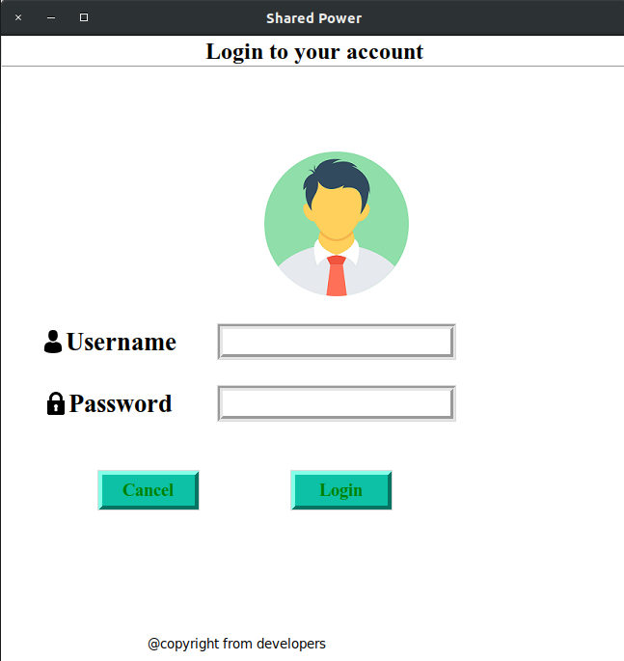

2.Register

Register consists of First name, Last name, Username and Password. New users whoever want to explore the Lenden: the customers satisfaction, they have to register them first into our system. The username and password consists of more than a five character and the username must be unique every time the user register to the system. If the user provides the correct details then he/she will be redirected to the buyer panel.

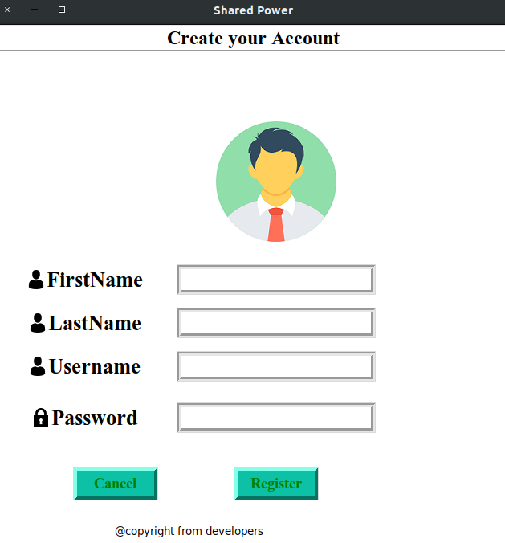

3.Seller Panel

Seller panel consists of Uploading the tools and viewing their details. While uploading the tools the Uploading user must provide the name, image, description, condition , half day rate and full day rate of the tool. If any of the field is missing then the error message will pop up and redirect to the upload frame else the tool will be successfully uploaded. On the otherhand, seller can see the tool details that has been uploaded in the database.

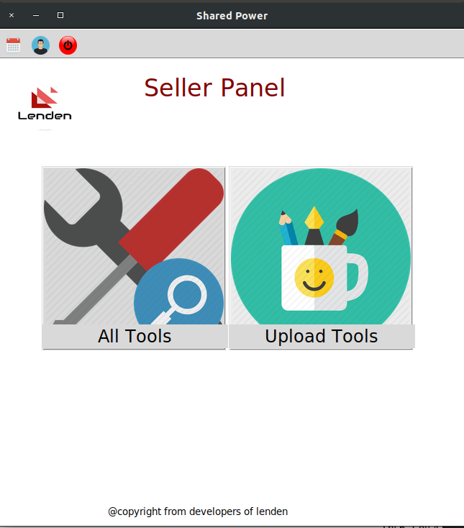

4.Class Diagram

I have designed the class diagram according to the use case and activity diagram that we have designed first. Drawing the class diagram was bit confusing in the beginning but discussing with the team members generates the concept which makes me easy to show the system using class diagram.

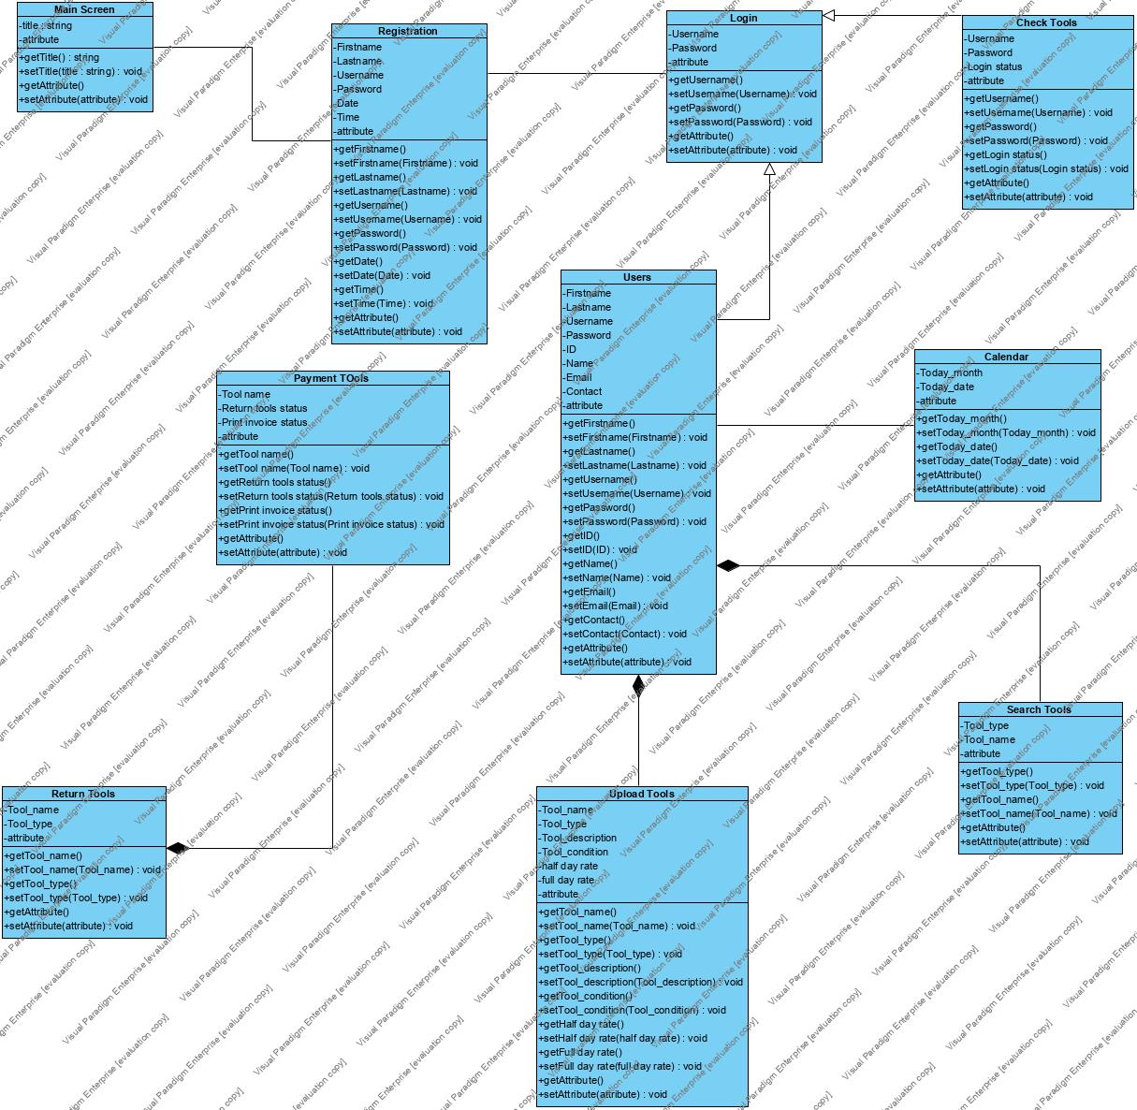

The below table is the rating for every individual performance during software development
process

Student Number | Student Name | Contribution
1915684 | Roshan Bist | S
1916447 | Santosh Shahi | S
1822747 | Chiranjeebi Khanal | S

S-Significant(Fully cooperated in the every steps of project)
I-Insignificant(Little help in the project)
N-No contribution(Perform no work at all)

After a hard work and research we are able to develop a fully functioning software named Lenden: The customers satisfaction. As a beginner in the field of software it wouldn’t have been completed single handedly. Every member of the team have given their best so that we are able to complete our project in time. I would also like to thank Bishwo Kiran Bhattarai sir to coordinate us in every obstacles we faced during the whole software development process. I feel proud and motivated myself after completing this project. I learn lots of thing from this project like working in a team, how the fully functioning software can be written from python. I think it will motivate me to do such time of project more in future.

Registered users and uploaded tools details in database
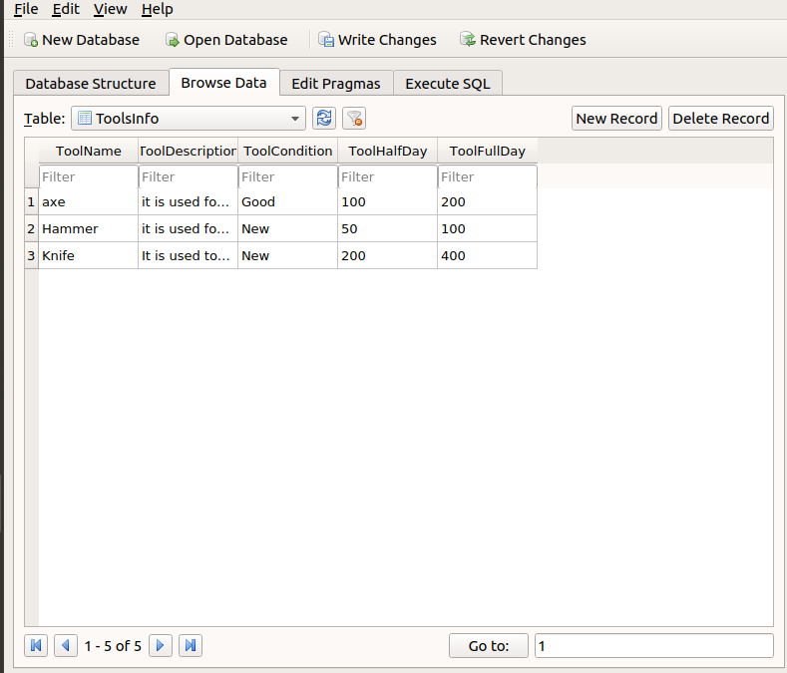
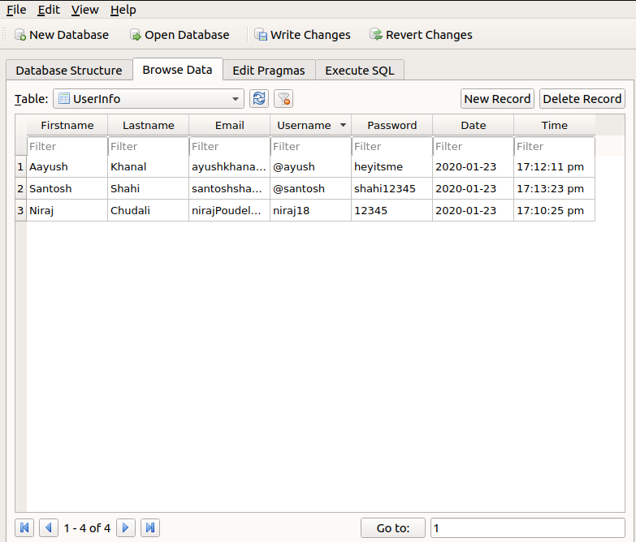

Code Snippets

