1.INTRODUCTION
Today there is a wide spread talk about improvement of the human interface to the computer. Because no longer people want to sit and read data from the monitor. Since there is a painstaking effort to be taken, this involves strain to their eyes. In thisaspect Speech Synthesis is becoming one of the most important steps towards improving the human interface to the computer.
The art of making PC's talk hasalwaysentranced the humancommunity. After all, voice is one of the best alternatives for hours of eyestrain involved ingoing through any document. Also, Voice isa better interface when it comes to illiterate people rather than Graphic User Interface inEnglish. So, research is being done throughout the world for improving the Human Interface to thecomputer and one of the best options found out till date is theability of acomputer to speak tohumans. Here comes the role of the Text to Speech (TTS) engines. Text-To-Speech is a process through which input text isanalysed, processed and “understood”, and then the text is rendered as digital audio and then “spoken”. It is a small piece of software, which will speak out the text inputted to it, as if reading from a newspaper. There have been many developments found around the world in the development of TTS Engines invarious languages like English, French, German etcand even in Hindi. Thishas not been tried out till date, (according to our knowledge) inKannada. So here is the first step towards making computersspeak toKannadigas around the world.
1.1 Types of TTS Systems
Most Text to Speechenginescan becategorized by the method that they use to translate phonemes into audiblesound. Some TTSSystems are listed below:-
Prerecorded :-
In this kind of TTSSystems, we maintain a database of prerecorded words. The main advantage of this method is good quality of voice. But limited vocabulary and need of large storagespace makes it lessefficient.
Formant :-
Here voice is generated by thesimulation of the behaviour of humanvocal cord. Unlimited vocabulary, need of low storagespaceand ability to produce multiple featuredvoices makes it highly efficient, but roboticvoice, which is sometimes not appreciated by the users.
Concatenated: -
In this kind of TTS systems, text is phonetically represented by thecombination of its syllables. These syllablesareconcatenated at run timeand they produce phonetic representation of text. Key features of this techniqueare unlimited vocabulary and good voice. But it can’t produce multiple featured voices, needs large storagespace.
Various methodologies of implementation, prospects | and | challenges | of
implementation of a Kannada TTS engine with regard tospeech synthesizer and its high-l e v e l applicationsare presented here. The Implementation of this TTS is done using the concatenation method. Integral parts of a Text to Speech engineare phoneme identifier, voice mapping and speech synthesiz
1

1.2 Problem definition
Text-to-speech (TTS) is a type of assistive technology that reads digital text aloud. It’s sometimes called “read aloud” technology. With a click of a button or the touch of a finger, TTS can take words on a computer or other digital device and convert them into audio. TTS is very helpful for kids who struggle with reading. But it can also help kids with writing and editing, and even focusing.
Text-to-speech (TTS) technology plays a crucial role in accessibility, communication, and convenience for various individuals and industries. Here are some reasons why text-to-speech is important:
Accessibility: TTS technology enables people with visual impairments or learning disabilities to access written content. It converts written text into spoken words, allowing visually impaired individuals to consume information from digital sources such as websites, e-books, documents, and more.
Inclusive Communication: TTS enhances communication for individuals with speech impairments. It enables them to convert typed or written messages into spoken words, facilitating communication with others in real-time or through recorded messages.
Multimodal Interaction: TTS is essential for multimodal interfaces, where users interact with devices or applications through multiple modes such as voice, touch, and gestures. Integrating TTS allows for a seamless user experience, especially in applications like virtual assistants, navigation systems, and smart devices.
Language Learning: TTS technology aids language learners in pronunciation, comprehension, and listening skills. Learners can hear the correct pronunciation of words and phrases, helping them improve their spoken language abilities.
Productivity and Efficiency: TTS increases productivity by enabling users to listen to content while performing other tasks. It allows individuals to consume information hands-free, such as listening to emails, articles, or documents while driving, exercising, or doing household chores.
Localization and Globalization: TTS technology supports the localization of content into multiple languages, allowing businesses to reach a broader audience. It facilitates the adaptation of digital content, such as websites, apps, and e-learning materials, for users worldwide.
Assistive Technology: TTS is a fundamental component of assistive technology solutions for individuals with disabilities. It enables the development of assistive devices and software applications that enhance independence, accessibility, and quality of life for people with disabilities.
Audio Content Creation: TTS technology provides a cost-effective solution for generating audio content, such as audiobooks, podcasts, and voiceovers for videos. Content creators can use TTS to produce spoken versions of written material quickly and efficiently.
Overall, text-to-speech technology plays a vital role in improving accessibility, communication, and efficiency across various domains, making it an important tool in today's digital age.
2

2. Review of related work
Reviewing related work in a Text-to-Speech (TTS) project is crucial for understanding the landscape of existing solutions, identifying gaps, and determining the direction for your own research or development. Here's a structured approach to reviewing related work in a TTS project
2.1 Existing system
In this section, you will discuss the current state-of-the-art TTS systems or any existing system you're building upon. Here's how you can structure it:
Introduction to the Existing System: Briefly introduce the TTS system or systems that are currently being used or researched in the field. Highlight the importance of TTS in various applications such as accessibility, virtual assistants, and entertainment.
Overview of the Existing System: Provide a detailed description of the architecture of the existing system(s) including any preprocessing steps, feature extraction methods, and synthesis techniques. Discuss the strengths and weaknesses of the existing system(s) in terms of naturalness, expressiveness, and computational efficiency.
Implementation Details: If applicable, provide information about the programming languages, libraries, and frameworks used in building the existing system(s). Describe any customizations or optimizations made to tailor the system to specific use cases or domains.
Evaluation and Results: Summarize the evaluation metrics used to assess the performance of the existing system(s) such as MOS (Mean Opinion Score), MCD (Mel-Cepstral Distortion), and subjective user evaluations. Present the results of the evaluation, highlighting any achievements or areas for improvement.
2.2 Literature survey
In this section, you will review relevant literature in the field of TTS. Here's how you can structure it:
Introduction to Literature Survey: Provide context for the literature survey by explaining its importance in understanding the current state of research in TTS. Highlight the scope and objectives of the literature survey.
Traditional Approaches: Review traditional TTS techniques such as concatenative synthesis, formant synthesis, and articulatory synthesis. Discuss their limitations and challenges compared to modern approaches.
Statistical Parametric Approaches: Discuss TTS systems based on statistical models such as Hidden Markov Models (HMM) and Unit Selection Synthesis. Highlight their strengths in capturing speaker variability and generating natural-sounding speech
Deep Learning Approaches: Review recent advances in TTS using deep learning techniques such as Deep Neural Networks (DNNs), Sequence-to-Sequence models, and Generative Adversarial Networks (GANs).
3

Discuss the advantages of deep learning approaches in terms of flexibility, scalability, and performance. Multi-speaker and Style Transfer: Explore techniques for multi-speaker TTS and voice conversion. Discuss methods for transferring speaking style or voice characteristics from one speaker to another.
Evaluation Metrics and Datasets: Review commonly used evaluation metrics and datasets in TTS research. Discuss the importance of objective metrics and the availability of benchmark datasets for training and evaluation.
Challenges and Future Directions: Identify key challenges in TTS research such as robustness, real-time synthesis, and expressiveness.
Discuss potential future directions and research opportunities in the field of TTS
4

3.Planning
The planning phase of a project serves as the foundational bedrock upon which successful execution is built. It is during this crucial stage that objectives are defined, requirements are gathered, and the overall strategy is outlined. By meticulously laying out the roadmap for development, stakeholders can align their efforts, allocate resources effectively, and mitigate potential risks. In essence, the planning phase sets the tone for the entire project, ensuring clarity of purpose, direction, and ultimately, success.
1.Define Objectives and Scope:
a.Clearly define the goals and objectives of the TTS project. This could include creating a high-quality TTS system for a specific language, domain, or application. b.Determine the scope of the project, including the target audience, supported languages, and platforms (e.g., mobile, desktop, web).
2.Gather Requirements:
a.Identify the functional and non-functional requirements of the TTS system.
Functional requirements may include text input processing, speech synthesis, and output generation, while non-functional requirements may include performance, scalability, and usability.
b.Gather requirements through stakeholder interviews, literature review, and analysis of similar existing systems.
3. Design Architecture and Components:
a.Design the architecture of your TTS system, including the various components such as text preprocessing, feature extraction, acoustic modelling, and waveform synthesis.
b.Determine the technology stack and tools required for each component, considering factors such as programming languages, libraries, and frameworks.
4.System Integration and Development:
a.Develop the TTS system by integrating the various components and models into a cohesive software application.
b.Implement text processing, model inference, and audio synthesis functionalities. c.Test the system thoroughly, ensuring proper functionality, performance, and usability.
5. Evaluation and Optimization:
a.Evaluate the performance of your TTS system using objective metrics (e.g., MOS, MCD) and subjective user evaluations.
b.Identify areas for optimization and improvement, such as speech quality, naturalness, and efficiency.
c.Iterate on the system design and implementation based on feedback and evaluation results.
6. Documentation and Deployment:
a.Document the TTS system architecture, components, algorithms, and APIs for future reference and collaboration.
5

b.Prepare user documentation, including installation instructions, usage guidelines, and troubleshooting tips.
c.Deploy the TTS system to production or distribution platforms, ensuring compatibility and scalability.
7. Maintenance and Updates:
a.Monitor the performance of the deployed TTS system and address any issues or bugs that arise.
b.Stay updated on advancements in TTS research and technology, incorporating new techniques and improvements into your system.
c.Provide regular updates and maintenance to ensure the continued reliability and effectiveness of the TTS system.
6

4.Methodology
The methodology section outlines the systematic approach and techniques utilized to achieve the project's objectives. It serves as a blueprint for the execution of the project, providing a structured framework for activities such as data collection, analysis, implementation, and evaluation. By selecting and detailing the appropriate methodologies, the project team ensures rigor, reliability, and efficiency throughout the project lifecycle. This section not only clarifies the methods employed but also highlights the rationale behind their selection and how they contribute to the overall success of the project.
4.1 Proposed system overview
The proposed system aims to develop a robust and efficient Text-to-Speech (TTS) solution that converts written text into natural-sounding speech in real-time. Leveraging cutting-edge machine learning techniques and deep neural networks, the system will seamlessly synthesize speech from input text, offering a wide range of applications across various domains.
Key features of the proposed system include:
•Text Preprocessing: The system will preprocess input text to handle linguistic variations, punctuation, and formatting for optimal synthesis.
•Acoustic Modelling: Utilizing advanced machine learning algorithms, the system will model the acoustic properties of human speech, capturing nuances in pitch, intonation, and rhythm.
•Multi-Lingual Support: The system will support multiple languages, enabling users to synthesize speech in diverse linguistic contexts.
•Customization and Adaptation: Users will have the flexibility to customize and adapt the TTS models to specific voices, accents, or speaking styles, enhancing the system's versatility and personalization.
•Real-time Performance: Designed for real-time applications, the system will deliver fast and responsive speech synthesis, making it suitable for interactive dialogue systems, virtual assistants, and assistive technologies.
•Evaluation and Quality Assurance: Rigorous evaluation metrics and quality assurance measures will be implemented to ensure the generated speech meets high standards of naturalness, intelligibility, and expressiveness.
By combining cutting-edge technology with user-centric design principles, the proposed TTS system aims to deliver an immersive and seamless auditory experience, empowering users to interact with digital content in a more intuitive and accessible manner.
4.2 Algorithm details
The algorithm for the given program can be broken down into the following steps:
•The program starts by initializing the Tkinter window with specified dimensions and properties.
7

•Labels and entry fields are created for user input, such as file name and text.
•Buttons for playing the speech, exiting the program, and resetting the text field are created.
•When the user clicks the "PLAY" button, the Text_to_speech() function is called, which
converts the entered text to speech using gTTS, saves it as an MP3 file, and plays the audio.
•The "EXIT" button calls the Exit() function, which closes the Tkinter window and exits
the program.
•Clicking the "RESET" button calls the Reset() function, which clears the text entry field
.
•Error handling is implemented to catch exceptions during text-to-speech conversion and
display error messages using messagebox.showerror() if necessary.
1.Import Necessary Modules:
• Import the required modules for the program, including Tkinter, message box for
GUI elements and error handling, gTTS for text-to-speech conversion, and play
sound for playing audio files.
2.Define Functions:
• Text_to_speech():
• Retrieve the file name and text input from the GUI entry fields.
• Use gTTS to convert the text to speech.
• Save the generated speech as an MP3 file with the specified file name.
• Play the generated audio using playsound.
• Handle exceptions such as ValueError and generic exceptions, displaying
error messages using messagebox.showerror() if necessary.
3.Exit(): Destroy the Tkinter window when the "EXIT" button is clicked.
4.Reset(): Clear the text entry field when the "RESET" button is clicked.
5.Create Tkinter GUI:
• Initialize the Tkinter window (root) with specific dimensions, background colour,
and title.
• Create labels for "TEXT TO SPEECH", "Enter File Name", and "Enter Text" using
the Label widget.
• Create entry fields (Entry) for user input for the file name and text.
• Create buttons (Button) for "PLAY", "EXIT", and "RESET", with corresponding
functions assigned to them.
• Position the widgets using the place() method.
6.Main Event Loop:
• Enter the main event loop (root.mainloop()) to start the Tkinter application and
handle user interactions.
8

4.3 System requirements
For a Text-to-Speech (TTS) project, system requirements encompass hardware, software, and other dependencies necessary for development, deployment, and operation. Below are the key system requirements for such a project:
Hardware Requirements:
•Processor (CPU):
oA modern multi-core processor (e.g., Intel Core i5 or higher) is recommended for efficient processing of text-to-speech tasks.
•Memory (RAM):
oAt least 4GB of RAM is recommended for smooth operation, especially when dealing with large datasets or complex machine learning models.
•Storage:
oSufficient storage space for storing datasets, trained models, and generated audio files.
oSSD storage is preferred for faster data access and processing.
•Audio Output:
oSpeakers or headphones for listening to the synthesized speech output.
Software Requirements:
•Operating System:
oCompatibility with major operating systems such as Windows, macOS, and Linux is desirable to ensure broad accessibility.
oSpecific dependencies or libraries may have OS-specific requirements.
•Python:
oThe project may be developed using Python, so Python 3.x should be installed on the system.
oPackage management tools like pip should also be available for installing dependencies.
Libraries and Frameworks:
•Required libraries and frameworks for text processing, machine learning, and audio manipulation, such as:
ogTTS or pyttsx3 for text-to-speech conversion.
oplaysound or pyaudio for audio playback.
oTkinter or other GUI libraries for creating a user interface if necessary.
Additional Tools:
•Text editors or Integrated Development Environments (IDEs) for coding and development (e.g., Visual Studio Code, PyCharm).
•Version control systems like Git for managing project code and collaboration.
Internet Connectivity:
9




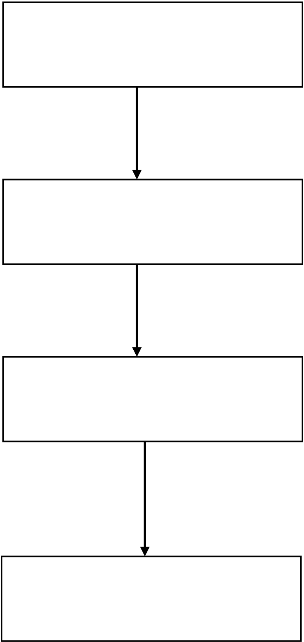
•While not strictly required for local development and execution, internet connectivity may be necessary for accessing online resources, APIs, or cloud-based services for certain functionalities (e.g., downloading datasets, using external TTS APIs).
5.Design of the system
5.1 Use case diagram
In a Use Case Diagram, the primary elements include actors and use cases. Actors are the entities that interact with the system, such as users or external systems. Use cases represent the specific functionalities or tasks that the system provides to its users. Each use case describes a sequence of interactions between the system and one or more actors to achieve a specific goal
User
1.provides text input
Text to speech
software
2.required conversion
Text to speech API
3.convert text to speech
Audio output
Figure 1 : use case diagram
1.Provides text input: The user interacts with the application by providing text input.
2.Requests conversion: The application receives the text input and requests the Text-to- Speech API to convert the text into speech.
10




3.Converts text to speech: The Text-to-Speech API processes the text and converts it into speech.
4.Audio Output: The generated speech is then played back as audio output to the user.
This diagram provides a clear representation of the interactions between the user, your application, the Text-to-Speech API, and the resulting audio output.
5.2 Class diagram
A Class Diagram is another type of diagram in the Unified Modelling Language (UML), often used in software engineering to visualize the structure of a system. It represents the static view of the system, focusing on the classes and their relationships.
Interface
- root: Tk
- main_frame: Frame
- file_name_entry: Entry - text_entry: Entry
- buttons_frame: Frame - play_button: Button
- exit_button: Button
- reset_button: Button
+tk()
+button()
+label()
+entry()
Text_to_speech
- message: str
+ __init__(self, message: str) + generate_audio(self) -> str + play_audio(self)
Figure 2 : class diagram
11

•Interface: This class represents the main application.
oAttributes:
▪root: Tkinter root window object.
▪mainframe: Tkinter Frame for organizing the UI elements.
▪file_name_entry: Tkinter Entry widget for file name input.
▪text entry: Tkinter Entry widget for text input.
▪buttons frame: Tkinter Frame for organizing buttons.
▪play button: Tkinter Button widget to trigger text-to-speech conversion and playback.
▪exit button: Tkinter Button widget to exit the application.
▪reset button: Tkinter Button widget to reset input fields.
oMethods:
▪__init__(self): Constructor method to initialize the application and set up the UI.
•Text_to_speech: This class represents the functionality related to text-to-speech conversion.
oAttributes:
▪message: The text message to convert to speech.
oMethods:
▪__init__(self, message: str): Constructor method to initialize the object with the text message.
▪generate_audio(self) -> str: Method to generate audio file from the text message and return the file name.
▪play_audio(self): Method to play the generated audio file.
5.3 Sequence diagram:
•The user enters text into the text interface. This can be done either by directly typing the text into the editor or by opening a text file.
•Once the text is entered, the user clicks on the "Read" button.
•Clicking the button activates the Text-to-Speech (TTS) engine, which then converts the written text into spoken language.
•The synthesized speech is then delivered through the speech interface, which can be headphones or speakers.
•Optionally, the user can provide feedback on the synthesized speech. This feedback loop helps improve the TTS engine over time.
12

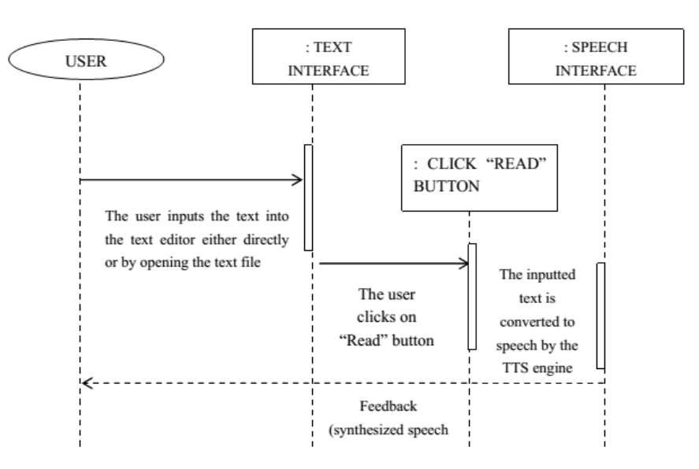
Figure 3 : sequence diagram
13

6.Experimental Results
6.1 Output:
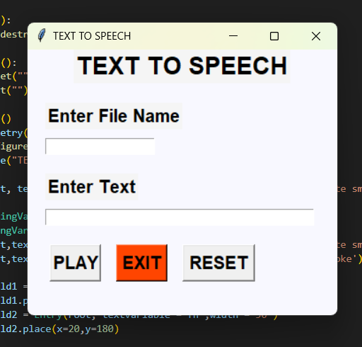
Figure 4 : output no 1
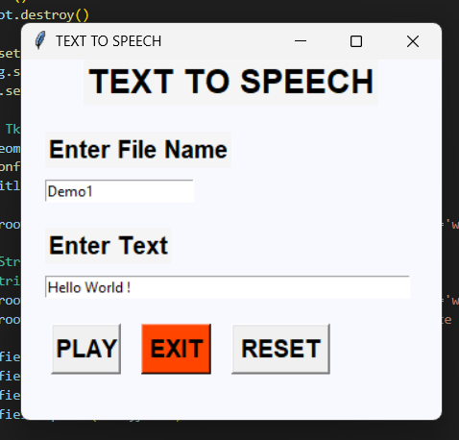
Figure 4 : output english
14

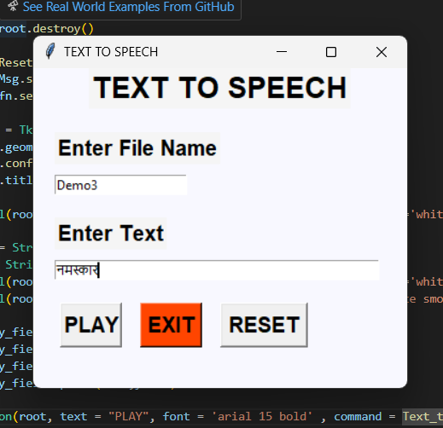
Figure 6: output marathi
6.2 Advantages:
•Accessibility: TTS technology makes digital content accessible to individuals with visual impairments or reading difficulties. It allows them to consume written content in audio form, enabling greater participation in education, work, and leisure activities.
•Multilingual Support: TTS systems can convert text into speech in multiple languages, facilitating communication and accessibility for speakers of different languages. This is particularly valuable in globalized contexts where multilingual communication is essential.
•Enhanced User Experience: Integrating TTS into applications, websites, or devices enhances the user experience by providing an alternative means of content consumption. Users can choose between reading and listening based on their preferences, contexts, or needs.
•Productivity: TTS technology can improve productivity by converting large volumes of written content into speech, allowing users to multitask or consume information while on the move. For instance, it can be used in educational settings for audio lectures or in professional environments for proofreading documents.
•Assistive Technology: TTS serves as a crucial assistive technology tool for individuals with dyslexia, learning disabilities, or cognitive impairments. It aids in reading comprehension and reduces the cognitive load associated with decoding written text.
•Naturalness and Intelligibility: Advancements in TTS technology have led to more natural-sounding and intelligible speech synthesis. High-quality TTS systems can mimic
15

human speech patterns, intonation, and pronunciation, providing a more engaging and immersive experience for users.
•Cost and Time Efficiency: Automating speech synthesis through TTS systems can save time and resources compared to hiring voice actors or recording audio content manually. Once developed, TTS solutions can be deployed and scaled rapidly across different platforms and applications.
•Customization and Personalization: TTS systems can be customized to suit specific applications or user preferences. Parameters such as voice type, speed, and pitch can be adjusted to enhance comprehension and user engagement. Additionally, personalized TTS voices can be created to cater to individual user preferences or brand identities.
•Innovation and Research: TTS projects drive innovation and research in fields such as linguistics, artificial intelligence, and human-computer interaction. Advancements in TTS technology contribute to the development of voice-enabled interfaces, virtual assistants, and interactive storytelling applications.
•Inclusive Design: By incorporating TTS technology into digital products and services, designers and developers promote inclusive design principles that prioritize accessibility and usability for diverse user populations. This fosters a more inclusive and equitable digital ecosystem.
Overall, text-to-speech projects offer a wide range of benefits, ranging from accessibility and productivity to innovation and inclusivity, making them valuable tools in various domains and applications
6.3 Application:
•Accessibility Tools: TTS technology is widely used to make digital content accessible to individuals with visual impairments, dyslexia, or other reading difficulties. Screen readers, assistive reading devices, and accessibility features in software applications leverage TTS to convert text into speech, enabling users to access and interact with digital content.
•Language Learning: TTS systems aid language learners by providing audio
representations | of | written | text, | facilitating | pronunciation | practice, | listening
comprehension, and vocabulary acquisition. Language learning platforms, educational apps, and language courses integrate TTS to enhance the learning experience for learners of all ages and proficiency levels.
•Navigation and Directions: GPS navigation systems and mapping applications utilize TTS technology to deliver turn-by-turn directions and spoken instructions to users. TTS-enabled navigation systems enhance user safety and convenience by providing real-time voice guidance while driving, walking, or cycling.
•E-books and Audiobooks: E-book readers and audiobook platforms leverage TTS technology to offer audio versions of digital books and textual content. Users can listen to books in audio format, providing a convenient alternative to traditional reading and expanding access to literature for readers of all abilities.
16

•Virtual Assistants and Chatbots: Virtual assistants and chatbots utilize TTS technology to deliver spoken responses and interact with users through natural language dialogue. TTS-enabled virtual assistants, such as Siri, Google Assistant, and Amazon Alexa, assist users with tasks, answer questions, and perform voice-activated commands.
•Customer Service and Call Centres: TTS technology is employed in automated customer service systems and interactive voice response (IVR) systems to deliver pre-recorded messages, prompts, and information to callers. TTS-enabled IVR systems enhance efficiency and scalability in call centres by automating routine interactions and reducing the need for human intervention.
•Language Translation and Localization: TTS systems support language translation and localization efforts by converting text into speech in multiple languages. Multilingual TTS technology enables the creation of audio content in diverse languages, facilitating cross-cultural communication and accessibility in global markets.
•Entertainment and Gaming: TTS technology is integrated into entertainment and gaming applications to provide voiceovers, character dialogue, and interactive storytelling experiences. TTS-enabled games, interactive fiction, and narrative-driven experiences offer immersive audio experiences for players and users.
•Educational Resources and Learning Tools: TTS technology is used in educational resources, learning management systems, and digital study aids to provide audio versions of textbooks, lectures, and instructional materials. TTS-enabled educational tools support diverse learning styles, accommodate learners with disabilities, and enhance engagement and comprehension.
•Smart Devices and IoT Applications: Smart devices, IoT (Internet of Things) devices, and connected appliances leverage TTS technology to deliver spoken notifications, alerts, and status updates to users. TTS-enabled smart home devices, wearable technology, and IoT applications enhance user interaction and accessibility in connected environments.
These applications demonstrate the versatility and utility of text-to-speech technology across various domains, enriching user experiences, improving accessibility, and enabling innovative solutions in diverse industries and contexts.
17

7. Conclusion
Text-to-speech (TTS) technology has revolutionized the way we interact with digital content and information across a wide range of applications and industries. By converting written text into natural-sounding speech, TTS systems enhance accessibility, convenience, and user experience for individuals of all abilities. From aiding individuals with visual impairments or reading difficulties to facilitating language learning, navigation, customer service, and entertainment, TTS technology plays a crucial role in fostering inclusion, efficiency, and innovation.
The widespread adoption of TTS technology underscores its importance in enabling access to information, communication, and education for diverse populations. As advancements in artificial intelligence and natural language processing continue to improve the quality and capabilities of TTS systems, we can expect to see even greater integration and innovation in the future. Overall, text-to-speech technology represents a powerful tool for promoting accessibility, enhancing productivity, and enriching the way we engage with digital content and services in our daily lives.
18

References
19

