**Testing Customer Service in** [**http://10.96.33.58/cm**](http://10.96.33.58/cm)

Logged in as **j_spradlin**

|  |
| --- |
|  |

1. Search: by name **‘ka’**

Selected Rented Unit M527 - 24310

|  |  |  |  |  |  |  |  |  |  |  |
| --- | --- | --- | --- | --- | --- | --- | --- | --- | --- | --- |
| [**Unit Number and Site Number**](javascript:__doPostBack('gvSearchResults','Sort$SpaceNumber')) | [**Customer Name/Company Name**](javascript:__doPostBack('gvSearchResults','Sort$LastName')) | [**Phone Number**](javascript:__doPostBack('gvSearchResults','Sort$PhoneNumber')) | [**Email**](javascript:__doPostBack('gvSearchResults','Sort$Email')) | [**DL Number**](javascript:__doPostBack('gvSearchResults','Sort$DriverLicense')) | [**Move In Date**](javascript:__doPostBack('gvSearchResults','Sort$MoveInDate')) | [**Account Number**](javascript:__doPostBack('gvSearchResults','Sort$AccountID')) | [**Reservation Number**](javascript:__doPostBack('gvSearchResults','Sort$ReservationNumber')) | [**Expiration Date**](javascript:__doPostBack('gvSearchResults','Sort$ExpirationDate')) | [**SSN**](javascript:__doPostBack('gvSearchResults','Sort$SSN')) | [**Current Status**](javascript:__doPostBack('gvSearchResults','Sort$CurrentUserStatus')) |
| **M527 - 24310** | **Kabamba, Sandrine** | **(817)353-6747** | **alexkabamba2001@yahoo.fr** | **\*\*\*\*\*\*\*\*1823** | **06-02-2013** | **17404820** |  |  |  | **Rented** |

1. Auto pay disabled :

Accepting the invalid **callconid ‘234234234444444444444444444444444444’**

Disable happened without callcon id

Autopay enabled without callcon id and accepting invalid information

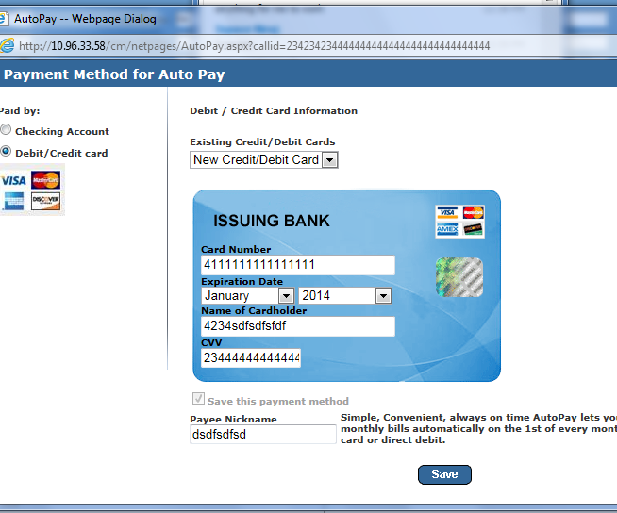

1. Selected Payment Tab

Thowing Error while making payment sometimes and successful also.

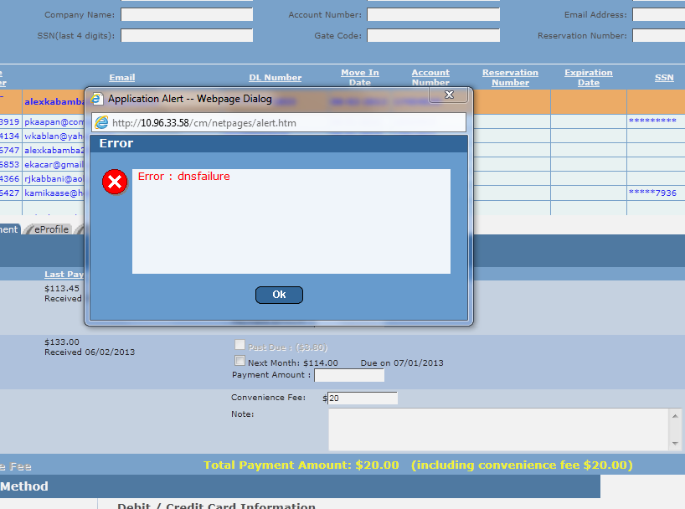

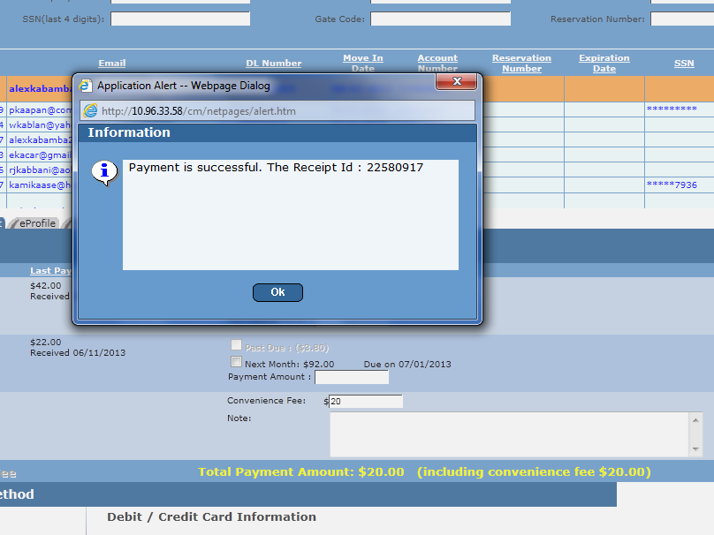

1. No validation for Convenience fee field accepting invalid number also **2322222222222222222333**
2. **Touchpoints** Tab Selected. Timeout Exception sometimes while loading data sometimes

.

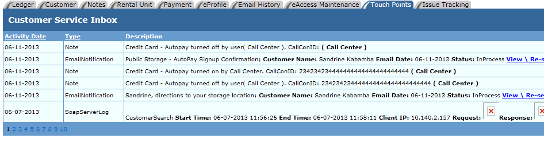

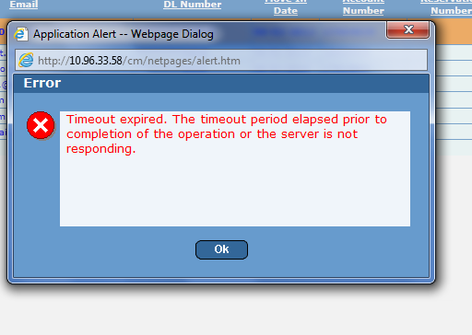

1. **Issue tracking** tab selected

No data found.

1. **Rental Unit** Tab selected

Emergency contact not loading information. 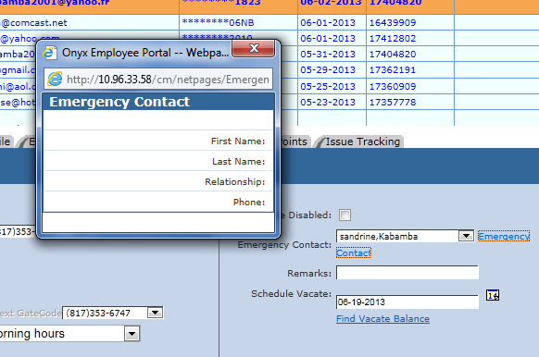

1. Selected **‘Notes’ tab.**

Notes updating successfully.

1. Search by SSN ‘2345’. Selected Vacated unit

Search by Driving License. Selected Rented unit

Search by Reservations/Occupied units.

Updated existing reservations.

* While coming back from the reservation page to the existing Customer search.
* While performing search by Driving license throwing error page.

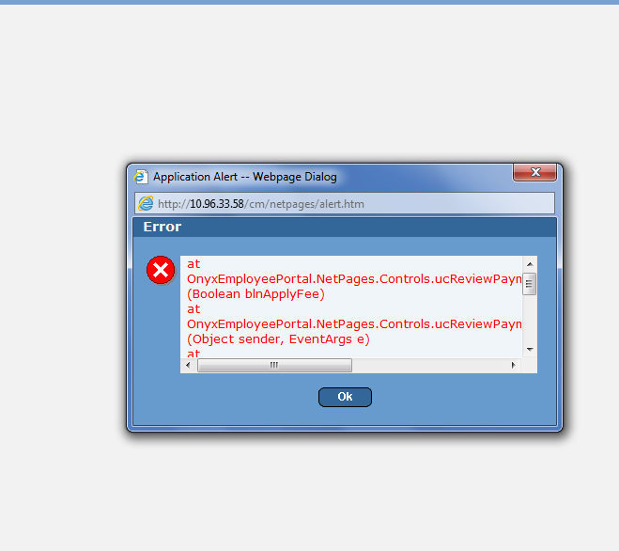

1. Selected **E - Access Maintenance.**

Showing the account information. Email links working properly.

1. Selected **E – Mail History**

Email resend working properly.

Email History filter by type not working properly.

Sorting fails while clicking on the column.

After Filter



After Clicking on the Account # filter not working

