1. Change the “Save” button to “Select”
2. Display the name as LastName, First Name in customer search results.
3. Format the phone number in customer search results
4. Maintain the state of phone type Drop down in the search criteria
5. Work phone is not getting displayed on the commom area, when searched by home phone Example (3239565959) and don’t display “0” when there is no work phone number.
6. Limit the customer search to 100 and display a message like webchamp
7. Need to create an index on SSN
8. Space number and Property search is not working

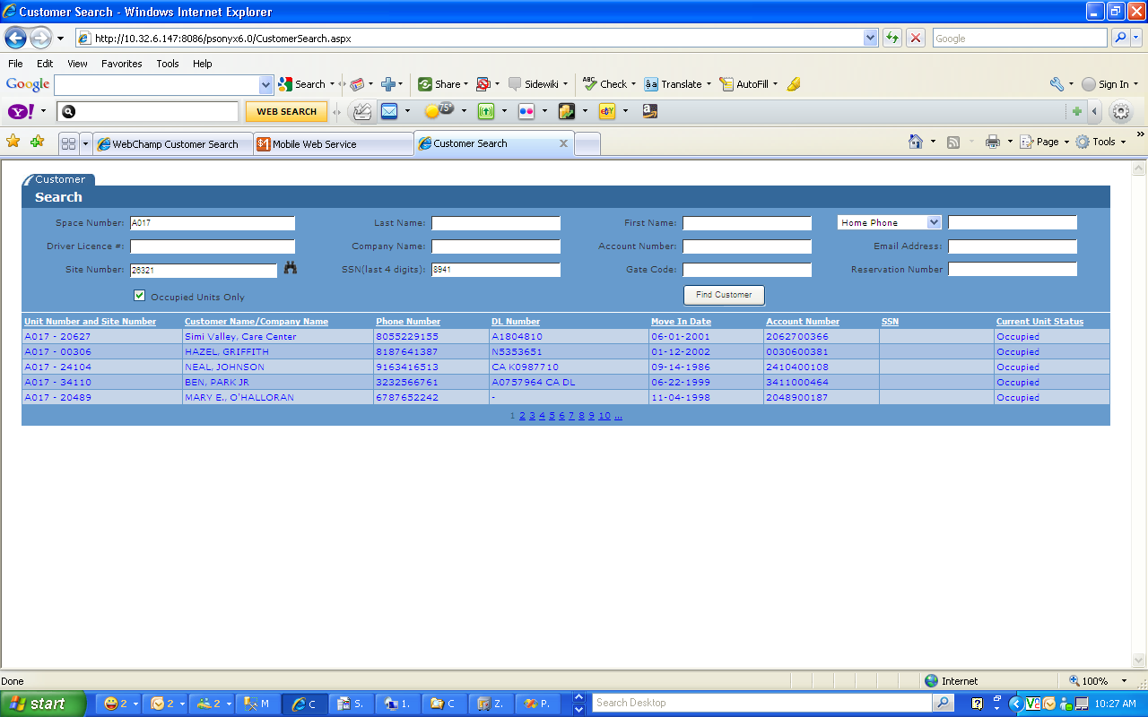

1. Got the following error

