Docker

1. $ docker-compose -f docker-compose.json up :- You can use JSON instead of YAML for your compose file
2. $ docker ps: - The above command lists down only running containers by default.
3. $ docker ps –a: - To look for all containers
4. $ docker start <container_id> :- start container
5. $ docker stop <container_id> :- stop container
6. $ docker rm -f <container_id> :- remove container
7. $ docker system prune :- to remove all the stopped containers
8. $ docker build <path to docker file> to build a Dockerfile
9. $ docker rmi <image-id> :- to delete an image from the local storage system
10. $ docker rm <container id> :- to delete a stopped container
11. $ docker push <username/image name>:- image to push it to docker hub
12. $ docker commit <container id> <username/imagename> :- to edit and update container.
13. $ docker kill <container_id> :- to kill a container
14. $ docker exec -it <container id> bash :- to get inside a container
15. $ docker run -it -d <image_name> :- to you create a docker container from an image
16. $ docker pull <image_name> :- to pull an image from docker hub
17. $ docker login :-to login into docker repository
18. **$ docker version :-** to check Docker Server version
19. **$ docker info :-** to get container info
20. $ docker –help :- how to use a command
21. $ docker <command> --help :- to lists all Docker commands
22. Docker image build –t myimag:v1 :- to create an image
23. Docker image tag myimag:v1 ns7324(account id Docer hub)/myimage:v1 : to share/tag image with docker hub
24. Docker image push ns732/myimage:v1 :- to push image in docker-hub

Linux

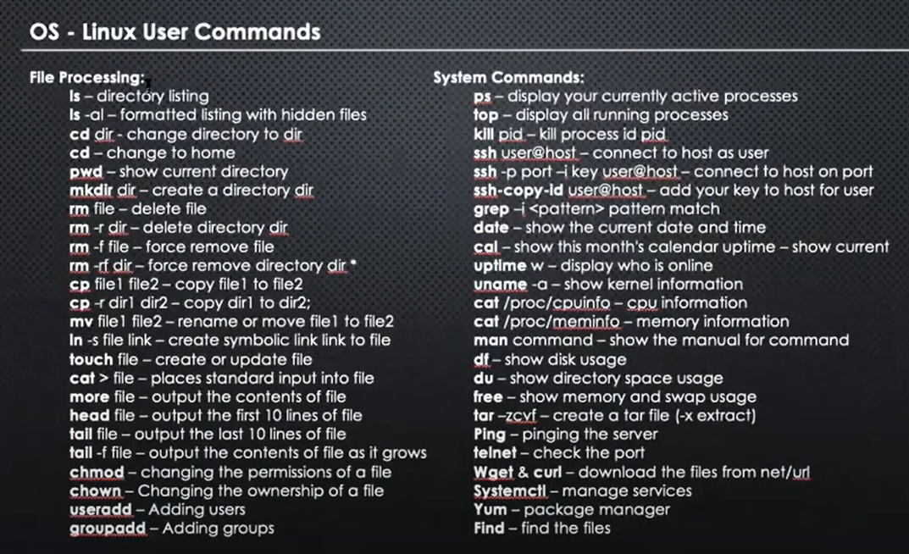

GIT

Git init

Touch file

Git status

Git add filename

Git commit –m “hi”

Git status

Git log

Git remote add origin <https://github.com/nirajsinha73/Devops.git>

Git push –u origin master or group name