**Table of Content**

1 Introduction to Project 1

2 Problem Statement 2

3 Objectives 3

4 Methodology 4

4.1 Requirement Identification 4

4.1.1 Study of Existing System 4

4.1.2 Literature Review 4

4.1.3 Requirement Analysis 5

4.1.3.1 Functional Requirement 5

4.1.3.2 Non-functional Requirement 5

4.2 Feasibility Study 6

4.2.1 Technical 6

4.2.2 Operational 6

4.2.3 Economic 6

4.3 High Level Design of System 6

4.3.1 Process Modelling (DFD) 7

4.3.2 ER Diagram 9

5 Gantt Chart 10

6 Expected Outcome 11

7 References 12

# Introduction to Project

In the scenario of the assignment, we are required to develop a web-based application on Job Portal Management System. In this time of recession where everyone, is either experienced or fresher, is in search for a job. This job portal can prove to be very helpful since it allows users of different profile to upload their CVs, search job on the basis of their qualification. Every user can access through user id and apply for multiple jobs at a time.

Currently, we are working on a manual system where data is stored in the form of registers. Viewing available jobs, or applying for the job at the agency can be done for which job seekers has to go to the agency and check the available jobs at the agency. Job seekers check the list of jobs available and apply the job. Then the agency will show available jobs for the job seeker for his qualifications and then updates the jobs database. The developed Job Portal management system is web-based which Requires Employee Registration & Profiles, Job Search, Employer Registration & Profiles, and Subscription Option for both Employee and Employer etc. Employer can add Own Profile and post jobs and Job Seeker can Search Jobs based on Geographical Area (Country, State, and City), Qualification, and Company wise or on the Basis of Experience and Expertise wise.

# Problem Statement

Some existing problems which job seekers and a company face from existing job portals are listed below:

* Duplication of jobs - Sometimes job seekers could not reach the employers who originally posted the job.
* No proper feedback through portal after employer viewed the profile.
* Not all the portal has cover letter in the job application.
* Irrelevant recruiter and candidate connection
* Fake Jobs

# Objectives

The main objective of this job portal application is to give the job seekers a platform for finding a right and a satisfactory job according to their qualification. It also connects the job seekers with the major agencies.

This system eliminates the existing problem with the following objectives:

* To connects the job seekers with the major agencies based on the qualification and requirements respectively.
* To provide a proper communication channel between job seeker and a employer.
* To get updated catalogue from Admin and employers all the time so that the Job seekers get the updated information all the time.
* To filter out unauthorized applications and fake job posts.

# Methodology

For this project, we are thinking of doing by following Agile Methodology. Agile methodology is a type of project management process, mainly used for software development, where demands and solutions evolve through the collaborative effort of self-organizing and cross-functional teams and their customers

## Requirement Identification

### Study of Existing System

There are a few online freelancing tools which offer such facilities to hire freelancers online but they do not guarantee that the developer being hired is completely efficient and able to take on that project. The hiring process of contractors over the existing system is very complex. The clients are not able to see the complete profile of the available freelancers before the hiring process starts. Even it is difficult for the freelancers to collect sufficient information from the website about the clients who are hiring them. This application will work to remove such problems and offer people a website which would make the freelancing and hiring of freelancers a simplified process.

### Literature Review

E-Freelancing is a very new concept in Nepal and it is prevalent just in the IT Sector mainly. Nowadays people are getting intended towards this concept and this works on a single concept:

"The online marketplace to bring the contractors and clients under one roof ".

Though it's a new concept in Nepal, it has been working in other developed nations for a longer period. Thus, a large part of the researchers concerned with online project outsourcing have tended to focus on the qualitative aspects of the project outsourcing being done online.

Throughout the literature review, the developer talks about the system which he is intended to develop. This system is a website which facilitates online bidding of projects, hiring freelancers online to get projects done within shorter duration and minimum expense. Since this concept of online project outsourcing is new in India and prevalent mostly in the IT sectors, the developer is thus limiting his literature review to activities related to the IT sector only. He is more concerned with the ongoing research and development works going on in the IT Sector and so, the developer wishes to make such a system which will provide a helping hand to this industry.

### Requirement Analysis

This system needs to fulfill following functional and non-functional requirements.

#### Functional Requirement

Functional requirements define the capabilities and functions that a system must be able to perform successfully. The application comprises the following major modules:

* **Job Seeker Module:**

This module provides functionalities for job seekers. Applicants can post their resumes with personal and professional details. They can also update the resume as frequently as required. The applicant can also browse through the present vacancies available. Job seekers can also get mail alerts when their resumes are selected by employers.

* **Employer Module:**

This module provides functionalities related to employers. Employers can post vacancy details and update the details as and when necessary. Employers can search through applicant resumes based on different criteria.

* **Administration Module:**

This module provides administrator related functionalities. Administrator manages entire application and maintains the profiles of applicants and employers.

#### Non-functional Requirement

A non-functional requirement is a requirement that specifies criteria that can be used to judge the operation of a system, rather than specific behaviors. Some of the non-functional requirements include:

* Availability: It will be available online whenever the system is needed.
* Security: It will be secure because user information won’t be available for other user and the payment method is also secure.
* Performance: It will be fast with good response.
* Reliability: It will be reliable.

## Feasibility Study

Feasibility study is totally dependent upon the preliminary investigation & requirements of the system. Hence, we have to determine if the system requested is feasible or not. This helps us to check Technical, Economical & Operational feasibility of the requested system against the current system.

### Technical

This system doesn’t require additional hardware, software and technical expertise. In short, it doesn’t require any additional hardware and software; it uses off-self and existing technologies, hardware and software.

### Operational

This system will use simple technologies to design. So, it is user friendly and easy to use. The system is operational feasible since the user are familiar with the technologies.

* Front-end

1. HTML & CSS
2. Javascript

* Backend

1. Python
2. SQLite DB

* Framework

1. Django
2. React JS

### Economic

This application will be highly economically feasible because this system doesn’t require any extra software and hardware i.e., it uses open-source technologies. So, there is no recurring cost other than just the internet connection and just making an environment for the development.

## High Level Design of System

### Process Modelling (DFD)

Job Portal

Login & Register

Create Profile

Search

Upload Resume

Apply Job

Login & Register

Create Profile

Post Vacancy

Hire Applicant

Applicant

Company

Manage Company

Manage Applicant

Admin

**Fig 1.1: Level 0 DFD**

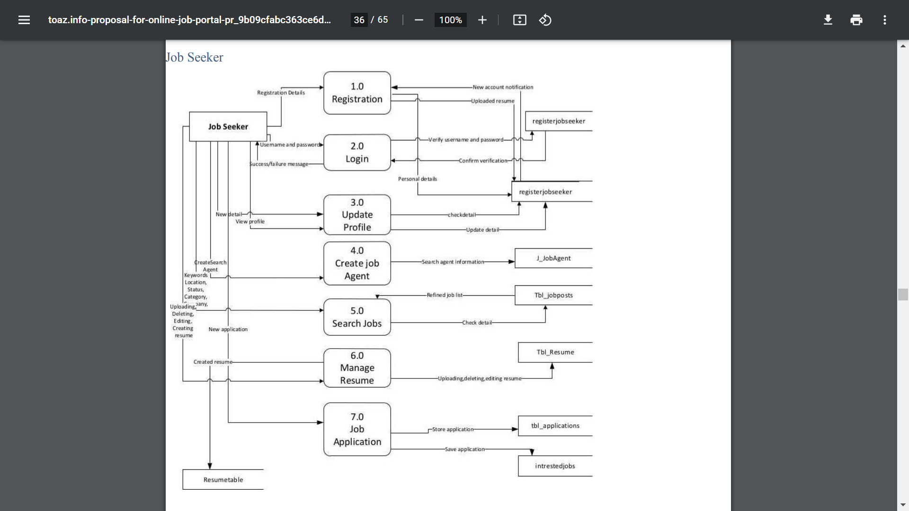

**Fig 1.2: DFD of Job Seeker**

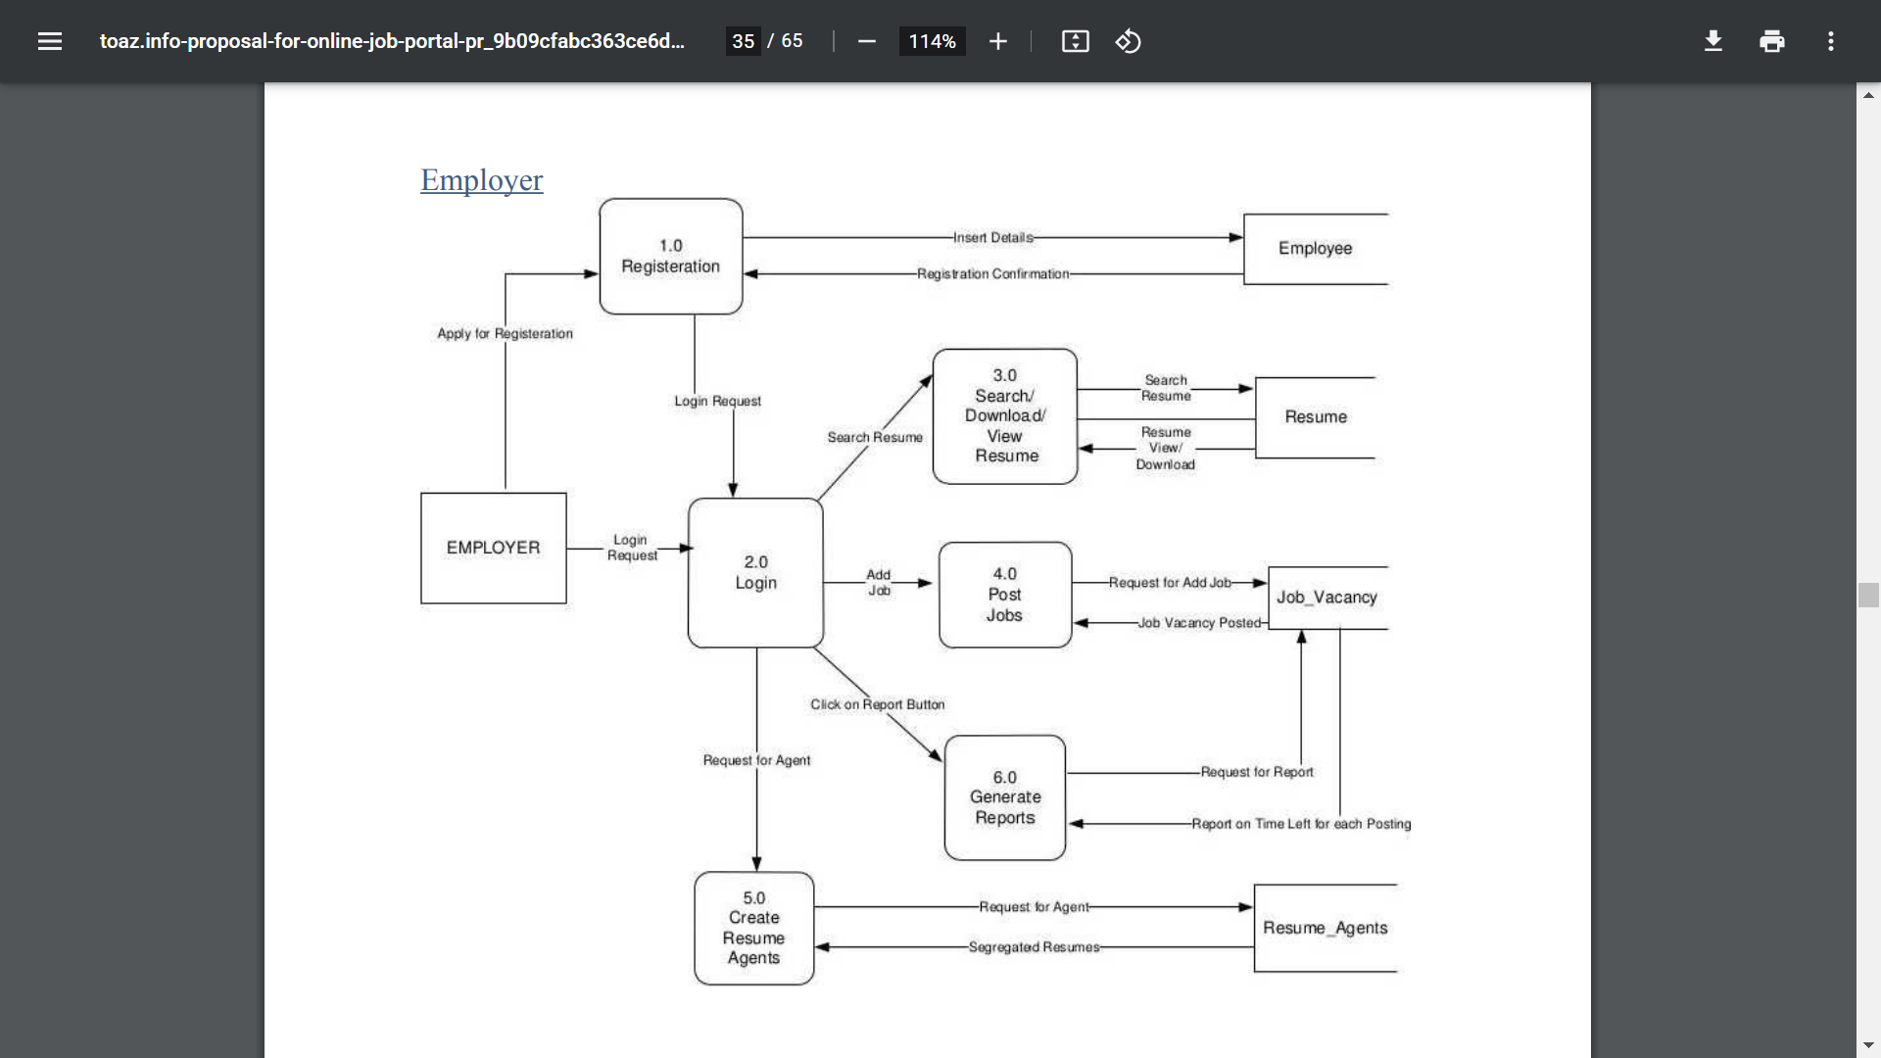

**Fig 1.3: DFD of Employer**

### ER Diagram

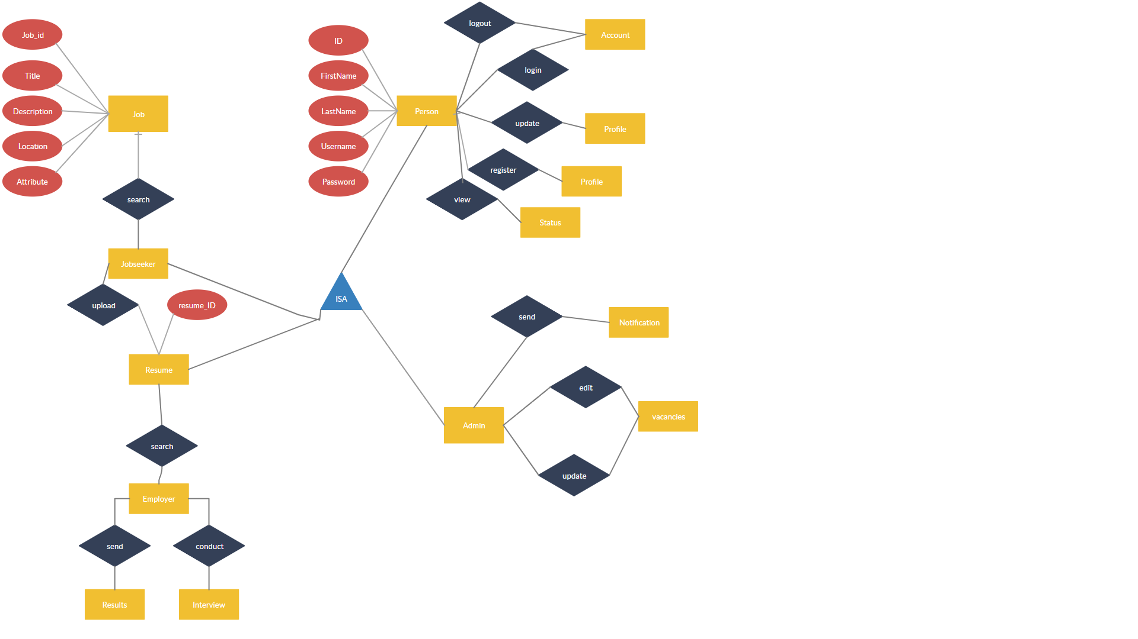

**Fig 1.4: ER Diagram**

# Gantt Chart

Proposed system would be designed as per the time calculated. Likelihood that timeframes can be met and that this adequate to meet organization's needs.

Table 1: Expected Working Schedule

|  |  |  |  |  |  |  |  |  |  |  |  |  |
| --- | --- | --- | --- | --- | --- | --- | --- | --- | --- | --- | --- | --- |
| Phase week | 1 | 2 | 3 | 4 | 5 | 6 | 7 | 8 | 9 | 10 | 11 | 12 |
| Study and Analysis |  | |  |  |  |  |  |  |  |  |  |  |
| Data fetching |  |  |  |  |  |  |  |  |  |  |  |  |
| Implementation |  |  |  | | | |  |  |  |  |  |  |
| Testing |  |  |  |  |  | | |  |  |  |  |  |
| Documentation |  |  |  | | | | | | | |  |  |
| Review |  |  |  |  |  |  |  |  |  |  | | |
| Presentation |  |  |  |  |  |  |  |  |  |  |  |  |

# Expected Outcome

The application can be used by any company and individuals to provide a communication channel between job seeker and employer. In this application any user can create an account either as a job seeker or an employer. Job seeker can upload resume and can apply to a job according to his/her qualification. Similarly company can post a job vacancy. GUI is easy to use. User friendly screens are provided. The application is easy to use and interactive to find jobs through this job portal application.

# References

WEB SITE REFERENCING

• (1995). Asp tutorials. Available: http://w3schools.com/asp/default.asp.

• (2004). ASp.netand sql. Available:http://www.tu torialized.com/tutorial/Conncctingto-a-SQL-database-from-ASP-.NET-Il/5745.

• Dc Montfort University. 2010. Purpose of WISDM. [ONLINE] Available at:http://www.ccsr.cse.dmu.ac.uk/conferences/ethicomp/ethicomp 2010/abstracts/ethic omp2010_ramrattan_ramrattan_patel_hussain.php. [Accessed 13 March 13].