NAME: NIRAJ THANKI SID: 19376 CLASS: CS531

SERVER.py

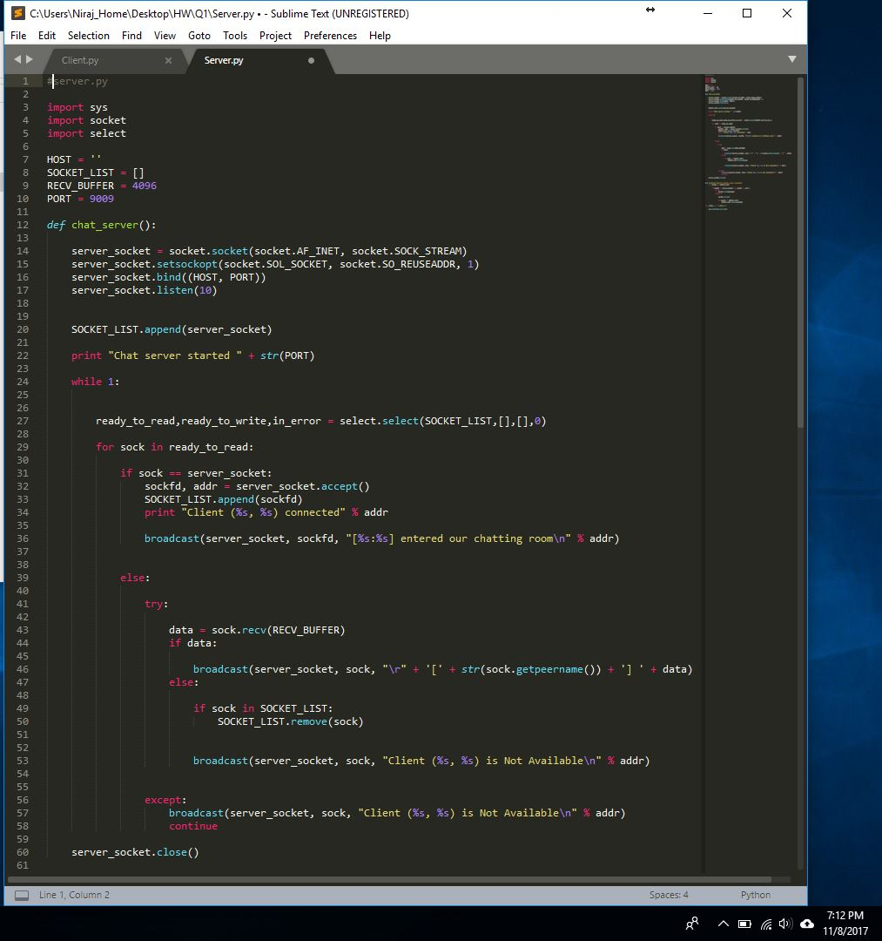

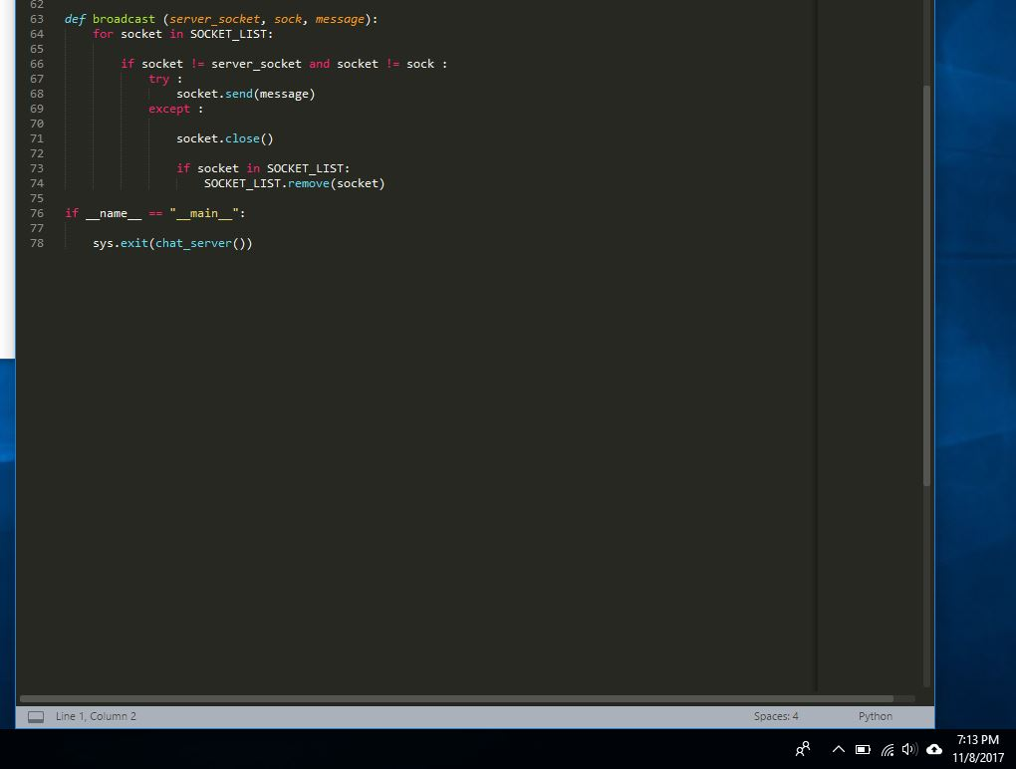

Source Code:

#server.py

import sys

import socket

import select

HOST = ''

SOCKET_LIST = []

RECV_BUFFER = 4096

PORT = 9009

def chat_server():

server_socket = socket.socket(socket.AF_INET, socket.SOCK_STREAM)

server_socket.setsockopt(socket.SOL_SOCKET, socket.SO_REUSEADDR, 1)

server_socket.bind((HOST, PORT))

server_socket.listen(10)

SOCKET_LIST.append(server_socket)

print "Chat server started " + str(PORT)

while 1:

ready_to_read,ready_to_write,in_error = select.select(SOCKET_LIST,[],[],0)

for sock in ready_to_read:

if sock == server_socket:

sockfd, addr = server_socket.accept()

SOCKET_LIST.append(sockfd)

print "Client (%s, %s) connected" % addr

broadcast(server_socket, sockfd, "[%s:%s] entered our chatting room\n" % addr)

else:

try:

data = sock.recv(RECV_BUFFER)

if data:

broadcast(server_socket, sock, "\r" + '[' + str(sock.getpeername()) + '] ' + data)

else:

if sock in SOCKET_LIST:

SOCKET_LIST.remove(sock)

broadcast(server_socket, sock, "Client (%s, %s) is Not Available\n" % addr)

except:

broadcast(server_socket, sock, "Client (%s, %s) is Not Available\n" % addr)

continue

server_socket.close()

def broadcast (server_socket, sock, message):

for socket in SOCKET_LIST:

if socket != server_socket and socket != sock :

try :

socket.send(message)

except :

socket.close()

if socket in SOCKET_LIST:

SOCKET_LIST.remove(socket)

if __name__ == "__main__":

sys.exit(chat_server())

CLIENT.py

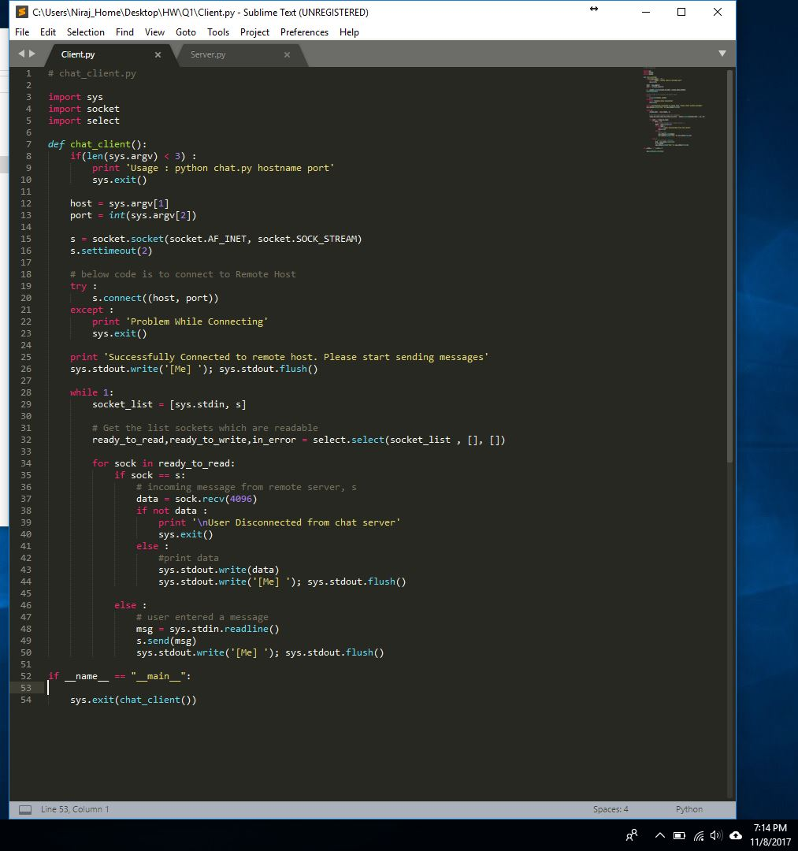

Source Code:

# chat_client.py

import sys

import socket

import select

def chat_client():

if(len(sys.argv) < 3) :

print 'Usage : python chat.py hostname port'

sys.exit()

host = sys.argv[1]

port = int(sys.argv[2])

s = socket.socket(socket.AF_INET, socket.SOCK_STREAM)

s.settimeout(2)

# below code is to connect to Remote Host

try :

s.connect((host, port))

except :

print 'Problem While Connecting'

sys.exit()

print 'Successfully Connected to remote host. Please start sending messages'

sys.stdout.write('[Me] '); sys.stdout.flush()

while 1:

socket_list = [sys.stdin, s]

# Get the list sockets which are readable

ready_to_read,ready_to_write,in_error = select.select(socket_list , [], [])

for sock in ready_to_read:

if sock == s:

# incoming message from remote server, s

data = sock.recv(4096)

if not data :

print '\nUser Disconnected from chat server'

sys.exit()

else :

#print data

sys.stdout.write(data)

sys.stdout.write('[Me] '); sys.stdout.flush()

else :

# user entered a message

msg = sys.stdin.readline()

s.send(msg)

sys.stdout.write('[Me] '); sys.stdout.flush()

if __name__ == "__main__":

sys.exit(chat_client())

Output:

