NAME : NIRAJ THANKI SID : 19376 CLASS: CS531

CHAT.py

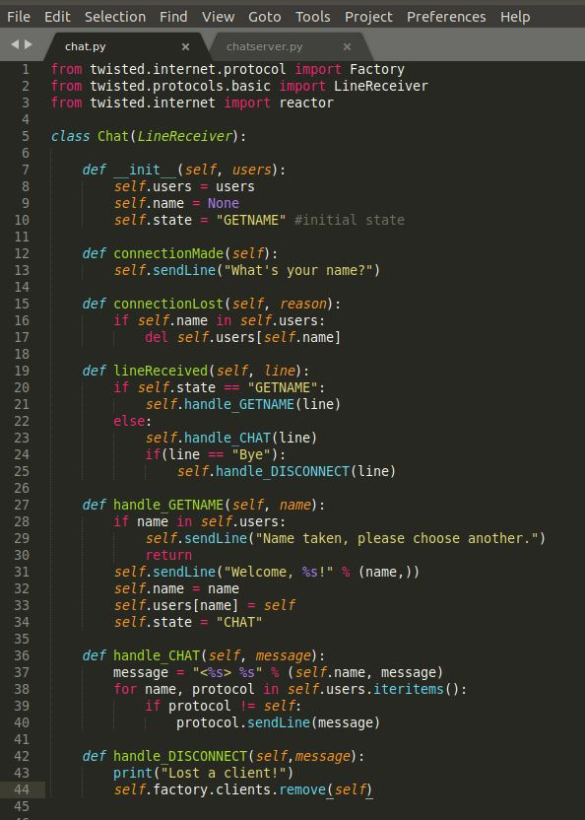

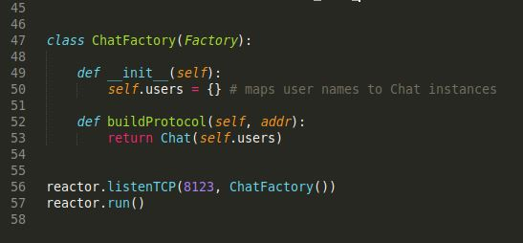

SOURCE CODE:

from twisted.internet.protocol import Factory

from twisted.protocols.basic import LineReceiver

from twisted.internet import reactor

class Chat(LineReceiver):

def __init__(self, users):

self.users = users

self.name = None

self.state = "GETNAME" #initial state

def connectionMade(self):

self.sendLine("What's your name?")

def connectionLost(self, reason):

if self.name in self.users:

del self.users[self.name]

def lineReceived(self, line):

if self.state == "GETNAME":

self.handle_GETNAME(line)

else:

self.handle_CHAT(line)

if(line == "Bye"):

self.handle_DISCONNECT(line)

def handle_GETNAME(self, name):

if name in self.users:

self.sendLine("Name taken, please choose another.")

return

self.sendLine("Welcome, %s!" % (name,))

self.name = name

self.users[name] = self

self.state = "CHAT"

def handle_CHAT(self, message):

message = "<%s> %s" % (self.name, message)

for name, protocol in self.users.iteritems():

if protocol != self:

protocol.sendLine(message)

def handle_DISCONNECT(self,message):

print("Lost a client!")

self.factory.clients.remove(self)

class ChatFactory(Factory):

def __init__(self):

self.users = {} # maps user names to Chat instances

def buildProtocol(self, addr):

return Chat(self.users)

reactor.listenTCP(8123, ChatFactory())

reactor.run()

CHATSERVER.py

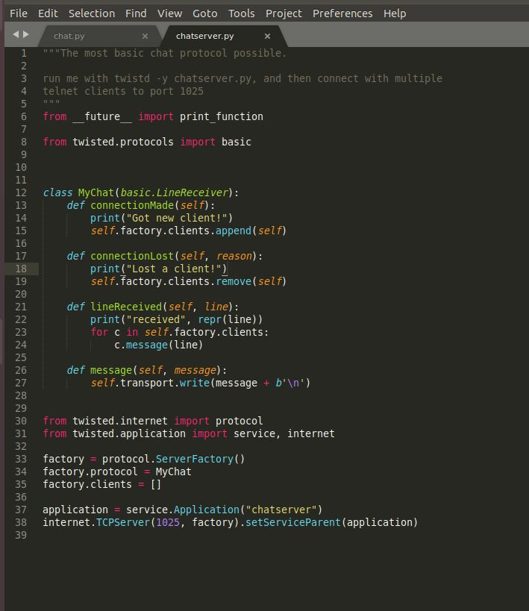

Source Code:

"""The most basic chat protocol possible.

run me with twistd -y chatserver.py, and then connect with multiple

telnet clients to port 1025

"""

from __future__ import print_function

from twisted.protocols import basic

class MyChat(basic.LineReceiver):

def connectionMade(self):

print("Got new client!")

self.factory.clients.append(self)

def connectionLost(self, reason):

print("Lost a client!")

self.factory.clients.remove(self)

def lineReceived(self, line):

print("received", repr(line))

for c in self.factory.clients:

c.message(line)

def message(self, message):

self.transport.write(message + b'\n')

from twisted.internet import protocol

from twisted.application import service, internet

factory = protocol.ServerFactory()

factory.protocol = MyChat

factory.clients = []

application = service.Application("chatserver")

internet.TCPServer(1025, factory).setServiceParent(application)

Output:

