**NAME: NIRAJ THANKI**

**STUDENT ID: 19376**

**CLASS : CS531**

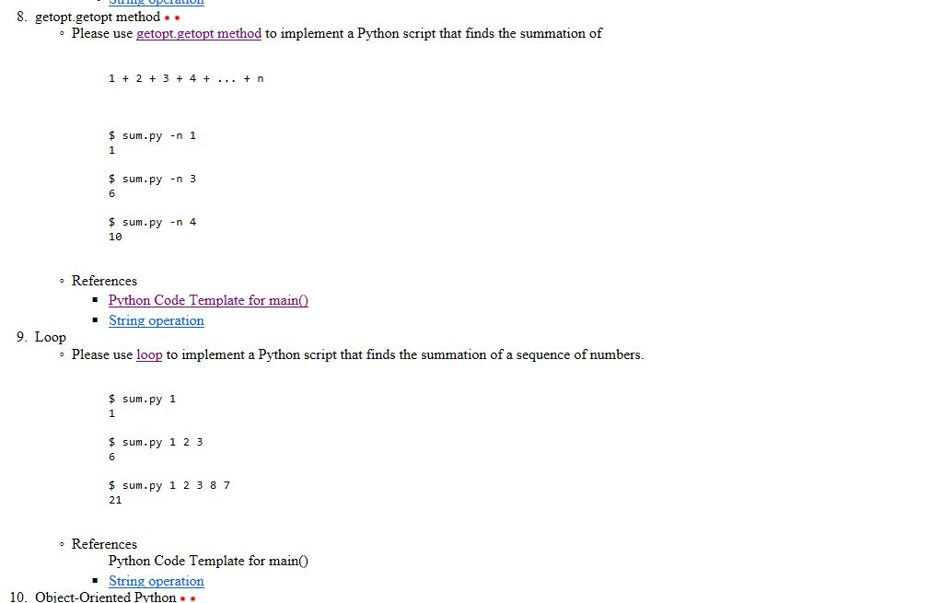

**Q-8**

**Source Code:**

#!/usr/bin/python

# Add1.py

import sys, getopt

def usage():

print ('Usage: hw2_q8.py -h')

print ('Usage: hw2_q8.py -n <number>')

print ('Usage: hw2_q8.py --num=<number>')

def main(argv):

num = ''

try:

opts, args = getopt.getopt(argv,"hn:",["num="])

except getopt.GetoptError:

usage()

sys.exit(2)

for opt, arg in opts:

if opt == '-h':

usage()

sys.exit()

elif opt in ("-n", "--num"):

num = arg

print ('Number is ',int(num))

if(int(num) <= 0):

print("Enter positive Number")

else:

pass

sum1 = 0

while(int(num) > 0):

sum1 += int(num)

num = int(num) - 1

print("The sum is",sum1)

if __name__ == "__main__":

main(sys.argv[1:])

ScreenShot :

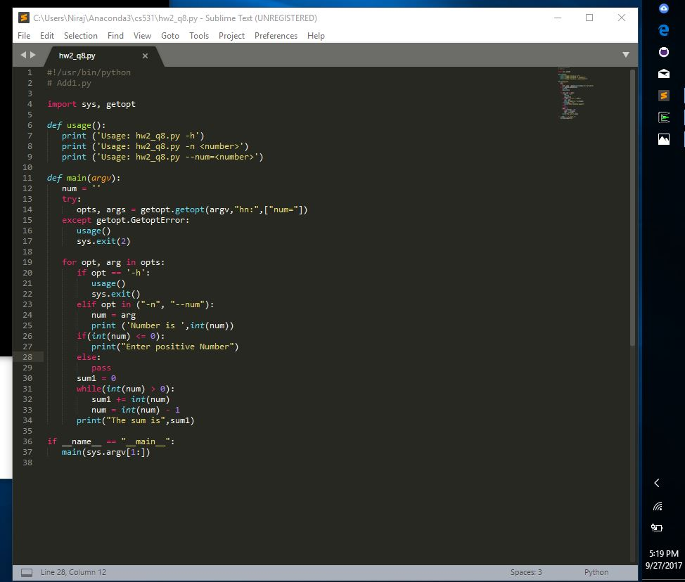

OutPut:

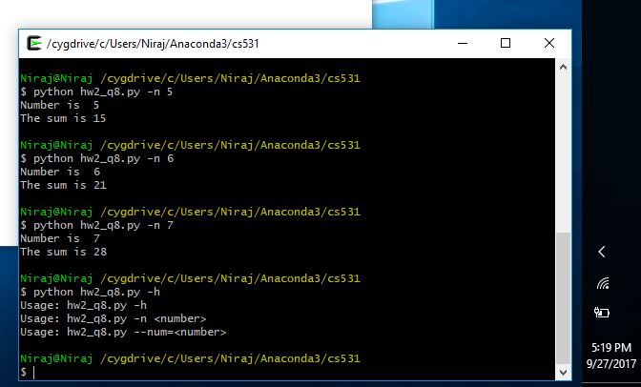

**Q-9**

**Source Code:**

#!/usr/bin/python

# Add1.py

import sys, getopt

def usage():

print ('Usage: hw2_q9.py -h')

print ('Usage: hw2_q9.py -n <number>')

print ('Usage: hw2_q9.py --num=<number>')

def main(argv):

num = ''

try:

opts, args = getopt.getopt(argv,"hn:",["num="])

except getopt.GetoptError:

usage()

sys.exit(2)

for opt, arg in opts:

if opt == '-h':

inputArgs = sys.argv[2:]

b = sum(int(i) for i in inputArgs)

print(b)

sys.exit()

elif opt in ("-n", "--num"):

num = arg

print ('Number is ',int(num))

if(int(num) <= 0):

print("Enter positive Number")

else:

pass

sum1 = 0

while(int(num) > 0):

sum1 += int(num)

num = int(num) - 1

print("The sum is",sum1)

if __name__ == "__main__":

main(sys.argv[1:])

ScreenShot:

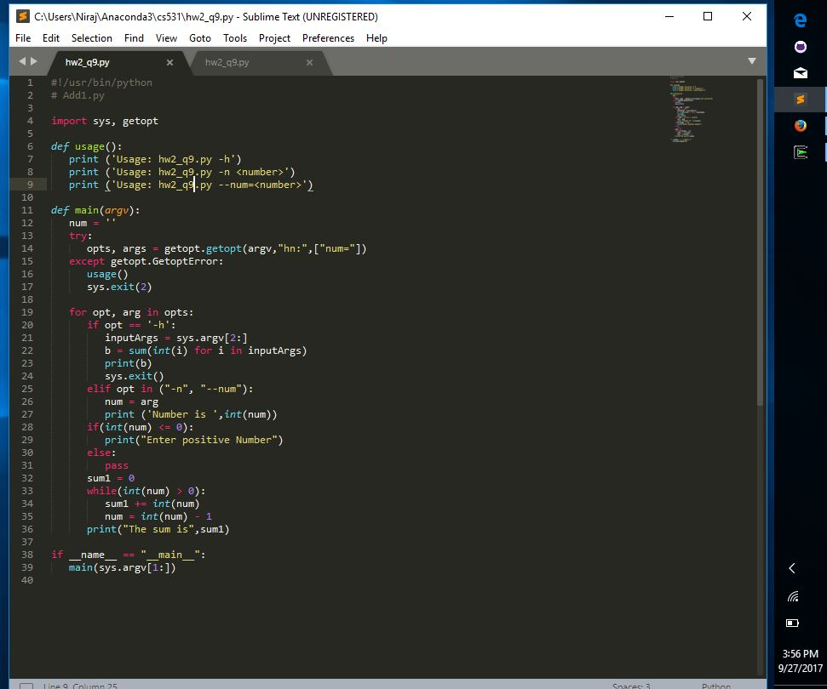

OutPut:

