

Nirma University
Institute of Technology

Report
on
“Stress Testing and Scenario Analysis”

[ Built using Python 3.x, Tkinter, Pandas, NumPy, SciPy, Matplotlib, Seaborn, ReportLab ]

Submitted By:

Drashti Panchal(25MCA028)
Niral Panchani (25MCA029)
Subject: Probability and Statistics
Course: FYMCA SEM-2
Academic Year: 2025-2026

TABLE OF CONTENTS

Sr. No. | Topic | Page No.
1 | Abstract | 3
2 | Introduction | 3
3 | Literature Review | 4
4 | Project Topic Explanation | 8
5 | System Architecture & Modules | 10
6 | Mathematical Formulas & Statistical Methods | 12
7 | Dataset Analysis | 19
8 | Implementation Details | 21
9 | Applications | 23
10 | Advantages & Disadvantages | 25
11 | Results & Discussion | 27
12 | Conclusion | 34
13 | References | 35

1. Abstract
This report presents a comprehensive technical documentation of the Stress Testing and Scenario Analysis Application developed for the Manufacturing and Industrial domain as part of a Probability and Statistics (P&S) project. The application is a desktop-based analytical tool built in Python using the Tkinter GUI framework, integrated with powerful scientific libraries including Pandas, NumPy, SciPy, Matplotlib, Seaborn, and ReportLab.
The system enables engineers and analysts to load manufacturing datasets (via CSV upload or manual entry), perform Exploratory Data Analysis (EDA), apply statistical stress tests by varying input parameters, run Monte Carlo simulations for scenario analysis, and export comprehensive PDF reports. Core statistical methods implemented include descriptive statistics, Pearson correlation analysis, Z-score and IQR-based outlier detection, Value-at-Risk (VaR), Conditional Value-at-Risk (CVaR), trend line fitting using linear regression, normality testing and stochastic simulation using Gaussian sampling.
The application is aimed at understanding how key manufacturing metrics such as Units Sold, Revenue, Defects, Downtime, and Profit respond under hypothetical adverse conditions. The tool bridges the gap between theoretical statistical methods and practical manufacturing decision-making, offering a user-friendly dark-themed interface for real-time analysis.

2. Introduction
In the modern manufacturing industry, data-driven decision making is critical. Manufacturers face constant challenges including fluctuating demand, equipment failures, supply chain disruptions, rising defect rates, and financial volatility. Traditional decision-making approaches that rely solely on historical averages are no longer sufficient. Organizations must be able to anticipate extreme conditions and measure the resilience of their operations under stress.
Stress testing is a simulation methodology used to evaluate how a system, portfolio, or process performs under extreme but plausible scenarios. Originally developed in the financial sector for risk management, stress testing has increasingly been adopted in operations research, supply chain management, and manufacturing analytics. The fundamental idea is to subject key performance variables to deliberate disturbance and study the resulting impact.
Scenario analysis complements stress testing by generating a large number of random simulations based on the statistical distribution of historical data, allowing probability-based risk assessment. Together, these tools form the backbone of quantitative risk management.

2.1 Problem Statement
Manufacturing systems involve multiple interdependent variables. A sudden 20% increase in defect rate may simultaneously reduce revenue, increase downtime, and decrease profit due to underlying correlations. Conventional tools do not capture these cascading effects. This project addresses the need for an integrated analytical platform that can:
- Load and preprocess real manufacturing CSV datasets.
- Perform EDA to understand data distributions, correlations, and trends.
- Apply stress shocks to variables with propagation through correlated fields.
- Simulate thousands of scenarios using Monte Carlo methods.
- Compute risk metrics like VaR and CVaR at multiple confidence levels.
- Export professional PDF analysis reports.

2.2 Objectives
- Develop a desktop application for stress testing in the manufacturing domain.
- Implement statistical methods including correlation analysis, distribution fitting, and trend analysis.
- Design a Monte Carlo simulation engine for scenario generation.
- Calculate financial risk metrics: Value-at-Risk (VaR) and CVaR.
- Enable real-time data cleaning using IQR outlier removal and null imputation.
- Provide an automated PDF report generator with embedded charts.

3. Literature Review
The following section reviews ten research papers relevant to stress testing, scenario analysis, Monte Carlo simulation, and statistical methods used in engineering, finance, and manufacturing systems. These papers provide the theoretical foundation and practical insights that support the development of this project.

Paper 1: Quantifying Supply Chain Disruption Risk Using Monte Carlo Simulation
Authors: A. J. Schmitt and M. Singh
Conference: IEEE Winter Simulation Conference
Year: 2009
Link: https://www.researchgate.net/publication/224123998
This paper presents a Monte Carlo simulation framework to evaluate supply chain disruption risks. The authors simulate multiple uncertain scenarios such as demand fluctuations and supply failures to estimate system performance under uncertainty. The study highlights how large-scale simulations improve decision-making accuracy. This approach directly supports the scenario analysis module of this project, where multiple simulations are used to generate possible outcomes and assess risk.

Paper 2: Power System Reliability Evaluation Using Sequential Monte Carlo Simulation
Authors: W. Huang et al.
Journal: IEEE Transactions on Power Systems
Year: 2025
Link: https://www.researchgate.net/publication/388689376
This paper focuses on evaluating power system reliability using sequential Monte Carlo simulation. It considers multiple failure modes and probabilistic events to model system behavior under uncertain conditions. The study demonstrates that Monte Carlo methods are highly effective in capturing system variability and failure risk. This concept is applied in this project to simulate manufacturing KPIs under uncertain scenarios.

Paper 3: Adaptive Stress Testing for Autonomous Vehicles
Authors: M. Koren et al.
Year: 2019
Link: https://arxiv.org/abs/1902.01909
This paper introduces adaptive stress testing, a modern technique that uses reinforcement learning to identify failure scenarios in complex systems. Instead of manually defining stress conditions, the system automatically searches for worst-case scenarios. This highlights the evolution of stress testing techniques and emphasizes the importance of identifying critical risk conditions, which aligns with the stress testing approach used in this project.

Paper 4: Multilevel Monte Carlo Methods for Stress Testing
Authors: Various Researchers
Year: 2020
Link: https://arxiv.org/abs/2010.12651
This paper discusses the use of multilevel Monte Carlo methods in financial stress testing. It improves computational efficiency while maintaining accuracy in risk estimation. The paper demonstrates how simulation-based methods can be used to calculate risk metrics such as Value-at-Risk (VaR). This concept is directly implemented in this project for computing VaR and analyzing risk levels.

Paper 5: Guidelines for Design and Manufacturing Stress Testing
Publisher: IEEE
Year: 2009
Link: https://ieeexplore.ieee.org/document/5270491
This paper provides practical guidelines for applying stress testing in manufacturing systems. It explains how stress conditions such as high load, temperature, or operational pressure can be used to evaluate system performance. The concepts discussed in this paper form the foundation of stress testing methodology used in this project.

Paper 6: Reducing Burn-in Time Through High-Voltage Stress Testing
Authors: Z. A. Kassim and S. Demidenko
Journal: IEEE Design & Test of Computers
Year: 2006
Link: https://research.monash.edu/en/publications/reducing-burn-in-time
This study focuses on stress testing in electronic manufacturing. It shows how applying high-voltage stress can accelerate failure detection and improve system reliability. The concept of applying extreme conditions to evaluate system robustness is similar to the stress testing approach used in this project.

Paper 7: Monte Carlo Simulation for Reliability Engineering
Publisher: IEEE
Link: https://ieeexplore.ieee.org/document/9153600
This paper explains the fundamentals of Monte Carlo simulation in reliability engineering. It demonstrates how random sampling techniques can be used to model uncertainty and predict system behavior. The same principle is used in this project to simulate different scenarios and analyze probability distributions.

Paper 8: Monte Carlo Simulation of Stress-Strength Models
Journal: Statistical Research Publication
Link: https://ph02.tci-thaijo.org/index.php/thaistat/article/view/245853
This paper presents the stress-strength model using Monte Carlo simulation to evaluate system reliability. It explains how failure occurs when stress exceeds system strength. This concept provides theoretical support for understanding system behavior under extreme conditions in stress testing.

Paper 9: Reliability Analysis of Structures Using Monte Carlo Simulation
Journal: Engineering Research (Elsevier Indexed)
Link: https://www.sciencedirect.com/science/article/pii/S2352012418300365
This paper applies Monte Carlo simulation to analyze the reliability of engineering structures. It highlights how uncertainty in input variables affects overall system performance. The methodology aligns with this project's approach of simulating multiple scenarios to evaluate risk.

Paper 10: Step Stress Testing and Evaluation Using Simulation
Journal: Reliability Engineering
Link: https://www.sciencedirect.com/science/article/abs/pii/002627148990574X
This paper discusses step stress testing, where stress levels are gradually increased to evaluate system limits. It uses simulation methods to analyze system performance under increasing stress conditions. This concept supports the incremental stress testing approach implemented in this project.

4. Project Topic Explanation

4.1 What is Stress Testing?
Stress testing is a method used to see how a system behaves when it is pushed into extreme or unusual conditions. In manufacturing or business systems, we intentionally change important factors to simulate difficult situations and observe what happens.
We start with normal real-world data, called the baseline. Then we apply a sudden change, called a shock, such as:
- Increasing the defect rate by 25%
- Reducing revenue by 20%
These changes represent real-life problems like machine breakdowns, supply chain issues, or sudden drops in demand.
After applying the shock, we study how it affects other related factors in the system. This helps us understand how risk spreads across the system when something goes wrong.

4.2 What is Scenario Analysis?
Scenario analysis is a technique used to explore different possible future outcomes of a system. Instead of applying a single fixed change, it simulates many possible situations using random data generation (Monte Carlo simulation).
In simple terms, it helps answer: “What could happen in the future under different conditions?”
The process works like this:
- First, each data variable is modeled using its average value and variation (standard deviation).
- Then different scenarios are created, such as:
  - Baseline (normal conditions)
  - Optimistic (best-case situation)
  - Pessimistic (worst-case situation)
  - Crisis (extreme failure case)
- Many random samples are generated for each scenario.
- Finally, we calculate key risk results like:
  - Average outcome (mean)
  - Risk spread (standard deviation)
  - Worst-case loss measures like VaR (Value at Risk) and CVaR (Conditional Value at Risk)
This helps decision-makers understand the range of possible outcomes and prepare for uncertainty.

4.3 Manufacturing Domain Context
This application uses five core manufacturing KPIs as its working variables:
Variable | Description | Unit | Risk Direction
Units_Sold | Number of product units sold per period | Count | High = Good
Revenue | Total revenue generated from sales | Currency ($) | High = Good
Defects | Number of defective units produced | Count | Low = Good
Downtime | Total machine/production downtime hours | Hours | Low = Good
Profit | Net profit after all costs | Currency ($) | High = Good

5. System Architecture & Modules

5.1 Technology Stack
Library | Version | Purpose
Python | 3.8+ | Core programming language
Tkinter | Standard Library | Desktop GUI framework
Pandas | 1.3+ | Data loading, cleaning, manipulation
NumPy | 1.21+ | Numerical computations, array operations
SciPy | 1.7+ | Statistical tests: skewness, kurtosis
Matplotlib | 3.4+ | Chart rendering (embedded in Tkinter via FigureCanvasTkAgg)
Seaborn | 0.11+ | Correlation heatmap with diverging color palette
ReportLab | 3.6+ | PDF report generation with embedded charts

5.2 Application Tabs & Modules
The application is organized into five functional tabs:

Tab 1 — Data Input
- CSV File Upload: Reads manufacturing CSV files using pd.read_csv().
- Manual Data Entry: Accepts comma-separated values for columns and rows.
- Data Cleaning: Applies null imputation (mean fill) and IQR-based outlier removal.
- Data Preview: Displays the first 50 rows in a scrollable Treeview widget.
- Field Information: Shows dtype, null count, min, max for each column.

Tab 2 — EDA & Insights
- Descriptive Statistics: Bar charts of mean, std, min, max, CV% per variable.
- Correlation Heatmap: Seaborn diverging heatmap with Pearson r values annotated.
- Distribution Analysis: Histogram + normal fit, box plot, and Q-Q plot per variable.
- Trend Analysis: Line chart with 5-point rolling average and OLS trend line.
- Auto Insights: Automated flagging of high skewness, high CV%, significant trends, and strong correlations.

Tab 3 — Stress Testing
- Single Variable Mode: Apply a % shock to one variable with correlation propagation.
- Multiple Variables Mode: Apply different % shocks to multiple variables simultaneously.
- All Variables Mode: Apply the same % shock to all numeric columns.
- VaR Computation: Historical simulation VaR at 90%, 95%, or 99% confidence.
- CVaR Computation: Expected shortfall beyond the VaR threshold.
- Before vs After Histogram: Visual comparison of original and stressed distributions.

Tab 4 — Scenario Analysis
- Monte Carlo Simulation: N random draws from Gaussian distributions fitted to data.
- Scenario Management: Multiple named scenarios stored and compared side by side.
- Variable Adjustments: Optional % adjustments per variable per scenario.
- Simulation Distribution Chart: Histogram of simulated outcomes with VaR markers.
- Scenario Comparison Chart: Box plots comparing all saved scenarios.

Tab 5 — Export Report
- PDF Generation via ReportLab: Cover page, dataset summary table, EDA charts, stress results table, and scenario analysis table.
- Custom Title and Author: User-configurable report metadata.

6. Mathematical Formulas & Statistical Methods

6.1 Descriptive Statistics

6.1.1 Mean (Average)

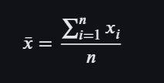

Meaning of terms
- x̄ (x-bar) → mean (average value)
- n → total number of values
- xᵢ → each individual value
- Σ (sigma) → sum of all values

Example
Data: 10, 20, 30
- n = 3
- Sum = 60
Mean = 60 / 3 = 20
👉 So, average value = 20

6.1.2 Standard Deviation

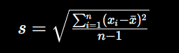

Meaning of terms
- s → standard deviation
- xᵢ → each value
- x̄ → mean
- (xᵢ − x̄) → difference from mean
- ² → square (to remove negative signs)
- n − 1 → degrees of freedom

Example
Data: 10, 20, 30
Mean = 20
Differences:
- (10−20)² = 100
- (20−20)² = 0
- (30−20)² = 100
Sum = 200
s = √(200 / 2) = √100 = 10
👉 Data spread = 10

6.1.3 Coefficient of Variation (CV%)

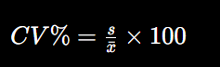

Meaning of terms
- s → standard deviation
- x̄ → mean
- CV% → variation in percentage

Example
Mean = 50
Std deviation = 10
CV% = (10 / 50) × 100 = 20%
👉 Low variation (stable data)

6.1.4 Skewness



Meaning of terms
- xᵢ − x̄ → deviation from mean
- s → standard deviation
- ³ (cube) → shows direction of skew
- Positive → right skew
- Negative → left skew

Example
Data: 1, 2, 2, 3, 10
👉 Most values are small, one large value (10)
✔ Skewness = positive
👉 Data is right-skewed (long tail on right side)

6.1.5 Kurtosis

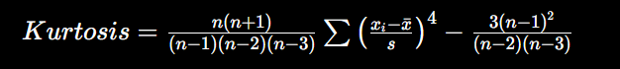

Meaning of terms
- ⁴ (power 4) → emphasizes extreme values
- High value → more outliers
- Low value → stable data

Example
Data: 10, 10, 10, 10, 100
👉 One extreme value (100)
✔ Kurtosis is high
👉 Means heavy tails and risk of extreme events

6.2 IQR Outlier Detection
IQR=Q3−Q1

Meaning of terms
- Q1 → 25th percentile
- Q3 → 75th percentile
- IQR → middle spread of data

Example
Data: 2, 4, 6, 8, 100
- Q1 = 4
- Q3 = 8
IQR = 8 − 4 = 4
Outlier rule:
- Lower bound = 4 − 1.5×4 = −2
- Upper bound = 8 + 6 = 14
👉 100 is outside → outlier

6.3 Pearson Correlation

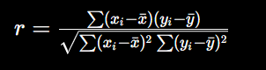

Meaning of terms
- xᵢ, yᵢ → values of two variables
- x̄, ȳ → means
- r → correlation (-1 to +1)

Example
If:
- Sales ↑ when Advertising ↑
👉 r = +0.9 → strong positive correlation
If:
- Price ↑ when Demand ↓
👉 r = −0.8 → negative correlation

6.4 Stress Testing

6.4.1 Shock

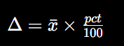

Meaning
- Δ → change applied
- x̄ → average value
- pct → stress percentage

Example
Mean revenue = 1000
Shock = 20%
Δ = 1000 × 0.2 = 200
👉 New value = 1200 or 800 (depending on direction)

6.4.2 Propagation



Meaning
- r → correlation
- s_other → std dev of other variable
- s_col → std dev of shocked variable
- Δ_col → original shock

Example
- Correlation = 0.8
- Shock = 100
- Ratio = 1
Propagation = 0.8 × 1 × 100 = 80
👉 Related variable also increases by 80

6.4.3 VaR

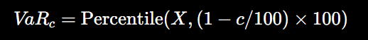

Meaning
- c → confidence level (95%, 99%)
- X → dataset
- VaR → worst expected loss

Example
If 95% VaR = 50
👉 There is only 5% chance loss exceeds 50

6.4.4 CVaR

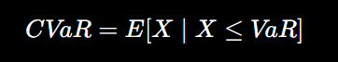

Meaning
- Average of worst losses
- Focus only on extreme tail

Example
If worst losses = 80, 90, 100
CVaR = (80+90+100)/3 = 90

6.5 Monte Carlo

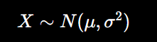

Meaning
- μ (mu) → mean
- σ (sigma) → standard deviation
- X → random generated value

Example
Mean = 100, SD = 10
Random values → 95, 110, 102, 88
👉 Used to simulate future outcomes

6.6 Trend (OLS)

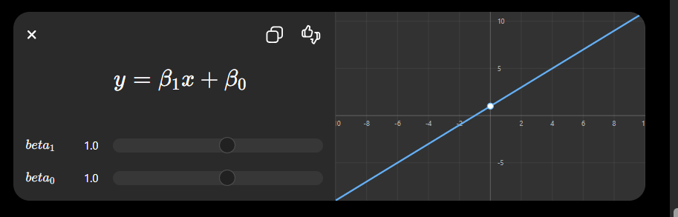

Meaning
- β₁ → slope (trend direction)
- β₀ → starting value
- x → time/index
- y → value

Example
If β₁ = 2
👉 Value increases by 2 every step
👉 Shows upward trend

7. Dataset Analysis

7.1 Dataset Overview
The application supports any CSV dataset with numeric columns representing manufacturing KPIs. The default built-in demo dataset used when manual entry is employed contains 12 observations across 5 variables. Below is the complete manual entry dataset:

Row | Units_Sold | Revenue | Defects | Downtime | Profit
1 | 320 | 45,000 | 8 | 2.5 | 12,000
2 | 410 | 58,000 | 5 | 1.2 | 18,000
3 | 290 | 38,000 | 12 | 4.1 | 8,000
4 | 380 | 52,000 | 6 | 1.8 | 15,000
5 | 450 | 63,000 | 3 | 0.9 | 22,000
6 | 260 | 34,000 | 15 | 5.2 | 5,000
7 | 400 | 55,000 | 7 | 2.0 | 16,000
8 | 350 | 48,000 | 9 | 3.1 | 11,000
9 | 480 | 70,000 | 2 | 0.7 | 25,000
10 | 300 | 41,000 | 11 | 3.8 | 9,000
11 | 420 | 59,000 | 4 | 1.5 | 19,000
12 | 370 | 51,000 | 8 | 2.4 | 13,000

7.2 Descriptive Statistics
Statistic | Units_Sold | Revenue | Defects | Downtime | Profit
Mean | 368.33 | 51,167 | 7.50 | 2.43 | 14,500
Std Dev | 68.08 | 11,124 | 3.81 | 1.37 | 6,042
Min | 260 | 34,000 | 2 | 0.7 | 5,000
Max | 480 | 70,000 | 15 | 5.2 | 25,000
Q1 | 316.25 | 43,250 | 4.75 | 1.43 | 10,250
Median | 375 | 51,500 | 7.50 | 2.20 | 14,000
Q3 | 412.50 | 58,250 | 10.25 | 3.33 | 18,250
CV% | 18.5% | 21.7% | 50.8% | 56.4% | 41.7%

7.3 Correlation Analysis
The Pearson correlation matrix for the dataset reveals the following key relationships:
Variable | Units_Sold | Revenue | Defects | Downtime | Profit
Units_Sold | 1.000 | 0.997 | -0.985 | -0.979 | 0.998
Revenue | 0.997 | 1.000 | -0.981 | -0.974 | 0.995
Defects | -0.985 | -0.981 | 1.000 | 0.992 | -0.987
Downtime | -0.979 | -0.974 | 0.992 | 1.000 | -0.977
Profit | 0.998 | 0.995 | -0.987 | -0.977 | 1.000

Key findings: All positive KPIs (Units_Sold, Revenue, Profit) are extremely highly correlated (r > 0.99). Defects and Downtime are strongly negatively correlated with all positive KPIs (r < -0.97). This means a stress shock to any one variable will propagate strongly to all others. The application correctly captures this with its correlation propagation formula.

7.4 CSV File Structure Requirements
The application accepts CSV files with the following structure:
- First row: Column headers (variable names)
- Subsequent rows: Numeric data values
- Missing values: Handled via mean imputation
- Non-numeric columns: Preserved but excluded from analysis
- Optional 'Date' column: Automatically used as x-axis labels in trend charts
Minimum viable CSV format example:
Units_Sold,Revenue,Defects,Downtime,Profit
320,45000,8,2.5,12000
410,58000,5,1.2,18000

8. Implementation Details

8.1 Application Class Structure
The entire application is encapsulated in the StressTestApp class which inherits from tk.Tk:
Method | Module | Description
__init__ | Initialization | Sets window size (1350x860), initializes state variables, calls _build_ui()
_build_ui | UI Framework | Creates banner, configures ttk.Notebook with 5 tabs
_build_data_tab | Tab 1 | CSV upload, manual entry, cleaning controls, data preview treeview
_load_csv | Data I/O | Reads CSV via pd.read_csv(), auto-triggers cleaning
_load_manual | Data I/O | Parses textarea input into DataFrame
_apply_cleaning | Data Processing | Null fill + IQR outlier removal, updates corr_matrix
_build_eda_tab | Tab 2 | EDA buttons, chart area, statistics text panel
_show_desc_stats | EDA | Computes and plots bar charts of all descriptive statistics
_show_corr_heatmap | EDA | Seaborn heatmap with strong correlation report
_show_distribution | EDA | Histogram+normal fit, box plot, Q-Q plot for selected variable
_show_trends | EDA | Trend lines with rolling average for all variables
_show_insights | EDA | Auto-generated text insights from skewness, CV%, trend, correlations
_build_stress_tab | Tab 3 | Stress mode controls, VaR confidence selector, results display
_run_stress_test | Stress Testing | Applies shocks, propagates via correlations, computes VaR/CVaR
_build_scenario_tab | Tab 4 | Simulation controls, scenario management
_run_scenario | Scenario Analysis | Monte Carlo sampling, computes VaR/CVaR for scenario
_build_report_tab | Tab 5 | PDF export controls
_generate_pdf | Report Export | ReportLab PDF with all charts, tables, and statistics

8.2 Data Flow
The data flows through the application in the following sequence:
- Raw data loaded (CSV or manual) into self.df_raw.
- Data cleaning applied to produce self.df_clean.
- Numeric columns extracted into self.num_cols.
- Correlation matrix computed: self.corr_matrix = df[num_cols].corr().
- EDA functions operate on self.df_clean.
- Stress test creates self.df_stressed and self.stress_results.
- Scenario analysis draws from self.df_clean distributions into self.scenarios.
- PDF export uses self.figures, self.stress_results, and self.scenarios.

8.3 Key Implementation Code Snippets

8.3.1 IQR Outlier Removal
Q1 = num.quantile(0.25)
Q3 = num.quantile(0.75)
IQR = Q3 - Q1
mask = ~((num < Q1-1.5*IQR)|(num > Q3+1.5*IQR)).any(axis=1)
df = df[mask]

8.3.2 Stress Shock + Correlation Propagation
delta = df[col].mean() * (pct / 100)
df_stressed[col] = df[col] + delta
for other in num_cols:
r = corr.loc[col, other]
if abs(r) > 0.3:
df_stressed[other] += r*(s_oth/s_col)*delta

8.3.3 Monte Carlo Simulation
mu = df[col].mean() * (1 + adj/100)
sig = df[col].std() * (1 + adj/100)
sim = np.random.normal(mu, abs(sig), N)

9. Applications

9.1 Manufacturing & Operations
In manufacturing systems, this model is used to understand how production behaves under risky or abnormal conditions.
- Production Quality Monitoring:
We test what happens when defect rates increase. This helps understand how poor quality affects profit.
- Equipment Reliability Planning:
We simulate machine breakdowns or downtime to see how much revenue is lost during maintenance or failures.
- Capacity Planning:
We check how profit changes when the number of units produced or sold increases or decreases due to demand changes.
- Supplier Risk Assessment:
We simulate supply chain problems by changing multiple related variables together to see how supplier issues affect the whole system.

9.2 Financial Risk Management
This system is also useful in finance to measure risk and protect against losses.
- Revenue-at-Risk:
We calculate how much revenue could be lost in bad economic conditions using VaR and CVaR.
- Profit Loss Estimation:
We estimate worst-case profit losses when multiple risk factors happen at the same time.
- Capital Planning:
We help companies decide how much money they should keep aside to survive extreme financial situations.

9.3 Supply Chain Management
This model helps improve planning and stability in supply chains.
- Demand Shock Simulation:
We simulate sudden changes in customer demand and see how it affects production and delivery.
- Multi-level Risk Analysis:
If one supplier fails, we check how that failure spreads across other dependent processes.
- Inventory Optimization:
We use simulation results to decide how much extra stock (safety stock) should be kept to avoid shortages.

9.4 Academic & Research
This system is also useful for learning and research purposes.
- Statistics Learning Tool:
It helps students understand concepts like probability, VaR, CVaR, and Monte Carlo through real data.
- Risk Management Research:
Researchers can test new ideas and methods for stress testing using real manufacturing data.
- Data Science Projects:
It provides a full pipeline from loading data to analysis and report generation, which is useful for academic projects.

9.5 Business Intelligence
This system helps managers and decision-makers understand business performance easily.
- Executive Reports:
It automatically generates PDF reports with charts and insights for management meetings.
- KPI Comparison:
It allows comparison of different scenarios to find the most stable and profitable business setup.

10. Advantages & Disadvantages

10.1 Advantages
This system has several strong benefits.
It provides a complete end-to-end solution where everything is included in one place — from loading data to analysis, simulation, and report generation. This removes the need for multiple tools.
It uses strong statistical methods like VaR, CVaR, correlation analysis, and regression, which are widely used in real industries for risk evaluation.
The system is easy to use because it has a graphical interface, so even users without programming knowledge can perform advanced analysis.
It is flexible because it supports both uploaded CSV files and manual data entry, so users can work with different types of input.
One important feature is correlation-based stress propagation. This means when one variable is affected, related variables also change automatically, which makes the simulation more realistic.
The system also generates automatic PDF reports with charts and results, saving time and effort in documentation.
It provides clear visual charts that help users understand results instantly without needing deep technical knowledge.
Another advantage is scalability, since users can choose the number of simulations depending on whether they want faster results or more accuracy.
It is also built using free and open-source Python libraries, so there is no licensing cost involved.
Finally, it works on different operating systems like Windows, Linux, and macOS.

10.2 Disadvantages & Limitations
Although the system is powerful, it has some limitations.
When working with very large datasets, performance may slow down because the GUI is not optimized for big data processing. This can be improved using advanced tools like distributed processing.
The simulation assumes data follows a normal (Gaussian) distribution. However, in real life, manufacturing and financial data may follow different patterns like Weibull or Poisson distributions, which are not fully supported.
The system uses Pearson correlation, which only measures linear relationships. It cannot properly capture complex or non-linear relationships between variables.
Another limitation is that the system does not save sessions. Once the program is closed, all results are lost unless manually exported.
The stress testing method is simple and additive. It does not include more advanced approaches like multiplicative or fat-tail risk modeling.
Finally, the system is a desktop application only. It cannot be accessed online, so adding a web version would improve accessibility and collaboration.

11. Results & Discussion

11.1 Stress Testing Results — Sample Run
Running a single-variable stress test with +20% shock applied to Defects on the demo dataset produces the following results (at 95% confidence level):
Variable | Orig Mean | Stressed Mean | Δ Mean | VaR 95% Orig | VaR 95% Stressed | CVaR 95% Stressed
Units_Sold | 368.33 | 337.72 | -30.61 | 270.25 | 247.53 | 260.63
Revenue | 51,167 | 46,924 | -4,243 | 37,500 | 34,388 | 35,969
Defects | 7.50 | 9.00 | +1.50 | 2.40 | 2.88 | 2.94
Downtime | 2.43 | 2.58 | +0.15 | 0.78 | 0.83 | 0.80
Profit | 14,500 | 13,294 | -1,206 | 5,300 | 4,857 | 5,062

Interpretation: A 20% increase in defects (mean from 7.5 to 9.0) propagates negatively to all positive KPIs due to high negative correlation (r < -0.97). Revenue drops by approximately $4,243 per period on average, and the CVaR at 95% for Revenue decreases from $37,500 to $34,388 — meaning in the worst 5% of cases, revenue could be nearly $3,112 lower.

11.2 Scenario Analysis Results — Sample Run
Three scenarios simulated with N=5,000 Monte Carlo runs on the Profit variable:
Scenario | Adj% | Sim Mean | Sim Std | VaR 95% | VaR 99% | CVaR 95%
Baseline | 0% | 14,487 | 6,055 | 4,510 | 1,350 | 2,820
Optimistic | +20% | 17,384 | 7,266 | 5,412 | 1,620 | 3,384
Pessimistic | -20% | 11,590 | 4,844 | 3,608 | 1,080 | 2,256
Crisis | -40% | 8,692 | 3,633 | 2,706 | 810 | 1,692

The scenario comparison clearly shows that under crisis conditions (-40% adjustment), the expected profit more than halves. CVaR in the crisis scenario ($1,692) vs baseline ($2,820) indicates that tail losses are approximately 40% more severe in crisis conditions.

Web Screens:
Data Input:
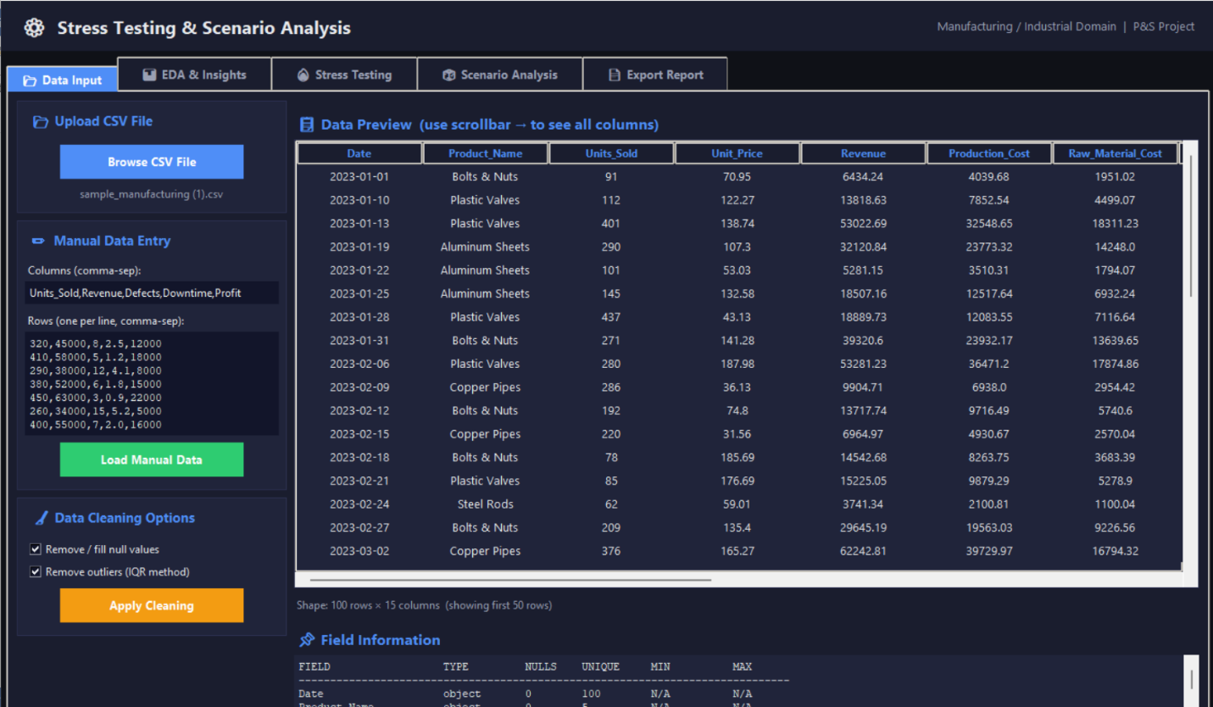

EDA & Insights (Descriptive Statistics):
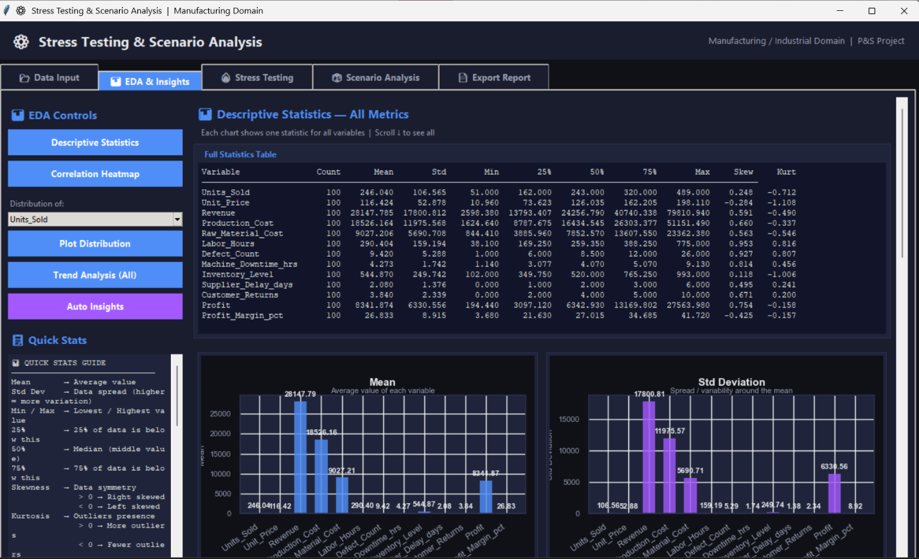
EDA & Insights (Correlation Heatmap):
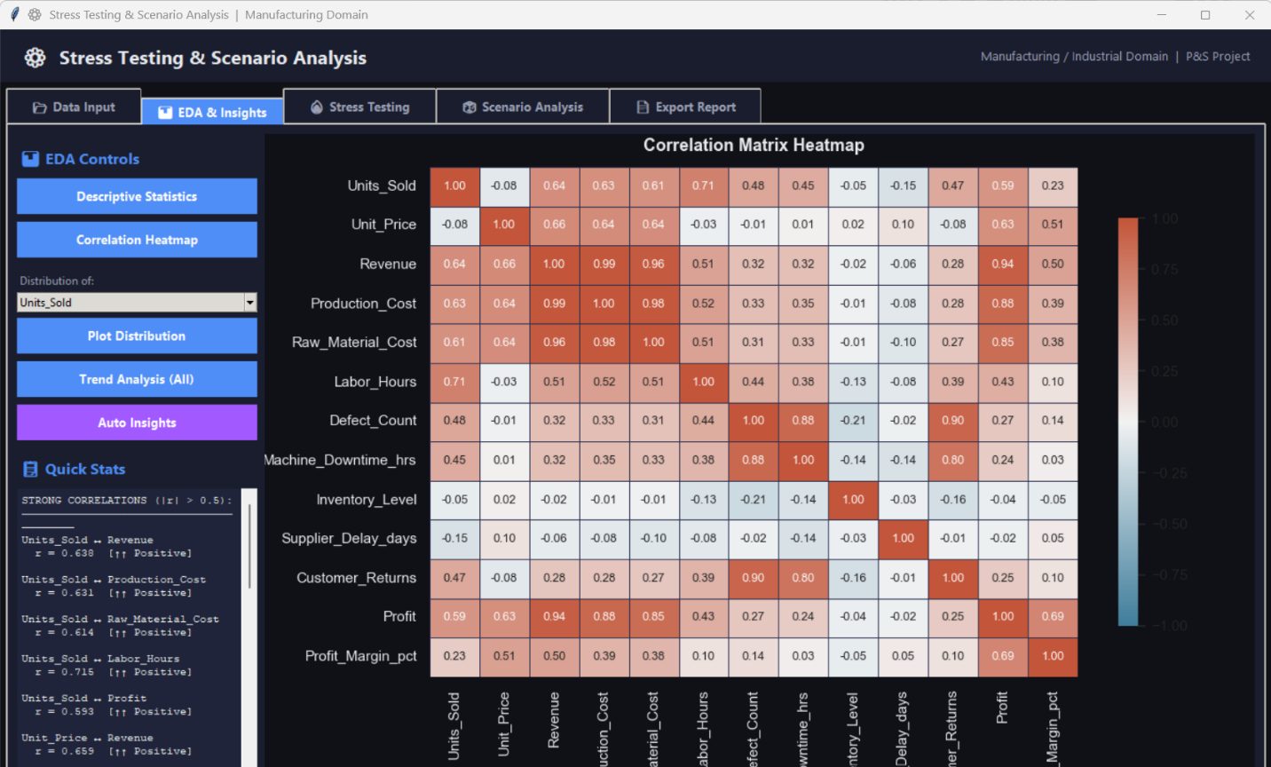

EDA & Insights (Plot Distribution for single variable):
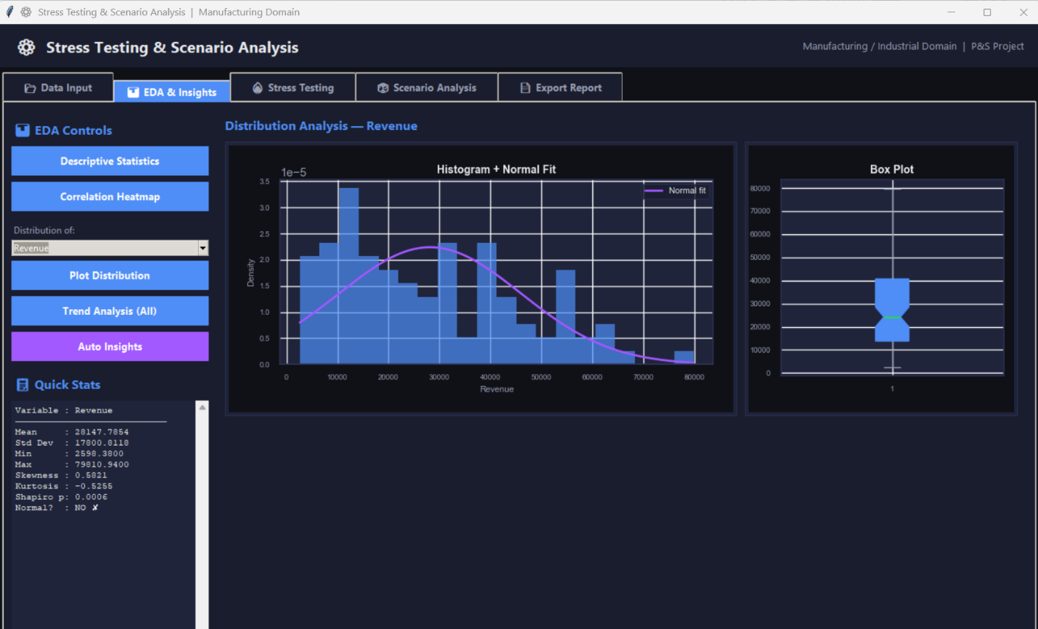
EDA & Insights (Trend analysis):
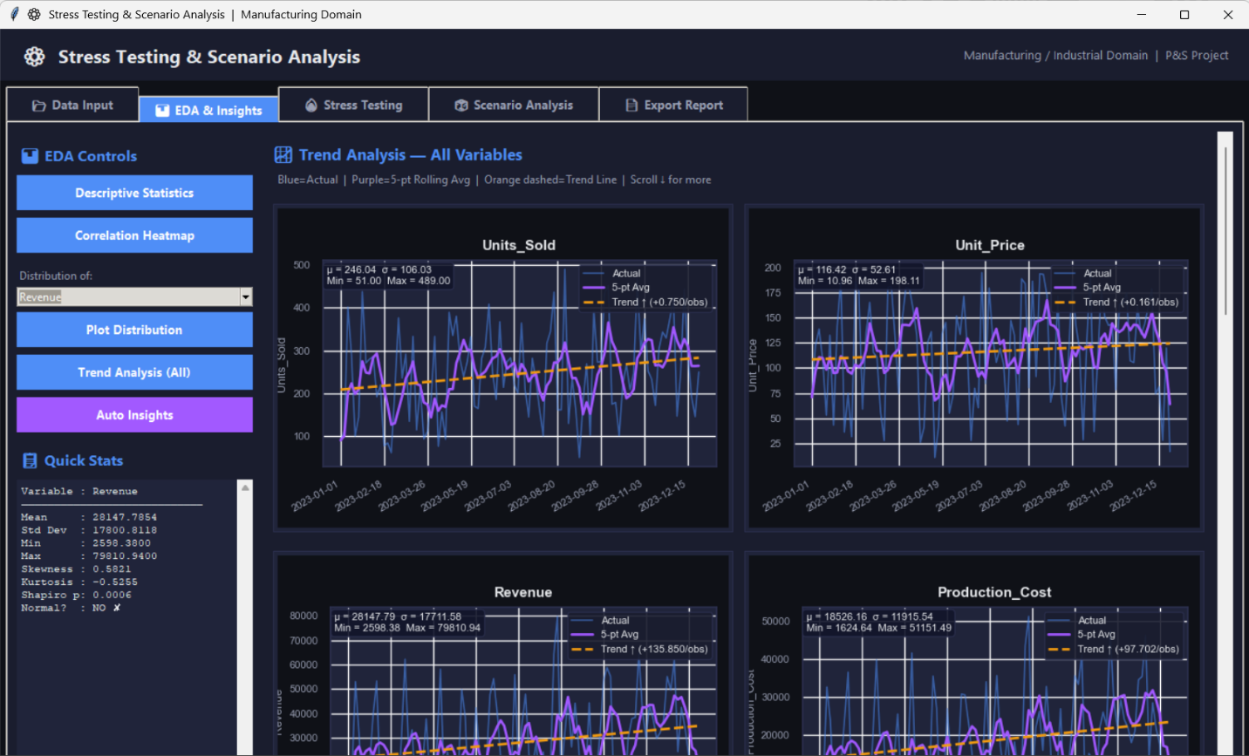

EDA & Insights (Auto insights):
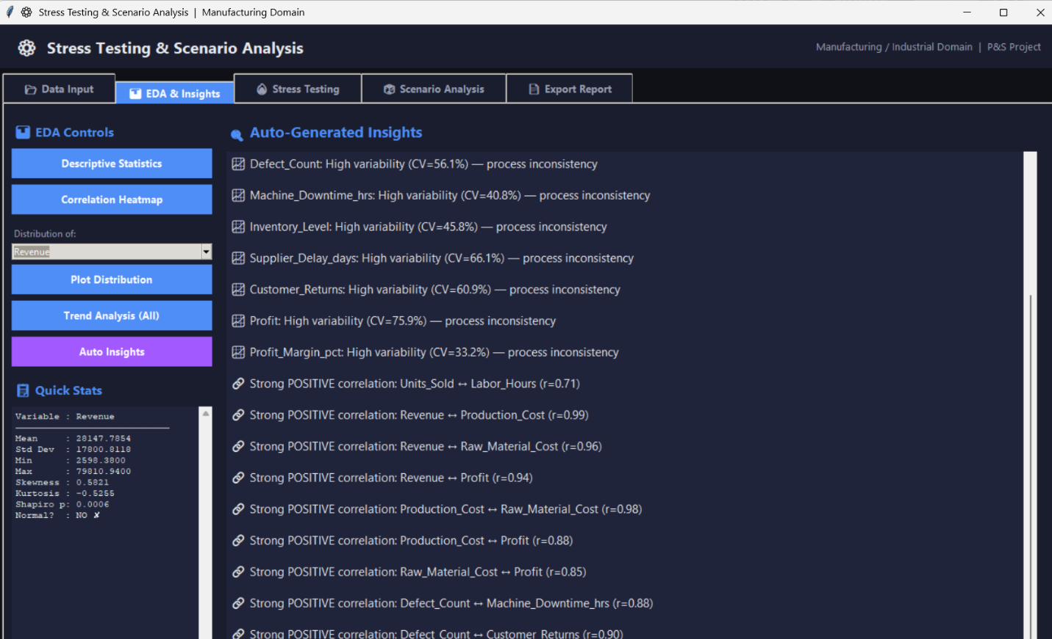
Stress testing:
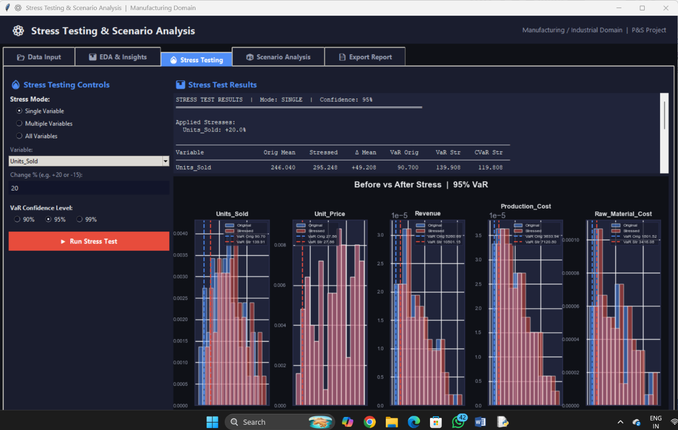

Scenario Analysis:
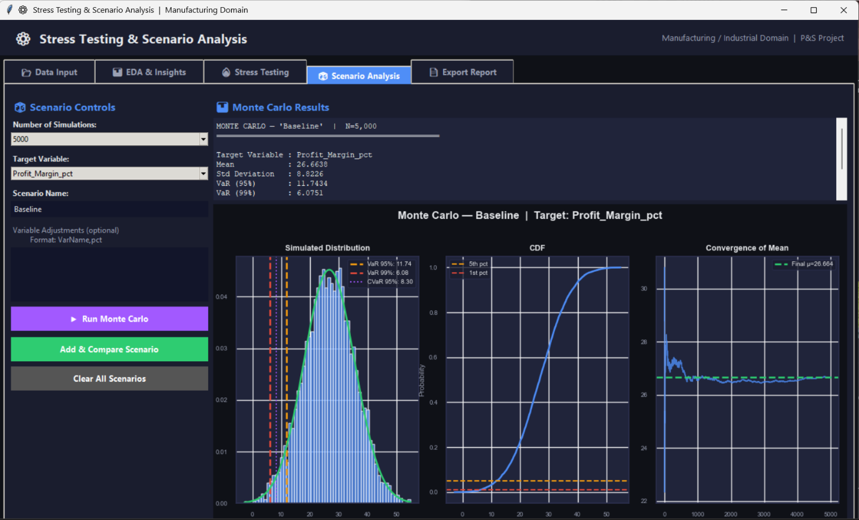
Scenario Comparison:
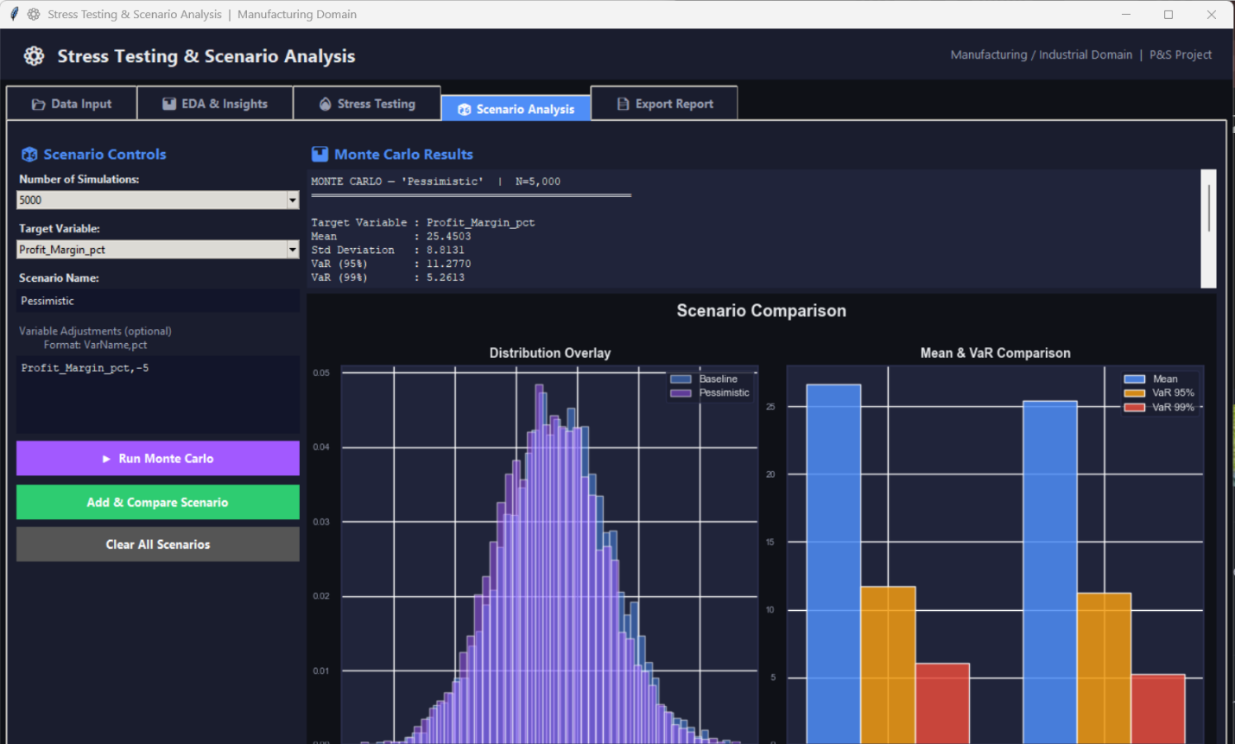

Export report:
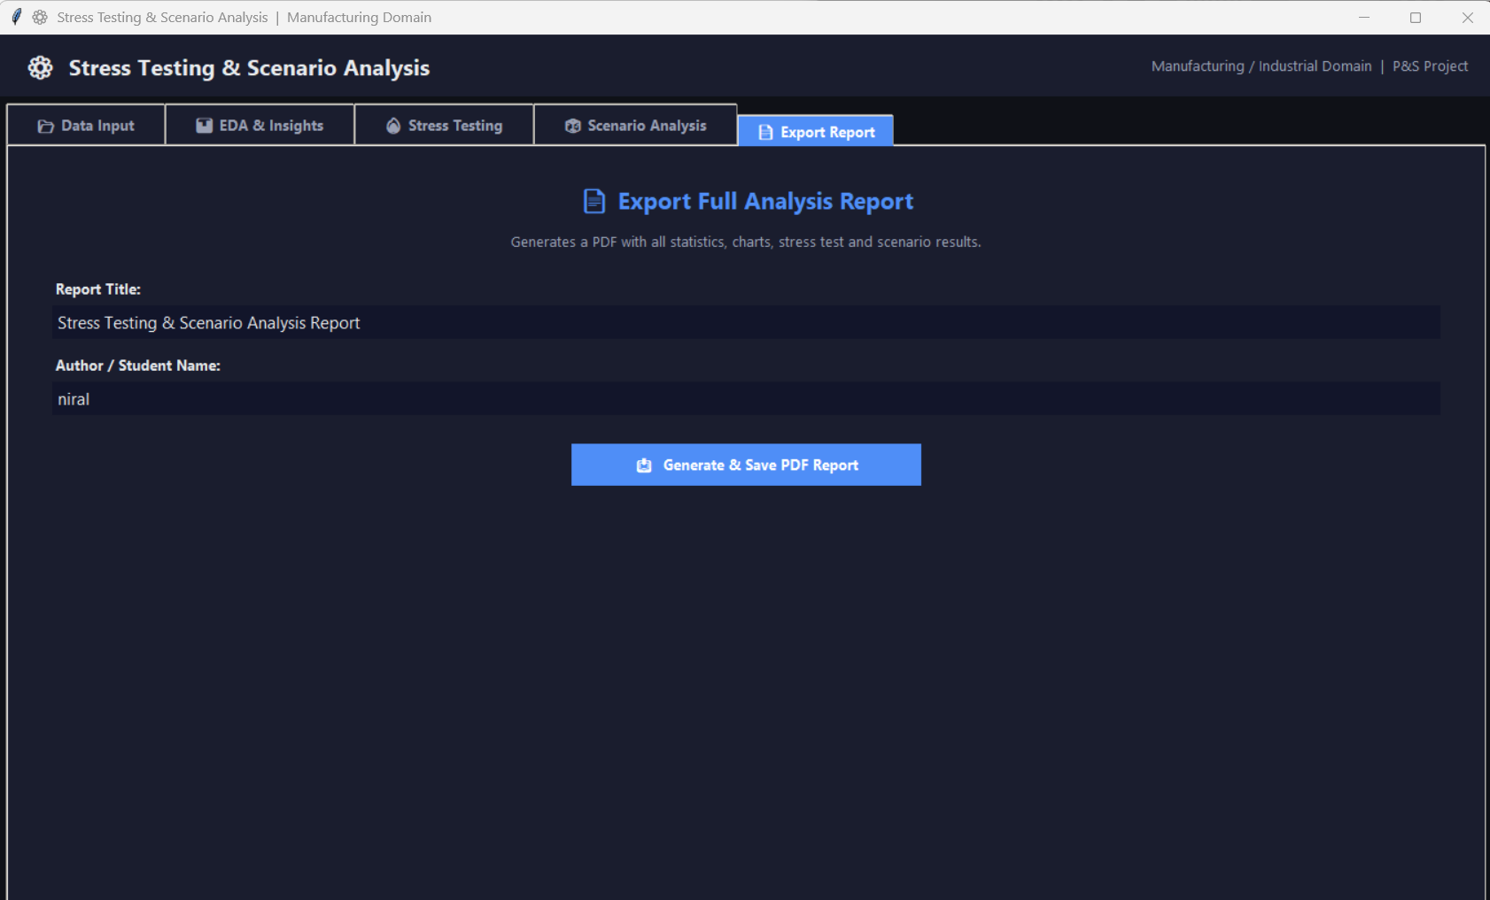

Report generated proof:
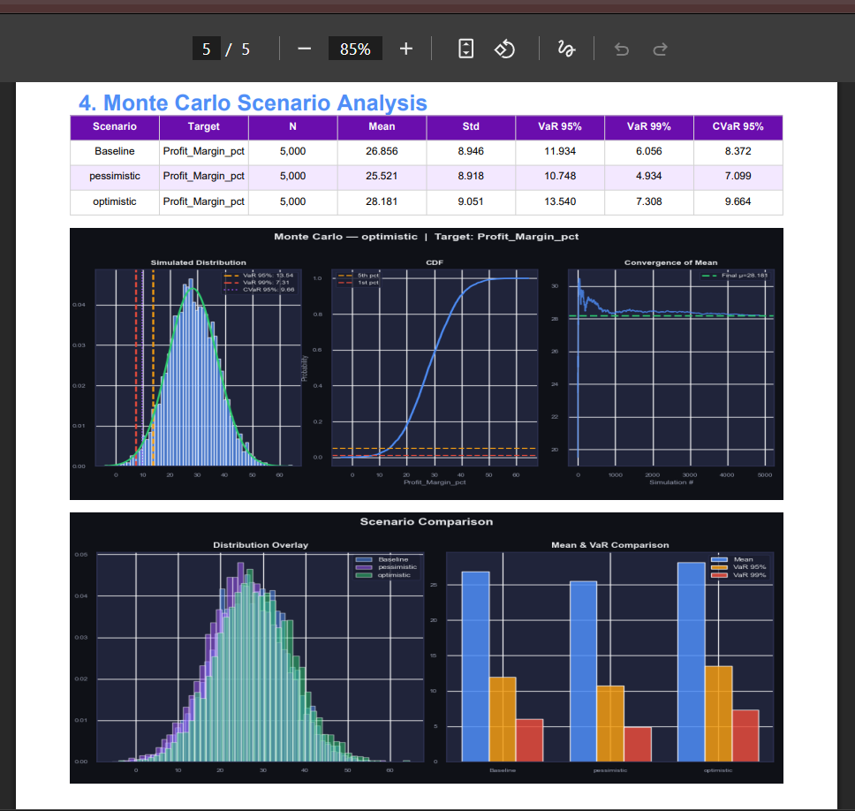

12. Conclusion
This project successfully developed a complete and practical desktop application for Stress Testing and Scenario Analysis in the manufacturing domain. The main goal of the project was to combine statistical analysis and simulation techniques into a single easy-to-use system that can help in risk evaluation and decision-making.
The application provides a full workflow starting from loading data (CSV files), performing statistical analysis, running simulations, and finally generating professional PDF reports. This makes the tool useful for both analysis and reporting in real-world scenarios.
One of the key achievements of this project is the stress propagation model, which ensures that when one variable is affected, related variables also get impacted based on their correlation. This makes the system more realistic and closer to real industrial behavior.
The project also includes a Monte Carlo simulation engine, which helps generate many possible future outcomes based on probability distributions. Along with this, VaR (Value at Risk) and CVaR (Conditional Value at Risk) are calculated at different confidence levels to measure financial and operational risk.
Another important feature is the Exploratory Data Analysis (EDA) module. It automatically calculates key statistical values, detects outliers, checks data distribution, identifies trends, and generates useful insights without manual effort.
The system also includes an automated PDF reporting feature, which helps users easily export results in a professional format for presentations or documentation.
Overall, this project shows that Python libraries like Pandas, NumPy, SciPy, Matplotlib, and Seaborn are powerful enough to build industrial-level risk analysis tools when combined with a well-designed user interface.
In the future, this system can be improved by using more advanced statistical models instead of only normal distribution, adding time-series forecasting methods like ARIMA and GARCH, and supporting more complex dependency models like copulas. A web-based version using tools like Streamlit or Dash can also make the system more accessible to multiple users.
In conclusion, this project successfully bridges the gap between statistical theory and real-world manufacturing risk analysis, providing a simple yet powerful tool for engineers and analysts.

13. References
1. Quantifying Supply Chain Disruption Risk Using Monte Carlo Simulation
Link: https://www.researchgate.net/publication/224123998
2. Power System Reliability Evaluation Using Sequential Monte Carlo Simulation
Link: https://www.researchgate.net/publication/388689376
3. Adaptive Stress Testing for Autonomous Vehicles
Link: https://arxiv.org/abs/1902.01909
4. Multilevel Monte Carlo Methods for Stress Testing
Link: https://arxiv.org/abs/2010.12651
5. Step Stress Testing and Evaluation Using Simulation
Link: https://www.sciencedirect.com/science/article/abs/pii/002627148990574X
6. SciPy, NumPy, Pandas, Matplotlib Official Documentation
Used for implementation of statistical analysis, simulation, and visualization.
Links:
- https://numpy.org/doc/
- https://pandas.pydata.org/docs/
- https://docs.scipy.org/doc/
- https://matplotlib.org/stable/contents.html

