Game Design Document

Fill up the following document

1. Write the title of your project.

RUN OF HORRENDOUS

1. What is the goal of the game?

The goal of this game is to collect thehorror pumpkins and go away from the house of evil nun.

1. Write a brief story of your game.

The story is about a child who is scared trying to go away from the

evil nun house from a scary path facing a lot of scary things in his

way.

1. Which are the playing characters of this game?

* Playing characters are the ones who respond to the user based on the input from the user.
* Cars, monkeys, dinos, wizards, etc., are the playing characters in the game.

|  |  |  |
| --- | --- | --- |
| Number | Character Name | What can this character do? |
| 1 | Child | This is the main character, he will try to run away from the evil nun house collecting pumpkin by going from the scary path. |
| 2 | Scary Nun | Nun will come to caught the child if he touches any obstacles. |
| 3 |  |  |
| 4 |  |  |
| 5 |  |  |
| 6 |  |  |
| 7 |  |  |
| 8 |  |  |

1. Which are the Non-Playing Characters of this game?

* Non-Playing characters are the ones that don't have an action or behavior when the user interacts with the game.
* Hurdles, stones, bananas, coins, etc., are non-playing characters in the game.

|  |  |  |
| --- | --- | --- |
| Number | Character Name | What can this character do? |
| 1 | Scary Pumpkin | This can be collected by the child. |
| 2 | Scary Skeleton | Use to scare the child on his way. |
| 3 | House | This is the house of evil nun from where the kid is going away. |
| 4 |  |  |
| 5 |  |  |
| 6 |  |  |
| 7 |  |  |
| 8 |  |  |

Draw your imagination of this game. What does this game look like?

* Draw the game either on your computer or on paper.
* Add images of the game scenes to show each of the playing and non-playing characters at least once.

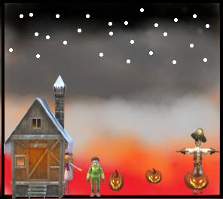

Imagination of the game

How do you plan to make your game engaging?

I thought to make a horror game by creating a horror picture on my mind ,then I thought of the characters which I need for making this scary game ,then I search for it and it is done.