**Application1**

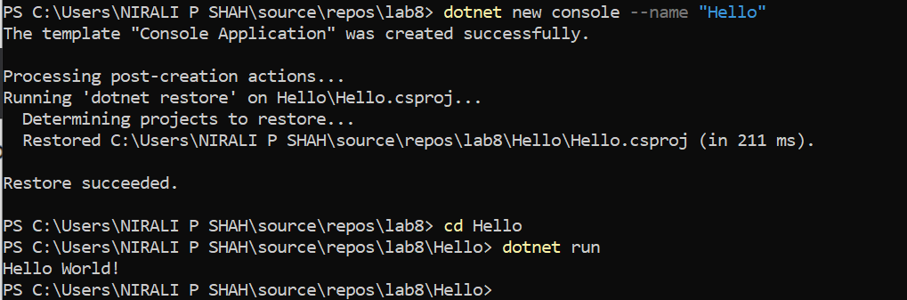

**Application2**

**→** Index method(default)

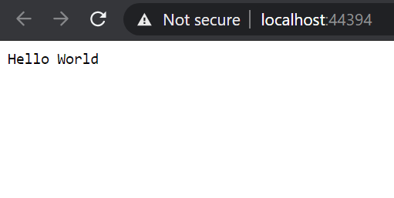

→ test1 action method

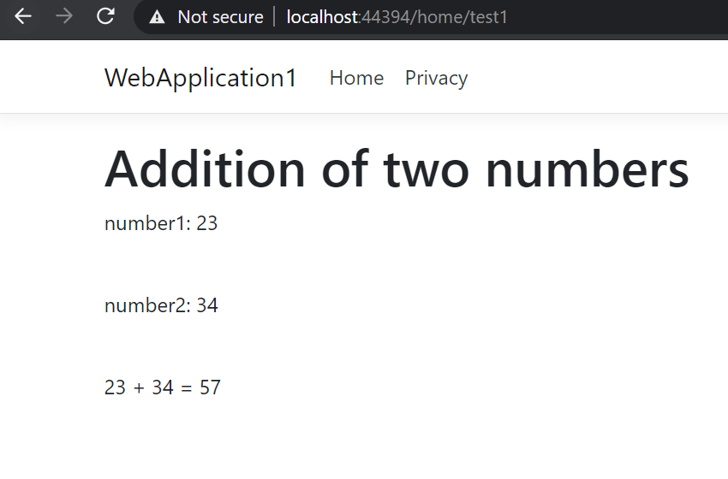

→ test2 action method

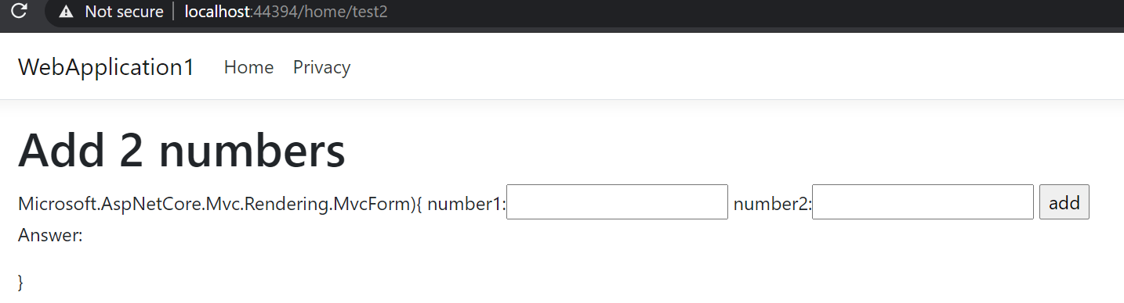

→ give 2 numbers as input

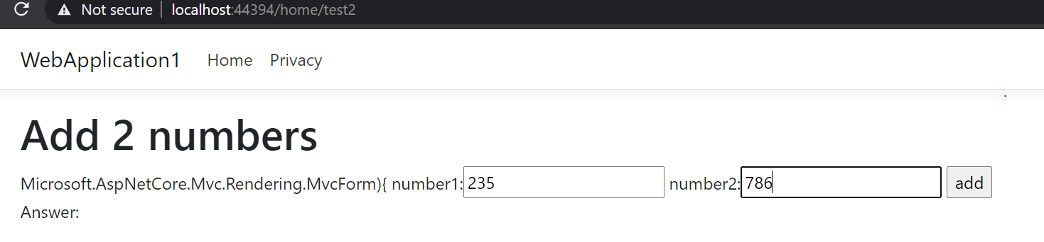

→ calculate sum of 2 input numbers passed using ViewBag

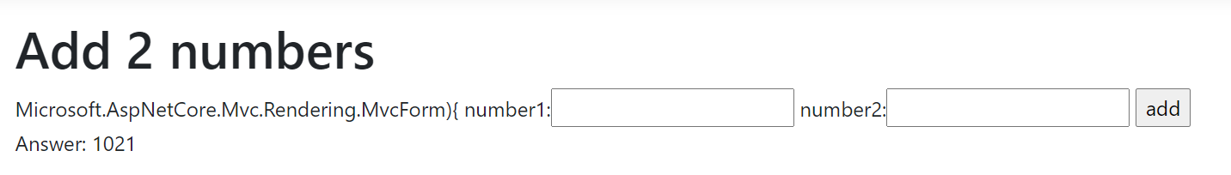

→ user_registration action method

