GRAPH 1(p2p-Gnutella31.txt)

1.Degree Distribution
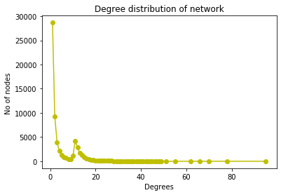

2.Diameter
NetworkXError: Found infinite path length because the digraph is not strongly connected.

3.Geodesic path length
shortest path arbitary pair of nodes: 6
Average shortest path length: 3.1766666666666667

4.Clustering coefficient and average clustering coefficient
Avg clustering coefficient: 0.005463878874361474
5.Strongly connected components
Streaming output truncated to the last 5000 lines.
1 1 1 1 1 1 1 1 1 1 1 1 1 1 1 1 1 1 ................

6.Properties of SCC
Is the network strongly connected: False
Number of strongly connected components: 48438

7.Sparseness
Density: 7.551395650121503e-05
Sparseness(taken as 1/density): 13242.585163497688

8.Connected component
Connected components are: 12.

GRAPH2(soc-Slashdot0902.txt)

1.Degree Distribution

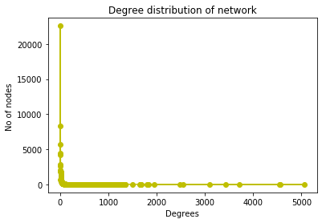

2.Diameter
NetworkXError: Found infinite path length because the digraph is not strongly connected.

3.Geodesic path length
shortest path arbitary pair of nodes: 3
Average shortest path length: 3.1633333333333336

4.Clustering coefficient and average clustering coefficient
Avg clustering coefficient: 0.06034485957583573

5.Streaming output truncated to the last 5000 lines.
1 1 1 1 1 1 1 1 1 1 1 1 1 1 1 1 1 1 1 1 1 1 1 1 1 1 1 1 1 1 1 1 1 1 1 1 1 1 1 1 1 1 1 1 1 1 1 1 1 1 1 1 1 ..................

6.Properties of SCC
Is the network strongly connected: False
Number of strongly connected components: 10559

7.Sparseness
Density: 0.00017256407249715723
Sparseness(taken as 1/density): 5794.949003747427

8.Connected component
Connected components are: 1

GRAPH 3(email-Enron.txt)

1.Degree Distribution

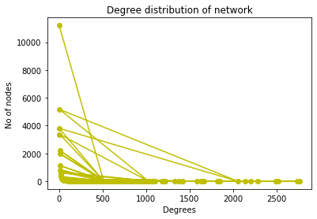

2.Diameter
NetworkXError: Found infinite path length because the digraph is not strongly connected

3.Geodesic path length
shortest path arbitary pair of nodes: 3
Average shortest path length: 2.6809523809523808

4.Clustering coefficient and average clustering coefficient
Avg clustering coefficient: 0.49698255959950266

5.Strongly connected components
Strongly connected componets: [{0, 1, 2, 3, 4, 5, 6, 7, 8, 9, 10, 11, 12, 13, 14, 15, 16, 17, 18, 19, 20...................

6.Properties of SCC
Is the network strongly connected: False
Number of strongly connected components: 1065

7.Sparseness
Density: 0.00027309755503535
Sparseness(taken as 1/density): 3661.6951765480253

8.Connected component
Connected components are: 1065

ASSIGNMENT2

1.GRAPH1

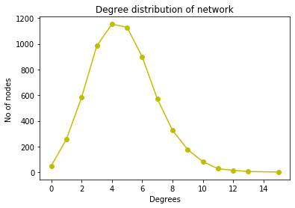
ERDOS-RENYL

watts_strogatz
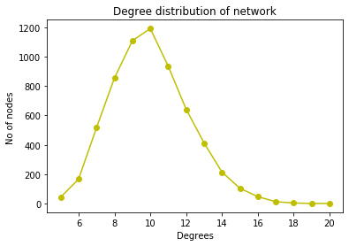

barabasi_albert
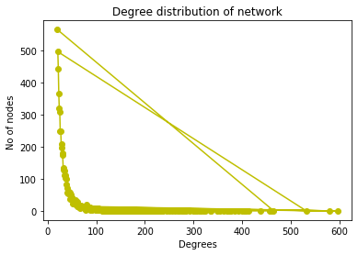

2. GRAPH3
ERDOS-RENYL
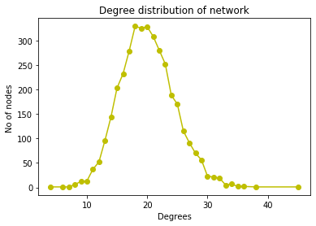

watts_strogatz

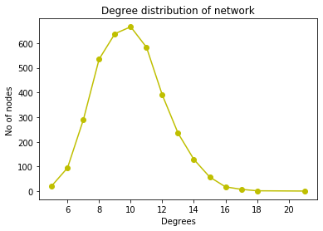

barabasi_albert

