Date – 14TH April 2016

DCT Applied. 256 features selected. Results for different classifiers –

2. NEURAL NET:

Hidden Layer - 10

ROC –



Confusion



Hidden Layer - 30

ROC -



Confusion –



Hidden Layer – 5

ROC-



CONFUSION



15 -04 – 2016

Number of images per class – 125

Validation – 10%

Testing – 20%

Results –





Date: 20th April

**Support Vector Machines:**

Poly Degree:2

Holdout: 1/5

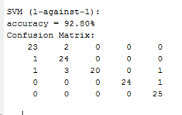

Degree: 3 , Holdout: 1/5

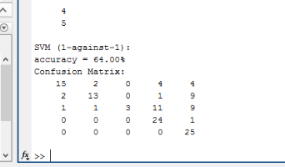

Degree :1, Holdout : 1/5

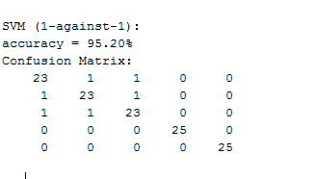

Degree :1 , Holdout:1/4

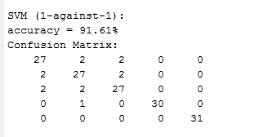

Degree:1, Holdout: 1/6

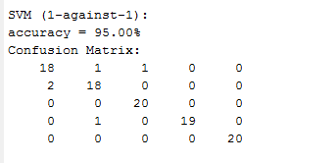

Degree:1, Holdout: 1/5 (2nd time)

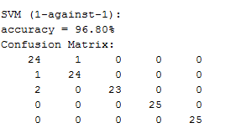

14 consonants :

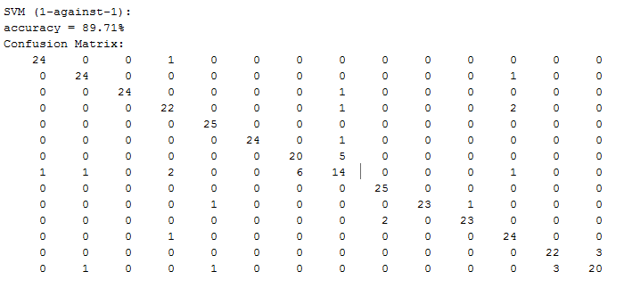

Neural Network:

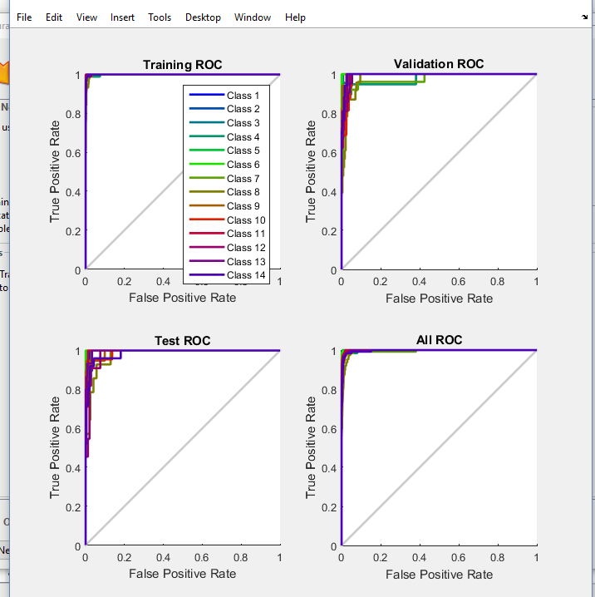

April 30th :Holdout- 1/5,

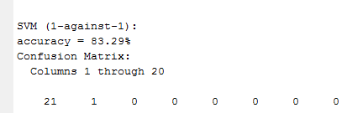

K-fold :10,

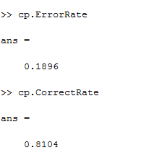

Neural Network:

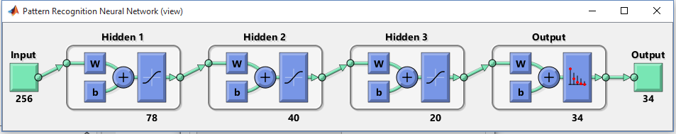

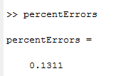

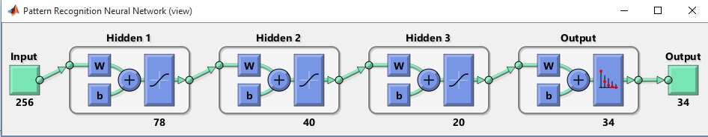

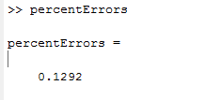

SVM: K-fold second time:

