SVM:

Poly Degree:2

Holdout: 1/5

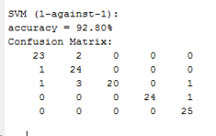

Degree: 3 , Holdout: 1/5

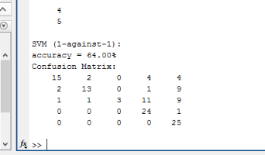

Degree :1, Holdout : 1/5

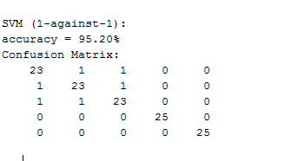

Degree :1 , Holdout:1/4

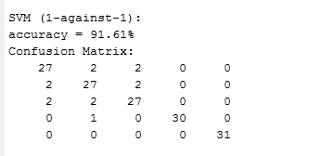

Degree:1, Holdout: 1/6

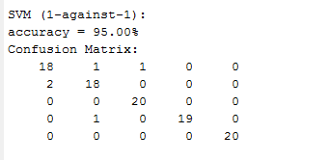

Degree:1, Holdout: 1/5 (2nd time)

