**22AIE457 - Full Stack Development**

**Lab Report IV – Responsive Web Design**

**Introduction**

This experiment demonstrates key concepts of responsive web design using HTML and CSS. It covers the use of the viewport meta tag, responsive images, scalable text, media queries, Flexbox, Grid, and Multi-Column layouts. These techniques help web pages adapt to different screen sizes and provide a consistent user experience across devices.

**1.Viewport meta tag**

**Code:**

<html>

<head>

    <title>GeeksforGeeks</title>

    <meta charset="utf-8"

          name="viewport"

          content="width=device-width,

                   initial-scale=1.0" />

    <style>

        .gfg {

            font-size: 40px;

            font-weight: bold;

            color: green;

            text-align: center;

        }

        .geeks {

            font-size: 17px;

            text-align: center;

        }

        p {

            text-align: justify;

        }

    </style>

</head>

<body>

    <div class="gfg">GeeksforGeeks</div>

    <div class="geeks">HTML Introduction</div>

    <p>

        HTML stands for HyperText Markup Language. It is

        used to design web pages using a markup

        language. HTML is a combination of Hypertext and

        Markup language. Hypertext defines the link

        between web pages. A markup language is used to

        define the text document within the tag which

        defines the structure of web pages. This

        language is used to annotate (make notes for the

        computer) text so that a machine can understand

        it and manipulate text accordingly. Most markup

        languages (e.g. HTML) are human-readable. The

        language uses tags to define what manipulation

        has to be done on the text.

    </p>

</body>

**Output:**

**Inference:**

1. The <meta name="viewport"> tag allows the webpage to scale content based on the device width.
2. It enables responsive design, ensuring the layout adjusts to different screen sizes.
3. It improves user experience on mobile devices by setting the initial zoom and width.

**2.Responsive Images**

**2.1 Width property**

**Code:**

<!DOCTYPE html>

<html>

<head>

    <meta name="viewport" content=

        "width=device-width, initial-scale=1.0" />

</head>

<body>

    <img class=".img-fluid" src=

"https://media.geeksforgeeks.org/wp-content/uploads/20220201191443/logo-200x32.png"

         style="width: 100%" />

    <h2>Responsive Images</h2>

    <p>

        Responsive images are just a part of Responsive

        websites. Images that can change their

        dimensions, scaling them up or down, according

        to the browser width are responsive images. The

        above image is responsive as it is adjusting

        itself according to the width of the browser.

    </p>

</body>

</html>

**Output:**

**Inference:**

1. Setting width: 100% allows images to expand or shrink based on the parent container’s width.
2. It ensures that the image scales uniformly across all device widths.
3. It contributes to consistent layout behavior and prevents horizontal scrolling.

**2.2 Max-Width property**

**Code:**

<!DOCTYPE html>

<html>

<head>

    <meta name="viewport"

          content="width=device-width,

                   initial-scale=1.0" />

</head>

<body>

    <img class=".img-fluid"

         src=

"https://media.geeksforgeeks.org/wp-content/uploads/20220201191443/logo-200x32.png"

         style="max-width:100%;

                height:auto;" />

    <h2>Responsive Images</h2>

    <p>

        Responsive images are just a part of Responsive

        websites. Images that can change their

        dimensions, scaling them up or down, according

        to the browser width are responsive images. The

        above image is responsive as it is adjusting

        itself according to the width of the browser.

    </p>

</body>

</html>

**Output:**

**Inference:**

1. max-width: 100% prevents images from exceeding their container size.
2. height: auto maintains the aspect ratio of the image.
3. Helps in maintaining image quality while avoiding distortion or overflow.

**2.3 Different Browser width**

**Code:**

HTML

<!DOCTYPE html>

<html>

<head>

    <title>HTML Responsive Web Design</title>

</head>

<body style="text-align: center;">

    <h1 style="color: green;">GeeksforGeeks</h1>

    <h2>HTML picture Tag</h2>

    <picture>

        <source media="(min-width: 700px)"

                srcset=

"https://media.geeksforgeeks.org/wp-content/uploads/20190825000042/geeks-221.png">

        <source media="(min-width: 450px)"

                srcset=

"https://media.geeksforgeeks.org/wp-content/uploads/20190802021607/geeks14.png">

        <img src=

"https://media.geeksforgeeks.org/wp-content/uploads/20190808102629/geeks15.png"

             alt="GFG">

    </picture>

</body>

</html>

**Output:**

**Inference:**

1. The <picture> tag enables different images to be loaded based on screen size using media queries.
2. It enhances performance by serving optimized image sizes per device.
3. Improves accessibility and responsiveness for various devices and screen densities.

**3. Responsive Texts**

**Code:**

<!DOCTYPE html>

<html>

<head>

    <style>

        body {

            max-width: 100%;

        }

        .gfg {

            font-size: 7vw;

            font-weight: bold;

            color: green;

            text-align: center;

        }

        .geeks {

            font-size: 5vw;

            text-align: center;

        }

        p {

            font-size: 3vw;

            text-align: justify;

        }

    </style>

</head>

<body>

    <div class="gfg">GeeksforGeeks</div>

    <div class="geeks">HTML Introduction</div>

    <p>

        HTML stands for HyperText Markup Language. It is

        used to design web pages using a markup

        language. HTML is a combination of Hypertext and

        Markup language. Hypertext defines the link

        between web pages. A markup language is used to

        define the text document within the tag which

        defines the structure of web pages. This

        language is used to annotate (make notes for the

        computer) text so that a machine can understand

        it and manipulate text accordingly. Most markup

        languages (e.g. HTML) are human-readable. The

        language uses tags to define what manipulation

        has to be done on the text.

    </p>

</body>

</html>

**Output:**

**Inference:**

1. Text size adjusts dynamically based on the viewport width using vw units.
2. Enhances readability by scaling font sizes proportionally on different screens.
3. Eliminates the need for multiple breakpoints for text resizing.

**4.CSS media queries**

**Code:**

<!DOCTYPE html>

<html>

<head>

    <title>GeeksforGeeks</title>

    <style>

        .gfg {

            font-size: 100px;

            font-weight: bold;

            color: green;

            text-align: center;

        }

        .geeks {

            font-size: 50px;

            text-align: center;

        }

        p {

            font-size: 25px;

            text-align: justify;

        }

        /* styling for screen width less than 800 */

        @media screen and (max-width: 800px) {

            body {

                background-color: aqua;

            }

            .gfg {

                font-size: 50px;

            }

            .geeks {

                font-size: 25px;

            }

            p {

                font-size: 12px;

            }

        }

    </style>

</head>

<body>

    <div class="gfg">GeeksforGeeks</div>

    <div class="geeks">HTML Introduction</div>

    <p>

        HTML stands for HyperText Markup Language. It is

        used to design web pages using a markup

        language. HTML is a combination of Hypertext and

        Markup language. Hypertext defines the link

        between web pages. A markup language is used to

        define the text document within the tag which

        defines the structure of web pages. This

        language is used to annotate (make notes for the

        computer) text so that a machine can understand

        it and manipulate text accordingly. Most markup

        languages (e.g. HTML) are human-readable. The

        language uses tags to define what manipulation

        has to be done on the text.

    </p>

</body>

</html>

**Output:**

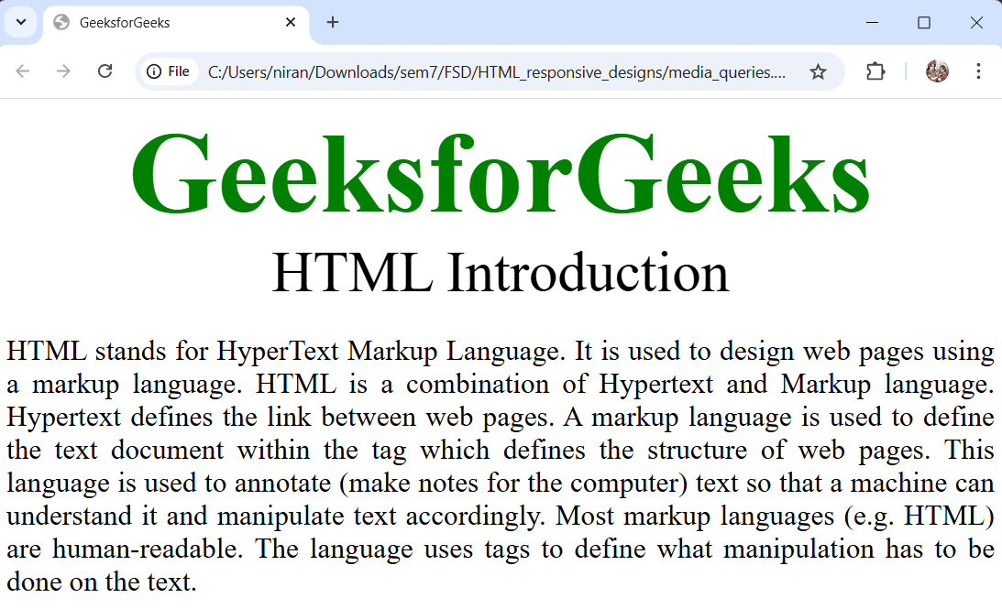

**Inference:**

1. Enables conditional styling based on device characteristics like screen width.
2. Dynamically adapts fonts, colors, and layout to improve user experience.
3. Reduces the need for separate mobile or desktop versions of the site.

**5.Responsive Layouts**

**5.1 Flexbox property**

**Code:**

<html>

<head>

<title>GeeksforGeeks</title>

<style>

body {

background-color: aqua;

}

.gfg {

font-size: 5vw;

font-weight: bold;

color: green;

text-align: center;

}

button {

width: 300px;

font-size: larger;

      }

        .container {

            display: flexbox;

        }

    </style>

</head>

<body>

    <div class="gfg">GeeksforGeeks</div>

    <div class="container">

        <button>HTML</button>

        <button>CSS</button>

        <button>JavaScript</button>

    </div>

</body>

</html>

**Output:**

**Inference:**

1. display: flexbox (though technically flex should be used) organizes content efficiently in a single direction.
2. Allows for easy alignment and spacing of elements without floats or complex margins.
3. Automatically adjusts layout for various screen sizes.

**5.2 CSS Grids**

**Code:**

<html>

<head>

    <title>GeeksforGeeks</title>

    <style>

        body {

            background-color: aqua;

        }

        .gfg {

            font-size: 5vw;

            font-weight: bold;

            color: green;

            text-align: center;

        }

        .container {

            font-size: x-large;

            text-align: center;

            display: grid;

            grid-template-columns: 1fr 1fr;

        }

        .grid-item {

            background-color: rgb(220, 208, 232);

            border: 2px solid rgb(70, 54, 84);

        }

    </style>

</head>

<body>

    <div class="gfg">GeeksforGeeks</div>

    <div class="container">

        <div class="grid-item">HTML</div>

        <div class="grid-item">CSS</div>

        <div class="grid-item">JavaScript</div>

        <div class="grid-item">Bootstrap</div>

    </div>

</body>

</html>

**Output:**

**Inference:**

1. display: grid creates two-dimensional layouts (rows and columns).
2. Grid layout allows precise positioning of elements in a structured format.
3. Supports complex layouts with minimal code.

**5.3 CSS Multi-Column**

**Code:**

<!DOCTYPE html>

<html>

<head>

    <title>GeeksforGeeks</title>

    <style>

        body {

            background-color: aqua;

        }

        .gfg {

            font-size: 5vw;

            font-weight: bold;

            color: green;

            text-align: center;

        }

        .container {

            font-size: x-large;

            text-align: left;

            column-count: 3;

            column-gap: 5%;

        }

    </style>

</head>

<body>

    <div class="gfg">GeeksforGeeks</div>

    <div class="container">

        <div>

            HTML stands for HyperText Markup Language.

            It is used to design web pages using a

            markup language. HTML is a combination of

            Hypertext and Markup language. Hypertext

            defines the link between web pages. A markup

            language is used to define the text document

            within the tag which defines the structure

            of web pages. This language is used to

            annotate (make notes for the computer) text

            so that a machine can understand it and

            manipulate text accordingly. Most markup

            languages (e.g. HTML) are human-readable.

            The language uses tags to define what

            manipulation has to be done on the text.

        </div>

    </div>

</body>

</html>

**Output:**

**Inference:**

1. column-count and column-gap create multi-column text layouts similar to newspapers.
2. Enhances readability by breaking long text into narrow columns.
3. Automatically adjusts column flow for different screen widths.

**Conclusion:**

This lab successfully demonstrated how responsive web design techniques using HTML and CSS enhance the adaptability of web pages across different devices. By applying viewport settings, media queries, flexible layouts, and scalable elements, we learned how to create user-friendly and mobile-compatible websites. These practices are essential in modern web development to ensure accessibility, performance, and a seamless user experience.