Lab Report I – Version Control using Git and GitHub
22AIE457 - Full Stack Development

Introduction
The lab Experiment demonstrates the basics of Git and GitHub for version control.
The basic functionalities like configuring Git, tracking file changes, committing updates, and pushing code to GitHub are explored here.
Navigating to Project Directory
- Opened the terminal and navigated to the desktop.
- Navigated to the directory Git and GitHub tutorial.
- Prepared the local folder to initialize Git.
- This is required to specify the workspace folder where Git will track file changes.

Initializing the Git Repository

- Executed git init to initialize a Git repository.
- Git responded that the repository has been initialized.
- The .git hidden directory was created to start version control.
- This marks the beginning of version control in the project folder.

Checking File Tracking Status
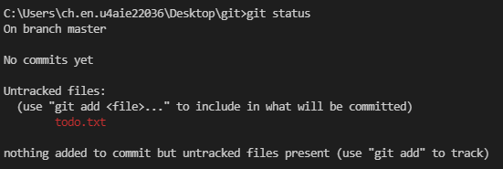
- Used git status to check the state of files.
- Confirmed that no files were being tracked.
- Indicates the working directory is clean but empty.
- Helps verify whether files are tracked or need staging.

Creating a Sample To-Do File
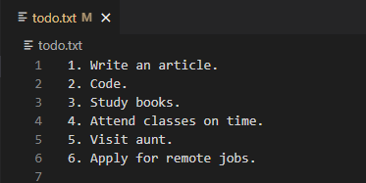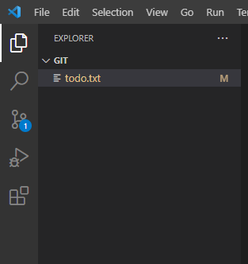

- Created a new file todo.txt with a list of tasks.
- This file includes entries like “Write an article” and “Study books.”
- Demonstrates content to be tracked by Git.
- A base file is needed to demonstrate version tracking and commits.

Staging Files for Commit
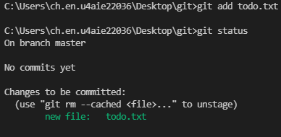
- Ran git add . to stage the file.
- This moved todo.txt to the staged state.
- Prepared the file for committing.
- Staging is essential for marking files to include in the next snapshot.

Committing the First Changes
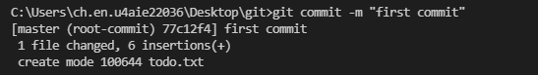

- Committed the changes using git commit -m "first commit".

- Git recorded the snapshot of the staged files.

- The file is now in the committed state.

- Commits help save the current state and provide a message for tracking history.

Connecting to Remote GitHub Repository

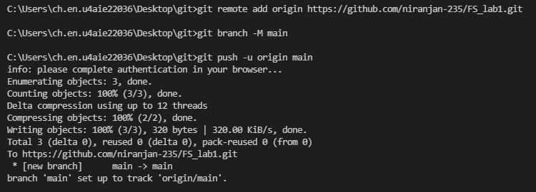
- Added a remote GitHub repository using git remote add origin <URL>.
- Connected the local repo to the GitHub remote repository.
- No output indicates the command executed successfully.
- This enables syncing local changes with GitHub for collaboration or backup.
- Set the branch name to main using git branch -M main.
- Ensures consistency with GitHub’s default branch name.
- No errors were shown, so the renaming was successful.
- Using the standard main naming convention avoids confusion across platforms.
- Used git push -u origin main to push the committed file.
- Uploaded the local repo to GitHub.
- GitHub now contains a copy of the local repository.
- Pushing allows remote access, backup, and team collaboration.

Modifying Tracked File
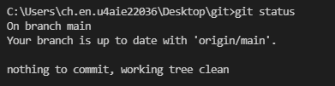
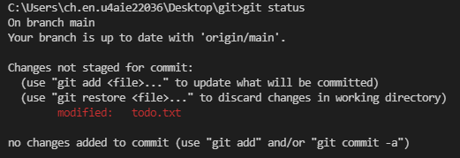
- Made an update to todo.txt by adding another task.
- Used git status to view the modified state.
- File shown as modified but not yet staged.
- Identifying file states helps avoid missing updates before committing.

Committing Modified File
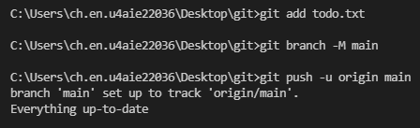
- Staged the modified file again using git add ..
- Committed the new change using git commit -m "added new task".
- Finally, pushed the changes to GitHub with git push -u origin main.
- Regular commits help document and organize incremental improvements.

Creating a New Branch
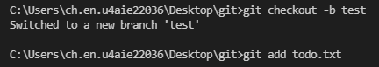

- Created a new branch named test with git checkout -b test.
- Switched to the test branch to try out new changes.
- Demonstrates branching to avoid affecting the main version.
- Branching enables experimenting without disturbing the stable project version.

Making Changes in New Branch
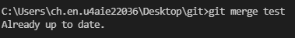
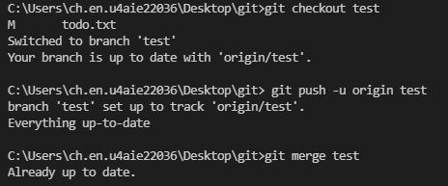
- Added more tasks like to the file.
- Staged and committed these changes in the test branch.
- Prepares for merge into the main branch.
- Allows testing enhancements in isolation before merging.
- Switched back to the main branch using git checkout main.
- The main branch remains unchanged at this point.
- Ready to incorporate changes from the test branch.
- Switching between branches helps manage parallel development paths.
- Merged the test branch into the main branch using git merge test.

- All new tasks from test were added to main.

- Shows a successful merge with an updated list in the main branch.

- Merging branches integrates improvements from isolated development.

Cloning Repository from GitHub
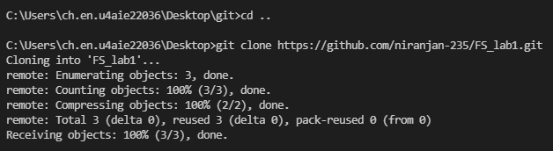

- The command cd .. is used to navigate one level up in the directory structure (from the git folder to Desktop).
- The command git clone https://github.com/niranjan-235/FS_lab1.git is used to download the repository FS_lab1 from GitHub.
- Git successfully connects to the remote repo and fetches all objects, creating a local copy named FS_lab1.
- Cloning a repository allows users to work on a project stored on GitHub by copying it to their local system.

Conclusion:
The fundamental Git operations including init, add, commit, push, branch and clone. Project from local desktop is being pushed to GitHub and learned how to manage multiple development paths with branches. By following step-by-step commands, version control using Git and GitHub became more practical and understandable.

