1)

a) UDP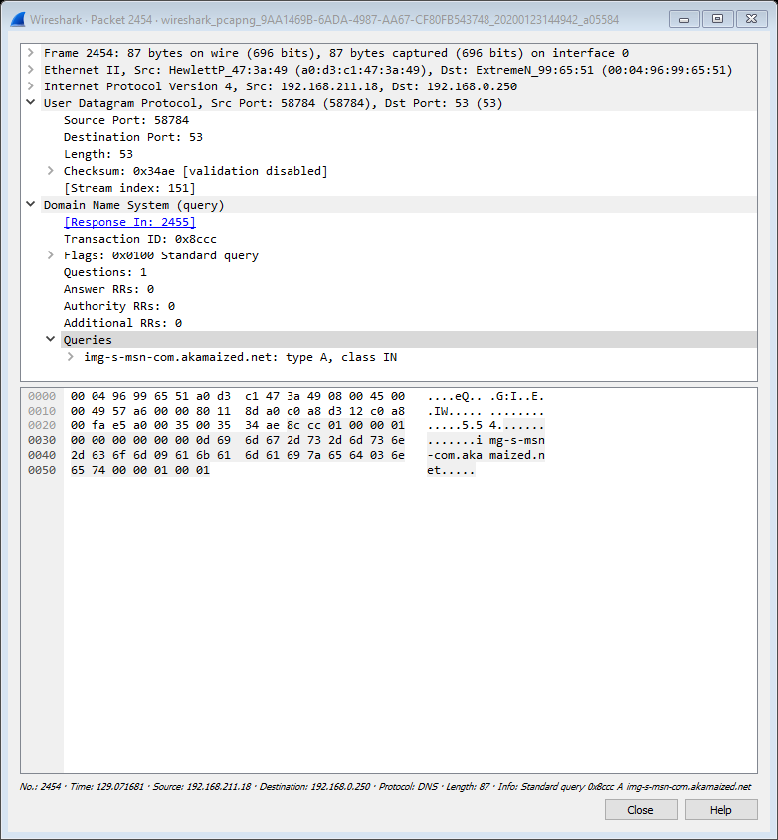

b) Destination Address: 192.168.0.250 Local DNS Server: 192.168.0.250. They are same. 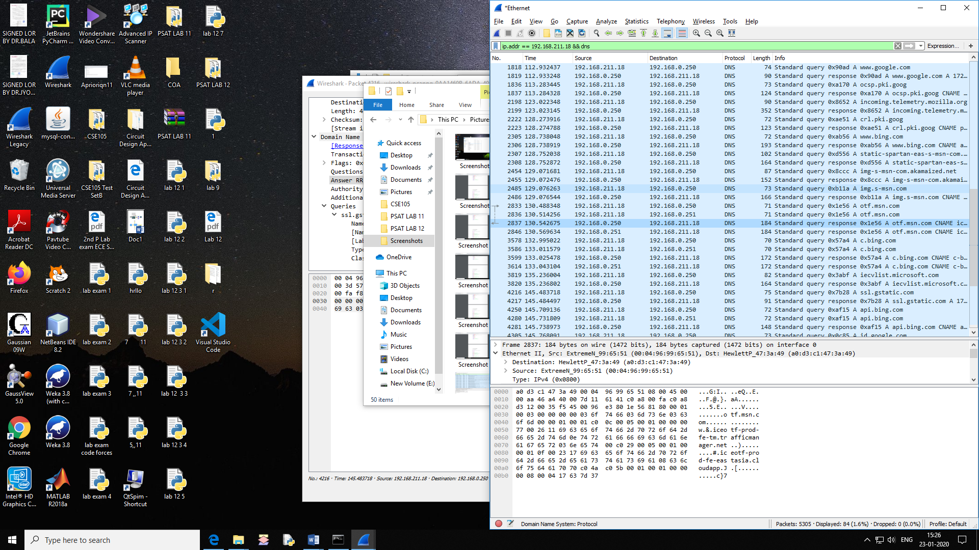

c) DNS - type-A. The query message does not contain answers

d) 4 Answers

they contain the following

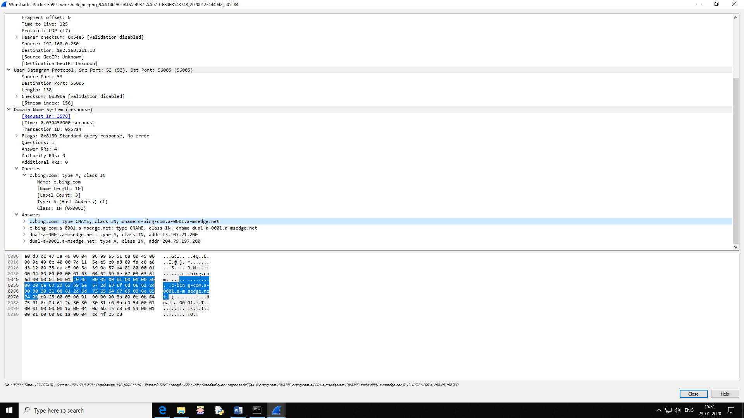

e)Destination Port for Query message is :53 & Source Ports for Response message is also : 53

2)

a)Destination Port for Query Msg: 53

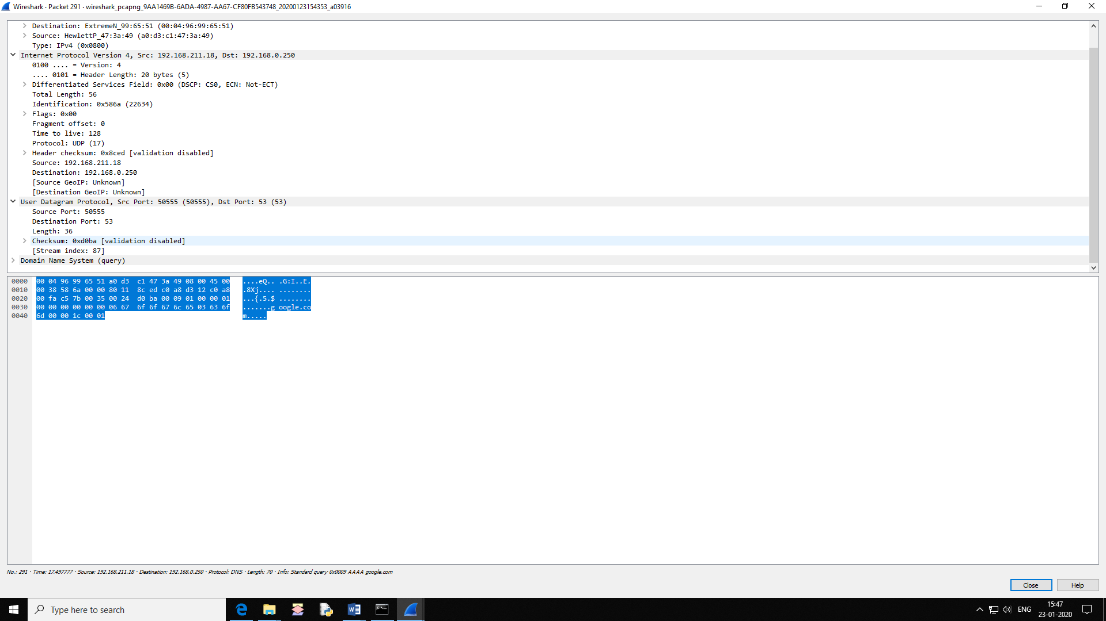

Source port for Response Message : 53

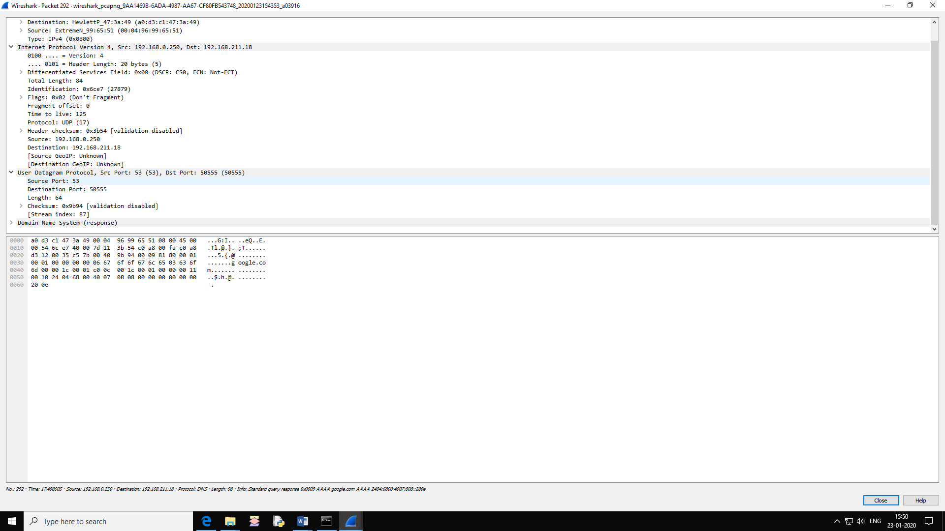

b) Destination Address: 192.168.0.250 Local DNS Server: 192.168.0.250. They are same.

c)Type:AAAA

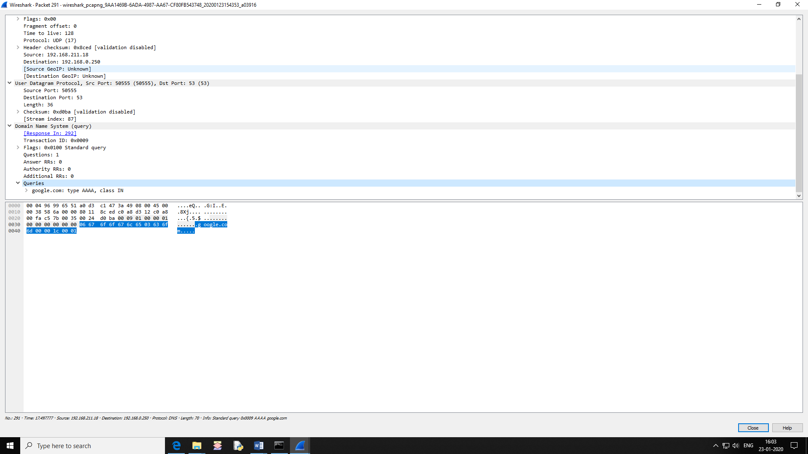

d) 1 Answer