**Develop neural network based time series forecasting model**

**AIM:**

To develop a neural network based time series forecasting modelusing jupyter notebook.

**ALGORITHM:**

1. Load the taxi dataset then clean and load the values

2. Train a neural network to predict the next hour's total_amount using the previous 24 hours as input features.

3. Plot the graph and visualize the values

**CODE:**

import pandas as pd

import numpy as np

import matplotlib.pyplot as plt

from sklearn.preprocessing import MinMaxScaler

from sklearn.neural_network import MLPRegressor

from sklearn.metrics import mean_squared_error

# Load data

df = pd.read_csv("dataset.csv")

# Create datetime column

df['datetime'] = pd.to_datetime(df[['year', 'month', 'day']]) + pd.to_timedelta(df['hour_of_day'], unit='h')

# Aggregate total_amount per hour

ts_df = df.groupby('datetime')['total_amount'].sum().reset_index().sort_values('datetime')

# Normalize total_amount

scaler = MinMaxScaler()

ts_df['scaled'] = scaler.fit_transform(ts_df[['total_amount']])

# Create sequences

def create_sequences(data, window_size=24):

X, y = [], []

for i in range(window_size, len(data)):

X.append(data[i-window_size:i])

y.append(data[i])

return np.array(X), np.array(y)

X, y = create_sequences(ts_df['scaled'].values, window_size=24)

# Train/test split

split = int(len(X) * 0.8)

X_train, X_test = X[:split], X[split:]

y_train, y_test = y[:split], y[split:]

# Create and train neural network model

model = MLPRegressor(hidden_layer_sizes=(64, 32), activation='relu', solver='adam', max_iter=500, random_state=42)

model.fit(X_train, y_train)

# Predict

predictions = model.predict(X_test)

# Inverse transform predictions

predicted_values = scaler.inverse_transform(predictions.reshape(-1, 1))

actual_values = scaler.inverse_transform(y_test.reshape(-1, 1))

# Plot results

plt.figure(figsize=(12, 6))

plt.plot(actual_values, label='Actual')

plt.plot(predicted_values, label='Predicted')

plt.title('Neural Network Forecast (MLPRegressor)')

plt.xlabel('Time Step (Hour)')

plt.ylabel('Total Amount')

plt.legend()

plt.show()

**OUTPUT:**

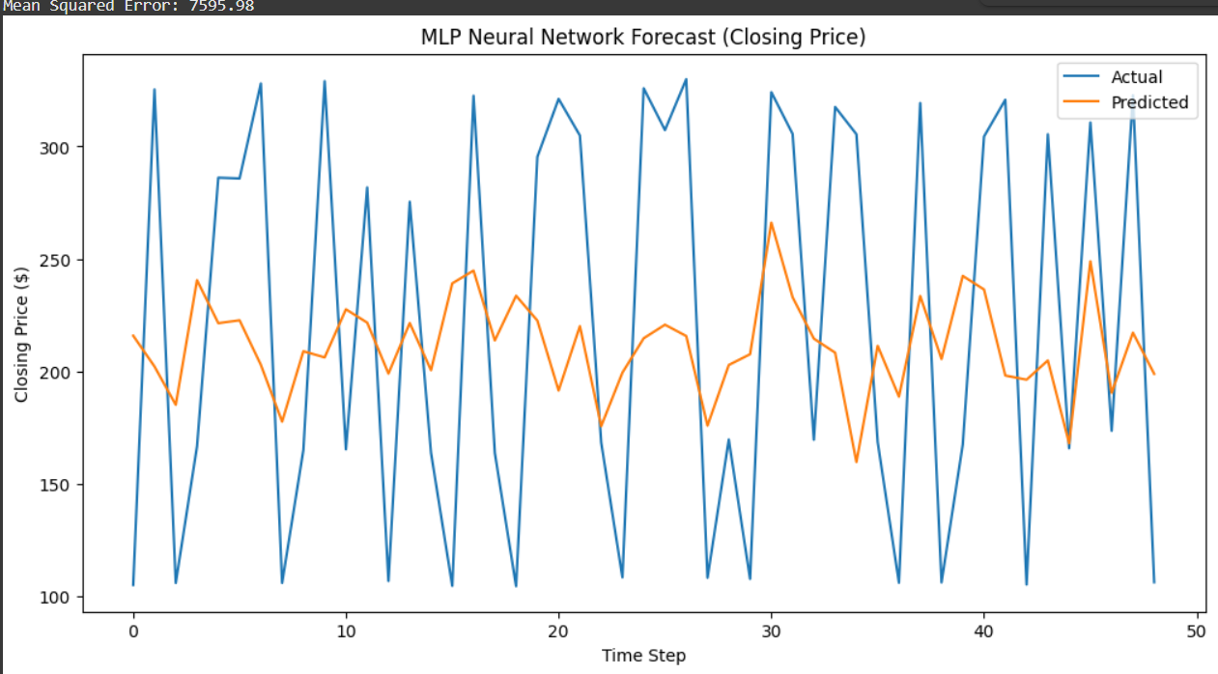

**RESULT:**

ToDevelop a neural network based time series forecasting model completed

successfully and the output is verified.